# CFETR NEUTRONICS BENCHMARK CROSSCHECKING USING JMCT SHOWS GOOD AGREEMeNT IN TRITIUM BREEDING RATIO CALCULATION AND some IDEAL ASSUMPTIONS in design models SHOULD BE INVESTIGATED FURTHER

1XIN WANG, RUI LI

2 YUANGUANG FU,GUIMING QIN, LI DENG,XUEMING SHI

1CAEP Software Center for High Performance Numerical Simulation, Beijing, China

2Institute of Applied Physics and Computational Mathematics, Beijing, China

Email: [sxm_shi@iapcm.ac.cn](mailto:address@correspondingauthor.com)

Tritium self-sufficiency is necessary for Fusion China Fusion Engineering Test Reactor (CFETR). There are three kinds of blanket design concepts for CFETR, such as helium cooled ceramics from SWIP[1] , water-cooled ceramics from ASIPP[2] and helium cooled lithium lead from FDS. The calculated Tritium Breeding Ratio(TBR) from these concepts are 1.18, 1.21 and 1.19 respectively. **Under support of national magnetic confinement fusion energy research project, Joint Mont Carlo neutron-photon-electron Transportation code(JMCT[3]) is used to crosscheck blanket neutronics of CFETR**. JMCT is self developed by Institute of Applied Physics and Computational Mathematics(IAPCM)and is widely used in China’s fission projects.

At the first stage, **a 200MW CFETR neutronics benchmark in MCNP input format** based on detailed CAD design **is shared in China**. **It is then converted to JMCT input format by manual** **within several months as shown in figure 1** with the aid of JLAMT ,which is a 3D visual pre-processor. The 25 blanket modules of the benchmark are then replaced by the 3 kinds of blanket design mentioned above. **All the JMCT crosschecking results are in good agreement with those of reference values and the relative error of calculated TBR are all within 0.5%**.

**The relative error of the local cells contribution to TBR are also satisfying.** T**here are 2283 cells in the helium cooled ceramics blanket, and 707 of them are in tritium production zone.** Among the tritium production cells, there are 546 with relative error less than 1%, which contributes 93.96% to TBR and 114 cells with relative error between 1%-2%, which contributes 5.57% to TBR. **There are 47 cells with relative error bigger than 2%, which contributes 0.47% to TBR**. In the water-cooled ceramics blanket, there 500 cells and 100 of them are in tritium zone, and there are 4 cells with relative error bigger than 2%, which contributes 5.45% to TBR. In the helium cooled lithium lead blanket, there are 125 cells and 25 of them are in tritium zone,and all the relative error are within 2%.

**It is also important to point that there are some ideal assumptions in all the three blanket neutronics modles.** Homogenization is widely used , each cell is either a plate or a wedge which is not consistant with the thermal hydraulic models. In the water-cooled ceramics model, the packing ratio is breeding zone is 80% (14.4% Li2TiO3 and 65.6%Be12Ti).In the helium cooled ceramics blanket, only radial structual materials are considered. In the helium cooled lithium lead blanket, each blanket module has only one tritium zone. **These simplication or ideal assumptions may overestimate TBR and should be further investigated in future designs.**

At the second stage, a **1000MW CFETR benchmark based on up to date CAD files in STP format are converted to JMCT input file within 1255 seconds by a CAD to Monte Carlo Geometry Converter tool** (CMGC[4])**directly** as shown in figure 2. In this stage, only the helium cooled ceramics blanket design need to be crosschecked and the validation of the calculation is underway.

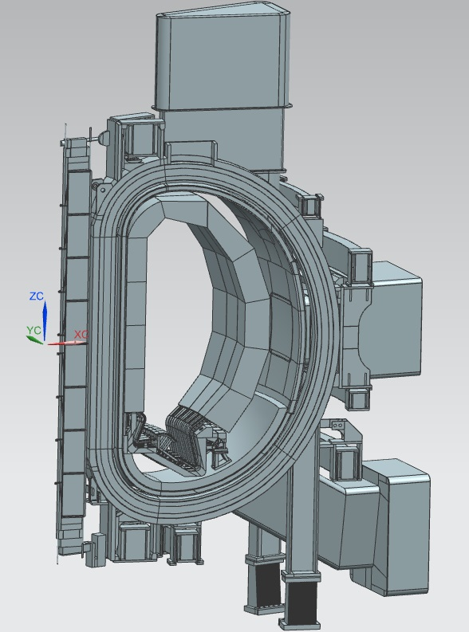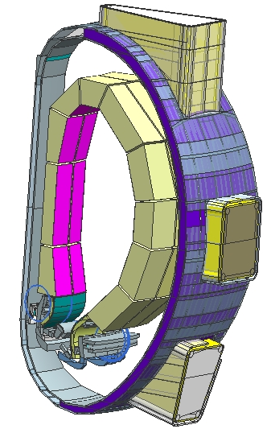

***Fig 1 200MW CFETR benchmark* *Fig 2 1000MW CFETR benchmark***

ACKNOWLEDGEMENTS

This research is sponsored by National MCF Energy R&D Program(No. 2022YFE03160001).

References

[1]]Z L LV, Neutronics Design and Analysis of Helium Cooled Solid Breeder Blanket for CFETR (in Chinese), University of Science And Technology of China, Hefei, China, 2016 a dissertation for doctors degree.

[2] Y P, Neutronis Design and Analysis of a Water Cooled Ceramic Breeder Blanket for CFETR, Institute of plasma physics, Hefei, China, 2015 a dissertation for master degree.

[3]Li Deng,Gang Li,Bao-Yin Zhang,etal,A high fidelity general purpose 3-D Monte Carlo particle transport program JMCT3.0,Nuclear Science and Techniques, 33:108(2022).

[4] Wang, X., Li, JL., Wu, Z. et al. CMGC: a CAD to Monte Carlo geometry conversion code. NUCL SCI TECH 31, 82 (2020). https://doi.org/10.1007/s41365-020-00793-8.