observation of nonlinear coupling of waves excited at distinct regions of overlapping dual lower hybrid and ion cyclotron resonances

H. IGAMI,
National Institute for Fusion Science,
Toki-city, Japan
Email: igami.hiroe@nifs.ac.jp

M. TOIDA
National Institute for Fusion Science,
Toki-city, Japan

A. FUKUYAMA
Graduate School of Engineering Kyoto University,
Kyoto-city, Japan

S. INAGAKI
Institute of Advanced Energy, Kyoto University,
Uji-city, Japan

R. SEKI, H. YAMAGUCHI
National Institute for Fusion Science
The Graduate University for Advanced Studies, SOKENDAI
Toki-city, Japan

Y. KATOH
Graduate School of Science, Tohoku University
Sendai-city, Japan

Abstract
This study shows the evidence of the non-linear coupling between waves in the lower hybrid (LH) and its harmonic frequency range excited spontaneously at spatially separated regions in a magnetically confined fusion-oriented (MCF) plasma with existence of energetic ions. (i) Burst-like emissions of waves in LH frequency (f₀) and their harmonic frequency ranges accompanied by sidebands with two distinct ion cyclotron (IC) frequency range intervals f₁, and f₂ were observed. (ii) Bicoherence analysis revealed that LH and its harmonic range waves (lf₀​) nonlinearly coupled with the sidebands (mf₀±nf₁, mf₀±nf₂) characterized by f₁​ and f₂​. (iii) Two spatially separated "dual resonances", namely DR1 and DR2 were identified in the main confinement region. The LH resonance (LHR) of f₀​ overlaps with the ion cyclotron resonance (ICR) of f₁​ at DR1 and the LHR of f₀​ overlaps with the ICR of f₂​ at DR2. This fact that waves, which can potentially contribute to the resonant heating of bulk ions, spontaneously grow nonlinearly due to the presence of high-energy ions and distinct spatially separated dual resonances, has a significant impact on exploring scenarios for sustaining fusion burning plasmas

INTRODUCTION
Understanding of the energy cascade process of energetic ions is an important issue for fusion plasma research. If we can find a scenario where fusion born alpha particles excite waves that resonantly heat bulk ions, efficient sustainment of the burning plasma can be expected. Interaction of alpha particles with lower hybrid (LH) waves and ion Bernstein waves in fusion plasmas have been studied theoretically [1-4]. Nonlinear first-principles simulations demonstrated that stimulated fast Alfvén wave emission whose frequency is 18𝜔_{c𝛼} caused by population inversion in the velocity space of fusion-born alpha particles enhance the externally applied weak fast Alfvén wave of 18𝜔_{c𝛼} and increase the energy density of the thermal majority deuterons [5].
In magnetically confined fusion (MCF) plasmas, an analogous energetic ion population can be realized by neutral beam injection (NBI). Observation of waves and their interactions originated from beam ions are instructive for studying the energy cascade process of alpha particles via waves. In the Large Helical Device (LHD), emissions of ion cyclotron (IC) and its harmonic range, namely ion cyclotron emissions (ICEs) have been observed in variety types of plasma discharges with NBI [6-12]. Not only ICEs but also waves in LH frequency range have been observed [8, 12] in LHD. Waves in the LH frequency range detected during perpendicular NBI were interpreted as magnetosonic mode [13]. While waves in LH frequency range observed during the start-up phase of the plasma discharges initiated with tangential NBI and electron cyclotron resonance heating (ECRH), that consist of characteristic spectrograms: spectral peaks shifted in a stair-like manner with increasing density, were interpreted that ion cyclotron waves (ICWs) and ion Bernstein waves (IBWs) were excited in the core region of the plasma. Electromagnetic particle-in-cell (PIC) simulations using with assuming local plasma parameters near the magnetic axis and a ring-like velocity distribution of energetic ions demonstrated that ion Bernstein waves (IBWs), with dispersion coupled to LH waves, can be excited by energetic ions, yielding spectra with peaks close to integer multiples of the IC frequency [14]. PIC simulations have also demonstrated that LH harmonic range waves can be excited by energetic ions with sidebands whose gaps correspond to the IC frequency [15].
In LHD, LH harmonic range waves have been observed with sidebands whose intervals are almost correspond with IC frequency when the stair-like spectrogram mentioned above appears. We have also found that the emission intensity shows burst-like modulations. Numbers of sidebands appear during large bursts. Previous PIC simulations using local plasma parameters did not capture the burst-like behavior in the simulation period less than 100 ion cyclotron period. The period of the burst seen in the experiments are approximately 10⁴ times of ion cyclotron period, namely several kHz. In this paper, characteristics of nonlinear coupling between waves are investigated. During large bursts, a wave in LH frequency range interacts with distinct ion cyclotron frequencies.

RESULTS

Observation of stair-like spectrogram during the plasma start-up phase
Antennas to detect high frequency electric fluctuations up to 2 GHz are installed in a vacuum vessel port viewing a viewing the horizontal cross section (10-O port) and a port viewing a longitudinal cross section (9.5-L port) in LHD. During the plasma start-up phase with simultaneous tangential hydrogen NBI with 164 keV/3.86 MW and ECRH with 154 GHz/2.0 MW in total from t = 3.30 s, semi periodic burst-like emissions were detected in the LH frequency (~200 MHz) and their harmonic frequency ranges accompanied with sidebands with frequency intervals of IC frequency range (30~40 MHz) in Fig.1-(b) and Fig.2-(b). In this experiment, the magnetic configuration was (R_{ax}, B_{t)} = (3.90 m, 2.538 T) where R_{ax} is the distance from the center of the torus to the magnetic axis and B_{t} is the magnetic field strength at the magnetic axis. As the background plasma density increases, higher hydrogen IC harmonic frequency appears in order like stairs. As mentioned previously, the previous PIC simulation study shows that the IC harmonic wave with 𝜔 ≃ l𝜔_{ci}, is excited when the lower hybrid wave with 𝜔_{LH} approaches l 𝜔_{ci} in the presence of energetic ions.
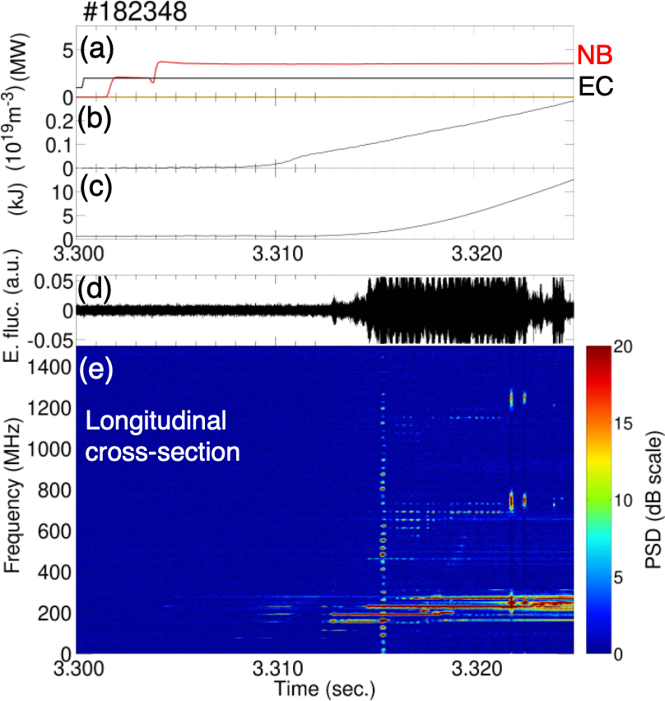
Figure 2: Graphs similar to Fig. 1. Electric field fluctuation is detected in a port viewing a longitudinal cross section (9.5-L port).
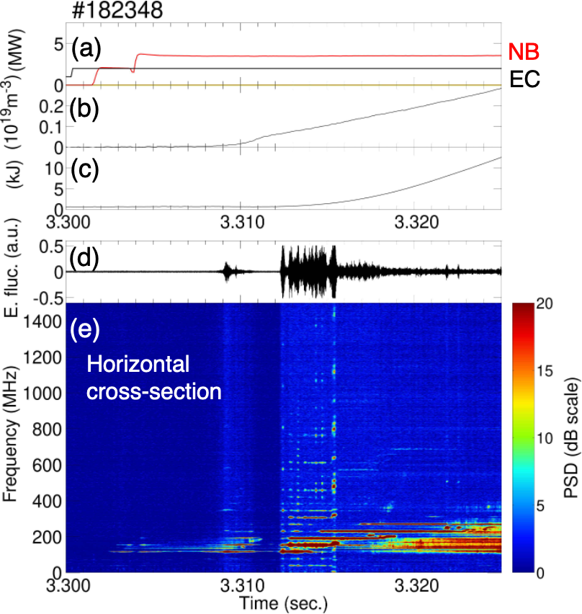
Figure 1: Time change of (a) heating power, (b) line averaged density, (c) stored energy, (d) electric fluctuation signal detected in a port viewing a horizontally long cross section (10-O port), (e) frequency spectrogram
Fig. 3 shows magnetic fluctuations detected by a Mirnov coil input to a digitizer of 1 MHz sampling and its frequency spectrogram. Different from previous observations of ICEs with large intensity burst synchronized with bursty MHD events, such as toroidal Alfvén eigenmode (TAE) [7, 12], tongue-shaped magnetic surface deformation with subsequent energetic-ion-driven MHD mode (EIC) [11], no apparent magnetic fluctuations synchronized with excited MHz range waves were detected during the stair-like spectrogram with semi-periodic burst-like intensity enhancements are observed.
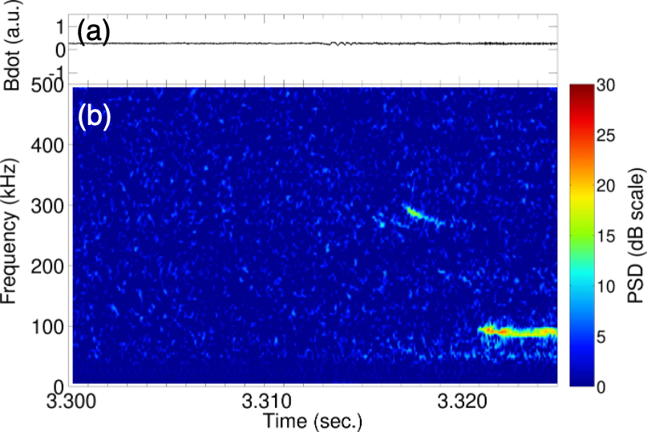Figure 3: Time change of (a) magnetic fluctuation detected by Mirnov coil, and (b) the spectrogram
2.2. Interactions between excited waves
When the whole emission intensity is bursty increased, intense peaks of the frequency spectrum appear at multiples of a lower hybrid frequency range wave f₀. Large number of sidebands appear around f₀ and nf₀. Fig. 4 shows the time expanded views of Figure 1. The whole emission intensities detected at the 10-O port viewing a horizontally long cross section during bursts was larger before the largest burst around t=3.31540 s than those after the largest burst. Harmonics of f₀=152.5 MHz are shown with sidebands during bursts that appear before the largest bursts. Figure 5 shows the auto bicoherence of the electric field fluctuations detected during a burst around t=3.314715 s. It is shown that harmonics of f₀=152.5 MHz and their sidebands interact with each other. Figure 6 shows the intensity and summed auto bicoherence plotted along the frequency. It is clearly shown that the sidebands appear around nf₀ with a constant gap frequency of 39 MHz.
Figure 6: (a) Frequency spectrum averaged around t=3.314715, detected at the 10-O port viewing a horizontal long cross section. (b) Sum of the auto bicoherence.
Intense peaks appear around f₀=152.5 MHz and their harmonics with sidebands whose gap frequency f₁ is 39 MHz.
In the graphs, dot-dashed lines are drawn with gaps of f₁.
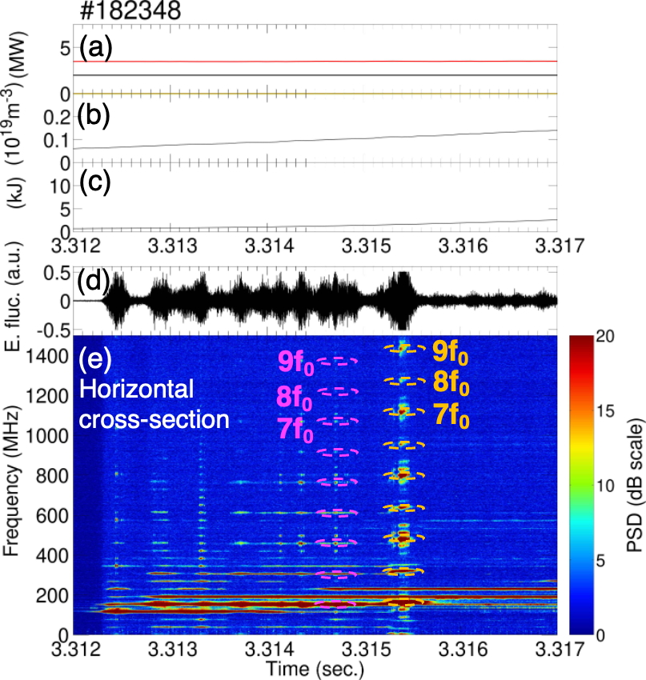
Figure 4: Time expanded view of Fig.1. Before the largest burst, harmonics of f₀=152.5 MHz are shown in the frequency spectrogram (e) with sidebands during bursts. During the largest burst, harmonics of f₀=159.167 MHz with sidebands.
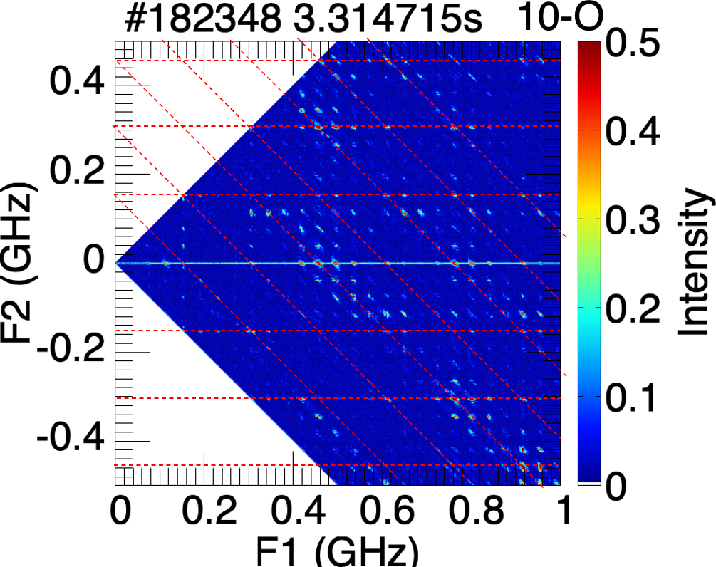
Figure 5: Auto bicoherence of electric fluctuation during a burst around t=3.314715s detected at the 10-O port viewing a horizontally long cross section. Red lines are drawn with gaps of 152.5 MHz
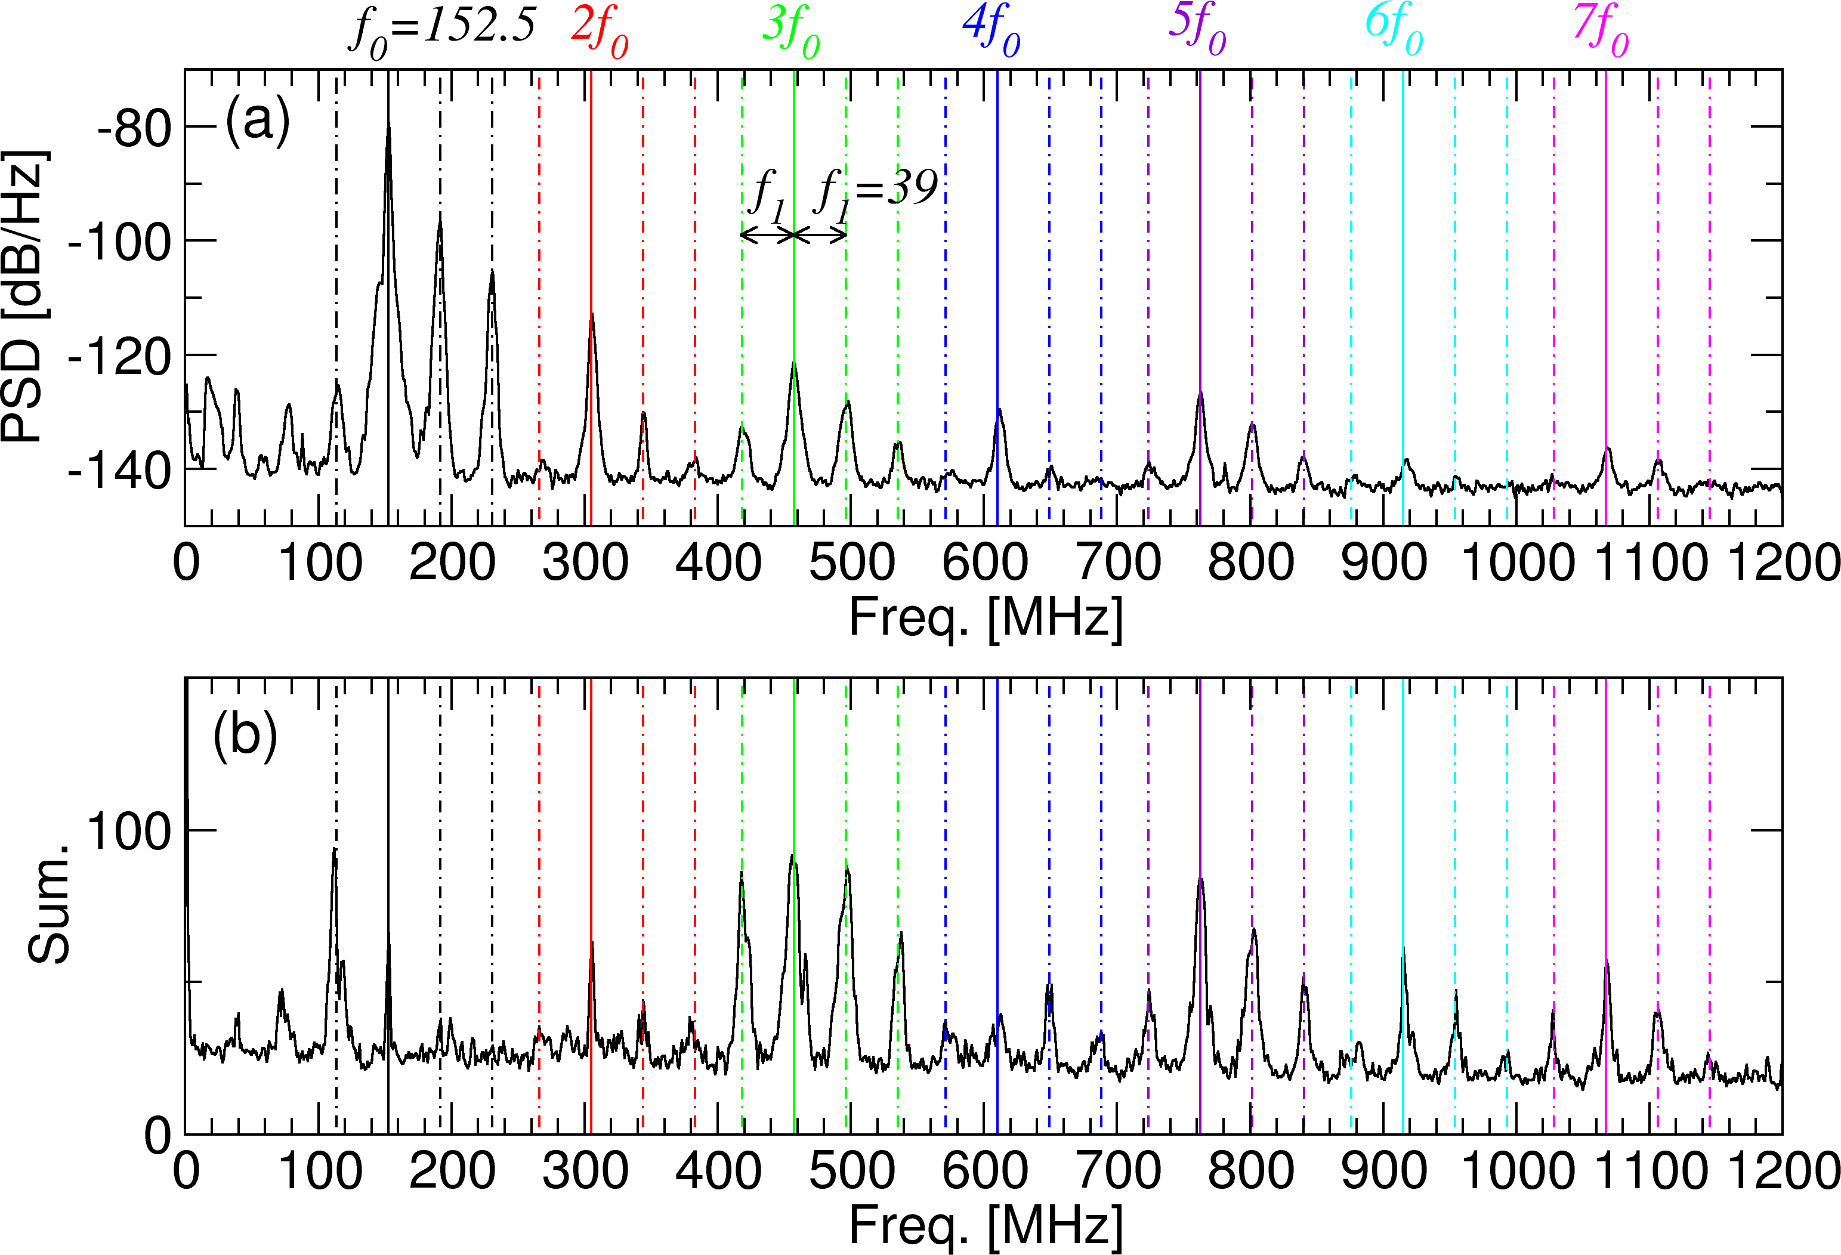
While the whole emission intensities during bursts detected at the 9.5-L port viewing a longitudinal cross section, became larger after the emission intensity at 230 MHz increases from t=3.3145 s. as shown in Figs. 7. Different from the observation near a horizontal long cross section, odd harmonics of f₀=230 MHz, only appear with sidebands. Figure 8 shows the auto bicoherence of the electric field fluctuations during a burst around t=3.31613 s after the largest burst. Interactions between sidebands around odd harmonics and even harmonics are strong. As a result, the spectrum of the sum of bicoherence shows peaks around odd harmonics as shown in Figure 9-(b). Note that the sums of bicoherence at sidebands around f₀=230 MHz, are larger than that just at f₀=230 MHz. Also, in the observation at the 10-O port viewing a horizontal long cross section, interactions between the even and odd harmonics of f₀=152.5 MHz, are dominant and emission intensities around odd harmonics are larger than those around the even harmonics.
Figure 9: (a) Frequency spectrum averaged around t=3.31613, detected at the 9.5-L port viewing a longitudinal cross section. (b) Sum of the auto bicoherence.
Intense peaks appear around f₀=230 MHz and their harmonics with sidebands whose gap frequency f₁ is 39 MHz. In the graphs, dot-dashed lines are drawn with gaps of f₁.
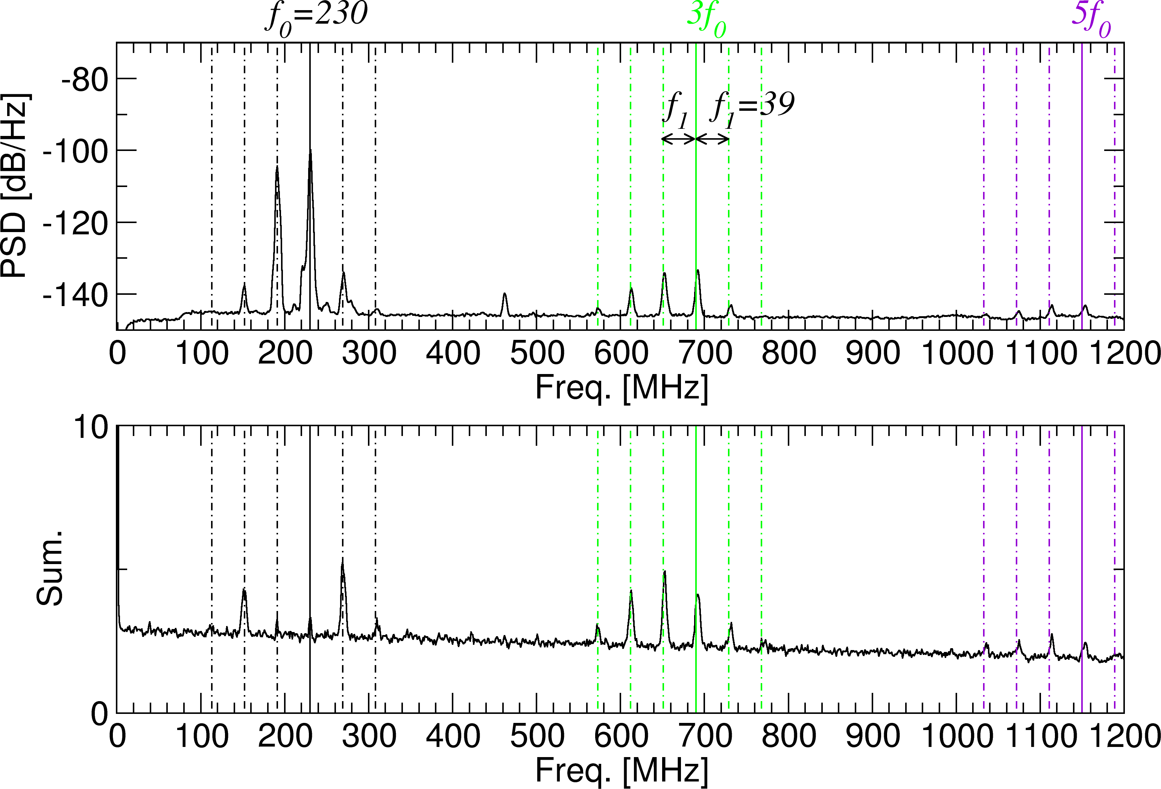
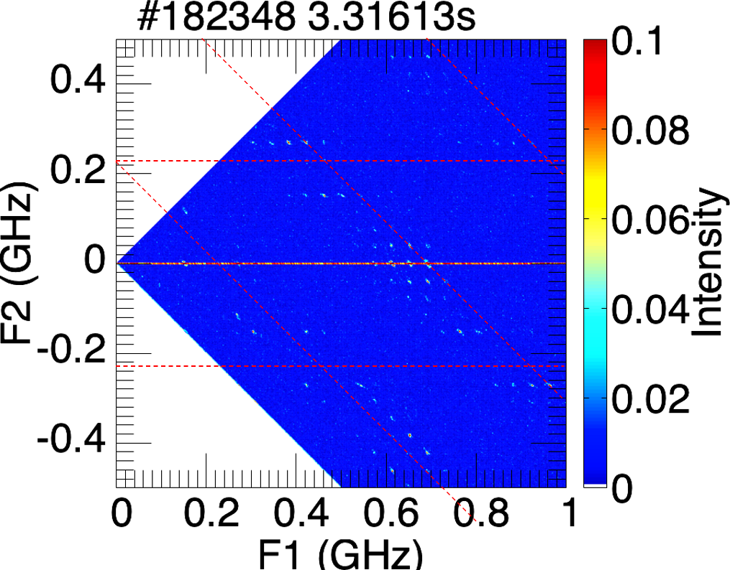
Figure 8: Auto bicoherence of electric fluctuation during a burst around t=3.31613s detected at the 10-O port viewing a horizontally long cross section. Red lines are drawn with gaps of 230 MHz
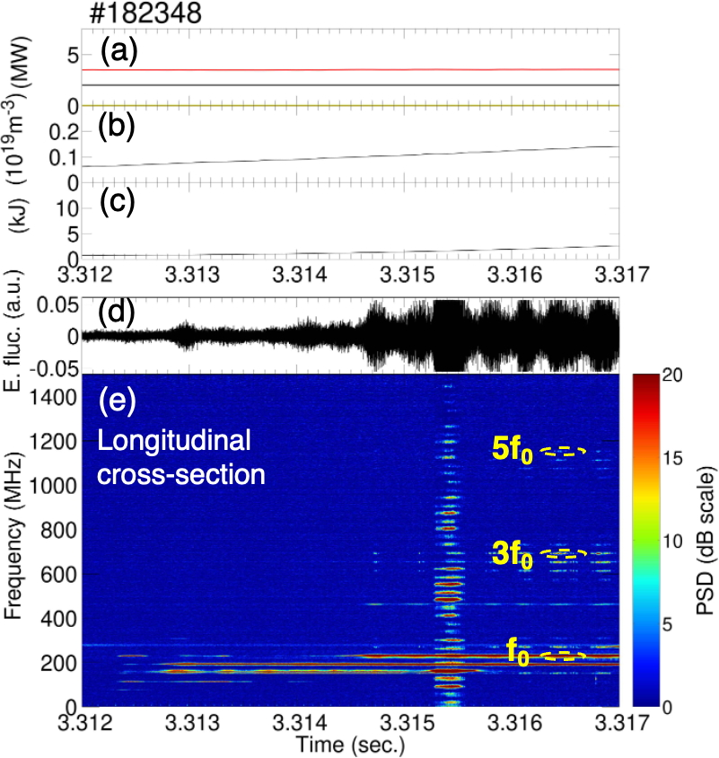
Figure 7: Time expanded view of Fig.2. After t=3.3145s, harmonics of f₀=230 MHz are shown with sidebands during bursts.
During the largest burst, complex frequency spectrums are detected by both antennas. It looks that the gaps of sidebands are not constant. Panels (a)/(b) of figure 10 show the auto-bicoherences of electric fluctuations detected at the 10-O/9.5-L ports viewing near the horizontal long/longitudinal cross section. In panel (a), strong interactions are seen with intervals approximately 160 MHz with sideband gaps. In panel (b), strong interactions are shown along F1, F2 ~ 320 MHz, and F2 ~ 70 MHz. Figures 11 and 12 show frequency spectrograms of the power and bicoherence of electric fluctuations detected at each port. There are two gap frequencies of sidebands around f₀ and its harmonics, i.e. f₁ = 32 MHz and f₂ = 35.67 MHz. Notably, it was found that f₀ shown in the spectrums is slightly different as f₀=159.167 MHz detected at the 10-O port viewing a horizontally long cross section, and f₀=160.5 MHz detected at the 9.5-L port viewing a longitudinal cross section.
Figure 12: (a) Power spectrum averaged around t=3.3545, detected at the 9.5-L port viewing a longitudinal cross section. (b) Sum of the auto bicoherence.
Intense peaks appear around f₀=160.5 MHz and their harmonics with sidebands whose gap frequencies, f₁ =32 MHz and f₂=35.67 MHz.
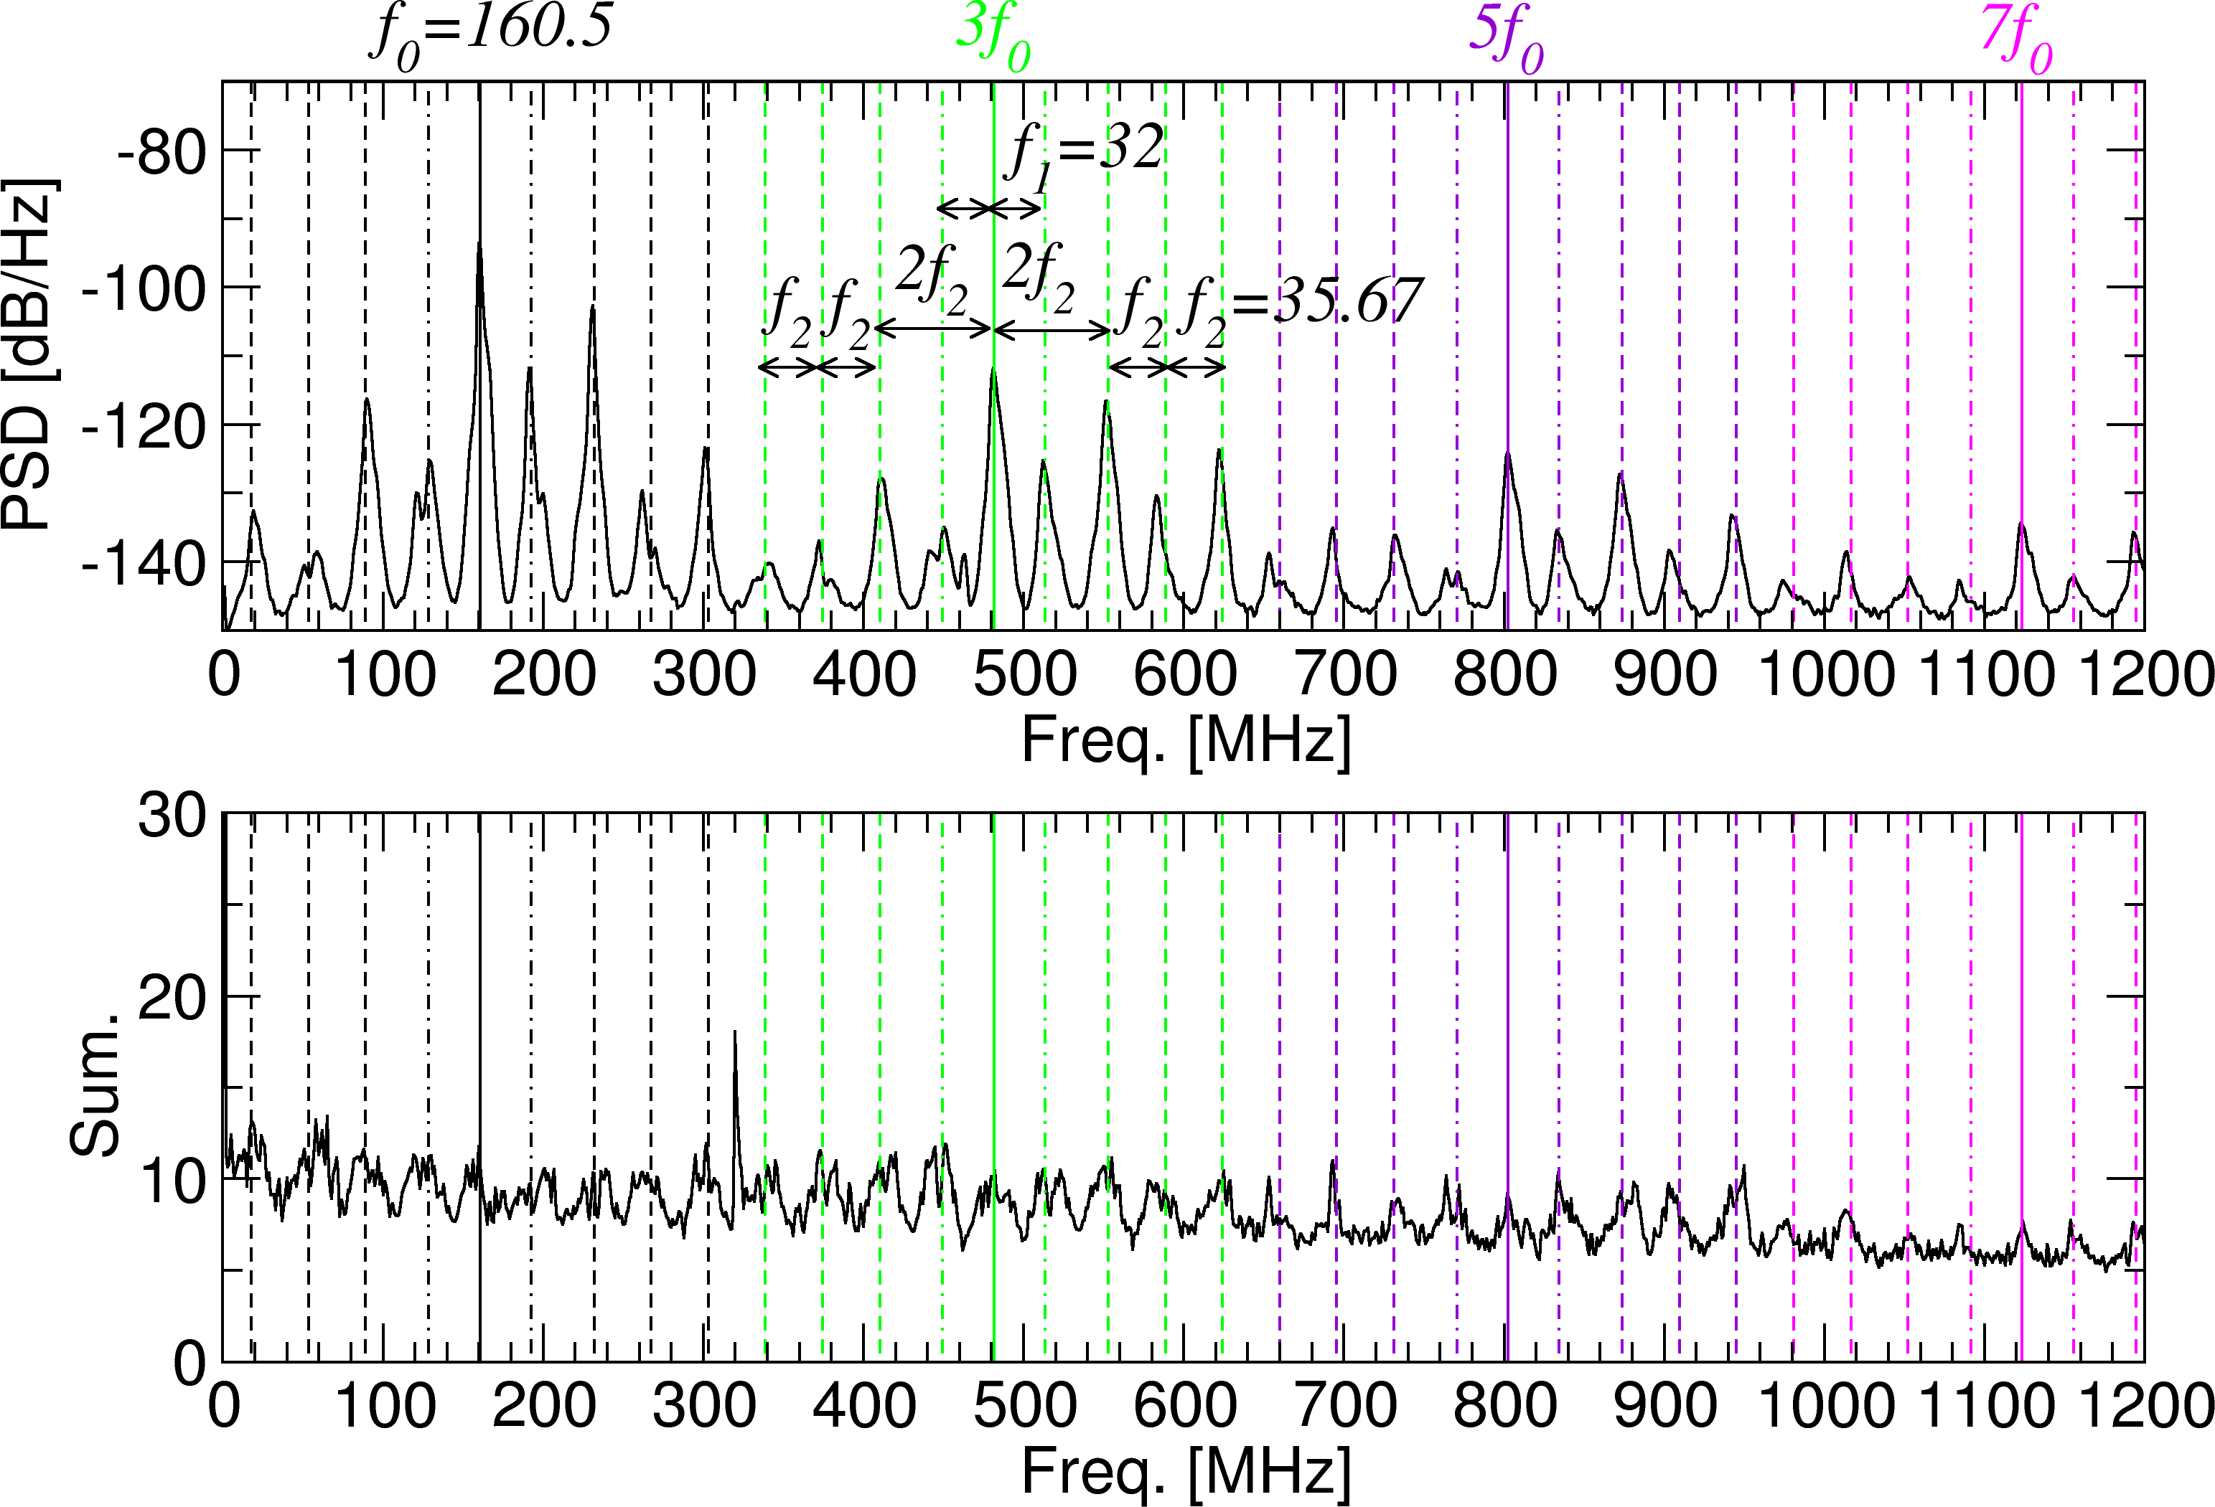
Figure 11: (a) Power spectrum averaged around t=3.3545, detected at the 10-O port viewing a horizontally long cross section. (b) Sum of the auto bicoherence.
Intense peaks appear around f₀=159.167 MHz and their harmonics with sidebands whose gap frequencies, f₁ =32 MHz and 2f₂ =71 MHz
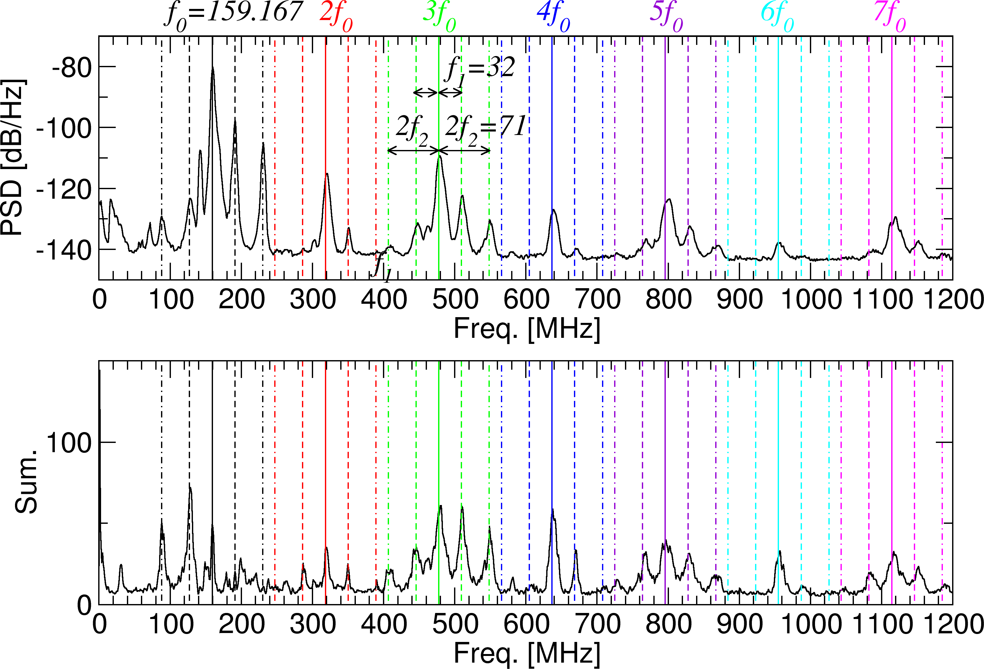
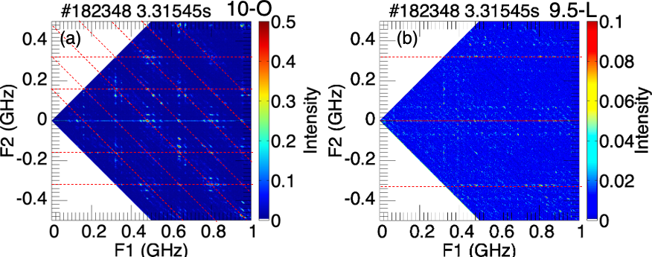
Figure 10: Auto bicoherence of electric fluctuation during the largest burst around t=3.31545s; (a) detected at the 10-O port viewing a horizontally long cross section, with red lines drawn with gaps of 160 MHz; (b) detected at the 9.5-L port viewing a longitudinal cross section with red lines drawn with 320 MHz.
3. DISCUSSION
3.1. Locations of corresponding wave resonances during the largest burst
In the previous PIC simulation study [14], it was derived that the ion cyclotron wave (ICW) at a constant frequency l𝛺_{ci} is excited when the lower hybrid frequency approaches l𝛺_{ci,} and the (l-1) 𝛺_{ci} ICW excited by energetic ions couples with the bulk ion Bernstein mode whose dispersion curve connects to 𝜔_{LH} for l=5, 6, 7. These characteristic are similar to experimental observation of stair-like frequency shift of intense peak frequency with increase of the background density. We examined the locations of the lower hybrid resonance (LHR) corresponding to f₀ = 159.17 MHz and ion cyclotron resonances (ICRs) corresponding to f₁=32 MHz, and f₂=35.5 MHz with assuming a hollow density profile where the electron density is 0.028×10¹⁹m⁻³ at the magnetic axis. We found that the LHR corresponding to f₀ = 159.17 MHz overlaps with an ICR of f₁=32 MHz at the poloidal cross-section 8 degrees away from the longitudinal cross-section namely dual resonance 1 (DR1) as shown in panel (a) of figure 13. And the LHR corresponding to f₀ = 159.17 MHz also overlaps with another ICR of f₂=35.5 MHz at the longitudinal cross section, DR2 as shown in panel (b) of figure 13. Note that there are relationships such as 5f₁= 160 MHz ~ f₀ =159.17 and 160.5 MHz, 9f₂= 319.5 MHz ~ 2f₀. Based on simulation results, the excitation of intense lower hybrid and cyclotron harmonic emissions can be expected in DR1 where the lower hybrid frequency is around 160 MHz that is almost corresponds the 5th harmonic of the ion cyclotron frequency of 32 MHz.
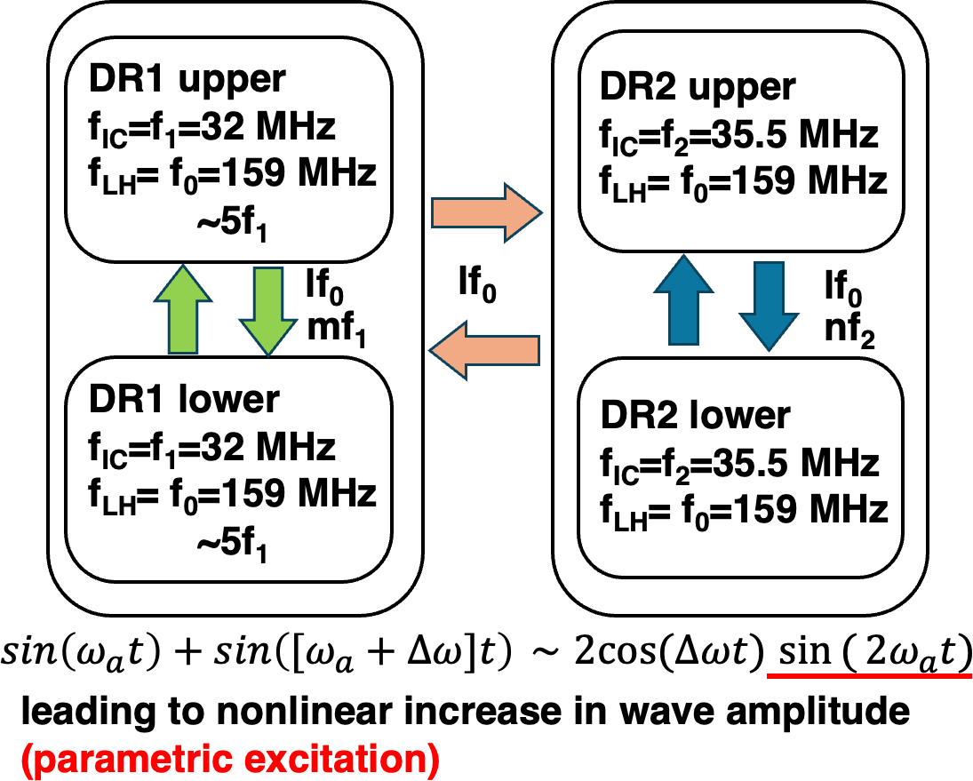
Figure 14: Possibility of periodic amplitude modulation at twice the resonant frequencies at each DR
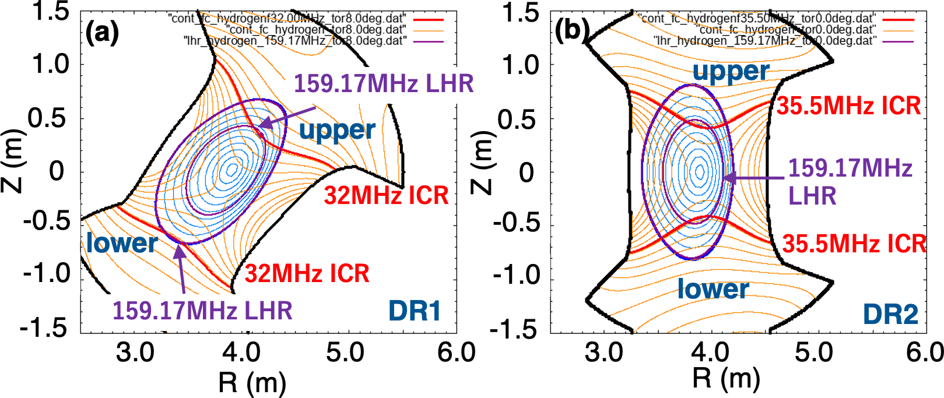
Figure 13: Locations of the LHR of f₀ = 159.17 MHz overlapping with (a) the ICR of f₁=32 MHz, namely DR1 upper and lower, (b) the ion cyclotron resonance of f₂=35.5 MHz, namely DR2 upper and lower. The blue lines represent magnetic flux surfaces, while the orange lines represent magnetic field strength contours.
The ICR of f₁=32 MHz, that overlap with the LHR of f₀ ~ 160 MHz can exist continuously in the torus plasma. However, the condition where multiple, i.e. more than two ICR contours of f₁=32 MHz overlap with LHR contours of f₀ ~ 160 MHz within the same poloidal cross-section occurs discretely as described in Fig. 13 (DR1/2 upper and lower).
3.2. Discussion about the mechanism of bursty enhancement
At this stage, this remains a hypothesis, but we consider that waves traveling between these DRs interfere with each other as summarized in Fig.14, leading to nonlinear increase in wave amplitude. Like the vibrato tone in music scene, application of slightly different frequency oscillations can cause nonlinear enhancement of the fluctuation intensity. Actually, we found that at the different locations, f₀ are slightly different during the largest burst by the power spectrum and bicoherence analyses. To verify this hypothesis, both wave propagation analysis and analysis with introducing a mathematical model described with some nonlinear equations such as the Mathieu equation or Hill equation are required.
4. SUMMARY
This study demonstrated the potential to enhance the growth of waves at the LH frequency and its harmonic wave ranges, as well as waves at the IC frequency and its harmonic frequencies, by establishing multiple dual resonances at distinct locations in the presence of energetic ions. It has been suggested that excitations of lower hybrid range waves which have slightly different frequencies can lead large bursty enhancement of the wave amplitude. Large enhancement of IBWs, and ICWs have potential to perform efficient resonant heating of bulk ions. This opens the possibility of exploring scenarios for bulk ion heating in fusion MCF plasmas through resonant heating induced by these spontaneously excited waves.
ACKNOWLEDGEMENTS
The authors would like to thank the technical staff of the LHD group at the National Institute for Fusion Science for their helpful support during this work. The data supporting the findings of this study are available in the LHD experiment data repository at https://doi.org/10.57451/lhd.analyzed-data. This work was supported by JSPS KAKENHI Grant Number 23K03363.
References
- FISCH N. J. and RAX J.-M., Physical Review Letters, 69, (1992) 612-615
- OCHS I. E., BERTELLI N., and FISCH N. J, Physics of Plasmas, 22, (2015) 112103
- FISCH N. J. and HERRMANN M. C., Nuclear Fusion 35 (1995) 1753
- ROMANELLI F., and CARDINALI A., Nuclear Fusion 60 (2020) 036025
- COOK, J. W. S., DENDY, R. O., CHAPMAN, S. C., Physical Review Letters, 118, (2017) 185001
- SAITO K., KASAHARA H., SEKI T., et al., Fusion Engineering and Design 84 1676-1679, (2009)
- SAITO K., KUMAZAWA R., SEKI R., Plasma Science and Technology 5, (2013), 209-212,
- SAITO K., IGAMI H., TOIDA M., et al., Plasma and Fusion Research 13, (2018), 3402043
- REMAN B. C. G., DENDY R. O., AKIYAMA T., et al., Nuclear Fusion 59, (2019), 096013
- REMAN B. C. G., DENDY R. O., AKIYAMA T., et al., Nuclear Fusion 61, (2021), 066023
- REMAN B. C. G., DENDY R. O., IGAMI H., et al., Plasma Physics and Controlled Fusion 64, (2022) 085005
- IGAMI H., SAITO K., REMAN B. C. G. et al., submitted to Journal of Fusion Energy
- TOIDA M., SAITO K., IGAMI H., et al., Plasma and Fusion Research 13, (2018), 343015
- TOIDA M., IGAMI H., SAITO K., et al., Plasma and Fusion Research 14, (2019), 340112
- KOTANI T., TOIDA M., MORITAKA T., and TAGUCHI S., Physical Review E 108, (2023), 035208

