#id abstract

- Background and Goal of the present work
Within the IAEA, the Nuclear Data Section (NDS, http://www-nds.iaea.org/) assembles, develops and disseminates nuclear data for basic science and practical applications.
This paper gives an overview of recent activities aimed at the development and maintenance of experimental and evaluated reaction cross-sections data for general use and specific energy/material applications.
The latest upgrades, developments and weaknesses are highlighted.

- General experimental and evaluated cross-section databases

2.1. Experimental cross-section database EXFOR
EXFOR contains published nuclear reaction cross-section data,
presently more than 19 100 experiments and 141 600 tables.
EXFOR is under improvement and extension (2010/2011 examples):
- collection of neutron energy spectra from light ion induced reactions at accelerators and from fission reactors, used to measure energy averaged cross-sections
(opens possibility to use hundreds of experimental data for validation of evaluations)
- more than 40 original articles reporting results on accelerated driven neutron sources (like Li(d,xn) for IFMIF) were found missing and will be included in EXFOR
- inclusion of Nuclear Resonance Fluorescence data - (γ,γ') reaction with excitation of strong dipole resonances enables a specific fingerprint of isotope (it experiences a renaissance as novel non-destructive method for detecting clandestine materials)
- compilation of cross-sections and decay modes for nuclear fusion synthesis of new super heavy elements - extension towards heavy projectiles and frontier physics.

  - Collection of evaluated cross-section data ENDF
ENDF is a collection of the recommended general purpose evaluated nuclear reaction cross-sections developed by national labs and includes original contributions from NDS.
NDS web-site contains the latest updates, archives and 20 special libraries for fission, fusion, medical, activation and other applications.
Last year the ENDF collection was updated with:
EAF-2010 - European Activation File (816 isotopes, n, p and d, energy up to 60 MeV),
JENDL-4.0 – Japanese general purpose n-reaction library (406 nuclides, E < 20 MeV),
RUSFOND-2010 – Russian evaluated files (619 nuclei and 20 materials) for reactors,
TENDL-2010 – TALYS’ library (⁶Li - ²⁸¹Ds, incident n, γ and light ions, E < 200 MeV).
NDS provides web-retrieving to search, down load, plot and compare with EXFOR:
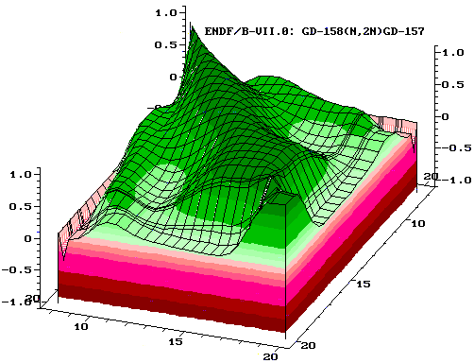
ZVView plot: measured and evaluated cross-sections with uncertainties
for ⁵⁵Mn(n,2n) (left), covariances for ¹⁵⁸Gd(n,2n) reactions (right)

- Databases for material analyses, fission and fusion applications

3.1. Ion Beam Analysis Nuclear Data Library IBANDL
IBANDL contains evaluated data for Ion Beam Analysis (IBA) and covers the most important techniques: Elastic Backscattering Spectroscopy and Nuclear Reaction Analysis by means of (p,α) and (d,p) reactions. This year a new CRP “Particle Induced Gamma-ray Emission (PIGE)” was launched to extend the scope of IBANDL.
These techniques exploit interaction of fast (~ MeV) charged particles with materials to determine the composition and structure of the surface up to 500 μm by measuring the scattered protons, light ions or characteristic prompt γ-rays.
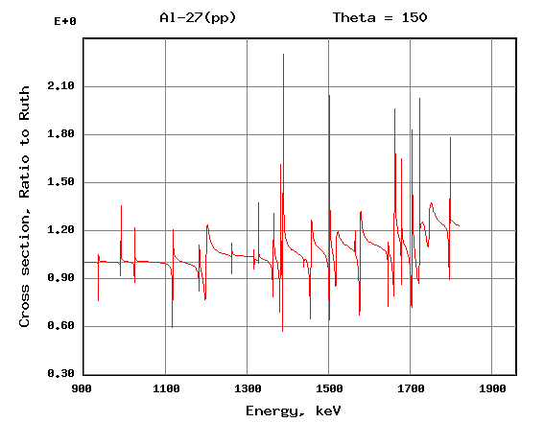 | Proton  back elastic  scattering  cross-section  (ratio to Rutherford)  at 150º for Al
  - International Reactor Dosimetry File IRDF
IRDF-2002 contains a standardized and benchmarked evaluated cross-sections with uncertainties for 66 neutron activation and fission reactions; radiation damage for 5 and total cross-sections for 3 cover materials, decay data for reaction product nuclei.
Recently NDS initiated the updating of IRDF-2002 that will finally result in the inclusion of 29 new reactions and energy extension up to 60 MeV to cover fusion applications.
Experimental and evaluated data for dosimetry reaction ¹⁹⁷Au(n,2n)¹⁹⁶Au

3.2. Fusion Evaluated Nuclear Data Library FENDL
Fusion Evaluated Nuclear Data Library FENDL 3.0, currently under preparation, will be extension to FENDL-2.1 toward higher energies for the ITER and IFMIF neutronics.
It will comprise (i) neutron transport cross-sections up to 150 MeV for 180 materials,
(ii) n-, p- and d-activation cross-sections up to 60 MeV for 816 materials and
(iii) covariances of the evaluated cross-sections.
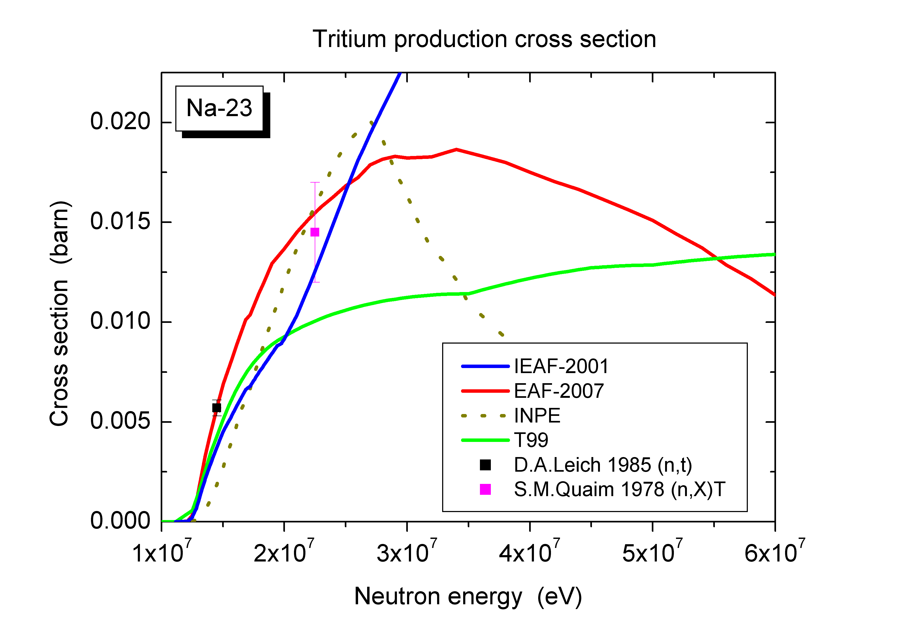
³H production cross-sections in ²³Na | He production cross-sections in Fe

3.3. Radiation Damage Libraries
Radiation induced damage and gas accumulation rates in materials are needed to predict the lifetime and safety issues for fission and fusion reactors and accelerators.
NDS assembles dpa, H, He and T production cross-sections in the next databases:
- IRDF-2002 – displacement cross-sections for Cr, Fe, Ni, Si and GaAs up to 20 MeV,
- BISERM-2 - dpa, H and He production cross-sections for 259 isotopes, E_{n} < 1 GeV,
- DXS - dpa for Cr, Fe, Ni (n) and Cr, Fe, Ni, Cu, W (p), E < 1 GeV, NRT + MD/BCA.
Traditionally the dpa-cross-sections are estimated employing Norgett-Robinson-Torrens (NRT) standard (atoms knocked from the lattice). Molecular Dynamics (MD) and Binary Approximation (BCA) demonstrated that during the cascade relaxation stage many initial vacancies and interstitials will recombine and only survived Frankel pairs (FP) or interstitial clusters will form primary defects in materials.
Displacement cross-sections caused by neutrons and protons in Fe

NRT standard and primary survived defects (Frankel pairs or interstitial clusters) in the iron components of IFMIF, fusion power and fast research reactors components:
Facility | IFMIF, HF module | Fusion Power Reactor, first wall | Fast research Reactor, Petten
power (th), MW | 10 | 3400 | 45
n-Flux, 10⁺¹⁴ n/cm²/s | 7.3 | 11 | 12
max. PKA energy, MeV | 3.7 | 2.7 | 1.2
dpa (NRT), 1/fpy | 30 | 20 | 10
dpa (MD: Frankel pairs) | 9.7 | 6.7 | 3.3
dpa (MD: interst. clusters) | 5.6 | 3.8 | 1.9

- Conclusions and Acknowledgements
  - General and special purposes libraries of experimental and evaluated nuclear reaction data compiled and developed by the NDS are presented. Their regular updating and maintenance guarantee general mature status. However, a few examples demonstrated a need for further measurements and evaluations to meet the specific requirements.

