# The Nuclear Power Plant with the

# High-Temperature Gas-Cooled Reactor and

# Chemical Process Equipment as an Option

# for Solving the Problem of Large-Scale

# Production of Low-Carbon Hydrogen

V. PAVLIKHINA

Afrikantov OKBM JSC

Nizhny Novgorod/Russia

Email: pavlikhina@okbm.nnov.ru

T. ISHCHENKO, I. SHMELEV, A. LAZAREV, N. KODOCHIGOV, V.PETRUNIN.

Afrikantov OKBM JSC

Nizhny Novgorod/Russia

**Abstract**

Nuclear power is a reliable and stable source of energy in context of global reduction of carbon dioxide emissions. Nuclear power may be used for desalination of sea water, production of low-carbon hydrogen, district heating and other industrial applications.

The development of nuclear hydrogen energy in Russia involves both large-scale production of hydrogen and related products using thermochemical processes (for example,steam reforming of methane) at specialized nuclear power plants with high-temperature gas-cooled reactors, as well as local production of hydrogen by water electrolysis at electrolysis facilities powered by electricity from nuclear power plants.

This paper will describe the progress in development of an innovative project of Rosatom State Corporation, i.e. a nuclear power plant with the gas (helium)-cooled high-temperature reactor (HTGR) (with thermal capacity of 200 MW) integrated with chemical process equipment for hydrogen production.

The purpose of the HTGR is to generate high-temperature thermal power to be transferred to the chemical process equipment for large-scale, competitive hydrogen production.

The use of the HTGR as a source of thermal power will provide for significant reduction of carbon dioxide emissions that are inevitably produced in hydrogen production processes that use methane not only as a raw material for steam reforming of methane, but also as a fuel to provide heat necessary for process running.

* 1. INTRODUCTION

Solving the global issue of achieving carbon neutrality in Russia requires consideration of emission sources where nuclear power can be used most effectively.

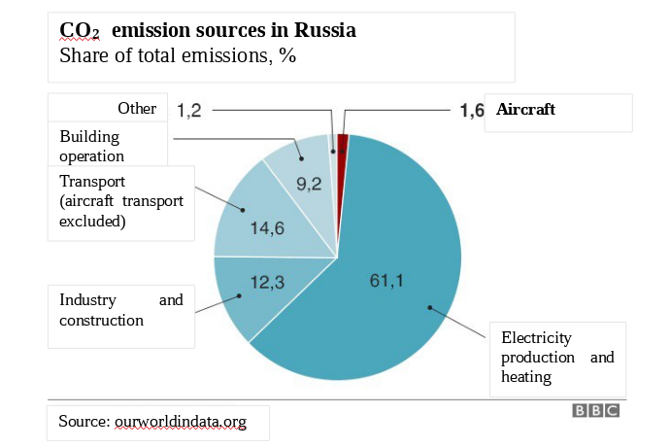

*FIG. 1. CO2 emissions sources in Russia in 2019*

According to the data, the largest contributors to CO2 emissions are electricity production and heating, transport and industry. These contributors account for about 88% of total emissions. In the field of electricity generation, the State Atomic Energy Corporation Rosatom is to build 29 power units by 2045 [1]. This will amount to 25% of total electricity generation, making a significant contribution to decarbonization. In addition, it is planned to build floating and land-based small-sized nuclear power plants, as well as nuclear-powered ships. Among possible future areas of nuclear energy use for decarbonization are industry and transport. The chemical, oil refining and metallurgical industries use hydrogen and hydrogen-containing gases. These gases are produced by heat from the combustion of fossil fuels, producing a large amount of CO2.

Large-scale production of hydrogen and hydrogen-based products can be created on the basis of technologies of high-temperature gas-cooled reactors (HTGR).

Work aimed at the development of nuclear and hydrogen energy technologies has become especially relevant in recent years due to the trends in the transition of the developed economies to environmentally friendly types of energy carriers, among which hydrogen is the most environmentally friendly energy carrier [2].

* 1. HYDROGEN ENERGY AND HISTORY OF HTGR DEVELOPMENT IN RUSSIA

The foundation of the technologies necessary for hydrogen energy was laid in Russia in the middle of the last century. At that time, the first research and development programs were developed for the widespread introduction of hydrogen energy into the national economy.

In 2021 the State Atomic Energy Corporation Rosatom launched a large-scale investment project “Research and Development of Nuclear Hydrogen Energy Technologies for Large Scale Hydrogen Production and Consumption” including the pre-development of the Nuclear Power Plant with the High-Temperature Gas-Cooled Reactor and Chemical Process Equipment (hereinafter referred to as NPP with HTGR and chemical process equipment). The NPP under development has several predecessors.

TABLE 1. Experience of HTGR development in Russia

|  |  |  |  |  |
| --- | --- | --- | --- | --- |
| Period, year | Project | Power, MW | Helium t, C | Purpose |
| 1974-1987 | VG-400 | 1060 | 950 | Heat (ammonia production), electricity |
| 1986-1991 | VGM | 200 | 950 | Heat, electricity(pilot industrial) |
| 1990-1996 | VGM-P | 215 | 750 | Oil refining |
| 1995-2013 | GT-MHR | 600 | 850 | Electricity (direct gas-turbine cycle) |
| 2003-2004 | MHR-Т | 600 | 950 | Hydrogen, electricity |

The data given in the table show that most projects were developed for energy process applications.

* 1. Project of the Nuclear Power Plant with the High-Temperature Gas-Cooled Reactor and Chemical Process Equipment

The Nuclear Power Plant design under development includes four units with HTGR reactor plant and chemical process equipment. High temperature nuclear heat is used to heat the reaction mixture (steam plus methane) to produce hydrogen by the process of steam methane reforming.

The baseline technology for large-scale hydrogen production as part of the project of the Nuclear Power Plant with the High-Temperature Gas-Cooled Reactor and Chemical Process Equipment is steam methane reforming without carbon dioxide emissions. This technology is based on well-proven chemical processes, catalysts and equipment. A new element in this technology is the safe integration of nuclear and chemical process parts into a single complex - a nuclear power-and-process station. [3].

The Nuclear Power Plant with the High-Temperature Gas-Cooled Reactor and Chemical Process Equipment produces commercial quality hydrogen (99.99% purity) for its wide use as an environmentally friendly energy carrier and chemical reagent in industry, transport and everyday life.

Drawing from calculations, using one HTGR unit with a thermal capacity of 200 MW for the production of hydrogen will allow cutting down on around 135 million m3 of natural gas per year by replacing “fire” heat generation [4].

The carbon dioxide generated in the process will be released in concentrated form for further use or storage.

The simplified diagram of the demonstration unit of the Nuclear Power Plant with the High-Temperature Gas-Cooled Reactor and Chemical Process Equipment shows the three main components (Fig. 1):

* a nuclear island with a HTGR;
* an intermediate helium heat transfer circuit;
* chemical process part ensuring steam reforming of methane, separation of hydrogen and capture of carbon dioxide.

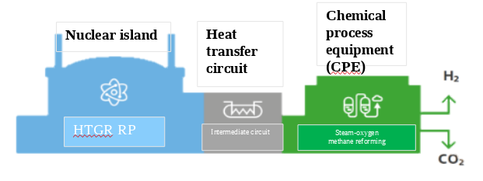

*FIG. 2. Structural diagram of the NPP unit with HTGR and a chemical process equipment*

The design of the HTGR reactor plant and this NPP is based on:

* taking into account the results of R&D carried out in nuclear hydrogen field earlier;
* selection of the reactor parameters on the basis of the properties of the internal self-protection of the core, which provides for fission reaction and removal of residual heat from the core through the reactor vessel due to natural physical processes;
* applying engineering solutions implemented in the Russian industry, using national production facilities;
* integration of nuclear and chemical process part of NPP using an intermediate helium circuit (heat transfer system);
* production of hydrogen using steam-hydrogen reforming of methane (placement of chemical process equipment in an open area).

The roadmap (Fig. 2) for the creation of a Nuclear Power Plant unit with HTGR and a chemical process equipment in Russia suggests that pilot operation of one Nuclear Power Plant unit with a HTGR-200 reactor plant will begin not earlier than in 2032 [5].

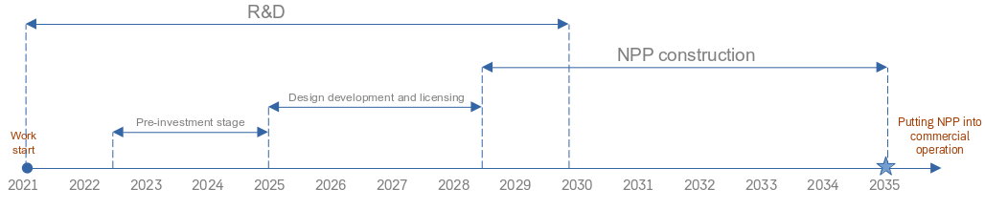

*FIG. 3. Nuclear Power Plant with HTGR and a chemical process equipment Creation Roadmap*

The main characteristics of the Nuclear Power Plant with HTGR and chemical process equipment are presented in Table 1.

|  |  |
| --- | --- |
| Technical characteristics of 4-unit | Value |
| Thermal power, MW | 800 |
| Capacity (Hydrogen), thousand tons/year | 440 |
| Hydrogen purity, % | 99,99 |
| Natural gas consumption, million tons/year | 1,4 |
| Water consumption, million tons/year | 8 |
| Electricity consumption, MW | 200 |

*Table 1. – Main characteristics of NPP when operating at 100% of rated power*

* 1. PROSPECTS FOR THE USE OF The Nuclear Power Plant with the High-Temperature Gas-Cooled Reactor and Chemical Process Equipment FOR THE PRODUCTION OF HYDROGEN ON AN INDUSTRIAL SCALE

Today, the world produces more than 90 million tons of hydrogen per year, of which, according to various estimates, 5-7 million tons are annually produced and consumed in Russia. Given the current trends associated with the decarbonization of industry and the reduction of greenhouse gas emissions in general, a different growth rate of global hydrogen production and consumption is predicted: the range of estimates for 2050 varies in different scenarios from 250 to 600 million tons of hydrogen annually.

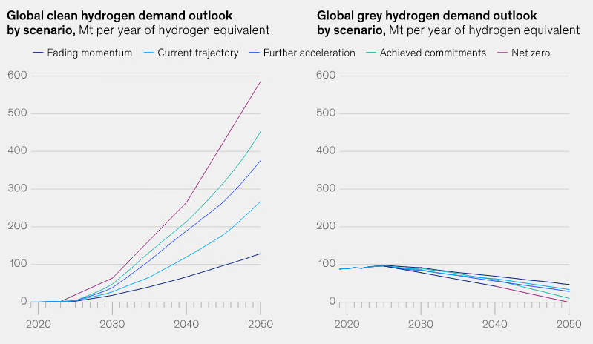

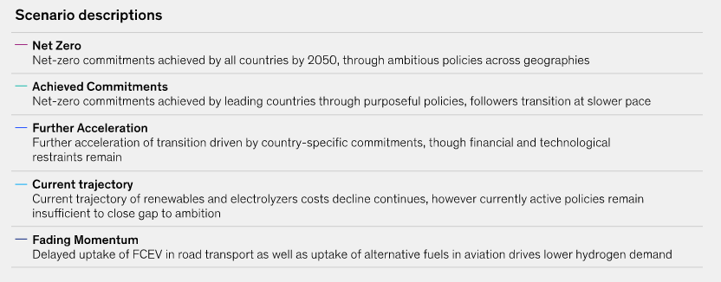

*FIG. 4. Hydrogen demand scenarios [6]*

The capacity of one Nuclear Power Plant unit with HTGR and chemical process equipment is 110 thousand tons of hydrogen per year, NPP of the state-of-the-art design includes four HTGRs, thus the capacity of the NPP is 440 thousand tons of hydrogen per year. [7]

In order to achieve the specified global hydrogen production volume, given the range of estimates, Nuclear Power Plant with HTGR and chemical process equipment could make a significant contribution to hydrogen production. [8]

It is planned to use hydrogen as a raw material in those industries where it is already used or planned for use, as well as in autonomous sources of electricity. Currently, strenuous efforts are underway to cooperate with potential consumers in the chemical and oil refining industries.

The fundamental issue of hydrogen energy is the large-scale environmentally friendly production of hydrogen. Currently, around 80% of hydrogen is obtained from natural gas and petroleum products by steam reforming of methane. During the endothermic process of steam reforming, about half of the natural gas is burned with the release of combustion products into the atmosphere. It is obvious that the transition to hydrogen production without carbon dioxide emissions in industrial volumes cannot be ensured in a blink of an eye, since it is necessary to improve technologies and increase production volumes on the one hand and modernize consumer production on the other. These factors provide an opportunity and time for the gradual integration of NPP with HTGR and chemical process equipment into the technological chain, since the project allows providing the market with hydrogen on an industrial scale.

The use of the HTGR reactor plant as part of the NPP to generate high-temperature thermal energy will be economically and technically effective when using heat transferred over relatively small distances from the unit. Launching industrial hydrogen production requires the development of the entire hydrogen supply chain from the supply of raw materials to the production site for the production of hydrogen to the transportation of hydrogen to the end user, and therefore, infrastructure solutions, infrastructure R&D for storage, transportation of hydrogen, as well as CO2 utilization are required.

The implementation of the NPP with HTGR and chemical process equipment for the production of hydrogen will contribute to solving the global problem of decarbonization in the age of increasing energy consumption and give a boost to the establishment of a new technological pattern of hydrogen energy.

Russia has raw materials (water, natural gas, nuclear fuel) and a knowledge base accumulated in the process of research and development on nuclear and hydrogen energy to streamline the cutting edge track.

* 1. CONCLUSION

The global trend in the energy supply of industry, transport, public utilities is aimed at decarbonization and with that this trend can be promoted by the development of hydrogen energy and the economy. The fundamental key problem of hydrogen energy is the industrial production of hydrogen. The creation of HTGR-based NPP with methane steam reforming technology leads the way to large-scale environmentally friendly hydrogen production.

Nuclear power process stations are able to provide significant input into an industrial scale hydrogen production and substitute raw fuel with high-temperature heat generated by HTGR. This will allow reducing methane use in comparison to conventional processes and avoiding emissions of products from its combustion.

Development and commercialization of technologies of safe, well-resourced, ecologically clean nuclear hydrogen economy, including consumption, storage, distribution and nuclear hydrogen production is a promising area of scientific- technical development and international cooperation.

References

1. Rosatom has plans to build 29 power units by 2045, ria.ru/20230220/ aes – 1853160898.html,20.02/2023
2. Ponomarev-Stepnoy, N.N., Petrunin, V.V., Nuclear hydrogen energy - Proceedings of the scientific meeting, Dollezhal readings in JSC NIKIET, Moscow, pp.470-508, 2022
3. Nuclear Energy Plants with High-Temperature Gas-Cooled Reactors. Monograph in two volumes, ed. Ponomarev-Stepnoy, N.N., member of the Russian Academy of Sciences, Nizhny Novgorod, vol. 1, p.478, vol. 2, p.504.
4. Nuclear Energy Plants with High-Temperature Gas-Cooled Reactors. Monograph in two volumes, ed. Ponomarev-Stepnoy, N.N., member of the Russian Academy of Sciences, Nizhny Novgorod, vol. 1, p.478, vol. 2, p.504.
5. Zubrilov, M.V., Nuclear hydrogen energy. Reactor plant with high-temperature gas-cooled reactor in a nuclear power-and-process station for hydrogen production// XI International Youth Industrial Forum “Engineers of the Future” 2023, Tula region, Alexinsky district, Bunyrevo village, June, 28th 2023.
6. Global Energy Perspective 2023: Hydrogen outlook, January 10, 2024, https://www.mckinsey.com/industries/oil-and-gas/our-insights/global-energy-perspective-2023-hydrogen-outlook
7. Vestnik Atomproma (Nuclear industry annals) No. 7, September 2023
8. Ponomarev-Stepnoy, N.N,member of the Russian Academy of Sciences, scientific advisor to the CEO of Rosenergoatom, Nuclear hydrogen energy prospects report, Moscow, October, 25th 2018.