# a digital solution to support

# site selection and resilience of

# advance and small modular reactors

# installation

Khwansiri NINPAN

Digital Excellence Center, Assystem

Courbevoie, France

Email: [kninpan@assystem.com](mailto:kninpan@assystem.com)

**Abstract**

The paper proposes a novel recommendation tool for evaluating potential installation sites for Advanced and Small Modular Reactors (AMRs and SMRs) considering a multidimensional perspective. It combines various types of spatial and non-spatial data into the Geographic Information System at a 0.12 km² resolution, incorporating diverse parameters including transportation infrastructure, topography, water access, and geohazards. The tool offers flexibility for users to define the decision variables and assign weights reflecting their relative impacts. Leveraging multi-objective optimization, the tool can identify a set of solutions that represent trade-offs between different criteria. This allows users to prioritize their specific needs and rank geographic areas accordingly. For broader applicability, the tool employs a digital twin-based assessment of potential interactions with existing electrical grids. The DIgSILENT simulator enables comprehensive power system analysis, encompassing diverse studies such as load flow, consumption, and contingency assessment. Furthermore, it incorporates climate predictions, such as sea surface temperature and sea level rise, to account for the multi-decade lifespans of SMRs. Additional relevant variables can be integrated based on user requirements to maximize project resilience. In conclusion, our approach accelerates the development and deployment of AMRs and SMRs to meet the growing global energy demand. Through a holistic site selection process, our solution provides an innovative framework for sustainable energy management.

## INTRODUCTION

Nuclear energy is projected to make a significant contribution to global decarbonization initiatives. The development of Advanced and Small Modular Reactors (AMRs and SMRs) is expected to substantially enhance the role of nuclear energy in the global energy mix. The intrinsic characteristics of SMRs, such as their smaller size, modularity, and certain aspects of passive safety, make them suitable for applications beyond electricity production, including urban heating, seawater desalination, or replacing coal-fired power plants. Additionally, as these reactors are less expensive, they will be more easily deployable in countries new to nuclear energy [1-5]. AMRs provide even more value because, in addition to the benefits of SMRs, they can produce higher temperature heat, making them suitable for more demanding industrial uses, such as steel, cement, or glass production—industries that are typically very energy-intensive and emit a lot of greenhouse gases [6]. The role of SMRs and AMRs thus appears very promising, which is why many countries, including emerging ones, are seizing this opportunity.

To maximizing the potential benefits offered by SMRs and AMRs, one of the most crucial aspects is the efficient selection of suitable locations. This process encompasses several critical perspectives and criteria that must be carefully evaluated. The details of some significant criteria involved are as follows:

* Site-specific evaluations: Site selection for SMR and AMR necessitates evaluations of numerous factors, including geological suitability, cooling water access, transportation networks, population density, and environmental impact minimization [7,8]. This process requires careful trade-off analysis to balance these diverse priorities.
* Integration with existing electrical infrastructure: Grid integration is another key factor for SMR/AMR deployment [9]. Electrical grids rely on a delicate balance between generation and consumption, maintaining frequency, current, and voltage stability. Introducing a new power source could disrupt this equilibrium. Therefore, a comprehensive grid integration study is crucial to ensure the new energy source can be accommodated without compromising grid stability and functionality.
* Long-term climate impact assessments: AMRs and SMRs' extended lifespans necessitate considering potential environmental changes during siting [10,11]. Integrating robust climate projections and uncertainty quantification methods strengthens long-term site suitability and demonstrates commitment to sustainability.

This paper proposes innovative methodologies that integrate the critical aspects discussed above. Our solution leverages a multi-objective optimization algorithm within Geographic Information Systems (GIS) to identify suitable sites meeting user-defined criteria. **Furthermore,** the approach employs digital twin simulations to evaluate grid interaction, while incorporating climate predictions to enhance project resilience against potential environmental challenges.

## methodologies

To demonstrate the concept's versatility across diverse geographies, we implemented case studies in geographically distinct locations, leveraging data from Morocco and Uzbekistan. Even with varying local contexts requiring different site selection processes, all case studies adhered to the core principles and objectives of our methodology, enabling evaluation of optimal site selection across a broad range of settings. A detailed description of the case studies and their corresponding methodologies is provided in the following section.

### Multi-criteria site selection algorithm

#### Case study

Selecting optimal locations for SMRs and AMRs necessitates a comprehensive understanding of the surrounding geographical landscape. To illustrate this process, we present a case study focusing on Morocco. We employed shapefiles, a common format for storing GIS data, to obtain detailed information on various geographical features within the study area, including elevation level, slope gradients, and landslide hazard. Additionally, the data encompassed distance information to various key locations, such as military sites, populated areas, natural reserves, forests, water bodies, water sources, seaports, roads, railways, and airports.

To facilitate a comprehensive and granular analysis of the spatial data across the study area, we transformed the selected region into a grid system comprised of approximately 400,000 individual cells. Each cell within this grid has an area of 0.12 square kilometers, serving as the initial test size. Following this step, the generated grids were exported as a comprehensive dataset in comma-separated value (CSV) format. This dataset encompassed all relevant information, including the unique grid identifier, detailed attributes of the considered geographical features, and the latitude and longitude coordinates for each individual grid cell within the study area. The resulting CSV file served as the primary input for the optimization and ranking algorithms employed in the subsequent stage of the analysis.

#### User-defined evaluation criteria

As previously described, the input data leverages multiple geospatial features. To enhance user flexibility, the platform enables users to define their desired geospatial criteria for site selection. This includes selecting features of interest, specifying acceptable feasibility margins, and assigning optimization objectives for each feature, indicating whether the goal is to maximize or minimize its value. Additionally, users can establish the relative importance to each criterion, enabling the platform to prioritize locations that best align with user preferences.

#### Site selection and ranking methodology

After filtering grids based on user-defined criteria, the remaining grids were ranked using the weighted-sum method. This approach assigns weights to each criterion based on user-specified importance levels and combines the weighted objectives into a single function for optimization [12]. To ensure consistent assessment across diverse criteria, the analysis employed a quantile-based scoring system that normalizes the range of values for objective comparison. For criteria with a maximization objective, grid cells with values below the 25th percentile (Q1) receive the lowest score, while those exceeding the 75th percentile (Q3) receive the highest score. Conversely, for criteria with a minimization objective, the interpretation of scores is reversed. The scores were then multiplied by their corresponding user-defined weights and scaled to 100 for user comprehension. Finally, grid cells were ranked by total scores, with higher scores indicating greater suitability for the site selection process.

### Grid impact assessment

Following the shortlisting of potential sites based on the aforementioned process, the next crucial step involves studying their grid connection feasibility and assessing the potential impact of connecting the new energy source on the existing grid infrastructure at the given location. The objective was to assess the most cost-effective solution for each potential location, considering the operational expenses associated to grid integration.

#### Case study

The proposed approach was implemented and tested on the Uzbek electrical grid, utilizing the electrotechnical modeling and simulation software PowerFactory from DigSilent, in conjunction with Python scripts [13-15]. The study encompassed the high and medium voltage transmission systems of 500, 220, 110, and 35 kV across the entire country. A comprehensive model was constructed, incorporating over 35 km of overhead lines, 2,000 substations, 50 power plants, and industrial facilities. This enabled the execution of various electrical studies, providing valuable insights into grid’s behavior.

#### Grid simulation

To evaluate the grid connection feasibility, several electrical studies were conducted. As illustrated in Fig. 1., the grid simulation process involved the following steps:

1. For each potential location, a new power source was modeled and incorporated into the existing grid model.
2. Load flow, short circuit, and other relevant studies were conducted to assess the impact on the grid.
3. Simulation results were exported for further evaluation.
4. Violations based on predefined rules, such as voltage level in equipment, frequency fluctuations, or other criteria were identified.
5. To eliminate identified violations, mitigation strategies were implemented sequentially based on client specifications. This may involve transformer tap adjustments, shunt compensation, equipment upgrades, or other solutions.
6. If violations persisted, additional actions were simulated until all violations were eliminated from the grid.

*FIG 1. Procedures for grid simulation*

Mitigation actions play a crucial role in reducing violations within the electrical grid. The primary criterion is maintaining terminal voltages within ±10% of the nominal value. When a voltage violation occurred, various client-specific enablers were implemented. These included switching actions to change the active configuration and maintain voltage variations within range, transformer tap adjustments to regulate output voltage, gradual changes (±5%) in generation levels of existing power plants within operational limits, utilizing shunt compensation (reactors/capacitors, 6x10MVAr) at substations, and long-term grid investments. The latter may involve creating new lines or terminals (avoiding overlap with existing infrastructure) or connecting new generators to terminals near voltage violation areas.

The primary objective of this study was to evaluate and compare different locations for connecting to the electrical grid. The comparison encompasses both construction and operational costs. Construction costs could be approximated based on the distance from the proposed location to the nearest overhead line or substation. This approach enabled a comprehensive assessment of the financial implications associated with each potential grid connection site, facilitating informed decision-making regarding the most suitable location.

### Climate prediction models

Climate prediction data was retrieved from the Copernicus Climate Data Store (CDS), a repository offering a variety of publicly available datasets. Users can filter data within CDS based on several criteria, including the geographic location of interest, desired climate variable, type of climate experiment and model, temporal resolution, and target timeframe.

This study utilized climate predictions for a 15-year period starting from 2024 on the Morocco region. These predictions were automatically integrated with the site selection ranking results. Three climate variables were selected: ambient air temperature, mean sea surface temperature, and mean sea level [16-18]. To integrate the climate data with the spatial grid system, climate models were linked to each grid cell based on the nearest measurement station's location. Considering database documentation and discussions with project stakeholders, specific adjustments were applied to the climate variables related to the sea. The mean sea surface temperature and mean sea level variables were analysed only for coastal areas within a distance of 3 kilometers from the sea.

The climate risk analysis was conducted based on the following criteria:

* Air temperature risk: If the predicted ambient air temperature for a grid cell is greater than or equal to 40oC, that grid cell is considered to be at risk of facing high-temperature conditions.
* Sea surface temperature risk: Coastal grid cells with predicted mean sea surface temperature exceeding 32°C are flagged for elevated sea surface temperature risk.
* Sea level risk: Grid cells located near the coast where the predicted mean sea level surpasses their elevation are considered at risk due to potential sea level rise and inundation.

## Results

This section presents the significant findings obtained from the experiments conducted in this study. These findings can be categorized into three main aspects:

### Multi-criteria decision making for sustainable site selection

The site selection process encompassed approximately 400,000 grid cells within the Morocco in approximately one minute on an eight core CPU. The process commenced with retrieving CSV data containing the geographical features and localization details of each grid cell. By applying user-defined criteria, we filtered out unsuitable locations and scored the remaining sites based on their suitability. Fig. 2a. illustrates how users can specify criteria of interest, along with the detailed parameters associated with each selected criterion. The platform provides a real-time visualization of the chosen features, facilitating user comprehension. This interactive interface allows users to tailor the criteria to their specific requirements and make informed decisions based on how their selections are represented. Fig. 2b. illustrates the ranking output, where grid cells that satisfy all the defined criteria are represented as circles with varying colors based on their ranking group. To support informed decision-making, hovering over filtered areas reveals ranking, score, and complete geological data, including relevant aspects beyond user-selected criteria.

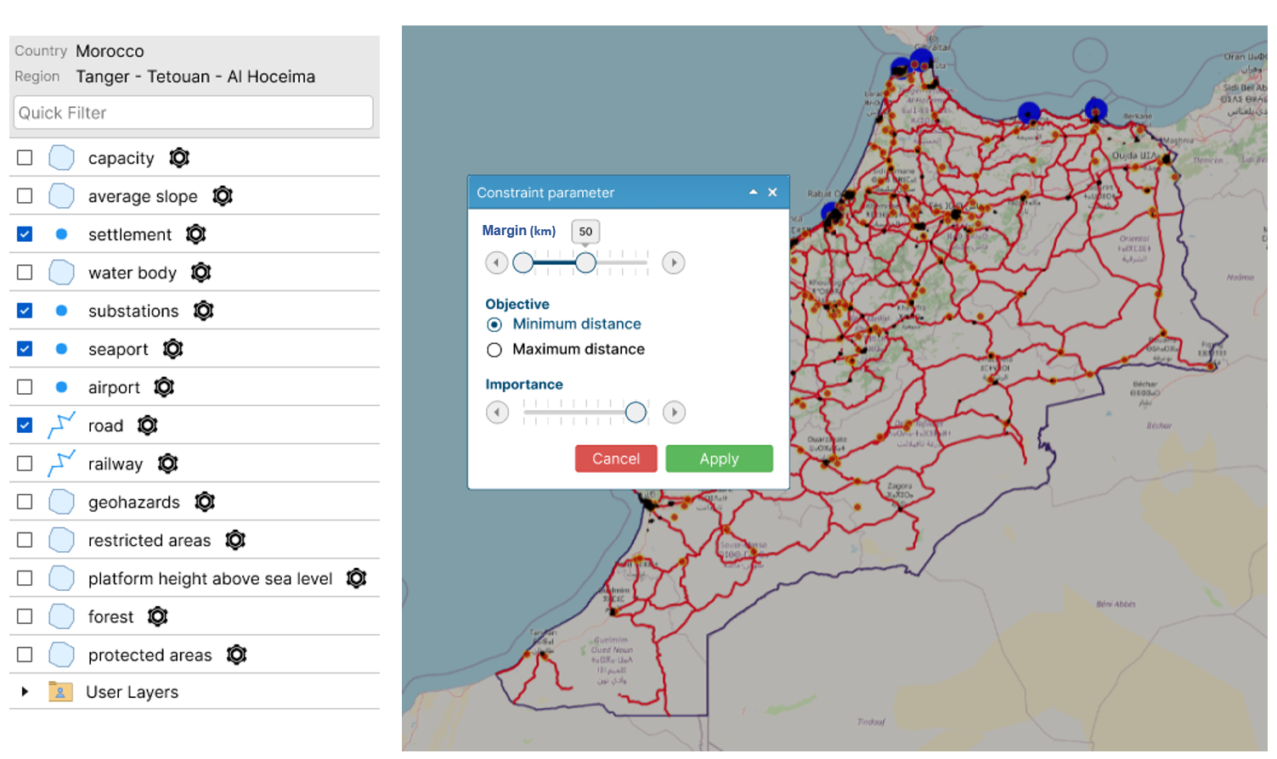 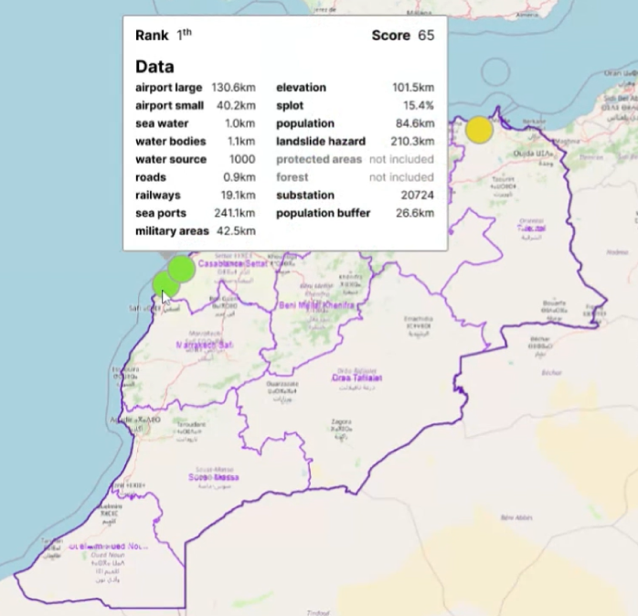

1. *(b)*

*FIG. 2 (a) The interactive interface showcasing the Morocco study area, overlaid with user-defined features. These features include settlement areas, substation locations, seaports, and road networks within the region. In this scenario, the user aims to filter grid cells that are in close proximity to existing roads, within a range of 0 to 50 kilometers. (b) Sample output from the site selection process after filtering and ranking. Hovering over the selected area reveals additional details, including its rank (in this case, the 1st rank), overall score achieved (65 out of 100), and other relevant geospatial features.*

### Assessment of grid interactions using a Digital Twin Approach

The grid impact assessment was carried out in Uzbekistan. To achieve this, simulations were performed using the Digsilent PowerFactory software and Python scripts. The simulations were based on Automation in Grid Studies calculation scenarios, with a primary focus on grid stability studies. Mitigative actions were implemented to reduce grid violations, taking into account multiple enablers. This approach facilitated a fast and reliable assessment of system behavior through data exchange between two platforms. Additionally, it enabled the comparison of different power plants from various sites in a single run, allowing for easy observation of step-up transformer and transmission line loadings across multiple scenarios. The main steps involved in the grid impact assessment process are illustrated in Fig. 3.

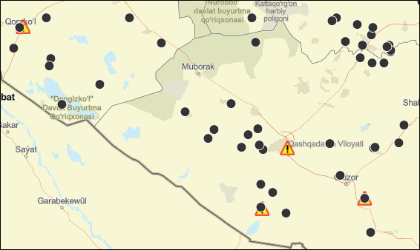 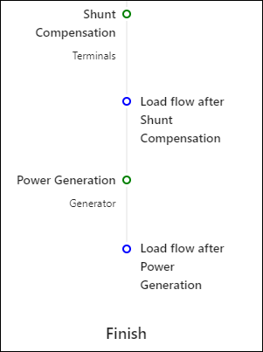 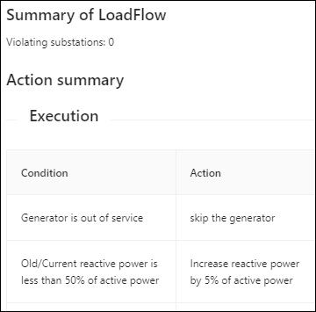

1. *(b)* *(c)*

*FIG. 3 (a) The application displays a region in Uzbekistan, where black markers represent existing electrical substations and overlapped warning signs indicate violations at specific substations. (b) This snippet showcases a part of the mitigation action process, which is followed by a load flow check after each enabler execution. (c) The output screen presents the load flow summary results, providing details on the action and suggesting the necessary actions to be taken under specific conditions.*

### Leveraging climate change projections for advanced reactor strategies

The climate projection analysis conducted in this study focused on the Morocco region from 2024 to 2038. These projections encompassed three climate risks: air temperature, sea surface temperature, and sea level. While these projections are inherently predictive in nature, the primary objective was to provide supplementary data on the potential risks associated with each grid that satisfied the selection criteria. An example of the results is depicted in Fig. 4.

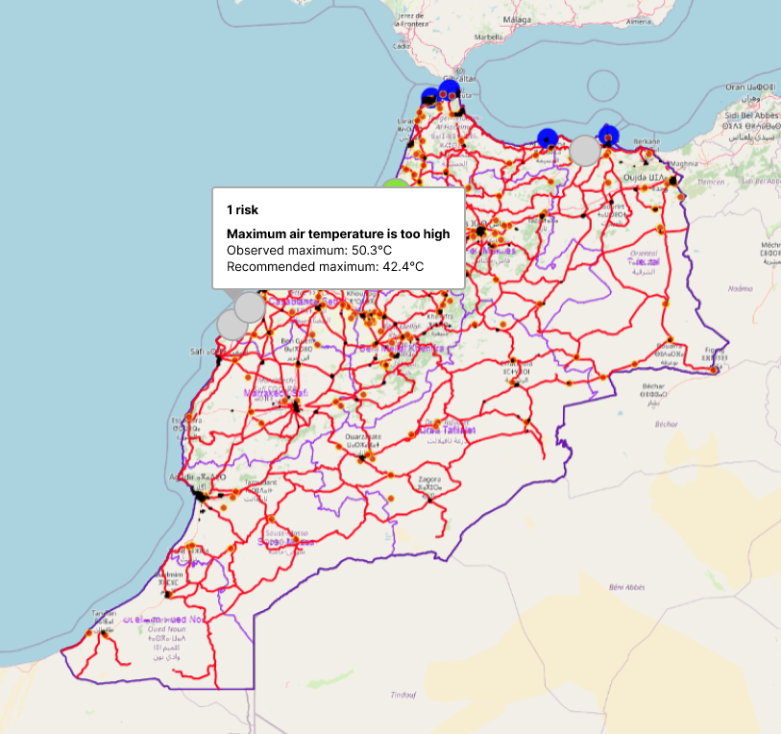

*FIG. 4 Example of climate projection analysis. This figure illustrates the climate projection analysis for the top-ranked grid cell identified in Fig. 2b. The projections encompass air temperature, sea surface temperature, and sea level risks for the 2024-2038 timeframe. The analysis reveals that this grid cell faces one risk related to air temperature, with a projected maximum of approximately 50°C exceeding the recommended maximum of around 42°C.*

## discussion

This study presented an innovative approach to holistic site selection, incorporating multi-criteria geographical analysis, grid interaction simulation, and climate change projections. By allowing the definition of criteria of interest, users can customize the evaluation process to align with their unique requirements and concerns. The filtering and ranking of grid cells based on defined criteria is computationally efficient, facilitating a streamlined evaluation process. However, its applicability is highly dependent on the availability of relevant GIS data in the form of shapefiles. This data availability can vary significantly across different geographical areas, potentially restricting the methodology's use in data-scarce regions. The creation of grid cells is another crucial aspect to be considered. The proposed approach utilizes non-overlapping cells, which can introduce two potential limitations. First, this approach may lead to information loss at cell borders, particularly for features that vary rapidly across space. Second, the initial placement of the grid can influence the values of geographical features within each cell, such as slope gradients. To mitigate these limitations, future research could explore alternative grid generation processes, such as implementing overlapping grids or employing adaptive cell sizes.

This study emphasized the importance of incorporating grid impact assessment into the site selection process. The proposed approach provided reliable results and analytical simulations by utilizing comprehensive grid asset data, including equipment and subcomponents, from various sources. This data enabled cost-effective and efficient modeling for diverse power system projects. The analytical simulations based on this model generated technical and economic recommendations, informing strategic grid development choices. While this case study identified grid bottlenecks under specific voltage conditions, its impact extends to both existing and new grid models. Future research can be conducted in this direction to address and understand strategic recommendations for improving grid architecture, prepare the basis for potential technological investments, and develop a high-level 'Smart Grid' roadmap for new and existing grid regimes.

The proposed tool further incorporates climate prediction information, enhancing the solution's ability to factor in site resilience during selection. However, the availability of climate data can vary significantly across regions, potentially limiting the consistency and comprehensiveness of information used in the site selection process. For instance, not all regions may have access to the same climate variables from a single database. To address this challenge, fostering collaborations and data-sharing initiatives between regions and organizations could significantly improve the availability and consistency of climate data on a global scale.

Despite the limitations identified, the proposed site selection framework offers a comprehensive and adaptable foundation for identifying suitable locations for AMRs and SMRs. This holistic approach empowers more informed decision-making, ultimately contributing to the long-term sustainability of selected sites. By addressing the identified limitations and exploring the suggested future research directions, the methodology can be further refined and adapted to meet the evolving needs of various site selection applications.

ACKNOWLEDGEMENTS

We would like to express our gratitude to Onur Oztuncer, Ozden Afacan, and their team for providing the crucial geospatial data that formed the foundation of this study. Their insights and active participation throughout the research process were invaluable. We would also like to thank Tejas Jayram Bhor, Mohamad Ali Assaad, and Olivier Vincent for their contributions to the writing process. Their specialized knowledge in grid simulation studies (Bhor, T.J. & Assaad, M.A.) and SMRs/AMRs (Vincent, O.) significantly enriched this work. Finally, our gratitude extends to Lies Benmiloud Bechet, Jean-Francois Bossu, and Robert Plana for their insightful guidance in validating the study's findings.

References

1. Vujić, J., Bergmann, R. M., Škoda, R., *et al.*, Small modular reactors: Simpler, safer, cheaper?, *Energy* **45**  (2012) 288–295.
2. Boldon, L., Sabharwall, P., Painter, C., *et al.*, An overview of small modular reactors: Status of global development, potential design advantages, and methods for economic assessment, *Int. J. Energy Environ. Econ.* **22** (2014) 437–459.
3. Värri, K., Market Potential of Small Modular Nuclear Reactors in District Heating, *Semantic Scholar* (2018).
4. Guo, Y., Yuan, X., Zhao, H., *et al.*, Coupling a small modular molten salt reactor with desalination, *Nucl. Eng. Des.* **413** 112513 (2023).
5. DeCotis, P. A., Cartwright, E. D., The Role of Small Modular Reactors in Decarbonization, *Clim. Energy* **38** (2022) 12–17.
6. Industrial applications and nuclear cogeneration (2017), https://www.iaea.org/topics/non-electric-applications/industrial-applications-and-nuclear-cogeneration
7. Poore, I. I. I., Evaluation of Suitability of Selected Set of Department of Defense Military Bases and Department of Energy Facilities for Siting a Small Modular Reactor (2013) https://www.osti.gov/biblio/1073001
8. Moe, W., *Site Suitability and Hazard Assessment Guide for Small Modular Reactors* (2013), https://www.osti.gov/biblio/1097149
9. Boudot, C., Broin, J.B., Sciora, P., *et al.,* Small Modular Reactor-based solutions to enhance grid reliability: impact of modularization of large power plants on frequency stability, *EPJ N - Nucl. Sci. Technol.* **8** 16 (2022).
10. Linnerud, K., Mideksa, T. K., Eskeland, G. S., The Impact of Climate Change on Nuclear Power Supply, *Energy J.* **32** (2011) 149–168.
11. Corner, A., Venables, D., Spence, A., *et al.,* Nuclear power, climate change and energy security: Exploring British public attitudes, *Energy Policy* **39** (2011) 4823–4833.
12. Marler, R. T., Arora, J. S., The weighted sum method for multi-objective optimization: new insights, *Struct. Multidiscip. Optim.* **41** (2010) 853–862.
13. López, C. D., “Python Scripting for DIgSILENT PowerFactory: Leveraging the Python API for Scenario Manipulation and Analysis of Large Datasets”, Advanced Smart Grid Functionalities Based on PowerFactory, Springer, Cham (2018).
14. Shrivastava, D. R., “Interfacing Python with DIgSILENT Power Factory: Automation of Tasks”, Intelligent Computing Techniques for Smart Energy Systems, Springer, Singapore (2020).
15. Lopez, C. D., “Enhancing PowerFactory Dynamic Models with Python for Rapid Prototyping”, IEEE 28th International Symposium on Industrial Electronics (ISIE) (Vancouver, BC, Canada, 2019), IEEE (2019).
16. Lopez, A., Essential climate variables for water sector applications derived from climate projection (2018), https://doi.org/10.24381/CDS.201321F6
17. Copernicus Climate Change Service., Global sea level change time series from 1950 to 2050 derived from reanalysis and high resolution CMIP6 climate projections (2022), https://doi.org/10.24381/CDS.A6D42D60
18. Clayson, C.A., et al., NOAA Climate Data Record (CDR) of Sea Surface Temperature - WHOI, Version 2 (2016), www.ncei.noaa.gov/access/metadata/landing-page/bin/iso?id=gov.noaa.ncdc:C00972