# Digital Twin Technology based Modeling of Small Modular Reactor for early deployment within power Energy Systems

S. TOUATI

Nuclear Research Centre of Birine (CRNB)

Po Box 180, 17200 Ain Oussera, Djelfa Province, Algeria.

Email: s.touati@crnb.dz

A. BOUHLAL, B. DJAROUM and A. SOULI

Nuclear Research Centre of Birine (CRNB)

Po Box 180, 17200 Ain Oussera, Djelfa Province, Algeria.

**Abstract**

The Small modular reactors (SMRs) deﬁned based on the output nuclear power plant rate, typically less than 300 MW), are an emerging nuclear power plant technology, suitable for large grids as well as remote load centers and offer load following and frequency response capabilities. Detailed dynamic models including reactor dynamics are necessary for power system dynamic studies. These reactors provide a broad range of applications beyond the electrical system, possibly addressing partial or full thermal power to cogenerate applications, such as heating, hydrogen generation, and desalination.

Several nations are developing small modular reactors (SMRs) to incite the use of nuclear energy in the world’s energy matrix to meet future energy demands and environmental standards. These reactors aim for the deployment of innovative nuclear technologies in energy systems by several advantages (security, safety, waste management, adapting plant output to increase operating ﬂexibility...etc.).

## INTRODUCTION

Numerical methods are used to solve the partial differential equations representing the nuclear reactor physics, and these methods are derived from discretization techniques. For numerical solutions in any scientific area, computational tools have been developed including software and hardware. In the past, the former computer processing was the sequential execution of computer commands, meaning to say that program tasks are carried out one after one. Modern computational tools have been developed for parallel processing, executing several tasks concurrently[1,2].

A nuclear reactor is a highly complex, nonlinear, and time- varying system. Therefore, the control of variables, including core power, for safe operations of nuclear reactors is a challenging task [3]. Random external disturbances and uncertainties due to parametric variation of the system with operating power level, fuel burn-up, and component ageing contribute to some of the challenges in nuclear power plant operations. Moreover, the need for a ﬂexible mode of operation of nuclear reactors [3] from their traditional use as baseload plants has led to a power tracking challenge in recent times. Consequently, safe operations of nuclear power plants require a control system that is insensitive to random external disturbances and highly robust against uncertainties such as unmodelled dynamics and parametric variation.

Recent developments of high-performance computer equipment and software have made the use of supercomputing in many scientific areas possible. The appropriate selection of parallel computing software, like newly developed linear algebra libraries, to be used in a specific project may result in a suitable platform to simulate nuclear reactor states with relatively prompt results. Various control techniques have been implemented for the safe operation of nuclear power plants. Model predictive control technique was used in the load-following operation of a nuclear reactor [4,5]. This controller has good performances in a constraint system in which a load- following or power tracking nuclear reactor represents a perfect.

## Overview of Digital Twin Technology for Nuclear plant Modelling

Digital twin technology is an innovative approach that involves creating a virtual model or replica of a physical system, whether it is a machine, building, industrial production process, or even an entire city. This virtual model aims to accurately mimic the characteristics, behavior, and functionality of its physical counterpart in real time. Harnessing the power of digital twins yields deeper insights into the performance, behaviour, and life cycle of the physical system, enabling more effective monitoring, analysis, and optimization. The term digital twin was first introduced in NASA’s draft version of the technological road map in 2010, and it was also known as the virtual digital fleet leader. Figure 9 shows a timeline depicting the evolution of digital twin technology.

FIG. 1. Timeline showcasing the evolution of digital twin technology.

Real-time monitoring is considered as a key advantage of digital twin technology for the reason that it allows for continuous monitoring of the physical system. By connecting sensors and data collection devices to the physical system, the digital twin receives a constant stream of data, reflecting the current state and conditions of the system. These real-time data can facilitate proactive measures by enabling the identification of potential issues before they escalate. The feature significantly reduces downtime and enhances operational efficiency by empowering operators and maintenance personnel to address problems promptly and effectively.

FIG.. 2 Digital twins: contributing technologies.

Digital twin technology provides a virtual replica of a physical system that enables real-time monitoring and control of the system’s performance . [Figure 2](https://www.frontiersin.org/articles/10.3389/fenrg.2024.1339836/full#F2) shows the technological contributions to digital twin. This technology can be integrated with advanced manufacturing techniques to create a complete digital model of a nuclear energy system, including its physical components and their behaviour. For example, one can integrate sensor data with artificial intelligence, enabling the specialist care of different stages in additive manufacturing for the creation of designs or components. This digital model can be used to simulate different scenarios, test new designs, and optimize nuclear energy systems for improved performance, reduced downtime, and enhanced safety.

## Nuclear reactor model

The mathematical models representing the nuclear reactor physics are based mainly on two theoretical areas: neutron transport theory and neutron diffusion theory, where it is necessary to remark that neutron diffusion theory is really a simplification of the neutron transport theory.

A simpliﬁed conceptual version of the SMR with its reactor core, major integral components, and power conversion subsystems is shown in Fig. 3.

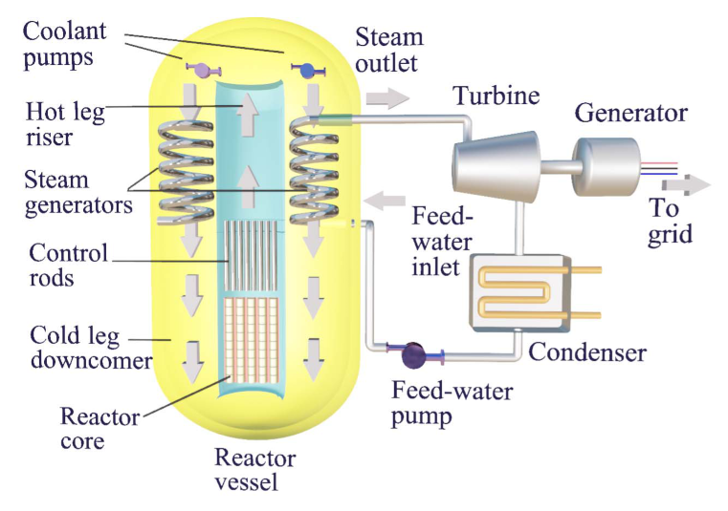

FIG. 3 Major components of a PWR type SMR with an integrated core and heat transport system

The nuclear reactor core is modelled based on the point kinetics equations with three group-delayed neutron precursors. The model comprises four main parts: the neutronic model, the thermal-hydraulics model, the neutron poison model, and the reactivity model. The thermal-hydraulics model is based on the singly lumped model of fuel and coolant temperatures. The Iodine and Xenon equations are used to model the neutron poison model in the reactor core. The feedback effects from the complementary thermal-hydraulics and the poison model contribute to the total reactivity in the core. Therefore, the reactivity model comprises reactivity due to the control rod, the coolant and fuel temperature, and the reactivity due to Xenon[6-10].

Point kinetics equations with the six-group delayed neutron precursor concentrations are given as follows:

$$\frac{\text{d}n_{r}\left(\text{t}\right)}{\text{dt}}\text{=}\frac{ρ\left(t\right)-β}{Λ}n_{r}\left(\text{t}\right)+\sum_{1}^{6}{λ_{i}C_{i}(t)}$$

$$\frac{dC_{i}(t)}{dt}=\frac{β_{i}}{Λ}n_{r}\left(t\right)-λ_{i}C_{i}\left(t\right), i=1…6$$

However, in this study, three-group delayed neutron is adopted and the normalized three-group delayed neutron point kinetics equation with respect to an equilibrium condition used to model the reactor core is given below [11-12].:

$$\frac{\text{d}n_{r}\left(\text{t}\right)}{\text{dt}}\text{=}\frac{ρ\left(t\right)-β}{Λ}n_{r}\left(\text{t}\right)+\sum_{i-1}^{3}{\frac{β}{⋀}∁_{ri}}$$

$$\frac{dC_{ri}(t)}{dt}=λ_{i}n_{r}-λ_{i}C_{r}, i=1,2,3$$

$$\frac{dX(t)}{dt}=γ_{x}\sum_{f}{ϕ+λ_{I}I-σ_{x}Xϕ-λ_{x}X}$$

$$\frac{dI(t)}{dt}=γ_{x}\sum_{f}{ϕ-λ_{I}}$$

$$\frac{dT_{f}(t)}{dt}=\frac{f_{f}}{μ_{f}}n_{r}\left(t\right)-\frac{Ω}{μ_{f}}T_{f}+\frac{Ω}{{2μ}_{f}}T_{l}+\frac{Ω}{{2μ}_{f}}T_{e}$$

$$\frac{dT_{l}(t)}{dt}=\frac{(1-f_{f})P_{0}}{μ_{c}}n_{r}\left(t\right)+\frac{Ω}{μ_{c}}T_{f}-\frac{(2M+Ω)}{{2μ}_{c}}T_{l}+\frac{(2M-Ω)}{{2μ}_{c}}T_{e}$$

$$ρ\left(t\right)=ρ_{r}+α_{f}\left(T_{f}-T_{f0}\right)+α_{c}\left(T_{c}-T_{c0}\right)-\left(\frac{σ_{x}}{∑_{f}}\right)(X-X_{0})$$

$$\frac{dρ_{r}(t)}{dt}=G_{r}Z_{r}$$

$$P\left(t\right)=P_{0}n_{r}$$

where the parameters are defined in Table 1 and the quantities used in this study are given in Table 2.

TABLE 1. Nomenclature

|  |  |  |  |
| --- | --- | --- | --- |
| $$n_{r}$$ | Neutron density relative to initial equilibrium density | $$P_{0}$$ | Initial equilibrium power [*MW*] |
| $$n$$ | Neutron density [*n/cm3*] |  | Total heat capacity of the fuel [*MW.s/°C*] |
| $$n_{0}$$ | Initial equilibrium (steady-state) neutron density [*n/cm3*] |  | Total heat capacity of coolant [*MW.s/°C*] |
| $$∁_{i0}$$ | Initial equilibrium (steady-state) density i-th group precursor density [*n/cm3*] |  | Heat transfer coefﬁcient between fuel and coolant [*MW/°C*] |
| $$∁_{i}$$ | Core averaged i-th group precursor density [*atom/cm3*] |  | Mass ﬂow rate multiply by heat capacity of water [*MW*] |
| $$∁_{ri}$$ | Relative density of the i-th group precursor | $$ρ_{r}$$ | Reactivity due to control rod |
| $$ρ$$ | Reactivity | $$Z_{r}$$ | Control rod speed [*fraction of core length /s*] |
| $$Λ$$ | Effective prompt neutron lifetime [*s*] | $$G_{r}$$ | Total reactivity worth of control rod [*pcm*] |
| $$λ_{i}$$ | Radioactive decay constant of i-th group [*s-1*] |  | Coefﬁcient of reactivity due to coolant temperature [$△$ k/k/°C] |
| $$β$$ | Total delayed neutron fraction | $$α_{f}$$ | Coefﬁcient of reactivity due to fuel temperature [$△$ k/k/°C] |
| $$β_{i}$$ | Delayed neutron fraction of the i-th group | $$T_{f0}$$ | Initial equilibrium fuel temperature (steady state) |
| $$T_{f}$$ | Average reactor fuel temperature [*°C*] | $$T_{c0}$$ | Initial equilibrium coolant average temperature(steady state) [*°C*] |
| $$T_{l}$$ | Temperature of water leaving the reactor core [*°C*] | $$σ_{x}$$ | Microscopic absorption cross-section of xenon [*cm2*]. |
|  | Temperature of water entering the reactor core [*°C*] | $$λ_{x}$$ | Xenon decay constant [*s-1*] |
|  | Average reactor coolant temperature [*°C*] | $$λ_{l}$$ | Iodine decay constant [*s-1*] |
|  | Fraction of reactor power deposited in the fuel | $$γ_{x}$$ | Xenon yield by fission |
|  |  | $$γ_{l}$$ | Iodine yield by fission |

### Power Control strategy by rods withdrawal

Control of nuclear power plant can be regulated generally by moving the control rods and changing the boric acid concentration of the heat carrier. Generally, any power control strategy is designed based on a controller using one of the reactor core power control methods: PID control, optimal control, neural network control, fuzzy control, predictive control, sliding mode control and fractional order control. The PID controller is the simplest to design and use in industrial as real-time controllers.

in the absence of the parameters of an SMR, we used the parameters of a WWER-1200 type Power Reactor obtained from the literature. we will use an SMR parameters in the final version of the paper.

TABLE 1. Parameters Values

|  |  |
| --- | --- |
| Parameters | Value |
| Thermal power | 2500 MW |
| Core heights | 400 cm |
| Core radius | 200 cm |
| Diffusion constant (D) 0:16cm | 0.16 cm |
| Mean velocity of thermal neutrons (v) 2200m=s | 2200 m/s |
| Microscopic absorption cross-sectionrx | 3x10-18 cm2 |
| Fractional ﬁssion yield of Xenon cx | 0.003 |
| Fractional ﬁssion yield of Iodine cI | 0.059 |
| Xenon decay constantk | 2.1 x 10-5 s-1 |
| Iodine decay constantk | 2.9 x 10-5 s-1 |
| Macroscopic ﬁssion cross-section | 0.3358 cm-1 |
| Total delayed neutron fraction b | 0.0065 |
| Delayed neutron fraction of ﬁrst group neutron precursor b | 0.00021 |
| Delayed neutron fraction of second group neutron | 0.00225 |
| Delayed neutron fraction of third group neutron | 0.00404 |
| Radioactive decay constant of ﬁrst group neutron | 0.0124 s-1 |
| Radioactive decay constant of second group neutron | 0.0269 s-1 |
| Radioactive decay constant of third group neutron | 0.632 s-1 |
| Total reactivity worth of control rod G | 14.5 x 10-3 pcm |
| Total heat capacity of the fuel lf | 26.3 MW s/°C |
| Total heat capacity of the coolant lc | 71.8 MW s/°C |
| Effective prompt neutron lifetime(K) | 2 x 10-5 s |
| Fraction of reactor power deposited in the fuel f | 0.92 |

The simulation results are obtained using the model developed without xenon effect (WOXE) and with xenon effect (WXE).

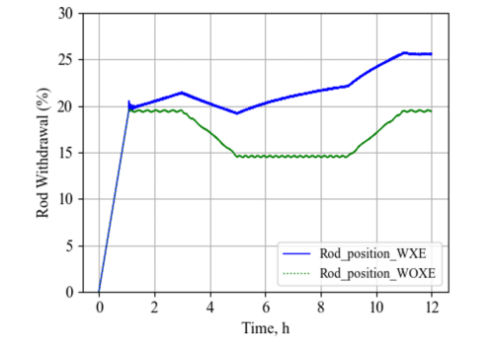

FIG. 4. Rod withdrawal from reactor core bottom

In Figure (4), we observe that the movement of the control rods is more intense for xenon effect power control, which makes it possible to compensate for this effect and maintain better charge monitoring in the nuclear reactor. : For example, at the relative power level (60%), maintained for 4 hours, the control bar moves upwards to compensate for the insertion of negative reactivity by the xenon and maintain a very small difference between the power of the reactor and the desired one.

FIG. 5. Power variation with PID controller [100%-60%-100%].

The simulation results are analyzed to understand the reactor core model responses and evaluate the performance of the power control strategy. The relative power of the reactor, without and with the effect of xenon on the total reactivity as shown in Figure (5), indicates a non-negligible deviation of this power compared to the desired power. This difference is significant before the model reaches a stable steady state in the case considering xenon effect affecting the quality of the control strategy. The proposed power control strategy with PID controller, applied to reactor core power presents good load following performances.

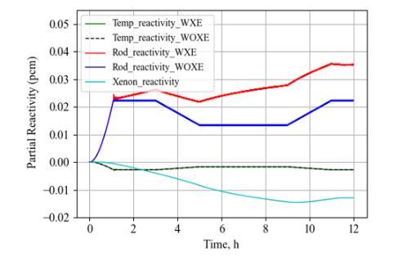

FIG. 6. Partial reactivity due to rod movement, coolant temperature, and xenon.

The contribution of the control rod reactivity to the total reactivity, shown in Figure (7), is compared to the reactivity due to coolant temperature feedback and xenon effect. The reactivity of the negative feedback due to the temperature (fuel and coolant) is the same for the two cases of power regulation with or without xenon effect.

## Experimental Implementation of SMR emulator

The experimental implementation will be carried out at the Birine Nuclear Research Center, Nuclear Instrumentation Development Division, Electrical Engineering Department.

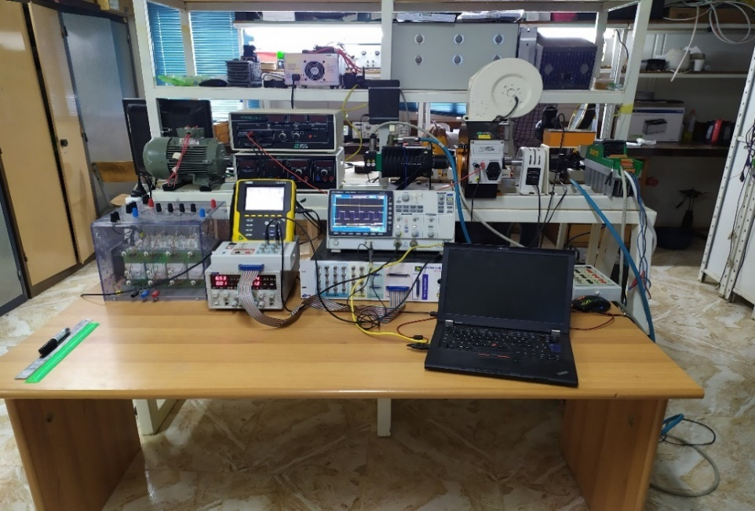

FIG. 7 Laboratory Test Bench

The aim of this study is to create an SMR emulator, which will generate a control of a direct current motor to imitate the behavior of the turbine, which will drive a generator to produce electrical energy.



Turbine and generator Test bench

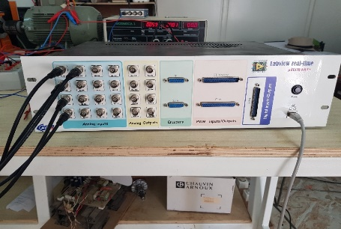

SMR Real Time Simulator

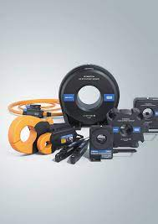

Parameters Measurement

Fig. 2: Experimental Implementation of SMR in the Loop Based on Digital Twin technology.

The experimental implementation is in progress and has fallen a little behind schedule, but it will be finalized within the deadlines for the final version of the paper in September.

## Conclusion

The modeling of a nuclear reactor core, based on point kinetic equations and a group of delayed neutrons, was carried out. Using the PID controller, the reactor power monitoring capacity is simulated with a load monitoring scenario of a PWR type reactor. The feedback of the overall temperature of the fuel and the coolant is taken into account in the developed model. Additionally, the effect of xenon concentration is also included in the model. The analysis of the results obtained from the simulations carried out demonstrates the good control of the reactor power by the strategy designed for this purpose. Therefore, it can be concluded that the developed reactor model can be used for future implementation of other power control strategies. In addition, other reactor core modeling methods and different power control strategies (sliding model control, Fuzzy-PID, optimal control and predictive control) can also be used to develop new, more efficient models and algorithms. advanced power control for nuclear reactors intended for load following mode.

ACKNOWLEDGEMENTS

This research is supported by International Atomic Energy Agency (IAEA), Coordinated Research Project I31039 Technologies ‘Enhancing the Competitiveness and Early Deployment of Small Modular Reactors’, IAEA Research Contract No: 26715 and Nuclear Research Centre of Birine (CRNB), Algeria.

References

1. Abdulraheem, K.K., Andreevich, S., Laidani, Z., 2021. A differentiator based second- order sliding-mode control of a pressurized water nuclear research reactor considering Xenon concentration feedback. Ann. Nucl. Energy 156, 108193.
2. Ansarifar, G.R., Akhavan, H.R., Sliding mode control design for a PWR nuclear reactor using sliding mode observer during load following operation. Ann. Nucl., 2015. Energy 75, 611–619.
3. Ansarifar, G.R., Nasrabadi, M.N., Hassanvand, R., Core Power Control of the fast nuclear reactors with estimation of the delayed neutron precursor density using Sliding Mode method. Nucl. Eng. Des. 296, 1–8. 2016.
4. Ansarifar, G.R., Rafiei, M.. Second-order sliding-mode control for a pressurized water nuclear reactor considering the xenon concentration feedback. Nucl, 2015. Eng. Technol. 47, 94–101.
5. Arab-Alibeik, H., Setayeshi, S.. Improved Temperature Control of a PWR Nuclear Reactor Using an LQG/LTR Based Controller. IEEE Trans. Nucl. Sci. , 2003, 50, 211–218.
6. Ben-Abdennour, A., Lee, K.Y., Edwards, R.M.. LQG/LTR Robust Control of Nuclear Reactors with Improved Temperature Performance. IEEE Trans. Nucl. Sci. , 1992. 39, 2286–2294.
7. Kamal Kayode Abdulraheem, Sergei Andreevich Korolev, Robust optimal-integral sliding mode control for a pressurized water nuclear reactor in load following mode of operation, Annals of Nuclear Energy, Volume 158, 2021, 108288, ISSN 0306-4549, <https://doi.org/10.1016/j.anucene.2021.108288>.
8. Eliasi, H., Menhaj, M.B., Davilu, H. Robust nonlinear model predictive control for a PWR nuclear power plant. Prog. Nucl. Energy 54, 2012, 177–185.
9. L. Fridman, A. Poznyak, F.J. Bejarano. Robust output LQ optimal control via integral sliding modes, Systems and Control: Foundations and Applications. 2014.
10. IAEA,. Non-baseload Operation in Nuclear Power Plants: Load Following and Frequency Control Modes of Flexible Operation. IAEA Nucl. Energy Ser. 1–190,2018.
11. Reddy, P.M.S., Shimjith, S.R., Tiwari, A.P., Kar, S., 2020. State Feedback Output Tracking Model Reference Adaptive Control for Nuclear Reactor. IFAC- PapersOnLine 53, 319–324.
12. Wang, G., Wu, J., Zeng, B., Xu, Z., Wu, W., Ma, X.. State-space model predictive control method for core power control in pressurized water reactor nuclear power stations. Nucl. Eng. Technol. 49, 134–140 , 2017