# SecurinG small modular REACTORS in urban environments

Collin Evans

Sandia National Laboratory

Albuquerque, United States of America

Email: cjevans@sandia.gov

Alan Evans

Sandia National Laboratory

Albuquerque, United States of America

**Abstract**

Current small modular reactor (SMR) deployment use cases consider both rural and urban deployments depending on the operational in-country needs for clean and reliable sources of energy. Many studies have been conducted analyzing security in rural and remote deployment locations, but this study looks at the physical security implications of an SMR placed in an urban environment and its uses for electricity production, district heating, and process heating.

SMRs used for electricity production, district heating, and process heating may be key sources of both energy infrastructure and commercial infrastructure within a city and within a State. As a result, long-term shutdowns could have a serious impact on a State’s overall energy or commercial production. Therefore, operators may consider further security applications to protect an SMR plant from physical attacks against both radiological sabotage and sabotage acts that could result in the SMR facility being offline for a significant amount of time.

In this study, the team designed and analyzed a physical protection system (PPS) for securing an urban SMR facility against acts of radiological sabotage and sabotage acts that could disrupt the facility’s long-term operation. Additionally, this work analyzed the nuanced security issues related to siting an SMR near an urban environment (versus in a rural environment). The result of these analyses includes recommendations for PPSs for urban SMR facilities used for energy production, district heating, and process heating.

## INTRODUCTION

The use of SMRs could enhance an ongoing effort to combat climate change. However, there are challenges regarding securing these urban SMRs. A significant concern is the closer proximity to outside threats. Adjacent and nearby structures could hinder detection, which could result in the need for additional delay (which comes at an increased cost) to ensure an adequate time for response to arrive on site. In contrast, response could be closer, given the urban environment.

Site perimeter changes and other measures need to be considered to ensure response forces have adequate line-of-sight (LOS) to maintain the security of these SMRs. With a more limited response force and smaller distances to targets, the placement of each individual response tower must be precise to lower costs while maintaining security integrity.

The study will analyze the shortened detection time and its effect on response time, the security structure and layout, and finally, a variety of simulated attacks and how effectively the security layout defends targets within the site. In all, these three components can answer the question of how to effectively secure an SMR in an urban environment.

## Site design layout

The site consists of an outer fence that defines the limited access area (LAA), also called the owner-controlled area (OCA). Within the LAA, there is an entry control point (ECP) and three turbine buildings. The ECP area can handle both vehicles and personnel. There is a response tower that overlooks the ECP while maintaining LOS over the other buildings. After this is another inner fence line, which defines the protected access area (PA). Within the PA, there are five buildings, which consist of three reactor buildings, one central alarm station (CAS) building, and a spent fuel building. There are three more response towers located at strategic points to maintain LOS throughout the perimeter. Fig. 1 provides an overview of the site layout.

As stated previously, the first response tower overlooks the ECP. It also has clear LOS over other areas of the site, which aids in scenarios where attacks come from the area at the top of Fig. 1. The second response tower is on top of the CAS, which offers assistance to the ECP and overlooks the turbine buildings in case of an attack originating from the area at the bottom of Fig. 1. The third response tower is on the left most reactor building, which offers LOS over the turbine buildings as well as over the area on the left side of Fig. 1. The last response tower is positioned on the spent fuel storage building, which offers the most LOS across the entire site layout and allows response to engage from all sides of the site.

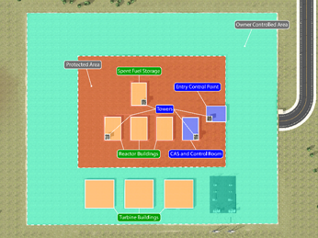

*FIG. 1. Site layout.*

One additional change was made to the site that forced adversaries to take a less advantageous path toward the turbine buildings. Originally the design called for roll-up doors to be positioned facing away from the reactor buildings, which allowed the adversaries to freely access these doors without being engaged by response forces located in the response towers. In order to force the adversaries to traverse into LOS of response forces, the team moved the roll-up doors as well as the personnel entry doors to face the reactor buildings. This forces the adversaries to choose one of the paths in between the buildings, where the response towers have a clear LOS down. With this change, the response won in these scenarios; the adversaries did not make it to the doors, as they were eliminated before arrival. The original door placement can be seen in Fig. 2 and the updated door placement can be seen in Fig. 3.

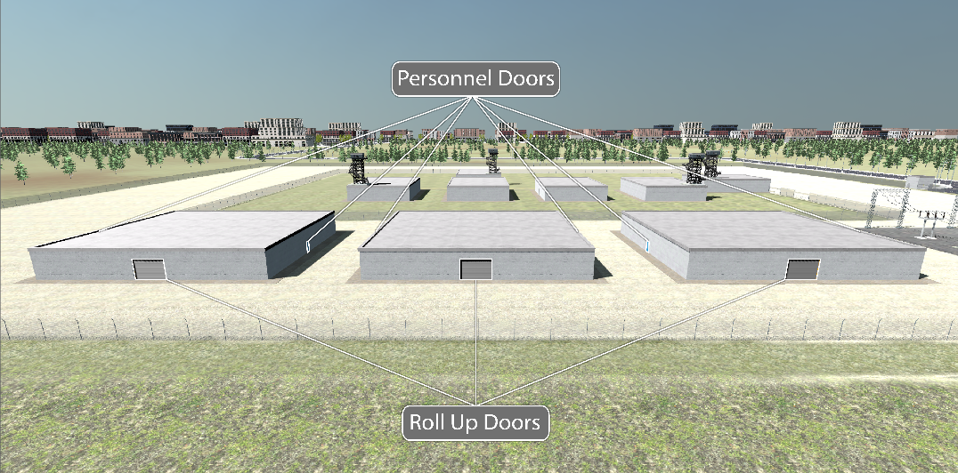

*FIG. 2. Original Door Placement*

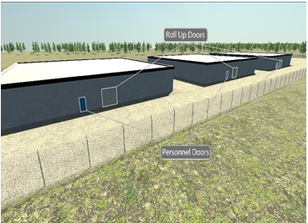

*FIG. 3. New door placement.*

## PPS Evaluations

To evaluate the PPS designed for this hypothetical SMR, tabletop exercises were conducted using subject matter experts (SMEs) to develop facility adversary attack plans with the highest likelihood of success. These SMEs have decades of experience working at nuclear power plants in the United States and at Department of Energy facilities and are experienced in providing armed response, physical protection, and adversary attack planning at domestic nuclear facilities in the United States. Five distinct adversary scenarios were identified and developed for this hypothetical SMR.

Each of the five scenarios was analyzed using Scribe3D© (Scribe). Scribe is a Sandia National Laboratories developed scenario and tabletop exercise visualization tool (not a combat simulation or probability of neutralization tool). For each scenario a total cumulative probability of neutralization was calculated to develop higher level results. Each engagement (i.e., where the adversary and response force had an opportunity to engage) was simulated 1,000 times to ensure a statistically significant number of engagements to determine the effectiveness of the response force and the response strategy. Based on the number of engagements and the total number of simulations for each scenario, a total cumulative probability of neutralization was identified. Because SCRIBE3D is not a combat simulation tool, the cumulative probability of neutralization was developed to provide a high-level of information than showing the results for each total engagement.

In scenario one, the adversaries attack from the area at the bottom of Fig. 1 and work their way to the reactor buildings. The scenario included a range of eight-to-four adversaries, and the results listed in Table 1 demonstrate that in scenario one, there was a high probability of neutralization. In addition, in many of the simulated engagements between the response force and the adversary, the adversaries were neutralized before they could pass the inner fence.

TABLE 1. SCENARIO ONE ANALYSIS RESULTS

|  |  |  |  |
| --- | --- | --- | --- |
| Number of Adversaries | Number of Responders Involved | Number of Engagements | **Cumulative Probability of Neutralization** |
| 8 | 4 | 4 | **90.6%** |
| 7 | 4 | 3 | **92%** |
| 6  5  4 | 4  4  4 | 2  2  2 | **85.6%**  **94.1%**  **95.8%** |

In scenario two, the adversaries perform a split attack, where one group attacks from the area at the bottom of Fig. 1 and the other from the area at the top. This was easily defended, as the towers were set up to defend against this scenario such that each tower could engage with the group closest to it. Tower placement even enabled combined engagement in the top area. The towers closest to the bottom of Fig. 1 were faced with individual conflicts with whoever appeared in their LOS first. From this approach, a high probability of neutralization was achieved for each scenario regardless of the size of the attack.

TABLE 2. SCENARIO TWO ANALYSIS RESULTS

|  |  |  |  |
| --- | --- | --- | --- |
| Number of Adversaries | Number of Responders Involved | Number of Engagements | **Cumulative Probability of Neutralization** |
| 8 | 4 | 3 | **99.3%** |
| 7 | 4 | 3 | **99.8%** |
| 6  5  4 | 4  4  4 | 2  2  2 | **98.1%**  **99.7%**  **99.8%** |

In scenario three, a range of eight-to-four adversaries originate their attack from the top of Fig. 1. From there, they breach the outer fence and engage with responders in all the response towers. All the response towers have a clear LOS toward this area and in one engagement are able to eliminate each adversary with a very high probability of neutralization (shown in Table 3). The data indicates that the top area of the site is the easiest to defend, as there are no buildings and there is a significant area for adversaries to traverse to even reach the inner fence line.

TABLE 3. SCENARIO THREE ANALYSIS RESULTS

|  |  |  |  |
| --- | --- | --- | --- |
| Number of Adversaries | Number of Responders Involved | Number of Engagements | **Cumulative Probability of Neutralization** |
| 8 | 4 | 1 | **99.7%** |
| 7 | 4 | 1 | **99.9%** |
| 6  5  4 | 4  4  4 | 1  1  1 | **99.99%**  **99.99%**  **99.99%** |

In scenario four, the adversaries range from eight-to-four and originate their attack from the area on the left side of Fig. 1, closer to the turbine building. Only the response towers closest to this left side area can engage, as the other two response towers either do not have clear LOS or are blocked by other response towers. Even with this problem, these two response towers can defeat the adversaries with a high probability of neutralization, as seen in Table 4.

TABLE 4. SCENARIO FOUR ANALYSIS RESULTS

|  |  |  |  |
| --- | --- | --- | --- |
| Number of Adversaries | Number of Responders Involved | Number of Engagements | **Cumulative Probability of Neutralization** |
| 8 | 2 | 1 | **83.2%** |
| 7 | 2 | 1 | **96.3%** |
| 6  5  4 | 2  2  2 | 1  1  1 | **97.5%**  **99.2%**  **99.8%** |

In scenario five, a range of eight-to-four adversaries originate an attack from the area at the bottom of Fig. 1 and attack a turbine building. As stated before, the high bay door would have been an easy access point for the adversaries and would not have allowed the response towers to engage with them. To avoid this problem, as stated in the previous section, the high bay door as well as the personnel entry door were moved to face the reactor buildings, which grants the response towers LOS and forces the adversaries to engage with the response towers in order to gain access into the turbine buildings. This scenario is similar to scenario one, and the responders achieved a high probability of neutralization, as seen in Table 5.

TABLE 5. SCENARIO FIVE ANALYSIS RESULTS

|  |  |  |  |
| --- | --- | --- | --- |
| Number of Adversaries | Number of Responders Involved | Number of Engagements | **Cumulative Probability of Neutralization** |
| 8 | 3 | 3 | **99.9%** |
| 7 | 2 | 3 | **99.9%** |
| 6  5  4 | 2  2  2 | 2  2  2 | **99.9%**  **99.9%**  **99.9%** |

### Evaluating Extended and Early Detection in Urban Environments

Many SMR vendors and operators are interested in using extended detection technologies to detect adversaries earlier and potentially increase the response force’s time to interrupt and neutralize an adversary. There are a variety of methods to achieve this, including deliberate motion analytics (DMA) [1]. Extended detection may provide additional time when applied outside of the LAA or PA fence line. Using the PathTrace tool, the team conducted a path analysis to identify the increase in the total adversary task time resulting from early detection, based on adversary distance and traversal time. Table 6 provides a summary of these results.

TABLE 6. PATHTRACE ANALYSIS

|  |  |  |  |
| --- | --- | --- | --- |
| Distance of Early Detection Perimeter (m) | Vehicle (20 m/s)  Time (s) | Walking (1 m/s)  Time (s) | Running (3 m/s)  Time (s) |
| 100 | 5 | 100 | 33.3 |
| 200 | 10 | 200 | 66.7 |
| 300  400  500  600  700  800  900  1,000 | 15  20  25  30  35  40  45  50 | 300  400  500  600  700  800  900  1,000 | 100  133.3  166.7  200  233.3  266.7  300  333.3 |

As shown in Table 6, if the facility terrain is not engineered to slow down people or vehicles, the increase in adversary task time is limited to the range of the extended detection and how the adversary is moving up to the facility. If extended detection technologies are pushed to 1,000 meters, the increase to the adversary task time is approximately 50 seconds to 5.5 minutes, which is not a significant increase in the adversary task time.

Another consideration when using an extended detection technology is where it could be impactful. In an urban environment the facility and PPS will have to consider normal vehicle traffic and persons that may be present within the area on a regular basis, as extended detection technologies may cause a large number of alarms as a result of normal activity within the detection range. This large number of alarms may become too burdensome for an alarm station operator, and as a result, negatively impact the effectiveness of this detection technology.

To increase the effectiveness of this type of detection in an urban environment, SMR facilities may consider a larger LAA or property-controlled area and engineering features into the terrain that increase the time to cross areas with extended detection. By extending the LAA or controlled area of an SMR facility, extended detection technologies may not alarm as often, which could result in a more manageable amount of nuisance alarms. Engineering features such as ditches, rocky terrain, or uneven terrain up to the facility perimeter adds to the delay time and can slow people and vehicles down, thereby increasing the total time to reach the facility.

### Response Force Considerations in Urban Environments

While use of response forces at nuclear facilities in urban environments is not new, there are unique challenges that should be considered for response forces at large SMR deployments in urban environments. As discussed, at SMR facilities there are significant amounts of plant capital equipment and potential radiological targets present. If offsite response forces are used, a detailed analysis and agreement must be developed to determine the time it takes for the response force to arrive at to the facility, as well as how long it takes the response force to effectively interrupt and neutralize an adversary force. These response times may be long, depending on the type of response force assigned to the facility. For example, if the response force is local law enforcement who have day-to-day jobs as well, response time may be longer than if response is assigned to law enforcement whose only responsibility is to respond to the SMR facility.

Additionally, depending on the location of the urban SMR and the daily amount of foot and vehicle traffic around the facility, strict rules of engagement may be needed to limit unattended and adverse consequences to persons or vehicles outside the SMR facility. Finally, an SMR in an urban environment may be prone to more anti-nuclear protests or other protests than SMRs in rural environments. The SMR facility, the guard force, and response force should develop a coordinated plan for handling protests. The plans should consider approaches for various types of protests (i.e., violent or non-violent), the number of protesters (i.e., hundreds or thousands), and identifying the mitigations and contingencies to limit the impact on operations and security at the SMR facility.

## Conclusion

Security requirements for SMRs located in urban environments may be the same or similar to those located in rural environments. However, there are additional considerations for urban environments, including protesters, limitations for extended detection, and the need for a coordinated and structured response plan.

Initial analysis using the benefits of extended detection shows that the additional time it provides is limited to the range at which the technology is applied and the speed of an adversary approaching the facility. Engineering the terrain around the facility in combination with extended detection technologies increases overall delay and effectiveness. Facility designers and operators should also consider anticipated foot and vehicle traffic around the facility, as this can increase alarm rates when using extended detection.

The site layout shows that there is a clear LOS for the response towers that cover the most vulnerable/target rich areas. Making small changes such as door placement reduces the cost of having to add a response tower to cover additional areas. Changes such as this can have a significant impact on the life and cost of an urban SMR, particularly given that cost is a key factor behind building them.

The PPS evaluation offers a glimpse into effectiveness of the site layout and design. The results show the adversaries are neutralized in an efficient manner even before they enter a building. This demonstrates that strategic PPS design and onsite response enables an effective neutralization of an adversary force attempting sabotage. This decreases the chances of a long-term shutdown of an SMR resulting from a successful adversary sabotage.

It should also be noted that there are other response force strategies that may be effective to protect an SMR placed in an urban environment. These strategies could include offsite response forces from a local law enforcement agency, federal police, or a State’s military. It should be noted that if an offsite response force is used, the PPS should be designed such that the offsite response force arrives in time to interrupt and neutralize an adversary force. Additionally, if local law enforcement agencies are the response force for an urban SMR, their day-to-day role should be taken into consideration when developing agreements/memorandums of understanding. For example, if local law enforcement is responding to other events in the urban environment, response times for nuclear security events at the SMR may be longer and/or the availability of local law enforcement may be limited.

References

1. Russell, John, “Deliberate Motion Analytics (DMA): An Enabling Technology For New Security Architectures”, NRC RIC Conference (Rockville, Maryland, 2023), Sandia National Laboratories, https://www.nrc.gov/docs/ML2305/ML23058A076.pdf (2023).

Sandia National Laboratories is a multimission laboratory managed and operated by National Technology & Engineering Solutions of Sandia, LLC, a wholly owned subsidiary of Honeywell International Inc., for the U.S. Department of Energy’s National Nuclear Security Administration under contract DE-NA0003525.