**Experimental Investigation and Modeling**

**of Passive DHRS with Plate-Type Compact**

**Steam Generator**

A. MISSAGLIA

Politecnico di Milano

Milano, Italy

Email: andrea.missaglia@polimi.it

A. BERSANO

SIET

Piacenza, Italy

C. LOMBARDO

ENEA

Bologna, Italy

M. CARAMELLO

Ansaldo Nucleare

Genova, Italy

A. ALEMBERTI

Ansaldo Nucleare

Genova, Italy

S. LORENZI

Politecnico di Milano

Milano, Italy

M.E. RICOTTI

Politecnico di Milano

Milano, Italy

**Abstract**

Within the EU-funded ELSMOR (Towards European Licensing of Small Modular Reactors) project, an experimental facility has been built at SIET (Piacenza, Italy) to test a passive Decay Heat Removal System (DHRS). Based on natural circulation, the main peculiarity is the adoption of a plate-type compact steam generator as heat source, whereas the heat sink is an in-pool condenser. An experimental campaign was conducted to investigate the effect of several parameters on the DHRS behavior, such as the secondary side filling ratio, the primary system temperature, the pool level, etc. The present activity simulated both the ELSMOR test 00099_C and ELSMOR test 00100_C where the reduction of the secondary side filling ratio triggers oscillations on the secondary side flow rate. Adopting the RELAP5 code, the simulations predicted the experimental data both qualitatively and quantitatively, promisingly encompassing the primary physical phenomena essential for the system's performance. Few discrepancies were noted in predicting the secondary side pressure, primary side compact steam generator outlet temperature and secondary side flow rate, highlighting the need for further code development and validation to support the adoption of compact heat transfer devices on safety related systems. In the context of advancing Small Modular Reactor (SMR) technologies, the paper contributes valuable insights into the validation of passive DHRS, addressing critical challenges and paving the way for enhanced safety and efficiency in future SMR deployments.

## INTRODUCTION

The ELSMOR project has established a thorough assessment methodology for research on the safety of Light Water Small Modular Reactors (LW-SMR), based on extensive experimental and analytical work [1]. Within the project, an experimental facility was designed and built at SIET (Piacenza, Italy), to investigate a passive Decay Heat Removal System (DHRS) operating in Natural Circulation (NC) conditions. The innovative feature of the facility is the adoption of a plate-type Compact Steam Generator (CSG) as heat source of the NC loop, while the heat sink was realized with a condenser composed by a bundle of five vertical straight tubes immersed in a water pool at atmospheric pressure.

Compact Heat Exchangers (CHEs) (e.g., plate-type, micro/mini-channels, helical coil etc.) are today considered in several SMR designs, due to their large heat transfer surface area in a relatively small volume, essential for integral designs. A plate-type CSG was chosen for the ELSMOR facility because a similar heat exchanger is planned for the French NUWARD SMR design [2]. Despite their extensive use in industries like chemical and pharmaceutical for gas-gas and liquid-liquid applications, CHEs have yet to be utilized for liquid-boiling applications, resulting in a lack of established correlations for two-phase flow within the typical nuclear reactor pressure and temperature ranges [3].

This paper presents the results of post-test analyses conducted with the RELAP5 code on selected experimental data collected at SIET (i.e., ELSMOR test 00099_C and ELSMOR test 00100_C), aiming at code assessment through a code-to-data benchmark. Following the benchmark exercise conducted by Bersano et al. [4], few changes were made to the nodalization and other necessary modifications to advance the benchmark from ELSMOR test 00099_C to ELSMOR test 00100_C. In these tests, the effect of the secondary side Filling Ratio (FR) was investigated to trigger NC instabilities, understand the system's behavior in the instability region, and ultimately reestablish the system stability. For the benchmark, ten parameters were selected for the code comparison and reported in Table 1.

Table 1 Experimental parameters selected for code comparison.

|  |  |  |
| --- | --- | --- |
| Quantity | Unit | Description |
| P_002 | MPa | PS cold Leg Pressure (CSG outlet) |
| P_003 | MPa | SS hot leg Pressure |
| TF-074 | °C | PS CSG inlet temperature (hot leg) |
| TF-075 | °C | PS CSG outlet temperature (cold leg) |
| TF-071 | °C | SS CSG outlet temperature |
| TF-070 | °C | SS CSG inlet temperature |
| L_001 | m | HX-Pool level |
| F_011 | kg/s | PS CSG cold leg flowrate |
| F_007 | kg/s | SS CSG cold leg flowrate |
| W_CSG-PS | kW | PS CSG power |

### The ELSMOR facility

The ELSMOR experimental facility consists of three systems. The primary system is thermally coupled to the secondary through a plate-type CSG, while the secondary system is thermally interconnected to a pool at atmospheric pressure via an in-pool condenser. In the considered tests, the Primary Side (PS) circulates single-phase liquid water under forced convection, while the Secondary Side (SS) operates in two-phase NC, which is driven by the heat exchanged in the CSG, serving as heat source, and an in-pool heat exchanger acting as heat sink.

FIG. 1 Overview of ELSMOR facility [1].

The facility is scaled considering a scaling factor of 1:50 with respect to a European LW-SMR concept. The main components are reported in FIG. 1, and exhaustively explained in Bersano et al. [4]. The geometrical characteristics of the facility are summarized in [1], along with the description of the instrumentation and the data acquisition system.

### The experimental test ELSMOR_00100_C

The experimental test matrix was developed based on pre-test calculations performed by ENEA with the RELAP5 code [5] and its latest version is composed by a total of 81 tests, subdivided in 7 groups [1]. The main objective of the experimental campaign was to investigate different steady state conditions to analyse the impact of various parameters, including the primary pressure and temperature, the secondary side FR and the amount of non-condensable gases.

For the present post-test analysis, a sub-set of the group D was selected (i.e., ELSMOR test 00099_C and ELSMOR test 00100_C), providing information on the stability of the DHRS without non-condensable gas in the SS and the FR ranging from 60.16 % to 14.08 %. Specifically, the FR is reduced from the initial 60.16% to 19.92% within the test 00099_C. Then, test 00100_C involves decreasing the FR below 14.96%, the threshold value that triggers NC oscillations in the mass flow rate, followed by a subsequent increase to 18.16% to restore stable system operation. The idea of the meticulous investigation of the FR came from its strong impact on the system as observed in the pre-test calculations [4] and in the experimental results as shown in Section 3. Lastly, Table 2 summarizes the main events timing, while the followed test procedure can be found in [1].

Table 2 Events timing of ELSMOR_00099_C and ELSMOR_00100_C tests.

|  |  |  |
| --- | --- | --- |
| Test code | Time (s) | Event |
|  | 0 | Initial filling ratio of the secondary side: 60.16% Vacuum in the Secondary Side (SS) 0.5 bar. |
| Elsmor_00099_C | 73 | Start up: triggering valve V_E10 opened |
|  | 74 - 299 | Natural circulation start-up and stabilization |
|  | 360 - 660 | Steady state at Primary Side (PS) T (TF_082) 309.6 °C; FR 60.16% |
|  | 700 - 1140 | PS temperature stabilization around 310 °C |
|  | 978 - 1060 | 6.5 kg mass extracted from the SS: F.R. 55.04% |
|  | 1140 - 1440 | Steady state at PS T 310.8 °C; FR 55.04% |
|  | 1550 - 1625 | 6.28 kg mass extracted from the SS: F.R. 50.00% |
|  | 1900 - 2300 | Steady state at PS T 310.0 °C; FR 50.00% |
|  | 2860 - 2930 | 6.22 kg mass extracted from the SS: F.R. 45.04% |
|  | 3070 - 3600 | Steady state at PS T 309.8 °C; FR 45.04% |
|  | 3615 - 3708 | 6.30 kg mass extracted from the SS: F.R. 40.00% |
|  | 3890 - 4350 | Steady state at PS T 309.7 °C; FR 40.00% |
|  | 4390 - 4470 | 6.35 kg mass extracted from the SS: F.R. 34.92% |
|  | 4500 - 4900 | Steady state at PS T 310.0 °C; FR 34.92% |
|  | 5349 - 5502 | 6.05 kg mass extracted from the SS: F.R. 30.08% |
|  | 5630 - 6400 | Steady state at PS T 309.9 °C; FR 30.08% |
|  | 6506 - 6600 | 6.4 kg mass extracted from the SS: F.R. 24.96% |
|  | 6700 - 7000 | Steady state at PS T 309.9 °C; FR 24.96% |
|  | 7075 | Refilling of HX-Pool through V009 by opening FCV07 |
|  | 7275 - 7353 | 6.3 kg mass extracted from the SS: F.R. 19.92% |
| Elsmor_00100_C | 7353 - 7448 | Stop of HX-Pool refilling through V009 by closing FCV07 |
|  | 7553 - 7823 | Steady state at PS T 309.6 °C; FR 19.92% |
|  | 7833 - 7868 | 3.1 kg mass extracted from the SS: F.R. 17.44% |
|  | 8053 - 8453 | Steady state at PS T 309.7 °C; FR 17.44% |
|  | 8537 - 8573 | 3.1 kg mass extracted from the SS: F.R. 14.96% |
|  | 9093 - 9453 | Steady state at PS T 310.5 °C; FR 14.96% |
|  | 9493 - 9503 | 0.55 kg mass extracted from the SS: F.R. 14.52% |
|  | 9578 - 9953 | Steady state at PS T 310.1 °C; FR 14.52% |
|  | 9975 - 9985 | 0.55 kg mass extracted from the SS: F.R. 14.08% |
|  | 10143 - 10453 | Steady state at PS T 310.0 °C; FR 14.08% |
|  | 10503 - 10563 | 0.46 kg injected into the SS: F.R. 14.45% |
|  | 10653 - 10953 | Steady state at PS T 310.1 °C; FR 14.45% |
|  | 11033 - 11093 | 0.46 kg injected into the SS: F.R. 14.82% |
|  | 11243 - 11593 | Steady state at PS T 309.9 °C; FR 14.82% |
|  | 11603 - 11663 | 0.46 kg injected into the SS: F.R. 15.19% |
|  | 11773 - 11833 | 0.46 kg injected into the SS: F.R. 15.56% |
|  | 12031 - 12091 | 0.46 kg injected into the SS: F.R. 15.94% |
|  | 12249 - 12309 | 0.46 kg injected into the SS: F.R. 16.31% |
|  | 12503 - 12563 | 0.46 kg injected into the SS: F.R. 16.68% |
|  | 12701 - 12761 | 0.46 kg injected into the SS: F.R. 17.05% |
|  | 12876 - 12936 | 0.46 kg injected into the SS: F.R. 17.42% |
|  | 13034 - 13094 | 0.46 kg injected into the SS: F.R. 17.79% |
|  | 13249 - 13309 | 0.46 kg injected into the SS: F.R. 18.16% |
|  | 13903 - 14253 | Steady state at PS T 309.9 °C; FR 18.16% |
|  | 14693 | PS temperature reduction start towards 260 °C |

## METHODS

### 2.1. The ELSMOR RELAP5 nodalization

The RELAP5/mod3.3 code is used for the post-test analysis presented in this work. The ELSMOR facility nodalization was developed exploiting the SIET and ENEA experience on the SPES3 facility design and simulation that included a similar in-pool heat exchanger [6]. To the latest nodalization version found in [4], few changes were made helping the code to reach the instability region within the test 00100_C:

1. The suppression of the chimney linked to the pool, as it was not object of the investigation and slowed down the simulation due to high velocity of vapour coming from the evaporation inside the pool.
2. The suppression of pool cross-junctions, due to high cross mass flow rates which were considered unphysical.
3. The re-nodalization of BRANCH 250 (in-pool heat exchanger lower collector) to a PIPE with 12 nodes, because with the FR approaching instability values the BRANCH 250 started to empty and one control volume was not enough to appreciate the water level depletion in heat exchanger collector. Consequently, both BRANCH 308 and BRANCH 310 were substituted by a PIPE with 12 nodes.
4. The suppression of the vertical stratification in PIPE-240, to avoid oscillations in the flow regime selection.
5. Introduction of the level tracking in PIPE-240, PIPE-250, PIPE-260, to the help the code simulating the lowering of the water level in the secondary system due to the decreasing FR.
6. Introduction of the level tracking in the upper part of the pool (PIPE-360), where a water level is found varying according to the evaporation caused by the in-pool condenser and the pool refilling event in-between the two considered experimental tests.

Considering the modifications to the RELAP5 input file and being the test 00100_C the direct continuation of the test 00099_C, as the experiments were carried out in series, it was decided to conduct the simulation of both tests.

FIG. 2 shows the new RELAP5 nodalization, which is composed by three hydrodynamic systems. The primary system comprehends the separator, the CSG primary side, the hot leg from the separator to the CSG and the cold leg from the CSG to the separator. The secondary system incorporates the CSG secondary side, the hot leg from the CSG to the in-pool HX, the in-pool HX and the cold leg from the in-pool HX to the CSG. The pool surrounds the in-pool HX.

The primary system is thermally coupled to the secondary through a heat structure, between the two sides of the CSG. The pool is thermally coupled to secondary system through the heat structures simulating the in-pool HX headers and tube bundle walls and the piping in the pool. Moreover, heat structures are connected to the different components of the nodalization to simulate heat losses, considering insulating material where present. Pressure loss coefficients were adjusted in the CSG channels to reach the expected pressure drop. Finally, considering previous experiences on the modelling of in-pool condensers with the RELAP5 code [6, 7], the tube-side heat transfer was increased using fouling factors.

## RESULTS

 The comparison of the calculated results with the experimental data for selected benchmark parameters (Table 1) are reported from FIG. 3 to FIG. 7.

FIG. 2 RELAP5 nodalization of the ELSMOR facility.

The primary pressure is shown in FIG. 3-Left. The experimental value has some variations at the beginning of the test and then it is almost constant around 11.9 MPa for the test 00099_C. When the transient 00100_C begins, the pressure oscillates around 11.7 MPa and then stabilizes on this value. In the numerical model, the primary pressure was fixed as boundary condition at the separator inlet according to the experimental data.

The primary side mass flow rate (FIG. 3-Right) is almost constant around 3.5 kg/s during both tests and it is quantitatively predicted by RELAP5.

In FIG. 4-Left, the numerical primary inlet temperature of the CSG keeps the value of 310 °C along the transients, in agreement with the experimental data. FIG. 4-Right shows instead the CSG outlet temperature. The experimental behaviour is predicted by the code for the test 00099_C, where the primary CSG outlet temperature shows a slight stepwise reduction following the FR trend in the secondary side. When the NC instability starts around 8500 s (FIG. 7-Left), the code is also able to predict the increase in the secondary CSG outlet temperature. Such a step is primarily caused by a drop in the power exchanged by the plate-type CSG, as it can be seen in FIG. 5-Left. The deterioration of CSG heat transfer comes from the unstable operation of the secondary system, which undergoes reverse flow with oscillatory behaviour of the secondary mass flow rate. The occurrence of the two-phase instability, if not primarily caused by, may be accentuated by the presence of a loop seal in the cold leg of the secondary side, just prior to the entrance of the CSG (PIPE 270 in FIG. 2). Specifically, when the FR goes below a certain threshold, the liquid phase is no longer able to enter the CSG. In the loop seal, a two-phase stratified flow is established, where the liquid occupies the lower portion of the pipe due to gravity and the vapour phase has enough momentum to enter alone in the plate-type CSG. This deteriorates the heat transfer coefficient and the heat exchanged drops. When the vapor exits the CSG, it is sufficiently superheated, preventing the in-pool condenser from generating condensate. Moreover, as the vapor passes through the cold leg, it interacts with the liquid, transferring some momentum, which is insufficient to allow the liquid to enter the CSG. It is reasonable to assume that the vapor passage primarily causes the oscillations in mass flow rate, as the returning liquid, unable to enter the CSG, reverses its flow. It is also plausible to assume that the experimental data are a result of a wavy stratified two-phase flow in the loop seal, while in the RELAP5 simulation, the higher vapor velocity results in slug flow, which can push some liquid into the CSG. This interpretation could explain the spikes in the exchanged power, the sudden increase of the secondary pressure and the oscillations of the CSG temperatures that are not found in the experimental data. More details about the two-phase instability caused by a loop seal can be found in [8], which clearly shows that slug flow exhibits oscillatory behaviour compared to stratified flow.

The secondary side is a closed loop, and the pressure is defined by the thermal–hydraulic conditions present at the different FRs in the tests. After an initial discrepancy, the secondary side pressure (FIG. 5-Right) is well predicted by the code, following the decreasing steps of the FR. When the two-phase instability occurs, the system experiences a significant pressure drop primarily caused by the loop seal. The RELAP5 code can predict the pressure loss, but it shows an oscillatory behaviour mainly due to the slug flow forming in the loop seal.

FIG. 6 shows both the secondary side CSG inlet and outlet temperature. The CSG outlet is mainly in saturation condition, therefore the temperature trend follows the pressure decrease at the different FR. The behaviour is predicted by the code with slight discrepancies due to the overestimation or underestimation of the secondary pressure within the test 00099_C. The consequences of the NC instability, i.e., the drop of CSG inlet temperature and the rise of the CSG outlet temperature, are reproduced with some discrepancies, especially in the outlet temperature where strong oscillations are found.

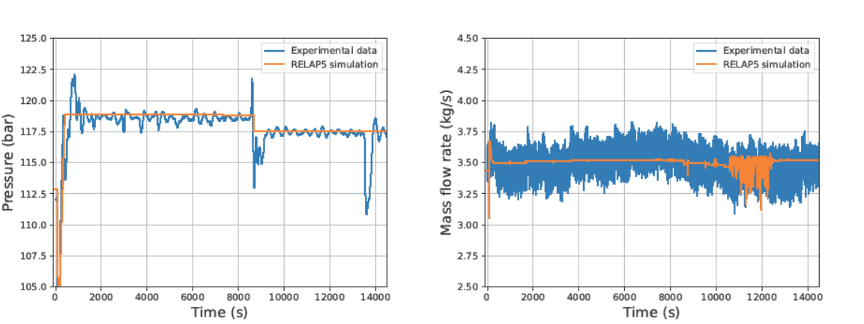The secondary side is in NC and, therefore, the mass flow rate is defined by the thermal–hydraulic conditions in the loop during the transient (FIG. 7-Left). At the NC activation, the experimental mass flow rate peaks and then stabilizes around 0.7 kg/s at the first FR value. The subsequent FR reduction during the test causes initially a slight stepwise increase of the mass flow rate. The qualitative behavior, with the initial peak, the first slight increment and the final reduction is predicted by the code. Moreover, the code is also able to predict mass flow rate oscillations in the instability region, where RELAP5 is also able to foresee reverse flow as found in the experimental data. In addition, when the stability is re-established, the mass flow rate is well predicted.

FIG. 3 Left) Primary side CSG outlet pressure. Right) Primary side CSG flowrate.

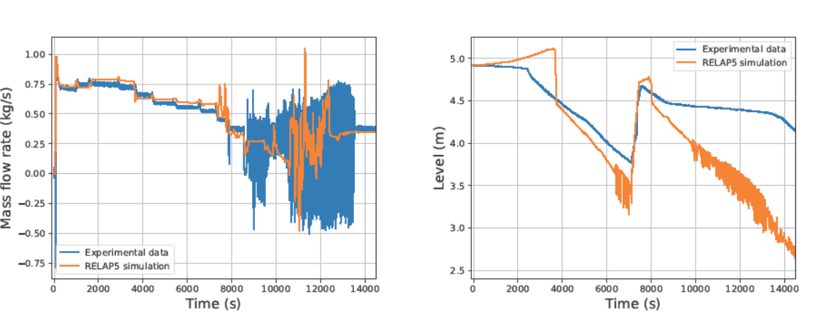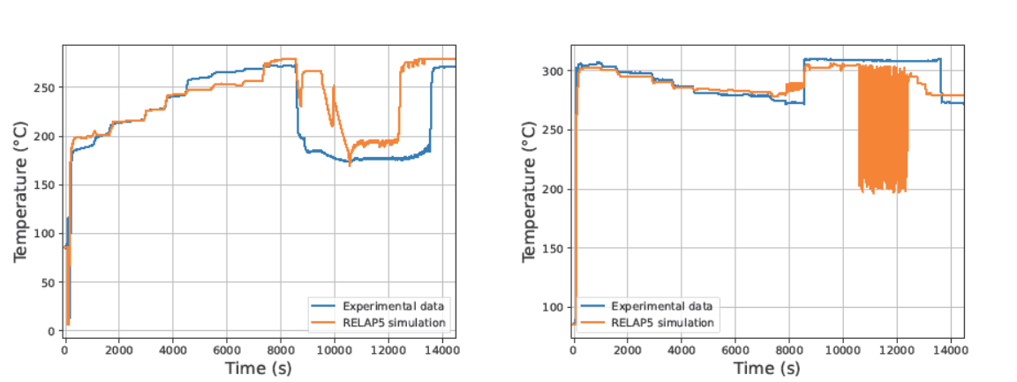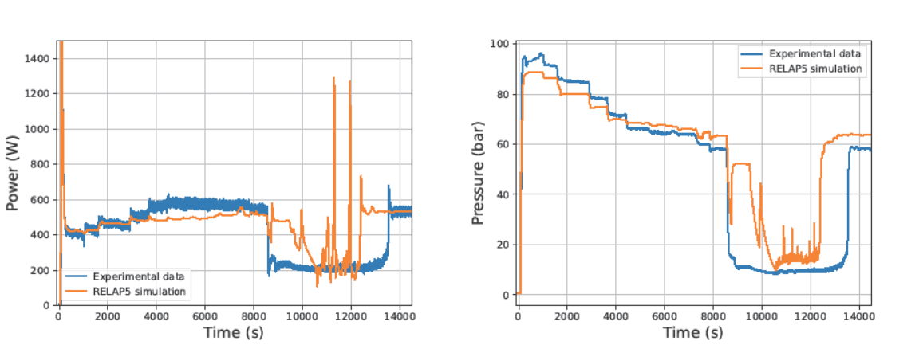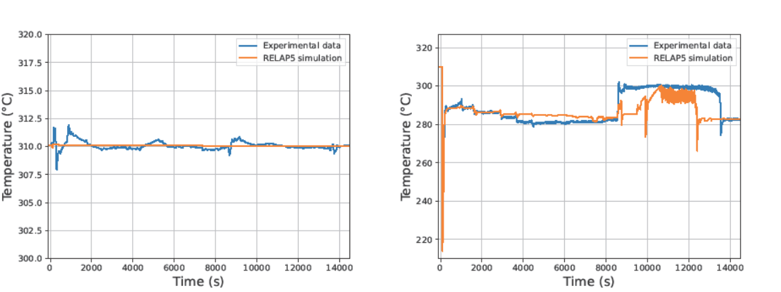FIG. 7-Right shows the level in the pool. The experimental data show an initial constant level until the water evaporation in the pool starts (at around 2450 s), with a gradual decrease of the pool level. The derivative with which the pool level decreases is higher in the code, meaning that the heat transfer is overestimated with respect to the experimental data of test 00099_C, until approximately 7300 s, and it is even worse for the test 00100_C. Instead, the pool refilling is well predicted by the code. The adoption of fouling factor to enhance the condensation heat transfer coefficient may a have a primary impact on this.

FIG. 4 Left) Primary side CSG inlet temperature. Right) Primary side CSG outlet temperature.

FIG. 6 Left) Secondary CSG inlet temperature. Right) Secondary CSG outlet temperature.

FIG. 5 Left) Primary side CSG power. Right) Secondary side CSG outlet pressure.

FIG. 7 Left) Secondary side mass flow rate. Right) Pool level.

One general conclusive comment regards the temporal end the of the two-phase instability. The RELAP5 simulation seems to anticipate the stabilization of the system operation. This must be further investigated to have a more satisfactory explanation, but the simulation seems to capture the main phenomenology of the experimental data.

## CONCLUSIONS

The ELSMOR project, ended in August 2023, helped to address key aspects of LW-SMR licensing, through experimental and analytical activities. Within the project an experimental facility was designed and constructed at SIET to investigate the behavior of a passive DHRS. One of the main features of the facility is the use of a plate-type steam generator as the heat source of the NC system.

Among the performed tests, the ELSMOR test 00099_C and the ELSMOR test 00100_C were selected for a code-to-data benchmark, using the RELAP5 code. The chosen tests explore the effect of the secondary side filling ratio on the DHRS performance. As a general conclusion, the code was able to predict the experimental data both qualitatively and quantitatively the experimental tests 00099_C and 00100_C, with some discrepancies found in the secondary side pressure, secondary side CSG inlet and outlet temperatures, and the exchanged power in the plate-type CSG in the region of two-phase instability. These discrepancies were in general attributed to uncertainties in the CSG internal geometry, the behavior of the In-pool HX (e.g. overestimation or underestimation of the heat transfer) and the pressure losses in the secondary system.

The above observations may be the basis for further development of thermal-hydraulic system codes, as the introduction of dedicated correlations for plate-type heat exchangers, or the development of dedicated separate effect tests validation facilities related to in-tube condensation, pool boiling and two-phase flow in a loop seal.

In conclusion, the remaining unexplored ELSMOR database collected could be exploited to perform other benchmarks considering tests in different operating conditions (e.g., with non-condensable gases in the NC loop, the primary side in two-phase conditions, etc.).

References

1. Ferri, R., Achilli, A., Congiu, C., Marciano, S., Gandolfi, S., Marengoni, M., Bersani A. and Passerin D’Entreves, A. (2023). ELSMOR European Project: Experimental Results on an Innovative Decay Heat Removal System Based on a Plate-Type Heat Exchanger. *Science and Technology of Nuclear Installations*, *2023*.
2. International Atomic Energy Agency. (2014). *Advances in Small Modular Reactor Technology Developments: A Supplement to the IAEA Advanced Reactors Information System (ARIS)*. IAEA.
3. Ayub, Z. H., Khan, T. S., Salam, S., Nawaz, K., Ayub, A. H., & Khan, M. S. (2019). Literature survey and a universal evaporation correlation for plate type heat exchangers. *International Journal of Refrigeration*, *99*, 408-418.
4. Bersano, A., Lombardo, C., Alblouwy, F., Karppinen, I., Silde, A., Nikitin, K., Grosjean, B., Morin, F., Martin, J. and Weyermann, F., (2024). Benchmark exercise on ELSMOR passive heat removal system. *Nuclear Engineering and Design*, *419*, p.112961.
5. Information Systems Laboratories, Inc., 2019. RELAP5/MOD3.3 CODE MANUALVOLUME I: CODE STRUCTURE, SYSTEM MODELS, AND SOLUTION METHODS.
6. Bersano, A., Falcone, N., Bertani, C., De Salve, M., Meloni, P., & Mascari, F. (2021). Qualification of RELAP5-3D code condensation model against full-scale PERSEO Test 9. Progress in Nuclear Energy, 139, 103891.
7. Alcaro, F., Bersano, A., Bertani, C., & Mascari, F. (2021). BEPU analysis of a passive decay heat removal system with RELAP5/MOD3. 3 and RELAP5-3D. Progress in Nuclear Energy, 136, 103724.
8. Tuomisto, H., & Kajanto, P. (1988). Two-phase flow in a full-scale loop seal facility. Nuclear Engineering and Design, 107(3), 295-305.