# Route for Disposal of Primary Waste

D.G.OXBERRY

Studsvik Limited

Preston, United Kingdom

Email: david.oxberry@studsvik.com

W.Y.LIU

Studsvik Limited

Preston, United Kingdom

Email: wai.liu@studsvik.com

**Abstract**

Small Modular Reactors (SMRs) present a series of opportunities and challenges to support the energy mix, with each type needing to present a clear and logical legal, structural, financial and regulatory approach to facilitate their development and deployment. The SMR vendors all have a common path to tread in order to develop their technology and ultimately ensure that its compliant and viable for deployment in a country. The vendor development trends have focused on power output, size, fuel, return on investment and technology types (including coolant materials), one area which naturally lags behind the development of the technology is ensuring that the waste streams are clearly understood, complaint, minimized and there is a route for disposal, this forms a significant part of the regulatory approval process. The Generic Design Assessment (GDA) process in the UK has previously focused on specific areas of waste arising and treatment in order to support the adoption of a sustainable technology into the energy mix. Learning from the GDA process, combined with recent Studsvik experience in focusing on the way to address waste challenges through a series of proof of principle trials for certain waste forms, is allowing us to enhance our knowledge in the field and support viable deployment. Studsvik is keen to share our thoughts on the necessary development needed to ensure that all waste forms are robustly understood to support vendor’s regulatory approvals.

## INTRODUCTION

As the world continues to develop towards its climate change targets, its becoming clearer that our energy sources need to be aligned with environmental, economic and practical drivers amongst others. Small Modular Reactors (SMRs) will form part of the energy mix needed to achieve these drivers and they represent opportunities to support the advancement of other industries. The design development of the various SMR types is at different levels of maturity ranging from concepts through to versions of existing reactors. The development of these different SMR types articulates different benefits and challenges between the SMR categories, which will be required to address during their development. Alongside this, different countries also have levels of maturity for their regulatory systems for new nuclear power to be deployed in their country which meets local and international laws, regulations and standards. Noting that there are the standard nuclear protocols, guidance and laws from an international perspective, each vendor will be required to develop their technology to be safe and compliant with local and international requirements.

## When to consider waste during the SMR Development process?

As with any product development, timing is one of the key factors for successful development and deployment and this is particularly relevant to SMR Vendors. Typically, the product development cycle is broken down into 7 stages as follows [1]:

* Ideation
* Research
* Validation
* Development
* Production
* Launch
* Post-launch

As Vendors progress through the early stages of ideation and research, focus needs to be on their objectives of safely generating small scale nuclear power plants. Therefore, the initial focused tends to be on concept design and with a view to power output, size, fuel, return on investment and technology types (including coolant materials) amongst other elements. Waste is clearly acknowledged by vendors as a critical part of the development process as waste understanding and compliance form key parts of the safe design and operation of the technology. However, as the technology develops through the product lifecycle, it could be perceived that waste naturally lags the development of the technology. As with all nuclear projects, it is critical that we ensure that the waste streams are clearly understood, complaint, minimized and there is a route for disposal, this forms a significant part of the regulatory approval process.

Following the product lifecycle steps as defined above, typically the waste considerations, understanding and demonstration are matured from Ideation through to Development. As the initial waste considerations and principles are defined early in the product lifecycle, the detailed understanding and demonstration (data gathering) comes primarily during the latter Devlopment stage. During, or after, the Development stage, it is assumed that SMR Vendors will formally enter the necessary regulator engagement in the chose country(s) of deployment.

As the primary waste is driven by the SMR design, Fuel types and the Coolants chosen for operation, the waste arising question is thereby raised in detail later in the Product Development Process. The operational parameters and waste arisings will be defined as the design matures, but this can lead to wastes needing to be treated with existing or new technologies and processes to meet country specific disposal requirements, or alternatively it can lead to changes in SMR design to optimise the performance or minimise the waste.

## SMR Waste types

Wastes types generated from exiting nuclear power plants are generally well known, with treatment methods and routes for disposal established due to the long-standing operations of existing power plants. A regulator can compare and assess the performance, proposed waste management and disposability of these more traditional wastes more ready.

SMRs and advanced reactors are pushing the operational envelopes and boundaries of what is known from the current and previous generation of reactors. As a result, fuel, materials of construction, coolants used etc can be less developed and new considerations for their management, treatment and disposal may need to be established. Providing evidence and underpinning that a robust system is in place to minimise the quantity of waste is important. Wastes need to be suitably managed in line with the waste management hierarchy and that the treatment process proposed is the Best Available Technology (BAT), as well as ensuring that all waste generated has a suitable disposal route, all of which is a lengthy task. Full considerations should be given to these aspects of waste management and treatment as early as possible. Regulators are keen to engage and see that vendor’s have suitable systems in place to manage all aspects of the waste generated. If a vendor doesn’t have an immediate solution in place due to the innovative nature of the technology, regulars will need to have evidenced a plan on how you will come to a solution. Typically, in the UK it will take around 12 months to complete GDA step 1 and a further 12 months to complete step 2. This does not give the developer much time to develop the required information for underpinning any novel treatment methods required. Developers should note, generally the more novel and innovative your technology is, the more time will be required to produce the evidence required to support and underpin your waste treatment and disposal options.

## The Importance of waste in the UK GDA process

Regulatory approval of nuclear reactor deployment around the world is required for all reactor types, which will ultimately lead to a nuclear licensed site being established for hosting the reactor. The regulatory system is often driven by international laws and guidance, coupled with local laws, rules and regulations depending upon the maturity of the country's nuclear experiences. In the UK, the Office for Nuclear Regulation (ONR) works in conjunction with the Environment Agency and Natural Resources Wales (NRW) to encourage Vendors to demonstrate “that any new nuclear power stations built in Great Britain meet high standards of safety, security, environmental protection and waste management, through a process called Generic Design Assessment (GDA)” [1]. Before a new nuclear power station can be built and operated in the UK and in addition to the reactor design going through the GDA process, the proposed operator must obtain permission from regulators and government in the form of:

* Site licence and relevant consent to begin nuclear-related construction from ONR;
* Environmental permits from Environment Agency or NRW; and
* Planning permission from the Planning Inspectorate.

The purpose of the GDA is to provide developers early confidence that its Nuclear Power Plant (NPP) design is capable of being constructed, operated, decommissioned, and sufficiently robust to meet the standards required in the UK. The process that any new build must go through is the same regardless of its power output and size, it must demonstrate it can meet the requirements for safety, security, environmental protection, and waste management. The GDA is a risk management tool offered to developers to assist with their decision making early in the project. The GDA assesses if there are any major risks to the design not meeting the regulatory requirements of the UK before embarking on the significant investment decisions of procuring a site, setting up a licensee organisation, and start to place contracts for components and construction activities.

The GDA consists of a non-mandatory three-stage process and can be stopped after stage 2 if the developer feels it has gained a sufficient level of confidence to proceed. For a full GDA assessment, a detailed assessment of the NPP design will be carried out in stage 3. The importance of environmental controls and waste management are an integrated part of the process from stage 1. In stage 1 the developer is expected to include in its planning engagement with Nuclear Waste Services (NWS) to obtain advice on the disposability of higher activity and more challenging wastes generated over the lifetime of the NPP. In the case where more challenging LLW waste may be generated, these should be highlighted and discussed with NWS to ensure any potential challenges to the waste acceptance criteria for disposal facilities are identified. In stage 2 an expert review on disposability will be carried out of all waste generated over the lifetime of the NPP will be carried out. It should be noted even if the developer decides not to undertake the GDA the same level of information and underpinning will be required for the waste generated by the NPP when requesting a site license.

Previous experience has shown that sometimes vendors have focused more on the reactor and reactor safety with waste management and disposability lagging behind in the product development lifecycle. This is not to say that this is right or wrong, but to merely note that timing of the various facets of reactor development is crucial and is impacted by a variety of factors including funding, policy, local drivers, strategy etc. Experience shows that the regulator’s expectations during the GDA assessment process places a high importance on the early understanding of waste generated by a NPP and how it will be managed and disposed of early in the design process. Highlighting the importance of sustainability and disposability further, the UK regulators updated its guidance in 2023, in light of recent learning to strengthen sustainability and disposability of waste considerations.

## Addressing future waste challenges during SMR Development

SMR’s and to a greater extent AMR’s, can present significant challenges when it comes to identifying, understanding and being able to present data on the waste arising during operations and decommissioning. As the design matures and the operational parameters are defined, this informs the waste arisings and overall management needs. At this stage, a clear and defined waste form can be ascertained during the normal operation of the reactor, which can then lead to identifying a process or technology for the management of the waste based on its final disposal. This waste management process can take significant time to gather the necessary data through the instigation of a trials programme. For newer, or more challenging waste forms, waste management trials will be undertaken on the back of a desk top study identifying the key features of the waste form and the identification of existing or novel techniques for treatment. The initial trials will be undertaken on inactive wastes at a proof of principle / laboratory scale to gather initial data and see if that the waste treatment process is suitable for scaling up. An example of this is the work undertaken by Studsvik in the National Nuclear Laboratory in the UK on sodium and molten salt waste streams that may arise from AMRs, including sodium-cooled liquid metal fast reactors (LMFRs) and MSRs. The project focused on verifying this approach to treating sodium waste and molten salt waste from MSR coolant or coolant/ fuel mixtures by laboratory-scale testing based on the patented Studsvik inDRUM treatment process.

Trials were carried out processing a likely waste from a GEN IV reactor in the form of LiCl/KCl chloride eutectic (or LKE) salt based on engagement with some vendors. Much learning was gained from these trials, demonstrating the ability to heat up the salt to the required reaction temperature of 450oC (and beyond if required up to 800oC) in a controlled manner and then to introduce a water vapour containing gas stream into the crucible to react with the LKE Salt. A drawing of the molten salt testing apparatus is shown in Fig 1 below. The quantity of water introduced into the salt and the mass of salt within the crucible were varied to investigate the impact on reaction rates.

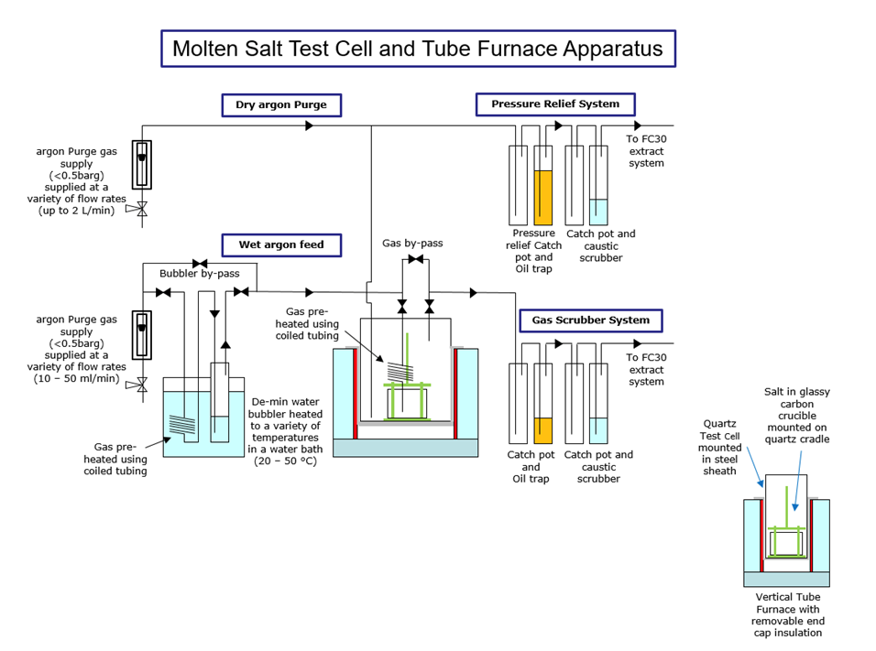 *Figure 1 – Diagram of the Molten Salt Testing Apparatus*

On the first LKE trial a potential contaminant was seen. This will be reviewed and improvements to the equipment set up/use will be recommended for any future work of this nature. A set of trials were performed with sodium including potential corrosion products. From this set of sodium trials, we were able to demonstrate the ability of inDRUM to treat sodium containing corrosion products. From the quantity of hydrogen detected from the off-gas, a steady controlled rate of reaction was achieved during the trials. The trials concluded that the “Proof of principle trials” to demonstrate the capability of Studsvik’s inDRUM technology to process the LKE eutectic salt and sodium with corrosion products have been a success.

The aim of the project was to undertake desktop research and laboratory trials to demonstrate a proof of principle of our process for both sodium and molten salt simulant waste forms. Following the successful trials, we can now demonstrate with data the evolution of our thinking and technology through the Technology Readiness Levels (TRL) based on this first laboratory scale. The alignment of a waste to a treatment technology and its demonstration through the TRL process is crucial for supporting the process of regulatory approval such as the UK GDA process. For new waste treatments to be included in GDA submissions, a TRL of 5-6 could be appropriate to demonstrate the technology and the resulting post treatment product. Developing through these TRL levels takes time and due consideration during the overall SMR development timescales.

## Conclusion

The global ambitions to make use of SMRs as part of the transition to a low carbon economy to meet Net Zero targets provides this necessary direction for Technology Development and Deployment. Typically, the product lifecycle can be used to represent the stages and progress through ideas, concepts, designs and developments of SMR Technologies. Noting that the duration from Ideation through to Production can be from years to decades, it's imperative that the correct technical decisions are made by the vendors at the necessary times. As further details of the design and operation emerge, and in combination with seeking regulatory approval to deploy and construct, the waste challenges that are presented from SMR’s come to the forefront. It should be noted that whilst some SMR technologies are smaller versions of existing technologies, others are revived technologies that haven't been operated in recent times and are at a smaller scale and a new category of technologies, all of them have waste challenges that take time to understand and to provide suitable management arrangements to explain to a regulator. Technical challenges can include changes in water chemistry, material properties, coolant types etc all of which will have an impact on operational and decommissioning wastes produced.

It's imperative that Vendors understand the waste arisings from operation and decommissioning to get through the regulatory process, such as the GDA in the UK. Ensuring that the approach is BAT can be a complicated process and development work needs to be undertaken on the treatment options. Examples of beginning to develop waste treatment processes like this include Studsvik’s successful demonstration of a technology for treatment of future waste types from molten salts and sodium cooled AMRs. Access to facilities has played an important part of the R&D cycle, but also a gateway for collaboration between industry and academia on projects designed to accelerate deployment of SMR’s. This project was only the start of the TRL journey for these waste forms, however it resulted in valuable information to be taken forward in the TRL journey.

ACKNOWLEDGEMENTS

This paper has been produced based on learning and experience from the team at Studsvik Limited whom have previously worked through in the Waste aspects of the UK’s GDA process. In addition, we must also note the successful project delivered with NNL, which was funded by the UK government under the ANSIC programme. The Authors sincerely thank the NNL team for their contribution to the project, which has in part stimulated this paper.

References

1. What is the Product Development Life Cycle? A 2024 Guide (careerfoundry.com);

<https://careerfoundry.com/en/blog/product-management/the-product-development-life-cycle/>

1. Generic Design Assessment (GDA) of new nuclear power stations | Office for Nuclear Regulation (onr.org.uk). <https://www.onr.org.uk/generic-design-assessment/>