# Aerosol evolution in a typical SMR containment under hypothetical accidental conditions

S. ANAND

Health Physics Division, Bhabha Atomic Research Centre

Mumbai, India

Email: sanand@barc.gov.in

JAYANT KRISHAN

Health Physics Division, Bhabha Atomic Research Centre

Mumbai, India

Email: jayantk@barc.gov.in

ARCHANA V

Reactor Safety Division, Bhabha Atomic Research Centre

Mumbai, India

Email: archanav@barc.gov.in

MANISH JOSHI

Radiological Physics & Advisory Division, Bhabha Atomic Research Centre

Mumbai, India

Email: mjoshi@barc.gov.in

ARSHAD KHAN

Radiological Physics & Advisory Division, Bhabha Atomic Research Centre

Mumbai, India

Email: arshad@barc.gov.in

M S KULKARNI

Ex-Health Physics Division, Bhabha Atomic Research Centre

Mumbai, India

Email: kmukund@barc.gov.in

**Abstract**

Enhancing safety measures for Small Modular Reactors (SMRs) necessitates a comprehensive understanding of aerosol behavior within containment structures during accidental conditions. The Bhabha Atomic Research Centre (BARC) has been conducting studies at the Nuclear Aerosol Test Facility (NATF), which have been utilized in the past for validation and development of reactor accident codes, as well as for gaining experimental insights. In the present study, the NAUA aerosol dynamics code is employed to investigate the dynamic evolution of aerosols in a typical containment structure (with a surface area to volume ratio of 0.022 cm−1, characteristic of an SMR containment). The study focuses on elucidating the effects of various accident scenarios, such as loss-of-coolant incidents, on aerosol distribution and concentration profiles over time. Assuming a large-scale aerosol release rate of 2.2 g/s for 1 hour in a containment volume of 3.5E+09 cm³, simulations are conducted for 104 minutes (~7 days). Results reveal that gravitational settling is the predominant deposition process, followed by diffusional deposition, while the contribution of diffusio-phoretic deposition is negligible. The decontamination factor results from NAUA are compared with those from the in-house developed aerosol module under PRABHVINI, an integral accident source term and consequence analysis code being developed to address Design Basis Accidents (DBA) and Beyond Design Basis Accidents (BDBA) in nuclear reactors. The results show close agreement between these two codes. Detailed analysis of the codes suggests that incorporating more realistic input conditions, such as initial size distribution, shape factor, aerosol density, and additional physical processes such as thermophoresis, spray removal, and turbulent effects, into the numerical code is important for improving the prediction of aerosol evolution and radioactive source term during postulated accidental conditions. In conjunction with these simulations, the manuscript also presents experimental specifics of NATF, which have been optimized and tuned for SMR-mapped simulations.

## INTRODUCTION

In the pursuit of enhancing safety measures for Small Modular Reactors (SMRs), understanding the behavior of aerosols within containment structures during accidental conditions is paramount. In this context, airborne particles (aerosols) carrying radioactive substances may contribute dose to the onsite and offsite personnel through various exposure pathways. An essential aim of reactor safety research is to avoid or at least minimize possible consequences of a severe accident for the environment. Thus, the purpose of severe accident aerosol research is deepening the understanding of aerosol behavior within the containment as well as transport in the atmosphere. The objective of these investigations is to gain predictive power regarding aerosol behavior and consequently to get a more reliable prediction of the potential radiological source term. It is generally addressed through experiments at laboratory and facility scale focusing on standalone and integral aspects as well as design features of engineered safety components. The outcomes are utilized for the validation and development of aerosol modules of severe reactor accident codes.

In the present study, we examine the application of two containment aerosol codes, NAUA and PRABHAVINI for studying the aerosol evolution in the containment during accidental release conditions, and present preliminary results of experiments carried out in an aerosol test facility at BARC. Through numerical simulations, this research examines the interplay of aerosol deposition, and transformation mechanisms within the containment system. The study focuses on elucidating the effects of different accident scenarios, such as loss-of-coolant accidents or steam generator tube ruptures, on aerosol distribution and concentration profiles over time. The findings shed light on crucial aspects of aerosol behavior, including particle size distribution, agglomeration dynamics, and spatial dispersion patterns. Insights gained from this investigation can inform the design and implementation of safety protocols, emergency response strategies, and containment systems optimization for SMRs, ultimately contributing to the advancement of nuclear safety engineering.

## Materials and methods

### Numerical Codes

#### NAUA

An aerosol dynamics code, NAUA [1], is used to study the behavior of aerosols released in SMR containment during a typical accident involving LOCA. NAUA is a comprehensive computational tool designed to simulate aerosol behavior under various conditions, aiding in the analysis and mitigation of potential hazards. It is a uniformly mixed model-based code where the activity released is assumed to be homogeneously mixed in the given compartment volume except for the boundary layer at the walls. The aerosols released in the containment undergo coagulation and condensation along with removal due to gravitational settling, diffusional plate-out, diffusio-phoresis, and leakage. The particle interaction processes considered in this code are, Brownian coagulation, gravitational coagulation, and steam condensation on particles.

The NAUA code has been recently modified to include additional removal process, namely thermophoresis, which may play a significant role in cases where a high thermal gradient in the bulk and the wall temperature is expected. The deposition velocity due to thermophoresis is given by [2],

$v_{th}=\frac{2 η C_{s} C_{c}(r) }{ρ_{g}}\frac{\left[\frac{k_{g}}{k_{p}}+C_{t} Kn\right]}{\left(1+3C_{m} Kn\right)\left[1+2\frac{k_{g}}{k_{p}}+2C_{t} Kn\right]}\frac{∇T}{T_{g}}$ (1)

$∇T=\frac{h_{g}\left(T_{interf}-T_{wall,in}\right)}{k_{g}}$ (2)

where $η$ is the dynamic viscosity of gas, $C_{s}=1.17$ is thermal slip coefficient (Talbot), $C_{c}(r)$ is Cunningham slip correction factor, $k_{g}$ is thermal conductivity of gas, $k_{p}$ is thermal conductivity of the particle, $C_{t}=2.18$ is the temperature jump (Brock and Talbot), $∇T$ is temperature gradient in gas at the wall surface, $T_{g}$ is the gas temperature, $ρ_{g}$ is density of the gas, $C_{m}=1.14$ is the momentum slip term (Brock and Talbot), $h_{g}$ is the heat transfer coefficient adjacent to containment volume inner wall and is estimated based on the steam mass fraction, $T_{interf}$ is the temperature at the interface, $T_{wall,in}$ is the inside wall temperature.

The equations described in this code are valid for the spherical particles and corrections for non-spherical nature of the particles needs to be accounted for by specifying the shape correction factors. The shape of the particles affects its mobility, and coagulation and condensation interaction processes. In most cases, the study of aerosol behavior is carried out assuming particles to be spherical. However, there are studies that hint at the fractal nature of aerosols even under humid conditions. Therefore, in the present work, size-dependent dynamic shape factors have been introduced in the code. These shape factors are estimated using rigorous calculations where the hydrodynamic/mobility radius of large number of aggregates is estimated using numerical algorithms [3], which is further used for the estimation of the dynamic shape factor. The correlations for the shape factor in different Knudsen number regime are given by [4],

$χ_{df=2.50}=\left\{\begin{aligned}χ_{df=2.50} = 0.93 {\left(\frac{R_{m}}{a}\right)}^{0.45} Free molecular regime \\ χ_{df=2.50} = 1.11 {\left(\frac{R_{m}}{a}\right)}^{0.27} Transition regime \\ χ_{df=2.50} = 0.56 {\left(\frac{R_{m}}{a}\right)}^{0.40} Continuum regime\end{aligned}\right.$ (3)

where $a$ is the monomer radius, $d_{f}=2.5$ is the fractal dimension of the aerosol aggregate, $χ$ is dynamic shape factor, and $R_{m}$ is the mobility equivalent radius. Dynamic shape factor accounts for the modification in the drag force experienced by an aggregate due to increase in surface area to volume ratio. Therefore, the mobility is then given by, $B\left(r\right)=\frac{C_{c}(r)}{6 π η r χ}$. The new expression (Eq.(3)) is introduced in the NAUA code

#### PRABHAVINI

PRABHAVINI is an integral accident source term and consequence analysis code, being developed to address Design Basis Accidents (DBA) and Beyond Design Basis Accidents (BDBA) in nuclear reactors [5]. The PARIRODHAN, PARIVAHAN, and RASAYAN modules [6] of PRABHAVINI are integrated to simulate aerosol and vapor transport as well as various iodine reactions within the containment. This coupled module addresses vapor-phase phenomena, including both homogeneous and heterogeneous nucleation, vapor interactions with structural components such as condensation and chemisorption, as well as vapor condensation onto aerosol surfaces. Additionally, it models aerosol-related processes such as deposition and re-suspension, accounting for factors such as gravitational settling, impaction in bends, thermo-phoresis, and diffusio-phoresis. Furthermore, this integrated module handles a wide range of iodine mass transfer processes, liquid-phase reactions, and gas-phase reactions.

### Input Conditions for Numerical Simulations

The activity from the fuel migrates to the reactor containment, which is the last barrier before this activity is released to the atmosphere. The underlying removal and dynamical process play an important role in determining the aerosol metrics such as mass and number concentration in the reactor containment along with the information of potential source term. The dimensions used in the present analysis correspond to a typical SMR containment [7]. The aerosol release rate is derived from the accident analysis of 540 MWe PHWR [8] by downscaling with respect to reactor power of ~300 MWe. Other aerosol parameters such as aerosol size and density is assumed to be similar as in case of accident analysis for PHWR [8].

TABLE 1. INPUT PARAMETERS FOR THE AEROSOL ANALYSIS CODE

|  |  |
| --- | --- |
| Parameter | Value |
| Aerosol release rate to the containment | 2.2 g/s |
| Release duration | 1.0 h |
| Total mass | 7.9E+03 g |
| Containment volume | 3.5E+09 cm3 |
| Surface area | 7.7E+07 cm2 |
| Floor surface area | 2.3E+06 cm2 |
| Leak rate | 7.2 % /d |
| Mean geometric radius of aerosol particles | 0.36 micron |
| Geometric standard deviation | 0.554 |
| Particle density (Assuming Cs-137) | 4.0 g/cm3 |

### Experimental Facility

The Nuclear Aerosol Test Facility (NATF) was commissioned in the year 2000 at BARC with an objective to study the mechanistic behavior of aerosols generated at a concentration and size expected during a postulated reactor accident [9]. It uses plasma torch aerosol generator (PTAG) as the generator system that generates particles at mass concentration in range of 0.1-10 g/m3, and consists of test piping assemblies and a 10 m3 cylindrical containment. This facility has necessary aerosol instrumentation and other associated measurement sensors (pressure, temperature, flows), and has been utilized in the past for validation of modules of the NAUA and ASTEC codes [10]. The facility has recently been upgraded specifically for measuring the number characteristics of PTAG generated particles at the chamber inlet and inside the chamber volume. As the gas temperature at the inlet is higher than the operating specifications for the aerosol instrumentation, dilution assembly (for controlled temperature and concentration dilution) has been coupled in the experimental set-up. Fig. 1 shows picture of experimental set-up used in optimization experiments performed for assessing the feasibility of NATF for designing experiments to comply with the test matrix linked to SMR’s relevance.

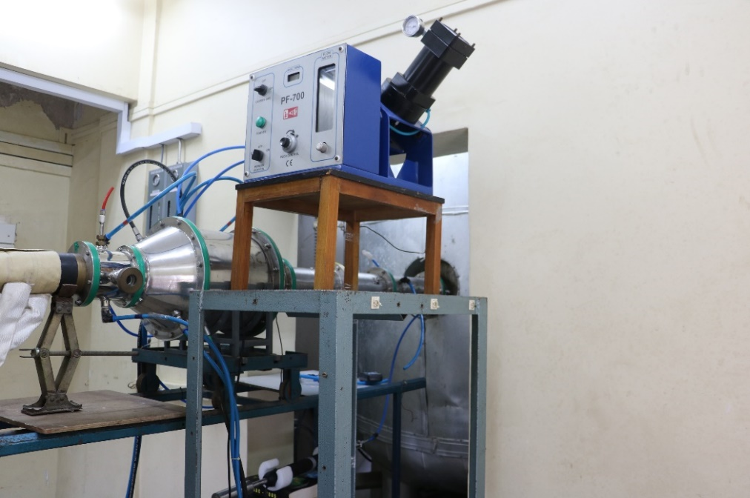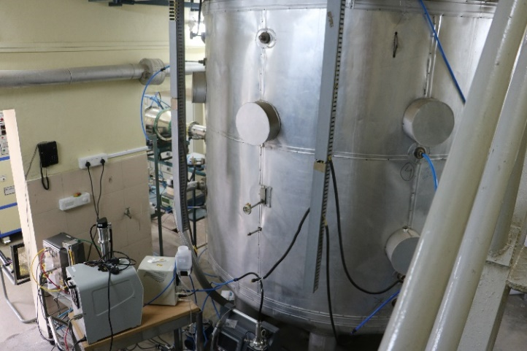

**Aerosol Instruments**

**PTAG**

**Cylindrical Chamber (10 m3)**

**Inlet Plenum**

**Powder Feeder**

**Inlet Plenum**

*FIG. 1. Picture of experimental set-up at NATF.*

**Cylindrical Chamber (10 m3)**

## results and discussions

The temporal evolution of mass and number concentration in the containment volumes is illustrated in Fig. 2. The initial increase in concentration is due to aerosol injection into the containment. Once the aerosol release stops, the airborne concentration decreases mainly due to the removal mechanism of gravitational settling, followed by diffusio-phoresis and diffusional deposition mechanisms. Coagulation plays a role in reducing number concentration in the initial period but conserves mass, hence, the peak of the size distribution shifts towards the larger particle sizes (Fig. 3). Additionally, condensation increases particle mass/size and leads to faster removal from the system via gravitational settling. The temporal evolution of aerosol mass distribution captures these effects, leading to modifications in the distribution function (Fig. 3).



*FIG. 2. Temporal evolution of air-borne aerosol mass/number concentration in a typical SMR containment – Effect of containment volume and dynamic shape factor.*



*FIG. 3. Mass -size (radius) distribution function at t = 1 h and t = 24 h.*

Total airborne mass as a function of time obtained from NAUA is compared with the results from the accident analysis code PRABHAVINI (Fig. 4). From Fig. 4, it is observed that the rate of increase of concentration follows a similar profile during the injection stage. However, there is slight variation in the removal profile after the injection phase is over. This is because the NAUA is a standalone code where the thermodynamically important parameters are defined as an input, whereas PRABHIVINI is a coupled code where the thermodynamically important parameters are coupled with the boundary conditions during the evolution of accident scenario. Slight variations in these conditions, such as variation of temperature and steam profile, lead to modifications in the concentration profile as compared to NAUA.

Recently, an experiment was conducted at NATF to assess the suitability for SMR-linked conditions since surface area to volume ratio of this facility is similar to that of SMR. Aerosol mass concentration of 0.1-0.5 g/m3 (measured at inlet) is injected into the 10 m3 containment vessel for a duration of 30 minutes at a total flow rate (carrier flow + primary plasma gas + secondary plasma gas flow) of 125 LPM. Aerosol measurements made with a scanning mobility particle sizer (SMPS) coupled to a diluter (for both high temperature and concentration conditions) revealed that number concentration during this phase remains in the range of 106-107 cm-3 with substantial fraction in the ultrafine (< 100 nm) size range. The measured number concentration confirms the suitability for experiments defined for time scales necessary for segregating coagulation effects from other dynamical processes in geometries simulating SMR conditions. In addition to commonly measured characteristics, we also focused on measuring the shape of the particles which could have an impact on the appropriateness of the input parameters. Fig. 5 shows the microscopic image of particles captured on grids of an electrostatic sampler. It can be seen that structure of particle is non-spherical and hence accurate conversion to equivalent diameter may impact the accuracy of the code predictions.



*FIG. 4. Comparison of temporal evolution of aerosol air-borne mass using NAUA and PRABHIVINI codes.*



*FIG. 5. Structures of PTAG generated particles analyzed by scanning electron microscopy.*

## conclusions

The study aims to understand how aerosols evolve within the containment system of an SMR, considering factors such as containment geometry and aerosol characteristics. Numerical simulations using NAUA and PRABHAVINI codes, alongside experimental investigations at the NATF, provided insights into the mechanisms influencing aerosol dynamics. The interplay between coagulation, condensation, and deposition processes was elucidated, offering a comprehensive understanding of aerosol behavior during accident scenarios.

Future research should build upon these findings by exploring more complex scenarios, including a wider range of accident conditions and containment geometries. The development of more sophisticated models, such as coupled computational fluid particle dynamics (CFPD), that accurately capture aerosol behavior and their interactions with containment surfaces is essential. Advances in computational power and techniques such as machine learning could further enhance the predictive capabilities of aerosol behavior models, leading to more effective safety protocols and containment designs.

In conclusion, this study provides a crucial foundation for understanding and managing aerosol behavior in SMR containment systems. By addressing key challenges and identifying areas for further research, it paves the way for the continued advancement of SMR technology, ensuring its role as a safe and sustainable option for nuclear power generation.

ACKNOWLEDGEMENTS

The authors would like to acknowledge Dr. D. K. Aswal, Group Director, Health, Safety & Environment Group, Dr. B. K. Sapra, Head, Radiological Physics & Advisory Division, Dr. J. Chattopadhyay, Head, Reactor Safety Division, and Dr Deb Mukhopadhyay, Head, Advanced Heavy Water Division of BARC for their guidance and support in conducting this project. Also, we would like to acknowledge Dr. Jitendra Bahadur of Solid State Physics Division, BARC for obtaining the SEM images.

References

1. BUNZ, H., KYORO, M. AND SCHOECK, W. NAUA Mod 5 and Mod 5-M, Zwei Computerprogramme zur Berechung des Aerosolverhaltens im Containmentsystem eines LWR nach einem Kernschmelzunfall. KfK4278, Kernforschungszentrum, Karlsruhe (1987).
2. TALBOT, L., CHENG, R.K., SCHEFER, R.W., WILLIS, D.R., Thermophoresis of particles in a heated boundary layer, J. Fluid Mech. 101, (1980) 737-758.
3. ZHANG, C., THAJUDEEN, T., LARRIBA, C., SCHWARTZENTRUBER, T. E., & HOGAN, C. J., Determination of the scalar friction factor for nonspherical particles and aggregates across the entire knudsen number range by Direct Simulation Monte Carlo (DSMC). *Aerosol Science and Technology*, *46*(10), (2012), <https://doi.org/10.1080/02786826.2012.690543>
4. JAYANT KRISHAN, SINGH, A., THAJUDEEN, T., JYOTI SETH, MAYYA, Y.S., ANAND, S., Estimation of dynamic shape factor for non-spherical aerosols using geometric descriptors-based approach (Article under review).
5. ARCHANA, V., GOKHALE, O.S., MITHILESH KUMAR, MAJUMDAR, P., Development of Coupled PARIRODHAN-PARIVAHAN-RASAYAN Modules, PRABHAVINI Newsletter, 15 (2023), 2-3.
6. ARUN VERMA, GOUTAM DUTTA, MITHILESH KUMAR, Numerical analysis of thermal-hydraulic safety for a reactor containment in the event of a main steam line break, Annals of Nuclear Energy, 183 (2023), 109631.
7. ZHIQIANG ZOU, FANGNIAN WANG, JIAN DENG, HANG ZHANG, MING ZHANG, HUANHUAN PENG, XIAOJI WANG, HUAN QIN, Hydrogen hazard mitigation in small modular reactor during SBO severe accident using GASFLOW-MPI, Progress in Nuclear Energy, Volume 147, (2022), 104193, ISSN 0149-1970, <https://doi.org/10.1016/j.pnucene.2022.104193>.
8. SANJEEV KUMAR SHARMA, MANOJ KANSAL, N. MOHAN, P. K. MALHOTRA & S. G. GHADGE, Aerosol Behavior During a Postulated Severe Accident in a 540-MW(electric) PHWR Containment, Nuclear Science and Engineering, 169:2, (2011) 222-227, DOI: 10.13182/NSE09-16
9. SAPRA, B. K., MAYYA, Y. S., KHAN, A., SUNNY, F., GANJU, S., & KUSHWAHA, H. S. Aerosol Studies in a Nuclear Aerosol Test Facility Under Different Turbulence Conditions. Nuclear Technology, 163-2 (2008), 228–244.
10. DWIVEDI ANUBHAV, KHAN ARSHAD, TRIPATHI S. N., JOSHI MANISH, MISHRA G., NATH D., TIWARI N., & SAPRA, B. K. Aerosol depositional characteristics in piping assembly under varying flow conditions, Progress in nuclear energy, 116, 148-157.