Coupled thermal-hydraulic and neutronic Deterministic safety analysis for the HTGR SMR research demonstrator HTGR-POLA

SKRZYPEK Maciej

National Centre for Nuclear Research

Otwock-Swierk, Poland

Email: maciej.skrzypek@ncbj.gov.pl

SKRZYPEK Eleonora, MUSZYŃSKI Dominik

National Centre for Nuclear Research

Otwock-Swierk, Poland

**Abstract**

Poland facing energy transformation considers large-scale LWRs, as well as SMRs. SMRs can be seen as a potential electricity supply and beyond, i.e. district heating, industrial process heat, and for hydrogen production. For the past few years, the National Centre for Nuclear Research, Poland (NCBJ) has been involved in several High Temperature Gas-cooled Reactor projects: at the national (Gospostrateg-HTR, HTR-MEiN) and European (Gemini Plus, Gemini for Zero Emission) level. Consequently, the small-scale, prismatic type, research HTGR of 30 MWth - named HTGR-POLA, is considered to be built at the NCBJ’s site. Its main mission is to serve as a demonstrator of HTGR technology for Polish industry. In the paper, for the reference HTGR-POLA plant design, the coupled neutronics/thermal-hydraulics (N/TH), and its impact on the reactor safety performance during selected Design Basis Accidents (DBA) – Depressurized Loss Of Forced Cooling (DLOFC) event as the most challenging one in different lifecycle states (BOL, MOL, EOL) will be investigated. The coupled N/TH scheme for the reactor core over the whole fuel cycle is a promising method, due to its possibility of approximation and identification of the most relevant safety issues without the need for introduction of over conservative assumptions. The results of the calculations for the coupled Serpent-CARTHARE codes, and MELCOR code will be presented, for the selected accident groups representing various types of Postulated Initiating Event (PIE) for HTGRs. The calculations performed, were compared to safety acceptance criteria established (the Safety Systems and Components - SSCs design parameters and Polish high-level requirements). The presented results were a supporting means for the Probabilistic Safety Analysis of the HTGR-POLA reactor for the assessment of the accident consequences and considerable part of the Preliminary Safety Analysis Report (PSAR), which is a requirement included in the legal framework of newly built Nuclear Power Plants (NPPs) and research reactors in Poland.

* 1. INTRODUCTION

Poland is actively pursuing nuclear energy as a key component of its energy mix due to its commitment to reducing greenhouse gas emissions and increasing energy independence. Currently, ongoing government-run and semi-private programs to deploy nuclear power technology (LWRs) are underway. The most advanced is the governmental initiative. The course is to build six large-scale units (in total 6-9 GWe) oriented on electricity production. The first reactor is scheduled to be constructed in the mid-2030s. In November 2022, Poland selected Westinghouse's AP1000 design for its first two units.

In parallel, as a complementary path, the government is supporting the activities focused on the development of the High-Temperature Gas-cooled Reactor (HTGR) technology. There are a number of strategic documents in Poland related to the economy, development, and energy policy framework that mention HTGR technology as a promising source of process steam for industry. The NCBJ has been actively involved in various HTGR projects over the past few years, including several European collaborations (Gemini Plus 2017-2022, Gemini for Zero Emission 2023-2025) and national initiatives (Gospostrateg-HTR 2020-2023, HTR-MEiN 2022-2024). The GEMINI projects, founded by Euratom Horizon 2020 Research and Innovation Programme, was dedicated to meet industrial needs (also Polish ones) – to supply superheated steam to industry (230 t/h at 540°C and 13.8 MPa) [1]. To pave the licensing framework, it is proposed to design and build a small-scale research reactor in Poland, called HTGR-POLA [2]. This reactor will have a thermal power of 30 MWth and will serve as a licensing precursor for a larger industrial GEMINI reactor (180 MWth). One of the objectives of the ongoing HTR-MEiN project is the development of the basic design of the HTGR-POLA. This is done in collaboration with Japan Atomic Energy Agency (JAEA) and its business partners on the basic design of the reactor [2], [3]. HTGR-POLA gathers advantages of GEMINI+ design, and Japanese experience in many key components, including fuel. Another objective is to prepare the first version of the Preliminary Safety Analysis Report (PSAR) which may make it possible to start a dialogue with the National Atomic Energy Agency (PAA) on the POLA-HTRG design. A crucial aspect of both the basic design and the PSAR is the reactor safety analysis. In this paper, we will focus on one of the key analyses performed, namely, the safety performance during the selected DBA – Depressurized Loss Of Forced Cooling (DLOFC) event as the most challenging one in different lifecycle states (BOL, MOL, EOL).

* 1. Reactor design

The HTGR-POLA reactor is a prismatic HTGR of 30 MWth thermal power. It is a helium-cooled, graphite-moderated reactor with a thermal neutron spectrum. Its key design features are given in Table 1. The thermal energy generated in the core is removed by a downward flow of helium coolant, which is heated up from 325°C to an average value of 750°C. The hot coolant is transported from the reactor vessel outlet via the coaxial duct to the steam generator (SG). The helium coolant pressure at circulator discharge is 4.0 MPa. Through the steam generator, the heat is transferred to the secondary water/steam cycle where the superheated steam is generated (540°C, 13.8 MPa).

TRISO fuel with kernels enriched in U-235 (HALEU) is the primary choice for the fuel in HTGR-POLA design. The active core consists of 19 fuel columns arranged on a uniform triangular pitch and assembled as two rings around central fuel column. The fuel column comprises a stack of six fuel blocks. A single fuel block is a hexagonal prism of 36 cm across the flats and 60 cm in height. There are two types of fuel blocks, standard blocks (fully fuelled) and control blocks (with a channel for reserved shutdown system). The active core is surrounded by two rings of the replaceable side reflector and the permanent side reflector. 18 control rods are placed around the core in the first ring of the replaceable reflector. There are top and bottom replaceable reflector structures (graphite blocks) above and below the active core. A metallic core barrel surrounds the periphery of the side permanent reflector, the outermost structure is the reactor pressure vessel. The core arrangement in a mid-plane together with reflector structures are shown in Figure 1.

TABLE 1. HTGR-POLA SYSTEM SPECIFICATION [2]

|  |  |  |  |
| --- | --- | --- | --- |
| Parameter | Unit | | Value |
| General Information | | | |
| Reactor thermal output (gross power) | MWth | | 30 |
| HTGR type | - | | prismatic, block-type |
| Design life | years | | 60 |
| Graphite block height | cm | | 60 |
| Graphite block hexagon flat-to-flat distance | cm | | 36 |
| Block material (fuel and reflector blocks) | - | | nuclear grade graphite |
| Fuel type | - | | TRISO, HALEU, UO2 |
| Active core height | cm | | 360 |
| Active core effective diameter | cm | | 165.5 |
| RPV outer diameter | cm | | 408.4 |
| Primary side | | | |
| Coolant type | - | | helium |
| Coolant flow direction | - | | downward flow pattern |
| Helium mass flow rate (at 100% power) | kg/s | | 13.3 |
| Primary system pressure | MPa | | 4.0 |
| RPV inlet coolant temperature | °C | | 325 |
| RPV coolant temperature | °C | | 750 |
| Number of cooling loops | - | | 1 |
| Steam generator type |  | | once-through, helically coiled bundles |
| Plant operational modes | | | |
| Cogeneration mode I | | max. 11.5 MWe (gross) | |
| Cogeneration Mode II | | process steam: 540°C, 13.8MPa, max. 25t/h | |
| Cogeneration mode III | | communal heat max. 16.5 MWth | |

1. 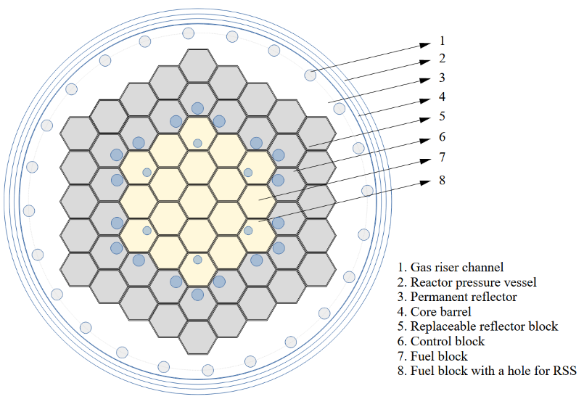

FIG. 1. *Mid-core, cross-sectional view of the reactor core.*

* 1. Calculation CamPaign

During the work process on the HTGR-POLA design, the results of the simulations were obtained and used to develop the PSAR documentation. There have been some activities performed for the regulatory purposes, which can be summarized as follows:

* Analysis of the radioactive substances distribution in the HTGR circulation loop and radiation hazards under normal operating conditions and some PIEs groups for accident conditions. Core releases and effects of those hypothetical releases.
* Analysis of built-in safety features, safety systems, requirements for their operation in emergency situations and their classification and qualification for emergency conditions.
* Identification of initiating events and accident scenarios (PIEs and limiting events).

Having in mind the Polish regulatory framework [4] and the international safety standards - IAEA SSR-2/1 Rev.1 [5], the study of accidents progression (in the frame of DBA) was investigated. The sequences that have been chosen are constituting the PIEs list, that is similar to the GEMINI Plus project accidents list [6] for the DBA conditions. The main criteria that was considered from the thermal-hydraulic perspective to derive the most suitable and effective core configuration was for the core configuration to be able to perform economically in a fuel cycle length of around 3 years with sensible uniform radial power distribution. Additionally, the most important issue was for the system to have normal operational and accidental radioactive releases to the environment kept within the regulatory limitations and for the core thermal-hydraulic design to be able to maintain the fuel temperature below 1600°C during the DBA selected most challenging event sequences. These constraints were to be fulfilled under the additional assumption of efficient pre-concept of the decay heat removal system able to perform in various operating conditions.

* 1. Power distribution investigations

Within the framework of the HTR-MEiN, the core design performance study and preliminary reactor safety analyses were done. This allowed to narrow the wide range of considered core configurations, and as a result define the reference core design for further and more detailed safety analyses. The core design performance study was done by means of neutronics, thermal hydraulics, as well as coupled neutronics-thermal hydraulics (N/TH) simulations. Serpent 2 [7] code was used to assess the reactor core neutronics. Serpent is a continuous-energy multi-purpose three-dimensional Monte Carlo particle transport code being developed at VTT Technical Research Centre of Finland. For the thermal hydraulics assessment, the CATHARE2 [8] code was used. CATHARE (Code for Analysis of Thermal hydraulics during an Accident of Reactor and safety Evaluation) is a two-phase thermal-hydraulic system code used in reactor safety analyses. The coupled N/TH calculations with control rods movement, allowed to find favourable core configuration, taking into account the fuel cycle over 1000 days, fuel utilization, and design limits. The reference core design features include the non-uniform fuel enrichment and TRISO packing fraction as well as the non-uniform burnable poison design (B4C-C). One of the data set which was used in further assessment, i.e. Deterministic Safety Analysis (DSA) calculations, are the axial and radial power profiles at the Beginning-, Middle-, and End-of-Life (BOL, MOL, EOL) presented in Figure 2.

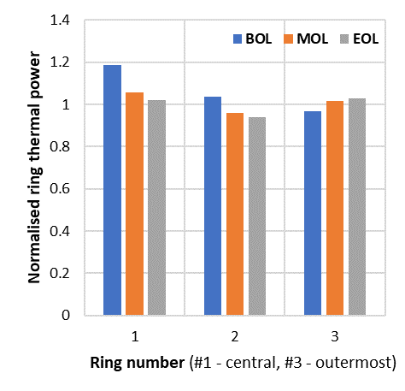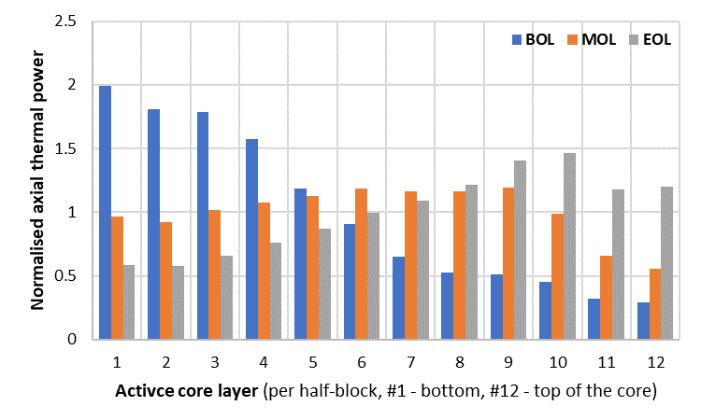

FIG. 2. *Power profiles – axial and radial – for the reference core design*

* 1. Thermal-hydraulic calculations

For the Deterministic Safety Analysis (DSA) calculations, the MELCOR 2.2.14 code [9] was utilized (referred as MELCOR 2.2) to assess the thermal-hydraulic response of the system for the designed HTGR reactor. The quantitative and qualitative assessment of the Reactor Protection System (RPS) and operating procedures, which are preventive measures able to ensure the safety of the core for the selected DLOF scenario was studied. One of the important tasks was the assessment of the Steady State (SS) and transient thermal evaluations with an anticipated plant response. The temperature distribution in the reactor core during steady state and the maximal fuel temperatures in the core during accidents were the prime interest, due to their influence on the neutronic core performance and possible fission products releases in the DBA conditions, respectively. The heat removal by the Reactor Cavity Cooling System (RCCS) was also analysed by system code (MELCOR 2.2) during transient progression.

* + 1. **Used thermal-hydraulic code - MELCOR 2.2 code**

The used thermal hydraulic code for the response of the system of the HTGR-POLA was MELCOR 2.2. This tool is a fully integrated, engineering level computer code that models the progression of severe accidents in nuclear power plants, which is able to model a broad spectrum of severe accident phenomena in both Light Water Reactors and Generation IV Reactors (in our case HTGR). For HTGR, the MELCOR framework is adopted and specific modules – HTGR dedicated are used. The legacy from the GEMINI Plus project [10], [11] was used, as well as the previous pre-conceptual research reactor design [12].

The model that was developed in MELCOR 2.2 code consist of the primary and secondary side of the research reactor. For the established system elements in the code, the main components and plant systems modelled are the Reactor Pressure Vessel (RPV) with the core (Figures 3 and 4), Steam Generator (SG) and helium Blower, Reactor Cavity, Safety Systems and Reactor Core Cooling System in the Reactor Cavity.

While creating the computational model, selected MELCOR 2.2 code packages were used, for example basic Control Volume Hydrodynamic (CVH), Flow Path (FL), Heat Structure (HS), Core (COR), and functional packages (Control Function (CF), Material Properties (MP), Tabular Function (TF)).

The geometry has been created in the MELCOR code, the nodalization which is illustrated in the Figure 3 and Figure 4 is showing the details of the model. Figure 4 is showing the RPV modelled according to the COR package nodalization and the volumes of the CVH package. There are also indicators of the flow values corresponding to the mass flow rates from the FL package and the temperature of the RPV and the permanent reflector, modelled using the HS package.

The model of the plant consist of 249 control volumes, 262 flow paths, 664 control systems, 25 defined materials and 95 heat structures. The nodalization of the active core and RPV is presented above in the Figure 3 and 4.

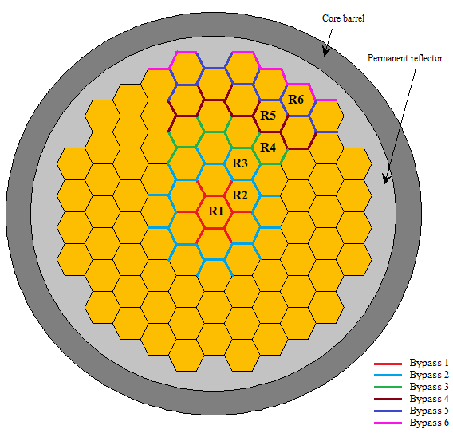

FIG. 3. MELCOR 2.2 horizontal RPV cross-section with specific core rings.

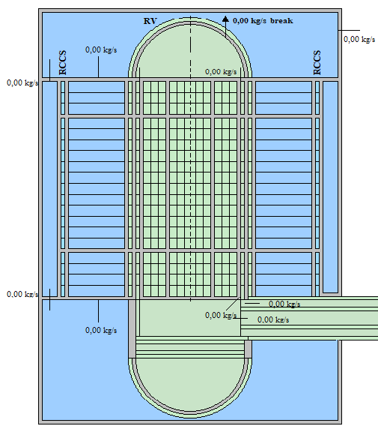

FIG. 4. MELCOR 2.2 axial RPV and cavity cross-section

For the proper qualification of the MELCOR 2.2 model of the primary circuit, the steady-state performance, and the main system design parameters were calculated. The values were compared to the nominal ones (partially presented in Table 1). The Table 2 presents the result of the model qualification, which shows that the agreement between evaluations and anticipated values of the parameters is achieved. The Design value in the Table is the anticipated parameter value, while the Simulation column is the value obtained in MELCOR 2.2 that are the resulting values from the calculations, not stiff boundary condition. The read power value from the simulation is the result of the heat flux multiplication on the fuel surfaces by fuel surface area. The inlet temperature of the core is derived in the simulation based on the amount of heat removed by the the SG through heat exchange.

TABLE 2. MELCOR 2.2 CODE MODEL QUALIFICATION TABLE AT “STEADY-STATE” LEVEL.

|  |  |  |  |
| --- | --- | --- | --- |
| Parameters | Design Value | Simulation MELCOR 2.2 | Relative Error |
| Reactor power (MWth) | 30.0 | 30.0 | 0.000% |
| Helium pressure of primary loop (MPa) | 4.0 | 4.0 | 0.000% |
| Helium mass flow rate (kg/s) | 13.3 | 13.3 | 0.000% |
| Helium RPV Inlet temperature (K) | 598.0 | 598.0 | 0.000% |
| Helium RPV Outlet temperature (K) | 1023.0 | 1014.0 | −0.8797% |

* + 1. **Accident sequences analysis**

The model was used to simulate the accidents of DLOFC - loss of the reactor coolant system integrity with loss of forced flow of the coolant - assumption of the best estimate (BE) at various lifecycle stages – BOL, MOL, EOL.

The assumptions for the Best Estimate calculations of the DLOFC scenario are as follows:

* Reactor power: 100%.
* Nominal temperature at the inlet of the pressure vessel.
* Nominal temperature at the outlet of the pressure vessel.
* Emission factor between RPV / RCCS: 0.9.
* Natural convection (multiplier), default: 1.0.
* Default decay heat curve – calculated by the SPECTRA and Serpent exchange in GEMINI Plus project [10].

The detailed timeline for simulated accident scenario DLOFC performed for BE assumptions is presented in table 3. For this scenario the initiating event is the pipe break with 65 mm rupture (equivalent diameter). The pipe break is located in one of the stand-pipes attached to the upper head RPV closure.

TABLE 3. DLOFC SCENARIO ASSUMPTIONS AND SEQUENCE PROGRESSION.

|  |  |
| --- | --- |
| Time [s] | Event description |
| 0 | Pipe break. Coolant flow decreases, pressure drops, core outlet temperature increases. The reactor power is slowly decreasing due to the negative temperature coefficient |
| 40 | SCRAM signal appears due to activation of one of the 4 logic signals (pressure difference, core outlet temperature, low primary/secondary flow ratio, high core power). |
| 41 | SCRAM. Control rods drop in 10 s providing -10 $ negative reactivity insertion. |
| 60 | The main feedwater pumps stop and feedwater isolation, primary blower stops (impeller rotation is assumed to drop to zero in 30 s). Long-term heat is removed by the RCCS system, cooling the reactor cavity and the reactor pressure vessel. |

* 1. Results and CONCLUSIONS

1. The results of the calculations for the HTGR-POLA reactor are presented in the Table 4 and Figure 5. The maximum temperatures for each scenario did not exceed the 1600°C – Figures 5, Table 4 (the starting temperature point of increased fission products (FP) release rate). Depending on the lifecycle stage, the maximum temperature position in the core was found in various positions and accident times. The Figure 5 presents two-time spans of the maximal temperature evaluation, short on the left and long calculation time on the right. The most challenging assumption of the DLOFC scenario for the proposed HTGR-POLA core configuration is the power distribution at the BOL stage. This is a result of the most peaking power distribution across the height of the core for the HTGR-POLA design. The results of the maximal temperature are characterized by highest values but with ones that do not exceed the steady state level. The preliminary calculation showed the benefits of the use of the coupled thermal-hydraulic and neutronic approach, due to the provision of more realistic power profile.

TABLE 4. CORE MAXIMAL TEMPERATURES FOR THE HTGR-POLA CORE AT BOL STATE FOR DLOFC (BE) ACCIDENT SCENARIOS.

|  |  |  |  |  |
| --- | --- | --- | --- | --- |
| Accidental scenario | Maximum fuel  temperature | Active core axial  position from the bottom | Active core radial  position | Time of  occurrence |
| - | [K] | [m] | [-] | [s] |
| DLOFC_BOL | 1464.0 | ~0.45 | central column | 12 400 |
| DLOFC_MOL | 1286.0 | ~0.75 | central column | 16 200 |
| DLOFC_EOL | 1255.0 | ~4.2 | central column | 40 000 |

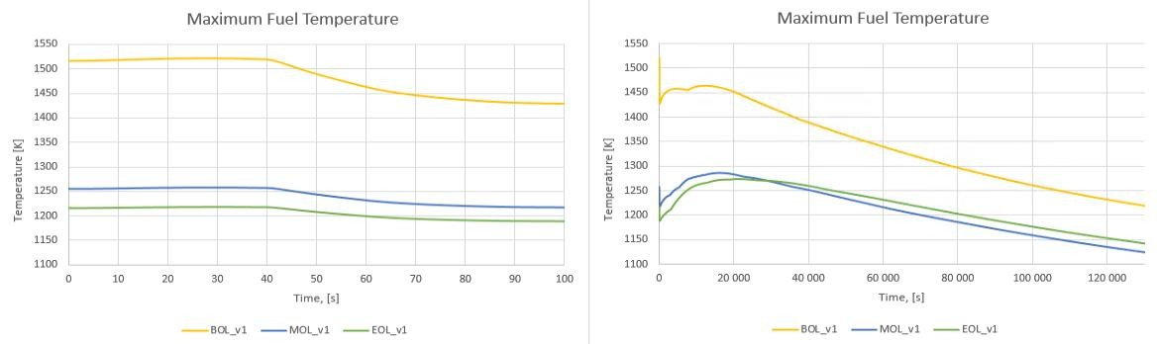

FIG. 5. Time evolution of fuel temperatures for all core computational cells in DLOFC accident scenario

ACKNOWLEDGEMENTS

This work was supported under the project ‘‘Technical description of the HTGR gas-cooled high-temperature research nuclear reactor’’ (Contract No 1/HTGR/2021/14) funded by the Ministry of Education and Science (MEiN) of Poland (2021-24).

Part of the calculations were carried out using the HPC cluster of the Swierk Computing Centre (CIS), National Centre for Nuclear Research (NCBJ), Poland.

References

|  |  |
| --- | --- |
| [1] | G. Wrochna, “Possibilities for deployment of high-temperature nuclear reactors in Poland. In: Report of the Committee for Analysis and Preparation of Conditions for Deployment of High-Temperature Nuclear Reactors,” Possibilities for deployment of high-temperature nuclear reactors in Poland. In: Report of the Committee for Analysis and Preparation of Conditions for Deployment of High-Temperature Nuclear Reactors. Ministry of Economy, 2018. |
| [2] | M. P. Da̧browski, A. Boettcher, W. Brudek, J. Malesa, D. Muszyński, S. Potempski, E. Skrzypek, M. Skrzypek and J. Sierchuła, “Concept of the polish high temperature gas-cooled reactor HTGR-POLA,” *Nuclear Engineering and Design,* August 2024. |
| [3] | Nuclear Energy Agency, Organisation for Economic Co-Operation and Development, “The NEA Small Modular Reactor Dashboard Second Edition,” 2024. |
| [4] | "Act of Parliament of 29 November 2000 on the Atomic law, with later amendments," [Online]. Available: http://isap.sejm.gov.pl/isap.nsf/download.xsp/WDU20010030018/O/D20010018.pdf. [Accessed March 2022]. |
| [5] | IAEA, “Safety Standards, Safety of Nuclear Power Plants: Design, Specific Safety Requirements No. SSR-2/1 (Rev. 1),” Vienna, 2016. |
| [6] | G. Brinkmann, D. Vanvor and A. Jung, “Final GEMINI + Safety Options Report,” European Union's Horizon 2020 research and innovation programme, 2020. |
| [7] | J. Leppänen, M. Pusa, T. Viitanen and V. Valtavirta, “The Serpent Monte Carlo Code: Status, Development and Applications in 2013,” *Annals of Nuclear Energy,* pp. 142-150, 2015,82. |
| [8] | CEA (French Alternative Energies and Atomic Energy Commission), “CATHARE 2 V25_3mode9.1 Code: General Description,” France, 2019. |
| [9] | L. Humphries, “MELCOR Computer Code Manuals, Vol. 1: User’s Guide, Vol. 2:Reference Manuals, Version 2.2.14959,” Sandia National Laboratories, Albuquerque, 2019. |
| [10] | M. Skrzypek, E. Skrzypek, M. Stempniewicz and J. Malesa, “Study on the DLOFC accident of the GEMINI+ conceptual design of HTGR reactor with MELCOR and SPECTRA,” in *Proceedings of HTR 2021*, Virtual Conference, Indonesia, 2021. |
| [11] | M. Stempniewicz, “GEMINI+ D1.15: Comparison of Air Ingress Calculations and Recommendations for Future Applications,” NRG, Arnhem, 2020. |
| [12] | E. Skrzypek, D. Muszyński, M. Skrzypek, P. Darnowski, J. Malesa, A. Boettcher and M. Dąbrowski, “Pre-Conceptual Design of the Research High-Temperature Gas-Cooled Reactor TeResa for Non-Electrical Applications,” *Energies,* 2022. |