**Challenges and Opportunities in Developing a Safety Case for Small Modular Reactors: The Ghanaian Perspective**

**1*Felix Ameyaw, 1Mark Nyasapoh and 1Joshua Gbinu**

**1Nuclear Power Institute, P. O. Box LG 80, Legon-Accra, Ghana**

**\*email: felix.ameyaw@gaec.gov,gh**

**Abstract**

This review paper critically analyzes the safety challenges and opportunities inherent in developing a safety case for Small Modular Reactors (SMRs) in Ghana. It delves into the safety objectives and the application of defense-in-depth principles, with a specific focus on the country's unique perspective. The review emphasizes key safety features such as inherent and passive safety, design simplification, and modularity, while also addressing challenges related to severe accident mitigation, hazard considerations, and fuel and core safety. Furthermore, the paper discusses the importance of materials and chemistry safety, risk-informed approaches, and innovative deployment models for SMRs in Ghana. It underscores the necessity of a robust safety case to address these challenges, highlighting the critical role of leadership and safety management in Ghana's nuclear power program. This paper provides valuable insights and recommendations for enhancing the safety and success of SMR deployment in Ghana, contributing significantly to the advancement of the country's nuclear power development efforts.

**Keywords:** Safety Case, Defense-in-Depth, Inherent and Passive Safety, Severe Accident Mitigation, Risk-Informed Approaches.

1. **INTRODUCTION**

Energy use is crucial for economic and industrial growth. However, in Ghana, energy insecurity has continued to be a perennial development inhibitor. The generation of electricity in Ghana has seen an unimpressive decline in the component of renewable energy (hydro) in favour of the use of thermal plants powered by hydrocarbon [1]. Given the importance of renewable energy and its daily discussion on the global scale about achieving Sustainable Development Goal (SDG) 7 by 2030, over the past decade, African countries, including Ghana, have been increasing investment in economic-technical factors such as renewable energy, rural electrification, industrialization, and digitization. Increased provision and access to these factors will provide the needed infrastructure to spur the economies toward inclusive and sustained growth [2].

Ghana’s continued increase in energy demand calls for feasible ways to generate base load energy that is economically efficient and environmentally tolerant to achieve its Sustainable Development Goal (SDG) 7. Ghana’s electricity generation relies heavily on approximately 69 % of fossil fuels such as oil and gas, as shown in Figure 1. Electricity consumption per capita is expected to increase from 586 kWh to 5000 kWh per annum by 2030 [1]. Ghana’s energy sector has relied heavily on fossil fuels, including oil, natural gas, and coal, for electricity generation and other energy needs [3].Nuclear and renewable energy sources emerge as promising solutions to address the escalating energy demand while mitigating Greenhouse Gas (GHG) emissions [4].

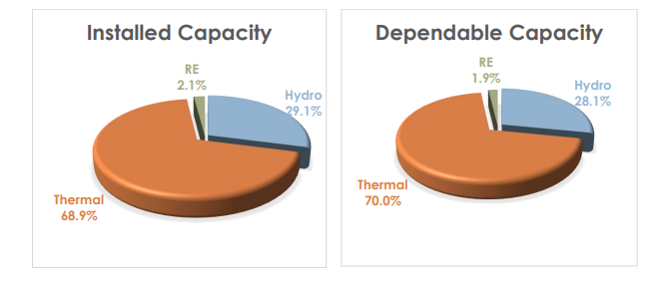

Figure 1: Shares of hydro, thermal, and renewable capacity at the end of December 2022 (Ghana Energy Commission, 2022) [5]

Owing to aggravated climate change, worldwide energy policies are aiming at carbon neutrality. Most of the ongoing conversations on climate change tend to shift from fossil fuels to low-carbon and reliable energy sources, such as nuclear [6],[7].It is one of the lowest emitters of greenhouse gases compared to other low-carbon sources and is highly reliable [8]. However, large nuclear energy projects are also associated with financial and safety risks due to construction, technical, operational, and political factors [9]. For this reason, Small Modular Reactors are much more suitable for financially constrained countries like Ghana.

Over the years, there has been a keen and increasing global interest in a newer generation of reactors termed SMR [10]. The International Atomic Energy Agency defines "small" nuclear reactors as those with a capacity of less than 300 MWe. The concept of small-scale nuclear plants is not novel since this technology has been utilized for over 5 decades in naval submarines [11]. In the context of SMRs, "modular" denotes the ability of these reactors to have their components manufactured remotely and then transported to the final site for rapid assembly[12].They offer a relatively small footprint with a significant advantage being their suitability for locations where constructing large nuclear reactors would pose challenges. The construction of large nuclear power plants has frequently experienced significant delays and cost overruns compared to initial design estimates. Factors contributing to these challenges include regulatory complexities, design alterations, project management hurdles, and rigorous safety standards [13]. SMRs are distinguished by their relatively smaller size and modularization, which can lead to reduced upfront investment costs, potential for industrial learning, and greater application flexibility. During the International Conference on Climate Change and the Role of Nuclear Power held in September 2019, it was revealed that SMRs are being considered by many Member States as a potential viable nuclear option to contribute to mitigating climate change[14]. Despite major milestones, that have been reached in SMR technology deployment in recent years, the industry is still challenged by several factors. Two quite different deployments are being considered:

1. In-groups, where several small reactors are an alternative to one large one; and
2. Individually, in remote, isolated locations where a large reactor is unsuitable.

This review explores the challenges and opportunities in developing a safety case for SMRs, focusing on Ghana's unique perspective. It highlights the importance of safety in nuclear power development and sets the stage for the discussion that follows.

**2. 0 SAFETY OBJECTIVES**

Safety management ensures that safety risks have been identified, prevented, and mitigated or minimized. The goal of safety management is to protect from injury, losses, and accidents. Safety management applies a set of principles, processes, and measures to fulfil its tasks. The severe accident in March 2011 involving several nuclear reactors at Fukushima in Japan brought renewed attention to reactor safety. The radiation release resulted in the evacuation of towns, the deliberate destruction of contaminated crops and food, and abundant anxiety and distress. To ensure safety, a nuclear facility must be licensed.

The Convention on Nuclear Safety that was adopted at the Vienna Diplomatic Conference in 1994 and came into force two years later gives priority to nuclear safety, and when applied, requires specific safety standards to be identified and followed. Article 3, Paragraph 6 of the “Statute of the International Atomic Energy Agency (IAEA)” stipulates that the IAEA is authorized to establish or adopt standards of safety to safeguard health and minimize danger to life and property and to provide for the application of these standards. Based on the provisions of this authorization, the IAEA has published the “Fundamental Safety Principles” [15], a document that focuses on the fundamental principles for the conduct of activities and management related to the use of nuclear energy and ionizing radiation from a perspective of nuclear safety technology. It is considered the foundational and overarching standard for all specific safety requirements and guidelines developed by the IAEA in the field of nuclear safety [16].

Nuclear licensing is one of the first and most crucial processes in deploying an SMR. The principal actor in a nuclear licensing process is the Nuclear Regulatory Authority (NRA), which evaluates if all the applicable safety, security, and other licensing criteria are satisfied, and the applicant, who shows compliance with the relevant nuclear safety requirements. The Nuclear Regulatory Authority Act 2015 (Act 895) applies to all activities and practices involving the peaceful uses of radiation, nuclear, and radioactive material conducted under the jurisdiction of Ghana. The Act establishes the Nuclear Regulatory Authority and provides for the regulation and management of activities and practices for the peaceful use of nuclear material or energy, radioactive material, or radiation. The prevailing licensing systems in most countries with nuclear power programs have been designed and operated in the context of large nuclear reactors [10], [17].Applying the same established licensing process to SMRs can present a whole new set of challenges, reason being that, whenever comparisons were made against Large Reactors (LR), it was used as a benchmark to emphasize the extent of the licensing issues in SMRs. The safety risk profile of SMRs differs from the LRs, as it is limited to factors such as smaller power output, reduced radioactive inventory, passive safety systems, and underground location of the reactor vessels for enhanced protection against hazards [18]. SMR designs are most likely to challenge legal and regulatory frameworks which can unfold into legal issues which may then impede the deployment of SMRs [9].

The licensing barriers as obstacles can negatively affect the deployment of SMR in Ghana. So instead of pre-defined norms for the first-of-a-kind designs, the regulators should use the principles of a graded approach to establish overall performance goals for the SMR in the form of numerical risk targets [9]. The risks are kept as low as reasonably achievable or as low as reasonably practicable. The SMR developers advocate for a reduced emergency planning zone (EPZ). It refers to a buffer area around NPPs designated for implementing the necessary operational and protective measures in a nuclear emergency [19]. Under a prescriptive regulatory approach, the current Nuclear Power Plants (NPP) are licensed with a traditionally large EPZ radius [9]. Applying the same large Emergency Planning Zone (EPZ) radius to SMRs is inefficient. Additionally, using regulatory approaches intended for Large Reactors (LRs) on SMRs results in either an increased number of control rooms or a higher staffing requirement for those control rooms. This, in turn, can drive up plant operation and maintenance costs, thereby diminishing the economic viability of SMRs [10]. So far, the optimum number of staff in the control room for single and multi-module SMR facilities and the number of control rooms necessary for the entire plant are unclear [20]. The Nuclear Regulatory Authority must review the number of staff proposed by the developers to warrant the safe operation of the plant [9].

Organizational culture is the basis on which the safety culture builds upon. The safety culture concept was launched by the expert group of the IAEA in the aftermath of the Chernobyl nuclear power accident. Safety culture in the nuclear context can be defined as an “assembly of characteristics and attitudes in organizations and individuals which establish that as an overriding priority, nuclear plant safety issues receive the attention warranted by their significance” [21]. A safety culture is a well-acknowledged concept in the nuclear field and many high-risk industry sectors.

Edgar Schein’s three-level model of organizational culture is used here as a framework for considering and analysing the relationship between safety and security [22]. Schein distinguishes between three layers of culture. The most visible layer is artifacts and consists of visible behaviour [22]. For example, how safety and security experts or senior managers communicate in an organization. The second layer embraces espoused values, and these values can manifest themselves in rules, standards, or prohibitions. The third layer consists of basic underlying assumptions. These are often unconscious, non-reflected assumptions that can be made visible, for example, by an external analyst. According to the model, there are three levels in organizational culture namely; the artifacts, values, and basic assumptions. From the perspective of the nuclear industry: artifacts, shared guidelines, and ideology. The first level (artifacts) are the characteristics that can be easily viewed, heard, and felt by individuals, including architecture, greeting rituals, dress codes, and forms of address. Values, which constitute the second level of nuclear safety culture, are shared beliefs or guidelines, including goals, laws, and operating specifications. The third level, basic assumptions, lies at the highest level of culture and reflects the predominant ideology, including individuals' understandings of safety laws and their various perceptions of safety. The basic assumptions are invisible and implicit[23]. These levels from low to high constitute a progressive process. Basic assumptions, once formed, affect the values and artifacts. For instance, when the ‘safety first’ principle becomes a basic assumption, it would be subconscious actions for members to report human errors.

**2.1 INHERENT AND PASSIVE SAFETY FEATURES**

Inherent safety and the concept of practical elimination are foundational elements in the design and operation of SMRs, aligning with the International Atomic Energy Agency's (IAEA) safety framework. Inherent safety refers to the intrinsic characteristics of a reactor that prevent accidents from occurring or mitigate their consequences without requiring active safety systems. SMRs achieve this through features such as passive cooling, low power density, and simplified designs, which inherently reduce the likelihood of severe accidents [24].

The concept of practical elimination, as described in the IAEA's SSR-2/1 Rev. 1, involves designing reactors to eliminate the possibility of certain severe accident scenarios by ensuring they are "practically eliminated" through design measures [25]. This implies that accident scenarios resulting in significant or early radioactive releases have been practically eliminated, either through physical impossibility or by being highly improbable with a high degree of confidence. The IAEA regulators forum further elaborates on this by providing specific criteria for assessing and demonstrating practical elimination in SMRs, emphasizing the need for rigorous safety assessments and robust design features that limit the release of radioactive materials [26].

Small Modular Reactors (SMRs) leverage inherent safety through their smaller core size, simplified systems, and passive safety features. Passive safety features rely on natural physical principles such as gravity, natural circulation, and heat conduction to ensure safety functions are maintained without the need for external power sources or active mechanical components. This reduces the likelihood of accidents and enhances the reactor's ability to safely shut down or cool the core under all conditions. These principles ensure that SMRs provide a high level of safety, minimizing risks and enhancing public and environmental protection.

The IAEA SSG 88 emphasizes the importance of inherent safety and demonstrate the practical elimination of plant event sequences that could lead to an early radioactive release or a large radioactive release [27]. The IAEA regulators forum further elaborates on these principles by discussing the role of passive safety features (chapter 2 paragraph 2.1.2) [26] and their integration into SMR designs to achieve high levels of safety with reduced complexity. These frameworks guide the development of SMRs to ensure they meet the highest safety standards, with a focus on minimizing risk through design simplification and the elimination of complex active safety systems.

1. **DESIGN SIMPLIFICATION AND MODULARITY**

The climbing interest in SMRs is due to their application potential since they offer some advantages when compared to large nuclear power plants, mainly in terms of modularity, shorter time of construction with lower costs, the applicability of natural cooling circulation with inherent safety features SMR components can be assembled in a remote factory and shipped or transported as unit modules to the end-user site. The SMR design includes all reactor categories such as water-cooled reactors, high-temperature gas-cooled reactors, liquid-metal, sodium, and gas-cooled reactors with fast neutron spectrum, and molten salt reactors. SMRs have high inherent and passive safety features compared to large commercial nuclear power plants due to its integrated design and reduced core thermal power. The high level of operational flexibility through modular arrangement can offer significant promise for extending the SMR for non-electricity applications such as desalination and hydrogen production [28].

Efforts to develop and deploy SMRs are actively underway across countries worldwide, with ongoing research focused on enhancing the passive safety and manufacturability of SMRs through innovative technologies. The following constraints are considered during the Ulsan National Institute of Science and Technology (UNIST) Reactor Innovation platform for SMR (URI-SMR) innovation platform design process.

1. Transparent vessel of the facility for visual access to the internal thermal-hydraulic phenomena and installed key components.

2. High degree of design modification flexibility with low construction and maintenance costs.

3. Easiness of integration with various engineering technologies and extended scalability to serve as a versatile platform for evaluating various SMR-related technologies and applications[29]. The design features of an SMR are depicted in Figure 2.

According to a 2022 International Atomic Energy Agency (IAEA) assessment, more than 80 SMR designs are at different stages of development and deployment in 18 IAEA member states. Some of the famous SMRs are enlisted in Table 1.

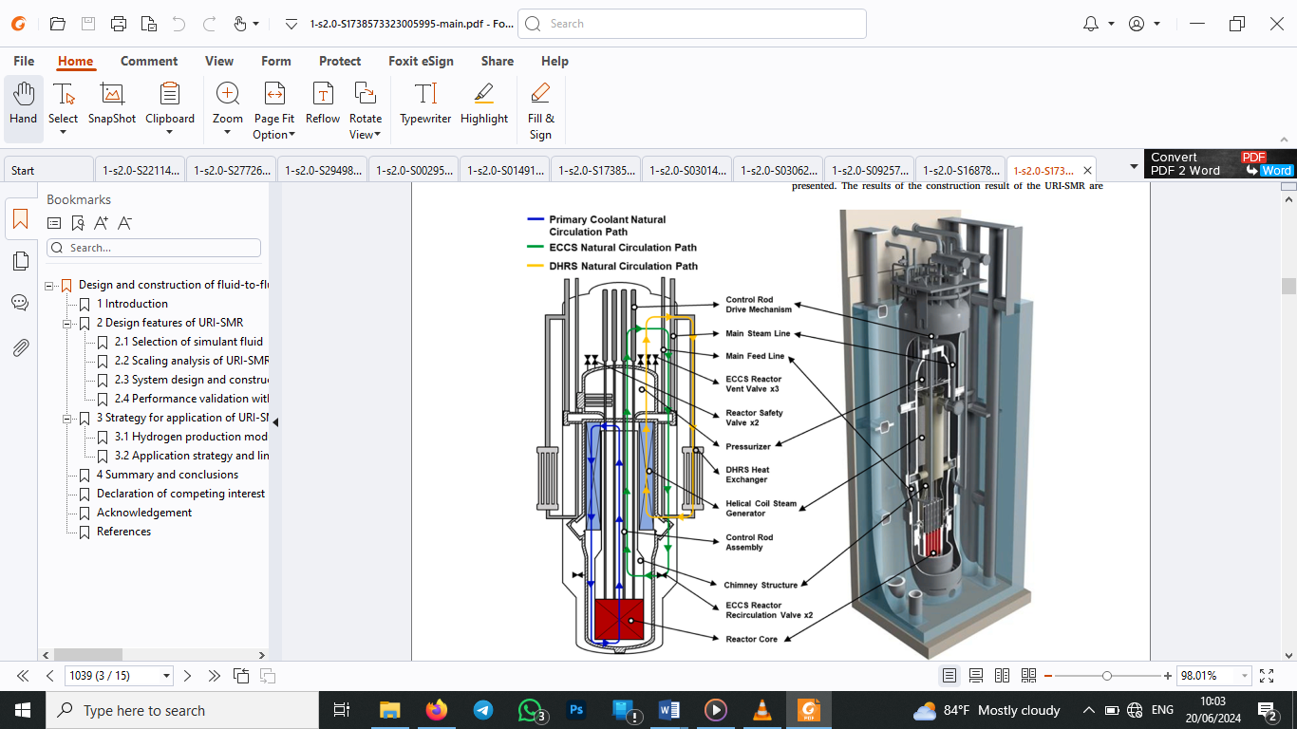

*Fig 2. SMR features* [29]

Table 1: List of SMRs with their major design features and status [30]

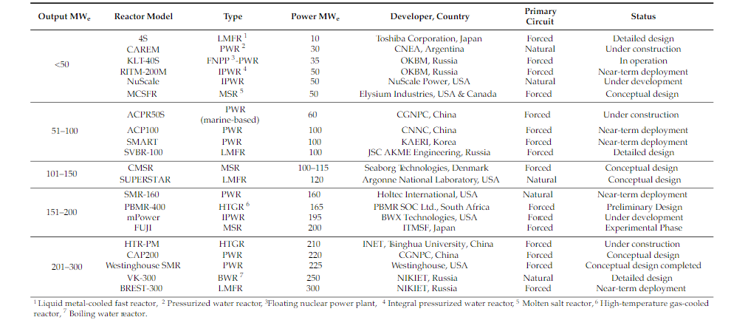

1. **LEADERSHIP AND MANAGEMENT OF SAFETY**

According to the Nuclear Energy Act (990/1987) [31], the nuclear facility shall have a management system. The licensee is responsible for the nuclear facility’s safety and for the planning, implementation, maintenance, functionality, effectiveness, and continuous improvement of the management system.

The role of leadership in securing good safety outcomes is well established. Investigations into accidents and disasters across all major hazardous industries have consistently found the actions or inactions of leaders to be contributory factors. In the nuclear industry, poor safety leadership behaviors were found to be key contributing factors to nuclear accidents. There have been many approaches to establishing the optimum model for effective leadership and management for safety within nuclear licensee businesses. Many organizations have developed their models with most being based on the widely recognized frameworks developed by IAEA, WANO, INPO, and the view of ONR.

**5.0 GHANAIAN PERSPECTIVE**

From Ghana’s viewpoint, integrating Small Modular Reactors (SMRs) into its energy strategy presents both significant challenges and unique opportunities. With the aim of diversifying its energy portfolio and improving energy security, Ghana is embracing SMRs for their inherent safety features and modular design, which align well with the country’s developmental context. Ghana’s nuclear energy program places paramount importance on safety, reflecting the nation’s commitment to protecting public health and the environment. The country’s safety objectives are aligned with international standards, particularly those established by the IAEA, ensuring that SMRs are operated under the highest safety protocols. This focus is essential in building public trust and ensuring regulatory compliance. For Ghana, the adoption of SMRs with advanced inherent and passive safety features addresses infrastructure constraints and enhances safety. These features, which rely on natural processes rather than active systems, are crucial in a context where technical support and infrastructure might be limited. They provide a reliable safety net, reducing the likelihood of accidents and simplifying emergency response. SMRs’ modularity and simplified design facilitate phased construction and incremental deployment, making them well-suited to Ghana’s growing energy demands. This approach allows for manageable initial investments and scaling up as needed, which is advantageous for a country with evolving infrastructure needs. The modular nature also simplifies maintenance and operational logistics, aligning with Ghana’s capacity-building efforts. Effective leadership and safety management are critical for Ghana’s successful integration of SMRs. The country is developing a robust safety culture through comprehensive training, regulatory frameworks, and stakeholder engagement. By investing in these areas, Ghana aims to ensure that the safety objectives, inherent features, and modular designs of SMRs are effectively managed, thus reinforcing its commitment to safe and sustainable nuclear energy. Ghana’s approach to SMRs demonstrates a pragmatic and forward-thinking strategy, harnessing technological advancements to address local needs while maintaining a strong focus on safety and sustainability.

**6.0 CONCLUSION**

This review provides valuable insights into the challenges and opportunities in developing a safety case for SMRs in Ghana. Developing a robust safety case for SMRs in Ghana involves addressing several critical challenges, including the unique safety objectives and application of defense-in-depth principles within the context of Ghana’s specific nuclear landscape. Inherent and passive safety features are crucial, as they can significantly reduce the likelihood of severe accidents and enhance overall reactor safety. However, these features must be thoroughly evaluated and demonstrated to be effective under Ghana’s specific environmental and operational conditions.

One of the primary challenges in developing a safety case for SMRs in Ghana is ensuring the mitigation of severe accidents. This involves rigorous analysis and planning for potential hazards and establishing comprehensive safety measures to manage and mitigate such events. Addressing fuel and core safety is another significant challenge, requiring detailed assessments of fuel behavior under various conditions and ensuring the core's integrity and stability. Moreover, the safety of materials and chemical processes within the reactor must be meticulously evaluated to prevent accidents and ensure long-term operational safety.

Despite these challenges, there are substantial opportunities for Ghana in leveraging the benefits of SMRs. Design simplification and modularity offer significant advantages, such as reduced construction times, lower initial capital investment, and increased flexibility in scaling up the nuclear power capacity as needed. These attributes can help Ghana to gradually build its nuclear power capabilities while managing financial and technical risks more effectively.

Risk-informed approaches provide an opportunity to enhance the safety case by integrating probabilistic risk assessments with traditional deterministic methods. This allows for a more comprehensive understanding of potential risks and the implementation of targeted mitigation strategies. Furthermore, innovative deployment models tailored to Ghana’s specific needs can support the effective integration of SMRs into the national energy mix.

Leadership and safety management play a critical role in the successful development and implementation of a safety case for SMRs in Ghana. Strong regulatory frameworks, continuous safety culture improvement, and effective stakeholder engagement are essential components for ensuring the long-term safety and success of the nuclear power program. By addressing these challenges and leveraging the identified opportunities, Ghana can enhance the safety and success of its nuclear power program, thereby contributing to the country's energy security and sustainability. The insights and recommendations provided in this review are instrumental in guiding the development of a robust safety case for SMRs, ultimately supporting Ghana’s nuclear power ambitions.

**7.0 REFERENCES**

[1] S. Amoako, “The mitigating role of financial development on renewable energy in Ghana,” *World Dev. Sustain.*, vol. 4, no. April, p. 100145, 2024, doi: 10.1016/j.wds.2024.100145.

[2] E. F. Oteng-Abayie, J. B. Dramani, F. Adusah-Poku, K. Amanor, and J. D. Quartey, “Decomposition and drivers of energy intensity in Ghana,” *Energy Strateg. Rev.*, vol. 47, 2023, doi: 10.1016/j.esr.2023.101090.

[3] S. Amoako and M. Insaidoo, “Symmetric impact of FDI on energy consumption: Evidence from Ghana,” *Energy*, vol. 223, 2021, doi: 10.1016/j.energy.2021.120005.

[4] S. M. Bragg-Sitton, “Hybrid energy systems using small modular nuclear reactors (SMRs),” in *Handbook of Small Modular Nuclear Reactors*, Elsevier, 2021, pp. 323–356. doi: 10.1016/B978-0-12-823916-2.00013-8.

[5] S. Outlook, *2023 Energy outlook for ghana*, no. April. 2023.

[6] V. Nian, A. Ghori, E. M. Guerra, G. Locatelli, and P. Murphy, “Accelerating safe small modular reactor development in Southeast Asia,” *Util. Policy*, vol. 74, 2022, doi: 10.1016/j.jup.2021.101330.

[7] M. Sadiq, R. Shinwari, F. Wen, M. Usman, S. T. Hassan, and F. Taghizadeh-Hesary, “Do globalization and nuclear energy intensify the environmental costs in top nuclear energy-consuming countries?,” *Prog. Nucl. Energy*, vol. 156, 2023, doi: 10.1016/j.pnucene.2022.104533.

[8] IAEA, “INTERNATIONAL ATOMIC ENERGY AGENCY, Climate Change and Nuclear Power 2020,” 2020.

[9] R. Sam, T. Sainati, B. Hanson, and R. Kay, “Licensing small modular reactors: A state-of-the-art review of the challenges and barriers,” *Prog. Nucl. Energy*, vol. 164, no. May, p. 104859, 2023, doi: 10.1016/j.pnucene.2023.104859.

[10] M. V. Ramana, L. B. Hopkins, and A. Glaser, “Licensing small modular reactors,” *Energy*, vol. 61, 2013, doi: 10.1016/j.energy.2013.09.010.

[11] WNA, “Small Nuclear Power Reactors: World Nuclear Association,” www.world-nuclear.org webpage.

[12] A. Abdulla, I. L. Azevedo, and M. G. Morgan, “Expert assessments of the cost of light water small modular reactors,” *Proc. Natl. Acad. Sci. U. S. A.*, vol. 110, no. 24, 2013, doi: 10.1073/pnas.1300195110.

[13] A. Gilbert, B. K. Sovacool, P. Johnstone, and A. Stirling, “Cost overruns and financial risk in the construction of nuclear power reactors: A critical appraisal,” *Energy Policy*, vol. 102, pp. 644–649, Mar. 2017, doi: 10.1016/J.ENPOL.2016.04.001.

[14] W. Bodel, G. Butler, and J. Matthews, “Nuclear Energy for a Net Zero World,” *Iaea*, no. June, 2021.

[15] IAEA, *International safety standards No. SF-1*, vol. 2. 2011. doi: 10.1007/978-94-007-0247-9_1.

[16] W. Gong, “International law obligations for the disposal of Fukushima nuclear-contaminated water under the principles of nuclear safety,” *Chinese J. Popul. Resour. Environ.*, vol. 22, no. 1, pp. 10–19, 2024, doi: 10.1016/j.cjpre.2024.03.002.

[17] T. Sainati, G. Locatelli, and N. Brookes, “Small Modular Reactors: Licensing constraints and the way forward,” 2015. doi: 10.1016/j.energy.2014.12.079.

[18] T. S. Carless, S. M. Talabi, and P. S. Fischbeck, “Risk and regulatory considerations for small modular reactor emergency planning zones based on passive decontamination potential,” *Energy*, vol. 167, 2019, doi: 10.1016/j.energy.2018.10.173.

[19] IAEA, “SMR Regulators’ Forum Pilot Project Report: Considering the Application of a Graded Approach, Defence-in-Depth and Emergency Planning Zone Size for Small Modular Reactors,” no. January, p. 158, 2018, [Online]. Available: https://www.iaea.org/sites/default/files/18/01/smr-rf-report-29012018.pdf

[20] H. Hidayatullah, S. Susyadi, and M. H. Subki, “Design and technology development for small modular reactors - Safety expectations, prospects and impediments of their deployment,” *Prog. Nucl. Energy*, vol. 79, 2015, doi: 10.1016/j.pnucene.2014.11.010.

[21] G. E. Apostolakis and M. V. Bonaca, “Issues Related To Safety Culture,” *Probabilistic Saf. Assess. Manag.*, pp. 863–868, 2004, doi: 10.1007/978-0-85729-410-4_140.

[22] K. Dimitrov, “Edgar schein’s model of organizational culture levels as a hologram,” *Ikon. Izsled.*, vol. 22, no. 4, 2013.

[23] E. Schein, “Organizational Culture and Leadership Organizational Culture and Leadership,” *Culture*, no. Idd, 2019.

[24] E. M. A. Hussein, “Emerging small modular nuclear power reactors: A critical review,” *Phys. Open*, vol. 5, p. 100038, Dec. 2020, doi: 10.1016/j.physo.2020.100038.

[25] IAEA. (2022). Safety of nuclear power plants: Design. *IAEA’s SSR-2/1 Rev. 1*, *67*(1), 17–17. https://doi.org/10.1515/kern-2002-0007

[26] International Atomic Energy Agency, “Small Modular Reactors Regulators’ Forum: Working Group on Design and Safety Analysis (Phase 2 Report),” no. June, 2021.

[27] IAEA, *IAEA Safety Standards for protecting people and the environment Specific Safety Guide No. SSG-88 Design Extension Conditions and the Concept of Practical Elimination in the Design of Nuclear Power Plants*. Vienna, 2024. [Online]. Available: https://www.iaea.org/resources/safety-standards

[28] R. S. El-Emam, H. Ozcan, R. Bhattacharyya, and L. Awerbuch, “Nuclear desalination: A sustainable route to water security,” 2022. doi: 10.1016/j.desal.2022.116082.

[29] J. Y. Kim, S. C. Yoo, J. H. Seo, J. H. Kim, and I. C. Bang, “Design and construction of fluid-to-fluid scaled-down small modular reactor platform: As a testbed for the nuclear-based hydrogen production,” *Nucl. Eng. Technol.*, vol. 56, no. 3, 2024, doi: 10.1016/j.net.2023.12.047.

[30] S. H. Ghazaie, K. Sadeghi, E. Sokolova, E. Fedorovich, and A. Shirani, “Comparative analysis of hybrid desalination technologies powered by SMR,” *Energies*, vol. 13, no. 18, 2020, doi: 10.3390/en13195006.

[31] F. Legally, S. Ministry, E. Affairs, and T. Act, “Chapter 1 Objectives and scope of application,” 2018.