# PAssive safety system and safety demonstration of innovative small modular reactor

SANG-GYU LIM

i-SMR Development Agency

Daejeon, Republic of Korea

Email: sglim@ismr.or.kr

SUN HEO

i-SMR Development Agency

Daejeon, Republic of Korea

Email: sunny@ismr.or.kr

TAE-CHEOL PARK

i-SMR Development Agency

Daejeon, Republic of Korea

Email: tcpark@ismr.or.kr

JONG CHEON

i-SMR Development Agency

Daejeon, Republic of Korea

Email: cheonjong@ismr.or.kr

HAN-GON KIM

i-SMR Development Agency

Daejeon, Republic of Korea

Email: kimhg1108@ismr.or.kr

**Abstract**

To respond to the global climate crisis and supply sustainable clean energy, the Republic of Korea has developing a new SMR named innovative SMR(i-SMR). The safety goals of the i-SMR are that a core damage frequency (CDF) is less than 1E-9 and a large early release frequency (LERF) is less than 1E-10. To achieve these safety goals, a passive system design is applied and a non-safety active system design is applied to back it up. The safety systems of i-SMR enable the emergency planning zone (EPZ) to be within the site boundary, which will be designed to practically eliminate the need for public evacuation during an accident. This paper discusses the design characteristics of the passive system adopted by the innovative SMR. The safety system of the innovative SMR consists of a passive emergency core cooling system to respond to LOCA accidents, a passive auxiliary feedwater system to respond to non-LOCA accidents, and a passive containment cooling system to cool down the steel containment vessel. Also, this paper deals with the design characteristics and working mechanism for those systems during the accidents. The paper is also focusing on the current experimental database and correlation equations used in the passive safety system design of i-SMR, and describes the plan for a series of the separate effect tests and the integral effect experiments to demonstrate the safety and the thermal hydraulic performance of the passive system.

## INTRODUCTION

The global climate crisis demands an evolutionary transformation of the current energy supply system as humans have built it to date. According to the International Energy Agency [1], renewable energy will need to provide two-thirds of all energy supply to achieve net-zero emissions in 2050. Also, a nuclear energy supply will need to be more than double its current supply. Recently, Small Modular Reactors (SMRs), as one of the advanced nuclear reactor technologies, are in the spotlight as the future of nuclear energy. SMRs can supply not only base electrical production but also provide energy to process heat, desalination, district heat, and coupled operation with renewables. According to the International Atomic Energy Agency (IAEA) publication [2], More than eighty-three SMRs are under development and deployment in eighteen Member States.

Republic of Korea is one of the first movers in SMR development. Korea Atomic Energy Research Institute (KAERI) developed a System-integrated Modular Advanced Reactor (SMART), which is an integral-type small reactor since 1997. SMART received the first standard design approval (SDA) of SMR from the Korean regulatory body in 2012. Moreover, the Republic of Korea has successful development and operation experience in large pressurized water reactors (PWRs). APR1400, APR+, and i-POWER have successfully developed large light water reactors for generation III+ reactors. Among them, six APR1400s are under construction and operating in Korea, and four have been exported to the UAE, where they have been completed and are currently in operation. During APR+ and i-POWER development, a series of passive safety systems have been developed and validated through extensive experiments and performance analysis.

Based on these SMR technologies and large PWR technology, the Republic of Korea has begun developing a new SMR, called innovative SMR (i-SMR) that will be the most competitive in the world. i-SMR is designed to secure the world's highest level of safety with 1E-9 order of a core damage frequency (CDF) by applying a fully passive electrical system, more flexibility by applying boron-free operation, and more economic by applying an integrated reactor vessel and modularization concept. In this paper, the design characteristics and working mechanism of passive safety systems for i-SMR. Lastly, a demonstration plan of the safety system through separated effect tests and integral effect tests is described

## general design characteristics

### Top-tier design requirements

This section introduces top-tier requirements of i-SMR in terms of general requirements, safety requirements, economic requirements, and flexibility requirements. For the general requirements, i-SMR has a 170 megawatt-electric PWR type reactor. The design lifetime is eighty years and the site envelope seismic design level is set as 0.5g.

For safety requirements, the CDF of i-SMR is less than 1E-9 and a large early release frequency (LERF) is less than 1E-10. To achieve these safety goals, passive safety systems are applied, and non-safety active systems are applied to back them up. The safety systems of i-SMR enable the emergency planning zone (EPZ) to be within the site boundary, which will be designed to practically eliminate the need for public evacuation during an accident.

For economic requirements, the main components and structures are modularized and designed for land transportation after factory manufacturing. This reduces construction time and improves economic efficiency. The target total construction cost is approximately US dollar 3,500/kilowatt electricity, with a target levelized cost of electricity of US dollar 65/MWh.

### Main design characteristics

The core thermal power is 520 MW. The core consists of 69 fuel assemblies, 49 Control Rod Assemblies (CRAs), and 20 In-Core Instrument (ICI) assemblies. The core is designed for the refueling cycle to be 24 months with a maximum fuel rod burn-up of 62,000 MWD/MTU.

i-SMR adopts boron-free operation which improves the safety of i-SMR. The boron-free operation inherently eliminates the boron dilution accident and excludes the primary water stress corrosion cracking (PWSCC) in the penetrations of the reactor vessel. During the long-term cooling in the small break loss-of-coolant accident (SBLOCA) scenario, the re-criticality of the core does not occur due to the boron precipitation phenomena in the reactor coolant system. To eliminate the control rod ejection accident, the In-Vessel type of CRDM is adopted.

Reactivity control is achieved through control rods, burnable poison, and a negative moderator temperature effect. The burnable poison is introduced to provide a flat radial and axial power distribution to increase the thermal margin of the core.

As shown in Fig. 1, i-SMR adopts the integral arrangement to eliminate the possibility of a Large Break Loss of Coolant Accident (LBLOCA). The reactor coolant system (RCS) transfers the core heat to the secondary system through the steam generator (SG). The reactor coolant flows upward through the core and upper riser region inside the Core Support Barrel (CSB), turns downward through the reactor coolant pump (RCP), SG shell side, and then returns into the core through the lower plenum. The forced circulation flow of the reactor coolant is formed by four RCPs installed at the upper side of the reactor vessel. By this coolant circulation, the core heat is delivered to the secondary system via the SG.

The RCP is seal-less canned-motor type which provides benefits in terms of safety and economic. For safety, RCP seal LOCA is inherently excluded in the safety analysis of i-SMR. During the normal operation and load following operation, the RCPs can minimize the adverse effect of a primary system from the secondary flow instability such as density wave oscillation of the steam generator. For the economics, the seal-less canned-motor RCP does not require the external seal injection function during normal operation.

The steam generators of i-SMR adopt a monobloc helical coil type. All helical-coil steam generator tubes are located inside the downcomer of the reactor vessel and are divided into eight sections. Eight feedwater headers and eight steam headers are installed on the outer wall of the reactor vessel. To prevent flow instability caused by secondary density wave oscillation, orifices are installed in the feedwater inlet side of the steam generator tubes.

The i-SMR Containment Vessel (CV) includes cylindrical steel shells with torispherical top and bottom heads. It covers the RV and associated structures, systems, and components of RCS, and the height and diameter are approximately 34.9 m and 9 m, respectively. The CV serves as a physical barrier to confine the release of fission products during normal operation and accidents. It is designed to maintain structural integrity during accidents, provide a physical barrier to prevent the uncontrolled release of radioactive materials into the environment and withstand pressure and temperature conditions under DBAs.



*FIG. 1. Major components of reactor coolant system and containment vessel*

## dESIGN CHARACTERISTICS OF PASSIVE SAFETY SYSTEM

The safety system of the i-SMR is designed to be fully passive to meet the safety objectives set by the top-level design requirements. The safety system of the innovative SMR consists of a passive emergency core cooling system to respond to LOCA accidents, a passive auxiliary feedwater system to respond to non-LOCA accidents, and a passive containment cooling system to cool down the steel containment vessel. The safety systems of i-SMR are designed by the following principles. All safety systems are not necessary to use Class 1-E AC/DC power for operating and maintaining the safety functions. The fail-safe concept is applied to achieve the right position for safety functions in coincident with loss-of-power. All safety systems are designed without any operator manual action to initiate the safety function. The safety systems and functions are physically separated in each module.

This section introduces the design characteristics and operating mechanism of each passive safety system. In addition, a series of experimental studies is presented to validate the performance of the passive safety system.

### Passive emergency core cooling system (PECCS)

#### Design characteristics

The passive emergency cooling system (PECCS) of i-SMR is similar to the automatic depressurization system (ADS) of i-POWER. The PECCS of i-SMR consists of the two Emergency Depressurization Valves (EDVs) and the two of Emergency Recirculation Valves (ERVs). Two ERVs are installed in the outside wall of the reactor vessel and two EDVs are installed in the top of the pressurizer. The EDVs perform emergency depressurization of RCS to equalize the pressure between the RCS and the containment. The ERVs provide a recirculation flow pathway from the containment to the RCS after the pressure equalization.

When an SBLOCA occurs, ERVs and EDVs automatically open at a predetermined setpoint. The high-pressure steam from the RCS is released into the containment vessel, and thus the pressure in the containment vessel is drastically increased and the pressure in the RCS is decreased, achieving pressure equalization between the containment and the RCS. The pressure equalization means that there is no longer any inventory release from the LOCA breakpoint, so the core water level is no longer reduced.

The released steam is condensed by the PCCS heat exchanger installed inside the containment vessel, so the released energy and decay heat are transferred to the ECT. The condensed water collects in the lower part of the containment vessel, and when the condensate level is high enough above the level of the ERV, coolant is recirculated and injected by gravitational force back into the core. Through this natural circulation and recirculation, the core water level is maintained and the core is cooled. The PECCS of the i-SMR is designed to not allow uncovering of the top of the core in any design basis accident.

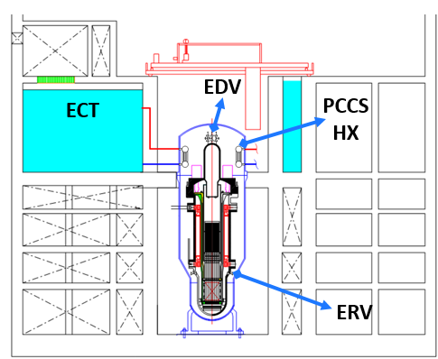

*FIG. 2. Configuration of passive emergency core cooling system*

#### Safety demonstration plan

Separate effect tests (SETs) will be conducted to confirm the safety performance of the PECCS. The SETs will verify the emergency recirculation flow rate of the PECCS.

As shown in Figure 3, the SET facility is designed to preserve the natural circulation height of the prototype and preserve the pressure drop coefficient of the ERV and the EDV for the prototype. From this test, the natural circulation flow rate of ERV coupled with condensation rate of the PCCS HX will be measured.

Another important phenomenon is natural circulation flow inside the PCCS HX. When accident comes, the containment heat transfers to fluid inside the PCCS HX. Thus, boiling and natural circulation flow is occurring from the ECT to the PCCS Hx. In this situation, density wave oscillation can be initiated in the specific operation condition. To validate the flow instability phenomenon in the ECT-PCCS HX loop, the PCCS loop flow rate will be measured at various core powers to establish the Database.

During this test, the temperature distribution in the ECT is also important measurement parameter. After the initiation of the natural circulation of the PCCS, hot fluid and steam are discharged into the pool of the ECT. Therefore, thermal stratification is expected in the ECT volume.

The experimental data will be utilized to verify the safety and performance analysis code (SPACE).

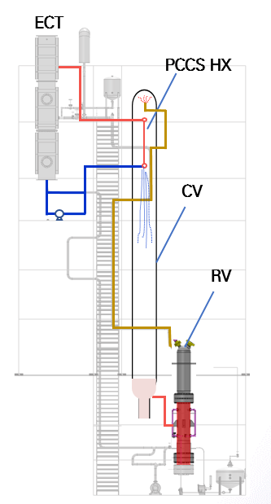

*FIG. 3. Separate effect test facility for natural circulation flow of PECCS-PCCS*

### Passive Auxiliary Feedwater System (PAFS)

#### Design characteristics

PAFS had been developed for APR+ to replace the conventional auxiliary feedwater system. The safety and performance of PAFS are already validated from the standard design approval of APR+.

As illustrated in Fig. 4, the horizontal heat exchanger of the PAFS is installed in the ultimate heat sink, the ECT. The piping starting from the front of the main steam isolation valve is connected to the top of the heat exchanger header inlet. The piping from the bottom of the heat exchanger header outlet is connected to the front of the main feedwater isolation valve. In the event of a design basis accident, the main steam isolation valve and the main feedwater isolation valve are closed, and the steam generator of RCS and the heat exchanger of PAFS become a closed loop.

As a result, steam from the steam generator moves to the heat exchanger by pressure difference, and condensation occurs inside the heat exchanger tube located in cold water of ECT. The condensed water accumulates in the PAFS supply pipe and is drawn back into the steam generator by the head difference. Through this natural circulation mechanism, the residual heat from the RCS is transferred to the ECT via the steam generator and PAFS heat exchanger.

The tube geometry of i-SMR PAFS is the same as APR+ but the number of tubes is changed. PAFS consists of two independent trains having 100% capacity of each train. PAFS of i-SMR is designed to cool down the RCS to safe shutdown condition within thirty-six hours after initiation of design basis accidents.

#### Safety demonstration plan

A series of tests for the prototype of PAFS are already performed from 2007 to 2022. As shown in Fig. 5, PAFS condensing heat removal assessment test lig. (PASCAL) test [3, 4] was conducted to evaluate the condensation performance of PAFS and to develop a condensation heat transfer model. In PASCAL test, the condensation heat flux, condensation heat transfer coefficient, natural circulation flow rate at the outlet pipe were measured for the single bare tube for the PAFS to establish the experimental database. Large scale PAFS loop for assessment of condensation Effectiveness (LAPLACE) test was performed to validate the performance of PAFS on a large scale [5, 6]. The bundle tube (15 tubes) for the prototype length were installed in the LAPLACE facility. The condensation heat transfer coefficients for the bundle tube under various operating conditions were measured to compare the condensation correlation of the single tube test. It is confirmed that the average of the bundle tube heat transfer rate and the natural circulation flow rate were the same with the single tube test data.

Integral effect test (IET), and ATLAS-PAFS test had been conducted for PAFS cooling performance coupled with the reactor coolant system. From these tests, the original database of PAFS was completely established to design the PAFS and condensation heat transfer model package in SPACE code [7].

For i-SMR PAFS, IET will be conducted to confirm the system performance with other passive safety systems in i-SMR.

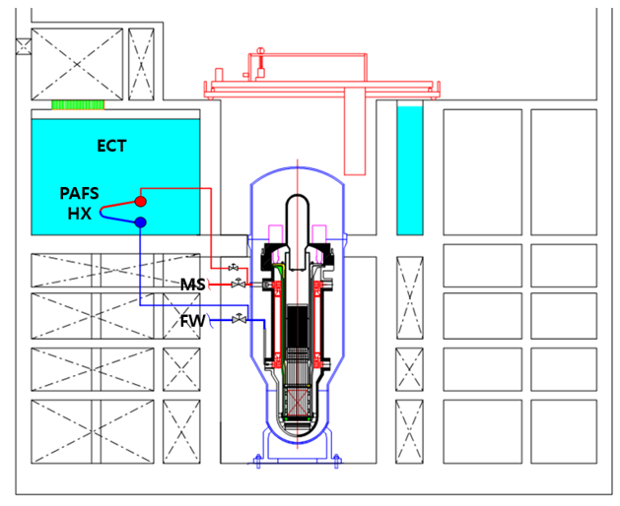

*FIG. 4. Configuration of passive auxiliary feedwater system*

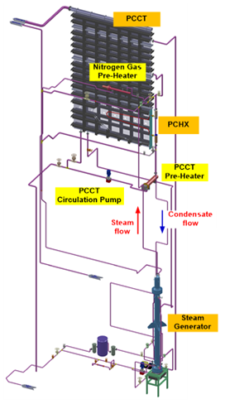 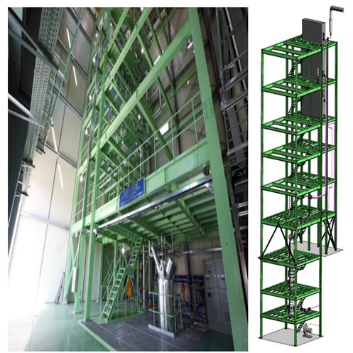 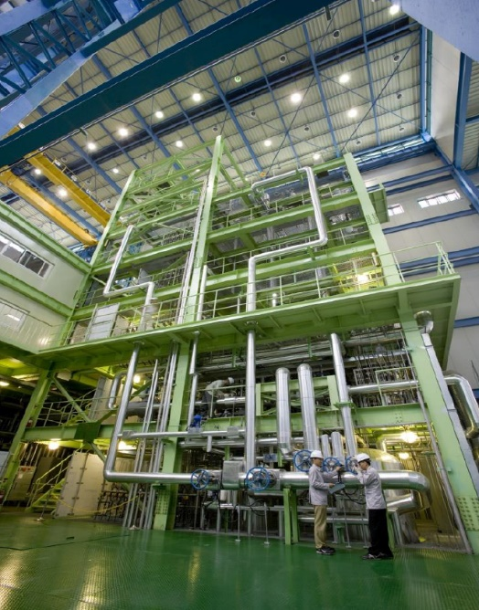

*FIG. 5. Layout of PASCAL facility (Left), LAPLACE facility (Middle), and ATLAS-PAFS facility (Right)*

### Passive containment cooling system (PCCS)

#### Design characteristics

The original design concept of PCCS had been developed for i-POWER [8] to replace the conventional containment spray system. The two independent trains of PCCS heat exchangers are installed in the top side of the steel containment vessel as shown in Fig. 6. The PCCS heat exchangers are connected with the ECT. In PCCS design, there are no valves to actuate the system. Thus, cooling water is filled inside the PCCS heat exchangers during normal operation.

When an accident occurs such as SBLOCA, the containment pressure and temperature are increased due to discharged steam from the breakpoint. After the accident progresses, the containment vessel pressure, and temperature will increase further due to the activation of PECCS. The released steam condenses on the cold surface of the PCCS heat exchanger. Due to the condensation heat transfer, the energy released to the containment vessel is released to the ECT through the PCCS heat exchanger. Inside the PCCS tubes, boiling occurs, which further enhances the natural circulation flow.

Since there are no actuation valves to operate the PCCS, there is no need for actuation signals and assumption of a single failure. The PCCS is designed to have sufficient heat transfer to keep the design pressure and design temperature of the containment vessel. It is also designed to reduce less than half of the peak pressure within 24 hours. The PCCS design ensures that the outer walls of the steel containment vessel remain dry at all times under normal and accident conditions. This has the advantage of placement of piping and valves, maintenance, and inspection.

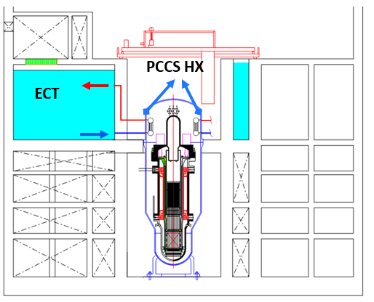

*FIG. 6. Configuration of passive containment cooling system*

#### Safety demonstration plan

The Condensation Loop for Advanced Safety System in Containment (CLASSIC) test [9] was conducted to obtain condensation heat transfer coefficient for single bare tube and bundle tube geometry. Under various non-condensable gas fractions and wall subcooling degrees, the PCCS heat removal performance was measured. i-POWER PCCS was designed to apply for the large dry concrete containment vessel, thus CLASSIC SET was performed under five bars.

Kang et al., also performed the condensation experiment under the various tube diameter condition, various pitch-to-diameter, non-condensation gas fraction, and wall subcooling condition. The new empirical correlation for the i-POWER PCCS was suggested [10, 11]. Above two different experiments showed that the bundle tube condensation test data fall into the single tube test data within about 10% deviation.

In the case of i-SMR, the design pressure of the containment vessel is about fifty bar. Therefore, we need to perform additional experiments under expanded pressure conditions. In addition, since the containment vessel is kept under vacuum during normal operation, the test condition should be close to the pure steam condition. As already shown in Fig. 3, SET for PCCS will be carried out to obtain the condensation data for the i-SMR condition.

Integral effect tests will be conducted to analyze the thermal hydraulic phenomena in the passive safety systems of the i-SMR and the main systems and components of the RCS. Major design basis accident tests such as LOCA, steam line break, and feedwater line break will be conducted to comprehensively verify the safety of the i-SMR. The test database will be utilized for the verification of the SPACE code. As shown in Table 1, the IET facility will be built with a height ratio of 1/2, an area ratio of 1/49, and a volume ratio of 1/98.

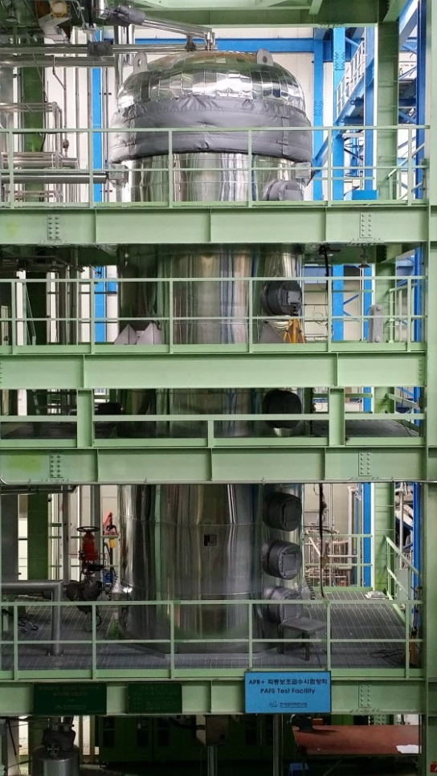

*FIG. 6. Configuration of passive containment cooling system*

TABLE 1. SCALING LAW FOR i-SMR INTEGRAL EFFECT TEST FACILITY

|  |  |
| --- | --- |
| Scaling Parameter | Model/Prototype |
| Pressure | 1/1 |
| Temperature  Length  Diameter  Area  Volume  Velocity  Time | 1/1  1/2  1/7  1/49  1/98  1/ $\sqrt{2}$ 1/ $\sqrt{2}$ |

## CONCLUSION

To prepare for the net zero scenario, the Republic of Korea is developing i-SMR. i-SMR requires a higher level of safety than the conventional nuclear power plant to be deployed near demand sites. The probability of an accident must be very low compared to large nuclear power plants, and even if an accident does occur, it must be designed so that the nearby public does not need to be evacuated. To achieve the safety goals of i-SMR, fully passive safety systems such as PECCS, PCCS, and PAFS are adopted. PAFS of i-SMR utilizes proven technology from APR+ and iPOWER. For PCCS and PECCS, a series of SET and IET will be conducted to verify the safety performance of the passive systems, including condensation heat transfer, boiling heat transfer, flow instability, and natural circulation flow.

ACKNOWLEDGEMENTS

This work was supported by the Innovative Small Modular Reactor Development Agency grant funded by the Korea Government (MOTIE). (No. RS-2024- 00404240)

References

1. IEA, Net Zero by 2050, A Roadmap for the Global Energy Sector, IEA, France, 2021.
2. IAEA, Advances in Small Modular Reactor Technology Developments, IAEA, Austria, 2022.
3. Byoung-Uhn Bae, Byong-Jo Yun, Seok Kim, Kyoung Ho Kang, Design of Condensation Heat Exchanger for the PAFS (Passive Auxiliary Feedwater System) of APR+, Annals of Nuclear Energy, 46 (2012) 134-143.
4. Seok Kim, Byoung-Uhn Bae, Yun-Je Cho, Yu-Sun Park, Kyoung-Ho Kang, Byong-Jo Yun, An experimental study on the validation of cooling capability for the Passive Auxiliary Feedwater System (PAFS) condensation heat exchanger, Nuclear Engineering and Design 260 (2013) 54-63.
5. Seok Kim, Yong Seok Choi, Byoung-Uhn Bae, Yusun Park, Seok Cho, Young-Jung Youn, Jong-Kuk Park, Hae-Seob Choi, Sang-Ki Moon, Overview of Commissioning Test of LAPLACE Test Facility, in: Korean Nuclear Society Spring Meeting, Jeju, Republic of Korea, May 19-20, 2022.
6. Sang-Ki Moon, Seok Kim, Yong-Seok Choi, Byoung-Uhn Bae, Yu-Sun Park, Seok Cho, Suk-Ho Lee, Sang-Won Lee, Validation of Cooling and Operational Performance of the Passive Auxiliary Feedwater System (PAFS) using the LAPLACE Test Facility, in: International Congress on Advanced Nuclear Power Plants, Gyeongju, Republic of Korea, April 23-27, 2023.
7. Sang-Ki Moon, Seok Kim, Yong-Seok Choi, Byoung-Uhn Bae, Yu-Sun Park, Seok Cho, Suk-Ho Lee, Sang-Won Lee, Validation of Cooling and Operational Performance of the Passive Auxiliary Feedwater System (PAFS) using the LAPLACE Test Facility, in: International Congress on Advanced Nuclear Power Plants, Gyeongju, Republic of Korea, April 23-27, 2023.
8. Sang-Won Lee, Sun Heo, Hui Un Ha, Han Gon Kim, The Concept of the Innovative Power Reactor, Nuclear Engineering and Technology, 49 (2017) 1431-1441.
9. Byoung-Uhn Bae, Seok Kim, Yu-Sun Park, Kyoung-Ho Kang, Experimental Investigation on Condensation Heat Transfer for Bundle Tube Heat Exchanger of the PCCS (Passive Containment Cooling System), Annals of Nuclear Energy, 139 (2020).
10. Jinhoon Kang, Huiyung Kim, Jinyeong Bak, Sang-Gyu Lim, Byongjo Yun, Condensation of steam mixed with non-condensable gas on vertical heat exchanger tubes in circumstances with free convection, International Journal of Heat and Mass Transfer 169 (2021) 120925.
11. [15] Jinhoon Kang, Jeongmin Moon, Youngchang Ko, Sang-Gyu Lim, Byongjo Yun, Steam condensation on tube-bundle in presence of non-condensable gas under free convection, International Journal of Heat and Mass Transfer 178 (2021) 121619.