**FLANGE MANAGEMENT APPROACH FOR RELIABLE**

**SMR REACTOR VESSEL INTEGRITY**

GARY BRIGGS

James Walker Sealing Products & Services

Woking, Surrey, UK

gary.briggs@jameswalker.biz

MARTIN COULTHARD

James Walker & Co. Limited

Cockermouth, Cumbria, UK

martin.coulthard@jameswalker.biz

ABSTRACT

SMR reactor pressure vessels depend greatly on the integrity of a bolted flange assembly. Whether subject to periodic refuelling cycles or through-life secure closure, the reliability and security of Reactor Vessel and ancillary containment will determine the overall safety of an SMR. This paper proposes the application of a highly proven approach from heat exchanger integrity technology to enhance the safety of SMR Reactor Pressure Vessels.

The “Flange Management” approach utilises holistic appreciation of flange design, seal specification and accurate bolt loading in the context of each specific application. Previous technology in nuclear has used varying methods, such as hot bolting, hydraulic tensioning and torque measurement. Whilst these have proven acceptable in some instances, the utilisation of Flange Management has emerged within nuclear structural inspection methodologies and offers a promising solution for the SMR community; reducing uncertainty, reducing time and reducing exposure to active environments within a plant. These integral elements of safety are achieved through practical elimination of uncertainty in design supported through analysis of all components in a system; utilizing already proven practices in similar applications.

1. INTRODUCTION

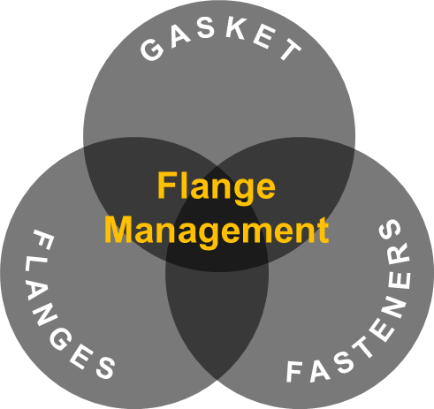As the focus on environmental sustainability and the reduction of harmful emissions intensifies, the issue of fugitive emissions (the unintended release of gases or vapours) from industrial activities, presents a challenge for planning future asset performance and integrity. In response, industries are progressively implementing stricter controls to control fugitive emissions and adhere to rigorous environmental regulations. Over time, various sectors have demonstrated a substantial commitment to this cause by adopting enhanced monitoring systems, the refinement of maintenance practices, updating sealing technologies, providing employee training, ensuring regulatory compliance and integrating technologies to decrease the levels of equipment leaks through fugitive emissions.

The EN 1591-1[4] calculation standard, currently applied in the assessment of flange connection design, is one of the most sophisticated algorithms for describing the operation of such joints (*See Appendix A*); it accounts for the elastic deformation of the joint and the elastic and plastic deformations of the seal. It also accepts limited plastic deformation of the flange and/or bolts. This allows for a comprehensive analysis of flange connection operation under various pressurized conditions, temperatures, and assembly states.

Fig. 1 – FMS Venn Diagram

The three key elements of flange joint reliability involve calculation of the appropriate gaskets, flanges and fasteners all working in synergy (Fig. 1). A key innovation in flange connection design and calculation is the consideration of the tightness class as input data for calculation. This paper delves into the factors surrounding this calculation standard and its value proposition in supporting nuclear SMR design and maintaining asset integrity over time.

1. A close-up of several different shapes

   Description automatically generatedFLANGES

Typically standard flange joints are chosen from a variety of flange types and different flange faces (Fig. 2); with the material of the flange selected based on the media’s chemical composition and targeted operating pressure & temperature. The design and shape of these flanges have been established over time and eventually codified under the supervision of international standards bodies like ASME, EN, DIN, API, and others. Their application across numerous industrial sectors has proven to be highly effective in delivering complete asset integrity.

A typical flange connection consists of three mechanical components: Fig. 2: Different Flange Types

* Flange
* Gasket
* Bolting

Flanges can be constructed from a variety of materials. Typically, the flange material is identical to or superior to the system’s material, often determined by the system’s specifications. The choice of flange material can be based on the type of media and the impact of temperature and pressure within the system. As a general rule, it’s advisable to avoid mixing different flange material qualities in a system to reduce risks associated with variations in thermal expansion coefficients and potential corrosion. However, there are instances where different grades of flange material can be mixed, especially when new equipment assets are integrated into existing site or plant infrastructure. In such situations, meticulous design and consideration are required for the interactions and relationships between flanges, bolts, washers, and gaskets to manage and mitigate the aforementioned risks.

Non-standard flanges can be engineered in accordance with ASME, EN, Taylor Forge, or other international standards, catering to a broad spectrum of process equipment such as pressure vessels, heat exchangers, reactors, and columns. Fig. 3: Bolted flange with load indicating bolts

The design of the flange and its hardware is typically established under the rules of the pressure vessel code, taking into account other design elements like the selected gasket type, materials, and bolting geometry. Given the design philosophies adopted at this stage, which can revolve around cost, quality, material availability, and maintaining long-term asset integrity; it is also feasible to conduct more comprehensive assessments. These assessments can incorporate operational variables like temperature, corrosion allowances, and expected thermal cycles and gradients over the equipment’s lifecycle, thereby reinforcing confidence in the original design philosophy.

1. GASKETS

The identification of suitable gasket selection for the application is one component of assuring integrity of the completed joint assembly; the performance of a gasket can be anticipated through a variety of characterisation testing. The European Standard EN13555[3] sets the benchmark for the design and testing of sealing gaskets for circular flange connections. It provides a framework for comparing gasket properties and introduces a new definition for maximum surface pressure. The standard also outlines four globally recognized parameters essential for achieving leak tightness in these connections. This section will delve into these aspects in some detail.

Tightness/leakage related factors:

* **QA**[MPa] – The gasket surface pressure at assembly prior to unloading,
* **Qmin(L)**[MPa] – The minimum level of surface pressure required to obtain the tightness class on assembly.
* **Qsmin(L)**[MPa] – The minimum level of surface pressure required to retain the tightness class after off-loading.

The meanings of the three values above are best explained in figures 4 and 5. The horizontal axis represents stress on the gasket [typically, MPa], the vertical axis represents leakage level [typically, mg/(m*s)] (also known as tightness classes). Figures 4 and 5 illustrate the variance that may be expected between different gasket sealing types. The left hand figure 4 is illustrates the tightness class that is achieved under increments of gaskets stress and figure 5 to the right then illustrates the maintained leak performance relative to loss in gasket stress through unloading; which illustrates the importance of proper gasket selection for the application requirement.

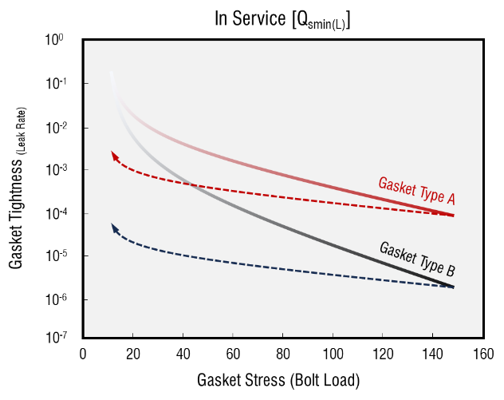

Fig 4: Illustration of gasket tightness in assy. Qmin(L) Fig 5: Illustration of gasket tightness in service Qsmin(L)

Gasket parameters and the gasket’s creep and relaxation properties, as defined in EN13555[3], are vital for gasket selection. The calculation parameters are continually refined to more accurately depict a gasket’s performance when fastened between two mating surfaces. A recent update includes an extension to the parameters that define the maximum surface pressure for a gasket material (QSmax). The prior standard emphasized the highest surface pressure a gasket could bear without mechanical failure, focusing mainly on mechanical gasket damage, but not on its dimensional stability. In the latest testing activities, new data constants (μG**)** have emerged that relate to surface tension/friction, flange surface finish, and varying gasket materials. These factors also include creep of gasket material at the bore and the impact this could have on gasket flow at the pipe bore. The EN13555[3] testing program provides additional data on this topic area. Test data availability in these areas can support customer for setting control measures for flange surface finish and limits on maximum allowable seat stress on gaskets to alleviate this issue.

The services offered for these tests encompass: the assessment of creep compression, compression relaxation and classification of leakages. The data collected from these tests is utilised to compute coefficients for the EN1591-1[4] algorithm. These tests are conducted under varying loads and temperatures, with the capability of test temperatures up to 400°C, (with options up to 800°C or cooling down to -150°C). Testing programs are run using calibrated testing equipment with fixed testing procedures to ease in cross comparison of different gaskets datasets. Test gasket samples are set to PN40 DN40 standard gasket sizes, to support the ability of cross assessment. Additionally, there is the capacity to carry out other non-standard tests and experiments as per customer requirements, such as thermal cycle testing, hot blow out testing, and testing of alternative sealing products like O-rings.

As the result of tests performed – the following gasket design factors are defined:

* QSmax and EG at ambient temperature
* QSmax and EG at temperatures elevated to 400°C*
* PQR at ambient temperature
* PQR at temperatures elevated to 400°C*
* Qmin(L) and Qsmin(L) at ambient temperature and elevated up to 400°C*

*With extended temperature options down to -150°C up to 800°C

QSmax Maximum allowable gasket stress without collapse or destruction

QSmin Minimum gasket stress required under the service pressure conditions (i.e., after off-loading and at the service temperature) to maintain the required tightness class L for the internal test pressure

EG Unloading modulus of elasticity determined from the thickness recovery of the gasket between the initial compression surface pressure and unloading to a third of this initial surface pressure (modulus of elasticity)

PQR Factor allowing for the effect on the imposed load of the relaxation of the gasket between the completion of bolt up and long-term experience service temperature

∆eGc  The change in gasket or sealing element thickness due to creep

μGThe static friction factor between the gasket and the flange facing.

In summary, EN 13555[3] offers a comprehensive and reliable guide for the testing and selection of gaskets in industrial applications. It sets key parameters and provides detailed testing procedures, ensuring that gaskets meet high-performance standards and contribute to reducing fugitive emissions, thus improving asset efficiency, safety, and integrity. The adoption of leakage test standards enables industries to enhance sealing performance, operational efficiency, and environmental sustainability. While no single standard covers all aspects of sealing, the combination of EN 13555[3] with other widely used industry standards, such as ASME B16.20[5] or customer-specific proprietary methods, allows the industry to continue prioritising environmental targets and regulatory compliance. These testing methodologies play a vital role in promoting the development of improved gaskets and enhancing the overall reliability and safety of industrial operations. By aligning industry practices with existing standards and specifications, we can potentially extend the use of gaskets characterisation data and these practices into servicing the nuclear sector, while providing a solid foundation of knowledge for technical services and support.

1. FASTENERS

In all connections involving bolted flange joints, the fasteners play a pivotal role in the design and expected functionality of the joint throughout its service life. These fasteners serve as a means to generate clamping force between the opposing faces of the joint. The tension created must be sufficient to seat and seal the joint during the initial assembly, and ideally, it should be able to withstand a wide array of mechanical, thermal, and process interventions that could result in a loss of clamping load due to the intricate interactions among the individual components of the joint over time. Some of these forces are illustrated in Fig. 6.

The assembly and operational behaviour of all hardware components are influenced by numerous variables, many of which are challenging or even impossible to control or accurately predict. Consequently, when dealing with bolted flange joints, we must inevitably contend with a significant amount of uncertainty, which primarily manifests once the joint is operational.

.

Fig. 6: Forces on a flange connection schematic

A robust flange management program will examine the individual components of the joint (Flanges, Gasket and Fasteners) and how they will interact with each other at the installation/make-up of the joint and then under the wider array of operational conditions found during service. In its simplest form, the target assembly clamp load (*Sbsel, see figure 7*) should be sufficient to meet the operational requirements of the application taking into account the desired parameters of performance such as joint tightness which are ultimately affected by stress relaxation (all components), creep, thermal transients, pressure spikes, external moments, vibration/fatigue and not least, the methods used to assemble the joint and the attention paid to achieving (and then maintaining) clamp load in the fasteners to a minimum desired limit (*Sbmin, see figure 7*).

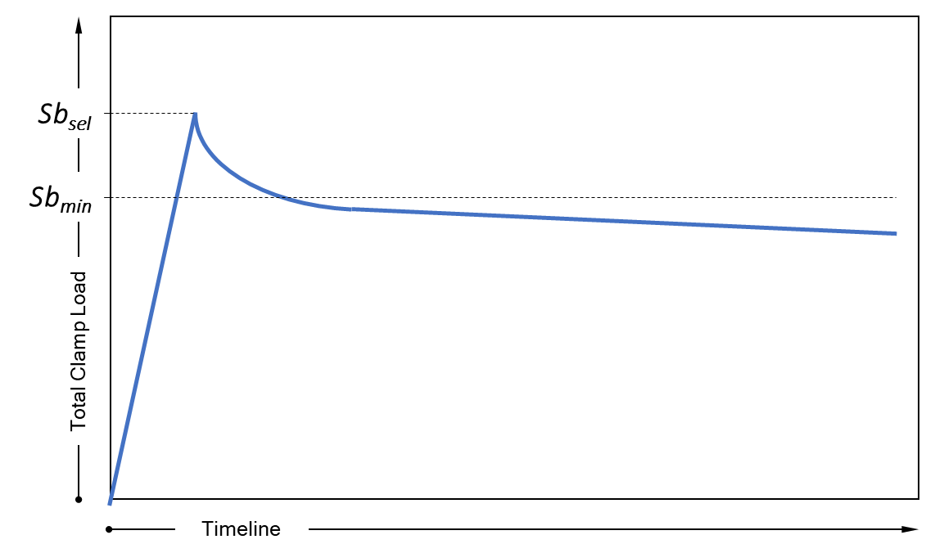

Fig. 7: Schematic that illustrates target load *Sbsel* and the load loss over time

The majority (>80%) of bolted flange joints that fail (defined as an unacceptable initial loading or loss of joint integrity/tightness) are due to initial overloading of the joint or a loss of clamp load over an extended period of time. That said, having a clear understanding of the importance in getting the optimal clamp load being applied at the start of the assembly phase is key to achieving longer term joint integrity over the intended life-cycle of the joint. There are many factors that need to be considered in trying to achieve the ‘target’ clamp load whether it’s the method of tightening the fasteners (generally torque or tension), but also the tightening sequence, new or used fasteners, hardened steel back-up washers, friction, type of lubricant, competence of the assembler, elastic interaction of the fasteners and a whole lot more to be sure that the translation of theoretical clamp load is delivered into useful working load at the flange faces and subsequently onto the gasket.

Just because the torque wrench is ‘clicking’ at the desired torque setting or, the hydraulic pressure on the tensioning tool is reading the desired setting doesn’t necessarily mean the fasteners have delivered the theoretical pre-load through the flanges and onto the surfaces of the gasket. In fact, all we actually know, is that based on the assumptions we’ve made regarding Hooke’s law and the generation of bolt stress (or clamp load) for a given method of delivering bolt extension, the bolt load is within some arbitrary figure anywhere between ±5% and ±30% and not always a reflection of actual clamp load that’s actually applied to the gasket.

The flange management concept involves understanding the entire hardware package of the bolted flange joint and the environment to which the pressure boundary closure is to be exposed. Taking ownership of the entire process (including the installation, assembly and commissioning into service) is the only way to ensure that for critical flanged connections the assumptions made at the design stage are implemented into practice.

1. EN1591-1

In the field of Small Modular Reactor (SMR) design, a number of standards support pivotal roles towards the integrity of SMRs including: ASME BPVC and EN1591-1. The ASME standard provides a thorough framework for the construction of pressure vessels & nuclear components; focusing on materials, design, and testing to ensure safety and integrity. The EN1591-1 standard, while applicable to various industries, offers detailed guidance on flange and joint design, crucial for SMR components with flange connections. The choice of standard may depend on the project's location and specific design requirements, with ASME being crucial in the U.S. for its comprehensive approach to nuclear safety, and EN1591-1 in Europe for its focus on flange connection integrity. In either case a maintained compliance with these standards is essential for the safety and performance of SMR designs; supporting the preferred approach for best available practice.

The EN 1591-1[4], a European Standard, provides a calculation methodology for bolted, gasketed & circular flange joints. Its primary aim is to ensure structural integrity and control leak tightness in these connections throughout their expected service life. This standard takes into account the entire system, including the flange, bolts, gasket and tightening method (to account for scatter and frictional losses). It uses tightness classes to maintain leak-tightness after installation and under subsequent conditions, such as hydrotesting of equipment to design condition, followed by operational (Load Condition 1) and cool-down (Load Condition 2) conditions, which cover both an upper and lower anticipated performance envelopes (see appendix A for details). Thus, ensuring that the loads and stresses the joint connection is subjected to at all points of its service life will not damage any components and are within the sealing range (as defined by the tightness class required).

Gasket parameters, based on definitions and test methods specified in EN 13555[3], are crucial to EN 1591-1 [4]. These parameters include the maximum allowable surface pressures at room and operating temperatures, the gasket’s modulus of elasticity, and the seating value. The minimum seating pressure for the corresponding tightness class (L) is considered during assembly and in the operating condition. Additional factors, such as the friction between the gasket and the flange face, determine permissible shear forces or torsional moments. During the EN 1591-1[4] calculations, it is possible to quickly assess the relative performance envelope from one gasket product to another to ensure optimal performance in the final equipment assembly.

EN 1591-1[4] calculations enable a thorough verification of the flange connection by considering the strength characteristics of the flange, bolt, and gasket. It also takes into account the coefficient of thermal expansion of flange and stud bolt materials, especially when using a variety of metal grades. Through technical knowledge and expertise, it is also possible to generate assumptions and rule sets around thermal transients, corrosion allowances, flange rotation effects, and ensuring suitable safety factors around bolt yield strengths. This allows for minimum to maximum target bolt stress allowances via different methods for bolt loading, such as hydraulic tensioning, torque tightening, or even load indicating fasteners.

Compared to other methods, EN 1591-1[4] offers several advantages. It allows for the precise determination of the minimum and maximum tightening torque during assembly. Its iterative calculation process ensures accurate limits, leading to material-saving and optimal flange connection design. Notably, it offers advantages towards flange calculations according to ASME or Taylor Forge by incorporating a range in temperature operations and modelling the complex elastic interactions between all assembled components, for their full intended performance envelope; with an example of a typical calculation survey presented in Appendix A.

1. CONCLUSIONS

It is possible that the operational safety of Small Modular Reactor (SMR) in the future can be enhanced by adopting a comprehensive EN1591-1[4] calculation approach utilising EN13555[3] gasket characterisation datasets. This approach can be involved right from the initial design of the asset, works in tandem with on-site maintenance engineering teams for equipment commissioning, and supports the long-term maintenance and integrity of the asset. Collectively, these efforts ensure the robustness of the various bolted flange assembly connections associated with SMR technology. The “Flange Management” strategy, derived from existing heat exchanger integrity technology, can be utilized to strengthen the safety of SMR Reactor Pressure Vessels. This strategy combines flange design, seal specification, and accuracy in bolt loading; offering a solution for the SMR customer by reducing uncertainty, saving time, and minimizing the possible risk of exposure to active environments. It achieves these safety measures by further reducing design uncertainty through detailed calculations and the application of proven methods.

In the context of bolstering future SMR performance, the use of EN 1591-1[4] can play a crucial role in ensuring the safety and reliability of flange connections across the asset; as well as facilitating the installation of equipment to existing site and plant infrastructure. The calculations provided can support both the design of small modular reactors and the engagement with site maintenance teams in installing and commissioning the equipment. It establishes a robust link between the existing original equipment design methodologies of ASME and Taylor Forge; and adding further detail via the EN1591-1[4] calculation approach, thereby enhancing the overall integrity and performance of these critical systems.

1. REFERENCES

[1] ASME PCC1-2019. “Guidelines for Pressure Boundary Bolted Flange Assembly”.

[2] Bickford, J.H., “An Introduction to the Design and Behaviour of Bolted Joints”. CRC Press 1995

[3] EN 13555-2021. “Flanges and their joints - Gasket parameters and test procedures relevant to the design rules for gasketed circular flange connections”.

[4] EN1591-1:2013, “Flanges and their joints. Design rules for gasketed circular flange connections Calculation”

[5] ASME B16.20-2023. “Metallic gaskets for pipe flanges’

**APPENDIX A**

Fig. 8 – Example flange management calculation sheet

**APPENDIX B**

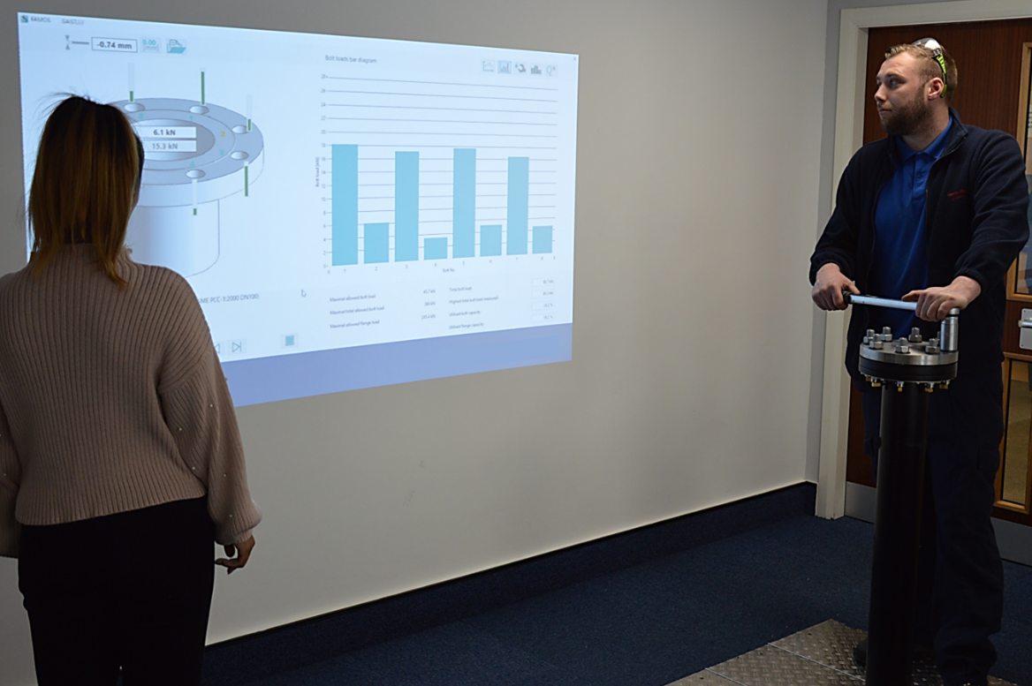

Fig. 9; Image showing demonstration rig and how the bolts interact during gasket assembly