THE QUALITATIVE RELIABILITY STUDY OF THE TMSR500
PASSIVE COOLING DESIGN AND DESIGN REQUIREMENTS APPLICABILITY

D.H. SUKARNO
Nuclear Energy Regulatory Agency (BAPETEN)
Jakarta, Indonesia
Email: d.hidayanti@bapeten.go.id

Abstract

Almost all advanced reactor designs, including SMRs, rely on passive cooling features in the decay heat removal process. However, the reliability of the passive cooling system must be carefully evaluated due to the limitation of experimental data. Advanced reactor designs, specifically non-water-cooled reactors, also face the challenge of the applicability of the existing safety design requirements. In this study, a qualitative reliability study of the TMSR500 passive cooling design has been performed. The applicability of the existing safety design requirements to the TMSR500 passive cooling design is also discussed. The reliability of the TMSR500 passive cooling system is studied qualitatively using fault tree analysis. The result of the study informs that the flow resistances in the system, especially those that disturb the access to the ultimate heat sink (atmosphere), become the key parameters in causing the failure of natural convection. The mechanical integrity of the system is also an important factor in maintaining the reliability of the passive cooling system. In general, the requirements in the IAEA Safety Standard No. SSR-2/1 (Rev. 1), concerned with the design of the passive cooling system, are applicable to the TMSR500 design. Several minor gaps have been identified, such as the interpretation of the integrity of the fuel, the reactor coolant pressure boundary, and the possible decay heat locations.

INTRODUCTION
Currently, advanced reactor designs are constantly being developed internationally. Many advanced reactor designs are small modular reactors (SMRs) and several SMR designs are non-water-cooled reactors. The majority of advanced reactors use passive cooling features for decay heat removal. The passive cooling features minimize the dependency on power supplies to operate active safety cooling systems, especially in accident conditions. The active cooling system failure can cause nuclear accidents, such as the Fukushima accident.
Although passive cooling features have a simple design and low cost, their reliability may not been adequately investigated, especially for non-water-cooled reactor designs. The reliability of a passive cooling system must be carefully evaluated due to the limitation of experimental data. Therefore, reliability studies of passive cooling systems are needed, especially for new reactor designs. As the initial stage, the qualitative reliability study can be conducted to analyse the components which have high contributions to the system reliability. This study aims to conduct a qualitative reliability study, by using the failure modes approach, on the passive cooling system of ThorCon Molten Salt Reactor (TMSR)500 NPP design. The TMSR500 is a new non-water-cooled-SMR design which is developed by ThorCon Power Indonesia Ltd and producing 500 MWe of electric power. The reactor utilizes molten salt as the fuel and the primary coolant. The general layout of the TMSR500 power plant can be seen in Fig. 1.
From the regulatory body’s point of view, the applicability of standards and regulations to new reactor designs is very important. The rapid development of advanced reactor designs should be followed by the improvement of regulatory infrastructure, especially standards, regulations, and guidance. Therefore, this study also discusses the applicability of the existing safety design requirements to the TMSR500 passive cooling system.

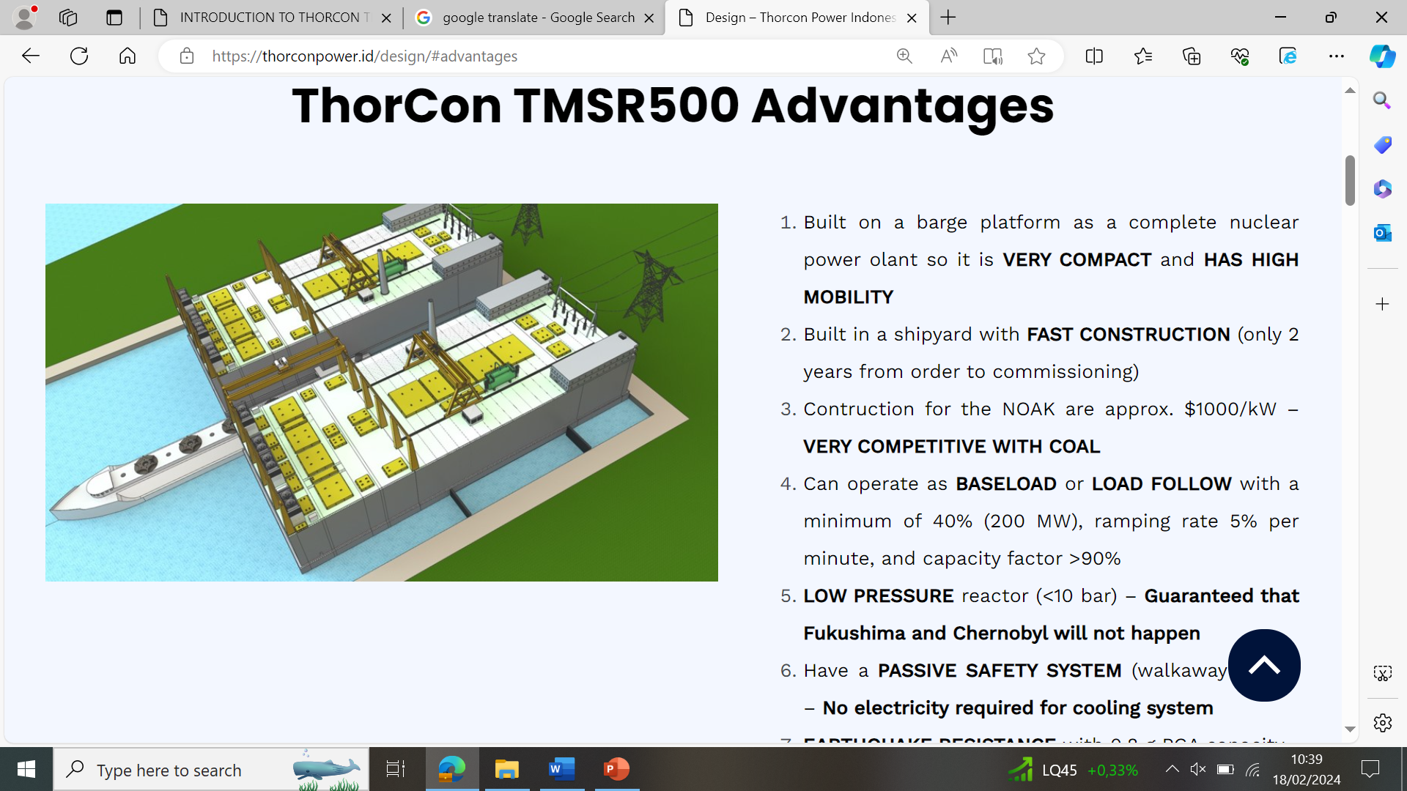
FIG. 1. The design of 2 x 500 MWe TMSR500 NPP [1]

Passive Cooling Implementation in the TMSR500 Design
The TMSR500 design discussed in this paper refers to the reference [1]. As shown in Fig. 1, the 500 MWe plant consists of two power modules. Each power module produces 250 MWe. The module is divided into three sections (see Fig. 2), i.e., section 1 (the silo hall), section 2 (the secondary heat exchanger hall), and section 3 (the steam generating cell hall).

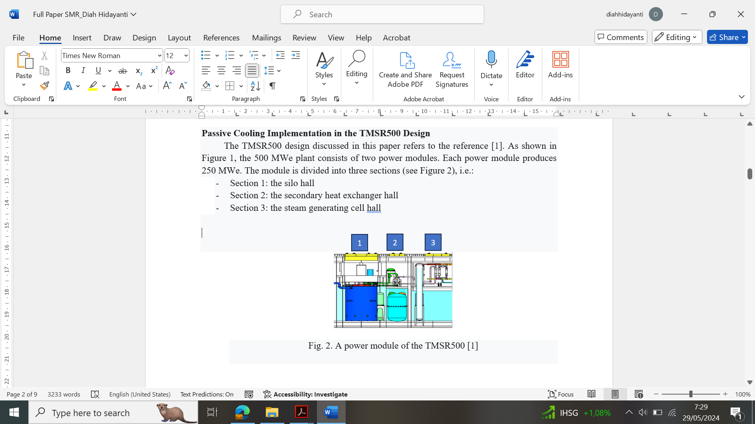
FIG. 2. A power module of the TMSR500 [1]

As shown in Fig. 3(a), the silo (blue colour) is a double concentric steel tank which forms an annulus which contains the basement water as the passive coolant. That is why the silo wall is also called the cold wall. In the silo hall, there are a steel can (red colour), a fuel drain tank (green colour), and the primary loop pump. The steel can contains a pot as the reactor core (yellow colour), a primary heat exchanger, and several tanks for fuel management (see Fig. 3(b)). Each power module has two cans, one can is in power operation and the other can is in cooldown mode. After 4 years, the cooled can is removed and replaced with a new one.
In operation condition, the core heat is removed by the active system using a primary loop pump as the conventional reactor design (see Fig. 3(c)). The cold fuel salt (560°C) flows down through the outer portion of the pot. Then, the hot fuel salt (704°C) flows up through the graphite moderator. The pot pressure is around 2-8 bar with no phase change.

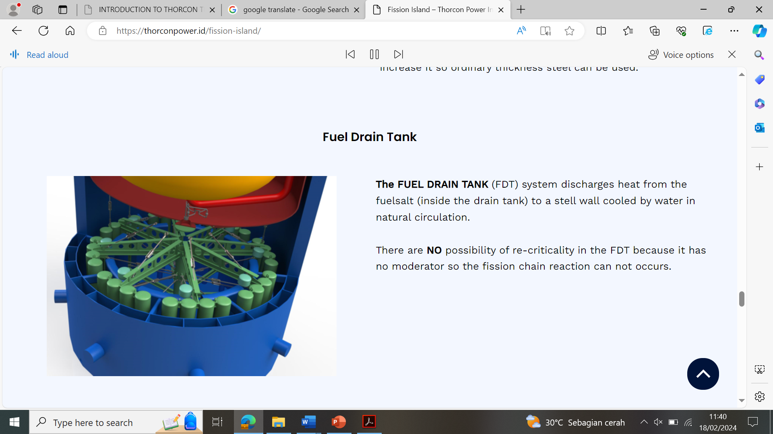 | 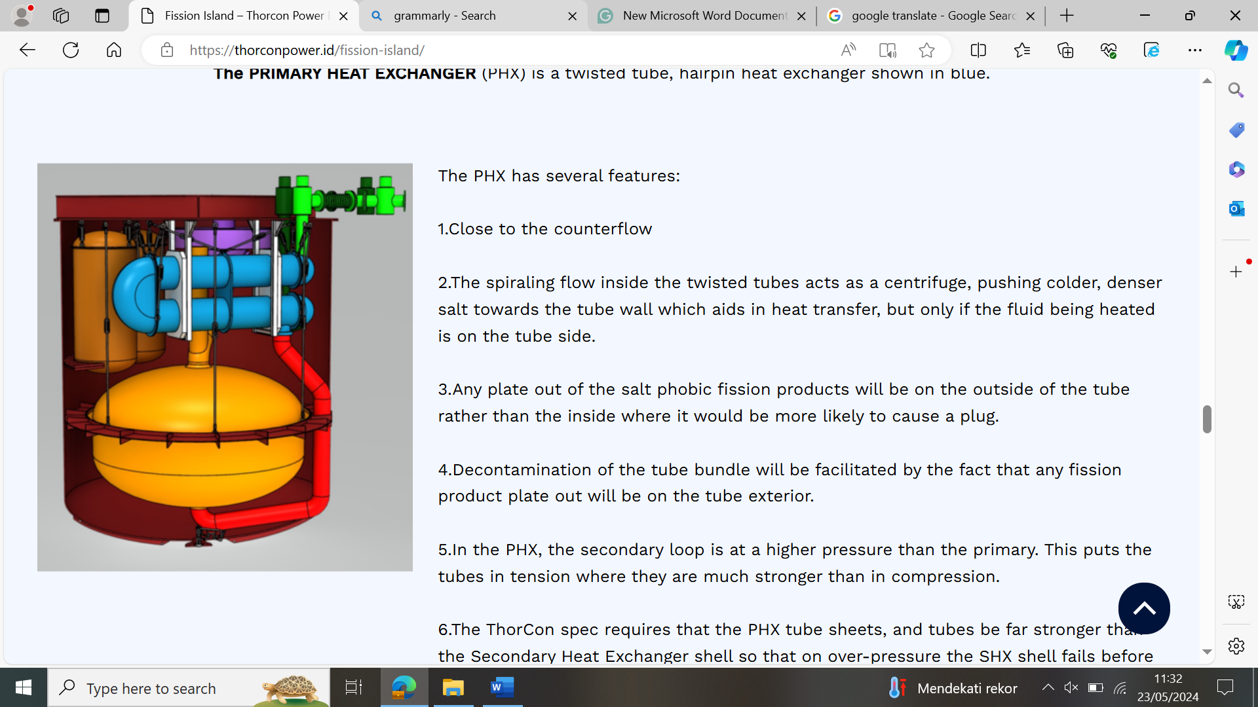 | 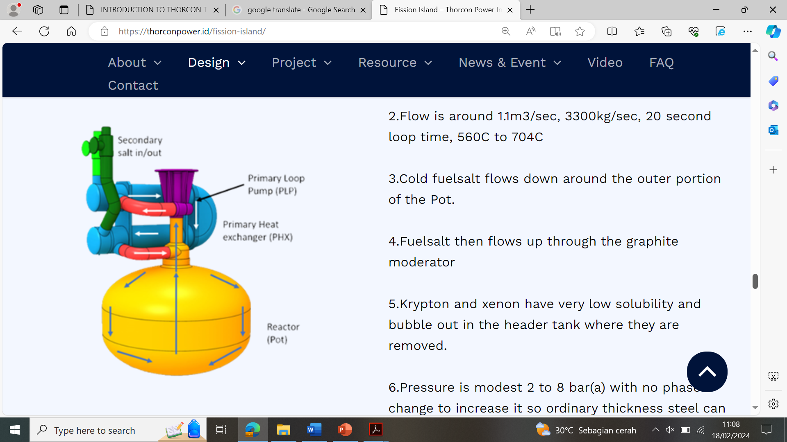
(a) | (b) | (c)
FIG. 3. The TMSR500 fission island design; (a) The silo; (b) The can; (c) The primary loop system [1]

All three sections in a power module (see Fig. 2) have basements which are flooded by water. The basement water plays an important role in the decay heat removal. It acts as the passive coolant which removes the decay heat by natural convection process. In shutdown and accident conditions, the decay heat is removed by a fully passive system. The passive cooling system also contributes to normal operation.
As depicted in Fig. 4, the passive cooling system operates in the silo hall and the forward (FWD) hall through two mechanisms. They are as follows:
- Natural convection of water (in the silo hall)
After the reactor shutdown, the fuel salt drops from the pot to the fuel drain tank. The decay heat is radiated from the fuel drain tank to the water in the cold wall. Fig. 4 shows that the cold wall water, the basement water and the spent fuel storage (vault tank) water are connected. The cold wall water naturally circulates up to the expansion tank and down to the radiators, then back down to the basement.
- Natural convection of air (in the FWD hall)
The FWD hall provides full passive air cooling utilizing dry radiators, two draft towers (chimneys) with an expansion tank in between, and two fans for each chimney. In the dry radiator, the decay heat is transferred from the cold wall water to the air which comes from the chimney inlet. Then, the hot air naturally circulates into the atmosphere through the chimney outlet. The fan assists in decreasing the air temperature. Passive air cooling is designed to prevent the basement water from boiling even at full decay heat with no fan operation [1].
There is no need for operator intervention in the passive cooling system operation until 3000 days. There are also no valves that must be realigned by either the system or the operator. [1].

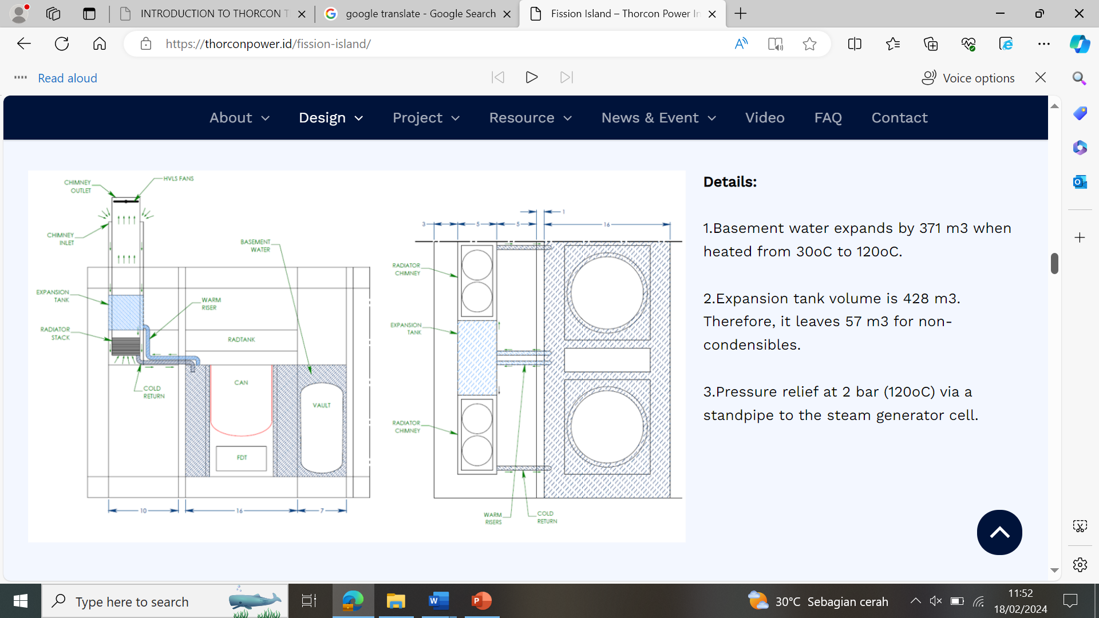

FIG. 4. The passive cooling system of the TMSR500 [1]

QUALITATIVE RELIABILITY ANALYSIS
The reliability of the TMSR500 passive cooling system is studied qualitatively using the failure modes approach. The purpose is to provide a preliminary appraisal of the system’s unavailability. The methodology used in this paper is the simplification of the APSRA methodology [2]. The method consists of four steps: 1) Identification of parameters affecting the operation; 2) Identification of key parameters which may cause the failure; 3) Root diagnosis to find the deviation of key parameters for causing system failure (using fault trees); and 4) Evaluation of system reliability.

Step I
In the TMSR500 passive cooling system, natural circulation heat transfer occurs in the cold wall (by water) and the dry radiator (by air). Several factors or parameters which may affect the natural circulation flow rate in one phase fluid are 1) cold wall inlet water temperature; 2) cold wall pressure; 3) presence of non-condensable gas; and 4) flow resistances in the system

Step II
Based on the result of step I, key parameters which may cause the failure of the passive cooling system can be identified. They are the cold wall inlet water temperature and the flow resistances in the system. The increase of annulus pressure does not degrade the natural convective heat transfer. The pressure increase caused by the increase of basement water pressure will support the buoyancy force in the cold wall.
The probability of the presence of non-condensable gas outside the silo hall is small. The non-condensable gas released in the core, such as krypton and xenon, will bubble out in the header tank due to their low solubility. In the header tank, the gas is finally removed.
The increase of basement water temperature which enters the cold wall affects the performance of natural convection in the annulus. It will decrease the heat radiated from the fuel drain tank which can be transferred to the water in the annulus through natural convection. The flow resistances in the system will also disturb the natural convection of water in the cold wall and air in the dry radiator.

Step III
Investigation of factors or parameters which contribute to the increase of cold wall inlet water temperature and flow resistances in the system can be performed using fault tree analysis as shown in Fig. 5. The radiator outlet pipe is the pipe which connects the radiator outlet to the basement, the expansion tank outlet pipe is the pipe which connects the expansion tank to the radiator, and the expansion tank inlet pipe is the pipe which connects the expansion tank to the basement.

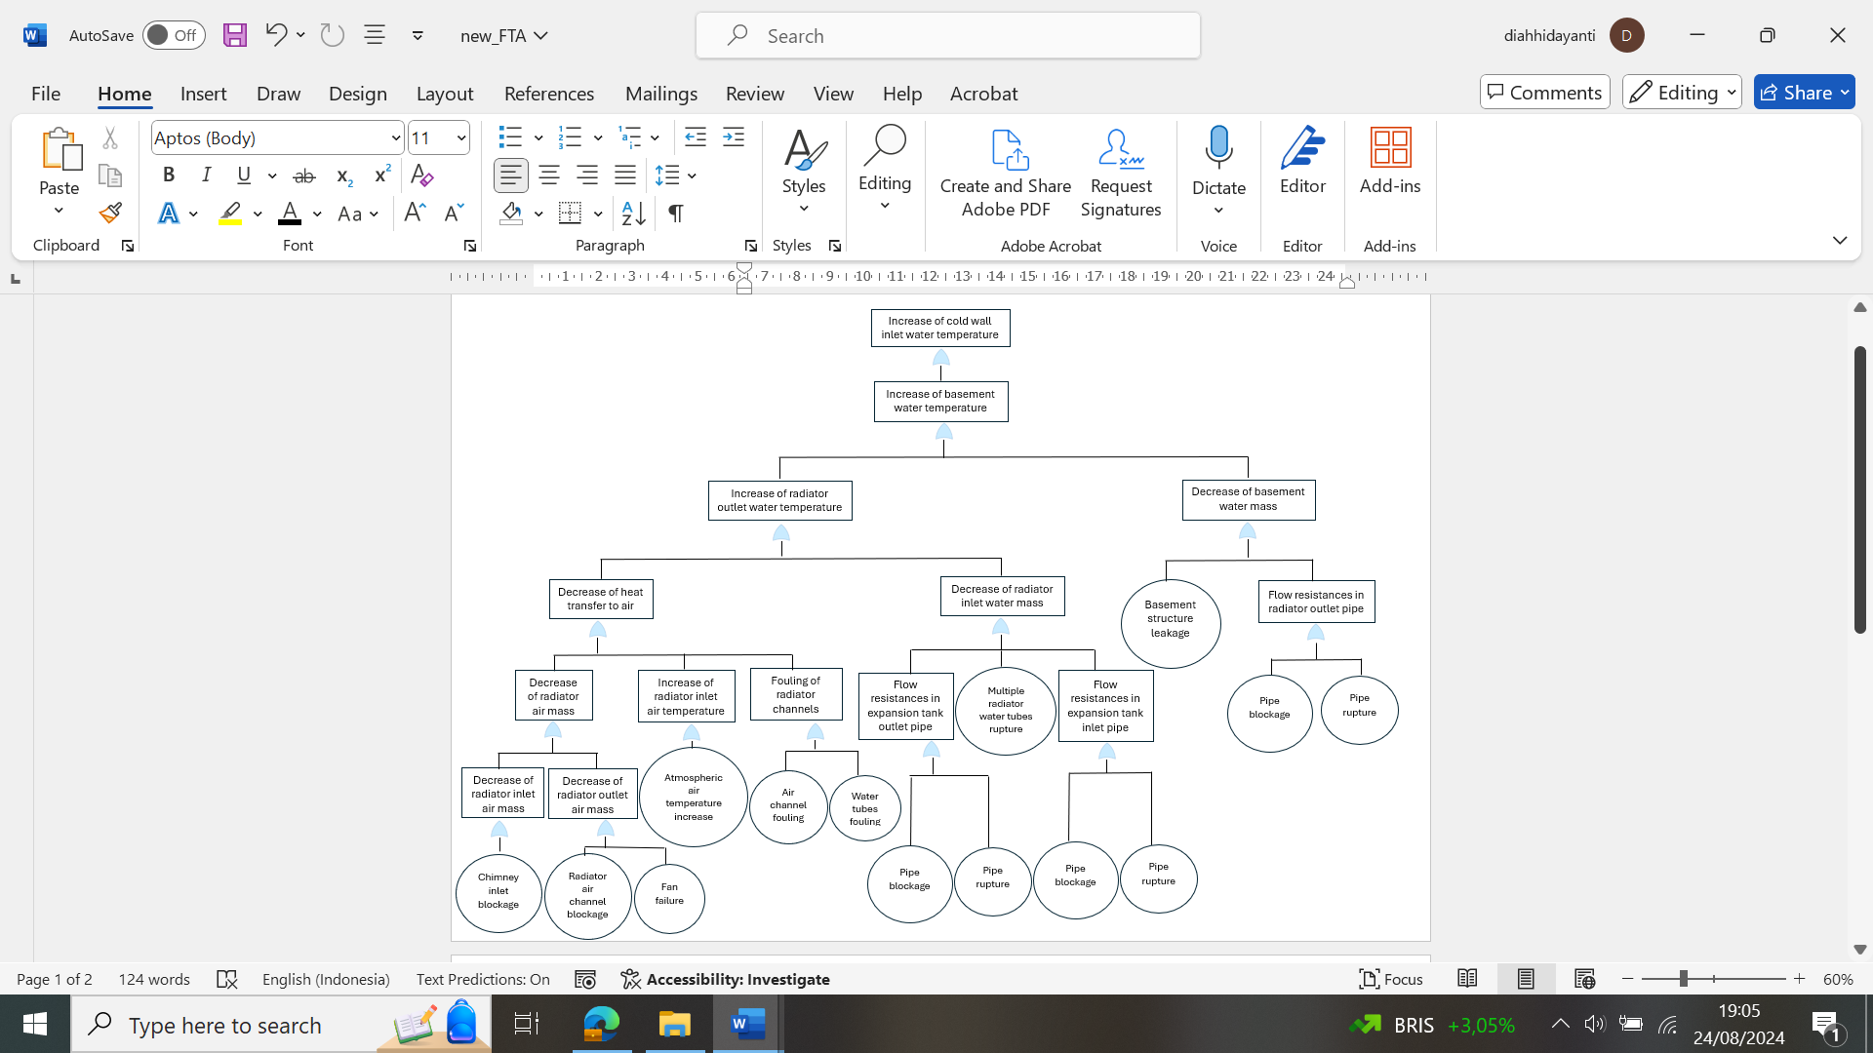
FIG. 5. Fault tree analysis

Step IV
In step IV, the result of step III can be evaluated qualitatively and quantitatively. The quantitative evaluation needs the values of the failure rate of components in all basic events. The reliability of the TMSR500 passive cooling system is determined by the probability of the increase of cold wall inlet water temperature which is calculated by summing all the probability of all basic events. Fig. 5 shows 14 basic events in the fault tree analysis.
In this paper, evaluation of the reliability of the TMSR500 passive cooling system is performed qualitatively by identifying the root causes of an undesired event that mostly threatens the passive cooling system, i.e., the increase of cold wall inlet water temperature. Based on all basic events shown in Fig. 5, there are several factors which become the root causes of the increase of the cold wall inlet water temperature, i.e.,:
- the flow resistances (blockage and fouling) in the system (in the chimney inlet, the radiator channels and tubes, the expansion tank inlet pipe, the expansion tank outlet pipe, and the radiator outlet pipe);
- the system rupture (the basement structure, the expansion tank inlet pipe, the expansion tank outlet pipe, the radiator outlet pipe, and the radiator water tubes);
- the failure of fans; and
- the increase of atmospheric air temperature.

The mechanical structures, systems, and components (SSCs) (i.e., the basement, the expansion tank, the dry radiator, the chimney, and the system piping) shall be designed to withstand the loads caused by the external hazards in the site. Therefore, they shall be designed, manufactured and fabricated with suitable quality requirements. To monitor the mechanical system integrity and the flow resistances, additional features, such as leak detector, flow rate meter, or basement water level indicator, should be available. The appropriate interconnections and isolation capabilities are also needed.
To ensure that the TMSR500 passive cooling system can keep its function and maintain plant safety at all plant states, it shall be analysed at the conservative values of the parameters which contribute to the system reliability, such as the atmospheric air temperature, the channels or tubes fouling quantity, and the number of failed fans. In the quantitative reliability calculation, the redundancy in the number of chimneys and fans must be taken into account. One power module of the TMSR500 has two chimneys with two fans for each chimney.

Applicability of Safety Design Requirements to the TMSR500 Passive Cooling Design
In the IAEA Safety Standard No. SSR-2/1 (Rev. 1) [3], the safety design requirements concerning the reactor coolant system are stated in Requirements 47–53. The requirements concern to the passive cooling system operation in the shutdown state, and accident condition are Requirements 51-53. The IAEA Safety Report Series No. 123 [4] has stated that Requirements 51-53 are generally applicable to evolutionary and innovative designs. In this paper, the applicability of Requirements 51-53 to the TMSR500 passive cooling design will be discussed.

Requirement 51: Removal of residual heat from the reactor core
In the molten salt reactor, the fuel salt is drained to the fuel drain tank to reach the subcriticality and shutdown the reactor. Finally, the decay heat will be fully located in the fuel drain tank, not in the core. The reactor shall be designed so that there is no failure to drain the fuel salt from the core to the fuel drain tank. In conditions where the fuel salt fails to flow down to the fuel drain tank, the features to ensure the subcriticality of the fuel salt in the core should be available. However, the passive cooling features shall also be ensured to remove the decay heat from the core in the case where the fuel salt fails to drop. So, the TMSR500 passive cooling system shall be able to remove the decay heat at all possible locations.
The TMSR500 NPP has provided a passive cooling system to remove the residual heat from the drain tank in the shutdown state and accident condition. Several means are provided for applying the passive cooling of decay heat, i.e.,:
- the cold wall and dry radiators are the channels for natural circulation heat transfer;
- the chimneys and fans allow the heat transfer from the plant to the atmosphere;
- the expansion tank is designed to accommodate non-condensable gas and expansion of the basement water when heated; and
- the basement is built to store the water as the passive coolant.
Besides the fuel salt decay heat, the off-gas heat shall be also removed. In the TMSR500, the off-gas is stored in the HUP tanks (see Fig. 6) until the decay heat is tolerable for cold traps. However, the reference [1] does not further explain the cooling features in the off-gas system.
The passive cooling system shall ensure the decay heat removal in the shutdown state works well such that the design limit for fuel is not exceeded. The design limit for fuel salt is its boiling point (1430°C). So, there is a large margin between the operating temperature (± 700°C) and the boiling point of the fuel salt. The creation of bubbles in the salt increases the pressure in the fuel tank and jeopardizes the tank’s integrity. The bubbles may also induce positive void reactivity [5]. In the TMSR500, the term of reactor coolant pressure boundary is less relevant because the primary loop works at near-ambient pressure (about 2-8 bar). In the event of the rupture of a primary loop, there will be little pressure release. However, the integrity of the primary coolant boundaries, such as the pot, the fuel drain tank, and the primary heat exchanger, is needed to maintain. The design limit for the structures important to safety (e.g., the can and the silo hall), shall be ensured to be not exceeded.

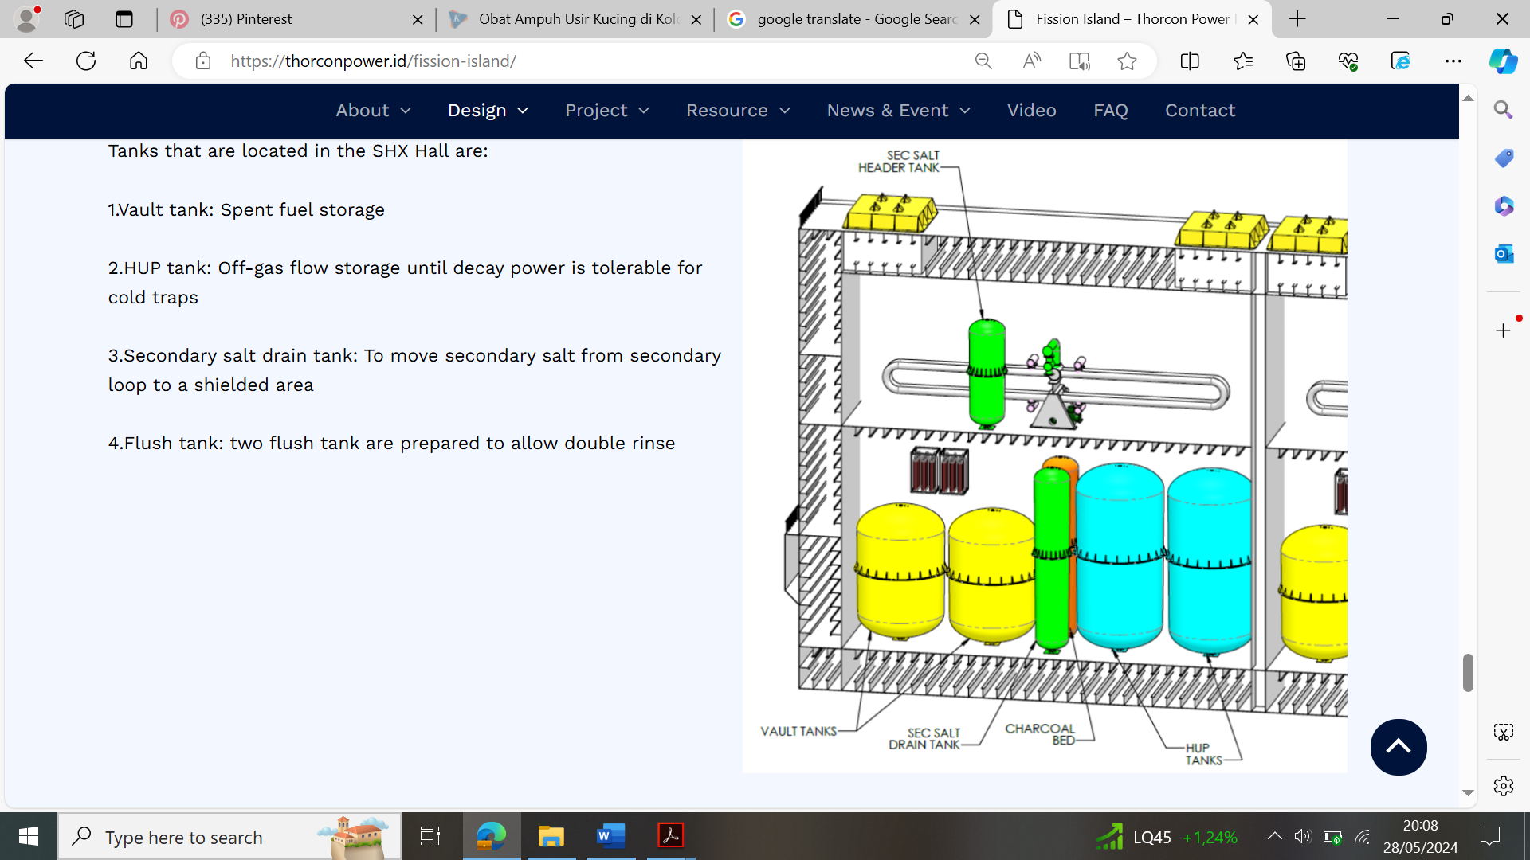
FIG. 6. The TMSR500 secondary heat exchanger hall [1]

Requirement 52: Emergency cooling of the reactor core
The TMSR500 passive cooling system works in the shutdown state and also in the accident condition. Accident analysis is needed to ensure that the passive cooling system can remove the decay heat for a sufficient time. The passive cooling system is expected to keep the integrity of the fuel under accident conditions. The integrity of fuel is interpreted as the integrity of the primary loop boundaries of the fuel, i.e., the pot, the primary pump, the primary heat exchanger, and the fuel drain tank. Even in the case of the primary loop boundaries integrity cannot be maintained, the passive cooling system shall be able to cool the fuel in the next physical barriers, i.e., the can and the silo hall. However, Requirement 52 does not account for the overcooling possibility of the fuel salt. The effects of fuel salt overcooling should be considered. For example, the effect of fuel salt freezing on the mechanical integrity of the tanks or pipes. The possible chemical reaction in the TMSR500 is the chemical reaction between fuel salt and the material of the fuel drain tank at high temperatures. Therefore, the integrity of the drain tank shall be ensured at the worst high temperature of the fuel salt.
The passive cooling features shall be designed with adequate reliability for each postulated initiating event. Fig. 5 shows that the mechanical integrity of the system and the flow resistances in the system are important in ensuring the reliability of the TMSR500 passive cooling system. Therefore, additional design features such as a leak detection system, flow rate meter, basement water level indicator, and sufficient isolation should be provided to maintain the passive cooling system reliability. Suitable redundancy and diversity should be also provided to fulfil the expected system reliability. Two chimneys and two fans for each chimney in a power module is an example of redundancy in the TMSR500 emergency cooling system.

Requirement 53: Heat transfer to an ultimate heat sink
In the TMSR500 design, the passive cooling system removes the decay heat to the atmosphere as the ultimate heat sink. The air enters the plant through the chimney inlet and leaves through the chimney outlet. With two chimneys for each power module, there are two accesses to the atmosphere. The fault tree analysis shows that the access to the ultimate heat sink (atmosphere), i.e., the chimney inlet and outlet, is significantly important to ensure the reliability of the passive cooling process. The chimney regions (inlet and outlet) shall be designed to protect against ice buildup and to prevent foreign objects or debris from entering the airflow path. The periodic visual verification should be performed to ensure that no obstruction to airflow.
The integrity of the chimney region shall withstand external hazards more severe than those considered for design. The chimney’s position on top of the building may make the chimney vulnerable to external human-induced hazards, such as aircraft crash and sabotage. Therefore, the redundancy in the access to the ultimate heat sink is important.
The fission island of the TMSR500 is covered by a 3 m wide double bottom, double roof, and double sides (see Fig. 7). The double sides and roof are filled with concrete. This strong structure cannot be penetrated by a Boeing 777 engine in a perpendicular impact at 400 knots [1]. However, the reference [1] does not inform about the mechanical integrity of the FWD hall where the passive air cooling transfers the decay heat from the plant to the ultimate heat sink.

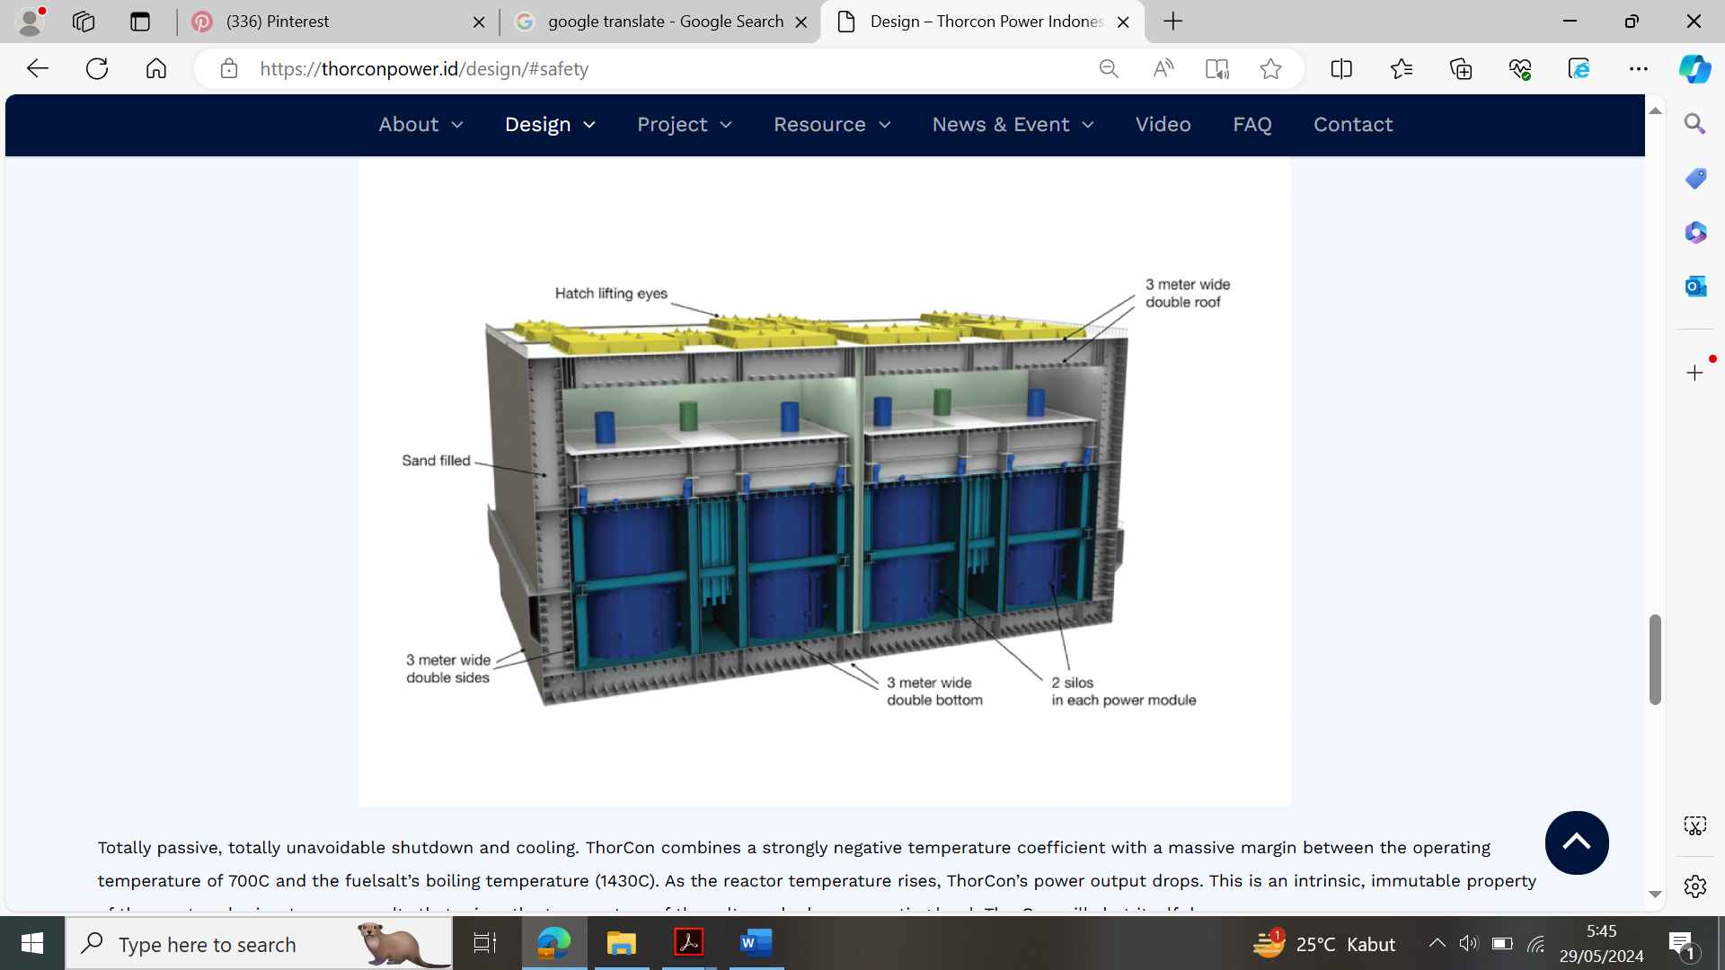
FIG. 7. The physical barriers of the fission island [1]

In general, requirements 51, 52, and 53 are applicable to the design of the TMSR500 passive cooling system. Several minor gaps are identified, such as:
- the integrity of the fuel needs to be interpreted to the integrity of the primary loop;
- the reactor coolant pressure boundary needs to be interpreted to the reactor coolant boundary; and
- in the shutdown state and accident condition, the decay heat is located in the fuel drain tank, not in the reactor core (pot).

CONCLUSION
A qualitative reliability study can be applied as the initial step to investigate contributing factors or parameters in maintaining the expected reliability level. The flow resistances in the system and the mechanical integrity of the system become key factors in ensuring the reliability of the TMSR500 passive cooling system. In general, the requirements of the IAEA Safety Standard No. SSR-2/1 (Rev. 1) are applicable, with several minor gaps, to the TMSR500 passive cooling design.

References
- www.thorconpower.id
- NAYAK, A.K., GARTIA, M.R., ANTONY, A., VINOD, G., SINHA, R.K., Passive system reliability analysis using the APSRA methodology, Nucl. Eng. Des. 238 (2008) 1430–1440.
- Safety of Nuclear Power Plants: Design, Specific Safety Requirements No. SSR-2/1 (Rev. 1), IAEA, Vienna (2016).
- Applicability of IAEA Safety Standards to Non-Water Cooled Reactors and Small Modular Reactors, Safety Reports Series No. 123, IAEA, Vienna (2023).
- KHAKIM, A., RHOMA, F., WALUYO, A., SUHARYANA, S., “The neutronic characteristics of thermal molten salt reactor”, AIP Conf. Proc. 2374, 020028 (2021) 1-11.

