# CIEMAT’S CONTRIBUTIONS TO THE RESEARCH OF

# SMR SAFETY AND DESIGN

L.E. HERRANZ

CIEMAT

Madrid, Spain

Email: luisen.herranz@ciemat.es

M. GARCIA

CIEMAT

Madrid, Spain

J. FONTANET

CIEMAT

Madrid, Spain

**Abstract**

On the way to decarbonization of human activities, most studies of energy scenarios to mid this century highlight the key role nuclear energy is called to play in terms of security, cost, environment, and reliability. In such a context, Small Modular Reactors (SMRs) are seen as a promising technology to be deployed in the short and medium term. Regardless the local context of nuclear electricity in Spain, CIEMAT, the national research centre for energy, environment and technology, has been committed for more than a decade with research on safety of advanced reactors, with a direct projection to SMRs.

CIEMAT’s investigation on SMRs may be synthesized according to the different technologies addressed: HTGRs, SFRs and LWR-SMR. Some highlights have been gathered: the need of proving reliability of passive safety systems under prevailing accident conditions; the potential to use filtered confinements instead of containments in high temperature reactors; the need of experimental investigations digging for physics and chemical properties of significance for Na-cooled reactors; and, last but not least, the use of “conservative scenarios” as a way to set encompassing conditions to characterize the plants responses to transients and accidents. In addition to these studies, CIEMAT developed capabilities closely related to the water-cooled SMR technologies related to passive safety systems.

## Introduction

The growing global demand for energy coupled with the recent energy crisis in Europe is forcing countries to look for new forms of energy generation in the context of climate change. In this framework, Small Modular Reactors (SMRs), with a power capacity less than 300 MWe, emerge as a valuable option due to their simplicity, enhanced safety levels due to their inherent safety characteristics such as simpler design, lower power and larger fractions of coolant, higher economic efficiency, due to their lower financial cost and shorter construction period and their versatility as they can also be designed to produce heat for industrial processes, such as water desalination, district heating or H2 production among others.

Small modular reactors encompass a variety of reactor technologies with more than 70 different SMR designs worldwide, from Light Water Reactor SMR (LWR- SMR) designs which include significant design modifications as the implementation of the Helically Coiled Steam Generators (HCSG) or the incorporation of passive safety systems to SMR designs based on GEN IV technologies as Molten Salt Reactors (MSRs), Sodium Fast Reactors (SFRs), Lead Fast Reactors (LFRs) and High Temperature Gas Reactors (HTGRs).

CIEMAT contribution to the Small Modular Reactors (SMRs) investigation may be synthesized according to the different technologies addressed along the last decade:

* High Temperature Gas-cooled Reactors (HTGRs).
* Sodium (Na)-cooled Fast Reactors (SFRs).
* Water-cooled SMRs.

In addition to these studies, which describe roughly a decade of research, CIEMAT developed capabilities closely related to the SMR technologies. In particular, CIEMAT developed phenomenological models of the passive containment cooling systems of mid- and large-size nuclear reactors that have inspired some of those included in the SMR designs [1], [2], [3], [4]. The main contributions made for the three technologies listed above are synthesized in the next sections [5].

It is worth mentioning that such works were developed under a diversity of frameworks, from bilateral agreements with nuclear utilities, like General Electric and PBMR Ltd., to collaborations with Academy (Universidad Pontificia COmillas, UPCO-ICAI; University of Wisconsin, UW; Technical University of Valencia, UPV). In last years the financial support has come from the EURATOM Framework Programme (from the 6th FWP to nowadays, H2020). In most cases CIEMAT’s research has been focused on safety aspects.

## High temperature gas-cooled reactors

Given the distinctive nature of Helium (He) as a coolant compared to water, a specific aspect of HTGR plants which is deserving attention is the potential use of a confinement system instead of a containment. To do so, it should be demonstrated that the confinement approach would be capable of reducing early and late offsite releases. CIEMAT modeled the performance of a postulated HTGR vented confinement under prototypical accident conditions resulting from a small and a large breach of the Helium Pressure Boundary (HPB) [6]. Two main configurations have been used which major difference is the presence of pools in the vent pathway to the environment (wet confinement). These pools would provide a passive closure of the confinement once the depressurization is completed.

In the event of a HPB break, the primary system depressurization would sweep fission products and graphite particles circulating within the primary circuit into the reactor building. More importantly, helium discharge from the primary system would make a fraction of previously deposited particles lift-off from surfaces and add-up to the source term into the confinement. Most of the fission products are expected to eventually become attached to airborne dust particles, so that the aerosol concentration suspended into the building and their transport are key magnitudes strongly affecting the amount of radioactivity potentially leaking to the environment.

By using the ASTEC and CONTAIN codes, the thermal-hydraulic response was thoroughly characterized. As for the aerosol behavior, the analytical tools agreed that most of the fission products inventory coming into the confinement would be eventually deposited onto the walls and only about 1% of the aerosol dust would be released into the environment. The inclusion of a permanently filled pool in the pressure relief path inside the confinement (i.e., “wet confinement”) would provide a passive closure of the confinement once the depressurization was completed. The effect of having a scrubbing pool in the pathway of fission products towards the confinement vent was also modelled with ASTEC 1.3 for a very large break accident [7]. Water pools would strongly change the thermal-hydraulic evolution within the building and would become efficient aerosol traps, which scrubbing efficiency would depend on their configuration (i.e., vent cross section and pool submergence). Aerosol scrubbing is usually characterized by the Decontamination Factor (DF), defined as the ratio between the mass entering and exiting the suppression pool. Similarly, a global decontamination factor can be defined as the ratio of the mass injected into the building through the HPB break and the mass released to the environment. A correlation was developed for the global Decontamination Factor (DF) in terms of the pool geometrical features (i.e., pool submergence, H; and venting cross section, S):

DFglobal = 3.54·H·S-0.25

As compared to the dry confinement configuration, the source term reduction in the wet version was roughly a factor of 10. *FIG. 1* compares the normalized mass released to the environment of a dry vented confinement compared to two wet-confinement configurations.

The results obtained also highlight that in-confinement pressure is strongly dependent on the flow cross section of the gas entering the pool (S). The peak pressure reached for each configuration, normalized to the maximum value (*FIG.*  2) can be well fitted by a quadratic curve:

Ppeak = 1.01 – 0.71·S + 0.45·S2

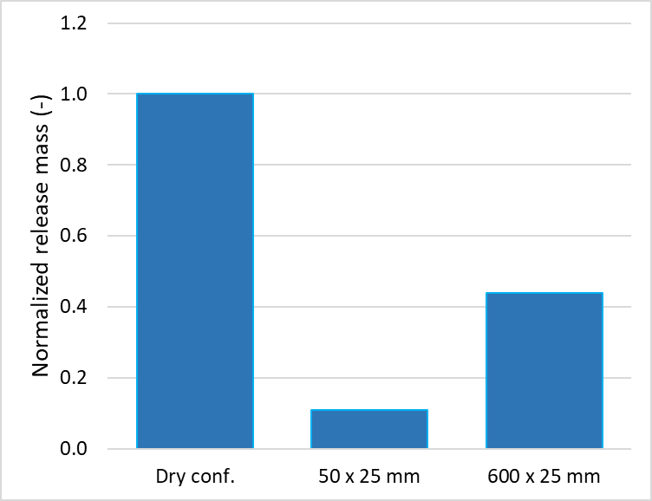

*FIG. 1. Normalized released mass to the environment: dry (1st column) vs. wet confinement (2nd and 3rd).*

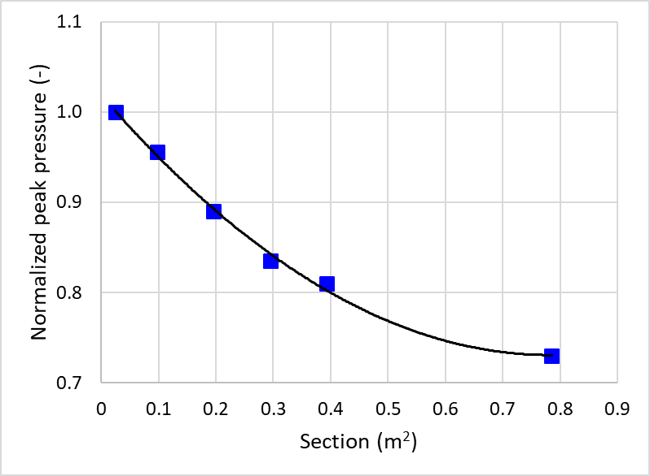

*FIG.*  2 *Normalized peak pressure as a function of the flow path cross section.*

Outside the safety domain, in collaboration with UPCO-ICAI, CIEMAT explored the potential of (V)HTRs (Very) to enhance their thermal efficiency by using Brayton cycles instead the traditional Rankine cycles used in large Light Water Reactors (LWRs). Some specific aspects, like regenerative reheating [8] and the use of inter-cooling and reheating [9], were proved to have the potential to significantly impact thermal efficiency. Some interesting concepts explored in these works were also nuclear cogeneration and load follow-up adapted configurations.

## Sodium-cooled fast reactors

In the domain of sodium-cooled reactors, CIEMAT focus has been on modeling radioactive transfer from Na pools to the gas atmosphere by two mechanisms: vaporization from hot pools and Na-pool fires. Both scenarios might set up if a disruption of the core happened and caused a gross rupture of fuel pins and some fuel assemblies. The fuel-coolant interaction could lead to a foaming and expanding bubble of vaporized sodium with core debris, fuel components and gases. The mechanical uplift of the overlying Na would then impact the reactor vessel head causing a breach in the primary system and the ejection of contaminated Na into the containment. There, the Na solution of fission products might get hotter due to fission products (FP) decay and, even, get oxidized to burning in the presence of oxygen.

Much work has been done in the past regarding the emission of volatile radionuclides in the context of evaporation from hot Na-pools in the reactor vessel to the inert cover gas region to determine the chemical and physical behavior of FPs under the wide range of conditions that can occur under accidental conditions [10], [11], [12], [13].

FPs dissolved in the hot sodium pool diffuse away from the liquid surface at the same time as sodium vaporization takes place enhancing the FPs release. In other words, there are two driving mechanisms for FPs to get transferred from the pool to the gas phase: diffusion of FPs and convective dragging by the Na vaporization from the pool. A pseudo-mechanistic approach based on the diffusion film theory, the analogy of heat-mass transfer and the Raoult’s law which includes the dragging effect of the vaporized Na on the volatile species release has been proposed (Extended Gas Mass Transport, EGMT model; [14]). The results of this model were compared to data from the NALA II experimental program in terms of the sodium iodide (NaI) pool Retention Factor (RF), as shown in *FIG. 3*. The results were discussed to mean a substantial enhancement of qualitative and quantitative predictability, and no less important, in all the cases they were conservative.

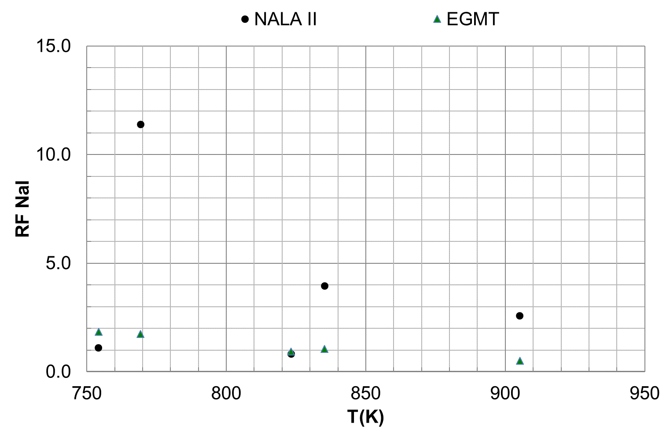

*FIG. 3. NaI RF vs. pool temperature*

The in-containment phenomenology governing evolution of sodium aerosols and radio contaminants involves many complex phenomena that have a strong influence on the amount and form of airborne contamination. A review of available data and modeling capabilities [15] showed that despite the large body of existing experimental information, there are two strong modeling needs in this field: aerosol generation which means to properly model sodium vaporization, chemical reactions with the surrounding gas, nucleation of combustion products and primary particle agglomeration and fission products partitioning.

In the presence of oxygen, combustion of Na would result in the formation of huge amounts of Na-oxide aerosols that might become the governing source of airborne radioactivity inside the containment. This together with the potential harm associated with the chemical species resulting from the Na-oxides reaction with water vapor present in the atmosphere would be responsible to a great extent for the radiological and chemical impact of any release to the environment.

A phenomenological Particle Generation (PG) model covering sodium-vapor burning and formation of sodium-oxide aerosols above an evaporating sodium pool has been developed with the objective to calculating the characteristics (number and size) of the particulate source term to the containment [16]. Based on a flame sheet approach, the model articulates a suite of individual models: Na vaporization (diffusion layer approach), O2 transport by air natural circulation (3D flow pattern modelling), Na-O2 chemical reactions (instantaneous reactions and energy input) and vapor-to-particle conversion of Na-oxides (i.e., classical nucleation theory and heterogeneous condensation). *FIG. 4* shows a schematics of the main pillars of the PG model.

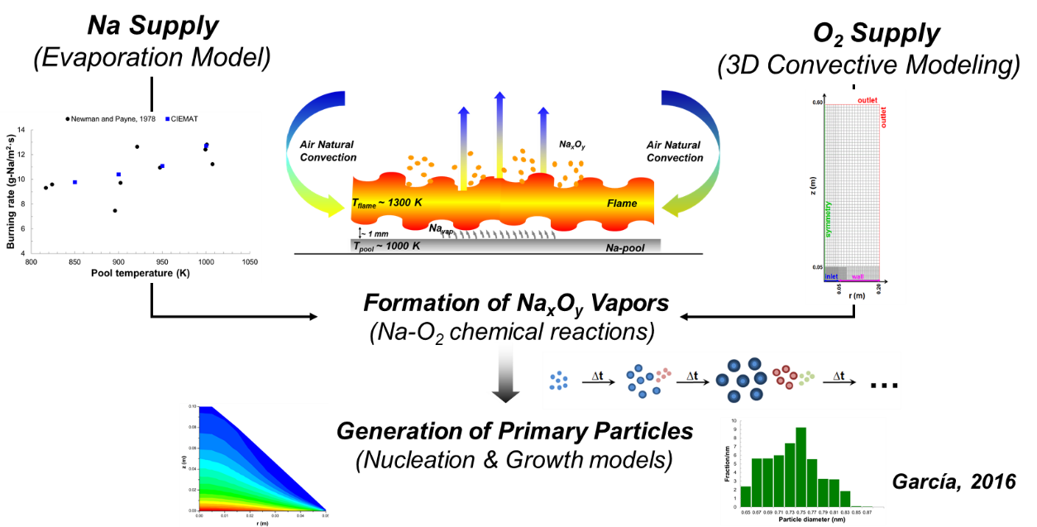

*FIG. 4. Key elements of the Particle Generation model*

Once validated through sodium pool experiments [17], [18], [19], [20] a derivation of suitable analytical correlations for use in a severe-accident code allowed its implementation in the ASTEC-Na code [21]. Calculated results using PG model option in the extended ASTEC-Na code showed a promising response in terms of order of magnitude of airborne concentration (*FIG. 5*a), dominant depletion mechanism and particle size variation (*FIG. 5*b) when compared with experimental databases. Trends have been proved to be physically sound by following data tendencies and the experimental data uncertainty prevents from qualifying one approach over the other. Besides, the proposed PG model correlations do not need any code-user assumption concerning the mass and energy transfer from a pool fire to the containment atmosphere, as other approaches do. In conclusion, the new correlations are very suitable for use in a severe-accident code in terms of the negligible additional computation burden. The new correlations, by originating from simplifications of soundly-based physical modelling, avoid the arbitrary assumption of a fixed primary-particle size in the existing modelling. Limited comparisons with experiments imply that use of the new correlations increases confidence in prediction of the pool-fire particulate source term to the containment.

|  |  |
| --- | --- |
| 1. Airborne concetration in AB1 test | 1. AMMD in AB1 test |

*FIG. 5. PG model main results*

## Water-cooled SMRs

Recently, CIEMAT joined the first European joint venture addressing severe accidents in water-cooled SMRs (the EC SASPAM-SA project). The highest level objective of the work is to achieve a sound knowledge and know-how transfer from the experience gained in the Large Water Reactor (LWR) severe accident domain and adapt whatever necessary. The major challenges CIEMAT is currently addressing are: to explore potential accident scenarios that could lead to severe consequences in an integrated Pressure Water type Reactor (iPWR), to assess the applicability of the existing pool scrubbing database [22], and to investigate feasibility and consequences of Accident Management (AM) measures, like In-Vessel Melt Retention (IVMR) and Filtered Containment Venting (FCV), among others. This work is foreseen to be developed in the next three years.

In the frame of the WP2 devoted to input development and hypothetical SA scenarios assessment, a campaign of postaluted DBA and SA scenarios has been carried out to evaluate how the availability of different passive safety systems would condition the accident progression of a generic iPWR design (300 MWe). Characterized by a dry spherical containment and the use of several passive systems, named, Emergency Heat Removal System (EHRS), Automatic Depressurization System (ADS), Emergency Boration Tanks (EBTs), Long-term Gravity Makeup System (LGMS ) and Pressure Suppresion System (PSS) (*FIG. 6*).

|  |  |
| --- | --- |
|  |  |

*FIG. 6. PG model main results*

The integral severe accident MELCOR 2.2 code has been used to assess the progression of a postulated small double-guillotine break in the Direct Vessel Injection (DVI). Preliminary results indicate that the EHRS actuation is essential to prevent any core degradation. On the contrary, all the other passive systems, event acting altogether, would not be able to avoid core uncover and its subsequent degradation.

## Conclusions

The conclusions from CIEMAT’s research can be synthesized as follows:

* Passive systems are highly valuable enhancements to nuclear safety. Nonetheless, their reliability under all accidental conditions foreseen should be proved.
* High temperature gas cooled reactors is a truly promising technology with interesting safety features, which third barrier deserves specific investigation to make the most out of its performance. The high integrity and reliability under nominal and anticipated accident conditions of the SiC layer of fuel TRISO particles, would allow considering replacing the traditional containment barrier by a filtered confinement.
* Sodium fast reactors pose safety challenges in case of core disruption. The large differences in the coolant properties (i.e., water and sodium) make any extrapolation from water to sodium impossible. This is particularly so when coming to coolant interaction with fission products, where physics-chemical interactions would need basic properties (i.e., mass transport properties), and the coolant interaction with oxidizing environments (i.e., pool and spray Na fires).
* SMR implementation opportunity needs research to address those open issues that might handicap their acceptance. Some of them might be design-specific and require information not available in the public domain. If so, they might be addressed by investigating “conservative scenarios”. This way, the prevailing boundary conditions under which safety systems would work would be identified and a closer characterization of the safety systems response would be obtained.

References

[1] L. E. Herranz, J. L. Muñoz-Cobo, y M. J. Palomo, «Modeling condensation heat transfer on a horizontal finned tube in the presence of noncondensable gases», *Nuclear Engineering and Design*, vol. 201, n.o 2, pp. 273-288, oct. 2000, doi: 10.1016/S0029-5493(00)00278-8.

[2] L. E. Herranz, M. H. Anderson, y M. L. Corradini, «A diffusion layer model for steam condensation within the AP600 containment», *Nuclear Engineering and Design*, vol. 183, n.o 1, pp. 133-150, jul. 1998, doi: 10.1016/S0029-5493(98)00164-2.

[3] L. E. Herranz, J. L. Muñoz-Cobo, y G. Verdú, «Heat transfer modeling in the vertical tubes of the passive containment cooling system of the simplified boiling water reactor», *Nuclear Engineering and Design*, vol. 178, n.o 1, pp. 29-44, dic. 1997, doi: 10.1016/S0029-5493(97)00178-7.

[4] J. L. Muñoz-Cobo, J. Peña, L. E. Herranz, y A. Pérez-Navarro, «Steam condensation on finned tubes, in the presence of non-condensable gases and aerosols: Influence of impaction, diffusiophoresis and settling on aerosol deposition», *Nuclear Engineering and Design*, vol. 235, n.o 10, pp. 1225-1237, may 2005, doi: 10.1016/j.nucengdes.2005.02.014.

[5] C. Queral *et al.*, «Spanish research related to SMRs projects», *Nuclear Engineering and Design*, vol. 417, p. 112818, feb. 2024, doi: 10.1016/j.nucengdes.2023.112818.

[6] J. Fontanet, L. E. Herranz, R. Alastair, y N. Lolan, «Modelling of HTR Confinement Behaviour during Accidents Involving Breach of the Helium Pressure Boundary», *Science and Technology of Nuclear Installations*, vol. 2009, ene. 2009, doi: 10.1155/2009/687634.

[7] L. E. Herranz y J. Fontanet, «Analysis of the effect of water ponds on HTR confinement behavior under accident conditions», *Progress in Nuclear Energy*, vol. 67, pp. 7-14, ago. 2013, doi: 10.1016/j.pnucene.2013.03.016.

[8] L. E. Herranz, B. Moratilla, y Linares, J.I., «Assessment of Regenerative Reheating in Direct Brayton Power Cycles for High-Temperature Gas-Cooled Reactors», *Nuclear technology*, vol. 159, pp. 15-24, jul. 2007, doi: 10.13182/NT07-A3853.

[9] L. E. Herranz, J. I. Linares, y B. Y. Moratilla, «Power cycle assessment of nuclear high temperature gas-cooled reactors», *Applied Thermal Engineering*, vol. 29, n.o 8, pp. 1759-1765, jun. 2009, doi: 10.1016/j.applthermaleng.2008.08.006.

[10] A. W. Castleman, «A REVIEW OF THE CURRENT STATUS OF RESEARCH ON THE CHEMICAL AND PHYSICAL ASPECTS OF LIQUID-METAL-COOLED FAST BREEDER REACTOR SAFETY. I. FISSION PRODUCT BEHAVIOR IN SODIUM.», Other Information: UNCL. Orig. Receipt Date: 31-DEC-70. Accedido: 22 de febrero de 2023. [En línea]. Disponible en: https://digital.library.unt.edu/ark:/67531/metadc867904/m1/38/

[11] W. S. Clough y A. Fraser, «Tellurium, caesium, iodine and methyl iodide in fast reactors», *Journal of Nuclear Energy*, vol. 27, n.o 1, pp. 1-14, ene. 1973, doi: 10.1016/0022-3107(73)90050-6.

[12] K. Haga, Y. Nishizawa, T. Watanabe, S. Miyahara, y Y. Himeno, «Equilibrium and nonequilibrium partition coefficients of volatile fission products between liquid sodium and the gas phase», *Nuclear Technology*, vol. 97, n.o 2, pp. 177-185, 1992.

[13] J. Starflinger, M. Koch, U. Brockmeier, W. Scholtyssek, W. Schütz, y H. Unger, «The release code package REVOLS/RENONS for fission product release from a liquid sodium pool into an inert gas atmosphere», Kernforschungszentrum Karlsruhe G.m.b.H. (Germany, KfK5426, dic. 1994.

[14] M. Garcia y L. E. Herranz, «Modelling FPs release from sodium pools under BDBA conditions», presentado en 10th European Review Meeting on Severe Accident Research (ERMSAR), Akademiehotel, Karlsruhe, Germany, may 2022.

[15] L. E. Herranz, M. Garcia, y M. P. Kissane, «In-containment source term in accident conditions in sodium-cooled fast reactors: Data needs and model capabilities», *Progress in Nuclear Energy*, vol. 54, n.o 1, pp. 138-149, ene. 2012, doi: 10.1016/j.pnucene.2011.07.003.

[16] M. Garcia, L. E. Herranz, y M. P. Kissane, «Theoretical assessment of particle generation from sodium pool fires», *Nuclear Engineering and Design*, vol. 310, n.o Supplement C, pp. 470-483, dic. 2016, doi: 10.1016/j.nucengdes.2016.10.024.

[17] R. K. Hilliard, J. D. McCormack, J. A. Hassberger, y L. D. Muhlestein, «Preliminary results of CSTF aerosol behavior test, AB1. [LMFBR]», HEDL-SA-1381, 1977. Accedido: 14 de julio de 2016. [En línea]. Disponible en: https://www.researchgate.net/publication/255220541_Preliminary_results_of_CSTF_aerosol_behavior_test_AB1_LMFBR

[18] R. K. Hilliard, D. McCormack, y A. K. Postma, «Aerosol behavior during sodium pool fires in a large vessel - CSTF tests AB1 and AB2», Hanford Engineering Development Lab., HEDL-TME 79-28, 1979. Accedido: 14 de julio de 2016. [En línea]. Disponible en: http://www.osti.gov/scitech/search/semantic:%22AEROSOL%20BEHAVIOR%20DURING%20SODIUM%20POOL%20FIRES%20IN%20A%20MRGE%20VESSEL%22/filter-results:F

[19] J. D. McCormack, R. K. Hilliard, y A. K. Postma, «Recent Aerosol Tests in the Containment Systems Test Facility», Hanford Engineering Development Lab., Richland, WA (USA), HEDL-SA-1686, oct. 1978. Accedido: 14 de julio de 2016. [En línea]. Disponible en: http://www.osti.gov/scitech/biblio/6167484-recent-aerosol-tests-containment-systems-test-facility

[20] F. J. Souto, F. E. Haskin, y L. N. Kmetyk, «Melcor 1.8.2 Assessment: Aerosol Experiments Abcove Ab5, Ab6, Ab7, and Lace La2», Sandia National Labs., Albuquerque, NM (United States), SAND--94-2166, oct. 1994. Accedido: 14 de julio de 2016. [En línea]. Disponible en: http://www.osti.gov/scitech/biblio/10102146-melcor-assessment-aerosol-experiments-abcove-ab5-ab6-ab7-lace-la2

[21] L. E. Herranz, M. Garcia, L. Lebel, F. Mascari, y C. Spengler, «In-containment source term predictability of ASTEC-Na: Major insights from data-predictions benchmarking», *Nuclear Engineering and Design*, vol. 320, n.o Supplement C, pp. 269-281, ago. 2017, doi: 10.1016/j.nucengdes.2017.06.010.

[22] L. E. Herranz, F. Sánchez, y S. Gupta, «Validation Matrix for Pool Scrubbing Models», *Nuclear Technology*, vol. 0, n.o 0, pp. 1-14, nov. 2022, doi: 10.1080/00295450.2022.2122679.