# Experimental testing of a large scale water-cooled Reactor cavity cooling system

Observations and considerations for passive decay heat removal

DARIUS LISOWSKI, QIUPING LU, MATTHEW JASICA, AND MITCH FARMER

Argonne National Laboratory, Lemont, IL. USA

Email: dlisowski@anl.gov

**Abstract**

The Natural convection Shutdown heat removal Test Facility (NSTF) is a large-scale test facility constructed at Argonne built to generate validation data for passive decay heat removal systems of advanced reactors. Reflecting key features of a ½ scale, water-based, Reactor Cavity Cooling System, the facility and testing program has been on-going since 2018. Over 60 test cases, performed over a wide range of operating conditions, have been completed to study behavior and assess heat removal performance. A majority of the test cases were performed at saturation temperatures with natural circulation driven boiling flow, the operational and fluid state most prototypic to a full-scale reactor. The characteristics of natural circulation phenomena and two-phase flow can trigger complex thermal hydraulic behaviors, some of which induce unstable flow mechanisms and degraded system performance. The following paper summarizes some of the major observations and findings related to performance and stability. Specific topics include the role of inventory level on RCCS behavior, impact of changes in channel and steam discharge loss coefficients, and consequences of flow blockages. Additionally, a discussion will be included on potential impacts of boiling induced vibrations on structural components., along with recommendations for design features that may improve system stability.

## Introduction

The Natural Convection Shutdown Heat Removal Test Facility (NSTF) at Argonne National Laboratory is a large-scale test facility designed to generate NQA-1 qualified validation data for passive decay heat removal systems in advanced reactor concepts. Supported by the Department of Energy (DOE) offices of Advanced Reactor Technologies (ART) and Advanced Reactors Regulatory Development (RD), NSTF mirrors key features of a ½-scale, water-based Reactor Cavity Cooling System (RCCS).

Its purpose is to study behaviour, performance, and guide design decisions for passive decay heat removal systems. Since NSTF also shares characteristics with a fundamental boiling water thermosiphon, the experimental data it generates enhances our understanding of natural circulation boiling and two-phase flow phenomena. The data serves two industry needs: validating codes for licensing and optimizing advanced conceptual designs. Rigorous scaling and validation processes ensure that the data remains applicable to full-scale systems. Feedback from industry and government stakeholders has driven the direction of the testing plan, and generated data sets are made available to those partners. Technical details of the facility design and instrumentation can be found in a previously published technical report by the authors [1].

## Motivation and Objectives

At the forefront of our program is an objective to provide data that supports the development and validation of passive safety decay heat removal systems for advanced nuclear power plants. These systems are critical for ensuring safe operation during both normal and emergency conditions. Specifically, we focus on natural circulation systems — an integral feature of several advanced safety concepts.

Anticipating boiling flow in the scaled water-based test facility, complex thermal hydraulic behavior associated with two-phase phenomena is anticipated. Instabilities like flashing, system-wide flow oscillations, and geysering require specialized instrumentation and structural considerations. Collaborating with modeling and simulation teams has been crucial for identifying nominal system behavior and optimizing instrumentation placement. This collaboration will continue as the program progresses and data accumulates. Additionally, characterizing anticipated instability modes across various conditions will help reduce uncertainties in water-based Reactor Cavity Cooling System (RCCS) modeling.

### Testing objectives

The behavior of boiling water natural circulation loops, such as the water NSTF, depends not only on specific initial and boundary conditions but also significantly on the loop’s network geometry. The testing program began by characterizing key design features, form, heat losses, nominal behavior, repeatability, and data uncertainty. In the single-phase flow regime, testing has assessed steady-state behavior and heat removal performance. Following, the program has shifted to focus on scaling verification, heat flux variation (integral levels and profiling), geometry, orificing, and investigating the role of the inventory storage tank. Finally, transitioning to saturation with inventory loss due to boil-off will provide insights into design basis accident conditions, complex two-phase flow behavior, and expected heat removal performance levels.

To establish a common reference basis for nominal behavior, system parameters, and to monitor system repeatability, a baseline case was established, and operating conditions derived from openly available literature on the full scale reactor design, the AREVA 625 MWt steam cycle high temperature gas reactor (HTGR) [2, 3]. In this regime, a series of parametric test cases have been performed which varied a single operating variable while otherwise keeping the remaining test conditions the same. A subset of the parametric are the focus of this paper, covering testing with variations in system inventory including depletion, variations in loss coefficients, and variations in available flow area within the piping. Provided for each is summary of the observed testing results, heat removal performance, and system behavoir, with further details and analysis available in previous reports by the authors [4, 5, 6, 7, 8].

## results from paramteric testing

### Starting coolant inventory level

The inventory parametric series focused on studying the influence of initial tank volume on start-up and boiling behaviours. This study was then extended further to examine the scenario of full tank depletion, where we studied the system as the inventory is fully depleted from the holding tank and the system experiences flow stagnation. For the baseline tests, we set the initial tank inventory level at 80%. Variant tests were conducted with reduced starting inventories of 70%, 60%, and 55%, Figure 1. The experimental procedure remained consistent across all tests: heater power was applied over a 90-minute automatic ramp, followed by constant heating to allow the facility and water inventory to reach saturation. Subsequently, boiling and flashing of water were observed in the upper chimney region, sustained for over 4 hours, and followed by a power ramp-down. The impact of initial tank inventory on system performance is analysed by comparing these tests. As the initial tank inventory increases, so does the associated thermal inertia. Consequently, more energy is stored in the liquid inventory, resulting in a delay in the initiation of two-phase boiling/flashing.

More interesting, however, is the impact on system behaviour once boiling begins. The initial tank inventory strongly affects the hydrostatic head within the loop, influencing the saturation temperature when boiling/flashing initiates. An initial start-up instability can be observed for all the cases, regardless of initial fill, resulting in a single large flow peak shortly after the start of boiling, and is the typical flashing instability mechanisms in commonly found in natural circulation boiling water loops. As the transient progresses, the instability mechanism is more determined by the inlet subcooling, Figure 2, and heat flux, explaining damping of the flow oscillations. There is no impact on the steam pressure within the air space of the storage tank generated from the boiling flow, Figure 3, which is expected given all tests has identical supplied thermal powers. As the subcooling reaches threshold levels, fluid in upper portions of the piping enters a regime of continuous boiling and is no longer in an oscillatory supressed-saturated state that define flashing mechanisms.

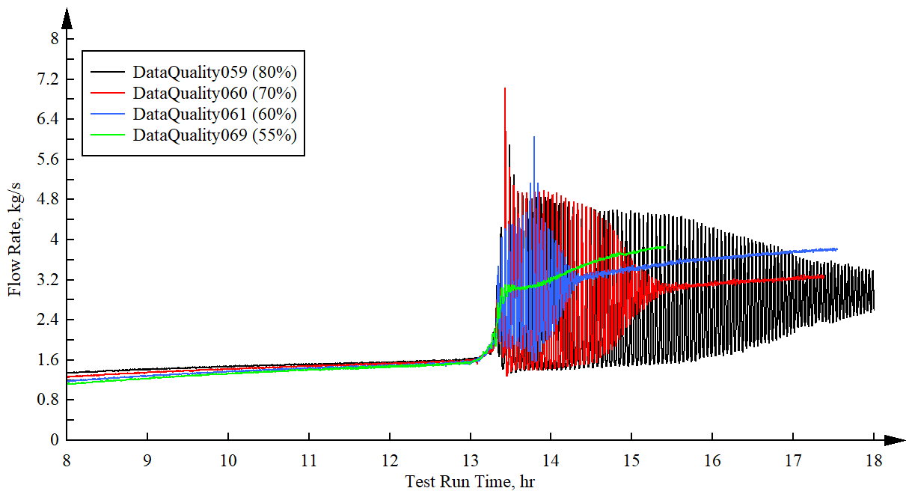

Fig. : Comparison of system flow rates at varying initial tank inventories (time shifted to align boiling incipience)

|  |  |
| --- | --- |
| Fig. : Tank gas space pressures | Fig. : Inventory subcooling at the inlet |

### Full inventory depletion

The depletion state represents a scenario during prototypic operation where continuous inventory boil-off causes the inventory level to drop below critical levels within the storage tank, impeding the natural circulation flow path resulting in cessation of heat removal function. Typically, the system will experience flow stagnation, followed by geysering phenomena and large flow excursions.

In the testing performed, two-phase operation with continuous boil-off was maintained for an extended period to allow the inventory to drop to these threshold levels. The first indication of changes in operating conditions was observed when the tank level reached the chimney inlet port. Prior to this elevation, the flow experiences a gradual but continuous increase in flow rate, at which point a “knee” can be observed followed by a start of reducing flow rates, Figure 4. This inflection point corresponds to the centerline of the chimney inlet to the tank, where the cold driving head and heated buoyancy pressure are no longer coupled by a common elevation. Following, the system entered a new state where the stable continuous flow began experiencing momentary flow spikes, followed by the appearance of high-frequency flow oscillations. Due to large voiding in the chimney and swelling of the heated leg, flow of the primary coolant continued to function even as the tank level fell 35-inches below the chimney discharge port within the tank. Finally, with sustained two-phase flow and continued inventory loss, the loop reached a depleted state with observed flow stagnation. During this condition, large amplitude excursions were observed when the primary tank reached the depletion state. With the onset of violent geysering flow, some peaks reaching 15 kg/s, a planned shutdown procedure was initiated, including the power ramp down and cold refill. The cold refill was continued until the tank inlet piping was fully covered to allow re-establishment of natural circulation flow

Geysering occurs when a vertical column of liquid is heated from the bottom, resulting in periodic flow excursions followed by an incubation period without boiling. This phenomenon involves three distinct events: initial subcooled flow stagnation, incubation with enthalpy addition, and the violent ejection of fluid. Audible steam eruptions within the heated section distinguish this phenomenon and readily transmit through piping and insulation, as attested by the authors.

Fig. : Time history of system flow and tank level for the extended duration depletion test [4]

### Variable Loss coefficient

For a typical forced flow system, throttling at the inlet of the heated section (specifically, the single-phase region) stabilizes the flow and dampens any prior oscillations caused by flow instability. To assess whether this stabilization effect extends to a two-phase natural circulation system like the RCCS, we conducted a two-phase with variable throttling at the inlet to the heated section. Ten degrees of throttling were studied, ranging from fully open with 100% available flow area to significantly throttled with only 17% available flow area.

The time history of system flow and applied degree of inlet throttling test case is shown in Figure 5. With the inception of boiling first observed near the 12.5-hr mark, the system experiences large amplitude, pure-flashing driven oscillations consistent with start-up instabilities of a natural circulation loop. The first throttle two stages reduced the flow area to 77% and 56% respectively, during which flow oscillations continued but with minor reductions in their peak-to-peak amplitude. By the following stage, a reduction in flow area down to 44% available, the flow restriction caused dampening of the oscillations and the facility began a period of stable two-phase flow. This stable period continued through the next two stages, which reduced the flow area to 33% and 29% respectively.

Instabilities were re-introduced at 25% total available flow area, which caused large amplitude flow oscillations, though of a different mechanism from the smooth sinusoidal shaped flashing induced peaks during startup and through early portions of the throttle test. These irregular oscillations, observed by jagged curves in the system flow rate and large voiding in the upper chimney, are likely characteristic of Type-II density wave oscillation (DWO) instabilities [9]. This is the most commonly observed form of density wave oscillation and is due to multiple regenerative feedback between the flow rate, vapor generation rate and pressure drop [10] The system stabilized after reducing the flow area further down to 22% and continued stable flow at 20% flow area. These stages, similar to those of 44% - 29% flow area, allowed the loop to flow in a stable two-phase mode of flow operation without oscillatory or periodic flow excursions.

At the 10th and final stage, with only 17% of the area available for flow, instabilities resurfaced. The flow restriction extended the residence time of the fluid in the test section, enabling local voiding. Unlike previous stages, where voiding primarily resulted from reduced hydrostatic head pressure, these low flow rates allowed sufficient energy transfer to reach saturation temperatures even before ascending through the chimney. Consequently, the parallel channel instability (PCI) mechanism emerged, driving out-of-phase voiding and independent flow excursions across the parallel riser tubes. The PCI instability, arising from coupled influences of flashing, boiling, and geysering, exhibits a highly complex dynamic [11]. Chaotic behaviour, including random flow reversals in individual channels, is commonly observed.

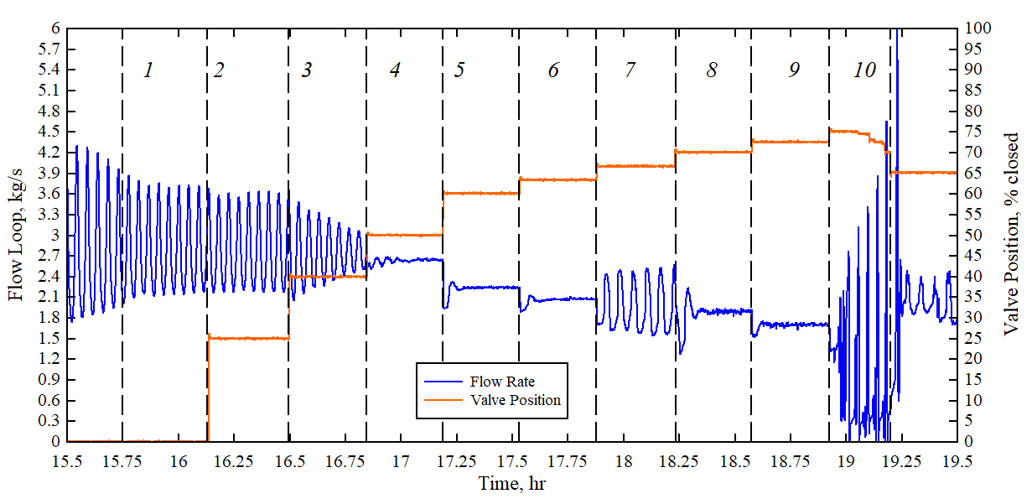

Fig. : Time history of system flow and degree of inlet throttling

### Blockages in flow paths

In this study, the effects of full riser blockage on overall system performance during a two-phase transient scenario were investigated. To achieve a full flow blockage condition, Risers 3 and 6 (out of 8 total) were isolated from the system by dual shut-off valves at the inlet and outlet. Initially, all risers were fully open, allowing natural circulation to develop uniformly across the eight risers and cooling structures.

The isolation procedure occurred while the system remained in single-phase conditions, with riser outlet fluid temperatures around 90°C. One riser was closed at a time: first, the riser inlet ball valve, followed by the outlet valve. A vent valve allowed safe release of steam (and initially heated liquid) as the liquid boiled off in the isolated risers. The vented steam and condensate were collected in a tank at the facility’s base. Static boiling commenced immediately upon isolation, with steady boil-off throughout the test duration. The system then proceeded as typical for a two-phase transient test, approaching saturation conditions and boiling incipience in the chimney. After reaching a peak in oscillation strength, quasi-steady-state two-phase operation was maintained for an extended period.

Comparing the blockage and baseline scenarios, we observe strong agreement during the unblocked single-phase regime until Risers 3 and 6 are isolated. A sharp flow rate drop occurs, persisting until boiling incipience. The initial system response to boiling incipience mirrors that of the baseline—a series of increasingly intense oscillations peaks in the flow rate These oscillations remain comparable for another 20 minutes before sharply decreasing and rapidly fading in intensity. Eventually, the blockage fully suppresses the oscillations, while the baseline maintains stable flow and oscillation amplitude, Figure 6 and Table 1. Initially, the blockage-induced riser flow rate exceeds the baseline due to mass conservation. However, the mean flow rate stabilizes close to the baseline value, coinciding with an overall drop in the loop flow rate for the blocked case. This suggests that, with a low number of blockages, the average flow through individual risers tends to return to the same value for a given power input.

One area concern for the blockage scenario is the impact on the thermomechanical performance of the heat removal structure, the steel pipes and the fins. While the subcooled liquid keeps the structural temperatures close to 100 °C in the baseline, significant temperature increases and deltas are observed along the elevation of the tube and fin material: 50 °C for the tube and 40 °C for the riser over 5 m of structure in the baseline, and deltas of 5 °C and 15 °C for the baseline tube and fin, respectively. The tube wall hot side temperature for the blocked risers are shown in Figures 7, with additional temperatures are compared in Table 2.

|  |  |  |  |  |  |  |  |  |  |  |  |  |  |  |  |  |  |  |  |  |  |  |  |  |  |  |  |  |  |
| --- | --- | --- | --- | --- | --- | --- | --- | --- | --- | --- | --- | --- | --- | --- | --- | --- | --- | --- | --- | --- | --- | --- | --- | --- | --- | --- | --- | --- | --- |
| Chart, histogram  Description automatically generated  Fig. : System flow rate in a 2-channel blocked system compared to a fully open baseline reference [5] | TABLE 1: System flow and boiling metrics for blocked and open test cases   |  |  |  |  | | --- | --- | --- | --- | |  | Baseline | Blockage | *diff* | | Scale Power, MWt | 1.4 | 1.4 | *-* | | Oscillation Period, s | 262.4 | 285.2 | *8.7%* | | Flow Rate, kg/s | 1.79 | 1.48 | *-17.3%* | | Oscill. Amp., kg/s | 1.09 | 1.06 | *-2.8%* | | Void Fraction, % | 44.7 | 52.0 | *16.3%* | | Condensate rate, gpm | 0.151 | 0.137 | *-9.3%* | |

|  |  |  |  |  |  |  |  |  |  |  |  |  |  |  |  |  |  |  |  |  |  |  |  |  |  |  |  |  |  |  |  |  |  |  |  |  |  |
| --- | --- | --- | --- | --- | --- | --- | --- | --- | --- | --- | --- | --- | --- | --- | --- | --- | --- | --- | --- | --- | --- | --- | --- | --- | --- | --- | --- | --- | --- | --- | --- | --- | --- | --- | --- | --- | --- |
| Chart  Description automatically generated  Fig. : Riser tube wall temperatures during blockage [5] | TABLE 2: Temperature for blockage case   |  |  |  |  | | --- | --- | --- | --- | |  | Baseline | Blockage | *diff* | | Heated section ΔT, °C | 3.83 | 4.22 | *10.1%* | | Water tube, hot side °C | 108.2 | 148.5 | *37.2%* | | Water tube, cold side °C | 103.5 | 139.5 | *34.7%* | | Panel fins, hot side °C | 122.8 | 156.1 | *27.1%* | | Panel fins, cold side °C | 124.2 | 146.1 | *17.6%* | | Heated plate surface °C | 340.16 | 343.69 | *1.0%* | | Side walls °C | 181.7 | 179.1 | *-1.4%* | | Cold wall °C | 105.8 | 108.8 | *2.8%* | |

## Conclusion

In our inventory parametric series, we explored the impact of tank level on two-phase flow. Experimental data was generated at starting inventory levels of 80%, 70%, and 60%. Additionally, we conducted a fourth test with an initial inventory level of 55%, allowing it to extend into a depleted state. Due to large voiding in the chimney and swelling of the heated leg, flow of the primary coolant continued to function even as the tank level fell 35-inches below the chimney discharge port within the tank.

Investigations were also made on the role of loss coefficients along the primary piping, where a throttling valve was used to impose varying degrees of flow restriction at the inlet to the heated test section. With the facility operating in a static mode of operation with continuous refill of condensed boil-off, flow restrictions of up to 83% of the nominal flow area were imposed on the loop while operating at steady-state two-phase conditions. Initially, the increasing restriction at the header inlet resulted in a stabilization of system flow oscillations, however with further reduction in flow area, was followed by the onset of unstable Type-II density wave oscillations. As the flow area continued to be reduced, a second period of stability was reestablished. With the final round of late-stage restrictions imposed on the loss coefficient of the inlet header at levels above 80% of the initial flow area, highly unstable flow behaviour was reintroduced with parallel channel interactions and geysering flow phenomena.

Testing to examine the role of flow blockages was made to examine the role on heat removal performance. In the test cases performed, shut-off valves were use to fully isolate 2 of the 8 heated flow channels, In the two-phase operating regime, no destabilizing response was observed as a consequence of the riser blockage. Rather, the system approached a stable condition (i.e., oscillation-free) faster as a result of the blockage. While the subcooled liquid keeps the structural temperatures close to 100 °C in the baseline, significant temperature increases were witnessed along the walls of riser tube walls in the case with blockages. Though these temperature excursions were highly, no negative impact to the performance of test facility was observed over this (relatively) short test. By the conclusion of this test, the structure temperatures appear to be approaching their ultimate steady-state values. However, further work is needed to understand the implication of such uneven thermomechanical stresses over a full scale RCCS.

The inherent complexity of natural circulation systems necessitates an understanding of the underlying phenomena that can occur in these two-phase boiling water loops. Our current observations from test conditions and behaviour indicate that heat removal performance remains largely unaffected by the observed instabilities. Regardless of the magnitude or frequency of system-wide flow oscillations, heat continues to be effectively transferred from the core to the ultimate heat sink.

ACKNOWLEDGEMENTS

This work by Argonne National Laboratory was supported by the U.S. Department of Energy, Office of Nuclear Energy, Office of Nuclear Reactor Technologies, Advanced Reactor Technologies under contract DE AC020 06CH11357

References

1. LISOWSKI, D., et al., Water NSTF Design, Instrumentation, and Test Planning, ANL-ART-98, Argonne National Laboratory, Lemont, IL United States (2017).
2. AREVA, No.: 12-9237246-000, Water-Cooled RCCS RD Designer Observation Report, Technical Record, (2014)
3. AREVA, No.:12-9239789-000, RCCS Designer Input Report, Technical Data Record (2014).
4. LV, Q., et al., Report on Year-3 of Water NSTF Matrix Testing: Two-Phase Parametric Test Series, ANL-ART-230, Argonne National Laboratory, Lemont, IL United States (2021).
5. LV, Q., et al., FY23 Report on Water NSTF Testing at Two-Phase Conditions: Off-normal Scenarios, ANL-ART-274, Argonne National Laboratory, Lemont, IL United States (2023).
6. LISOWSKI, D., LV, Q., et al., Test Report on Year 2 of Water NSTF Matrix Testing Program, ANL-ART-206, ANL-ART-206, Argonne National Lab. (2020).
7. OOI, Z.J., LV, Q., et al., Effect of inlet throttling on thermohydraulic instability in a large-scale water-based RCCS: A system-level analysis with RELAP5-3D, Nuclear Engineering and Technology **56** 5 (2024) 1902.
8. LV, Q. et al., Effect of inlet throttling on thermohydraulic instability in a large-scale water-based RCCS: An experimental study, Nuclear Engineering and Technology **56** 2 (2024) 655.
9. VAN DER HAGEN, T.H.J.J. et al., Exploring the dodewaard type-I and type-II stability; from start-up to shut-down, from stable to unstable, Annals of Nuclear Energy **24** 8 (1997) 659.
10. NAYAK, A.K., VIJAYAN, P.K., Flow Instabilities in Boiling Two-Phase Natural Circulation Systems: A Review. Science and Technology of Nuclear Installations (2008).
11. MARCEL, C.P. et al.,. Experimental Investigations on Flashing-induced Instabilities in One and Two-parallel Channels: A Comparative Study, Exp. Therm. Fluid Sci, 34, 879-892 (2010).