# Implementation of 3S by Design in INPRO

INPRO is the International Project

on Innovative Nuclear Reactors and   
Fuel Cycles

C.P. SCHERER

International Atomic Energy Agency

Vienna, Austria

Email: c.scherer@iaea.org

N. DAS

International Atomic Energy Agency

Vienna, Austria

**Abstract**

The International Atomic Energy Agency (IAEA) integrates activities in safety, security, and safeguards (3S) and promotes the concept of 3S by design. The IAEA objectives are to harmonize the 3S interfaces in an integrated manner to avoid compromise of any one realm over the others. The International Project on Innovative Nuclear Reactors and Fuel Cycles (INPRO), a key programme of the IAEA, assesses innovative reactors and fuel cycles for sustainability. INPRO incorporates the 3S concept through three of the six assessment areas: safety, security through the infrastructure assessment area, and safeguards through the proliferation resistance assessment area. In the past several years INPRO initiated collaborative projects to assess the sustainability of small modular reactors (SMRs). The INPRO methodology facilitates the successful and sustainable development and deployment of SMRs meeting the global energy needs. The INPRO assessment identifies areas where criteria are not fulfilled, which designers would need to address in order to satisfy that the SMR is sustainable. Often with innovative systems the assessment can identify gaps that need to be addressed through research, development, and demonstration (RD&D). INPRO activities thus support the 3S concept in a holistic manner for sustainable deployment of SMRs.

## INTRODUCTION

The International Project on Innovative Nuclear Reactors and Fuel Cycles (INPRO), is a key programme of the IAEA, launched in 2001 as a flagship project based on IAEA General Conference resolutions. Specifically, the resolution that invited all Member States to “combine their efforts under the aegis of the Agency in considering the issues of the nuclear fuel cycle, in particular by examining innovative and proliferation-resistant nuclear technology [[1]]” and to establish “a task force on innovative nuclear reactors and fuel cycles [[2]]”. The INPRO programme initial terms of reference stated that the “long-term outlook for nuclear energy should be considered in the broader perspective of future energy needs and environmental impact. In order for nuclear energy to play a meaningful role in the global energy supply in the foreseeable future, innovative approaches will be required to address concerns about economic competitiveness, safety, waste and potential proliferation risks. [[3]]”

One of the overall objectives of INPRO was “to help ensure that nuclear energy is available to contribute in fulfilling, in a sustainable manner, energy needs in the 21st century [3]. Another objective is to “consider jointly the international and national actions required to achieve desired innovations in nuclear reactors and fuel cycles that use sound and economically competitive technology, are based – to the extent possible – on systems with inherent safety features and minimise the risk of proliferation and the impact on the environment [3]”.

## Development of the INPRO Methodology

To meet the first objective of INPRO, (nuclear energy fulfils energy needs in a sustainable manner,) the project used the concept of sustainable development from the 1987 United Nations (UN) report, “Our Common Future”, often referred to as the Brundtland report. The report presented the concept that for development to be sustainable, it must “ensure that it meets the needs of the present without compromising the ability of future generations to meet their own needs [[4]].” Furthermore, “sustainable development is not a fixed state of harmony, but rather a process of change in which the exploitation of resources, the direction of investments, the orientation of technological development, and institutional change are made consistent with future as well as present needs. [4]” Institutional gaps require effective international cooperation to manage ecological and economic interdependence. The report identified new approaches to sustainable development which is closely linked to the environment. The first is environmental stresses, the second is economic development, the third is social and political factors, and the fourth is national and international frameworks [4].

In 2003 INPRO published its initial methodology, providing guidance for the evaluation of innovative nuclear reactors and fuel cycles [[5]]. The methodology is hierarchical and consists of a basic principle (BP), user requirement (UR) and criterion (CR). The criterion consists of Indicators and Acceptance Limits. Figure 1 shows the hierarchy of the methodology along with a description of each of the elements [5]. An assessment covers the sustainability of the nuclear energy system (NES) over their lifetime, from conceptual design through decommissioning. The NES encompasses the range of nuclear facilities and associated institutional measures [6].

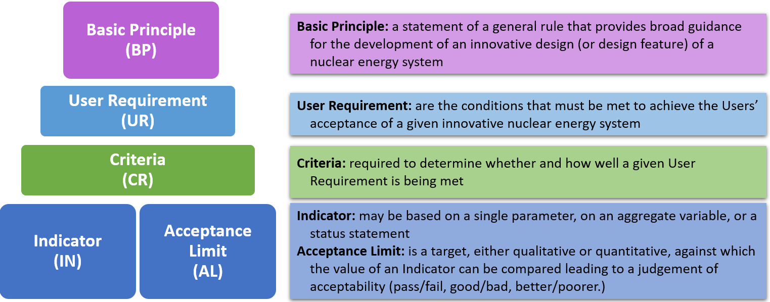

*Figure 1. Diagram showing the hierarchy of the INPRO methodology along with a description for the levels.*

The methodology is useful for countries expanding their nuclear energy plans or for newcomer countries engaging in nuclear energy. Newcomer countries need to understand the implications for the long-term sustainability of a nuclear energy program that covers the lifecycle of a nuclear energy system, from design through construction, operation, and decommissioning. Users of the methodology come from a broad range:

* representatives of investors, designers, energy commissions, power generators and utilities;
* representatives of regulatory bodies, State local organizations and authorities, national governments, legislative bodies, stakeholders including non-governmental organizations (NGO);
* end users of energy products, such as public and industry; and
* members of informed international organizations (such as the IAEA, Nuclear Energy Agency (NEA), International Energy Agency (IEA), etc.) [5].

## History of the INPRO Methodology

The initial INPRO methodology, published in 2003, addressed issues surrounding the use of nuclear power. The issues were: economic competitiveness, safety of nuclear installations, nuclear waste management, proliferation resistance, sustainable development and environmental protection, and physical protection of nuclear material and facilities. A major cross-cutting issue was infrastructure, which consisted of legal and institutional infrastructure, economic and industrial infrastructure, socio-political infrastructure, public acceptance, human resources, and knowledge preservation [5].

The INPRO members tested the methodology using 14 case studies from 7 States. The feedback and recommendations from the assessors provided input to improve the methodology [[6]]. The methodology is useful in: screening a nuclear energy system to evaluate whether it fulfils the objective of ensuring that it meets the energy needs of the next century in a sustainable manner; comparing different nuclear energy systems or components to find a preferred or optimum system consistent with the needs of a given State; and identifying RD&D required to improve the performance of existing components of a nuclear energy system or to develop new components [6].

In 2004 INPRO published an update to the methodology. The methodology supports “the overall objective of INPRO is to ensure nuclear energy is available to make a substantial contribution to fulfilling, in a sustainable manner, the growing need for energy in the 21st century [6].” The methodology is holistic in assessing sustainability of an NES and aligns well with the UN concept of sustainable development, (see Figure 2).

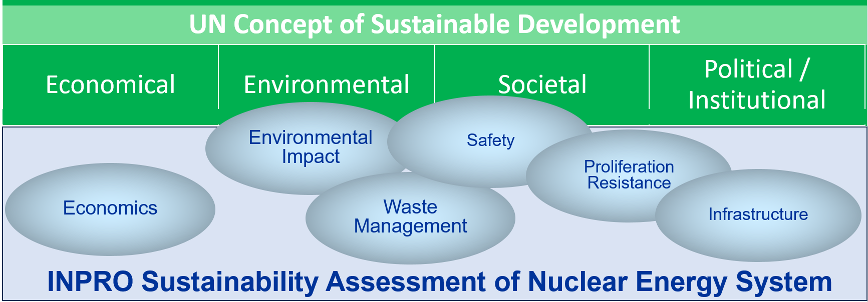

*Figure 2. Diagram showing the interrelationship of the UN concept of sustainable development and INPRO.*

The INPRO members requested additional guidance for using the INPRO methodology. Members also requested the addition of physical protection to the methodology as a distinct area, the 7th area. In 2008 INPRO published further updated guidance, IAEA-TECDOC-1575, (consisting of 9 volumes), in the form of INPRO manuals [[7]]. Many of the INPRO assessment areas had multiple BP.

In 2009, a publication highlighted lessons learned from nuclear energy system assessments (NESA) using the INPRO methodology [[8]]. Based on these recommendations INPRO began again updating the methodology manuals in all areas. The assessors stated that application of the INPRO methodology “was a worthwhile effort and provided valuable insights, and clear identification of gaps [8]” leading to follow up actions. Additionally the INPRO methodology is a useful “tool for meeting the INPRO objective of assessing how nuclear energy systems ‘contribute in a sustainable manner, to meeting the energy needs of the 21st century’ [8]”. A general recommendation was to simplify the basic principles, such as one per area, and make the assessments easier to use by reducing the number of user requirements and criteria. Additionally, they recommended further developing the proliferation resistance analysis and the environmental assessment. INPRO members began updating the manuals and simplifying the assessment process, see Table 1.

TABLE 1. UPDATES TO INPRO MANUALS

|  |  |  |  |  |
| --- | --- | --- | --- | --- |
| Vol. | TECDOC-1575 [7] | UR/CR | Updates to INPRO Manuals | UR/CR (Yr) |
| 1: | Overview |  | Introduction to INPRO Methodology [[9]] | (2010) |
| 2: | Economics | 4/8 | Economics [[10]] | 4/8 (2014) |
| 3: | Infrastructure | 6/19 | Infrastructure [[11]] | 6/19 (2014) |
| 4: | Waste Management | 7/17 | Waste Management [[12]] | 3/9 (2020) |
| 5: | Proliferation Resistance | 5/12 | Proliferation Resistance [[13]] | 5/11 (soon) |
| 6: | Physical Protection | 12/28 | Not updated |  |
| 7: | Environment | 4/14 | Environmental Impact from Depletion of Resources [[14]] | 2/7 (2015) |
|  | Environmental Impact of Stressors [[15]] | 3/5 (2016) |
| 8: | Safety of Nuclear Reactors | 14/37 | Safety of Nuclear Reactors [[16]] | 7/28 (2020) |
| 9: | Safety of Nuclear Fuel Cycle Facilities | 14/37 | Safety of Nuclear Fuel Cycle Facilities [[17]] | 7/16 (2020) |

## Applying INPRO Assessment to Safety, security, and safeguards by Design

The INPRO methodology is a holistic approach to assessing the sustainability of nuclear energy systems that cuts across many departments in the IAEA such as Nuclear Safety and Security (NS), Safeguards (SG), and the Office of Legal Affairs (OLA). Various parts of the INPRO Methodology address the 3S concept areas of safety, security, and safeguards: the INPRO methodology in safety of nuclear reactors and nuclear fuel cycle facilities specifically addresses the 3S concept area of safety; the INPRO Methodology area of proliferation resistance has a specific user requirement for facilitation of IAEA safeguards; and, the INPRO Methodology area of infrastructure, along with the previous INPRO Manual on physical protection, address security. See Figure 3.

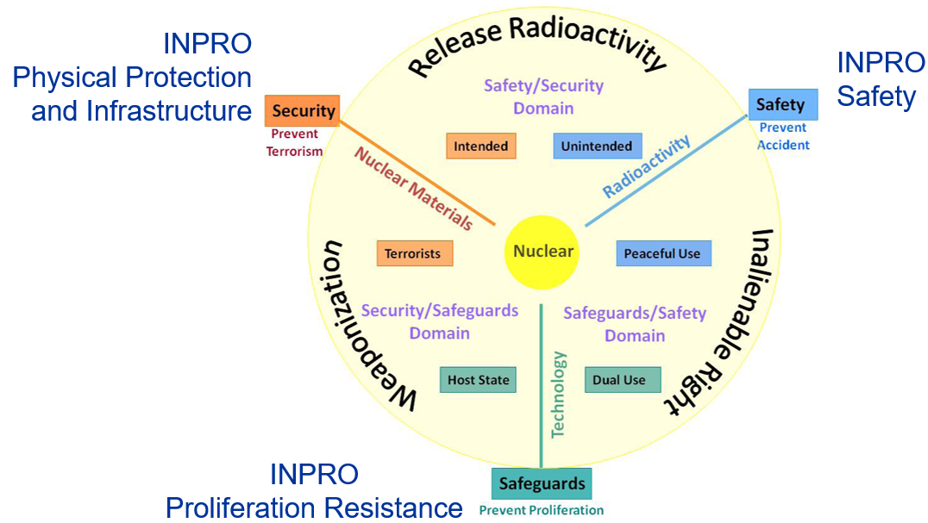

*Figure 3. Diagram showing the interrelationship of UN concept of sustainable development and INPRO [adapted from [18]].*

### INPRO Safety

As defined in the IAEA Nuclear Safety and Security Glossary, 2022, the term safety “means the protection of people and the environment against radiation risks, and the safety of facilities and activities that give rise to radiation risks. ‘Safety’ as used here and in the IAEA safety standards includes the safety of nuclear installations, radiation safety, the safety of radioactive waste management and safety in the transport of radioactive material; it does not include non-radiation-related aspects of safety [[19]].”An INPRO nuclear energy assessments in safety of nuclear reactors has seven URs [16] and the assessment for nuclear fuel cycle facilities is similar [17]. Figure 4 is an overview of the INPRO safety assessment.

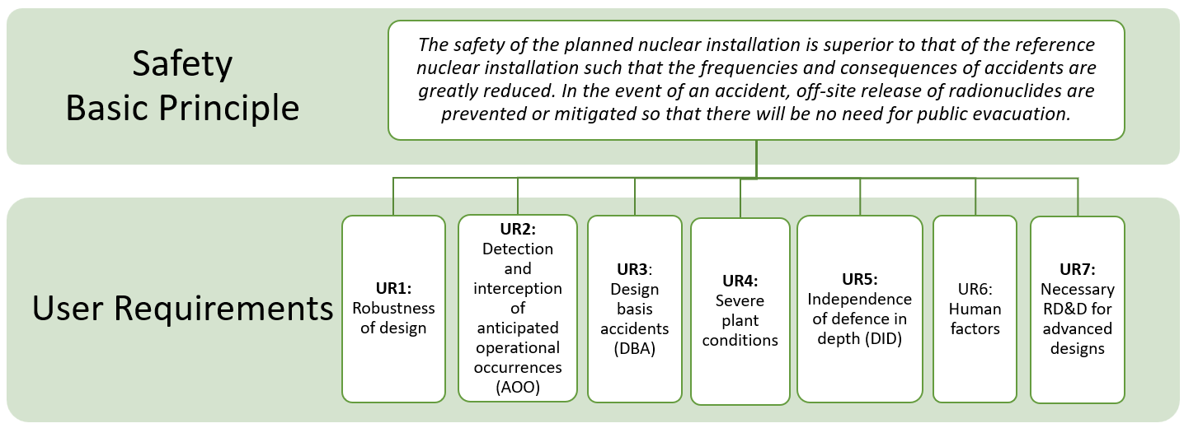

*Figure. 4. The INPRO safety basic principle (BP) and user requirements (URs)* [16]*.*

The Basic Principle in the INPRO manuals addressing safety states: “The safety of the planned nuclear installation is superior to that of the reference nuclear installation such that the frequencies and consequences of accidents are greatly reduced. In the event of an accident, off-site releases of radionuclides are prevented or mitigated so that there will be no need for public evacuation [16, 17].” The INPRO methodology in safety aligns very well with the concept of safety, specifically, the prevention of accidents and mitigation of accidents and their radiological consequences, to prevent the need for public evacuation.

The INPRO assessment in safety assumes that there is design information and results of a safety analysis to perform the sustainability assessment in safety. The INPRO safety assessment is not a safety analysis, however it uses information available in a safety analysis report and compares a new design to a reference design.

The safety URs align well with nuclear safety concepts. The first 4 URs align with safety defence in depths levels and IAEA nuclear and radiological events scale, see Figure 5. UR5 is about defence in depth and UR6 human factors, also important for safety. UR7 regards the need for research for the innovative designs.

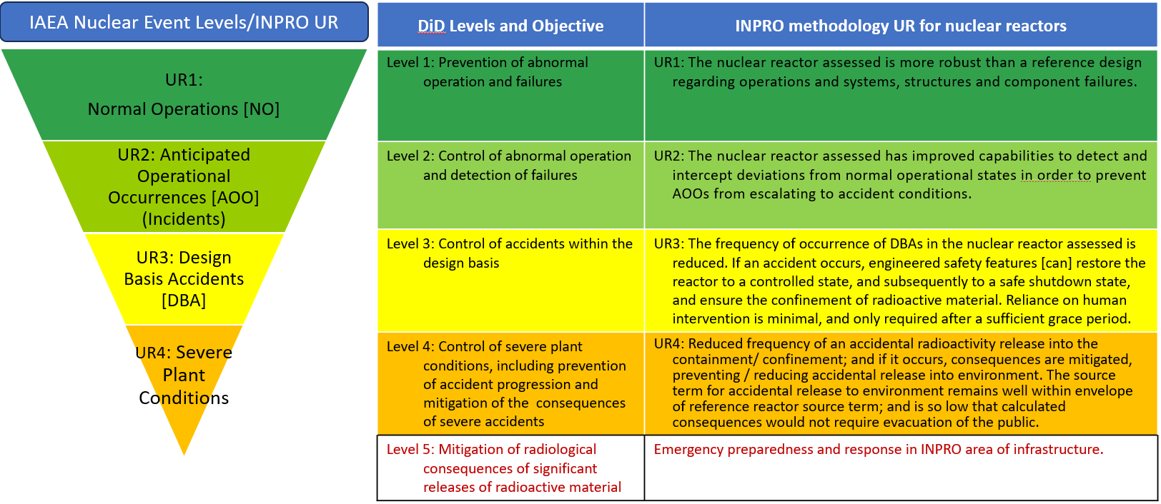

*Figure. 5. The INPRO safety aligns well with the defence in depth safety levels [adapted from [20] ].*

For INPRO safety assessment the expectation is technology developers will increase safety levels of reactors and NES. Incorporating enhanced defence in depth into reactor designs with inherently safe characteristics such as passive safety systems. Designers will also take human factors into account in design and operation of the reactor and will require sufficient RD&D for all innovative design features in new reactors.

### INPRO Infrastructure and Physical Protection for Security

As defined in the IAEA Nuclear Safety and Security Glossary, 2022, the term security is “[t]he prevention and detection of, and response to, criminal or intentional unauthorized acts involving or directed at nuclear material, other radioactive material, associated facilities or associated activities [19].” Nuclear security addresses theft of nuclear material or sabotage, which is the “deliberate act directed against a nuclear facility or nuclear material in use, storage or transport” [19]. The legally binding areas of physical protection (PP) are the Convention on the Physical Protection of Nuclear Material (CPPNM) [[21]] and the Amendment to the CPPNM [[22]].

The INPRO PP Manual [7] has 12 UR and 28 CR to assess the sustainability of PP in a NES. The BP for PP is: “A physical protection regime shall be effectively and efficiently implemented for the full lifecycle of an innovative nuclear energy system (INS) [7]”. Figure 6 shows the PP URs and how they address key areas of nuclear security. There are some additional areas of the INPRO methodology, such as infrastructure and proliferation resistance, useful for covering some parts of security. When the INPRO manuals in TECDOC-1575 were being updated INPRO members decided not to update the PP manual, for the updated Infrastructure Manual addressed PP. However, many MSs continue to use the PP manual for assessments in this area [[23]].

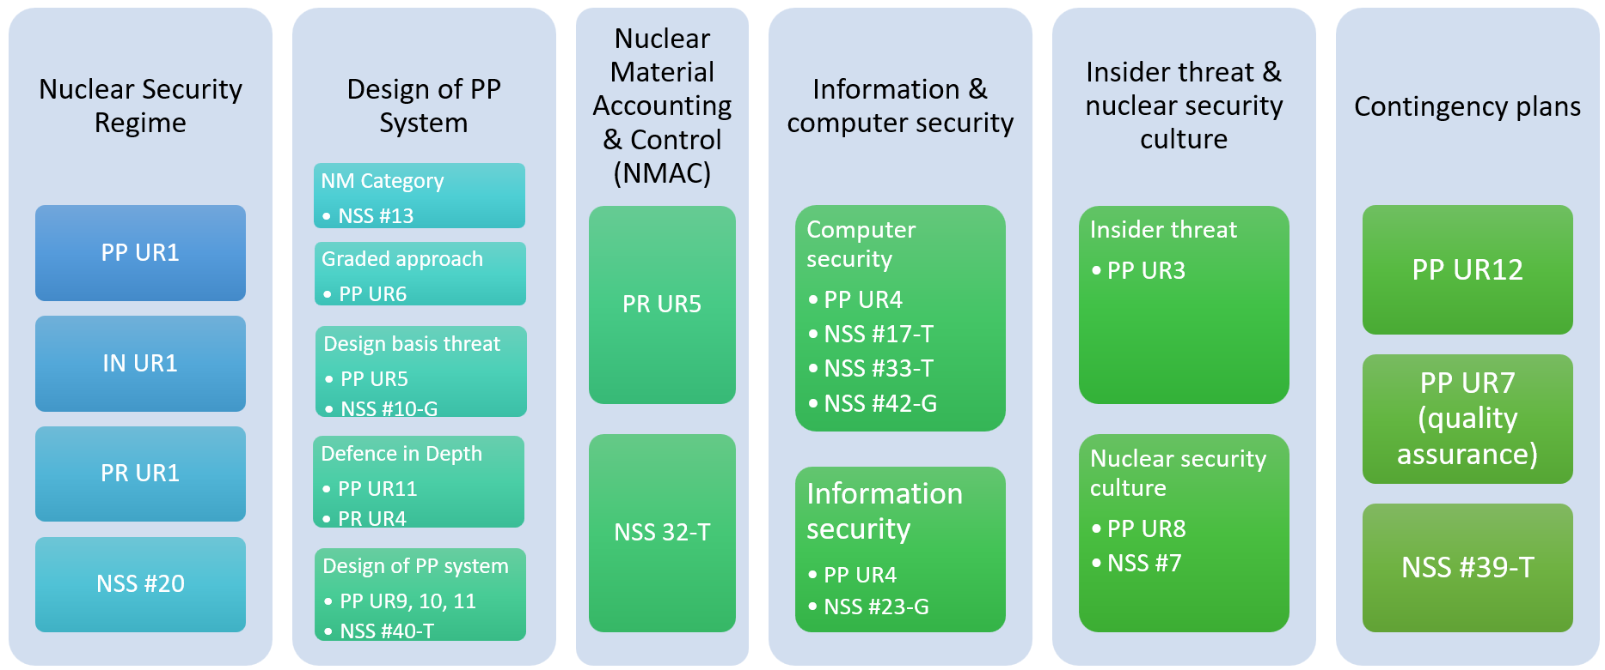

*FIG. 6. Mapping of INPRO methodology areas to nuclear security.*

The UR2 requires the integration of PP into all INPRO areas and throughout all phases. Specifically, CR2.1 looks at the synergies and divergences between PP (security), safety, and PR (safeguards), and operations, which covers the concept of 3S by design. Furthermore, the INPRO assessment should consider results from IAEA missions: International PP Advisory Service (IPPAS) or International Nuclear Security Advisory Service (INSServ). If there is a future update to the INPRO PP manual it will likely be more focused on the effectiveness and efficiency of the State’s nuclear security regime regarding the NES and its sustainability.

### INPRO Proliferation Resistance for Safeguards

The INPRO methodology covers safeguards within the proliferation resistance assessment area. Figure 7 shows the BP and URs for this area. Safeguards is specifically addressed in UR3, the facilitation of IAEA safeguards. This UR states, “The NES should have intrinsic features and implement extrinsic measures that readily facilitate IAEA safeguards [13]”. The first UR assesses the State’s obligations and commitments, both legal and institutional.

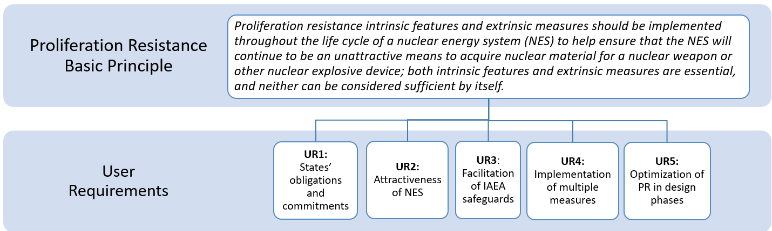

*FIG. 7. The INPRO proliferation resistance basic principle (BP) and user requirements (URs)* [13]*.*

The second UR examines the attractiveness of nuclear material and facilities in the NES. The PR assessment looks at intrinsic design features to make the system less attractive for a State to proliferate. These features include the amount and attractiveness of nuclear material and the attractiveness of the facilities in the NES. The designer can make options during the design phase to make the NES less attractive to proliferation. Several SMR designers are reducing the enrichment of the fuel from just under 20% to 5% or less. If a State has had an IAEA State System of Accounting and Control Advisory Service (ISSAS), it makes it easier to address this UR. The fourth UR is the implementation of multiple intrinsic features and extrinsic measures and to cover diversion paths, which is a defense in depth concept. The more attractive the nuclear material and technologies in an NES, the more measures and features are needed to address these proliferation concerns.

The third UR is the facilitation of IAEA safeguards, that they are effective and can be implemented efficiently. Through an IAEA Member State Support Programme (MSSP) project on ‘Safeguards by Design (SBD) for SMRs’ established in 2019, States can nominate specific SMR designs for SBD engagement with the IAEA. The fifth UR is focuses on the operator – that PR measures implemented be efficient and acceptable to the operator and the State, so the NES can meet PR concerns while still being profitable.

## Application of INPRO 3S Concept to SMRs

There are some projects with Member States in INPRO that are looking at the 3S concepts for SMRs. INPRO has several projects in the NESA process: the Danish Seaborg Technologies CMSR (compact molten salt reactor) project with Viet Nam in all INPRO areas; the gas-cooled microreactor by China Nuclear Power and Engineering (CNPE) in all areas including PP; the Indonesia NESA with SMART (Korean) SMR in all areas including PP; and the Russian RITM-200M (Rosatom) in safety and economics. Chile conducted a study looking at comparing several types of SMRs with the objective to compare technical, including safety, and economic aspects [[24]].

## Summary

The INPRO methodology is an excellent resource for technology developers and technology users to begin addressing the 3S concept of safety-security-and-safeguards by design. Figure 8 shows how the INPRO approach aligns with the 3S concept. When a technology developer is ready, they may approach the IAEA in the areas of safety, safeguards, or security to review their designs or a State may request an IAEA mission. The final caveat is that all designs will need to be economical to be deployed, and efficiencies gained by implementing 3S-by-design can lead to more economical operation.

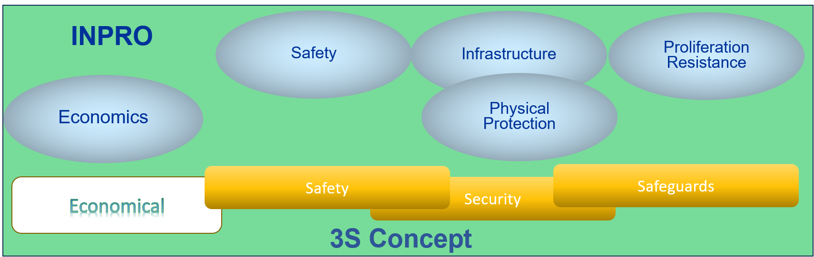

*FIG. 8. Overlay of INPRO methodology areas to 3S concept.*

ACKNOWLEDGEMENTS

This work’s funding was through INPRO Member States extrabudgetary contributions to the INPRO Section. These contributions support INPRO activities and are implemented by INPRO Members together with and assisted by the INPRO Section staff and are subject to availability of staff and budgetary resources.

References

1. [] INTERNATIONAL ATOMIC ENERGY AGENCY, GC(44)RES/21 (2000).
2. [] INTERNATIONAL ATOMIC ENERGY AGENCY, GC(44)RES/22 (2000).
3. [] INTERNATIONAL ATOMIC ENERGY AGENCY, International Project on Innovative Nuclear Reactors and Fuel Cycles (INPRO), Terms of Reference, Vienna (2000).
4. [] BRUNDTLAND, G., Report of the World Commission on Environment and Development: Our Common Future, United Nations General Assembly Document A/42/427 (1987).
5. [] INTERNATIONAL ATOMIC ENERGY AGENCY, Guidance for the Evaluation of Innovative Nuclear Reactors and Fuel Cycles Report of Phase 1A of the International Project on Innovative Nuclear Reactors and Fuel Cycles (INPRO), IAEA-TECDOC-1362, IAEA, Vienna (2003).
6. [] INTERNATIONAL ATOMIC ENERGY AGENCY, Methodology for the Assessment of Innovative Nuclear Reactors and Fuel Cycles Report of Phase 1B (first part) of the International Project on Innovative Nuclear Reactors and Fuel Cycles (INPRO), IAEA-TECDOC-1434, IAEA, Vienna (2004).
7. [] INTERNATIONAL ATOMIC ENERGY AGENCY, Guidance for the Application of an Assessment Methodology for Innovative Nuclear Energy Systems, IAEA-TECDOC-1575, IAEA, Vienna (2008).
8. [] INTERNATIONAL ATOMIC ENERGY AGENCY, Lessons Learned from Nuclear Energy System Assessments (NESA) Using the INPRO Methodology. A Report of the International Project on Innovative Nuclear Reactors and Fuel Cycles (INPRO), IAEA-TECDOC-1636, IAEA, Vienna (2009).
9. [] INTERNATIONAL ATOMIC ENERGY AGENCY, Introduction to the Use of the INPRO Methodology in a Nuclear Energy System Assessment, IAEA Nuclear Energy Series No. NP-T-1.12, IAEA, Vienna (2010).
10. [] INTERNATIONAL ATOMIC ENERGY AGENCY, INPRO Methodology for Sustainability Assessment of Nuclear Energy Systems: Economics, IAEA Nuclear Energy Series No. NG-T-4.4, IAEA, Vienna (2014).
11. [] INTERNATIONAL ATOMIC ENERGY AGENCY, INPRO Methodology for Sustainability Assessment of Nuclear Energy Systems: Infrastructure, IAEA Nuclear Energy Series No. NG-T-3.12, IAEA, Vienna (2014).
12. [] INTERNATIONAL ATOMIC ENERGY AGENCY, INPRO Methodology for Sustainability Assessment of Nuclear Energy Systems: Waste Management, IAEA-TECDOC-1901, IAEA, Vienna (2020).
13. [] INTERNATIONAL ATOMIC ENERGY AGENCY, INPRO Methodology for Sustainability Assessment of Nuclear Energy Systems: Proliferation Resistance, IAEA Nuclear Energy Series No. NG-T-3.26, IAEA, Vienna (to be published).
14. [] INTERNATIONAL ATOMIC ENERGY AGENCY, INPRO Methodology for Sustainability Assessment of Nuclear Energy Systems: Environmental Impact from Depletion of Resources, IAEA Nuclear Energy Series No. NG-T-3.13, IAEA, Vienna (2015).
15. [] INTERNATIONAL ATOMIC ENERGY AGENCY, INPRO Methodology for Sustainability Assessment of Nuclear Energy Systems: Environmental Impact of Stressors, IAEA Nuclear Energy Series No. NG-T-3.15, IAEA, Vienna (2016).
16. [] INTERNATIONAL ATOMIC ENERGY AGENCY, INPRO Methodology for Sustainability Assessment of Nuclear Energy Systems: Safety of Nuclear Reactors, IAEA-TECDOC-1902, IAEA, Vienna (2020).
17. [] INTERNATIONAL ATOMIC ENERGY AGENCY, INPRO Methodology for Sustainability Assessment of Nuclear Energy Systems: Safety of Nuclear Fuel Cycle Facilities, IAEA-TECDOC-1903, IAEA, Vienna (2020).
18. [] CHOI, J., presentation at workshop on “Success Through Safety, Security and Safeguards by Design (3SBD); From Concept to Application, University of New Mexico (2013).
19. [] INTERNATIONAL ATOMIC ENERGY AGENCY, IAEA Nuclear Safety and Security Glossary, Non-serial Publications, IAEA, Vienna (2022), <https://doi.org/10.61092/iaea.rrxi-t56z>
20. [] INTERNATIONAL ATOMIC ENERGY AGENCY, Hierarchical Structure of Safety Goals for Nuclear Installations, IAEA-TECDOC-1874, IAEA, Vienna (2019).
21. [] INTERNATIONAL ATOMIC ENERGY AGENCY, The Convention on the Physical Protection of Nuclear Material, INFCIRC/274/Rev. 1, IAEA, Vienna (1980) https://www.iaea.org/sites/default/files/infcirc274.pdf
22. [] INTERNATIONAL ATOMIC ENERGY AGENCY, Amendment to the Convention on the Physical Protection of Nuclear Material, INFCIRC/274/Rev.1/Mod.1/ (Corrected), IAEA, Vienna (2021) https://www.iaea.org/sites/default/files/publications/documents/infcircs/1979/infcirc274r1m1c.pdf
23. [] Johari, J.M.C., Pane, J.S., Dewayatna, W., et al., Evaluating the Performance of Indonesia’s Nuclear Energy Program Using INPRO Methodology, KERNTECHNIK: Independent Journal for Nuclear Engineering, 2023. https://doi.org/10.1515/kern-2022-0099
24. [] FERNÁNDEZ, C., & VERGARA, J. (2021). Multi-criteria comparison of nuclear reactors using the MULTIMOORA method: A case of study for Chile. Progress in Nuclear Energy, 138, 103802. https://doi.org/10.1016/j.pnucene.2021.103802