# PREPARATION OF REGULATORY FRAMEWORK

# FOR SMR DEPLOYMENT IN UKRAINE

O. DYBACH

State Scientific and Technical Center for Nuclear and Radiation Safety

Kyiv, Ukraine

Email: [om_dybach@sstc.ua](mailto:om_dybach@sstc.ua)

A. SHEPITCHAK

State Nuclear Regulatory Inspectorate of Ukraine (SNRIU)

Kyiv, Ukraine

Email: [av.shepitchak@snriu.gov.ua](mailto:av.shepitchak@snriu.gov.ua)

І. SHEVCHENKO

State Scientific and Technical Center for Nuclear and Radiation Safety

Kyiv, Ukraine

Email: [ia_shevchenko@sstc.ua](mailto:ia_shevchenko@sstc.ua)

O. PECHERYTSIA

State Scientific and Technical Center for Nuclear and Radiation Safety

Kyiv, Ukraine

Email: [ov_pecherytsia@sstc.ua](mailto:ov_pecherytsia@sstc.ua)

O. ZHABIN

State Scientific and Technical Center for Nuclear and Radiation Safety

Kyiv, Ukraine

Email: [oi_zhabin@sstc.ua](mailto:oi_zhabin@sstc.ua)

O. HORODNICHA

State Nuclear Regulatory Inspectorate of Ukraine (SNRIU)

Kyiv, Ukraine

Email: [os.horodnicha@snriu.gov.ua](mailto:os.horodnicha@snriu.gov.ua)

**Abstract**

Small modular reactors are widely considered as an essential part of an energy mix portfolio to reach the climate goals. In addition to their announced ability to generate clean, affordable and reliable power, Ukraine looks at SMRs also for decentralization the power system and to reduce its vulnerability to external impacts. International experience shows the benefits of early engagement of the regulatory body into assessment of SMR designs that could take different forms (design certification, generic design assessment, pre-licensing assessment, etc.) and the necessity for the regulator to advance prepare the framework for further regulating of new technologies. The Ukrainian national regulator SNRIU with assistance of its technical support organization SSTC NRS has been implementing a set of measures to prepare the national regulatory framework for SMR deployment. The specific guidance “Provisions for Pre-Licensing Review of Nuclear Facility’s Design” was issued in 2023 to outline a technical frame for the pre-licensing review in Ukraine. The paper presents the overview of the guidance on pre-licensing review and first experience in its application.

## INTRODUCTION

The Energy Strategy of Ukraine until 2050 sets ambitious targets for increasing of nuclear and renewable power generation capacity in order to achieve carbon neutrality in the energy sector [1]. Ukraine among twenty-two countries has signed up to the goal of tripling global nuclear energy capacity by 2050, at the 28th UN Climate Change Conference of the Parties (COP28) [2].

Small modular reactors (SMRs) are considered in Ukraine alongside to conventional nuclear power plants. In addition to SMRs’ announced ability to generate clean, affordable and reliable power, Ukraine looks at SMRs also for decentralizing the national power system, adding new load following capacities and increasing electricity grid resiliency to external impacts.

An effective regulatory framework, including a straightforward licensing process, is essential to the success of SMRs deployment. As the competent national regulatory body, the State Nuclear Regulatory Inspectorate of Ukraine (SNRIU), with assistance of its Technical Support Organization (SSTC NRS), is preparing the national framework suitable for SMR while avoiding regulatory burdens for implementation of novel technologies in Ukraine.

This paper outlines the recent SNRIU and SSTC NRS initiatives on development of the pre-licensing guidance and first experience in its application.

## ReGULATORY FRAMEWORK FOR SMR DEPLOYMENT IN UKRAINE

Given the growing interest in SMRs both globally and in Ukraine [3], [4], SNRIU has initiated activities to prepare the regulatory framework facilitating the further licensing of this emerging technology.

To outline the national regulatory framework suitable for SMRs, SNRIU examines international practices on early regulatory involvement in SMR reviews, which can take various forms such as design certification, generic design assessment, pre-licensing review and joint review by several regulators [5]. SNRIU and SSTC NRS engages in the international activities and bilateral co-operation on SMRs, utilizes outcomes from SMR Regulators Forum and WENRA. These efforts facilitate international cooperation and help establish common positions on regulatory issues associated with SMRs.

SNRIU is advancing in two principal aspects of the regulatory framework for SMRs: 1) development of regulations and guidance, and 2) capacity building efforts aimed at ensuring the availability of qualified and competent staff capable of effectively fulfilling the regulatory functions in SMR licensing.

Ukrainian regulations primarily address light water reactors technology and are based on the experience of regulating the current generation of pressurized water reactors, specifically the VVER type reactors. SNRIU regularly updates national requirements to implement WENRA reference levels, incorporate IAEA safety standards and consider relevant experience gained. In this process, particular attention is paid to ensure the regulations are technology-neutral, so they do not limit existing advanced and emerging technologies.

As part of the ongoing efforts on revising regulations, a new version of the safety regulations NP 306.2.245-2024 "General Provisions on Nuclear Power Plants Safety" was put into force in 2024. Issuing these new regulations is an important step towards updating the basic safety requirements aligning them with state-of-the-art international standards. NP 306.2.245-2024 formally introduces refined safety criteria, such as practical elimination of large and early radioactive releases for design extension conditions, as well as several rather new design concepts - fail-safe design, etc.

Additionally, NP 306.2.245-2024 reconsiders the previously established safety principle of proven engineering practices and allows the application of new technical solutions justified by appropriate research and experimental programs. New revision permits using international codes and standards. The list of those codes and standards needs to be defined and justified by the licensee and submitted for approval to the regulatory body.

As a result, SNRIU considers the existing national legislation and regulations, which establish safety requirements and the licensing process for nuclear power plants, to be adequate and applicable for SMR designs intended for near-term deployment.

To streamline the licensing process for new technologies in Ukraine, SNRIU has introduced a pre-licensing review. SNRIU Board approved the guidance document titled "Provisions for Pre-Licensing Review of Nuclear Facility Designs" at the meeting on 19 October 2023 [7]. The document was developed by the SSTC NRS at the insistence of the SNRIU with the support of the U.S. Nuclear Regulatory Commission.

Pre-licensing review is an optional service provided by the SNRIU and/or SSTC NRS at the request of nuclear facility design organization, vendor, operating organization (utility) or other customer. It involves providing the preliminary comments and conclusions regarding the compliance of the nuclear facility design and safety justifications, management system documentation related to preparation of a design and safety justification, with the requirements of national nuclear safety laws and regulations.

Pre-licensing review is not a part of the licensing process and does not affect SNRIU decision regarding the issuance of a license or any other regulatory permit for the activities related to a specific stage of the nuclear facility lifecycle. Nevertheless, this review allows the required corrective measures to be proposed and implemented before completion of the nuclear facility design phase and reduces regulatory uncertainties associated with the implementation of novel technologies and design features with no or limited operating experience.

According to [7], the main objective of pre-licensing review is to identify in a timely manner the potential issues related to the nuclear facility design and technologies applied, particularly the issues that may require significant changes to the design, methodology and the results of safety justification, and may significantly complicate or completely preclude licensing of construction and commissioning of the nuclear facility of this design.

The main tasks of the pre-licensing review are:

1. to confirm (taking into account the readiness, content, and scope of technical documentation provided for pre-licensing review) that the nuclear facility design and safety justifications adequately implements:

* fundamental and general organizational and technical safety principles;
* requirements of national nuclear and radiation safety regulations and rules;
* applicable requirements and recommendations of international organization (if corresponding requirements in national regulations and rules are not detailed);

1. to identify:

* the list of topics / questions for which, based on the results of pre-licensing review, additional information and explanations regarding the nuclear facility design and safety justifications, documentation of the management system are deemed necessary;
* potential issues, that may require significant changes to the nuclear facility design, methodology and the results of safety justification, or may significantly complicate or completely preclude licensing of construction and commissioning of the nuclear facility of this design;
* sufficiency of conducted or planned research and testing activities to confirm the applicability of design decisions and technologies with limited or no operating experience.

The main attributes of the established pre-licensing review process are as follows:

* related to a conceptual/generic design (several subsequent review steps may occur with each new step requiring higher completeness level of design documentation and safety justifications);
* 19 technical review areas, covering all principal safety related aspects (show on Fig. 1);
* not addressing site specific issues.

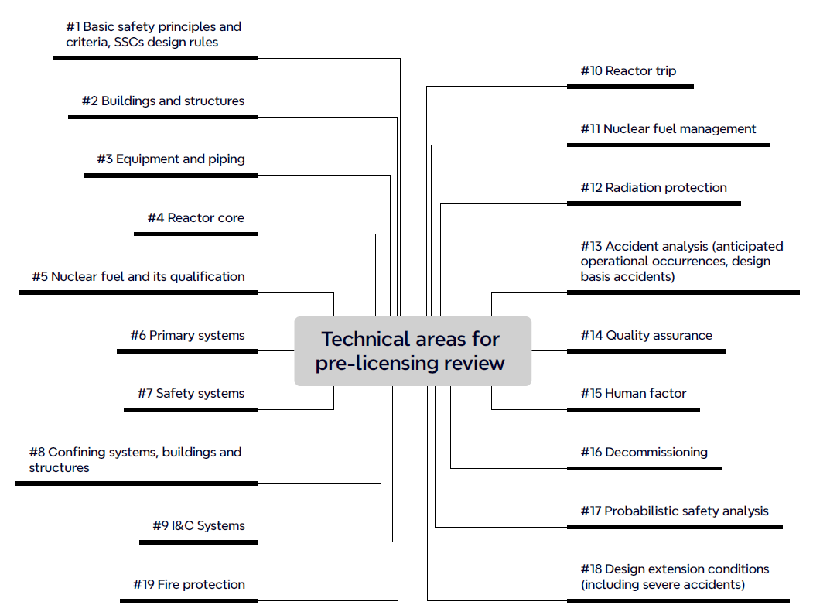

*FIG. 1. Technical areas for pre-licensing review.*

There are three stages of the pre-licensing review:

* Evaluation of the conceptual design of the nuclear facility;
* General evaluation of the nuclear facility design;
* Detailed evaluation of the nuclear facility design in specific areas.

As with the pre-licensing review as a whole, none of the stages are mandatory, and the need for their implementation is determined by the designer, vendor or other organization requesting the review. At each subsequent stage of the evaluation, the required level of readiness of design documentation and the detail of the nuclear facility safety justifications increase.

In the first stage, a familiarization with the nuclear facility design is conducted. This includes understanding the fundamental decisions and approaches underlying the design, the purpose, principles, and operating modes of the main systems and components, and the documentation of the management system, including the methodologies and guidelines used or planned to be used in the development of the design and the safety justifications. Their compliance with the main safety principles and criteria, as well as with the general safety provisions for nuclear facilities of the relevant type, is evaluated. It is verified that the documentation provided for this stage of the pre-licensing review outlines acceptable intents and approaches for adequately addressing the requirements of national regulations into the nuclear facility design.

The second stage of the review involves evaluation of compliance of design documentation with national safety regulations and rules, or, in their absence on specific issues, with the requirements and recommendations of international organizations (IAEA, WENRA). The acceptability of the information provided regarding the planned scope, approaches, and methods for completing the work on the development and justification of the nuclear facility safety is determined.

In the final, third stage of the review, documentation is examined in specific technical areas where potential issues were identified in the previous stages. These issues might require significant changes to the nuclear facility design, the methodology, and the results of the safety justifications. The scope of the pre-licensing review conducted at this stage may be supplemented with additional technical areas at the request of the organization requesting the review.

## FIRST INSIGHTS FROM THE PRE-LICENSING REVIEW GUIDANCE APPLICATION

As part of international cooperation, some pilot review activities are currently being conducted to enable practical application of the guidance document for SMRs (LWR design), providing feedback for its further improvement.

The pre-licensing review is limited by several focus areas, including the following:

* general aspects of safety analysis: this area covers both deterministic and probabilistic analysis, respective acceptance criteria, identification of postulated initiating events and accident scenarios, methodology, documentation etc.;
* design extension conditions: this area presents review of methods of identification and completeness of selected design extension conditions without significant fuel degradation (DEC-A) and with fuel melting (DEC-B), phenomenology of severe accidents, adequacy of design features for confining radioactive material, control and limitation of radioactive releases etc.;
* reactor core and fuel management: this area covers the review of design of fuel elements and fuel assemblies, qualification program of nuclear fuel, etc.

At the beginning of the review process, a comprehensive set of national regulations and international standards has been established, serving as a basis for defining review criteria (example for DEC review is shown on Fig. 2).

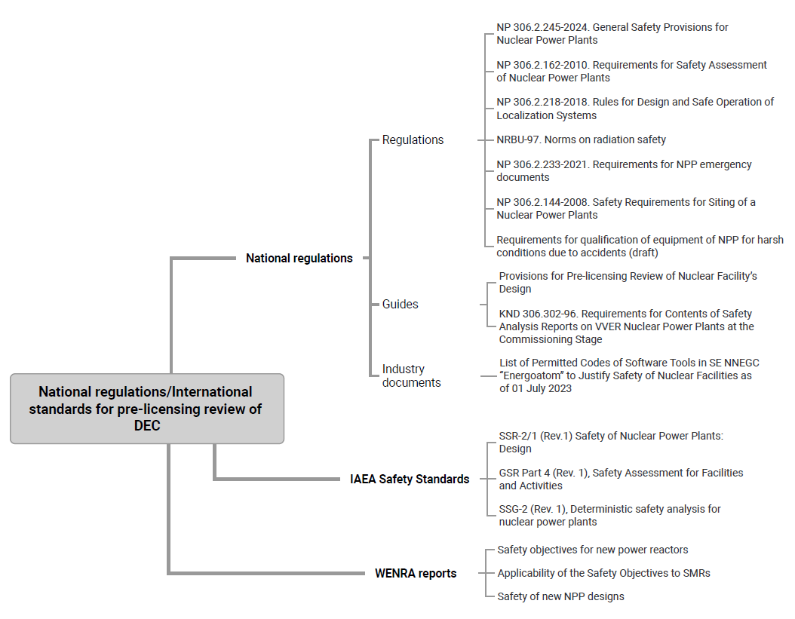

*FIG. 2. National regulations/international standards basis for pre-licensing review of design extension conditions.*

The on-going pre-licensing review has unveiled several potential issues, as outlined in Table 1.

Another inherent for SMRs design topic pointed out in the course of pre-licensing review is the consideration of multi-module effects. Multi-module SMR design can offer some safety advantages through enhanced availability and reliability of support services. On the other hand, it may require specific safety justification in some specific aspects, such as:

1. Use of shared system important to safety. Shared systems should not compromise overall plant safety and safety function they are intended to provide is to be ensured for all accident scenarios and for each module. There is specific requirement in NP 306.2.245-2024 [6] for multi-unit site that could be applied for multi-module SMR design with due consideration of modules proximity, integration etc.

An example of a shared system important to safety in certain SMR designs is a common UHS system for all modules. In this case, the UHS should be capable of providing sufficient cooling to remove heat from all modules (and spent fuel pool if relies on the same UHS) in case of accident conditions.

1. Potential impact/interaction between different modules. Accident conditions in one module could trigger adverse effects in others or initiate events in other modules. When selecting initiating events, it is needed to account for failures originating in shared systems utilized by multiple modules. Safety justifications should include thorough analyses of the potential impact of accidents in one module on others, including scenarios involving containment bypass and severe accidents.

TABLE 1. DISCUSSION OF THE POTENTIAL ISSUES AS THE FIRST INSIGHT FROM THE PRE-LICENSING REVIEW (NON-EXHAUSTIVE LIST)

| **#** | **POTENTIAL ISSUE** | **DISCUSSION** |
| --- | --- | --- |
| 1 | Safety criteria | National regulations [6] include two principal groups of the safety criteria – probabilistic and deterministic.  (1) The probabilistic safety criteria are established in terms of integral (total) core damage frequency and large release frequency referring to the full scope PSA (internal and external events, full power and shutdown operating modes).  International practice shows that there may be differences in required PSA scope and elements, risk aggregation methods, definition of large releases, etc. that need to be considered when comparing with established probabilistic criteria.  (2) Radiological safety criteria, serve as acceptance criteria for deterministic safety analysis, are established in alignment with national radiation protection norms [8]. For the design extension conditions these criteria are based on adverse doses for prompt and long-term protective measures ensuring practical elimination of early and large radioactive releases.  International practices reveal variations in dose boundaries across different accident categories, underscoring the importance of properly accounting for these differences when justifying compliance with safety criteria. |
| 2 | Safety classification | The difference in approaches used to develop the safety classification of SSCs could have a significant impact on SMR design and equipment supply.  For existing NPPs, Ukrainian regulations [6] establish a two-group classification system based on the impact on safety: important to safety and non-important to safety, further categorized into Safety Classes 1-4 primarily through deterministic judgements. For new NPPs, the recently updated version of regulations accounts requirement 22 IAEA SSR-2/1 (Rev.1) that allows more flexible approach, though the principles of classification, as well as classification of SSC itself, shall be justified by the operating organization and agreed upon with the regulatory body. |
| 3 | Principles of safety/important to safety systems design | National regulations [6] require the application of set of principles in design of safety systems: diversity, redundancy, physical separation and functional independence, single failure. Also, the concept of fail-safe design shall be incorporated, as appropriate, into the design of systems important to safety.  International practices reveal that vendors may apply these principles differently, taking into account the specifics of the technology. This variability in application can require additional justifications. |
| 4 | Qualification of the computer codes | Computer codes and associated models need to be developed according to quality assurance procedures and validated versus experimental test data (separate effect tests and integral facilities tests) to prove their capabilities to adequately simulate the phenomena expected to occur in the facility during normal operation, AOO, DBA and DEC taking into account the specifics of the particular facility design.  There is a list of computer codes permitted for use in safety justifications maintaining by the state operating organization in Ukraine [9]. The computer codes applied for SMRs need to be justified for inclusion into the list. |
| 5 | Codes and standards | The codes and standards contribute to prove that safety related structures, systems and components will perform their safety functions with a required level of reliability.  There is a national system of codes and standards (DSTU) and set of non-binding guides, developed by the state operating organization (SOU). The utilization of international or vendor country codes and standards needs to be justified by the licensee. |

## CONCLUSIONS

SNRIU prepares the regulatory framework for SMR deployment in Ukraine establishing the pre-licensing review process and strengthening capability in review and assessment of the emerging SMR designs.

The designs of SMRs incorporate smaller radioactive inventories and employ innovative technologies with inherent and advanced passive safety features. Nevertheless, the primary objective of regulatory requirements remains consistent: ensuring the protection of people and the environment from harmful effects of ionizing radiation.

Early pre-licensing engagements have demonstrated mutual benefits for both SMR vendors and regulatory authorities. By conducting pre-licensing reviews of SMR designs, potential issues can be identified at an early stage, facilitating identification of needs for design changes and additional safety justifications to meet the requirements of national regulations and expectations of the regulatory body. This proactive approach fosters greater confidence in further formal licensing process.

REFERENCES

1. CABINET OF MINISTERS OF UKRAINE. The Energy Strategy of Ukraine until 2050, 2023.
2. US DEPARTMENT OF ENERGY, Declaration to Triple Nuclear Energy (2023), <https://www.energy.gov/articles/cop28-countries-launch-declaration-triple-nuclear-energy-capacity-2050-recognizing-key>.
3. WORLD NUCLEAR NEWS (WNN), Mass deployment of Holtec SMRs in Ukraine is part of accord's aims (2023), <https://world-nuclear-news.org/Articles/Accord-sees-mass-deployment-of-Holtec-SMRs-in-Ukra>.
4. NUSCALE POWER, NuScale Power Signs Memorandum of Understanding with Energoatom to Explore SMR Deployment in Ukraine (2021), <https://www.nuscalepower.com/en/news/press-releases/2021/nuscale-power-signs-mou-with-energoatom-to-explore-smr-deployment-in-ukraine>.
5. NUWARD SMR Joint Early Review, Pilot Phase Closure Report, 2023.
6. General Provisions on Nuclear Power Plant Safety, NP 306.2.245-2024, 2024.
7. Provisions for pre-licensing review of nuclear facility’s design, SSTC NRS, 2023.
8. Norms of Radiation Safety (NRBU-97), 1997.
9. JOINT STOCK COMPANY "NATIONAL NUCLEAR ENERGY GENERATING COMPANY "ENERGOATOM", Safety analysis and assessment. The procedure for using software to justify safety of nuclear power plants. Methodical guidance, STP 0.41.076-2008, 2008.