# Design of a reusable Materials

# Irradiation DevIce (MIDI) in the High Flux

# Reactor in Petten for testing and

# qualification of SMR materials

N.J. BARRON

Nuclear Research & consultancy Group (NRG)

Petten, The Netherlands

Email: [barron@nrg.eu](mailto:barron@nrg.eu)

F. NAZIRIS

NRG

Petten, The Netherlands

D. VERBRUGGEN

NRG

Petten, The Netherlands

E. D’AGATA

European Commission - Joint Research Centre (EC-JRC)

Petten, The Netherlands

O. MARTIN

EC-JRC

Petten, The Netherlands

N.V.V.R.M. KOLLURI

NRG

Petten, The Netherlands

**Abstract**

Irradiation testing of novel and established materials is a crucial step to enable the deployment of SMRs utilizing new materials and/or manufacturing processes to meet hypothetical SMR construction timeframes and realize the complex integrated features of several designs. The High Flux Reactor (HFR) in Petten has played a substantial role in contributing to the irradiation testing of materials and fuels. Several hundred irradiation experiments have been performed over the decades, including the LYRA irradiations. LYRA was a re-usable irradiation facility in the HFR which has been extensively used for irradiation of reactor pressure vessel steels and other structural materials to support LTO-research and qualification of new materials. After its 10th irradiation campaign, the LYRA facility was dismantled and a project begun to replace it that incorporated this multi-year learning. This new, reusable **M**aterials **I**rradiation **D**ev**I**ce (MIDI) is being designed and developed in collaboration with the European Commission - Joint Research Centre (EC-JRC) Petten as part of the Dutch government funded PIONEER program. This paper will present the work to-date in developing the engineering design and specifications of the MIDI device, how learning from LYRA has been incorporated, and how the MIDI facility will support the irradiation testing of materials for selected SMR concepts.

## INTRODUCTION

The climate crisis, driver to “on-shore” energy production and industrialisation of developing nations presents a generational opportunity for nuclear to support nations meet their low carbon energy needs [1]. Modern, smaller designs are also seeking to go beyond more traditional baseload generation, providing a flexible capacity that integrates with renewables as well as provide the ability to decarbonise the more hard to abate industrial and process heat (non-electric energy vectors) applications such as steel making or green hydrogen production. To best integrate with existing industrial users, and support deployment on the timescales necessary will require new reactors ranging from the micro (<20 MW) to macro (>20 MW). It is expected that Small Modular Reactors (SMRs), encompassing both water and non-water (gas, liquid metal and molten salt) coolants will play a significant role in this given the various benefits they provide [2].

Many SMR concepts exist at various levels of development, with more mature designs based on widely established technologies. Yet even these systems are likely to place additional demands on structural materials due to the more compact cores and load following. Wider advances in manufacturing, such as Hot Isostatic Pressing (HIP), Additive Manufacture (AM) and electron beam (e-beam) welding offer the ability to further accelerate deployment and reduce the cost of SMRs but utilise processes that are often not fully qualified for a nuclear environment. To support the development and deployment of SMRs globally, NRG and the European Commission’s JRC have brought their strong history of materials irradiation and collaboration to develop the MIDI (**M**aterials **I**rradiation **D**ev**I**ce) facility for irradiation of SMR structural materials and materials fabricated via advanced manufacturing. The remainder of this paper will briefly provide an overview of materials research conducted at the High Flux Reactor (HFR) by NRG and JRC, before providing details of the MIDI facility.

## History of materials RESEARCH at hfr

### Overview of HFR

The High Flux Reactor (HFR) is a versatile 45 MWth materials test reactor that began operating in 1961 and is owned by the European Commission’s Joint Research Centre Petten (EC-JRC) and operated by the Nuclear Research & consultancy Group (NRG). The HFR is located at the Energy and Health Campus, Petten, the Netherlands along with many other nuclear facilities, energy and health organisations. Various re-usable facilities exist that enable irradiation of samples in both in-core and out of core positions, in the so-called Pool Side Facility (PSF) (FIG 1). HFR is an open pool type reactor with a unique design that enables a particularly high flux that is able to meet both the needs of research as well as medical radioisotope production capabilities [3].

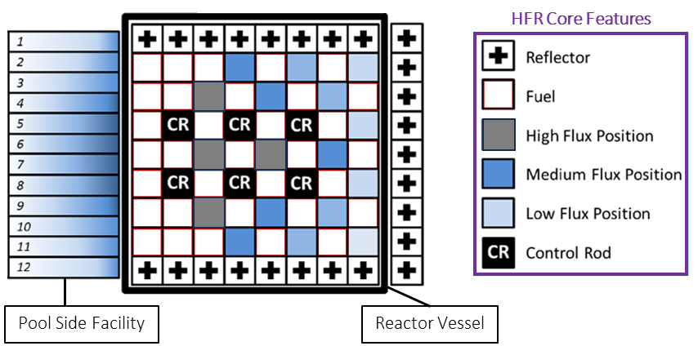

FIG 1: Layout of the HFR

The HFR has contributed to national, European and global research endeavours during its life that include the testing of fuels and materials for current and next generation nuclear reactors. As HFR approaches the end of its operation life, design endeavours began and in spring 2023 groundwork started for the construction of the HFR replacement, the PALLAS reactor [4].

### BRIEF HISTORY OF HFR IRRADIATIONS

NRG conducts research on behalf of the Dutch state, as part of European programmes and for commercial organisations. Alongside supporting research into more traditional nuclear systems, such as lifetime extensions in the project STRUctural MATerials research for safe Long Term Operation of Light Water Reactors (STRUMAT-LTO), NRG have conducted multiple public irradiation campaigns into advanced fuels and materials since 2000 (Table 1) as well as more recent endeavours to irradiate molten salts as part of the SALIENT experiments [4, 5, 6]. Most of these projects are in collaboration with the JRC who brings together multi-disciplinary expertise providing European policy support and technology innovation.

Table 1: Overview of selected Fuel and Material Irradiations in HFR since 2000

|  |  |  |  |
| --- | --- | --- | --- |
| **Fuel Irradiations** | | **Materials Irradiations** | |
| Name | Description | Name | Description |
| OTTO | Once through plutonium transmutation | CIWI | BWR core shroud welds |
| THORIUM CYCLE | Thorium fuel | IBIS | Material in lead-bismuth |
| EFFTRA | Transmutation | ENICKMA | Ni-based alloys for use in molten salt reactors |
| HELIOS | Minor actinide fuels & targets | EXTREMAT | High temperature advanced materials |
| CONFIRM | Nitride fuels | EXOTIC | Solid tritium breeder materials |
| FUJI | Breeder reactor fuels | HICU | Breeder materials for fusion |
| MARIOS | Minor actinide fuels | INNOGRAPH | HTR graphite |
| INET | HTR-PM fuel qualification | LYRA | Reactor Pressure Vessel Steels |
| HFR-EU1(is) | HTR pebbles | PARIDE | ITER first wall and divertor |
| SMART | Nitride fuels | PYCASSO | HTR surrogate particles |
| TRABANT | Fast breeder annular MOX | SOSIA | 9Cr creep and creep fatigue |
| SPHERE | Minor actinide sphere-pac fuels | SPICE | RAFM steel |
| MARINE | Minor actinide pellet fuel | STROBO | Stress relaxation of bolt materials |
| Fuel CREEP | Online measurement of fuel creep | SUMO | 9Cr steels and joints |

### LYRA EXPERIENCE

Between 1997 and 2018, the re-usable LYRA facility was a key research facility of the Ageing Materials European Strategy (AMES) Network. The purpose of AMES was to study the irradiation embrittlement behaviour of reactor pressure vessel (RPV) steels and the effectiveness of thermal annealing in mitigating RPV embrittlement [4]. During this period, 10 irradiation campaigns were successfully completed that utilised bespoke sample holders that were housed within the LYRA facility, an example of the sample holder used in LYRA-10 is visible in FIG 2b.

A brief summary of the LYRA experiments follows to highlight the range of projects that utilised the facility, this is based on the recent review of D’Agata *et al.* which provides a more detailed content prior to reviewing the individual references [4]. The LYRA-1 and -2 experiments were part of the REFEREE and RESQUE projects, which differed from LYRA-3 which principally irradiated mini Charpy specimens (KLSTs, 3 x 4 27 mm3) for the MODEL ALLOY project [7, 8]. Irradiations for the FRAME project (FRActure MEchanics based Embrittlement trend curves) to characterization RPV materials were carried out in LYRA-4 [9]. Irradiations into the influence of phosphorus on materials, as part of the PISA (Phosphorus Influence on Steels Ageing) were carried out in LYRA-5, -6 and -7 [10]. LYRA-8 and -9 highlighted the versatility of the facility as it was used to support HTR structural material irradiations at elevated temperatures through the use of integrated heaters, and irradiation of base plate and weld material extracted from the RPV of VVER-440 reactors [4].

LYRA-10 was the last irradiation campaign for the LYRA facility and was a joint JRC-NRG programme that irradiated more 600 specimens made of model base metal and weld alloys based on typical VVER-1000 and western Pressurized Water Reactors (PWR) RPV steels. Different specimens types (tensile, KLST, full-size Charpy, half-Charpy and slices for microscopy) were irradiated (see FIG 2b) and the unique flux of HFR resulted in the samples achieving the equivalent of more than 80 years of reactor operation in order to study synergetic effects of certain alloying elements (Ni and Mn and to a smaller extent Si) on RPV embrittlement. The irradiation conditions and a description of the LYRA-10 experiment are covered in detail in the work of D’Agata *et al.* [4].

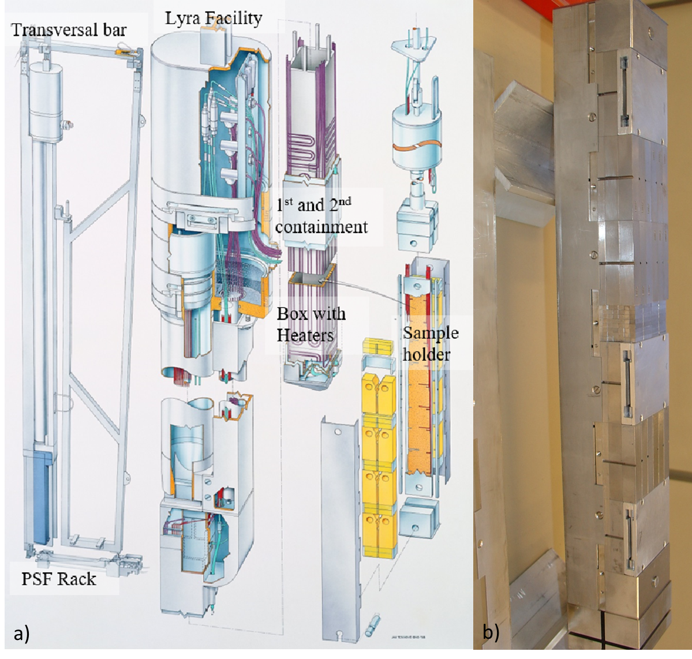

*FIG 2. a) Schematic view of the LYRA facility; b) loading of the sample holder in preparation for LYRA-10 [4], courtesy of EC-JRC and NRG PALLAS*

## MIDI overview

The irradiation experiments undertaken by NRG and in collaboration between NRG and JRC have resulted in thousands of samples for Post Irradiation Examination (PIE) and provided significant experience in the design and operation of a re-usable facility in HFR. This experience is being used as the basis for the design of a new facility to meet the immediate and increasing needs of the SMR and advanced manufacturing communities given the demands that will be placed on structural materials. Concept design activities are scheduled to complete in 2024, with a target date for first irradiation of the facility during 2026.

### MIDI Capabilities

The capabilities of the MIDI facility are captured as a series of needs that have influenced the concept design activities and span Irradiation Requirements, Functional Requirements and Sample Test needs. All of these needs have been defined based on operating experience from the LYRA facility, NRG’s wider irradiation activities, and the predicted needs of the advanced reactor sector. A key need for the MIDI facility is that is re-usable, and has a design life of at least 5-years, as well as:

* Nominal irradiation temperature(s): 280 – 310°C with an inert atmosphere.
* Temperature gradients: ± 15°C.
* Minimum fluence (E> 1 MeV): 6 x 1019 n/cm2.
* Axial fluence gradients: Maximum 20%, depending on the length of the sample holder.
* Fluence gradients in the samples: <5%.
* Online temperature measurement at multiple defined locations with several thermocouples throughout the experiment.
* Inclusion of activation monitor sets throughout the capsule for dosimetry analysis after irradiation.

As is obvious from the requirements of the MIDI facility, which are compulsory to be met, these were developed with the intention of supporting structural material qualification of Light Water SMRs, irradiation testing of advanced manufactured components, ageing studies of RPV and reactor internals steels for LTO of current LWRs and research reactor materials in mind. Yet, the concept design has incorporated additional features, including heaters to enable materials to be irradiated at higher temperatures of between 500°C and 900°C (maximum irradiation temperature will be confirmed during detailed design) which provides the ability for MIDI to support liquid metal, molten salt cooled and high temperature gas-cooled SMRs, as well as perform in-situ thermal annealing studies on RPV steels. The MIDI concept design is also considering multiple temperature zones per irradiation capsule to provide additional flexibility and demonstrate the impact of temperature on materials during irradiation.

For MIDI, various sample holders are considered to gain as much information about the materials under irradiation as possible. This led to an additional requirement for MIDI that specifies the number and geometry of sample types required.

* 24 Tensile/Low Cycle Fatigue specimens (Ø6 x 45 mm).
* 24 Mini-CT specimens (10 x 9.6 x 4 mm); or 6 sub-size CT specimens (25 x 24 x 10 mm).
* 24 KLST specimens (3 x 4 x 27 mm).
* 20 Small Punch Test discs (Ø8 x 0.5 mm).
* 6 Thermal diffusivity discs (Ø8 x 1 mm).
* 6 Thermal expansion cylinders (Ø5 x 25 mm).

### MIDI Design

The MIDI facility will be designed to occupy two PSF positions (10 and 11) of the HFR. Similar to LYRA, it is planned to use the PSF trolleys to adjust the distance between irradiation capsule from the core in order to tune the neutron flux on the sample. MIDI facility allows the periodic rotation of the sample holder (cycle by cycle) to achieve uniform distribution of neutron fluence on the sample holder. Unlike LYRA, MIDI facility will use the existing HFR connection head and irradiation devices, namely TRIO (FIG 3b) or REFA (FIG 3c) capsules as a starting point in the design, to minimise the design effort. The sample holders can be designed as per the irradiation requirements to fit the selected irradiation capsule. For example, the REFA capsule allows inclusion of large number of samples at a selected irradiation temperature, while the azimuthal gradients in temperature and fluences will be high. On the other hand, the use of a TRIO capsule will allow implementation of different irradiation conditions in each of the 3 irradiation legs. Unlike LYRA, the heaters in MIDI will be decoupled from the re-usable facility and included in sample holder to prevent their failures determining operational life of MIDI. MIDI’s instrumentation will also be integrated in the sample holder. Instrumentation might comprise: thermocouples (up to a maximum of 48 for the “REFA” configuration), flux monitors, pressure transducers (LVDT base technology) etc… The first concept design drawings of the MIDI facility can be seen in FIG 3(a-c).

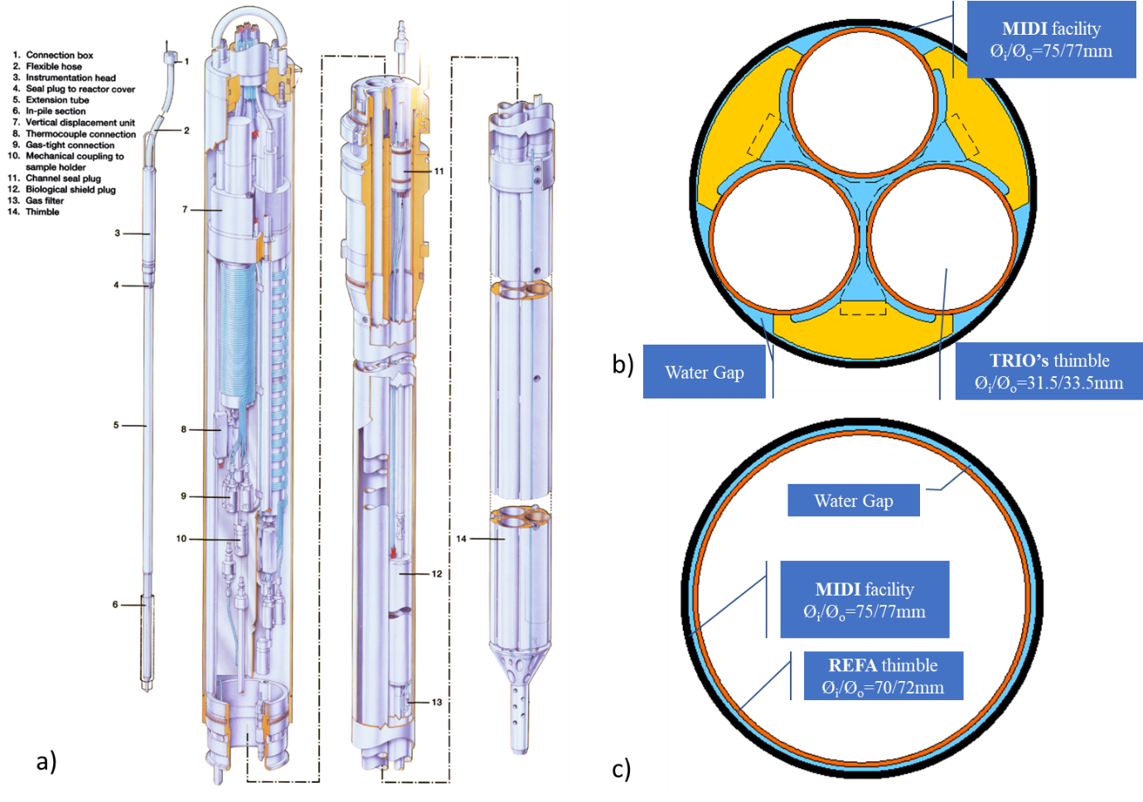

*FIG 3. Concept sketches of MIDI facility, a) full concept based on TRIO facility; b) cross section of 3-legged facility (TRIO) with available space for samples and sample holders in white; c) cross section of 1-legged facility (REFA) with available space for samples and sample holders in white.*

## CONCLUSION

NRG and JRC are developing a re-usable facility that offers the SMR community the ability to irradiate structural materials and materials produced via advanced manufacturing. The MIDI facility builds upon the design, operation, PIE and decommissioning experience of both organisations and is expected to operate until the end of operations in HFR. Currently, concept design activities are ongoing and on track for a first irradiation in 2026, collaboration opportunities exist to maximise the benefits to the global nuclear sector of this facility and accelerate the development, qualification and ultimately deployment of SMRs.

ACKNOWLEDGEMENTS

The work presented in this article is funded by the Dutch Ministry of Economic Affairs (EZS) and the Joint Research Centre of the European Commission. The work presented here is jointly performed by NRG and JRC in the framework of collaboration agreement No: 33990.

Export control note

The content within this document is classified with the code European dual use code (**EU DuC**) = **N**. Goods labelled with an EU DuC (European Dual-use Codification) not equal to ‘N’ are subject to European and national export authorization when exported from the EU and may be subject to national export authorization when exported to another EU country as well. Even without an EU DuC, or with EU DuC ‘N’, authorization may be required due to the final destination and purpose for which the goods are to be used. No rights may be derived from the specified EU DuC or absence of an EU DuC."

References

|  |  |
| --- | --- |
| [1] | International Energy Agency, "Nuclear power can play a major role in enabling secure transitions to low emissions energy systems," 30 June 2022. [Online]. Available: https://www.iea.org/news/nuclear-power-can-play-a-major-role-in-enabling-secure-transitions-to-low-emissions-energy-systems. |
| [2] | International Atomic Energy Agency, "What are Small Modular Reactors (SMRs)?," IAEA, 13 September 2023. [Online]. Available: https://www.iaea.org/newscenter/news/what-are-small-modular-reactors-smrs. |
| [3] | NRG, "NRG. Nuclear for Life," NRG, 2024. [Online]. Available: https://www.nrg.eu/en. [Accessed 30 May 2024]. |
| [4] | F. Roelofs, P. Breijder, R. Hania, G. de With, G.-J. de Haas, J. van den Broek and R. Schram, "Highlights and outlook of the Dutch PIONEER 2021–2024 R&D program," *Nuclear Engineering and Design,* vol. 417, p. 112873, 2024. |
| [5] | E. D'Agata, B. Acosta Iborra, A. J. Magielsen, M. Kolluri, O. Martin, C. Sciolla, R. F. Okel and B. T. Straathof, "The LYRA-10 experiment: Irradiation of Light Water Reactor Pressure Vessel with systematic variations in Ni, Mn and Si contents to assess Long Term Operation enhanced embrittlement," *TBC...,* vol. TBC..., no. TBC..., p. TBC..., 2024. |
| [6] | P. R. Hania, J. L. Kloosterman, D. Lathouwers, Z. Perkó, F. Roelofs, M. Rohde, J. Sietsma and A. Smith, "Chapter 11 - Netherlands," in *Global Progress on Molten Salt Reactors (Second Edition)*, Woodhead Publishing Series in Energy, 2024, pp. 57-73. |
| [7] | E. van Walle and C. Bolton, Symposium on RESQUE and REFEREE, Book of Abstract. BLG-890, Mol, Belgium, September2021. |
| [8] | L. Debarberis, F. Sevini, B. Acosta Iborra, A. Kryuko and D. Frak, "Fluence Rate Effects on Irradiation Embrittlement of Model Alloys," *International Journal of Pressure Vessels and Piping,* vol. 82, pp. 373-378, 2005. |
| [9] | M. Valo, E. Lucon, M. Brumovsky, B. Acosta, L. Debarberis, J. Kohopää, F. Gillemot, M. Horwath and U. Ehrnstén, "Fracture Mechanics Based Embrittlement Modelling (FRAME)," in nuclear science and technology. |
| [10] | European Commission, "Phosphorus Influence on Steels Ageing (PISA)," nuclear science and technology, 2005. |