nonlinear ultrasonic parameters to laser weld quality for small modular reactor

Hyunmyung Kim^{1),2)}
1) FAINDUS co., 2) Korea Atomic Energy Research Institute
1) Gyeonggi-do, Republic of Korea
2) Daejoen, Republic of Korea
Email: faindus_admin@faindus.com

Jongbeom Kim^{1),2)}
1) FAINDUS co., 2) Korea Atomic Energy Research Institute
1) Gyeonggi-do, Republic of Korea
2) Daejoen, Republic of Korea

Abstract

Nonlinear ultrasonic testing (NUT) technique can be used to identify microscopic material properties over conventional (linear) UT owing to its high sensitivity in which the nonlinear parameters establish a set of signal pattern recognitions such as forming higher harmonic waves. To replace conventional SAW, ESW on cladding, implementation of electron-beam or laser weld techniques have been studied to minimize machining surface and welding quality of small modular reactor (SMR). In this study, surface laser welding was applied to nuclear-grade stainless steel (316L) and NUT signals pattern processing algorithms were determined to identify the weld quality along with the materials properties. The NUT signals pattern and parameters were carefully analyzed for systematic auto-classification inspection and compared to microstrtucture and hardness values of the weldment. It was evident that the larger weld size showed the smaller nonlinear parameter values while the weld defects resulted in decreasing the maxmium signal amplitude.

1. INTRODUCTION

Advanced welding techniques have been developed for Small Modular Reactor (SMR) manufacturing process by electron beam and laser weldings [1]. Implementation of advanced welding plays a critical role in contruction process, which can reduce the period and cost of total construction. Various nuclear grade materials includin additive manufacturing parts have shown promises according to ASME code [2], which also involve laser processing.
Conventioanl ultrasonic tests in industrial weld analysis have been used to detect large cracks in mm scale (or larger) while ultrasonic nonlinearity parameter is closely related to the lattice structure of the material, it responds sensitively to lattice defects such as precipitates, dislocations, dislocation dipoles, and voids, so as to effective diagnose in the early of micro-damages by evaluating the material degradation [3]. Such characteristics could be used to evaluate weld conditions in which previous studies showed a great potential for industrial implications [4–6].
In this research, a nonlinear ultrasonic technique (NUT) is used to experimentally characterize fusion welding conditions aiming for systematic auto-classification of the weldment. The ultrasonic signals (including nonlinear responses) in joint welds were meausred and compared to microstructure and hardness results.

2. EXPERIMENTAL

2.1 Materials

Commercial grade 316L stainless steel hot-rolled plates were acquired 300 x 300 x 20T mm (TABLE 1) and prepared for subsequent laser welding. After welding of four different conditions(power output varied 6kW to 3kW), the weld cap was flatten by mechanical grinding. Ultrasonic tests were carried out and the plate was wire-cut into two specimens (top and bottom part of the signle bead) for subsequent cross-sectional tests including Vickers hardness and SE(BSE) characterization.

TABLE 1. CHEMICAL COMPOSITIONS AND HARDNESS OF 316L MATERIALS (MILL SHEET)
Fe | Cr | Ni | Mo | Mn | Si | C | N | Cu | HV (HRBW)
Bal. | 16.6 | 10.1 | 2.0 | 1.2 | 0.43 | 0.02 | 0.07 | 0.3 | 83.4-81.3

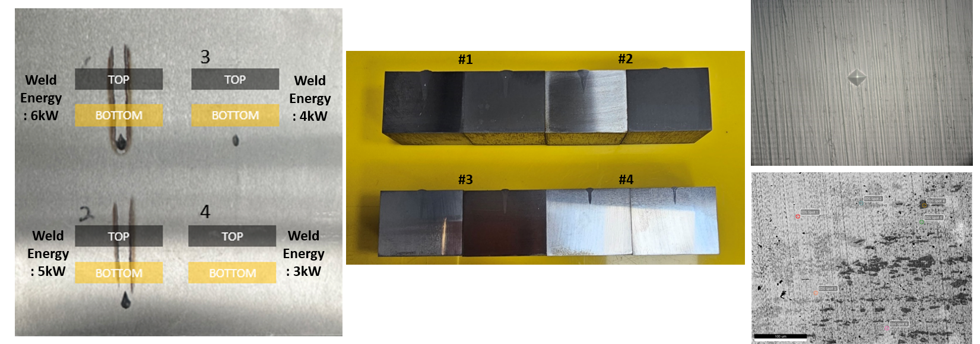
FIG. 1. Pictures of 316L after laser welding (after weld top removed) and wire-cut specimens for subsequent Vickers hardness and microstructure characterization SE(EDAX point analysis) images

2.2 Welding process and Material characterization

Surface laser welding equipment in Korea Institute of Machninery & Materials (KIMM, Busan Industrial Laser Technology Center) was used while the 316L plate was placed on stage while welding power of 6-3 kW laser power variation (IPG) QCW(pulse type) mode was applied with the speed of 1m/min (CNC movement) while cooled by Ar(99.99%) shielding 20 L/min (back shielding 5 L/min). The applied 1.8kW 200Hz 2ms top-hat laser created four straight bead lines on the plate surface named #1(6kW), #2(5kW), #3(4kW), and #4(3kW) expecting larger internal fusion zone size as the higher laser power applied as shown in FIG. 1. After polishing to 1 microns, the weld bead was visible where the size and depth was larger and deeper with the higher power.
Material characterization of as-receveid condition was conducted after ethcing (Glyceregia solution) by optical microscope while fusion weld and heat affected zone microstructure was observed by SE(BSE-mode)/EDS analysis (JSM-IT800) at 15kV. In addition to the microstructure images, Vickers hardenss test was carried out with 0.5Hv(500gf) indentation of 20 times average (exclude min. & max.) from the center of weld bead to 5 mm across the heat affected zone.

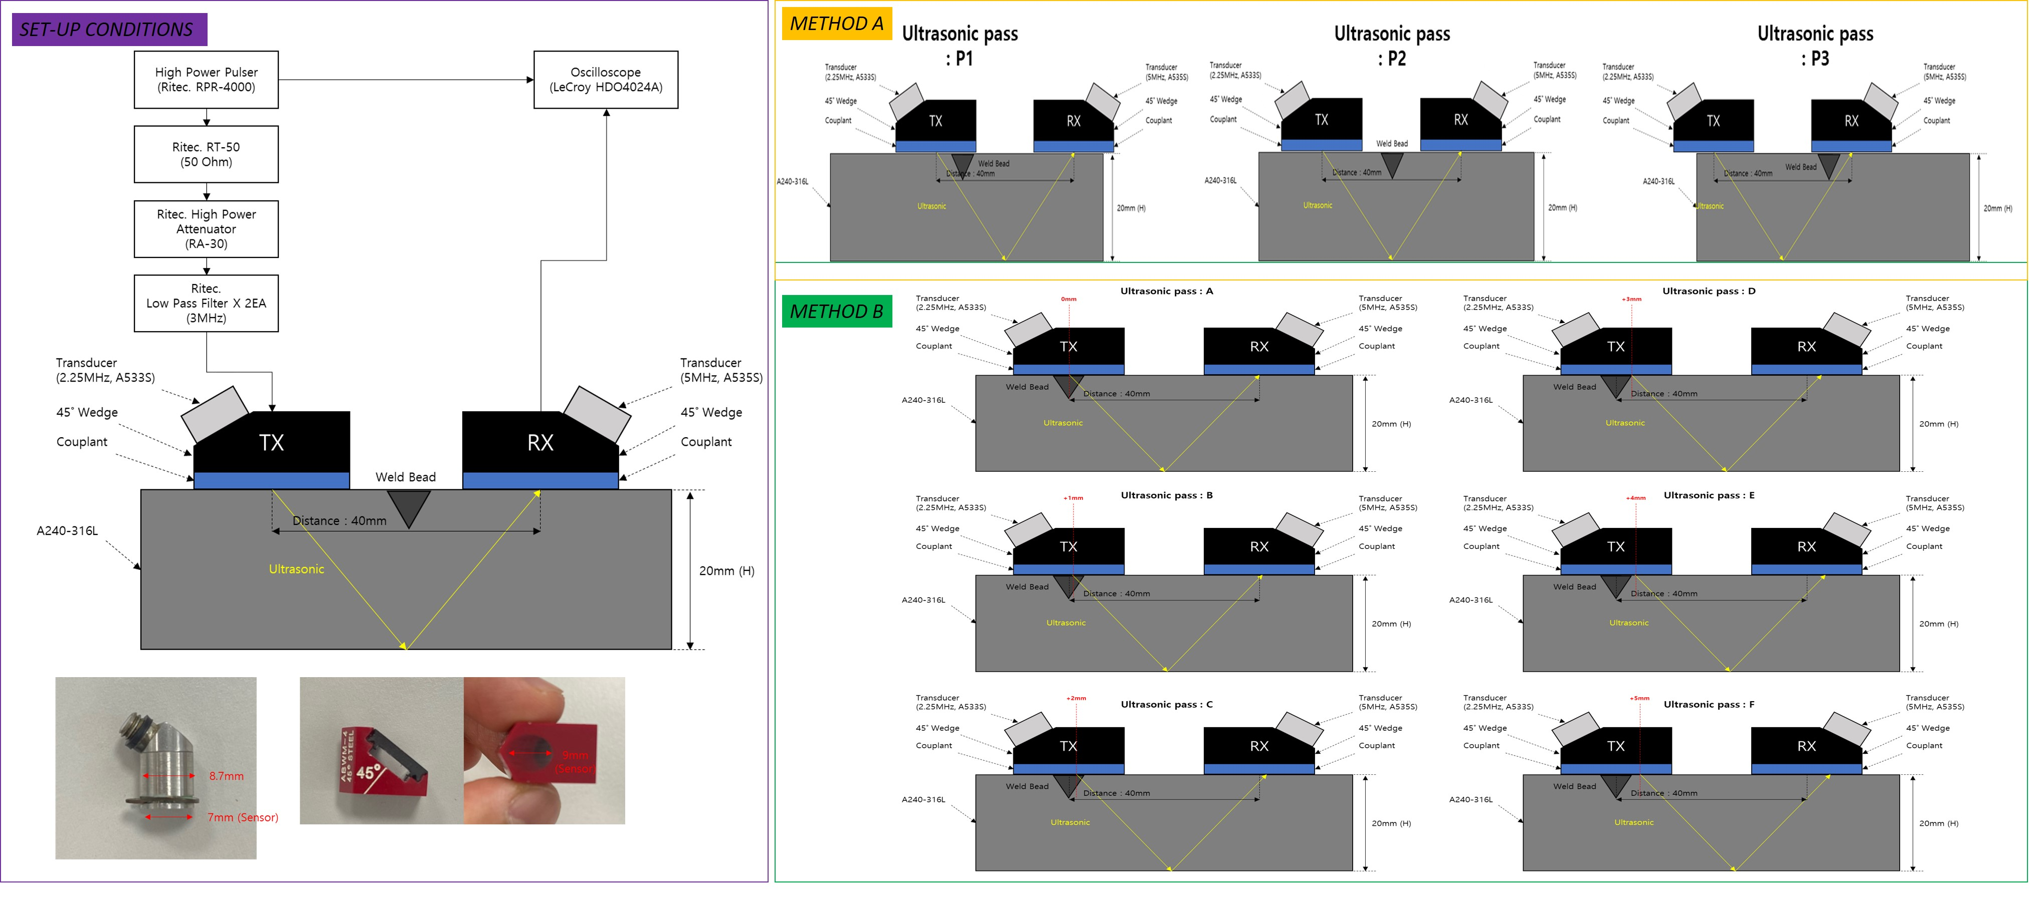
FIG. 2. (Right) Schematics of nonlinear ultrasonic inspection set-up conditions and geometry of transducer (A533S), and (Left) METHOD A : Centered the weld bead P2 (no weld zone,) whereas P1 and P3 (weld zone), METHOD B : Scan from the centre of weld bead to 1mm away each pass (A to F, total 6 points scan)

2.3 Nonlinear ultrasonic inspection and signal analysis

Gel-type couplant (ULTRAGEL II) was applied on the plate surface with two 45° wedge angle 2.25MHz(Transmitter) and 5MHz(Receiver) ultrasonic transducers(A525S, input voltage 250V, and control 17 step, 21EA cycles) while both transducers positioned differently with 40 mm distance to another. METHOD A directly compared weld zone(P2) and bare-metal zone(P1 and P3), whereas METHOD B tested different weld positions by changing the skip distance defines the weld zone while ultrasonic pass F represents for the bare-metal (no fusion weld affected zone). Each detection was repeated 3 time.
Author described on the ultrasonic nonlinear prameters analysis metod in detail elsewhere [7] while FFT signals (Hanning window) of A1 and A2 were obtained for beta(nonlinear parameter) as depicted in FIG. 3. In addition to the nonlinear measurement, pulse-echo technique was conducted to obtain the calibration function where the input and output signals of current and voltage were measured by current probe and voltage probe.

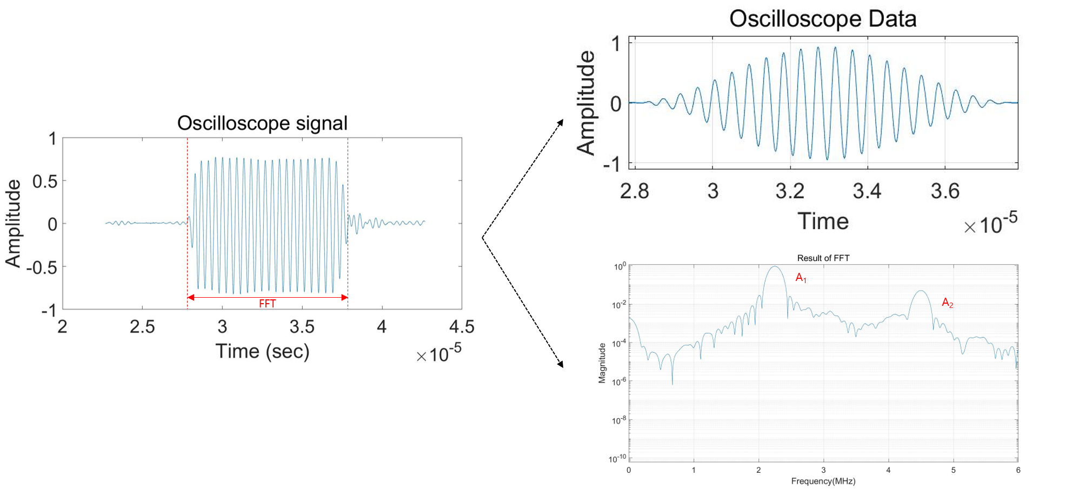
FIG. 3. Example of ultrasonic testing and analysis

3. RESULTS

3.1 Microstructure and Hardness

Typical 316L heat-treated microstructure was observed in the as-received (base) condition with grain size of 20-40 µm (FIG. 4), which can be related to ultrasonic inspection signals [8]. After welding, Vickers hardness tests on base and weld zone were carried out as the results shown in TABLE 2. The hardness of base was lower than that of weld zone in which weld #1 was higher than weld #4.
Cross-secional SE(BSE mode) images were observed at the fusion weld and heat affected zone(HAZ) as depicted in FIG. 5. Weld #1 showed dendric microstructure at the interface whereas Weld #4 showed island weld HAZ microstructure. Although not shown, weld #2 and weld #3 showed similar microstructure inbetween the dendric and island weld, which can be related to similar hardness across the fusion weld and HAZ zones.

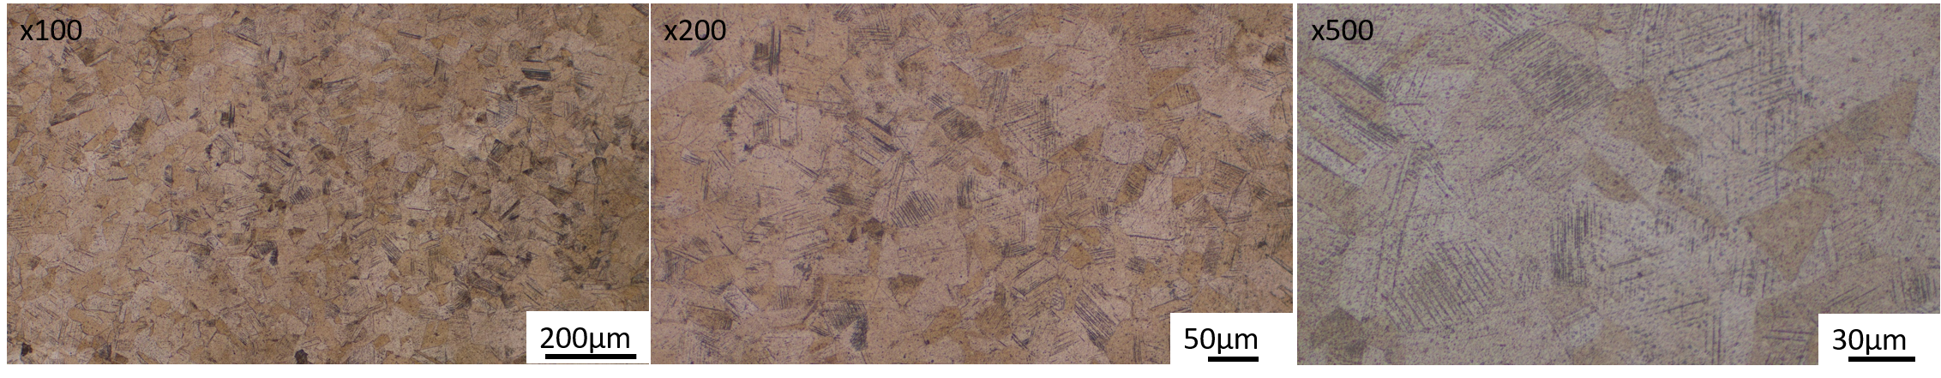
FIG. 4. Optical images of etched microstructure as-received 316L

TABLE 2. VICKERS HARDNESS OF 316L WELD
HV0.5 | WELD #1(6kW) | WELD #2(5kW) | WELD #3(4kW) | WELD #4(3kW)
BASE | 227±8 | 247±12 | 234±21 | 237±15
WELD | 527±43 | 475±32 | 457±50 | 435±32

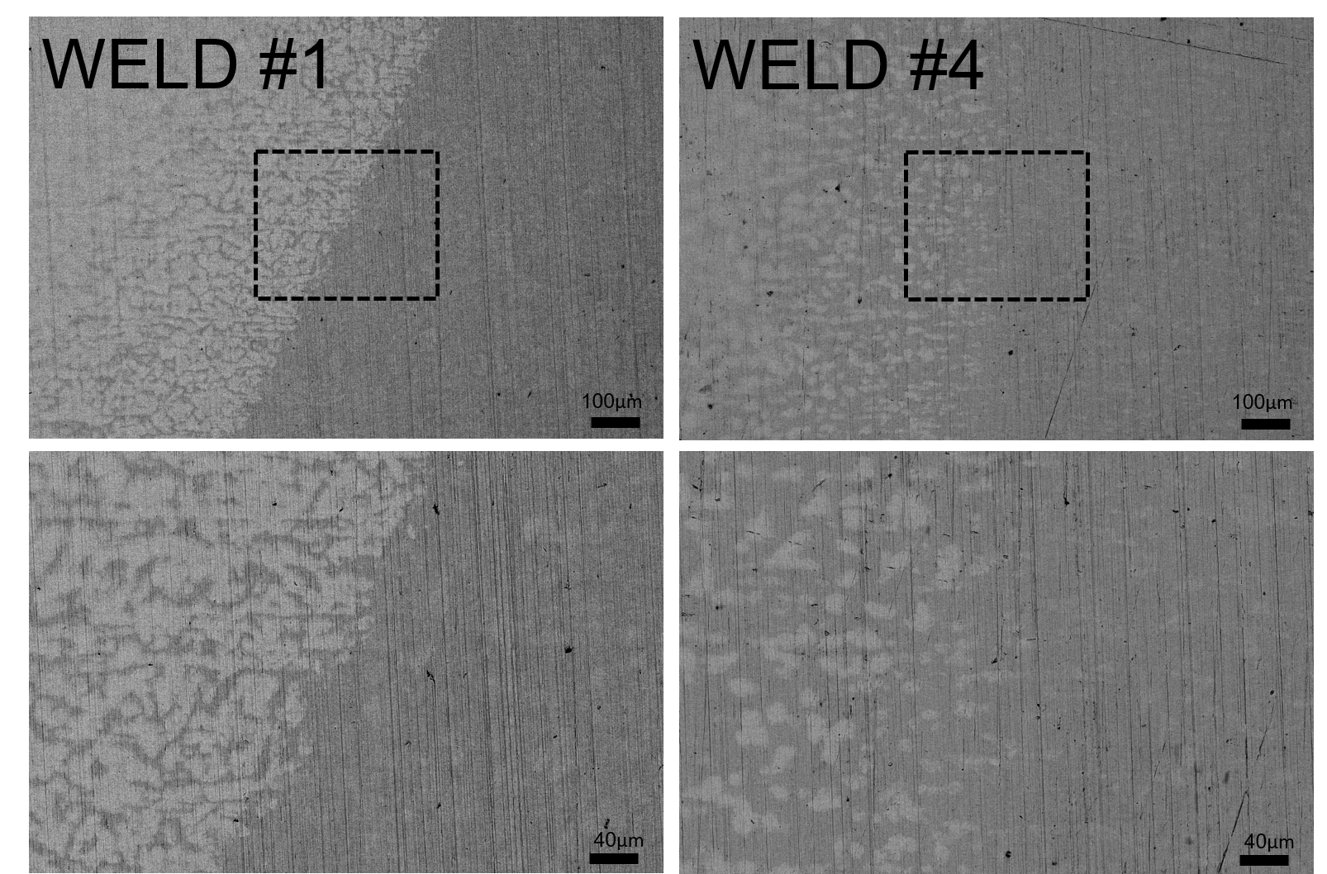
FIG. 5. Cross-sectional SE(BSE mode) images of 316L fusion weld and HAZ interface microstructure (#1 and #4)

3.2 Ultrasonic signal amplitude and Nonlinear parameters

A linear relationship (R²>0.9) between A₁²(V) and A₂(V) was observed resulting in the constnat β (FIG. 6). Such result indicates the reliability of the test method. Plots of different positions and laser welding power readily identified the difference between the base metal and weld zone (FIG. 7). Here, (a) and (b) P1 and P3 showed a large difference in A₁ and A₂ values among the weld numbers(#1 to #4), whereas P2 showed similar A₁ and A₂ values.

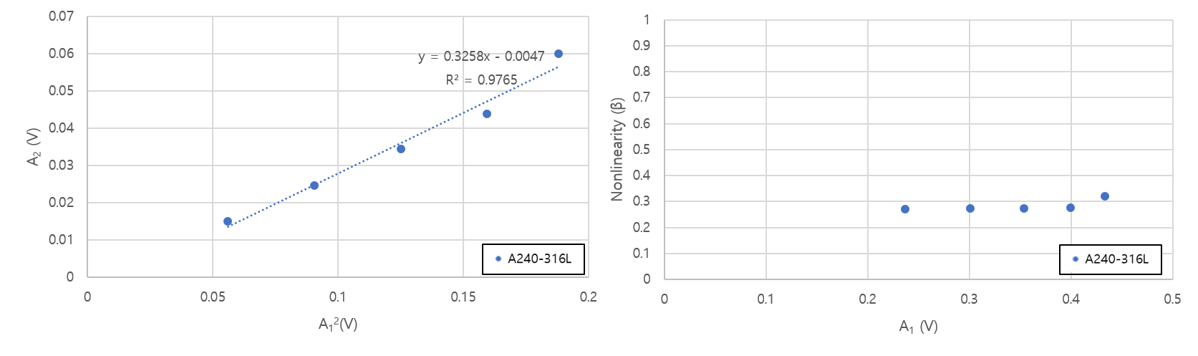
FIG. 6. (Right) A₁²(V) and A₂(V), and (Left) A₁ and β plots

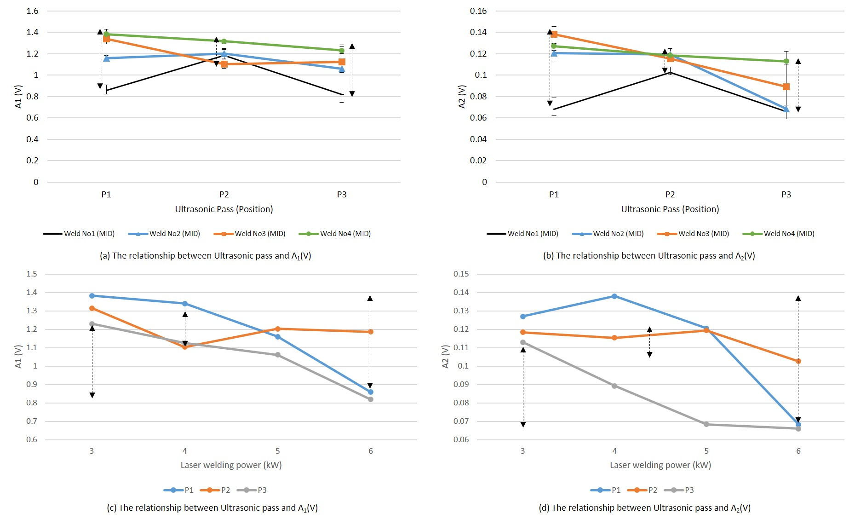
FIG. 7. METHOD A : A₁ and A₂ plots of a) and b) ultrasonic pass position, c) and d) laser welding power

In addition to the noticable diffrerence in A₁ and A₂ between the base metal and weld zone (METHOD A), A₂ and nonlinear parameter(β) plots were drawn from ultrasonic scanning of the weld bead from the center (noted as G) to left and right (FIG. 8). It was evidnet that A₂ values were low at the weld zone (position D, F) as compared to the base zone (position A, J). In other words, A₁(v) was lower in the order of weld #4(3kW) to #1(6kW) reflecting the larger and deeper weld bead. The top and bottom side of bead showed different A₂ and β values owing to different features of the weldment. Detail microstructure analysis is under investigation.

TABLE 3. METHOD B POSITION TO LENGTH OF ULTRASONIC PASS
Position | A | B | C | D | E | F | G | H | I | J
Pass Shift (mm) | -10 | -5 | -4 | -3 | -2 | -1 | 0 | +1 | +2 | +3
Length of  ultrasonic pass (mm) | 0 | 0 | 1.9 | 3.8 | 4.2 | 3.3 | 2.4 | 1.4 | 0.5 | 0

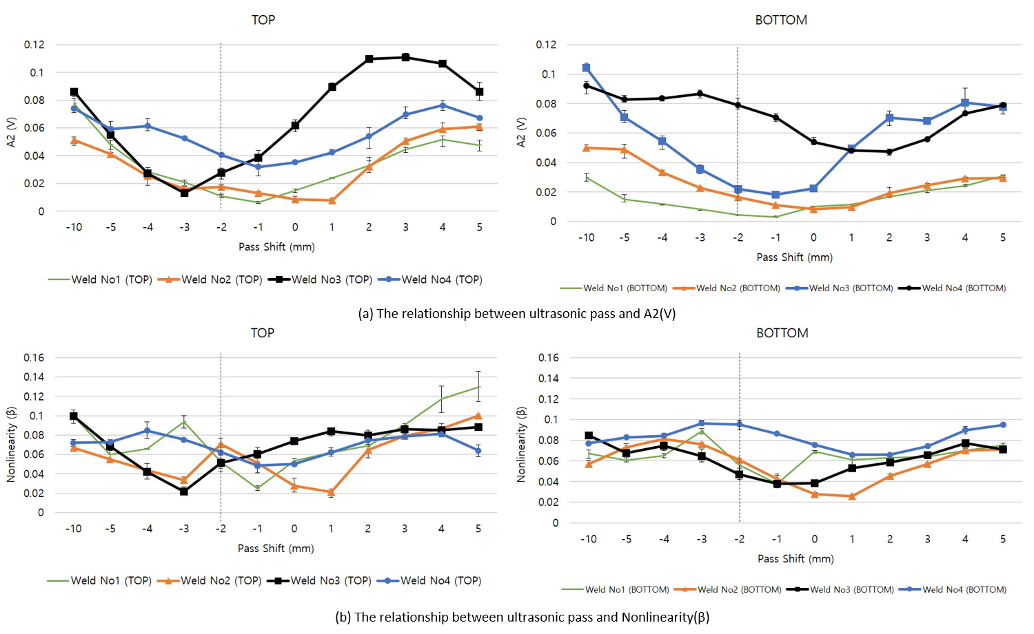
FIG. 8. METHOD B : A₂ and β plots of different ultrasonic positions where #1 weld showed a noticable change in P1 (base metal) and P3 (weld bead zone).

4. Summary

A nonlinear ultrasonic technique (NUT) is used to experimentally characterize laser welding conditions of nuclear-grade 316L aiming for systematic auto-classification of the weldment. The ultrasonic signals (including nonlinear responses) were meausred and compared to microstructure and hardness results. It was evident that the microstructure was distinguished by NUT parameters in which the nonlinear parameter(β) was lower in the weldment. Further investigations of the relation are in progress making detail classifications of materials for small modular reactors.

ACKNOWLEDGEMENTS
This work was supported by the Nuclear Safety Research Program through the KoreaFoundation of Nuclear Safety (KoFONS) using financial resources granted by the Nuclear Safetyand Security Commission (NSSC) of the Korea (No. 2106020).
References
- T. Dutilleul et al., “Development of elctron optical capabilities for manufacturing of large components by electron beam welding” Weleding in the Wrold 68 (2024) 819-828.
- M. Albert, “Advanced Manufacturing Demonstrations and Codes & Standards Developement”, IAEA Technical Meeting on Codes & Standards, Design Engineering, and Manufacturing of Components for Small Modular Reactors, Virtual, 2022.
- H. Yun et al., “Nonlinear ultrasonic testing and data naalytics for damage characterization: A review”, Measurement 186 (2021) 110155.
- S. Park et al., “nspection of steel tube welded joint using nonlinear ultrasonic technique", Proc. SPIE 12048, Health Monitoring of Structural and Biological Systems XVI, 120480V (19 April 2022).
- D-J. Kim et al., “Flow-acceralted corrosion assessment for SA106 and SA335 pipes with elbows and welds” Nuclear Engineering and Technology 53 (2011) 3003-3011.
- Y-X. Xiang et al., “Experimental and numerical studies of nonlinear ultrasonic responses on plastic deforamtion in weld joints” Chinese Physics B 25 (2016) 024303.
- J. Kim et al., “Absolute Measurement and Relative Meausrement of Ultrasonic Nonlinear parameters” Reserach in Nondestructive Evaluation 28 (2017) 211-225.
- M. Wang et al., “Characterization of Grain size in 316L Stainless Steel Using the Attenuation of Rayleigh Wave Measured by Air-Coupled Transducer” Materials 14 (2021) 1901.

