# Advancing Nuclear Design: Optimizing Burnable Poison Configurations for Extended Cycle Small Modular Reactors

AIMAN DANDI

Libyan Atomic Energy Establishment

Sidi Abdeljaleel/Janzour, Libya

Email: aiman.dandi@gmail.com

**Abstract**

The study introduces a novel application of a burnable poison (BP) known as Double Tube Burnable Poison (DTBP). Two design concepts of DTBP were tested in a small modular reactor (SMR) to extend the operating cycle while maintaining low soluble boron concentration. These concepts can be loaded in various locations in the fuel assembly, providing greater flexibility in nuclear design. The design's adaptability allows for an increased poison effect with the ability to control the depletion speed of its absorber materials. By incorporating DTBP pins in combination with Erbia pins resulted in a smooth k-infinite letdown curve and a noteworthy decrease in excess reactivity. DeCART2D and MASTER codes were used for assembly and core calculations. The results indicated that the DTBP and Erbia core combination achieved a cycle length exceeding 3.5 Effective Full Power Years. Furthermore, the Critical Boron Concentration was lowered to 309 ppm, staying within the design constraints associated with the moderator temperature coefficient and maximum pin power peaking.

## INTRODUCTION

Burnable poisons (BPs) play a crucial role in controlling design parameters such as pin power peaking, core excess reactivity, and moderator temperature coefficient in pressurized water reactors (PWRs). Although existing BP designs have demonstrated satisfactory performance up to 18-month cycles, they face challenges in meeting the demands of extended 24-month cycles due to high excess reactivity. Conventional BP designs, including Integral Fuel Burnable Absorber (IFBA), Erbia, gadolinia (Gad), and Wet Annular Burnable Absorber (WABA), exhibit various drawbacks, such as rapid depletion, weak control of excess reactivity, and high power peaking [1-3].

Efforts to address these issues led to the development of new BP designs focused on suppressing initial excess reactivity, maintaining a flat profile during burnup, and minimizing residual isotopes [4]. Some studies explored increasing the enrichment of poison isotopes [4,5], while others introduced sophisticated designs like Burnable absorber-Integrated Guide Thimble (BigT) [6], Burnable Poison Particles (BPPs) [7], Centrally-Shielded Burnable Absorber (CSBA) [8], Bi-ISOtropic particles of BP (BISO BP) [9], and Ring-type Burnable AbsorberS (R-BAs) [10]. However, the feasibility of the manufacturing process remains a common challenge.

Previous studies examined the combination of existing BP designs, with the WABA + Erbia core demonstrating promising results [11]. Another study introduced the Double Tube Burnable Poison (DTBP) concept, utilizing multiple tubes to control absorbent depletion speed. The DTBP design, with outer and inner tubes containing Gd2O3 and natural boron, respectively, showed improved performance for a 24-month large size PWR but had minor advantages over the WABA + Erbia core [12].

This study is dedicated to testing the DTBP design under extreme conditions, encompassing high excess reactivity and neutron leakage, utilizing 9.90w/o High-Assay Low Enriched Uranium (HALEU) fuel [13-15]. The objective is to illustrate the advantages of the DTBP design in surmounting the drawbacks of conventional BP designs while fulfilling design goals and limitations. The feasibility study seeks to evaluate DTBP concepts for long-operating cycle small modular reactors (SMRs) with low soluble boron operation.

The subsequent sections provide details on the reference core design, fuel assembly design, design goals, and the design code system used. The study then elaborates on two types of DTBP designs and discusses the results of assembly and core calculations, concluding with the overall findings.

## Reference Design and Computational Codes

The SMART reactor is a compact advanced pressurized water reactor (PWR) with a power of 100 MWe. Besides power production, SMART reactor has applications in seawater desalination. Although the detailed design features are not yet finalized, the system's standard design, licensed by the Korean regulatory body some years ago, serves as a useful reference core for this study. The SMART design employs a 17×17 Westinghouse (WH) type fuel assembly with an active height of 200 cm [16-19].

For this study, the reference design was adapted by incorporating HALEU fuel, presenting challenges due to increased excess reactivity and neutron leakage. The primary objective is to showcase the advantages of the DTBP design, especially under extreme operating conditions where conventional BPs struggle.

Table 1 summarizes the design goals for this study, include increasing the maximum fuel enrichment to 9.90w/o for higher excess reactivity and an extended operating cycle. Additionally, a significant challenge is imposed on DTBP design by reducing the maximum Critical Boron Concentration (CBC) to less than 350 ppm, aiming for a cycle length exceeding the reference design by approximately one year, equivalent to 3.5 Effective Full Power Years (EFPY). Achieving these conditions proves to be highly challenging for conventional BP designs [20].

The study utilizes the coupling of DeCART2D and MASTER codes for SMART core analysis [21,22].

TABLE 1. DESIGN GOALS FOR DEVELOPED SMART REACTOR

|  |  |
| --- | --- |
| Design Parameters | Limitation |
| Max. fuel enrichment (w/o) | 9.90 |
| Min. cycle operating length (EFPY) | 3.5 (> the reference design by ~ 1 year) |
| Max. CBC (ppm) | < 350 |
| Max. 2D power peaking factor (Fq-XY) | 1.59 |
| Max. 3D power peaking factor (Fq-XYZ) | 2.6 |
| Moderator temperature coefficient (MTC) (pcm/℃) | 0 ~ -80 |

## DTBP Design Concepts

### DTBP-Wet and DTBP-Dry Configurations

Table 2 outlining the DTBP design parameters [12]. In a previous study, the DTBP design featured an outer tube containing 20w/o Gd2O3 and an inner tube containing natural boron, meeting design goals and limitations [12]. However, for the present study, to address the high excess reactivity of the developed SMART design and achieve a 3.5-year cycle with low soluble boron operation, modifications were necessary. The absorber material in the DTBP design was increased by using pure Gd2O3 in the outer tube. Although various methods exist for increasing absorber material, this approach was chosen for its simplicity and minimal modification to the original DTBP design. Two DTBP designs were utilized in this study: DTBP-Wet, featuring a water hole, and DTBP-Dry, with a ZIRLO rod replacing the water hole, enabling loading in fuel rod positions.

Figs. 1 and 2 illustrate DTBP-Wet and DTBP-Dry designs, respectively, along with examples of their potential loading positions. DTBP-Dry aims to maintain an under-moderated core design when loaded in fuel rod positions.

TABLE 2. DESIGN PARAMETERS OF A DTBP DESIGN

|  |  |
| --- | --- |
| Design Parameters | DTBP |
| Inner Cladding I.D. (cm) | 0.44196 |
| Inner Cladding O.D. (cm) | 0.54864 |
| Inner Tube O.D. (cm) | 0.67818 |
| Inner Tube Absorber Material | Al2O3-B4C |
| Outer Tube O.D. (cm) | 0.80772 |
| Outer Tube Absorber Material | ZIRLO-Gd2O3 |
| Outer Cladding O.D. (cm) | 0.96774 |
| Cladding Material | ZIRLO |
| Gap Thickness (cm) | 0.01397 |
| Gap Material | Air |

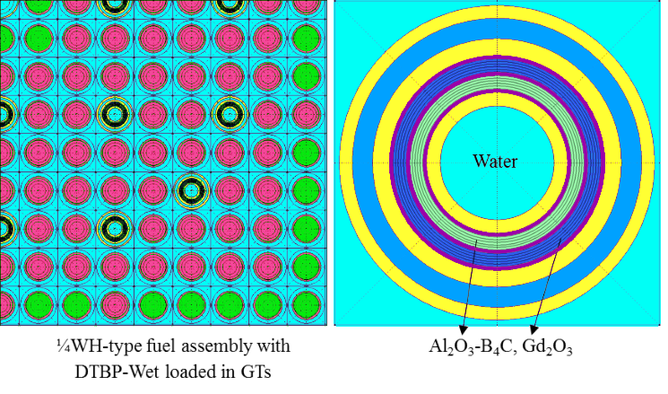

*FIG. 1. DTBP-Wet design*

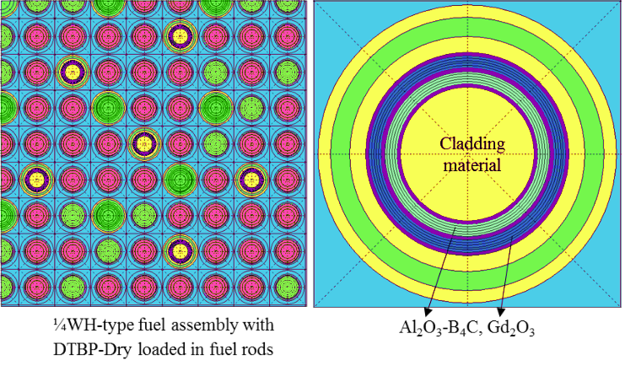

*FIG. 2. DTBP-Dry design*

### Optimizing k-Infinite Letdown Curve Procedures

Two steps are involved in flattening the k-infinite letdown curve around a desired value. The first step achieves a flat curve at the End of Cycle (EOC) by increasing the Gd2O3 concentration. Fig. 3 compares the k-infinite letdown curve for different DTBP cases with varying Gd2O3 concentrations. Both cases exhibit a gradual reduction in the k-infinite letdown curve at the Beginning of Cycle (BOC) and Middle of Cycle (MOC) due to the self-shielding effect of gadolinium. However, at the EOC, the curve becomes flat due to the extensive depletion of gadolinium at the outer tube and the effect of boron in the inner tube, preventing a sharp increase after the gadolinium depletion [12].



*FIG. 3. Comparison of k-infinite letdown curve for different DTBP cases with different Gd2O3 concentrations*

For this study, the 100% Gd2O3 concentration case was chosen due to its achievement of the lowest k-infinite value with a positive margin, aligning with the study's design goals. The second step involves flattening the k-infinite letdown curve at the BOC and MOC by combining DTBP with Erbia in the same fuel assembly, as shown in Fig. 4. This combination results in an almost flat k-infinite letdown curve around a value of 1.05, slightly lower than the lowest value achieved by the 100% Gd2O3 DTBP case. The slow depletion of erbium contributes to this behaviour, making the curve flat at a low k-infinite value.



*FIG. 4. Comparison of k-infinite letdown curve for DTBP and DTBP+Erbia cases with the concentration of 100% Gd2O3*

While a similar outcome could be achieved by increasing the 10B enrichment into 90w/o in the WABA design and combining it with Erbia, this option is not considered due to limitations in unoccupied Guide Tubes, high enrichment costs, and associated pressure concerns with helium gas.

## Results and discussion

The feasibility study utilizes a fresh SMART design core as the reference. The selected core design of DTBP-Wet&Dry + Erbia core aim to meet specific design goals, leading to increased fuel enrichment in two enrichment zoning (9.90w/o and 5.90w/o). The SMART core design details involve different fuel assembly types categorized into groups A and B, with fuel enrichments of 2.82w/o and 4.88w/o, respectively. Gad is chosen as the BP type, with an 8w/o concentration mixed with 1.8w/o of 235U in the UO2- Gd2O3 form. The developed core, targeting higher performance, consist of two groups with fuel enrichments of 5.90w/o and 9.90w/o. Further, the DTBP-Wet&Dry + Erbia core design is detailed with their respective BP concentrations, and distribution in Table 3, and Fig. 5. The subsequent calculations encompass CBC comparisons, depicted in Fig. 6, which show that DTBP-Wet&Dry + Erbia core achieves lower CBC values, meeting design goals with a cycle length of 1295 Effective Full Power Days (EFPD). Additionally, MTC values for both cores are presented in Fig. 7, where DTBP-Wet&Dry + Erbia core exhibit lower MTC values than the reference core, within the design limitation of the lowest MTC value. Power peaking factor calculations, illustrated in Figs. 8 and 9, showcase 2D (Fq-XY) and 3D (Fq-XYZ) power peaking factor values for reference, and DTBP-Wet&Dry + Erbia cores. The developed core exhibit values above the reference but remain within design limitations.

TABLE 3. DESCRIPTION OF DTBP-WET&DRY + ERBIA CORE

|  |  |  |  |  |  |
| --- | --- | --- | --- | --- | --- |
| Assembly type | # of assemblies | Fuel enrichment | # of BP pins | | Erbia concentration |
|  |  | w/o | DTBP | Erbia | w/o |
| 6A13 | 9 | 5.90 | 24 (DTBP-Dry) | 52 | 2 |
| 6A15 | 12 | 5.90 | 24 (DTBP-Wet) | 60 | 2 |
| 4B39 | 16 | 9.90 | 16 (DTBP-Dry) | 156 | 2 |
| 6B45 | 20 | 9.90 | 24 (DTBP-Wet) | 180 | 2 |

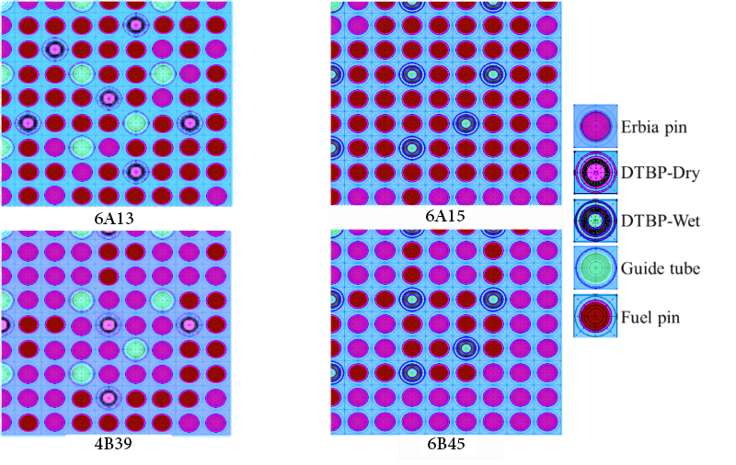

*Fig. 5. BP location distribution in different fuel assembly types for DTBP-Wet&Dry + Erbia*



*Fig. 6. Comparison of CBC for Reference, and DTBP-Wet&Dry + Erbia cores*



*Fig. 7. Comparison of MTC for Reference, and DTBP-Wet&Dry + Erbia cores*



*Fig. 8. Comparison of Fq-XY for Reference, and DTBP-Wet&Dry + Erbia cores*



*Fig. 9. Comparison of Fq-XYZ for Reference, and DTBP-Wet&Dry + Erbia cores*

## Conclusion

The study modifies a SMART core design to create a challenging configuration, demonstrating the exceptional performance of DTBP designs. Two DTBP designs, DTBP-Wet and DTBP-Dry, are introduced. The study reveals that the DTBP-Wet&Dry + Erbia core fulfills all design goals, proving the exceptional performance of the DTBP design. Future work may involve optimizing the design further.

References

1. Brown Jeffery A., Lam Ho Q., Hybrid IFBA Gad assembly designs for long PWR cycles. In: Water Reactor Fuel Performance Meeting, Ramada Plaza Jeju, Jeju Island, Korea, 2017. Sep. 10–14, 2017.
2. Secker J., Brown J., Westinghouse PWR burnable absorber evolution and usage, in: ANS Winter Meeting, Las Vegas, NV, USA, 2010. Nov. 7–11, 2010.
3. Dandi, A., Lee, MinJae, Kim, M.H., 2020. Feasibility of combinational burnable poison pins for 24-month cycle PWR reload core. Nucl. Eng. Technol. 52 (2), 238–247.
4. Choe, J., Shin, H.C., Lee, D., 2016. New burnable absorber for long-cycle low boron operation of PWRs. Ann. Nucl. Energy 88, 272–279.
5. Renier J.P.A., Grossbeck M.L., Development of Improved Burnable Poisons for Commercial Nuclear Power Reactors, Oak Ridge National Laboratory, 2001. ORNL/TM-2001/238.
6. Yahya, M.S., Yu, H.Y., Kim, Y., 2014. A Burnable Absorber-integrated Control Rod Guide Thimble for PWR. Trans. Am. Nucl. Soc. 110, 593–594.
7. Tran, H.-N., Hoang, V.-K., Liem, P.H., Hoang, H.T.P., 2019. Neutronics design of VVER-1000 fuel assembly with burnable poison particles. Nucl. Eng. Technol. 51 (7), 1729–1737.
8. Nguyen, X.H., Kim, C.H., Kim, Y., 2019. An advanced core design for a soluble-boron-free small modular reactor ATOM with centrally-shielded burnable absorber. Nucl. Eng. Technol. 51 (2), 369–376.
9. Yoo, H., Hwang, D.H., Hong, S.G., Shin, H.C., 2017. New long-cycle small modular PWR cores using particle type burnable poisons for low boron operation. Nucl. Eng. Design 314, 173–181.
10. Jang, J., Choe, J., Choi, S., Lemaire, M., Lee, D., Shin, H.C., 2020. Conceptual design of long-cycle boron-free small modular pressurized water reactor with control rod operation. Int. J. Energy Res. 44 (8), 6463–6482.
11. Dandi, A., Lee, MinJae, Kim, M.H., 2020. Feasibility of combinational burnable poison pins for 24-month cycle PWR reload core. Nucl. Eng. Technol. 52 (2), 238–247.
12. Dandi, A., Kim, M.H., 2022. Feasibility of innovative design concepts of Burnable poison pins for 24-month cycle PWR. Ann. Nucl. Energy 171, 109031.
13. Pierson, R., Tschiltz, M., 2018. Addressing the Challenges with Establishing the Infrastructure for the front-end of the Fuel Cycle for Advanced Reactors. NEI White Paper, Nuclear Energy Institute.
14. Office of Nuclear Energy 2020, U.S. Department of Energy, accessed 14 May 2021,

https://www.energy.gov/ne/articles/what-high-assay-low-enriched-uraniumhaleu

1. Centrus Energy Corp. 2021, accessed 14 May 2021,

https://www.centrusenergy.com/what-we-do/nuclear-fuel/high-assay-low-enriched-uranium

1. Lee, K.H., Park, S.Y., Lee, C.C., Cho, J.Y., Song, J.S., Zee, S.Q., Kim, K.Y., 2012. The Nuclear Design Report for SMART Standard Design Cycle 1, KAERI/TR-4622/2012. Korea Atomic Energy Research Institute.
2. IAEA, 2012. Status of Small and Medium Sized Reactor Designs: A Supplement to IAEA Advanced Reactors Information System (ARIS). http://aris.iaea.org. September 2012.
3. IAEA, 2018. Advances in Small Modular Reactor Technology Developments: A Supplement to IAEA Advanced Reactors Information System (ARIS). http://aris.iaea.org. September 2018.
4. Jang, K., Young, L.J., Kyeong, 2010. In-reactor irradiation performances of advanced fuels, ACE7TM, for Westinghouse type nuclear power plants. Trans. Korean Soc. Mech. Eng. Spring Meet. 5, 343–344.
5. Dandi, A., Kim, M.H., 2023. Conceptual design of the double tube burnable poison for the next generation small modular reactor. Ann. Nucl. Energy 186, 109776.
6. Cho J.Y., Lee J.C., Lee K.H., Park S.Y., Park H.J., Kim H.Y., Kim K.Y., Jung H.J., Song J.S., Zee S.Q., Jo C.K., Lee H.C., DeCART2D v1.0 User’s Manual, KAERI/TR-5116/2013, Korea Atomic Energy Research Institute, 2013.
7. Cho, B.O., Joo, H.G., Cho, J.Y., Song, J.S., Zee, S.Q., 2002. MASTER-3.0: Multi-Purpose Analyzer for Static and Transient Effects of Reactors, KAERI/TR-2061/2002. Korea Atomic Energy Research Institute.