# Facilitating SMR fuel fabrication

# from HALEU UF6

DR. MARINA SOKCIC-KOSTIC

NUKEM Technologies Engineering Services GmbH

Karlstein am Main, Germany

Email: marina.sokcic-kostic@nukemtechnologies.de

CHRISTOPHER REISER, KARL FROSCHAUER and DR. GEORG BRÄHLER

NUKEM Technologies Engineering Services GmbH

Karlstein am Main, Germany

**Abstract**

The paper addresses the need for SMR fuel production plants based on HALEU UF6 from the enrichment facility. Deconversion from UF6 yields UO2 with beneficial properties, which can be directly utilized for light water SMR pellets. UO2 can be fluorinated to UF4, which is ready to be applied in a molten-salt SMR. Finally, metallic uranium can be produced via calciothermic reduction of UF4. Uranium metal can be alloyed to fuel SMRs like the sodium-cooled fast reactor (SFR). Alternatively, UO2 can be calcined to yield the raw material of HTR TRISO-fuel production plants. Beginning from the dissolution of U3O8, fuel compacts or pebbles can be manufactured. The prerequisite of a criticality-safe process keeping state-of-the-art radioprotection standards is fulfilled for HALEU material up to 20 % enrichment. Reprocessing of uranium and chemicals for zero emission is included within the process.

## INTRODUCTION

Sourcing oxidic high-assay low-enriched uranium (HALEU) from downblended highly enriched uranium (HEU) has no prospects. Therefore, correspondingly enriched UF6 must be considered as main input material for fuel production plants. NUKEM gained experience as operator of fabrication plants for all common fuel types. Facilities considering UF6 as input material can be designed based on this knowledge.

## Processing HALEU from the enrichment facility

The majority of the most advanced or established reactor concepts can be designed as small modular reactors (SMRs). The four main SMR designs are based on either ceramic oxide pellets, fuel dispersed in a molten salt, metallic uranium alloys or TRISO-coated uranium kernels. Enrichments in the HALEU range (5% - 20%) are beneficial for SMR fuels, as they have a higher energy density, enabling smaller reactor cores and generally allowing for higher burnups. Consequently, refuelling cycles can be extended, and nuclear waste can be reduced in volume.[1] The preferred process for starting from HALEU uranium hexafluoride (UF6) is ammonium uranyl carbonate (AUC) deconversion, which yields uranium dioxide (UO2) with beneficial physical and chemical properties as shown in Fig. 1. If the aim was to produce ceramic oxide SMR fuel, UO2 could now be pressed into pellets and sintered at high temperatures.

Furthermore, AUC can be directly calcined to yield triuranium octoxide (U3O8), which is the input material for high-temperature reactor (HTR) TRISO fuel element production. Several TRISO-coated particles are processed into fuel spheres or cylindrical compacts for all HTR-SMRs. A major advantage for TRISO fuel applications is the comparably low fluorine content resulting from the AUC process. In particular, UO2 derived from AUC deconversion can be fluorinated to uranium tetrafluoride (UF4) using hydrofluoric acid (HF). UF4 is the base material for liquid molten-salt SMR fuel cores. Finally, metallic uranium can be produced via calciothermic reduction of UF4. Uranium metal can be alloyed to fuel liquid metal-cooled SMRs such as the sodium-cooled fast reactor (SFR).

It can be concluded that fuel for all common SMR types can be produced starting with uranium oxide gained from AUC deconversion.

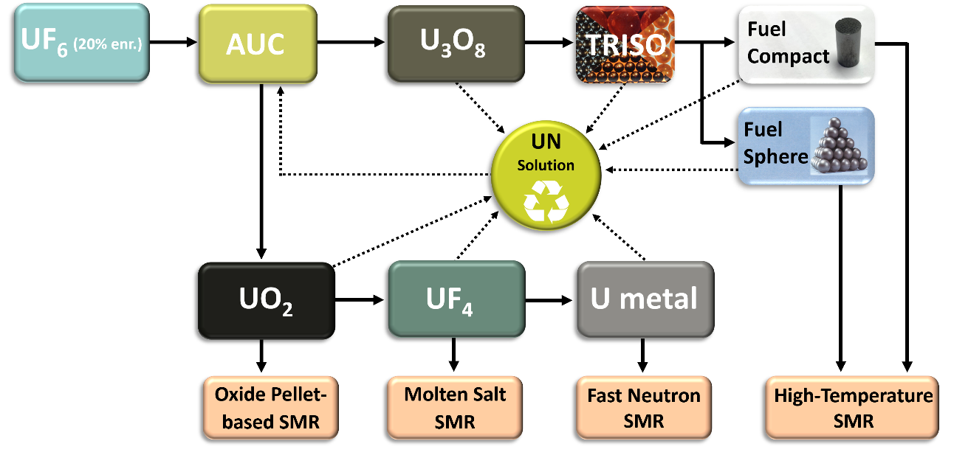

*FIG. 1. The ammonium uranyl carbonate (AUC) process enables fabrication routes towards all major SMR fuels starting from uranium hexafluoride (UF6) as it comes the high-assay low-enriched uranium (HALEU) enrichment facility. Uranium-bearing scraps occurring at different fuel fabrication steps can be recovered via the dissolution to uranyl nitrate (UN), which can be feed back into the AUC process after purification.*

## The major SMR types and their fuel

This paper will discuss the four major SMR types in the context of current reactor designs and implementations. The focus will be on the aforementioned uranium-based fuels: UO2 pellets, molten UF4 salt, metallic uranium alloys and TRISO particles.

Ceramic uranium dioxide pellets are utilised as fuel in the form of classical cladded fuel rods for light water-cooled SMRs. The most prevalent concept is the pressurized water reactor (PWR). The boiling water reactor (BWR) also exists as an SMR, although it represents a less common technology [2]. Russia has pioneered the use of HALEU-fuelled pressurized water SMRs, with the RITM-200 being a notable example. This has been in operation since 2019, powering the Arktika icebreaker. A land-based version of this SMR is known as the RITM-200N and is scheduled for commissioning in Yakutia by 2028 [3]. The next SMR type is the molten salt reactor (MSR). The key challenge lies in dispersing the fuel within the molten salt core. This allows the core material itself to be used as a coolant. UF4 is the compatible chemical form of uranium to be applied in this case. MSRs can be realised with a thermal as well as a fast neutron spectrum. The Danish developer Seaborg is designing a floating MSR with a capacity of 200 MWe per module. Their compact molten salt reactor (CMSR) has a thermal neutron spectrum and requires a moderator. The original design was based on HALEU and a sodium hydroxide moderator. To mitigate the risk of delays due to an inadequate supply of HALEU, Seaborg modified their current design to utilise more readily available low-enriched uranium (LEU) and substituted sodium hydroxide for graphite as the moderating material [4]. This example reiterates the necessity for a dependable HALEU supply chain. Seaborg remains willing to utilise HALEU in future CMSR designs.

A subset of fast neutron SMRs utilises fuel based on metallic uranium (and various alloys). The common reactor concept is the liquid metal-cooled fast reactor (LMFR). In order to maintain a fast neutron spectrum, the moderator must be removed from the reactor design; therefore, water cooling is no longer an adequate option. The use of liquid metal as a coolant also allows for higher operating temperatures, thus increasing the thermal conversion efficiency. In comparison to oxide fuel, metallic fuel exhibits superior heat conductivity and lower heat capacity. The ARC-100 reactor, which is scheduled for construction in Canada, employs a uranium-zirconium alloy with a 13% enrichment level as its fuel source. This sodium-cooled fast reactor (SFR) is based on the EBR-II (Experimental Breeder Reactor), which was operated for over 30 years at Argonne National Laboratory, USA [5].

The high-temperature gas-cooled reactor (HTGR) represents the established design within the fourth SMR category. All high-temperature reactors (HTRs) utilise tristructural-isotropic (TRISO) particle fuel. TRISO particles typically comprise uranium dioxide (UO2) or uranium oxycarbide (UCO) fuel kernels, which are coated by chemical vapour deposition to produce TRISO-coated particles covered with four successive carbon and SiC-based layers. This durable and tightly specified fuel largely guarantees the particularly high safety standard of HTRs. In late 2023, China's HTR-PM commenced commercial operation, thus becoming the inaugural commercial high-temperature SMR. It is fuelled by 8.5% enriched spherical fuel elements (pebbles) containing approximately 12,000 TRISO particles each [6].

It is important to note that in addition to gas-cooled HTRs, there are also salt-cooled HTRs, such as the fluoride salt-cooled high-temperature reactor (FHR), for example, the KP-FHR (140 MWe) promoted by Kairos Power (USA, California) [7]. Although it is salt-cooled, it has a typical solid HTR core and operates on TRISO fuel. It should be noted that this technology should not be confused with a molten salt reactor (MSR), where the core itself is in a liquid state.

## NUKEM's experience as fuel plant operator and designer

TRISO spherical fuel elements were developed by NUKEM in the 1960s and subsequently exported to China and the HTR-PM. In the 1970s and 1980s, NUKEM operated a TRISO fuel production plant in Hanau, Germany. As part of a collaboration between INET and NUKEM, sections of the original fuel fabrication plant were shipped to Beijing, China, in 1995 and rebuilt at Tsinghua University. The laboratory production line at the INET Institute commenced operations in 1998. Based on the experience gained from the INET plant, CNNC designed the fuel production plant of the HTR-PM, with NUKEM involved in the validation of the design.

NUKEM has experience with uranium metal-based fuel, in addition to HTR TRISO fuel, thus also covering the remaining three SMR fuel types. The process for uranium metal begins with the conversion of uranium hexafluoride (UF6) to uranium dioxide (UO2) and continues through the production of uranium tetrafluoride (UF4) to the formation of metallic uranium.

Since 1956, NUKEM has been responsible for the fabrication of fuel assemblies from metallic uranium for the research reactor FR2 at Karlsruhe, Germany and the ECO reactor at Ispra, Italy. In 1965, fuel assemblies containing uranium-aluminium alloy were manufactured for material test reactors, with enrichments up to 93% being processed. The uranium metal fuel production plant in Hanau, Germany was operated until 1990. The superior AUC process, which has been well established for the mass production of UO2 for standard light-water reactor (LWR) fuel, was first introduced in 1978 at a new pilot plant. An industrial uranium metal AUC plant was designed and installed for BATAN, the national nuclear energy agency of Indonesia, and has supplied 20% enriched fuel elements for a Siemens material test reactor.

A certain quantity of uranium-bearing scrap, which may be considered to be off-specification material, is typically generated at all stages of fuel element fabrication. The NUKEM processes include the recycling of all of the uranium via dissolution, extractive purification and the reintroduction of the resulting uranyl nitrate (UN) solution into the AUC process. This is accomplished using the same equipment, thereby ensuring that no uranium is lost during the process.

## Conclusion

A criticality-safe process that adheres to the most recent radioprotection standards is achievable for HALEU material up to 20% enrichment. The process incorporates the reprocessing of uranium and chemicals for zero emission. NUKEM is equipped to design industrial-scale fuel production plants with throughputs of several tons of uranium per year for all common uranium-based SMR fuel types.

References

1. World Nuclear Association, High-Assay Low-Enriched Uranium (HALEU), https://world-nuclear.org/information-library/nuclear-fuel-cycle/conversion-enrichment-and-fabrication/high-assay-low-enriched-uranium-haleu (2023)
2. World Nuclear Association, Small Modular Reactor (SMR) Global Tracker, https://world-nuclear.org/information-library/current-and-future-generation/small-modular-reactor-smr-global-tracker (2024)
3. Nuclear Engineering International, The RITM-200N Reactor as a Terrestrial Unit, https://www.neimagazine.com/analysis/the-ritm-200n-as-a-terrestrial-unit/?cf-view (2024)
4. World Nuclear News, Seaborg Switches Fuel Plans Because of HALEU Timeline Risks, https://world-nuclear-news.org/Articles/Seaborg-switches-fuel-plans-due-to-HALEU-supply-is (2023)
5. Nuclear Engineering International, Procurement of Long Lead Components to Begin for ARC-100 SMR, https://www.neimagazine.com/news/procurement-of-long-lead-components-to-begin-for-arc-100-smr-11206721/ (2023)
6. World Nuclear News, China's Demonstration HTR-PM Enters Commercial Operation, https://world-nuclear-news.org/Articles/Chinese-HTR-PM-Demo-begins-commercial-operation (2023)
7. World Nuclear News, Kairos Power Plans Hermes Demonstration Reactor at Oak Ridge, https://world-nuclear-news.org/Articles/Kairos-Power-plans-Hermes-demonstration-reactor-at (2021)