# Characterisation of spent LWR fuel with SMR-relevant initial compositions and operational conditions

G. ŽEROVNIK

Federal Office for the Safety of Nuclear Waste Management (BASE)

Salzgitter, Germany

Email: [gasper.zerovnik@base.bund.de](mailto:gasper.zerovnik@base.bund.de)

**Abstract**

The impact of the reactor core size on neutron multiplication factor, decay heat and spent fuel inventory was studied using Serpent model of a typical PWR and ENDF/B-VII.1 nuclear data library. A typical SMR-sized uniform core has an about 0.08 lower neutron multiplication factor than a large core with equal material composition and operation conditions. Use of HALEU fuel typically results in higher isotopic purity of 239Pu and an increased production of long-lived fission product 135Cs, and on the other hand a lower production of transuranic nuclides which results in reduction of the decay heat rate. Use of stainless-steel reflector leads to an increased production of transuranic nuclides and some fission products.

## INTRODUCTION

Currently, there is a large number of Small Modular Reactor (SMR) concepts in different stages of development [1]. Among them, many are Light Water Reactors (LWRs). To counteract their smaller size compared to the »classical« GEN II and III counterparts, various design adaptations are being proposed, e.g. the use of High-Assay Low-Enriched Uranium (HALEU) fuel [2] and different reflectors [3]. In addition, operational parameters may differ, e.g. having a lower power density [4] and more flexibility to operate in so-called load-following mode [5]. These modifications affect the composition of spent nuclear fuel (SNF), which has implications with respect to radioactive waste and resource utilisation [6].

The aim of this paper is to investigate some key aspects of fuel depletion. Assuming a generic SMR-relevant design, it explores the relationship between neutron multiplication factor $k_{eff}$ and reactor core size, examines the maximum achievable burnup considering different types of reflectors and initial 235U enrichments (IE). Additionally, some important components of the SNF nuclide vector are compared, along with integral parameters like decay heat. All calculations are performed with Serpent [7] neutron transport and fuel depletion code using the ENDF/B-VII.1 [8] nuclear data library.

## COMPUTATIONAL MODEL

Spent nuclear fuel (SNF) is characterised by its nuclide vector. To estimate the nuclide inventory of SNF, coupled neutron transport and fuel depletion calculations were performed. In addition, the effect of the reactor core size on $k_{eff}$ was assessed. All calculations were performed by the Serpent code [7] version 2.2.1, based on Monte Carlo (MC) method. In all calculations, nuclear data (ND) from the library ENDF/B-VII.1 [8] were used.

In the reference models, the UO2 fuel was used with the same pin-cell geometry and material composition. The pin spacing was $1.26 cm$. Each fuel pin consisted of four regions, separated by concentric circles/cylinders:

1. Fuel (UO2): ; ; ; 235U enrichment (no 234,236U).
2. Gap (4He): ; .
3. Cladding (Zr-alloy): $T = 600 K; d = 0.061 cm$; $ρ = 6.56 g/{cm}^{3}$;   
   Zr $98.17\%$ (wt.), Sn $1.45\%$, Fe $0.21\%$, Cr $0.10\%$, C $0.03\%$, Hf $0.02\%$, Si $0.01\%$, W $0.01\%$.
4. Coolant/moderator (H2O): ; no B.

### 2D fuel assembly (FA) model

A FA with $17×17$ pin configuration with $25$ empty positions (*FIG. 1*) was adopted. Such FA geometries are typical for GEN II/III reactors as well as some SMR concepts [9]. Empty pins consisted of cladding of same dimensions and composition as fuel pins, and were on inside and outside surrounded by water. The reference FA model had reflective boundary conditions. The irradiation conditions were as follows:

1. Average power density: constant, $P/m = 50 W/g$.
2. Irradiation time: up to $2000 d$ (BU up to $100 MWd/kg$); reference: $1000 d$ ($50 MWd/kg$).
3. Cooling time: up to ${10}^{6} a$.

The following numerical approximations were adopted:

1. For depletion, a predictor-corrector scheme with linear extrapolation and quadratic interpolation and 10 substeps was used.
2. The time steps were: $1 d$, $24 d$, $25 d$, $50 d$ and (up to) $13 × 100 d$.
3. At each time step, two MC simulations, corresponding to predictor and corrector steps, with $1000$ neutrons in $1000$ active neutron cycles each were performed.
4. The initial fission neutron source was uniformly distributed over all fuel regions and $10$ neutron cycles were used to converge the fission neutron source.
5. Each fuel pin was depleted separately, and was additionally divided into $4$ equi-volume radial regions.

For study of reflectors effects, two modified models were defined. In the “edge” model (*FIG. 1* left), the studied FA was in one direction surrounded by reflector material on one side and by an identical FA on the other. In the other direction, reflective boundary condition was defined. In the “vertex” model (*FIG. 1* right), the studied FA was surrounded by the reflector material and by other FAs on all sides. Neighbouring assemblies were depleted as a single zone. The reflector materials considered were: H2O, D2O, graphite and stainless steel type SS-304.

 

*FIG. 1. “Edge” (left) and “vertex” (right) models of the reflected fuel assembly.*

In addition, for the study of effects of initial 235U enrichment, the 235U weight fraction was modified within the interval $[0.03,0.2]$, always excluding 234,236U, and retaining a constant fuel density (including oxygen).

### 2D core model

The reference 2D core model consists of $37$ reference FAs (*FIG. 2* left). The active core was surrounded by a stainless-steel (SS-304; $ρ=8 g/{cm}^{3}$; Fe $70.173\%$, Cr $19\%$, Ni $9.25\%$, Mn $1\%$, Si $0.5\%$, C $0.039\%$, P $0.023\%$, S $0.015\%$) reflector with an outer radius $92.4922 cm$. The SS-304 reflector was surrounded by water in a square of a side length $236.9844 cm$. SS-304 was chosen due to its positive impact on core reactivity [3] compared to H2O, while being advantageous compared to some other reflector materials (e.g. graphite, Be, D2O) from financial, safety or other perspectives. It was adopted in some SMR concepts, e.g. in NuScale VOYGR [9].

The modified 2D core models were defined in two ways:

1. By adding or removing all edge and corner FAs. The resulting total number of FAs is $2n^{2}+6n+1$, where $n=3$ for the reference model (*FIG. 2* middle).
2. By adding $n-3$ FAs on each diagonal for $n>3$, preserving the octant symmetry (*FIG. 2* right).

The reflector radius was modified so that on the principal axes the distance between the fuel and outside water regions remained unchanged. For large cores, these models differ from realistic core configurations, however it is assumed be sufficient to be able qualitatively describe the dependences of important quantities on the core size.



*FIG. 2. The 2D reference core model $n=3$ geometry (left), and 2D core models with $n=7$*  *geometry, way 1. (middle) and way 2. (right).*

### 3D pin model

In the reference 3D single pin model, the active fuel height was $200 cm$. Above and below the core, a $2 m$ thick layer of a homogeneous $1:1$ (per volume) mixture of water and stainless steel with $ρ=4.5 g/{cm}^{3}$ was defined, simulating an in reality heterogeneous mixture of coolant and structural components serving as axial neutron reflectors. In horizontal directions, reflective boundary conditions were defined.

For the axial neutron leakage study, the active fuel height was modified within the interval $[50,400] cm$.

## REACTOR CORE SIZE

In the basic neutron diffusion theory [10], the neutron leakage is determined by geometric buckling. The latter depends on the geometry, and for a non-reflected reactor core it is generally proportional to $1/r^{2}$, where $r$ represents a typical system dimension (independent of the shape). For such a simple system $k_{∞}=k_{eff}(1+a/r^{2})$, where $a$ is a system-dependent constant. In realistic systems, the leakage fraction can be reduced by implementing different measures, such as e.g. use of different reflectors or using so-called low-leakage core configurations, however it will still essentially depend on the system size.

In order to study the impact of the core size on $k_{eff}$, the 2D PWR core model and the 3D pin model were used to quantitatively estimate the radial and axial leakage, respectively. The dependence of $k_{eff}$ on the system size is shown in *FIG. 3* for 3D pin model (left) and 2D core model (right), respectively, using fresh fuel. For both cases, theoretical functions, based on diffusion theory for non-reflected homogeneous systems, fit well the results, calculated by continuous-energy MC method and detailed geometry. Significant deviations occur only at very small core sizes, due to a much higher importance of the reflector, which is not included in the fitting function.

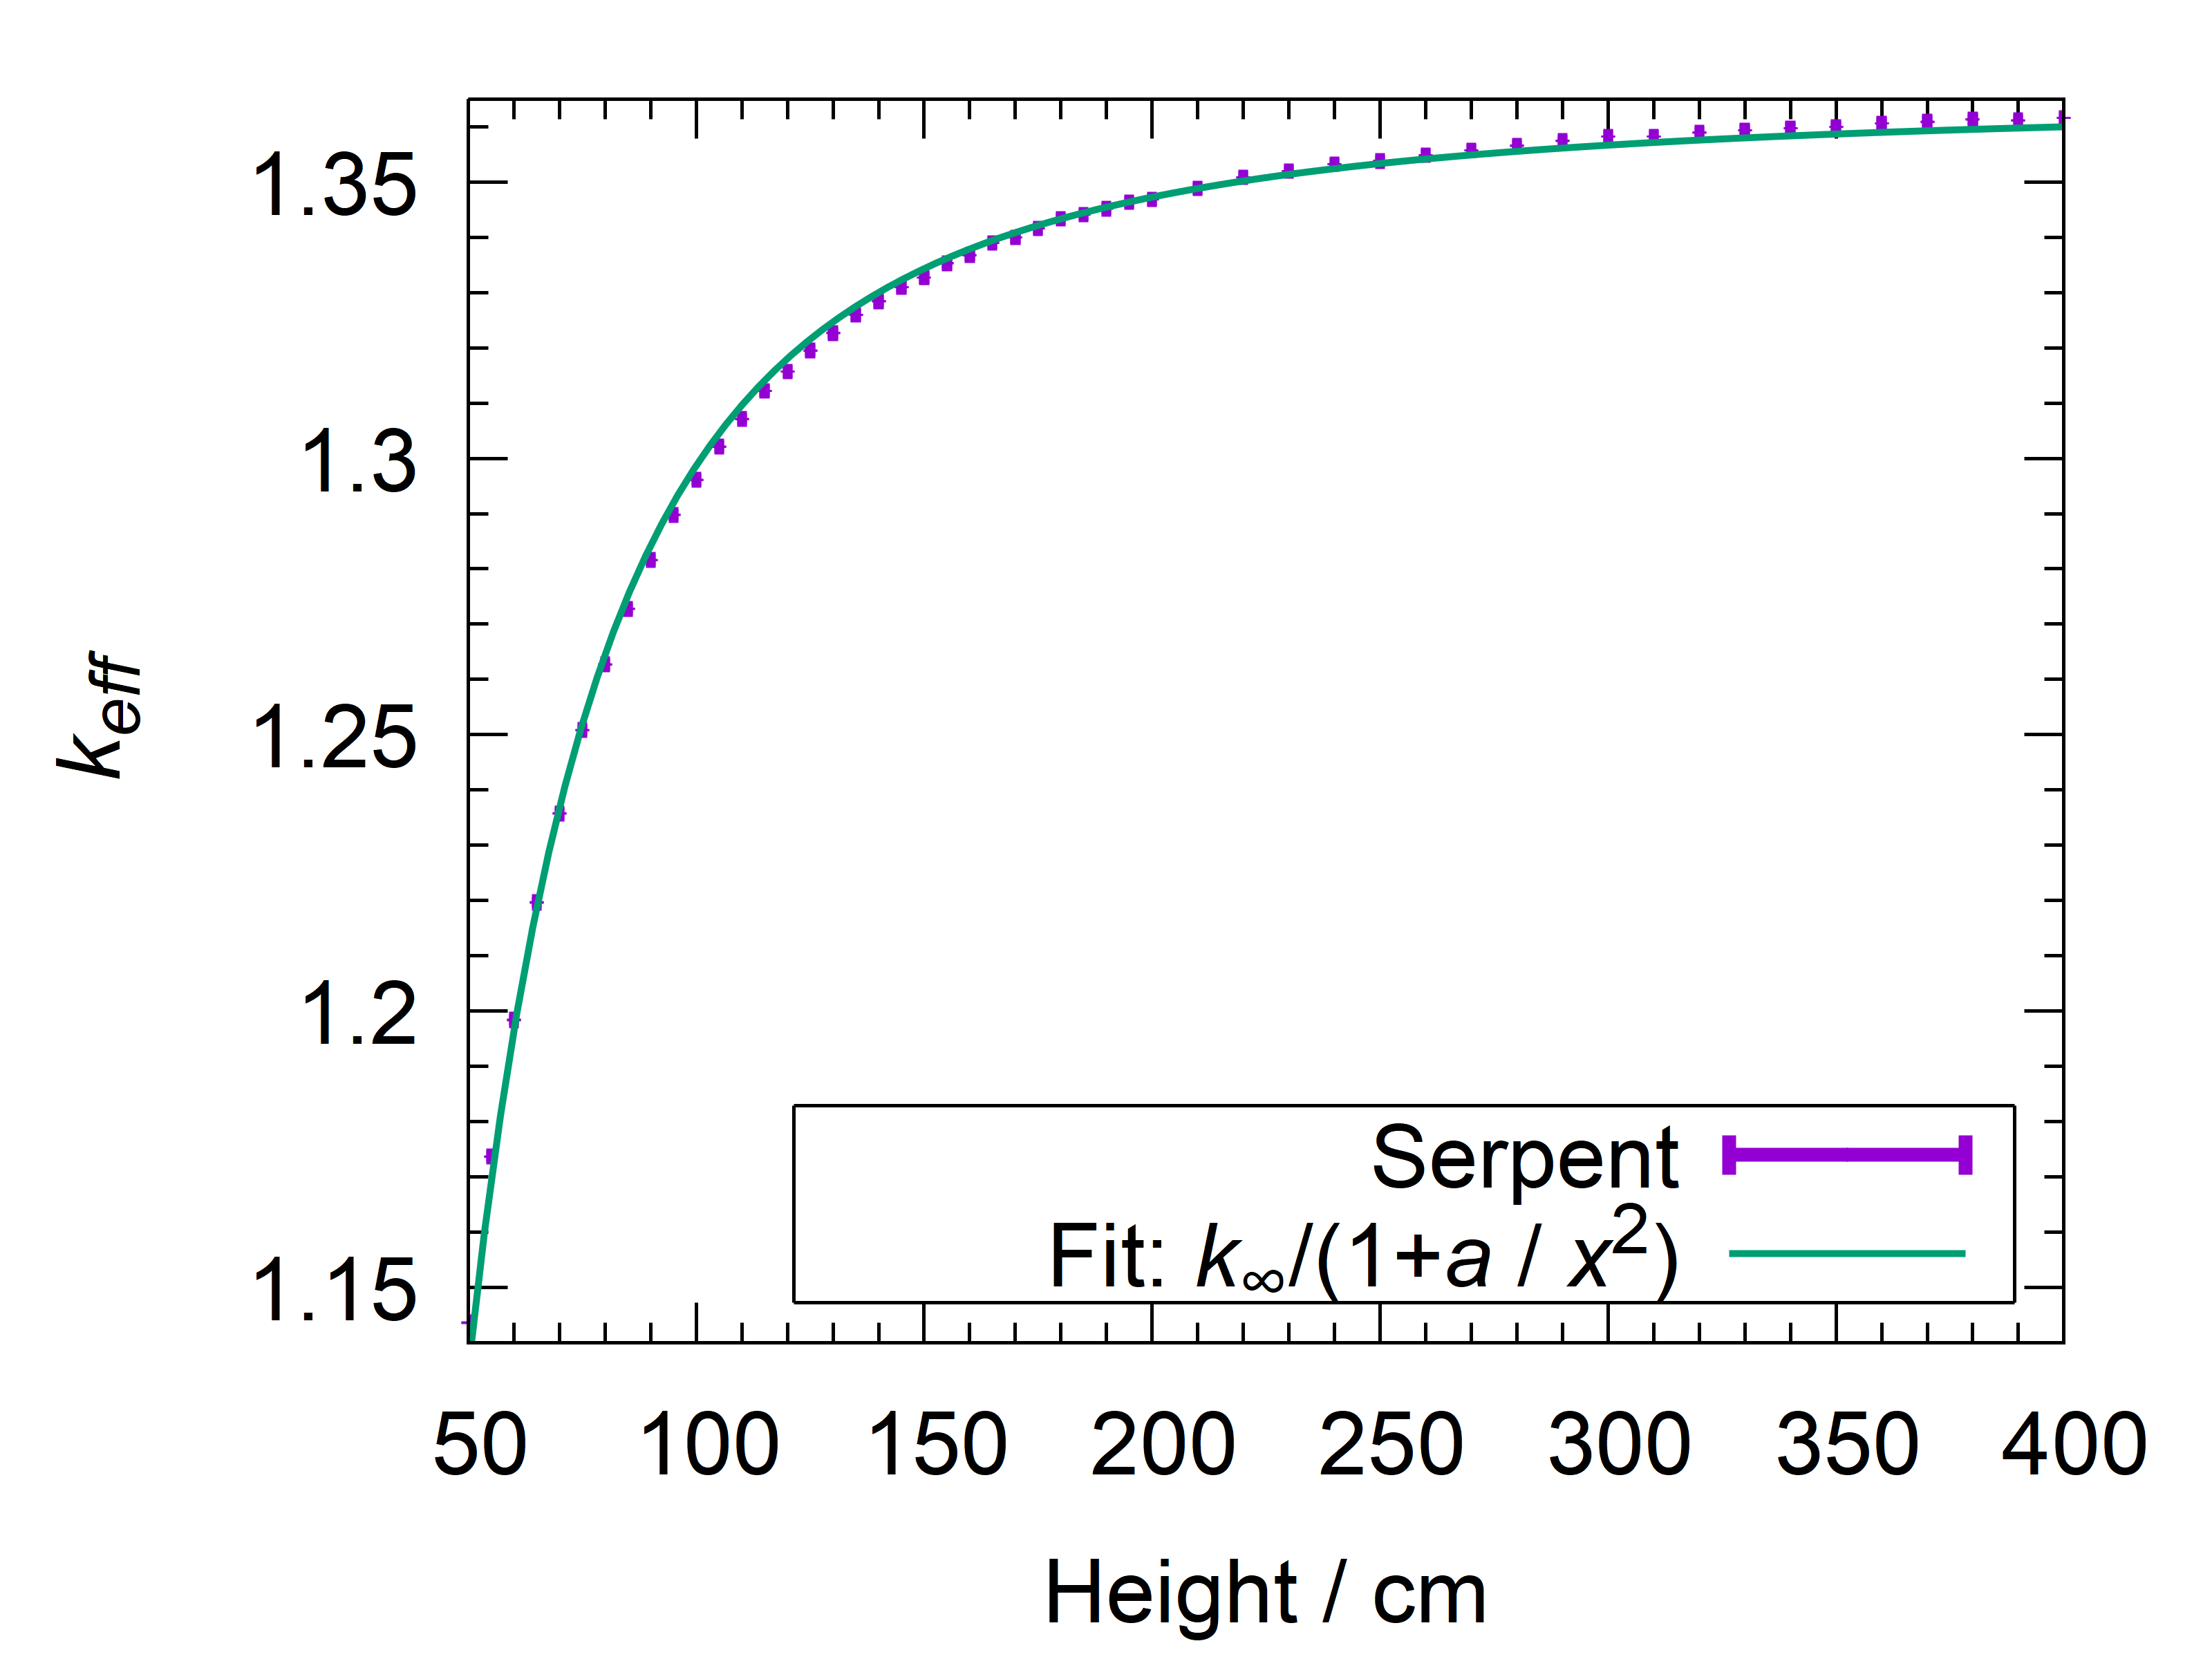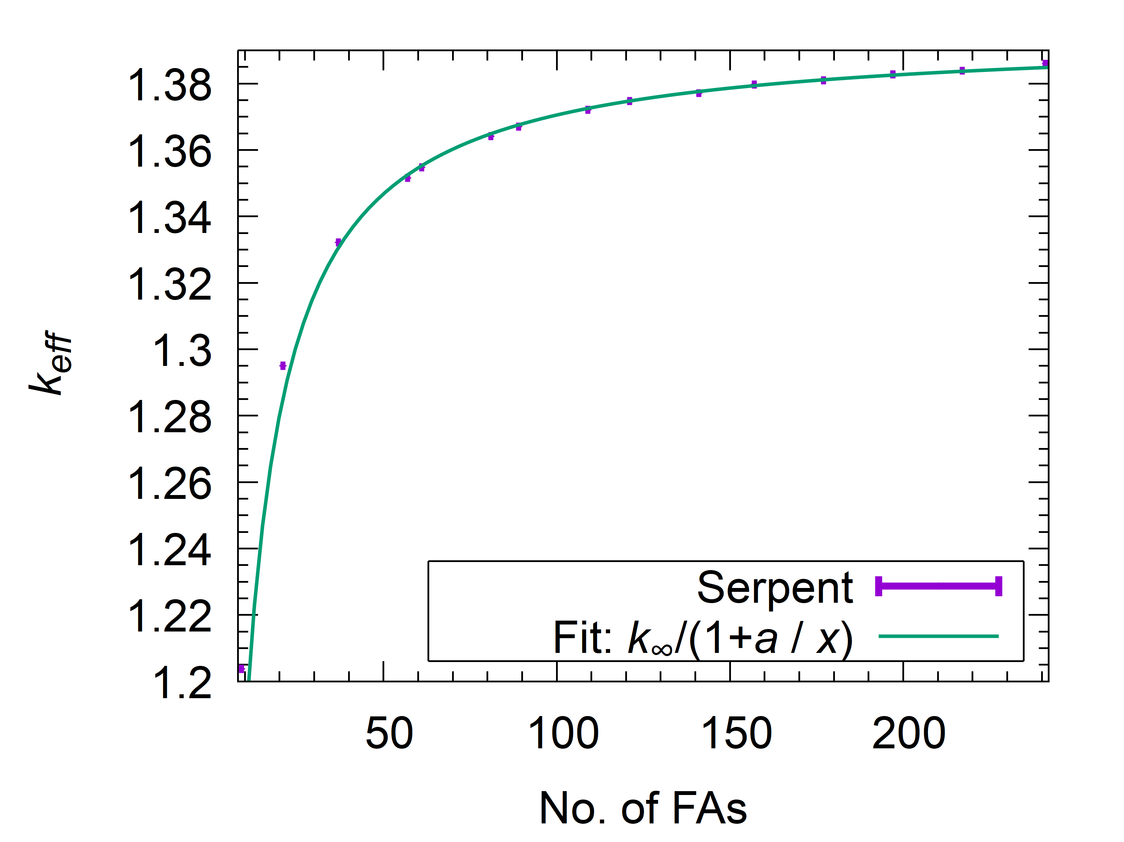

*FIG. 3. Neutron multiplication factor $k_{eff}$*  *as a function the active reactor core height (left) and the total number of FAs (right). In both cases, least-squares fits, inverse weighted by variance originating from Monte Carlo counting statistics, were done. In the 2D model, the outlying first two points were excluded from the fit.*

For the reference model, whose core size ( $37$ FAs with active fuel height $200 cm$) is comparable to a typical SMR, the inverse square dependence of the neutron leakage on the core dimensions is still valid. $k_{eff}$ reduction due to finite dimensions is about $\sim 0.017$ and $\sim 0.063$ in axial and radial directions, respectively. This corresponds to a total neutron leakage of $\sim 8\%$. In comparison, a large, e.g. EPR-size (241 FAs, active height $400 cm$), PWR with a uniform core configuration, has a neutron leakage of $\sim 1-2\%$.

In case of a comparable geometry and material composition of the ex-core components this results in almost an order of magnitude of difference in the total neutron fluence per unit of energy produced. Consequently, additional measures need to be taken to mitigate significant negative effect such as e.g. an increase in activation rates and a reduced pressure vessel lifetime. However, these topics are out of scope for this study.

## INITIAL 235U ENRICHMENT

In order to compensate for a higher neutron leakage rate, which leads to a lower $k_{eff}$ and maximum achievable BU, the so-called HALEU fuel with initial 235U enrichment $> 5\%$ is proposed in many SMR concepts [1]. The multiplication factor for infinite medium $k_{∞}$ is shown in *FIG. 4* as a function of BU for different IE.

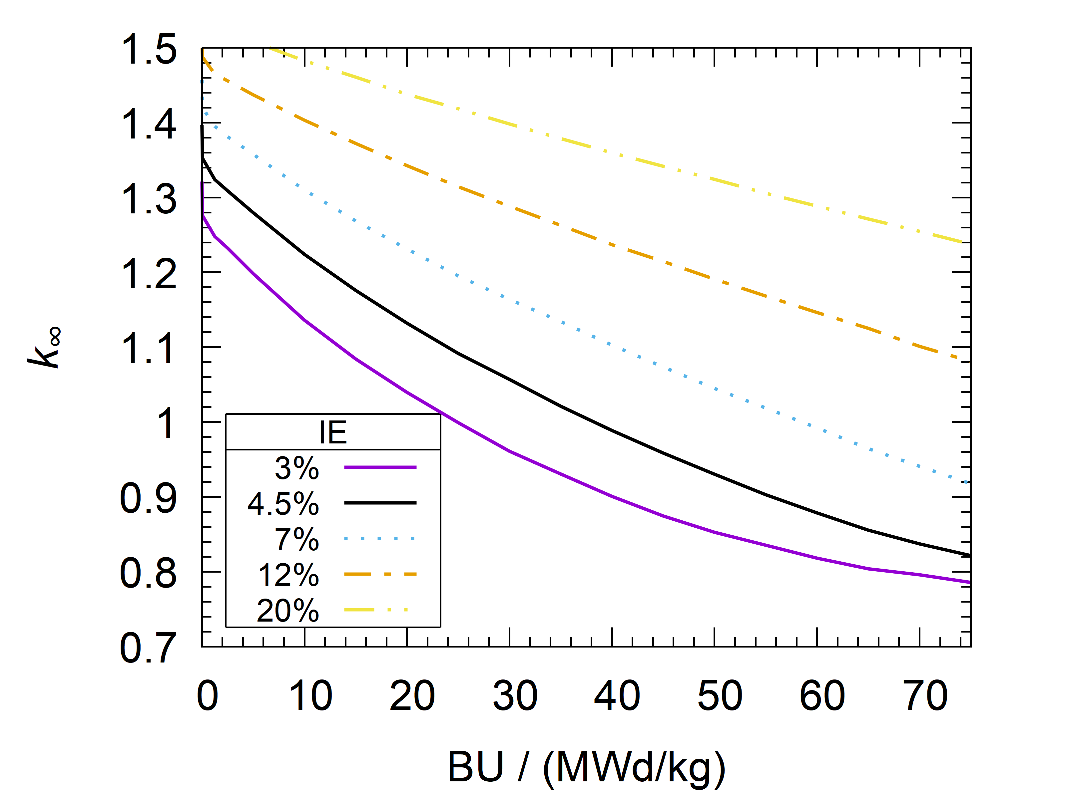

*FIG. 4. Infinite medium multiplication factor $k_{∞}$ as a function of BU for different IE. No boron.*

Due to core heterogeneity, the fuel can be burnt well below $k_{∞}=1$ for large systems. For small systems, $k_{eff}$ reduction was estimated at $\sim 0.08$ for the reference model, representative for the size of a typical SMR (Section 3). Assuming an average $k_{∞}=0.9$ at discharge for a large PWR, this results in the reduction of the maximum achievable BU of $\sim 15 MWd/kg$ for the reference initial 235U enrichment (4.5%) and for the HALEU fuel with $7\%$ IE. This can be compensated by an increase of IE by $2.5-3\%$, however resulting in increased stockpiles of the depleted uranium tail. For the HALEU fuel with $>10\%$ IE, the maximum achievable BU is large even for the reference SMR core size and is thus probably only interesting for so-called microreactors.

The decay heat (DH) rate is one of the most important safety parameters for SNF storage and disposal. The total DH rate and main contributing nuclides for cooling time (CT) interval $[1,1000] a$ are shown in *FIG. 5* (left) for the reference model (IE $4.5\%$, BU $50 MWd/kg$). The results confirm the well-known fact that for CT up to $\sim 30 a$, DH is dominated by decay of fission products (FPs), whereas for longer CT, the contribution from actinide decay is gradually gaining in prominence. The calculated 238Pu concentration presents the lower bound, corresponding to a (rare) case of fresh fuel not being contaminated by 236U. The DH/BU ratio is related with high-level waste burden per unit produced energy. This ratio, normalised per amount of initial actinide mass $m$, is shown in *FIG. 5* (right) for CT $30 a$. It reveals an increasing trend with BU and decreasing with IE. This trend can be explained with non-linear build-up of (mainly) actinides, discussed in detail below. Use of HALEU fuel with IE $7\%$ and BU $50 MWd/kg$ results in a slightly higher DH/BU ratio compared to a reference scenario with IE $4.5\%$ and BU $35 MWd/kg$. Compared to a large PWR (IE $4.5\%$ and BU $50 MWd/kg$), both lower BU or higher IE in an SMR lead to a lower DH/BU ratio, which may have a positive impact for interim storage and potentially final disposal.

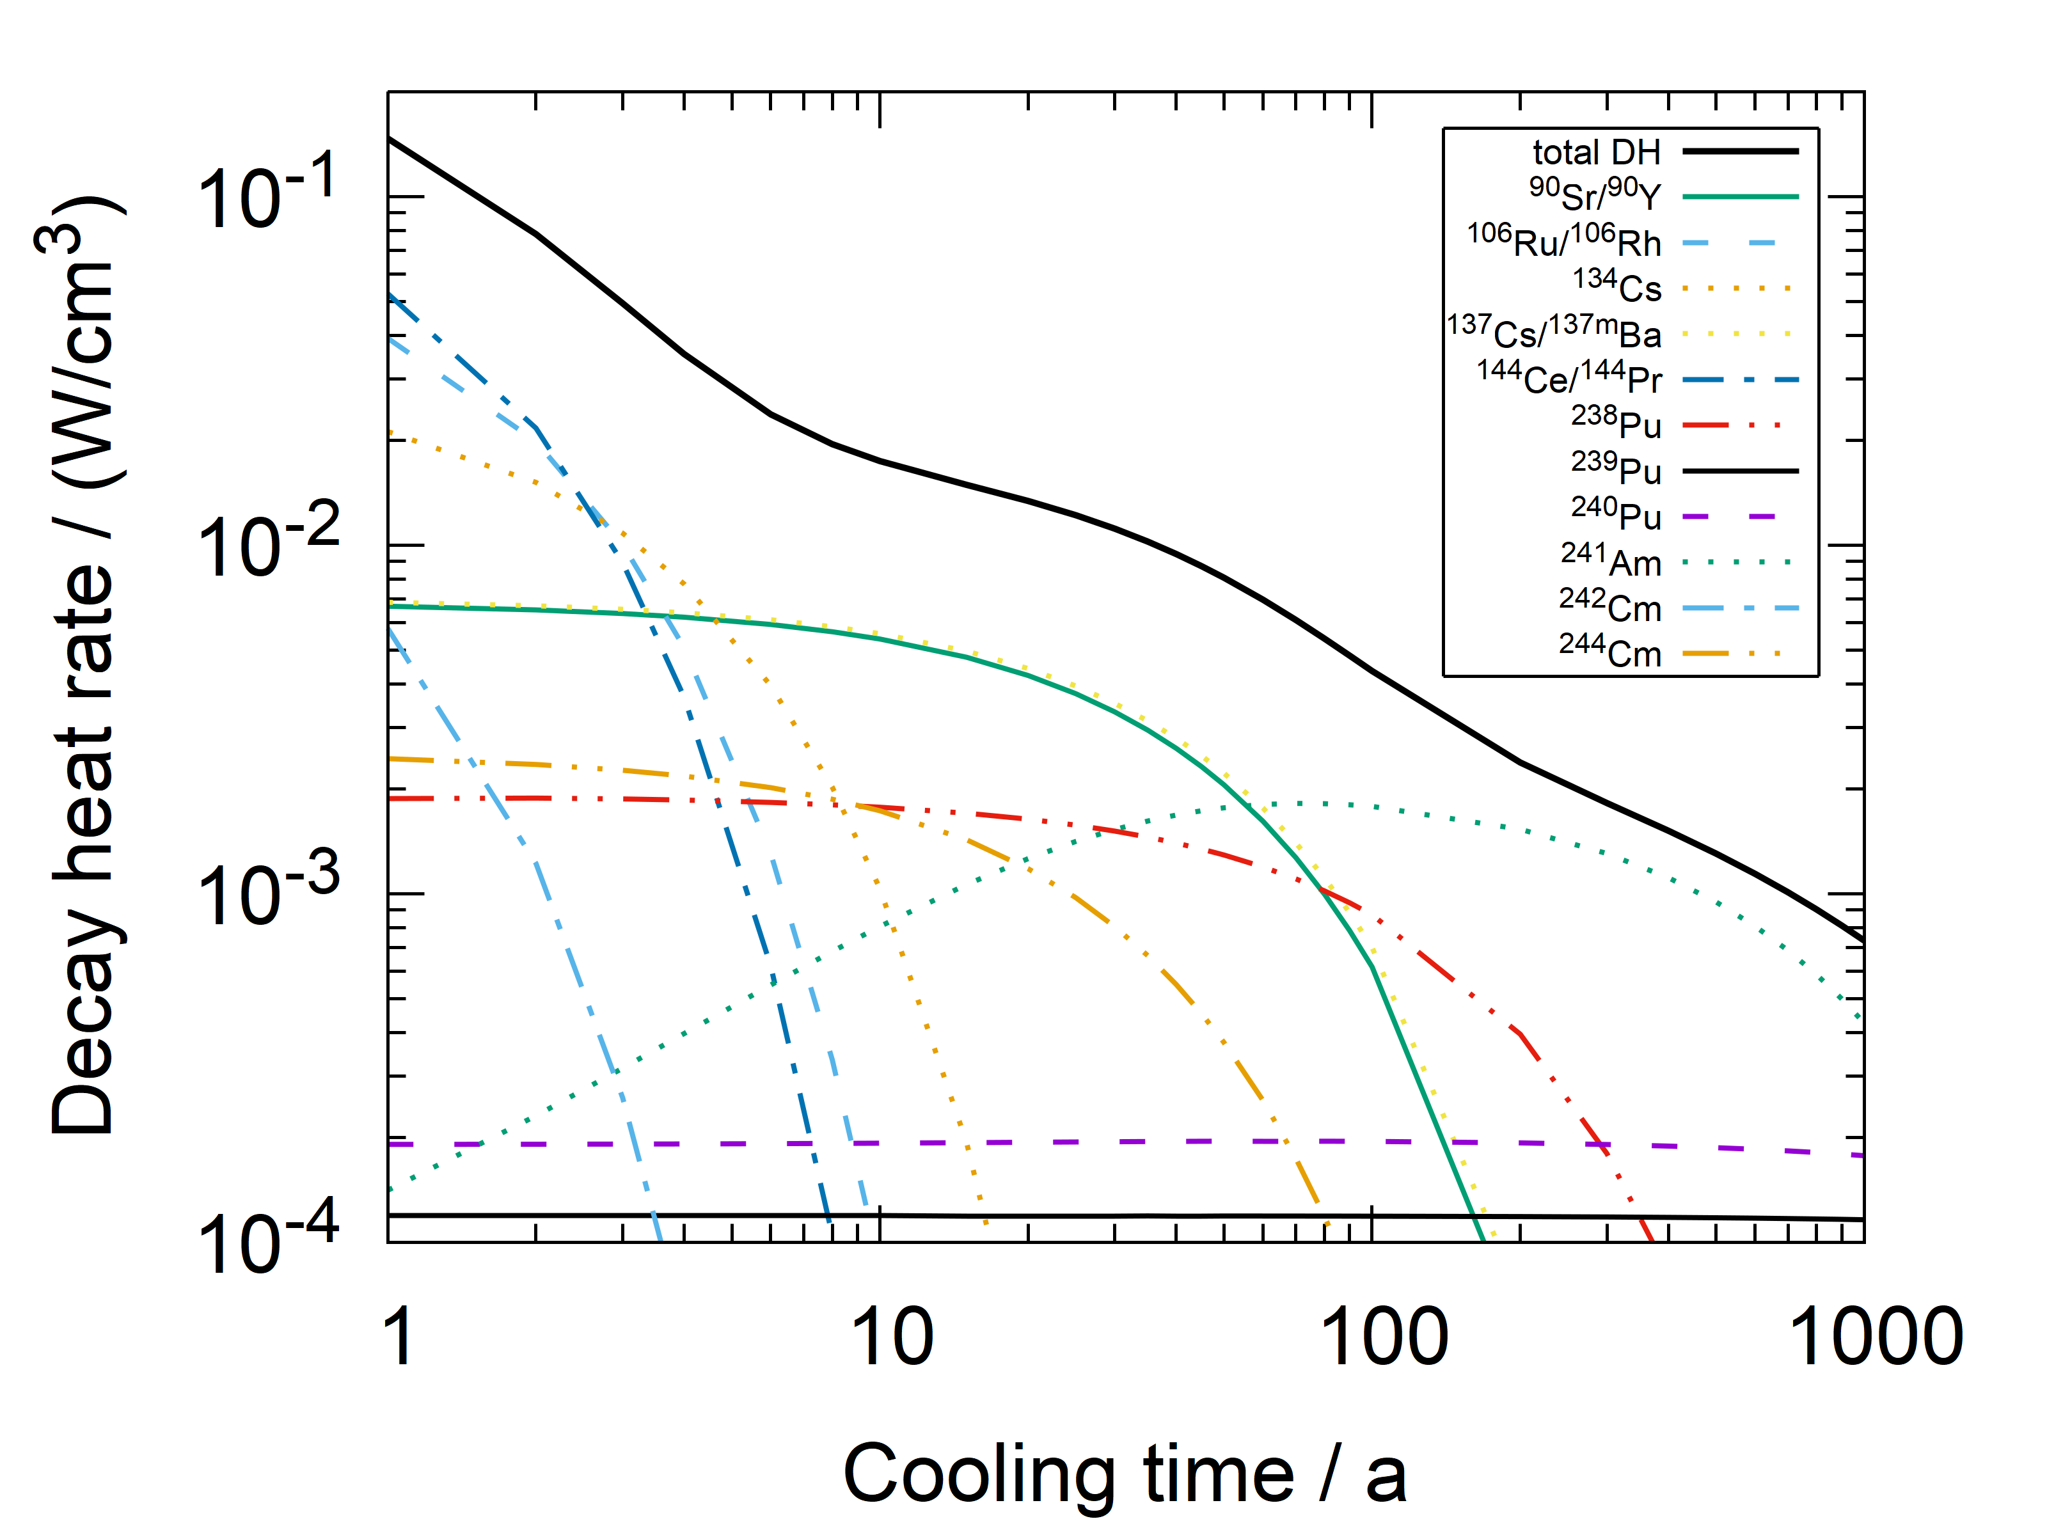 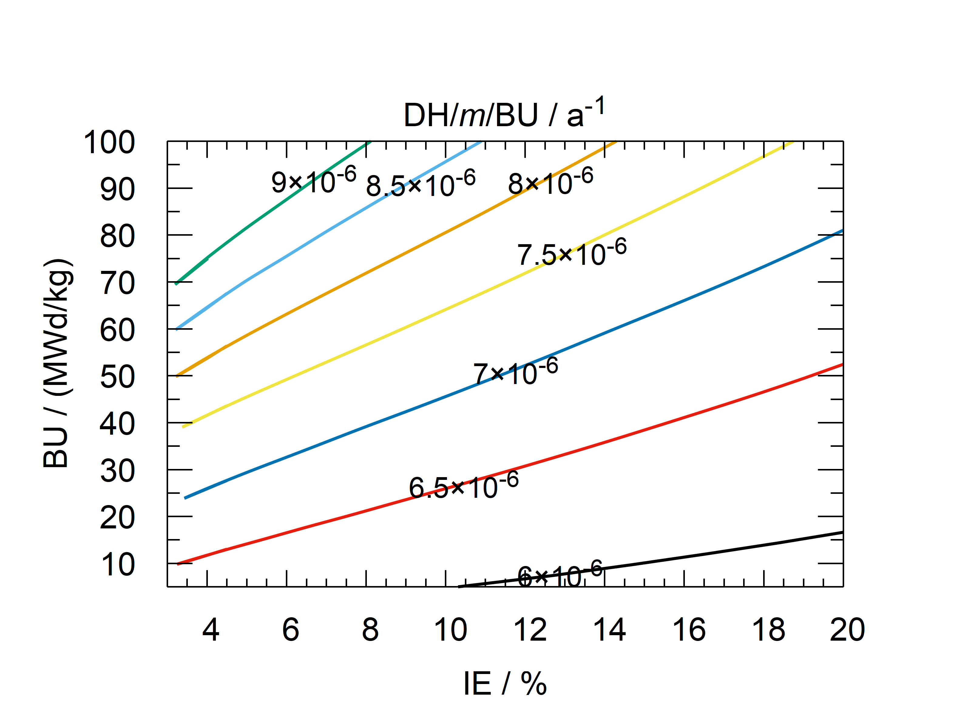

*FIG. 5. Decay heat rate density as a function of cooling time for the reference model (IE $4.5\%$) (left) and DH/BU/m ratio as a function of BU for CT $30 a$ and different IE (right).*

239Pu is the first major step in production of transuranic elements irradiated in UO2 fuel. It is important for many reasons: $k_{∞}$, conversion, long-term DH, radiotoxicity, proliferation, etc. For lower IE, it builds up faster but its conc. reaches a lower equilibrium at a lower BU (*FIG. 6* left). For HALEU fuel, one may expect an increased conc. For lower BU, the 239Pu isotopic fraction is larger which may negatively influence proliferation resistance.

241Am is the dominant contributor to DH for CT interval [100,1000] a and is thus a limiting factor for heat transfer in SNF repository. It builds up faster for lower IE, but does not reach equilibrium for realistic BU (*FIG. 6* right). One would thus expect a positive impact for final disposal.

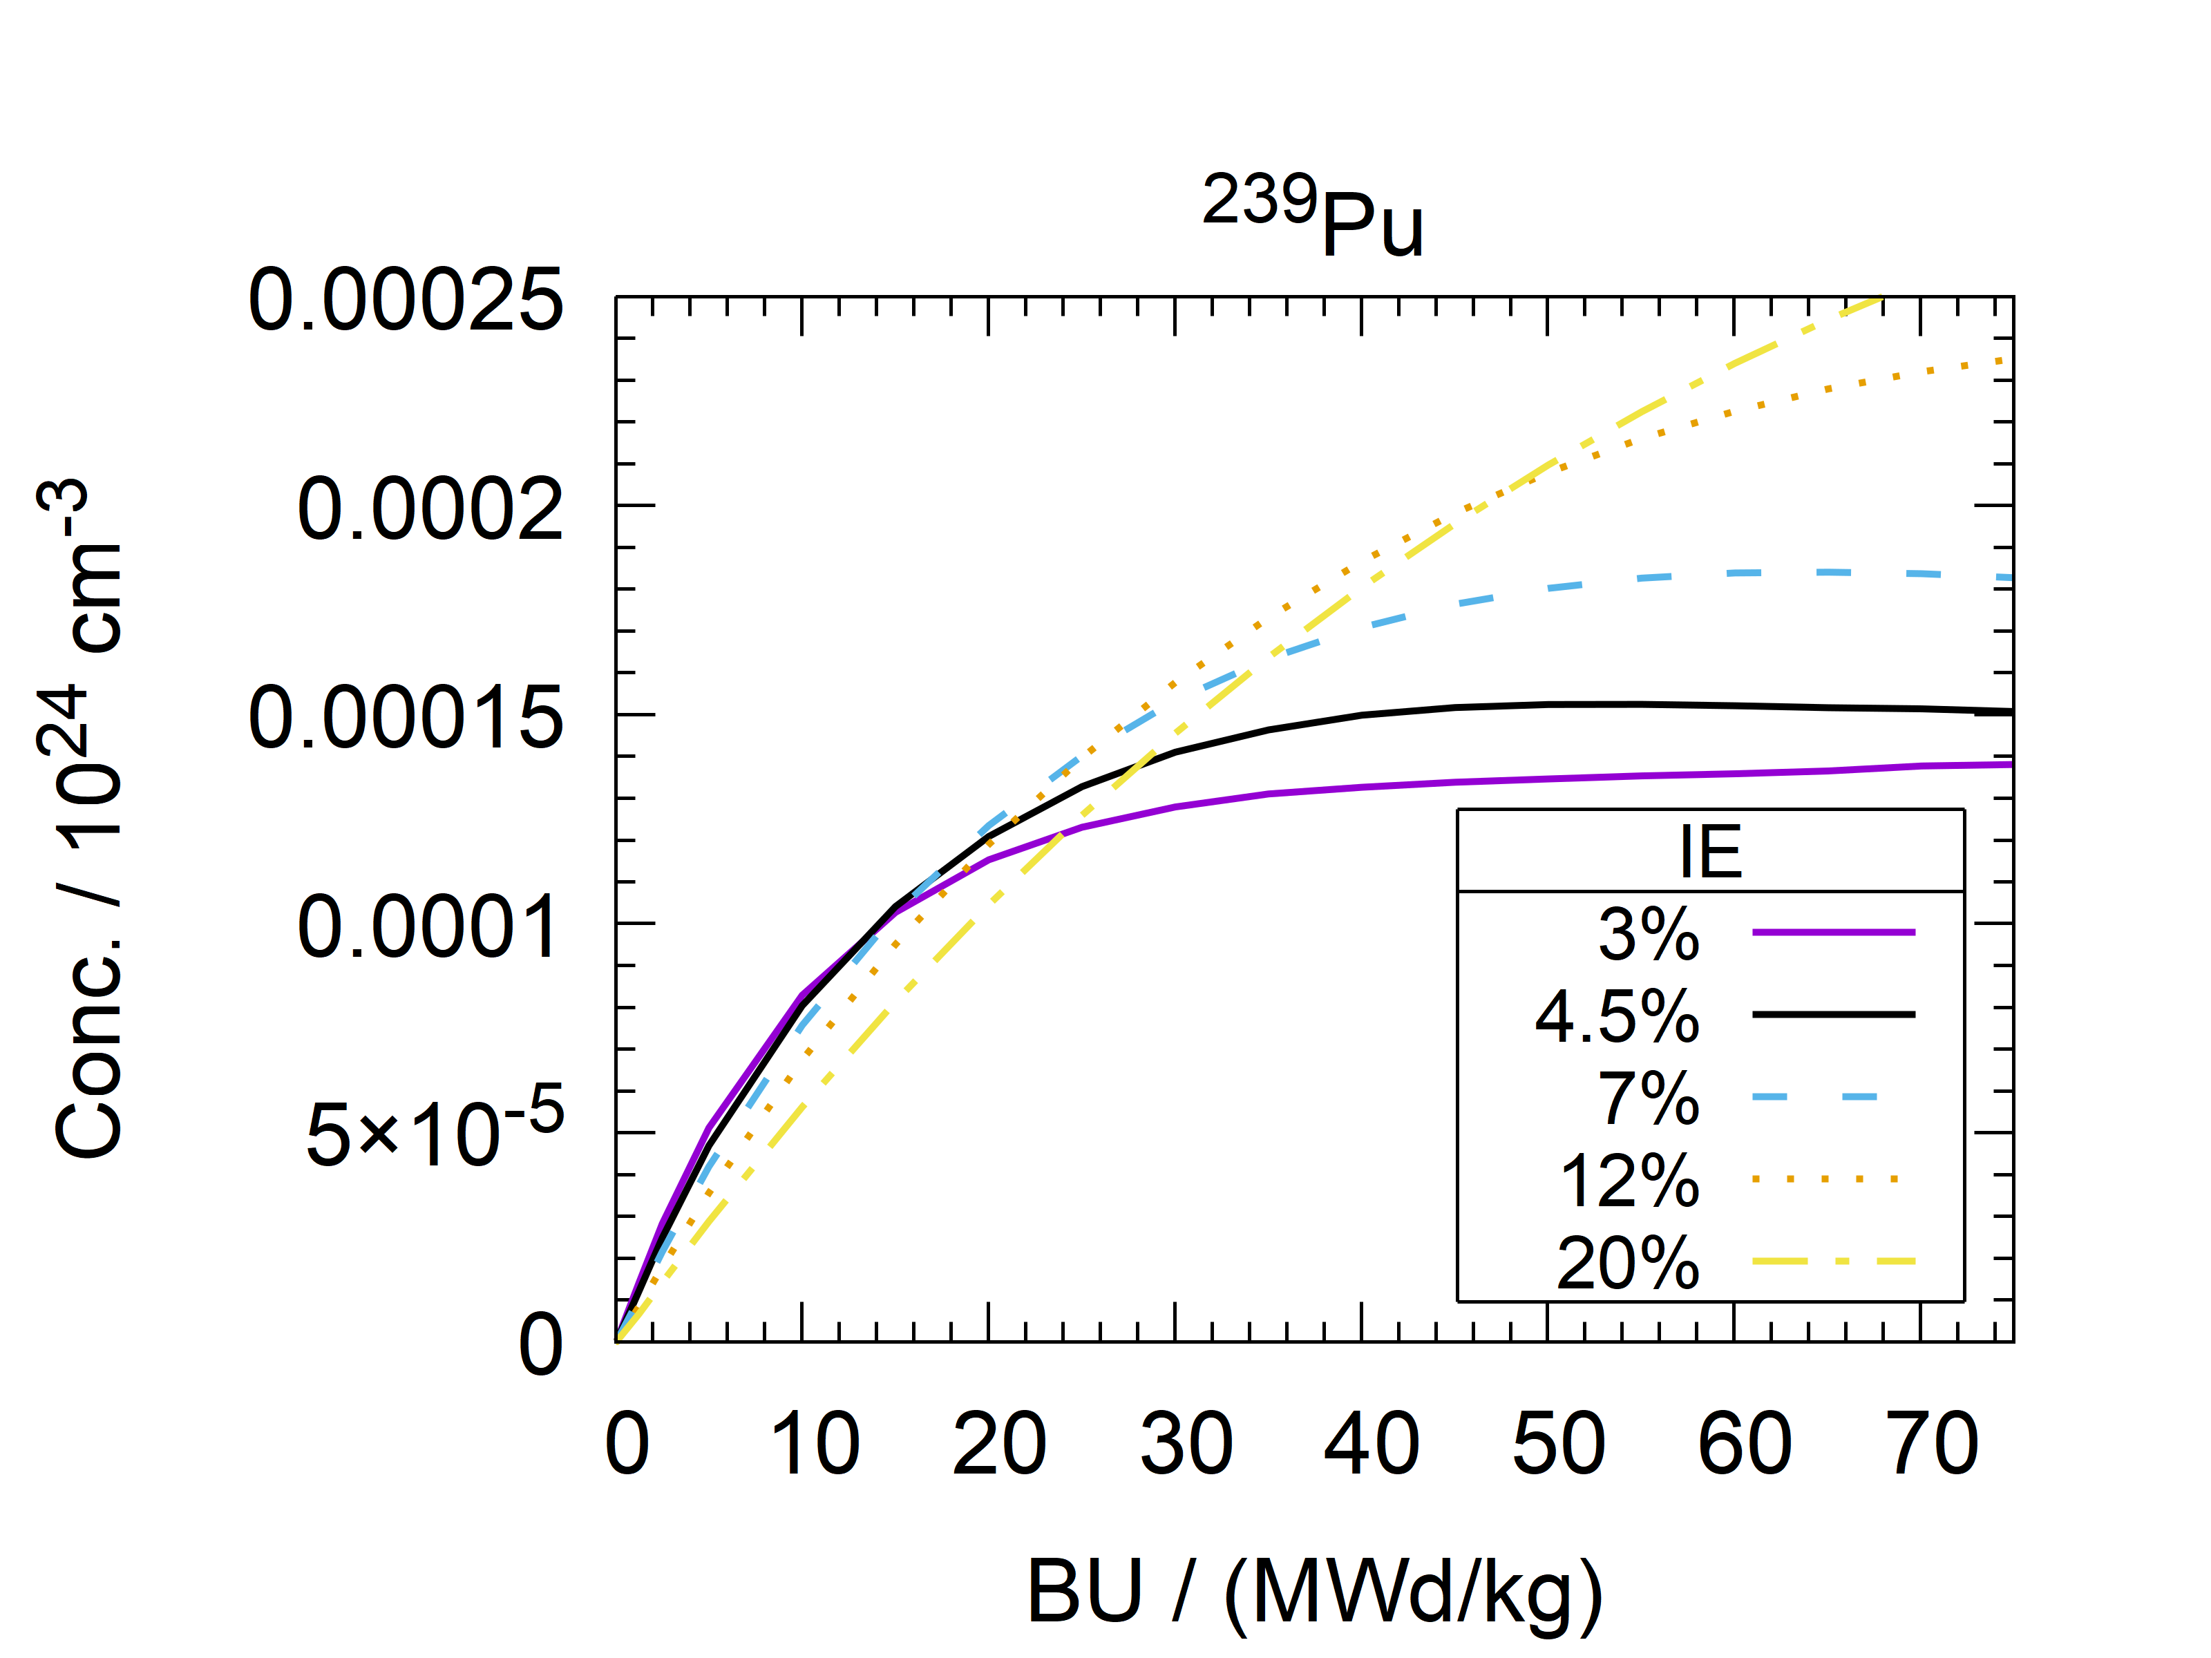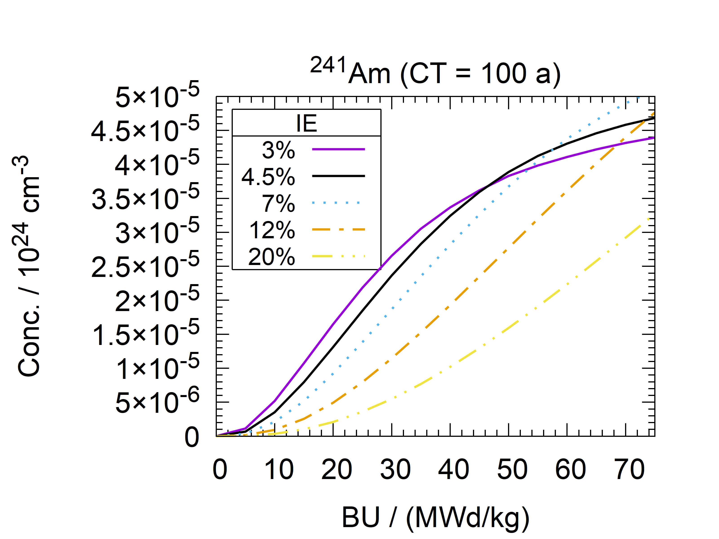

*FIG. 6. Conc. of 239Pu at discharge (left) and 241Am for CT $100 a$ (right) as a funct. of BU for different IE.*

244Cm is the dominant contributor to LWR SNF neutron emission for CT interval [1,100] a [11]. *FIG. 7* left confirms a high sensitivity of 244Cm conc. to BU, which makes it a potentially useful BU indicator [12]. The sensitivity to IE is negative. Its conc. in typical SMR SNF is expected to be lower compared to a large PWR.

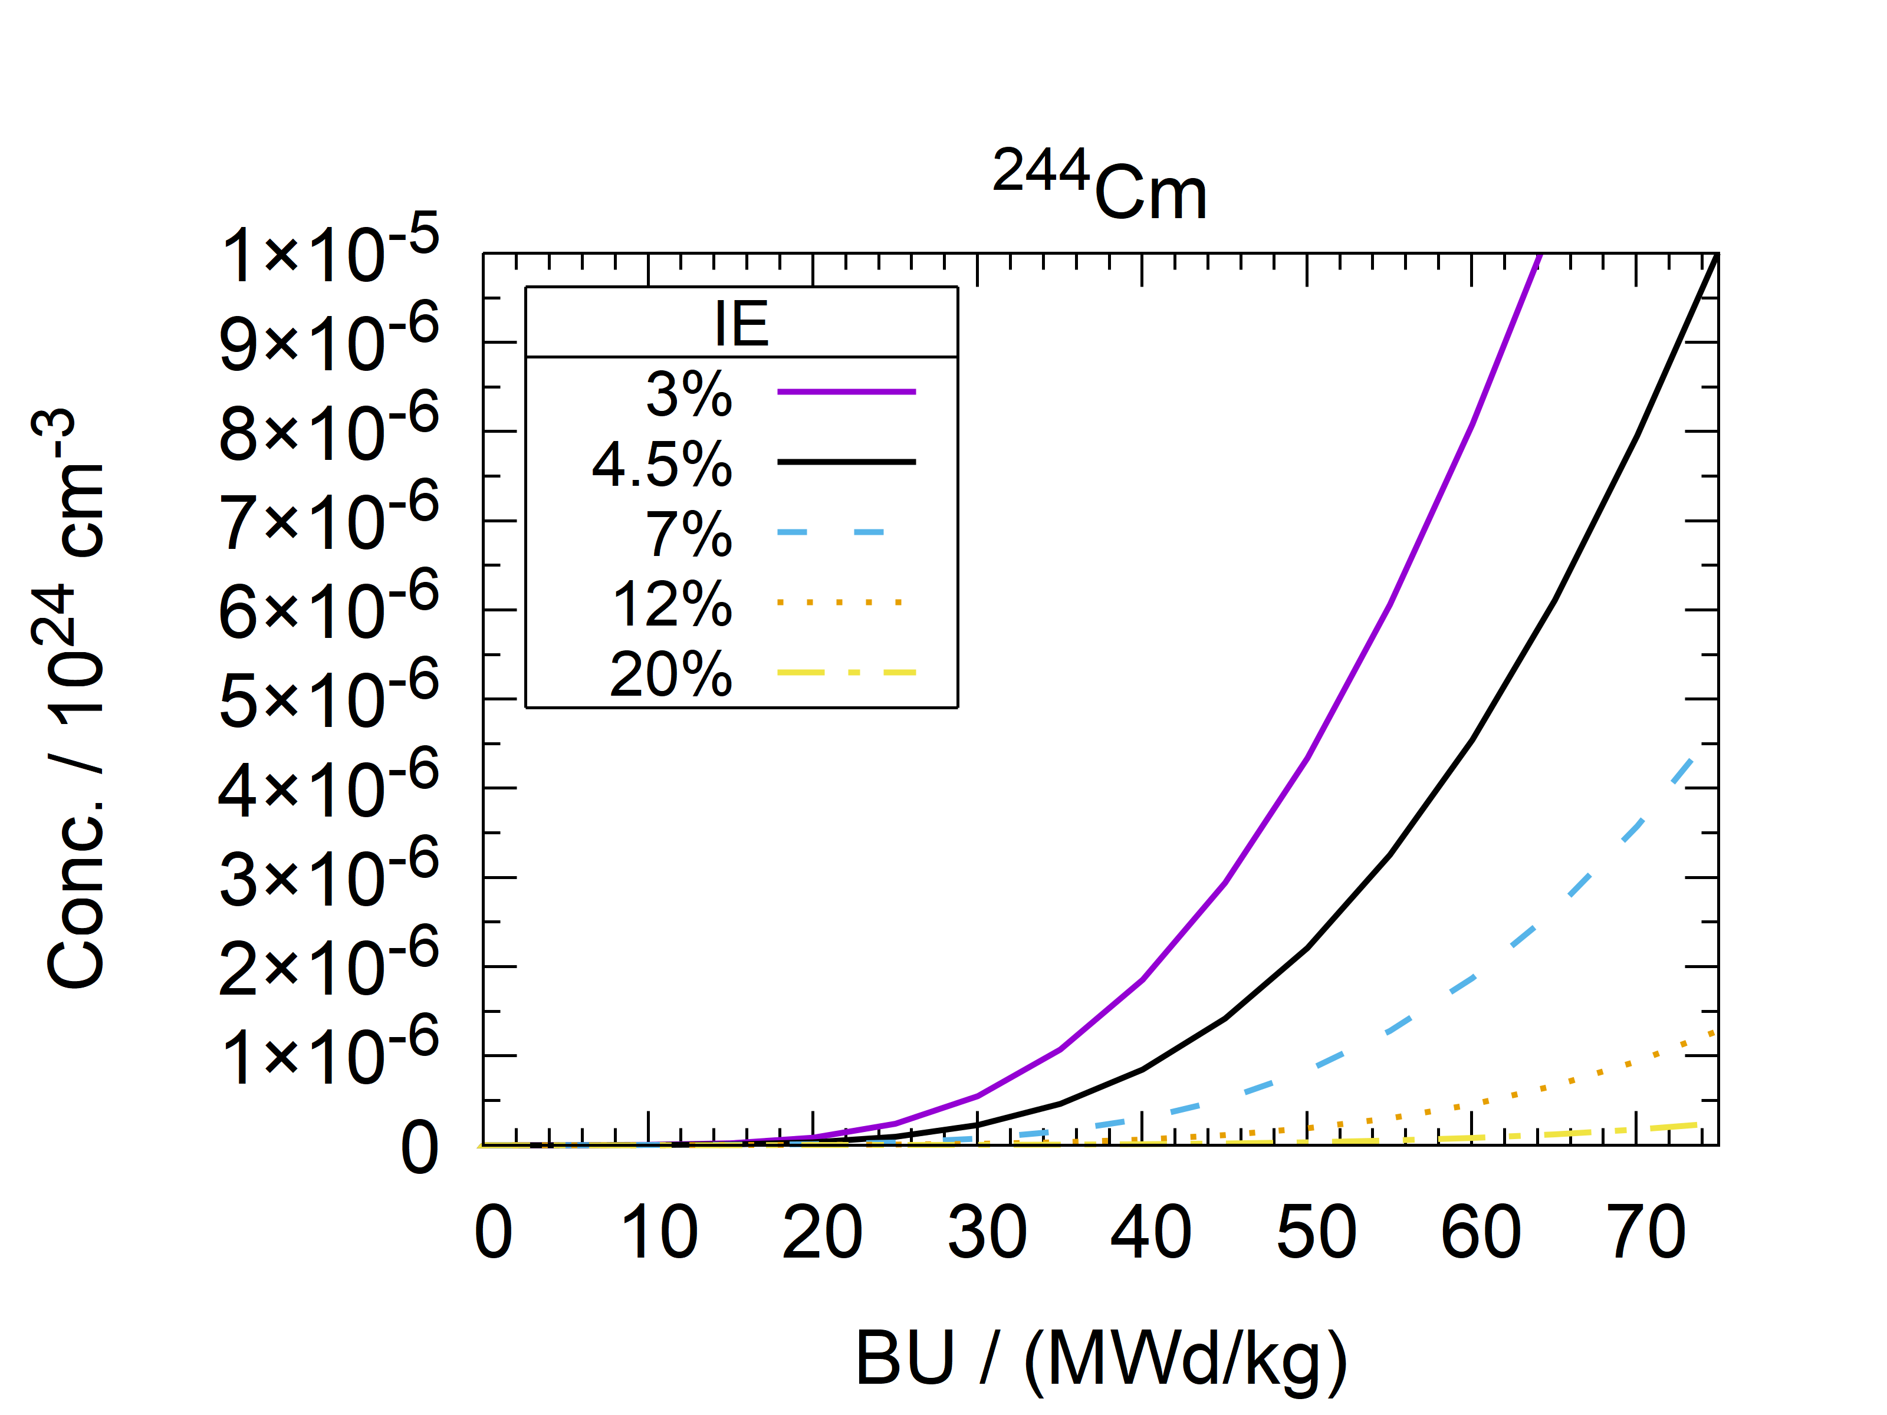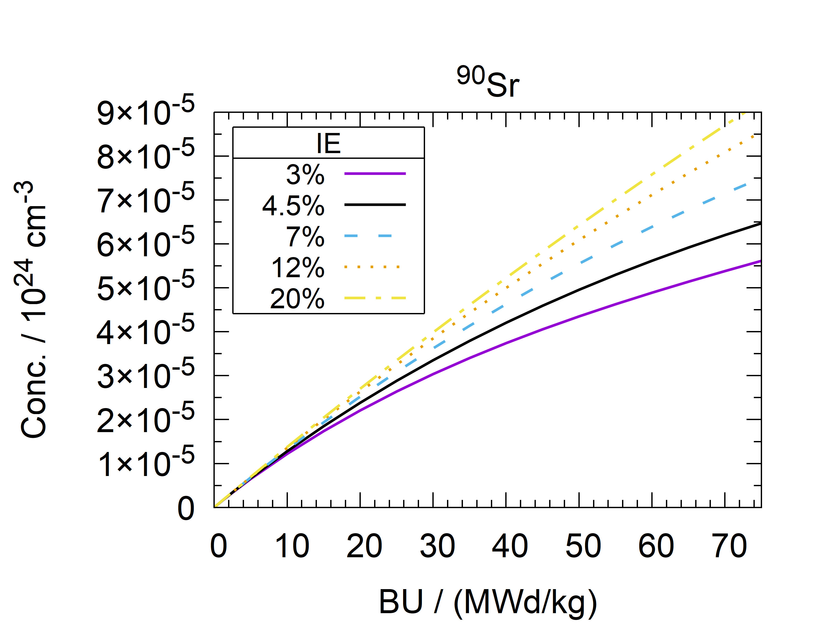

*FIG. 7. Concentration of 244Cm (left) and 90Sr (right) at discharge as a function of BU for different IE.*

137Cs is the main contributor to the γ-ray emission for CT interval [10,300] a [11]. The dependence of 137Cs concentration on BU is almost linear, and its sensitivity to IE is very low, e.g. the difference in 137Cs concentration between IE $4.5\%$ and IE $20\%$ case is $< 2\%$ at any considered BU. The dependence of concentrations other two important contributors for CT , 134Cs and 154Eu, on BU and IE at discharge is presented in *FIG. 8*.

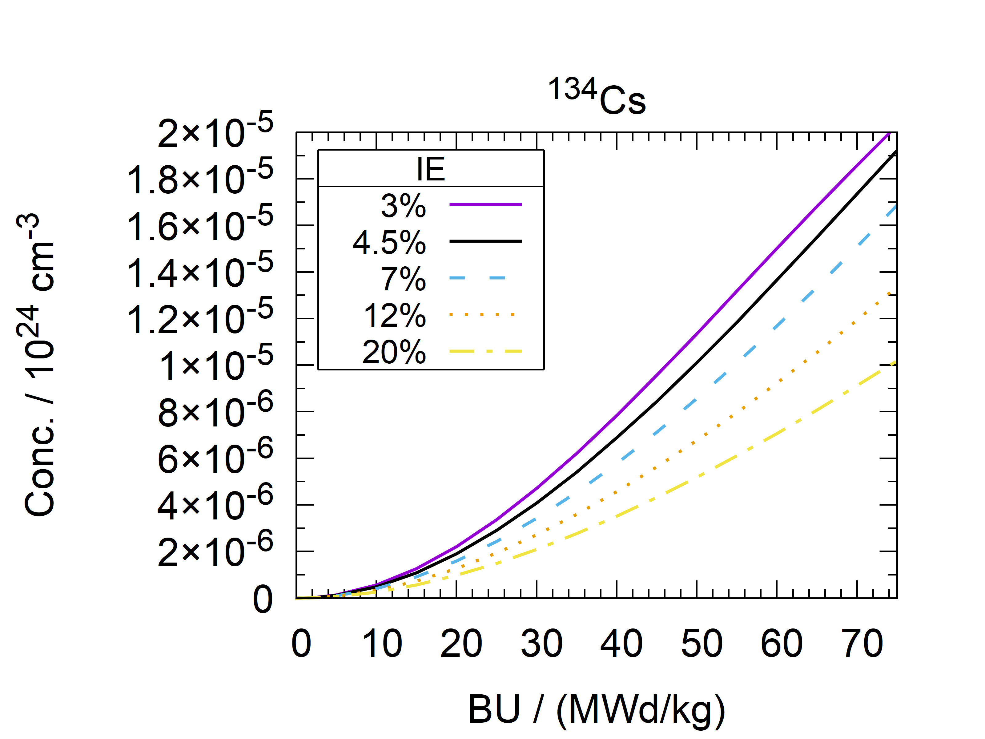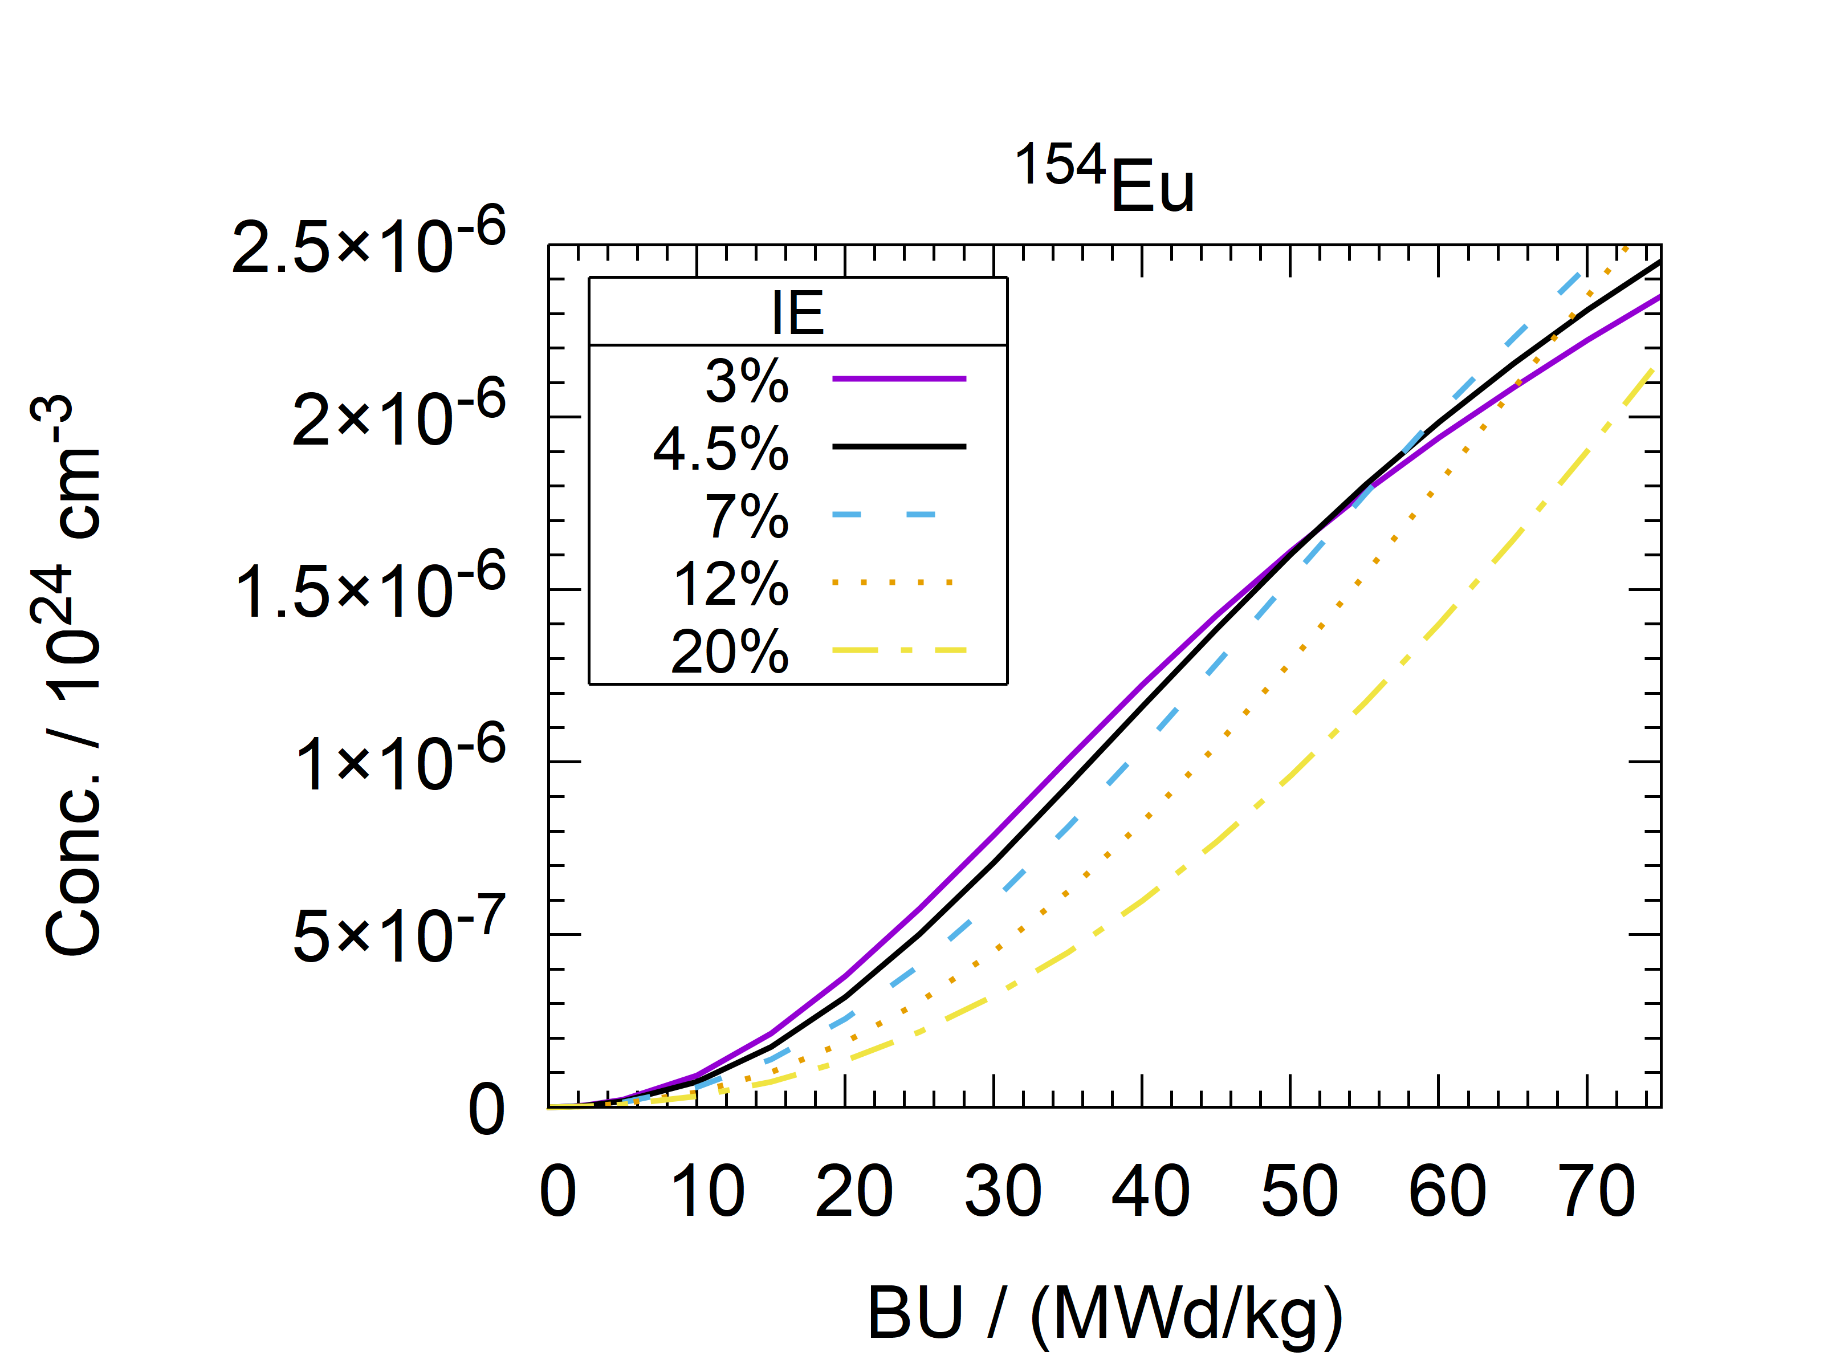

*FIG. 8. Concentration of 134Cs (left) and 154Eu (right) at discharge as a function of BU for different IE.*

90Sr is a pure β--particle emitter and an important contributor to decay heat up to ~ 100 a (*FIG. 5* left). Due to a large difference in cumulative fission yields for 235U (0.0578(6) [8]) and 239Pu (0.0210(4) [8]), non-linear dependencies on BU and IE occur (*FIG. 7* right). Since the 239Pu fission fraction increases with BU, this results in slower than linear 90Sr build-up with BU. Conversely, since 239Pu fission fraction decreases with IE, the 90Sr build-up increases with IE.

For long-term safety of high-level waste disposal, long-lived FPs, such as e.g. 99Tc, 135Cs and 129I play a crucial role. 99Tc build-up is close to linear with BU, and the differences in accumulated 99Tc for different IE are within 20% for any considered BU. 135Cs production depends on 135Xe(n,γ) rate, which decreases with IE at a fixed power density, resulting in increased 135Cs concentration (*FIG. 9* left). In order to see a full picture, variations in power density would have to be considered. A sharp increase in 135Cs production per unit energy produced is expected in systems with lower power densities, corresponding to some SMR concepts. 129I has a much higher cumulative fission yield for 239Pu (0.0137(5) [8]) than 235U (0.00543(5) [8]), which leads to increased build-up rate with BU and decreased with IE (*FIG. 9* right).

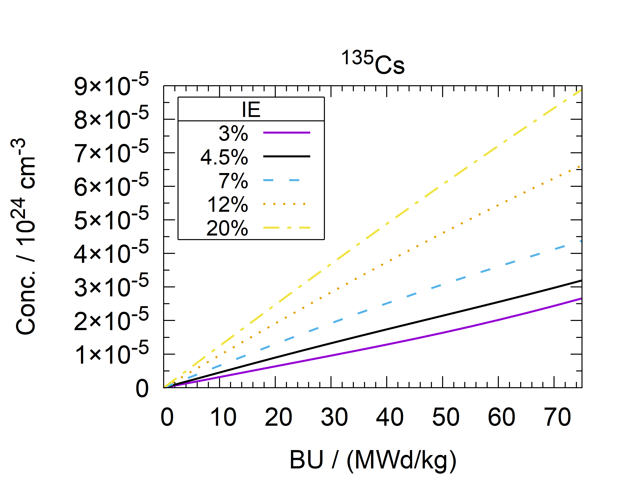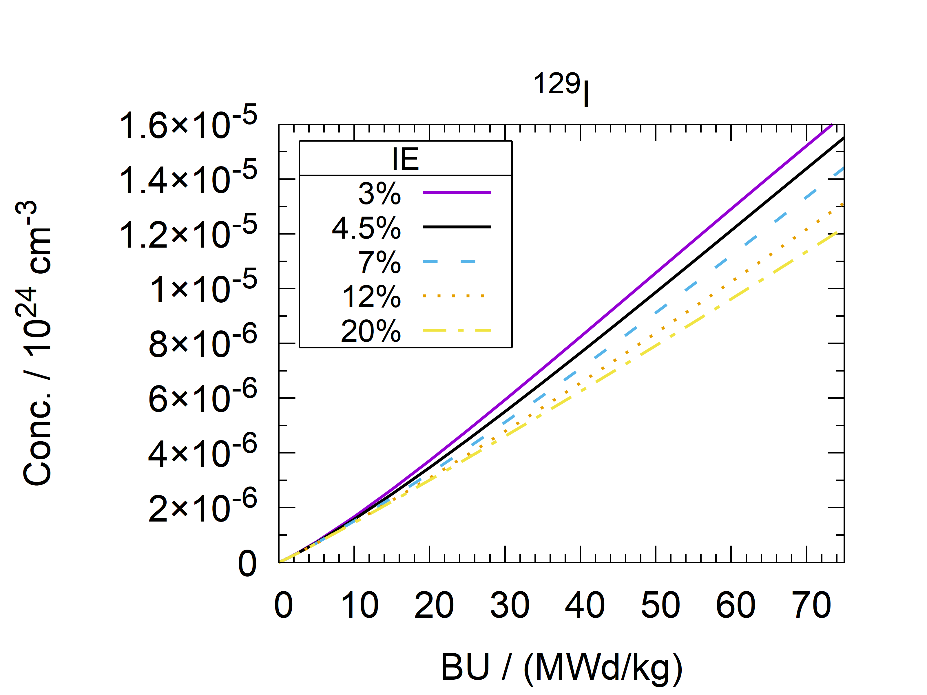

*FIG. 9. Concentration of 135Cs (left) and 129I (right) at discharge as a function of BU for different IE.*

## REFLECTOR

The influence of use of different reflector materials on SNF nuclide vector components is summarised in TABLE 1 for “edge” and “vertex” configurations. All effects are stronger for “vertex” than “edge” configurations. Differences in 90Sr, 99Tc and 137Cs conc. are small, as expected. Conc. of most other considered nuclides are lower for all other reflector types except SS-304. This is related with the neutron spectrum, which is except for SS-304 more thermalised, causing a lower resonance 238U(n,γ) rate. This effect is most pronounced for D2O reflector. For H2O, the effect is smaller due to neutron capture in H. A similar, but smaller, effect is observed for 134Cs and 154Eu. A more thermalised spectrum also leads to a higher 135Xe(n,γ) rate, resulting in lower 135Cs conc.

Using SS-304 reflector leads to increased production rate of most transuranic actinide nuclides and some FPs, including 134,135Cs and 154Eu. Other considered reflector materials achieve an opposite effect.

TABLE 1. CONC. OF SOME NUCLIDES AT DISCHARGE FOR FAs ADJACENT TO DIFFERENT REFLECTOR MATERIALS, RELATIVE TO THE REFERENCE MODEL (IE 4.5%, BU 50 MWd/kg).

|  |  |  |  |  |  |  |  |  |  |
| --- | --- | --- | --- | --- | --- | --- | --- | --- | --- |
| Nuclide | Ref. conc. / (${10}^{24} {cm}^{-3}$) | SS “edge” | SS “vertex” | H2O “edge” | H2O “vertex” | D2O “edge” | D2O “vertex” | C “edge” | C “vertex” |
| 239Pu | 1.526 × 10-4 | 1.057 | 1.109 | 0.892 | 0.802 | 0.823 | 0.673 | 0.866 | 0.754 |
| 241Pu | 4.358 × 10-5 | 1.033 | 1.058 | 0.890 | 0.800 | 0.801 | 0.636 | 0.862 | 0.743 |
| 244Cm | 2.191 × 10-6 | 1.105 | 1.215 | 0.906 | 0.863 | 0.985 | 0.928 | 0.951 | 0.870 |
| 90Sr | 4.957 × 10-5 | 0.994 | 0.988 | 1.015 | 1.028 | 1.013 | 1.024 | 1.012 | 1.023 |
| 99Tc | 6.465 × 10-5 | 0.996 | 0.993 | 1.008 | 1.015 | 1.002 | 1.004 | 1.004 | 1.009 |
| 129I | 9.877 × 10-6 | 1.005 | 1.013 | 0.983 | 0.972 | 0.960 | 0.922 | 0.975 | 0.951 |
| 134Cs | 1.013 × 10-5 | 1.033 | 1.059 | 0.962 | 0.927 | 0.941 | 0.888 | 0.959 | 0.920 |
| 135Cs | 2.144 × 10-5 | 1.022 | 1.045 | 0.935 | 0.884 | 0.907 | 0.837 | 0.925 | 0.862 |
| 137Cs | 7.442 × 10-5 | 1.002 | 1.005 | 1.001 | 1.004 | 1.002 | 1.004 | 1.001 | 1.003 |
| 154Eu | 1.603 × 10-6 | 1.022 | 1.045 | 0.909 | 0.840 | 0.816 | 0.674 | 0.876 | 0.770 |

## CONCLUSIONS

Effects of reactor core size on some aspects of operation and waste streams were studied. A reference SMR PWR core has a to multiplication factor about $0.08$ lower compared to a large PWR, which may lead to an increase in ex-core component activation. Maximum achievable burnup is about 15 MWd/kg lower.

These effects may be compensated by using a higher initial 235U enrichment. This results in increased depleted uranium stockpiles. A decreased decay heat rate may reduce the requirements for interim storage and final disposal. A higher isotopic purity of 239Pu may increase proliferation risks. From the aspect of the long-term safety of high-level waste disposal, the impact on 129I and 99Tc production is small, however 135Cs production may be significantly larger, especially for reactors operating at a lower power density.

Using SS-304 reflector increases the production rates of transuranic nuclides and some fission products.

References

1. OECD/NEA, The NEA Small Modular Reactor Dashboard: Second Edition, OECD, Paris (2024).
2. CARLSON, L., MILLER, J., WU, Z., Implications of HALEU fuel on the design of SMRs and micro-reactors, Nucl. Eng. Des. **389** (2022) 111648. <https://doi.org/10.1016/j.nucengdes.2022.111648>
3. KANG, J.K., ET AL., The effects of stainless steel radial reflector on core reactivity for small modular reactor, AIP Conf. Proc. **1704** (2016) 020009. <https://doi.org/10.1063/1.4940067>
4. World Nuclear Association, Nuclear Fuel Cycle, Small Nuclear Power Reactors (2024), <https://world-nuclear.org/information-library/nuclear-fuel-cycle/nuclear-power-reactors/small-nuclear-power-reactors>
5. LIU, M.-M., ET AL., “Study on the Load Following Control of SMR with Flexible Load”, Int. Symp. SICPNPP 2020, Lecture Notes in El. Eng. 779, Springer, Singapore (2021). <https://doi.org/10.1007/978-981-16-3456-7_73>
6. KRALL, L.M, MACFARLANE, A.M., EWING, R.C., Nuclear waste from small modular reactors, PNAS Env. Sci. **119** (2022) 2111833119. <https://doi.org/10.1073/pnas.2111833119>
7. LEPPÄNEN, J, ET AL., The Serpent Monte Carlo code: Status, development and applications in 2013, Ann. Nucl. Energy **82** (2015) 142-150. <https://doi.org/10.1016/j.anucene.2014.08.024>
8. CHADWICK, M.B., ET AL., ENDF/B-VII.1 Nuclear Data for Science and Technology: Cross Sections, Covariances, Fission Product Yields and Decay Data, Nucl. Data Sheets **112** (2011) 2887–2996.
9. NUSCALE, NuScale Standard Plant Design Certification Application, Chapter Four, Reactor, Part 2 – Tier 2, Revision 5 (2020).
10. DUDERSTADT, J.J., HAMILTON, L.J., Nuclear reactor analysis, John Wiley & Sons Inc., New York (1976).
11. ŽEROVNIK, G., ET AL., Observables of interest for the characterisation of Spent Nuclear Fuel, Report EUR 29301 EN, European Atomic Energy Community, Luxembourg (2018).
12. SCHILLEBEECKX, P., ET AL., An absolute measurement of the neutron production rate of a spent nuclear fuel sample used for depletion code validation, Front. Energy Res. **11** (2023) 1162367.