# EMPOWERING EMERGING NUCLEAR NATIONS:

# WASTIMATE’S APPROACH FOR SMALL MODULAR

# REACTOR RADIOACTIVE WASTE MANAGEMENT

H. TOHVER

University of Tartu, Institute of Physics

Tartu, Estonia

Email: [hando.tohver@ut.ee](mailto:hando.tohver@ut.ee)

S. SALUPERE

University of Tartu, Institute of Physics

Tartu, Estonia

M. JELTSOV

National Institute of Chemical Physics and Biophysics

Tallinn, Estonia

**Abstract**

Countries embarking on nuclear technology face challenges in evaluating waste burdens due to limited expertise and tools. Government-level decisions are further complicated when SMR’s enter the picture – the lack of large-scale fleet deployment limits already lacking information on radioactive waste management. In order to provide more information on waste quantities, characteristics, optimal management, and disposal means, a novel and easy-to-use waste estimation software, Wastimate, has been created using Python. The open-source radioactive waste tracking software is implemented with a large degree of automation, making it possible for radiation protection specialists and other stakeholders to conduct general waste system studies. Its design allows for the modeling of non-standard scenarios, including SMR deployment in emerging nuclear nations. Recognizing the absence of validation benchmarks specifically tailored to radioactive waste management systems, examples are proposed for low-level liquid waste and spent nuclear fuel. Demonstrating its versatility, Wastimate is effective in modeling waste quantity, activity, decay heat, and isotope flow over time. By providing comprehensive insights into complex systems, Wastimate empowers policymakers to navigate the complexities of nuclear waste management and make well-informed choices regarding the adoption and implementation of SMRs in emerging nuclear nations.

## INTRODUCTION

Nuclear energy is thought to be a cost-effective way to reduce the carbon emissions from the energy sector. For many countries, which have historically relied on emission-heavy energy production facilities, such as coal and gas power plants, nuclear energy can be a suitable alternative [1]. In recent years, more and more non-nuclear countries have started to see the potential of the nuclear industry in the form of small modular reactors (SMRs) [2]. The deployment of such reactor fleets might make it easier for non-nuclear countries to develop a nuclear capability, partly with the help of the technology vendor. Additionally, the electric grids of many smaller non-nuclear nations might not have the capacity to accommodate large nuclear power plants due to limitations set by the grid operator, out of contingency needs (such as the N-1 criterion) [3]. Smaller and independent modules can fulfil this requirement, making the grid more stable in unexpected reactor shutdown scenarios.

Future nuclear newcomers need to have the capacity to manage radioactive waste within the country of production. This requirement comes from the international agreement “Joint Convention on the Safety of Spent Fuel Management and on the Safety of Radioactive Waste Management” [4], which has been signed by all the major nuclear countries. The planning of radioactive waste management must start alongside with the selection of the technology and the creation of a nuclear regulatory body. It is possible that some countries might not have a suitable geology for the deep geological disposal of spent fuel, which would limit any nuclear energy production activities such country can undertake.

To assess the suitability of the local conditions and help with the decision-making, approximate waste quantities and characteristics must be known. This information will not only support the policymakers but can help estimate the cost of nuclear industry in the initial planning stages. Radioactive waste management depends on the chosen nuclear technology and already existing industrial capability of the nuclear newcomer [5]. For management of hazardous radioactive waste, it is difficult to engineer a one-solution-fits-all type of approach, but early stages of radioactive waste management planning can be supported with modeling.

Currently, most such models are developed in-house by large nuclear nations, mainly for meeting the needs dictated by the front-end of the nuclear fuel cycle (NFC) planning. Most well-known codes for this purpose are DYMOND, DANESS, VISION, CAFCA, and GENIUS. Some open-source alternatives have been developed as well, such as agent-based Cyclus [6] or NFCSS [7], but these codes are generally developed for fuel cycle assessments, focusing mostly on the front end of the cycle or spent fuel. Approaches enabled by these already existing software are either too customizable, requiring significant expertise in modeling of fuel cycles, or too rigid and general, therefore not able to meet the unique needs of newcomer countries. Agent-based NFC simulators are a more general approach, but the generality can make modeling specific scenarios painstaking and time-consuming. Often, to get a desired behavior out of the agents, heavy customization is required.

Therefore, in order to provide more information on waste quantities, characteristics, optimal management, and disposal means, a novel and easy-to-use waste estimation software, Wastimate, has been created using Python.

## Methodology

### Working mechanism of Wastimate

Wastimate is a code for tracking the movement and decay of radioactive materials in nodalized environments. The primary focus of the code is to model waste management systems and radioactive waste flows associated with nuclear energy. The code is written in Python for ease of use and installation. While there is no graphical user interface, creating and running simulations is made easy by a modularized class-based approach. Wastimate consists of five primary modules: PACKAGEs, NODEs, SOURCEs, ORDERs, and UNIVERSE.

PACKAGEs contain a discrete description of investigated radioactive materials, NODEs house the PACKAGEs, ORDERs move PACKAGEs between NODEs, and a UNIVERSE links all of the previously mentioned modules together. PACKAGEs require the initial characterization of the radioactive material by inputting the quantity (mass or volume) and radionuclide contents of a single package. In order to model waste characteristics with uncertainty, the waste inventory can be added to the model in the form of SciPy [8] statistical distributions. When a NODE containing the PACKAGE is added to the UNIVERSE, the decay of radionuclide inventory over time is calculated at the start of the simulation. The radioactive decay is estimated for each modeled timestep by solving the Bateman equation using the Chebyshev Rational Approximation Method (CRAM) [9].

Each NODE can contain a discrete number of packages. SOURCEs can be used to add new PACKAGEs to the NODEs. ORDERs can be used to move PACAKGEs between NODEs. There are four different types of movement possible: Transfer, Combine, Separate, and Sort. Transfer facilitates a simple movement from one NODE to another of fixed number of PACKAGEs given that all criteria (mass, inventory, activity, and/or decay heat) applied to the PACKAGEs are satisfied. Combine can be used to merge individual PACKAGEs into larger collections, such as dry storage canisters or final disposal packages. Separate can be used to homogenize the contents of a NODE and move a fraction of the NODE contents into a new NODE, for example waste drums (created PACKAGE) from liquid waste storage tank (NODE). Finally, Sort can be used to sort the radionuclide contents of a PACKAGE, transferring the sorted nuclides into one NODE, and the remainder into another.

By removing or adding ORDERs from the UNIVERSE, the simulation setting can be changed in the middle of a scenario (movement of PACKAGEs can be either allowed or prohibited). Once the UNIVERSE is properly set up to describe the desired system, simulating and plotting of results can be done by interacting with the UNIVERSE. Currently, Wastimate can either produce time-histories of NODE’s total PACKAGE mass/volume, inventory, activity, and decay heat, or the inventory, activity, and decay heat of specific radionuclides. The results can be easily retrieved by using NODE/PACKAGE built-in methods and plotted.

### Simplified radioactive waste flow characterization benchmark

To demonstrate the basic capabilities of Wastimate and verify the correct implementation of algorithms, two simple benchmarks were proposed. The first benchmark focuses on the management of spent nuclear fuel (SNF), and the second benchmark details the management of concentrated liquid radioactive waste. Both benchmarks start with the generation of the waste and model the waste pathways to final disposal solutions, as shown in Fig. 1.

*FIG. 1. Compartmentalized description of the modeled benchmark scenario.*

First, Wastimate requires waste production rates and isotopic composition as an input. For spent nuclear fuel, OpenMC [10] was used to estimate the isotopic description of the SNF by replicating the OECD/NEA’s “Burn-up Credit Criticality Safety Benchmark Phase III-C” study [11]. OpenMC’s default ENDF/VII.1 nuclear data library was used in the analysis. Spent fuel quantities were estimated based on the average core burnup of 50 GWd/tU and void coefficient of 40%. For concentrated radioactive liquids, waste quantity per energy produced and isotopic activity concentrations were evaluated using the literature [12]. The benchmarks were set up by considering a boiling water type SMR, since there is enough detailed information available on different waste characteristics. The exact model parameters can be found in Table 1 below.

TABLE 1. Setup parameters used in the SNF and LLW benchmarks

|  |  |  |  |  |  |  |  |
| --- | --- | --- | --- | --- | --- | --- | --- |
| **Reactor parameters** |  | **SNF management** |  | **LLW management** |  | **Modeling parameters** |  |
| Power | 300 MWe | Dry canister heat/capacity | 40 kW/89 | Conditioning capacity | 45 m3/yr | Timestep | 1 year |
| Operation | 60 yrs. | Dry canister transfer rate | 89/yr | Waste drum volume | 200 L | Simulation length | 200 yrs.  700 yrs. |
| Capacity | 90% | DGR canister heat/capacity | 1.5 kW/12 | Drums per disposal pack. | 8 | Solver | CRAM16 |
| Assemblies per year | 34 | DGR canister transfer rate | up to 20/yr | Vol. increase factor | 1.4 | Number of cores | 1 |
| Liquid waste per year | 61 m3 |  |  |  |  |  |  |

The SNF benchmark consisted of 3 NODEs: spent fuel pool (SFP), dry storage, and geological disposal. SNF was periodically added to the SFP, which was connected to the dry storage NODE. The spent fuel was transferred only when all 89 assemblies (capacity of a single dry storage cask) met the cask decay heat requirement (40 kW) [13]. Dry storage was connected to the packaging facility, where 12 packages were combined into a single final disposal canister. This transfer was limited by final canister decay heat requirement (1.5 kW) [14]. Once the spent assemblies had been properly combined, the canisters were sent to the geological repository.

The LLW benchmark was made up of 3 NODEs: concentrated liquid waste storage tank, near-surface disposal site, and released waste. The waste flow was simulated in the following manner: Liquid waste was blended within the holding tank, and the resulting mixture was periodically conveyed to the conditioning facility. There, the concentrated liquid waste was solidified into drums (with a volume increase factor of 1.4), and these drums were then grouped into sets of 8 to form a single waste package. The packaged waste was transported to the near-surface disposal NODE, and finally released when the activity concentrations have decayed below clearance level.

Each transfer was given a set of criteria related to package activity limits. For the transfer of packages from liquid storage tank to conditioning and near-surface repository, the activity limits for transport proposed by IAEA were used. (activity of 137Cs, 90Sr, 60Co, 55Fe were limited to 0.6, 0.4, 0.3, 40 TBq, respectively) [15]. The movement of packages from final storage NODE to release NODE was limited by the radioactive waste acceptance and release criteria (activity of 137Cs, 90Sr, 60Co, 55Fe were limited to 104, 105, 104, 106 Bq, respectively) [16].

The estimated quantities of Wastimate (package count, mass, inventory, activity, and heat) were verified in two different settings. First, the decay calculations were replicated using OpenMC’s depletion module. Since Wastimate implements the same solver using a similar algorithm, the main goal of the comparison was verification of correct implementation. Secondly, the package flow through NODEs were tracked manually by first calculating the necessary package age to meet decay heat requirement, and then sorting the packages for each timestep according to their age. For concentrated radioactive liquid waste, the nuclide inventory in time had to be calculated for each package separately. The main goal of comparison was to verify whether the transfer module and quantity estimation module worked as expected.

## Results

### Verification of the decay calculation module

As the first step, OpenMC was used to generate the nuclide inventory of the spent fuel. The inventory was decayed using Wastimate and OpenMC, and results were compared. Once individual nuclide inventories were confirmed to match for all investigated time-steps, the investigation was advanced to the level of decay heat calculation. The results of the decay heat comparison are shown in Fig. 2.

*FIG. 2. Decay heat calculation comparison for spent fuel assembly using OpenMC and Wastimate.*

The decay heat comparison indicates a very good agreement between both approaches. To further optimize the speed of upcoming calculations with Wastimate, varying levels of filtering was done to the nuclides present in SNF. The original spent fuel consisted of 3819 different radionuclides, which are computationally expensive to track. Three additional fuel compositions were investigated, in which less important nuclides were removed based on the number of atoms present: 307 nuclides with a limit of 1018, 194 nuclides with a limit of 1020, and 106 nuclides with a limit of 1022. The results indicate that such filtering provides acceptable accuracy for decay heat calculations when the nuclides with inventories less than 1020 atoms are removed.

### Analysis of the spent fuel benchmark

Once the decay module's proper implementation was confirmed, the waste tracking core of the Wastimate software was tested. In general, both Wastimate and manual calculations yielded very similar estimations for waste quantities and secondary characteristics like activity and decay heat across both benchmarks. The modeling provided various quantities, which are directly related to safe operation of the waste storage facilities. For the spent nuclear fuel benchmark (Fig. 3), it took the fuel 4 years to cool down to a level, where it could be removed from wet storage and be transported to a dry storage location. To move a package from dry storage to a packaging facility and then final disposal site, a minimum of 43 years was needed to satisfy the disposal container decay heat requirement. Additionally, Wastimate estimated that the spent fuel pool total decay heat production will not exceed 150 kW. Thus, the spent fuel wet storage solution must be appropriately dimensioned to reduce the risk of the pool temperature exceeding the set limits. In a similar vein, the wet storage must be built with the capacity to store at least 250 fuel assemblies plus the entire core of the reactor if dry storage will be used as an interim storage solution for a longer period. The first transfer of packages from wet storage to dry storage took place after 7 years, satisfying both the decay heat and package quantity requirements (89 assemblies = 1 dry cask).

*FIG. 3. Modeling quantity of used assemblies and associated decay heat in time for the spent fuel benchmark. Wastimate and manual results are well aligned.*

The decay heat limited the transfer rate of the packages from dry storage to final disposal. If final disposal is to be realized as soon as possible, the packaging rate should be limited to 3 packages of 12 assemblies per year. This meant that the dry storage capacity should be around 15 canisters of 89 assemblies (1335 assemblies in total). To completely dispose of the produced spent fuel, around 170 final disposal packages would be required.

Wastimate can be used to display the distribution of waste packages in time using colored histogram meshes. Two such graphs are shown in Fig. 4, one for each NODE (wet storage and final disposal). This analysis tool is useful for characterizing the types of packages contained by NODEs in time. In the presented example, the spent fuel pool is characterized by discrete decay heat levels (due to the choice of timestep) during the reactor operation. Once the spent fuel has decayed enough, a small amount of variation starts to appear due to the transfer of low-heat packages to the dry storage NODE.

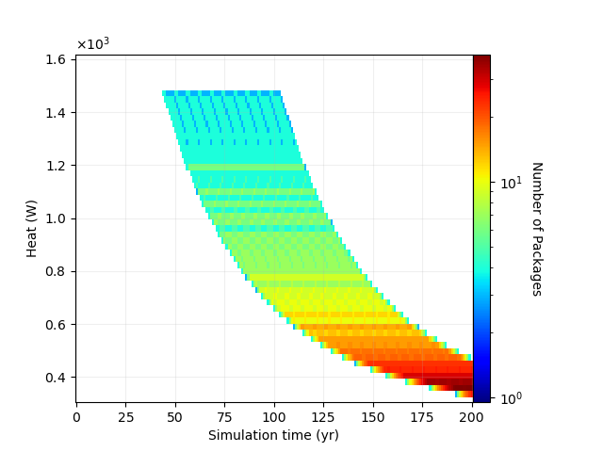

Geological disposal

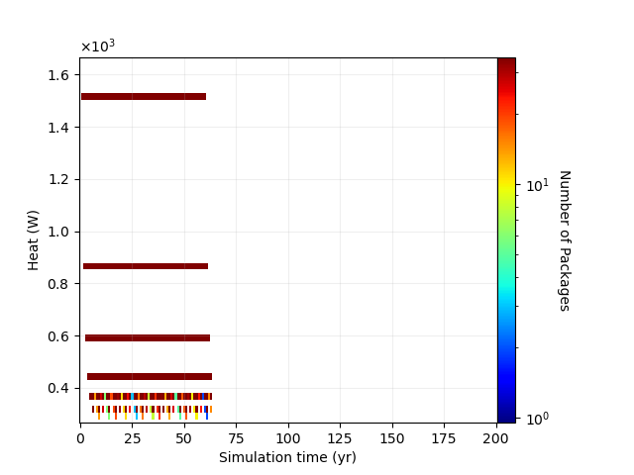

Spent fuel pool

*FIG. 4. A histogram in time showing the spent fuel distribution of heat production for the modeled NODEs.*

The change in heat output of packages becomes smaller as time moves on. As the packages decay, the gaps between seemingly discrete levels are reduced until they meld together. By the time the dry storage assemblies are packaged into final disposal canisters and sent to final disposal, no individual heat levels can be observed. Right at the end of the reactor operation, most packages in the final disposal location output roughly 1.2 to 1.5 kW of decay heat. The upper decay heat values do not change for the next 50 years or so since new canisters are filled every year. However, once 103 years has passed from the start of power plant operations, the dry storage is fully transferred to final disposal. No new packages are added and the higher-activity packages producing more heat will decay quicker, reducing the variability of decay heat in final storage. By the year 200, all the packages are confined to emitting from 0.3 kW to 0.5 kW of decay heat.

### Analysis of the low-level waste benchmark

While the spent fuel benchmark focuses on discrete packages, there are many examples of continuous radioactive waste, such as radioactive liquids. Waste modeling systems must be equipped to deal with waste that can homogenize and mix with the rest of the waste in the same NODE, such as liquid waste storage tanks. Since Wastimate models waste as discrete packages, a customized approach was implemented, where the discrete packages can be combined and separated not based on their original contents (per package), but based on their quantity, such as mass or volume. When transfer is made from such a NODE, all the contents of the NODE is combined into one package, and a fraction based on the quantity of the combined packages is sent to the target NODE. As Wastimate uses root-inventory approach for package tracking, the computationally expensive decay calculation is not done for each separated package, but only the connection to the original package is recorded, and the properties of the package can be calculated from the properties of the root package inventories.

The results for low-level waste benchmark are shown in Fig. 5. Similarly to the SNF benchmark, the manual calculation verified the correct implementation of the combined-package approach. Completing the simulation took 10 seconds with Wastimate, while over 2 hours by calculating the flow of packages manually and then evaluating the nuclide content of each package independently.

The waste production rate was slightly higher than the transfer rate from the tank to conditioning and then final disposal. This meant that even if all the generated packages satisfy transfer requirements (transport related activity restrictions), the mass of waste in the tank would still grow. Given the input parameters presented in the methodology section, the maximum waste quantity in the concentrated liquid waste tanks would reach around 320 m3 by the end of the reactor operation cycle (year 60). The following 5 years is enough to completely condition the leftover concentrated radioactive liquids.

*FIG. 5. Modeling quantity of liquid waste and activity in time for the low-level waste benchmark.*

The final disposal must be capable of housing a total of 3660 m3 of initially produced liquids, or 2925 grouted waste packages. After 550 years since the start, the first packages can satisfy the waste clearance level (release of packages is mainly delayed by 137Cs concentrations). The release of packages will continue for an additional 61 years, after which no packages above the clearance level shall remain.

When the specific nuclide activities are replaced with corresponding statistical distributions (input values are distributed normally with a standard deviation of 10%), using SciPy’s built-in distribution functionality, the sensitivity of the investigated values to input parameters can be investigated. One such example is shown in in Fig. 6, where the stored concentrated liquid waste activity is described over a period of 200 years. Initially, the deviation in the activity value remains small, this continues to be the case until 25 years has passed since the start of operations. Right after the final shutdown of the plant, the largest uncertainty in the total activity can be observed. The magnitude of the deviation starts to diminish when no new packages are added to the NODE, with radioactive decay reducing the overall activity levels and reducing differences between different scenarios.

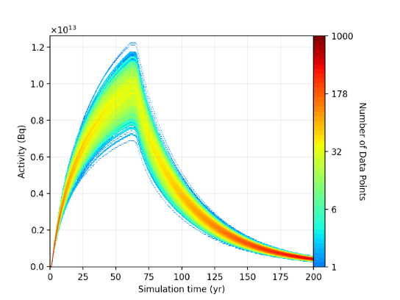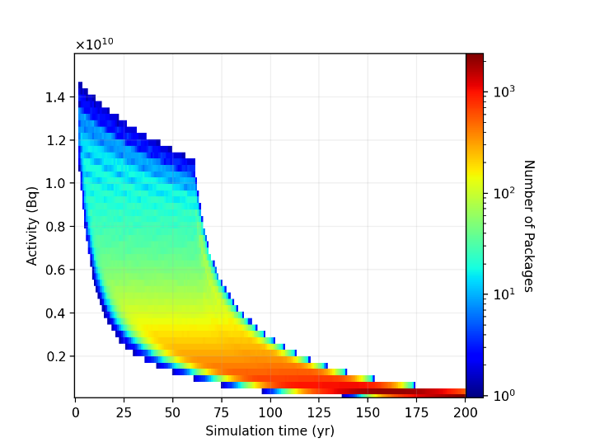

*FIG. 6. Total activity of conditioned concentrated liquid waste repository over time (left) and time-histogram of packages given statistical inputs (right).*

The waste package distribution in time shows differences compared to SNF benchmark mesh histograms detailed in Fig. 4. First, by using statistical inputs, the activity of packages is better homogenized. Thus, unlike the SNF mesh histograms, no discrete quantity levels can be identified. For the first 60 years, new liquid concentrate is added to the waste tank. However, due to radioactive decay of the tank contents, and steady increase in the waste volume, the mixing of liquids inside the tank slowly reduced the activity of packages produced by conditioning. This had a positive effect on reducing the quantity of higher-activity packages present in the repository during the active reactor operation period. Similarly to the SNF benchmark, once waste generation ends, the large variety of package activities collapses towards a smaller variation, being mainly driven by radioactive decay of waste.

## Conclusions

Future nuclear newcomers need to have the capacity to manage radioactive waste within the country of production. Wastimate software has been created to provide more information on potential radioactive waste management obligations. The study demonstrated the capability of Wastimate by analysing the liquid radioactive waste and spent fuel management of a 300 MWe BWR. Wastimate provided estimates for the necessary spent fuel pool, dry storage, and geological repository capacities as well as the concentrated radioactive liquid tank size and time necessary for clearance activities. While the benchmarks focused on low-level waste and spent nuclear fuel, practically any kind of radioactive waste can be modeled if the necessary input parameters are known.

References

1. Michaelides, D. N., Michaelides, E. E., Impact of nuclear energy on fossil fuel substitution, Nuclear Engineering and Design 366 (2020) 110742.
2. KESSIDES, I. N., KUZNETSOV, V., Small Modular Reactors for Enhancing Energy Security in Developing Countries, Sustainability 2012 (2012) 1806-1832.
3. Electric Grid Reliability and Interface with Nuclear Power Plants, IAEA NUCLEAR ENERGY SERIES No. NG-T-3.8, IAEA, Vienna (2012)
4. Joint Convention on the Safety of Spent Fuel Management and on the Safety of Radioactive Waste Management, International Treaty, IAEA, Vienna (1997)
5. Considerations for the Back End of the Fuel Cycle of Small Modular Reactors, IAEA-TECDOC-2040, IAEA, Vienna (2023)
6. HUFF, K. D., GIDDEN, M. J., CARLSEN, R. W., FLANAGAN, R. R., MCGARRY, M. B., et al., Fundamental concepts in the Cyclus nuclear fuel cycle simulation framework, Advances in Engineering Software 94 (2016) 46-59.
7. Nuclear Fuel Cycle Simulation System: Improvements and Applications, IAEA-TECDOC-1864, IAEA, Vienna (2019)
8. VIRTANEN, P., GOMMERS, R., OLIPHANT, T. E., HABERLAND, M., REDDY, T., et al., SciPy 1.0: Fundamental Algorithms for Scientific Computing in Python. Nature Methods 17(3) (2020) 261-272.
9. PUSA, M., Higher-order Chebyshev Rational Approximation Method and application to burnup equations, Nuclear Science and Engineering 182 (2017) 297-318.
10. ROMANO, P. K., HORELIK, N. E., HERMAN, B. R., NELSON, A. G., FORGET, B., et al., OpenMC: A State-of-the-Art Monte Carlo Code for Research and Development, Annals of Nuclear Energy 82 (2015) 90–97
11. Burn-up Credit Criticality Safety Benchmark Phase III-C, Nuclear Science NEA/NSC/R(2015)6, OECD (2016)
12. WILD, R. E., OZTUNALI, O. I., CLANCY, J. J., PITT, C. J., PICAZO, E. D., Data Base for Radioactive Waste Management, NUREG/CR-1759 Vol. 2, NRC, Washington, D.C. (1981)
13. BANERJEE, K., SCAGLIONE, J. M, Spent Nuclear Fuel Canister Capacity: Have the Limits Been Reached?, Oak Ridge National Laboratory, Oak Ridge (2013)
14. SOLANS, V., ROCHMAN, D., FERROUKHI, H., VASILIEV, A., PAUTZ, A., Loading optimization for Swiss used nuclear fuel assemblies into final disposal canisters, Nuclear Engineering and Design 370 (2020) 110897
15. Regulations for the Safe Transport of Radioactive Material, Specific Safety Requirements No. SSR-6 (Rev. 1), IAEA, Vienna (2018)
16. Application of the Concept of Exemption, General Safety Guide No. GSG-17, IAEA, Vienna (2023)