**LEGAL, INSTITUTIONAL AND POLICY INSTRUMENTS TO FACILITATE DEPLOYMENT OF NUCLEAR POWER PLANTS IN POLAND, INCLUDING SMRS**

KAMIL ADAMCZYK

PGE PAK Energia Jadrowa S.A.

Warsaw, Poland

kamil.adamczyk@pgepakej.pl

**Abstract**

The aim of the paper is to present legal, institutional and policy instruments adopted by the Polish Government and Parliament to facilitate deployment of nuclear power plants, including SMRs. Particular attention is given to the legislation adopted in 2023 which aimed at acceleration of implementation of nuclear power programme and provided for number of measures to streamline licensing proces as well as reducing various types of risks related to the implementation of nuclear investment projects.

1. INTRODUCTION

One of the main challanges for every country planning to introduce or expand its nuclear power programme is to establish efficient, transparent institutional and legal framework with this regards. The framework which will on one hand ensure very high level of nuclear safety and radiological protection in line with international requirements and IAEA safety standards, and on the other hand create favourable environment for investors by reducing regulatory and legal risks though streamlining licensing procedures.

The perfect example of country which is facing such challenge is Poland. The country which put several years ago the nuclear energy at the very centre of its energy policy and which has radically transformed its legal and institutional framework to accelerate implementation of nuclear power programme. Several factors makes Poland’s experience with this regards quite unique and worth analyzing.

**Firstly**, as a a nuclear newcommer, Poland it is simultaneously implementing not only large-scale nuclear power projects but also looking at SMR projects. While this is enormous challenge for all relevant authorities involved, it gives opportunity to introduce legal and institutional instruments that in other circumstances would have probably never been implemented.

**Secondly**, it introduced holistic approach to transform its legal framework based on the good practices of non-nuclear industries. Since there is limited space to streamline nuclear safety procedures the focus was put on non-nuclear safety laws and regulations applicable to nuclear power plants that while partially invisible for nuclear community have tremendous impact on development of nuclear power projects (e.g. energy law, construction law).

2. LEGAL INSTRUMENTS

* 1. **2023 legislation to speed-up implementation of nuclear power programme**

The origin of the current nuclear power programme dates back to October 2020 when the Council of Ministers adopted the current version of Polish Nuclear Power Programme [1] i.e. the strategic document outlining the goals and actions necessary to introduce nuclear power. The rationale for implementation of nuclear power is related to the current high-emmission Poland’s electricity generation structure which is largely based on fossil fuels (over 70% of hard coal and lignite), small fraction of renewables and no nuclear power plants. This made nuclear power programme based on the three pillars: energy security, climate and environment and economic competitivness.

Soon after the adoption of nuclear power programme in February 2020 the Council of Ministers adopted Energy Policy of Poland until 2040 [2] which put nuclear energy at the very centre of this strategy and the top priority of this policy. It also for the first time mentioned the possible role of SMRs[1].

The strategy outlined 8 measures to accelerate implementation of nuclear power. Taking into account that regulatory and licensing risks remains one of the main barriers to implement nowadays nuclear power projects (at least in the European Union) on time and on budget the action number one with this regards was to develop special legislation to accelerate implementation of nuclear power programme i.e.: „**Introduction of legal changes limiting delays in the implementation of the nuclear power plant contruction project for** **non-technical (formal reasons).”**

The main objective of the the legislation was to **derisk nuclear investment projects** to the extent possible while keeping the existing nuclear safety standards as high as possible. This was to be achieved through appropriate legal arrangements added to the existing legal acts. Reducing risks (e.g. licensing risks) would result with accelerating nuclear power projects. As nuclear safety law gives quite limited space for arrangements aimed at substantial streamlining nuclear investment projects the **holistic approach** to the modernization of nuclear-related legal framework with this regards was introduced. The holistic approach meant that:

1. legislation was focused not only on nuclear law but also on all other laws and regulations that are applicable to nuclear power projects, incl.: Environmental law, Spatial Law, Construction law, Energy Law etc.
2. proposed legal arrangements were to facilitate not some particular stages of the investment process (e.g. siting) but virtually all of them: from prelicensing and the State’s approval of the the NPP project, through Environmental Impact Assessment, siting, reparatory works, construction and operation of a cnuclear facility;
3. the legislation was to accelerate construction of not only nuclear facility but also the necessary auxilliary infrastructure (e.g. energy lines, roads, railways etc.) which on one hand is beyond the scope of nuclear law, but on the other hand plays a very important role in bringing nuclear power project on time and on budget.

Following the above policy objectives the multiple-days expert interministerial conference/workshop was organized by the Ministry of Climate and Environment (NEPIO) for in-depth and cross-cutting discussions on key principles of the anticipated legislation. It appeared to be very useful to gather in one place relevant representatives of various institutions and stakeholders as well as experts experienced in implementation of other than nuclear large-scale investment projects.

When developing the legislation the particular attention was given to the following factors:

1. good practices of implementation of other-than nuclear large-scale infrastucture investment projects;
2. recommendations of International Atomic Energy Agency outlined in various specific safety guides as well as resulted with the IAEA review missions to Poland;
3. good legislative practices of other countries implementing nuclear power programmes (such as Finand).
4. lessons-learnt from actions undertaken to prepare the investment project, in particular with regards to siting and environmental impact assessment process of country’s first nuclear power plant.

After preparing the initial version of the legislation by the Ministry of Climate and Environment (NEPIO), it was the subject of cross-cutting, public consultation with relevant stakeholders. Very active role was played in that process in particular by: (1) the investor of country’s first large-scale nuclear power plant (2) various companies going to implement SMRs projects (3) nuclear research institutes (4) environmental NGOs. In parallel the interministerial consultations were held with the most active role of those which were in charge of: infrastructure, defence, finance and agriculture. In August 2023 the draft legislation was adopted by the Council of Ministers.

Before the legislation was adopted by the Parliament it received positive opinion from the European Commission under article 37 of the Treaty Establishing European Atomic Energy Commission. This opinion confirmed that the legislation is in line with the European law.

Finally after signing the legislation by the President of the Republic of Poland in April 2023 the legislation [3] entered into force marking the new chapter of Polish nuclear-energy related legal framework. The next milestone was reached in July 2024 with the reorganization of institutional framework for nuclear power programme and transferring the then nuclear competences of Ministry of Climate and Environment (NEPIO) to the newly created Ministry of Industry [4]. With that step the legal and institutional framework to accelerate implementation of nuclear power programme has reached its final shape.

* 1. **Overview of the nuclear energy legal framework**

*2.2.1 Atomic Law Act*

The Atomic Law Act [5] is a **comprehensive** nuclear law act providing framework for system of: (1) nuclear safety, including safety and security of nuclear facilities, safety of radioactive waste and spent nuclear fuel, etc. (2) radiological protection, (3) physical protection of nuclear facilities and nuclear material, (4) safeguards, (5) civil liability for nuclear damage.

The Act establishes the Nuclear Regulatory Body i.e. the President of the National Atomic Energy Agency and specifies its role, structure, responsibilities as well as advisory bodies. The Act provides also framework for licensing process of nuclear installlations specifying i.a. general safety requirements to be met by the licence applicants with more detailed requirements determined in the implementing regulations.

At the time when the Polish Energy Policy until 2040 was adopted the Atomic Law Act was already well developed comprehensive nuclear act. As a result the 2023 legislation introduced only few but significant changes to that law. Currently Atomic Law Act consists of many provisions aimed at faciliating licensing procedures e.g. prelicensing instruments.

From the European perspective it should be noted that Poland is a party of the European Atomic Energy Community. Through Atomic Law Act all European directives adopted under the Treaty have been implemented into Polish legal system.

The Atomic Law Act is supplemented by over 40 implementing regulations containing among others very detailed requirements covering all stages of the nuclear power plant lifecycle (from siting to decommissioning). Some of the aforementioned regulations are supplemented with the relevant regulatory guides.

*2.2.2 Nuclear Investment Special Act*

In compare to most other countries specific feature of Polish nuclear legal framework is that apart from comprehensive nuclear law act there is also in place a separate law applicable to nuclear power plants aimed at promoting – Nuclear Investment Special Act. While the primary objective of the Atomic Law Act with regards to nuclear power plants is to ensure high level of nuclear safety, the Nuclear Investment Special Act (NISA) [5] is the legal instrument serving completely different purposes - to **facilitate implementation of nuclear power investment projects**. To achieve that goal this Act provides for number of measures aimed at:

* streamlining non-nuclear safety permitting procedures required to site and construct nuclear power plants;
* facilitation of various stages of the investment process by providing a number of incentives to investors (such as administrative “fast-track” to construct accompanying infrastructure (e.g. energy lines);
* reducing policy risks related to the construction of a nuclear power plant.

Given the above NISA is not a component of comprehensive national nuclear law but rather it should be classified as a law supporting implementation of nuclear power programme.

Scheme below presents the structure of NISA and the previously described Atomic Law Act:

|  |
| --- |
| **Nuclear Investment Special Act** |
| Chapter 1. General Provisions |
| Chapter 1a. Decision-in-principle |
| Chapter 2. Preparation of the investment with regard to construction of a nuclear power facility |
| Chapter 4. Acquiring legal title to real estate and carrying out the investment |
| Chapter 5. Administrative proceedings for carrying out the investment |
| Chapter 6. Awarding contracts for carrying out the investment |
| Chapter 8. Benefit sharing among municipalities in relation to the construction of nuclear power plants |
| Chapter 10. Instruments to facilitate construction of auxilliary investments |

|  |
| --- |
| **Atomic Law Act** |
| Chapter 1. General Provisions |
| Chapter 2. Licences regarding nuclear safety |
| Chapter 3. Nuclear safety and radiation protection requirements, and health protection of the workers |
| Chapter 4. Nuclear facilities |
| Chapter 5. Nuclear materials and technologies |
| Chapter 7. Radioactive Waste and Spent Nuclear Fuel |
| Chapter 9. Oversight and control of compliance with nuclear safety and radiation protection conditions |
| Chapter 10. Assessment of the national radiation situation |
| Chapter 11. Emergency preparedness and response |
| Chapter 12. Civil liability for nuclear damage |
| Chapter 13. Nuclear Regulatory Authority |

Fig. 1. Comparison of the structure of Atomic Law Act and NISA.

The Act incorporates the good practices of other than nuclear industries. Here it must be mentioned that over the last three decades Polish economy has experienced unprecedented economic boom that was followed by massive development of large-scale infrasture projects such as airports, highways, LNG terminals etc. To accelerate this process the priority of Polish law was to develop various arrangements aimed at **streamlining relevant licensing and permitting procedures** applicable to development of the aforementioned infrastructure while keeping high level of safety and environmental protection as required by international and European Law. As a result the aforementioned large-scale strategic investment projects were implemented under special laws that provided various of incentives to investors. These included among others various arrangements aimed at facilitating: (1) the process of issuing the relevant permits (2) acquisition of land where the facility is to be located (3) preparing the site (4) construction of auxilliary infrastructure. Since most of such arrangements were technologicaly neutral they could be easily adapted to nuclear power projects.

It should be also noted there are many branches of laws (with many interfaces and synergies with nuclear law), that affect implementation of nuclear power programme e.g. by setting out various conditions, requirements and permits to be gained by the NPP investor during various phases of NPP project in particular:

* + Environmental law – setting out among others the rules for conducting the environmental impact assessment of a planned nuclear facility as well as for providing access to environmental information relating to the nuclear activities, such as construction of nuclear power plants
  + Water law - setting out various requirements to protect quality of surface and underground waters
  + Building law – setting out various non-nuclear safety requirements of building design and construction
  + Energy law – setting out rules and conditions of connecting power plants to the energy grid
  + Urban planning and land use law

One of the most important role of NISA with these reagards is to introduce various arrangements streamlining procedures outlined in the aforemenitoned laws – NISA is ***a lex specialis*** (e.g. shorten period to issue certain permits, etc.).

* 1. **Licensing and permitting process for nuclear power plants under Atomic Law Act and the NISA**

The primary objective of every nuclear power investment project is to construct and operate of a nuclear power plant. This requires obtaining various licences and permits which are issued under the Acts decribed in the previous subchapter not only by the Nuclear Regulatory Body (i.e. the President of National Atomic Energy Agency) but also by some other relevant authorities. The aforementioned licences and permits are listed below:

1. Decision-in-principle – issued by the Minister of Industry (NEPIO)
2. Environmental Pemit – issued by the General Direcor of Environmental Protection
3. Location Decision – issued by the Province Governor (appointed by the Prime Minister)
4. Permit to prepare the site (non-obligatory) – issued by the Province Governor
5. Construction licence – issued by the Nuclear Regulatory Body
6. Construction permit (non-nuclear safety) – issued by the Province Governor
7. Investment use permit (non-nuclear safety) - issued by the Chief Inspector of Construction Oversight
8. Commissioning licence – issued by the Nuclear Regulatory Body
9. Operating licence – issued by the Nuclear Regulatory Body

On the below graph the licensing and permitting process is summarized:

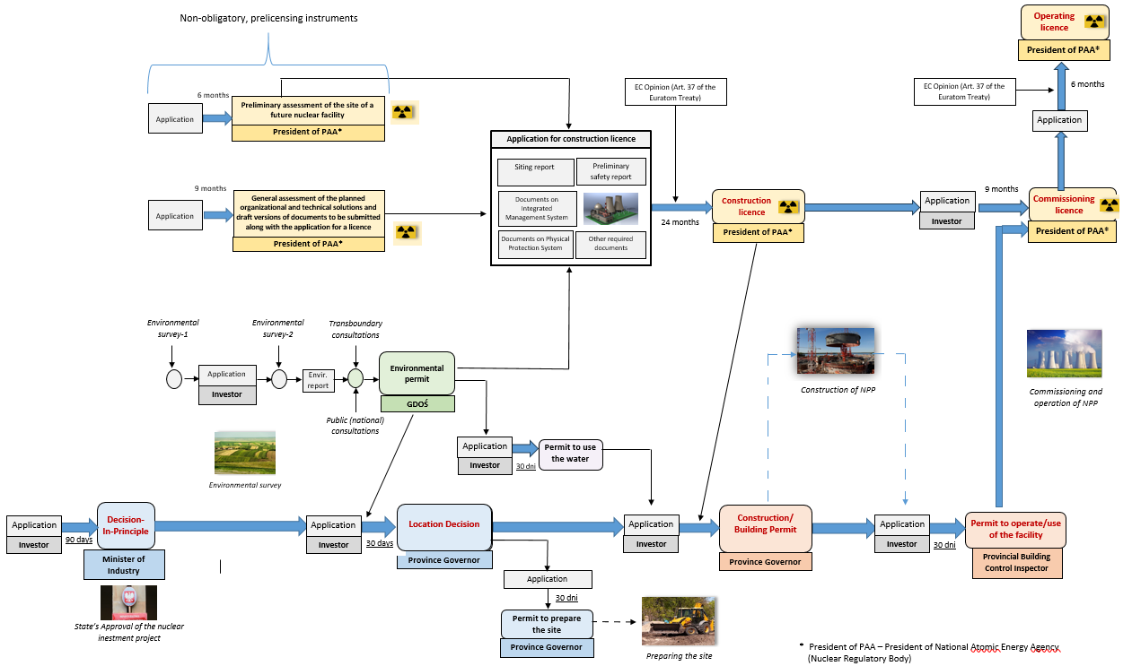

Fig. 2 Licensing process for nuclear installations in Poland

**2.4 Selected legal arrangements to facilitate nuclear investment projects**

Legal arrangements existing in Polish law aimed at accelerating nuclear power investment projects covers all stages of the nuclear power plant investment process and may be divided into 4 categories:

* Instruments to reduce energy policy risks and to bring nuclear project in line with State’s energy policy
* Instruments to facilitate licensing process
* Instruments to facilitate preparation and implementation of the nuclear investment project
* Instruments to enhance local community support for nuclear power project
  + 1. *Instruments to reduce energy policy risks*

Decision-in-principle

The decision-in-principle is issued by the Minister of Industry at the very early stage of the investment process and plays the role of the State’s approval of the nuclear investment project. Its role is to ensure that the proposed investment parameters (proposed site, technology, installed capacity) are in line in particular with energy policy goals and State’s security. With this regards the decision safeguards the public interest similarly like the similar decision existing in Finnish law. The Decision allows investor to apply for all other relevant licences and permits required to construct and operate nuclear power plant. Decision-in-Principle while serving mainly State’s interests it gives also some level of assurance to investor, that possible changes of State’s energy policy will have – at least in theory - limited impact on the nuclear investment project.

* + 1. *Instruments to facilitate licensing process*

1) Prelicensing instruments

One of the key instruments to enhance predictability of the licensing process is prelicensing, preliminary assessment of the planned nuclear site or certain other aspects of the planned nuclear facility by the nuclear regulatory body. Atomic Law Act (ALA) provides for two of such non-obligatory instruments, both issued by the President of the National Atomic Energy Agency (Nuclear Regulatory Body):

* General opinion on the planned organisational and technical assumptions and draft versions of documents to be submitted along with the application for a licence

Pursuant to article 39b of ALA before applying for a licence (e.g. construction licence) the investor may apply for the aforementioned general opinion of the President of NAEA. The scope of the opinion is defined by the applicant. The aim of this opinion is to identify at very early stage of the investment process legal barriers or design barriers that could complicate or prevent license issuance. Another benefit of this opinion is that the regulatory assessment process will become more effective and less time consuming [9].

To the application for the opinion depending on the scope of such application, the investor shall attach description or documentation of the planned organisational and technical assumptions (e.g. with regards to extended design conditions, reactor safety containment system etc.), as well as drafts of relevant documents required to obtain licence. The opinion is issued within 6 months or in most complicated cases - 9 months.

* Advance opinion on the planned nuclear facility site

According to article 36a of ALA before applying for a construction licence, the investor of a nuclear facility may apply to the President of NAEA for an advance opinion on the planned nuclear facility site. The application for the above opinion shall include among others siting report. The main benefit of the opinion is possibility to identify in advance potential issues with regards to the planned nuclear facility site that may complicate or prevent issuing construction licence (similarly as in case of the aforementioned general opinion). The opinion opinion is issued within 6 months from the date of submission of the application[2].

2) Possibility to conduct some licensing and permitting steps (administrative proceedings) in parallel

Licensing and permitting processes for nuclear power plants are highly complex and consists of many separate administrative proceedings during which all required licences and permits are granted. In most cases granting the particular licence (e.g. construction licence) „opens the door” to apply for another required licence or permit (e.g. non-nuclear safety building permit). That means that the delay in obtaining one licence will automatically results with the delay in application for another one and as result prolonging the entire licensing process. To avoid these risks various provisions of NISA and Atomic Law Act allow to conduct some steps **(administrative proceedings) in paralell**. This appears to be very efficient tool to significantly shorten the entire duration of the licensing and permitting process for nuclear power plant what is shown on the schemes below which compare the new and old approaches with these regards:

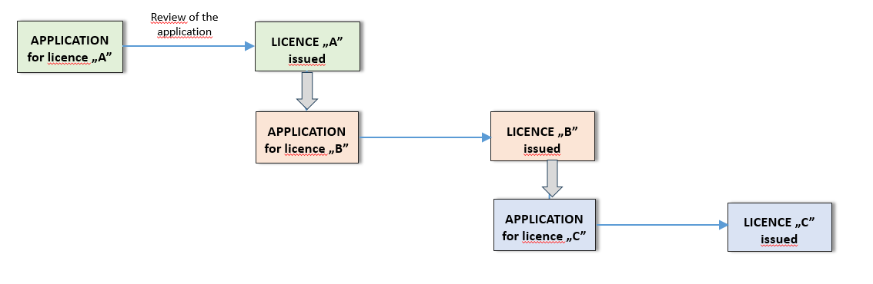

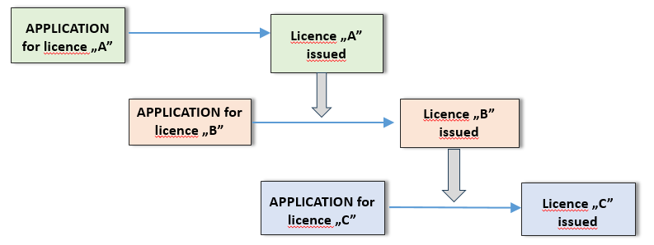

*Standard approach*

*New approach*

Fig. 3. Parallel administrative procedures – new and standard approach

For example it is possible to conduct paralell administrative proceedings aimed at granting construction licence (issued by the Nuclear Regulatory Body) and building permit (issued by the Province Governor) what until recently was not allowed. Pursuant to article 39k od ALA the construction licence does not need to be obtained by the investor before application for the building permit is submitted. According to law this licence may be submitted by the investor **during** the proceedings for issuing the construction permit what allows to shorten the process.

*2.4.3 Instruments to facilitate investment process*

1) Indication decision

Conducting site survey or environmental impact assessment in case of many nuclear power projects requires entering the somebody else’s property (real estate). Lack of the owner's approval may result with delays in conducting site survey with possible significant impact on nuclear power project timeline. To reduce this risk the investor may, pursuant to article 11 of the NISA, submit application to the Province Governor for „permit to enter the property”. This permit allows investor to enter the property to conduct aforementioned activities specified in the permit (for maximum 5 years). Upon completion of these activities the investor is obliged to restore the site to the previous state and if this is not possible the land owner is entitled to receive compensation.

2) Location decision

In some cases acquiring the legal title to real estate (land) where the planned nuclear power facility is to be sited may lead to various investment delays or causing other challenges to the investor. Nuclear Investment Special Act provides for special arrangements of preventing these risks. According to that Act the investor before applying for the construction licence must obtain the „location decison” (permit) issued by the Province Governor. In the application for the „location decision” the investor specifies among others the boundaries of the site and indicates the real estate that are not owned by him. The decision gives the investor the legal title to acquire necessary land for the need of construction of a planned nuclear facility under special mechanism specified in NISA. The „location decision” set forth also conditions for nuclear project implementation, including technical, environmental, conservation, and fire protection considerations.

3) Permit for preparatory works

A very time consuming part of the licensing process for NPPs is preparation of the application for construction licence and its review by the relevant authority. To speed up investment process at that time it is useful to prepare the site in advance before the construction permit is granted [10][3]. For that purpose, prior to obtaining the construction permit, the investor may submit an application for issuance of a permit for preparatory works. This permision allows investor to conduct following activities to prepare the site:

* surveying works, land levelling, management of the construction site together with building temporary facilities and other works that do not require a drawing up of an architectural and construction project;
* demolition of existing above-ground and underground construction facilities;
* removal of trees or shrubs located on the real estate.

4) Fast-track access to information needed to implement nuclear power project

Implementation of a nuclear power project requires often a large volumes of data (e.g. with regards to meteorology, geology etc.) that might be in possession of relevant public entities. Gaining access to such data in some cases may be limited or time consuming causing various delays e.g. in conducting site survey. To prevent these risks pursuant to article 21a of NISA all public administration authorities, their supervised and subordinate units, commercial law companies being state legal persons are obliged to share with the investor, free of charge and within 30 days, information and data possessed by them, also in the form of a digital data collections, indispensable for the investor to carry out actions with regard to construction of a nuclear power facility and accompanying investments. The application is submitted to the relevant entity via Ministry of Industry. The mechanisms for this are outlined in the implementing regulations.

5) Administrative fast-track to construct auxilliary infrastructure

Construction of a nuclear power plant in many cases (e.g. green-field projects) require construction also of the necessary massive auxilliary infrastructure such as energy lines, technical roads, railways, hydrotechnical infrastructure, gas networks etc. Any delays in developing such infrastructure may lead to the delays and cost overruns of construction of a nuclear facility. To reduce these risks Nuclear Investment Special Act provides for mechanisms of streamlining such accompanying investments. Pursuant to article 52. at the request of the investor the Minister of Industry may grant them a special status so that the provisions of Nuclear Investments Special Act aimed at accelerating constructions of nuclear facilities are applicable (with some exceptions) also to them.

*2.4.4 Instruments to enhance local community acceptance of nuclear investment project*

1) Local Information Centre

According to Article 39m of the Atomic Law Act, the Investor shall open a **Local Information Centre**, no later than on the day when the application for construction permit is submitted. The main responsibilities of the Centre include: (1) collecting and providing to people updated information on the operation of the nuclear power facility; (2) collecting and providing updated information on the status of nuclear safety and radiological protection in the area surrounding the nuclear power facility. The aforementioned Centre shall be operated by the investor until the decommissioning process of nuclear power plant is completed.

2) Sharing the benefits between communities where the nuclear facility is to be located

Pursuant to article 50 of the NISA the municipality on which territory the nuclear power plant or a part thereof is located, shall pay to the bordering municipalities a fee in the amount equal to 50% of the real estate tax paid by the taxpayers of the real estate tax on the nuclear power plant or a part thereof, for which a use (operating) permit has been issued. This fee shall be divided in equal parts among all the municipalities bordering with the given municipality and shall be paid into the budget accounts of each of the bordering municipalities by the 25th day of the given month The fee constitutes an exclusive income of the municipality and is at free disposal of this entity.

3. INSTITUTIONAL INSTRUMENTS TO ACCELERATE DEPLOYMENT OF NUCLEAR POWER PLANTS

3.1. NEPIO

Since its very beginning the development of institutional framework for nuclear power sector in Poland has reflected the relevant IAEA guides [7], recommendations from IAEA review missions to Poland as well as good practices of other countries. This included in particular designating and maintaining the authority in charge for promotion of nuclear energy, to function as the Nuclear Energy Programme Implementing Organization (NEPIO). Initially the function of NEPIO was played by the Ministry of Economy and the following bodies or units acting within that Ministry: the Government Plenipotentiary for Nuclear Power and Nuclear Energy Department. Over the recent years the structure of NEPIO has significantly evolved[4] and has reached its current shape in July 2024 when the nuclear-related competences of the Ministry of Climate and Environment (acting as a NEPIO in the years 2021-2024) has been transferred to the newly created Ministry of Industry.

The responsibilities of NEPIO are clearly specified in the art. 112a of the Atomic Law Act:

* developing drafts for plans and strategies related to the development and functioning of nuclear power in Poland, and in particular, the draft version of the Polish Nuclear Power Programme;
* coordinating the implementation of plans and strategies of the country related to the development of nuclear power, and shall also prepare guidelines for changing them;
* performing activities related to the public communication, education, popularization related to nuclear power
* performing activities aimed at: ensuring competent human resources for nuclear energy, developing nuclear technologies, participation of the Polish industry in the accomplishment of nuclear power tasks;
* monitoring the uranium market and the nuclear fuel cycle services market.

The Ministry provides a continuing forum for communication and cooperation among the key organizations and stakeholders, ensuring that the roles and responsibilities of each organization in stakeholder involvement are clear and that all stakeholders are being involved (including the public, local governments, industry, media, nongovernmental organizations, opposition groups and neighbouring States) [8].

3.2. The Advisory Committee for the Development of Nuclear Power Sector in Poland

Until 2021 there was only one company in Poland implementing nuclear power project. By the end of 2022 there were already three companies more: one planning to construct large scale nuclear power plant and two planning to construct fleets of SMRs. Given these developments **The Advisory Committee for the Development of Nuclear** **Power Sector in Poland** has been set up in February 2023 [9] by the Ministry of Climate And Environment. The main task of the Committee was to develop recommendations for the Minister on legislative and non-legislative arrangements aimed at acceleration of implementation of nuclear power projects in Poland. Pursuant to the regulation setting up the committee this included in particular:

1. recommending the legal arrangements aimed at streamlining licensing and permitting processes for nuclear power plants and reducing other types of risks;
2. exchanging information and good practices in the field of public communication on implementation of nuclear power projects, in particular with regards to the dialogue with local community;
3. exchanging information on the needs related to the provision of competent nuclear human resources for planned and ongoing nuclear investment projects;
4. exchanging information on the estimated amount of radioactive waste that will be generated by the planned nuclear power plants – for the need of possible update of National Plan for Radioactive Waste and Spent Nuclear Fuel Management
5. discussion on the need to adhere by Poland to relevant international legal instruments.

The Committee was composed of 10-12 members: 4 representatives of the Ministry of Climate and Environment (the then NEPIO), including the deputy minister in charge of nuclear energy (as a president of the committee), 1 representative of the Government Plenipotentiary for Strategic Energy Infrastructure as well as 1-2 representatives of each of the investors invited). With the approval of the chairman, invited experts could participate in the meetings.

The Committee appeared to be a very efficient platform of communication and discussion of various challenges related to implementation of NPP projects between (1) the NEPIO, (2) investors going to construct SMRs, (3) investors going to construct large-scale nuclear power plants, (4) other relevant stakeholders – except the Nuclear Regulatory Authority. Since many emerging investors planning to develop nuclear power projects, especially in the field of SMRs, have limited expierience and knowledge of relevant International, European and national requirements the Committee appeared also to be very efficient tool for **transferring the knowledge** (e.g. in the field of IAEA milestones approach) from NEPIO to investors on one hand and exchanging the good practices and lessons-learnt from implementing the NPP projects (e.g. in the field of public communication) between the investors themselves – especially form the more experienced investors to the less experienced ones.

3.3. Memorandum concluded by the Nuclear Regulatory Body with its counterpart from other country.

Nuclear Regulatory Body is not in charge of promoting nuclear energy. However by establishing the close cooperation with the counterparts from other countries it may significantly streamline licensing process in particular with regards to the advanced reactors. A good example for this is the memorandum concluded on 13 February 2023 between the President of National Atomic Energy Agency and the Canadian Commission of Nuclear Safety (that is undergoing safety assessment of one of SMR technologies which are also going to be implemented in Poland). Based on the memorandum the PAA and the CNCS will exchange information on the safety review. Lessons-learnt from that process may be later used in the licening of the same technology in Poland and by this shortening the duration of that process.

4. SUMMARY AND CONCLUSIONS

Over the recent years Poland has significantly transformed its nuclear-related legal (and institutional) framework, under holistic and non-standard approach presented in the paper, with aim to accelerate implementation of its nuclear power programme. During that process particular attention was given to lesson-learnt from implementation of other strategic infrastructure investment projects, lessons-learnt from implementation of domestic nuclear power programme and other nuclear power programmes (abroad) as well as to the relevant recommendations of the IAEA. Currently the Polish nuclear-related legal framework consists of significant number of regulations, arrangements aimed at streamlining licensing process, facilitating investment process and reducing various types of associated risks, enhancing public support for nuclear etc. with only some of them being presented in the paper. As all of them are technology neutral they are allowing to speed-up implementaion of both, large-scale and SMRs nuclear investment projects.

It should be noted that the experience of Poland in developing „applicant’s friendly approach to nuclear licensing” and other arrangements aimed at accelerating nuclear investment projects perhaps may be useful also for other countries going to introduce or expand its nuclear power programmes – and vice versa. Many such „pro-nuclear” regulations certainly are in place also in other countries despite being widely unknown at the global level - as there are very limited international platforms to exchange such good legislative practices (in opposite e.g. to the field of nuclear safety).

From that point of view it is worth to consider developing international guide (report, database, etc.) enlisting the best practices of various countries in streamlining nuclear licensing and permitting processes, reducing investment risks or enhancing social acceptance of nuclear energy. Such open and „organically-growing” set of best practices could be invaluable not only for law-drafters from counties planning to accelerate their nuclear power programmes (especially nuclear newcommes) but also to the IAEA. As it is well-known, the legislation might be a very powerful tool to speed up investment processeses. If so, the implementation of the proposed idea could make the upcomming nuclear „renessaince” – both with regards to large-scale nuclear power plants and SMRs - a one little step closer.

**REFERENCES**

[1] Resolution of the Council of the Ministers of 2 October 2020 on the amendment of Polish Nuclear Power

Programme (Official Journal of the Republic Of Poland „Monitor Polski” item 946)

<https://isap.sejm.gov.pl/isap.nsf/download.xsp/WMP20200000946/O/M20200946.pdf>

[2] Energy Policy of Poland until 2040 (Official Journal of the Republic Of Poland „Monitor Polski” of 2021 item

264) <https://isap.sejm.gov.pl/isap.nsf/download.xsp/WMP20210000264/O/M20210264.pdf>

[3] Act of 13 March 2023 on the amendment of Act on preparation and carrying out investments in nuclear power

facilities and accompanying investments and other acts (Journal of Laws, item 595).

<https://isap.sejm.gov.pl/isap.nsf/DocDetails.xsp?id=WDU20230000595>

[4] Act of amendments of certain acts related to the government structure (Journal of Laws of 2024, item 834).

<https://isap.sejm.gov.pl/isap.nsf/download.xsp/WDU20240000834/T/D20240834L.pdf>

[5] Act of 29 November 2000 on the Atomic Law (Journal of Laws of 2023 item 1173 with changes).

<https://isap.sejm.gov.pl/isap.nsf/DocDetails.xsp?id=WDU20010030018>

[6] Act of 29 June 2011 on preparation and carrying out investments in nuclear power facilities and accompanying

Investments / Nuclear Investment Special Act (Journal of Laws of 2024, item 412 with changes).

<https://isap.sejm.gov.pl/isap.nsf/DocDetails.xsp?id=WDU20111350789>

[7] In particular: „Responsibilities and Functions of a Nuclear Energy Programme Implementing Organization”,

IAEA Nuclear Energy Series No. NG-T-3.6 (Rev. 1), IAEA, Vienna (2019)

[8] Integrated Nuclear Infrastructure Review Self Evaluation Report (Phase 2), Republic of Poland,

2024 (unpublished).

[9] Nowacki T.R., *Opinie Prezesa PAA, o których mowa w art. 36a i 39b ustawy – Prawo atomowe jako*

*przykład pre-licencjonowania obiektów jądrowych*, Studia Iuridica 2020, t. 87, s. 388-411, DOI:

[10.31338/2544-3135.si.2020-87.19](https://doi.org/10.31338/2544-3135.si.2020-87.19)

[10] Nowacki T.R., *Nuclear Power on the Vistula River. Law and Policy in Shaping Energy Future of Poland*,

Prawo i Więź 2020, nr 3, s. 182-209, DOI: [10.36128/p riw.vi32.97](https://doi.org/10.36128/priw.vi32.97)

[11] The Ordinance of the Minister of Climate and Environment of 16 February 2023 to set up The Advisory

Committee for the Development of Nuclear Power Sector in Poland.

1. *According to the document: „The Works related to construction of the first Polish nuclear power plant (…) are accompanied with the parallel efforts aiming at perspective introduction of small modular reactors (SMRs).”* 
2.
3. E.g. by installing infrastructure needed to support future construction of nuclear power plants.
4. In 2015 the nuclear-related comptences of Ministry of Economy was transferred to the newly created Ministry of Energy, in 2019 to the Mnistry of State Assets and in 2020 to Ministry of Climate and Environment.