# The relevance of nuclear energy for district heating

Calogena, a pool-type reactor specifically designed to decarbonize district heating

Alain Vallée

Calogena

Paris, France

Email : a.valle@calogena.com

Jan Bartak

Calogena

Grenoble, France

Email : j.bartak@calogena.com

César Dulac

Calogena

Paris, France

Email : [c.dulac@calogena.com](mailto:c.dulac@calogena.com)

**Abstract**

District heating and cooling (DHC) systems present a crucial strategy for Europe's transition away from fossil fuels in heating. However, traditional low-carbon alternatives like biomass and geothermal energy face limitations in accessibility and scalability. The growing demand for DHC, coupled with the constraints of these alternatives, underscores the increasing relevance of nuclear energy for decarbonizing heat production. Calogena®, a company pioneering in this field, is developing a 30 MWth small modular reactor (SMR) specifically designed for district heating applications. This SMR is characterized by a simple and safe design, inspired by pool-type research reactors, ensuring a high level of safety through passive systems and inherent design features. Furthermore, Calogena® aims for economic competitiveness with low fuel costs and a long operational lifespan, providing long-term price stability. The paper explores the reasons SMRs offer a promising solution for decarbonizing DHC, combining safety, operational flexibility, and economic competitiveness to provide clean and efficient heat for urban areas.

## INTRODUCTION

The modernization and expansion of district heating and cooling (DHC) systems stand as a pivotal strategy in Europe's quest to curtail the reliance on fossil fuels. This approach is particularly significant given that heating is responsible for a staggering 78% of the primary energy consumption of households [1]. The urgency of this transition is underscored by the fact that the current DHC systems predominantly utilize fossil fuels, which contribute to 60% of their total output [2].

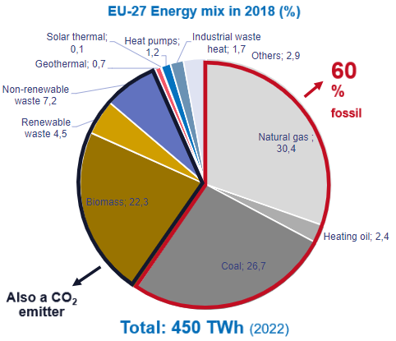

*Figure 1: Energy mix of DH in EU 27 (Heat Roadmap Europe)*

However, the shift towards alternative low-carbon sources, such as biomass, industrial heat pumps and geothermal energy, is not without its own challenges. These resources face constraints related to accessibility, favourable geographic and local conditions and competing uses, which can limit their widespread adoption. These constraints already impact the price of the heat produced, especially for biomass.

The district heating systems growth objectives combined with the pressure on alternative low-carbon solutions are making nuclear more relevant than ever to contribute to the decarbonization of heat production through district heating. The company Calogena is designing an SMR (Small Modular Reactor) dedicated to this purpose.

## Why did nuclear power never have a significant role in district heating in the past?

Some existing nuclear power plants in Finland, Switzerland, Ukraine or Russia are already co-generating heat for local district heating networks today. China has designed a 400 MW SMR specifically for district heating [3]. Yet, these examples remain marginal both in terms of their contribution to global district heat generation and in terms of their deployment in electricity generating nuclear power plants, often built too far from towns and cities.

The idea of creating a small reactor entirely dedicated to district heating is not completely new. The French project “Thermos”, led by the CEA in the late 1970s, was designed with exactly this objective. Yet, Thermos could not compete at the time with fossil fuels in terms of price, especially with coal, which was cheap and often local. And as the climate and environmental considerations were not driving public decisions in the 1970s, a solution like Thermos did not have a chance to succeed [4].

But times have changed: heating and cooling networks have considerably grown since then and the imperative of phasing out of gas, coal and oil is leaving very few options available. The situation is further compounded by the aging infrastructure of many fossil-fuel-based DH systems, which are nearing the end of their operational lifespan and necessitate timely replacement.

## Biomass and geothermal energy are not sufficient to phase out fossil fuels for district heating

At present, biomass stands as the predominant method for decarbonizing DH systems. Yet, burning biomass releases other pollutants like particulate matter and nitrogen oxides, impacting air quality, especially in urban and peri-urban areas where district heating is often used. Many recent studies are now calling to reserve biomass for more high-value applications and forecasting a shortage of sustainable biomass production in the EU [5] [6] [7]. Supplying the required quantities of biomass to power large district heating networks is challenging from the transport logistics and environmental impact perspectives. Large-scale harvesting reduces the forest carbon sink and leads to competition with other land uses for agriculture and conservation.

Burning biomass releases carbon dioxide (CO2) just like fossil fuels. While trees can absorb CO2 as they grow, it can take decades to recapture what is released when burned. If not sourced sustainably, using substantial amounts of biomass for heating could contribute to deforestation in some cases.

Geothermal energy is an attractive renewable option for district heating, but it has limitations that make it insufficient on its own for widespread decarbonization[1]. Geothermal resources are not uniformly distributed. Areas with usable geothermal pockets suitable for large-scale heating may be limited. Not all regions have the necessary geological conditions for geothermal power plants. It remains a valuable option, but it often needs to be combined with other renewable sources like solar thermal, biomass (used sustainably) or fossil heat to ensure a reliable and sufficient supply for decarbonizing district heating across all regions [8].

For the EU, the goal is not only to replace fossil fuels in the existing DH networks, but to substantially extend their numbers, lengths and generating capacities.

## Europe has set ambitious goals for district heating

The European Union (EU) recognizes that district heating and cooling systems play a crucial role in achieving climate and energy objectives. Nearly 40% of all primary energy in the EU is used for heating purposes, making it essential to harness the potential for emission reductions in the heat market. To this end, the EU encourages the transition to low-carbon sources for district heating systems. addressing low temperatures allows to cover 80% of this heat demand [9]. A demand increasingly covered by district heating.

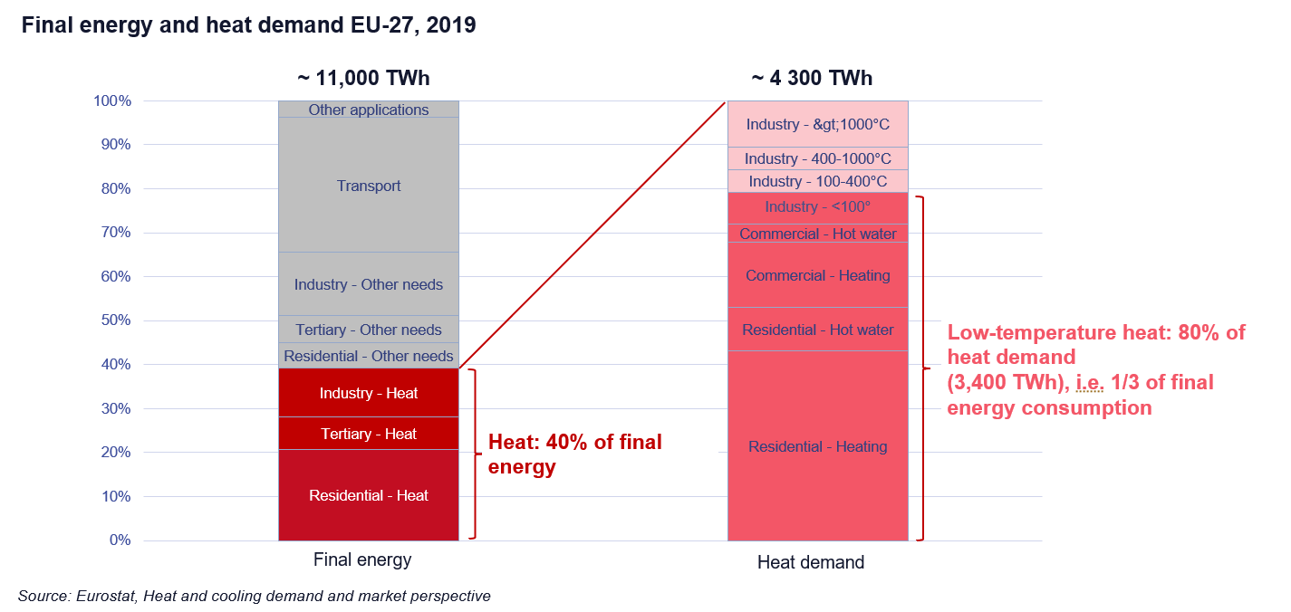

*Figure 2 Final energy demand by temperature, Europe 27, Eurostat*

In fact, the EU has set ambitious targets to elevate the role of DHC within the region's energy landscape. The goal is to boost the share of DHC in the total heat demand from the current 12% in 2023 to an impressive 30% by 2030, eventually reaching the 50% mark by 2050 [10]. Achieving these targets would represent a significant stride towards energy sustainability and reduced carbon emissions, provided the energy sources are low-carbon, locally sourced and affordable.

*Figure 3: District heating levels in EU27 countries and the UK towards 2030 and 2050[2] .*

## Calogena® - an SMR specifically designed for district heating

One innovative solution that has emerged in the realm of DHC is the utilization of nuclear reactors. The Calogena company is designing a 30 MWth small modular reactor specifically designed for DHC applications. Calogena® is a water-cooled reactor with a remarkably simple and inherently safe design, drawing inspiration from pool-type research reactors. It operates under low primary coolant pressure and temperature conditions of approximately 0.5 MPa and 110°C. The goal is to install Calogena® modules near urban areas (5 to 15 km).

*Figure 4: 3D view of a Calogena® module*

### An intrinsically safe, simple and robust design

Safety is paramount when considering SMRs near urban areas. Calogena® meets the most stringent safety standards and relies on passive physical principles to minimize risks.

The risk of core meltdown is excluded by design, and the containment of the radioactive inventory is guaranteed in all situations. In all circumstances, the reactor is completely self-sufficient for one week, without any action by the operator and no external power supply.

The design utilizes proven technologies with a high TRL, thus limiting the uncertainties and specific qualification requirements. Additionally, a very limited number of simple auxiliary systems and components allows for limited and efficient maintenance and easy inspections. The limited number and simplicity of systems and components imply short fabrication and construction times, the possibility of in-factory pre-assembly, and result in a very small footprint of the facility.

Calogena® uses a shortened version of standard 17x17 PWR fuel assemblies with low-enriched uranium (<5%). Thirty-two control rod mechanisms control the power of the reactor. No dissolved boron is used in the primary circuit.

*Figure 4: Examples of research reactors in (peri-)urban areas: Kyoto Univ. (5MWth) Kansai, Japan / RP-10 (10MWth) Lima, Peru / Réacteur à haut flux Grenoble, France / Maria (30MWth) Warsaw, Poland / LVR-15 (10MWth) in Prague, Czech Republic / RA-3(10MWth) Buenos Aires*

### Technical design for efficiency

The primary circuit of Calogena® is integrated in a cylindrical vessel submerged in the pool. The core is cooled by natural circulation, the produced heat is transferred to an intermediate circuit in a counter-current flow shell-and-tube heat exchanger. Circulating pumps and valves control the flowrate in the intermediate circuit. Stopping the pumps results in a completely passive switchover to core cooling by the water inventory of the pool. Refuelling occurs safely underwater within the pool, which also provides temporary storage for fresh and irradiated fuel assemblies.

### Flexibility and economic competitiveness

Calogena® is designed to integrate seamlessly with existing district heating infrastructure. It adapts to various temperature and heat supply requirements within a specific range and responds effectively to fluctuating heating demand throughout the day or season. The third and fourth generation district heating networks are now operating with hot water (less than 110 °C) and Calogena® is specifically designed to provide heat in this range of temperatures.

Calogena® targets economic competitiveness with other low-carbon heat sources. The low fuel costs and operating lifetime of 60 years offer a significant economic benefit and long-term price stability. Simple control systems adjust the reactor power to the network heat demand and allow for remote operation and supervision, reducing on-site staff presence. Centralized remote operating and maintenance services will be provided to a series of Calogena® modules. The simple design and the mature technologies make Calogena® a particularly reliable and robust reactor with limited maintenance requirements.

## Conclusion

In summary, the Calogena® SMR prioritizes safety, operational flexibility, and economic competitiveness, while providing a clean and efficient solution for district heating and cooling needs.

The design philosophy of Calogena® emphasizes a high level of safety by design, simplicity, a minimal footprint, allowing for seamless integration into heating networks of varying sizes. This adaptability makes it an ideal candidate for deployment in both urban and peri-urban settings, where it can be managed effectively by local municipalities and energy companies. The designers of Calogena® are confident that these attributes will play a crucial role in garnering public support and acceptance for nuclear-powered DHC as a very effective and economic means of their decarbonization.

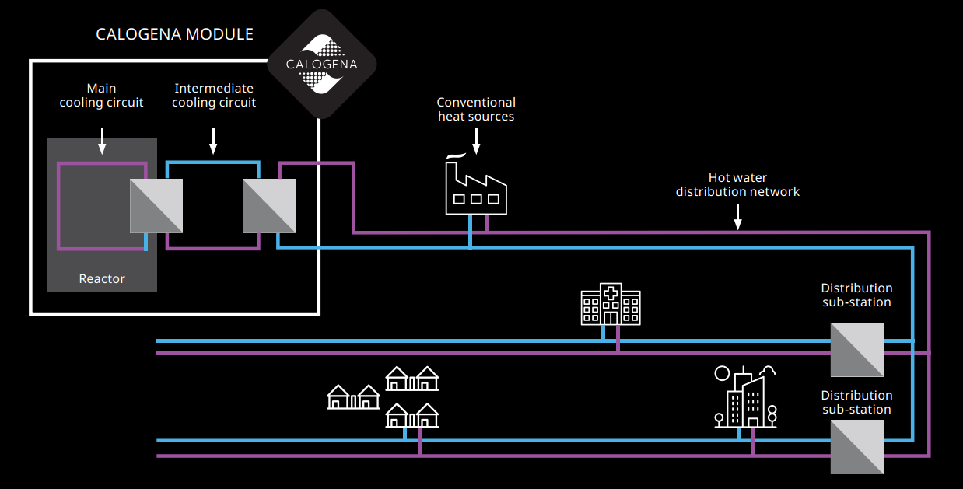

*Figure 6: Calogena modules fit in a hybrid system of DH alongside other conventional or renewable sources.*

References

1. ESTAT (2022).
2. Aalborg University, Heat Roadmap Europe: Combining district heating with heat savings to decarbonise the EU energy system. *Energy policy*, *65*, 475-489.
3. SFEN (2024), Chaleur nucléaire: une nouvelle solution pour décarboner ?
4. CEA, Le projet Thermos (1975-1981) ou l'échec de «l'atome au coin du feu. In *Colloque Nucléaire et développement régional, Tours, CEHMVI, Fondation EDF, 17-18 décembre 2008* (Vol. 13).
5. Académie des sciences - Rapport du Comité de prospective en énergie « Quelles perspectives pour la biomasse »– Janvier 2024.
6. Oludunsin Arodudu, “Ecological impacts and limits of biomass use: a critical review”, University of Twente, Netherlands, 2020.
7. Material Economics (2021). EU Biomass Use in a Net-Zero Economy - A course correction for EU biomass.
8. Rybach, L. (2010, April). The future of geothermal energy and its challenges. In *Proceedings world geothermal congress* (Vol. 29).
9. Naegler, T., Simon, S., Klein, M., & Gils, H. C. (2015). Quantification of the European industrial heat demand by branch and temperature level. *International Journal of Energy Research*, *39*(15), 2019-2030.
10. Mathiesen, B. V., Wild, C., & Nielsen, S. (2023). Heat Matters: The Missing Link in REPowerEU: 2030 District Heating Deployment for a long-term Fossil-free Future.

BIBLIOGRAPHY

FEDENE, Enquête des réseaux de chaleur et froid, 2023.

Euroheat & Power, Market Outlook, 2023.

Aalborg University, Heat matters: the missing link in RePowerEU, 2023

SGPE (French Prime Minister Services), La planification écologique dans l’énergie, 2023

Heat Roadmap Europe, 2023

F. Dalla Longa, Scenarios for geothermal energy deployment in Europe, 2020

Werner, S. (2017). International review of district heating and cooling.

Kim, T. R. (2016). Safety classification of systems, structures, and components for pool-type research reactors. Nuclear Engineering and Technology

Adelfang, P., & Ritchie, I. G. (2003). Overview of the status of research reactors worldwide

1. In France, FEDENE has estimated that, in the best-case scenario, geothermal energy might represent 7% (7,4 TWh) of the global DH objectives set by the government for 2035 (90 TWh per year).
2. Mathiesen, B. V., Wild, C., & Nielsen, S. (2023). Heat Matters: The Missing Link in REPowerEU: 2030 District Heating Deployment for a long-term Fossil-free Future. Aalborg University