# FORCE: A modeling approach to increase the value proposition for SMRs in non-electric applications

Aaron S. EPINEY

Idaho National Laboratory

Idaho Falls, ID, USA

Email: aaron.epiney@inl.gov

Paul W. TALBOT

Idaho National Laboratory

Idaho Falls, ID, USA

Rami M. SAEED

Idaho National Laboratory

Idaho Falls, ID, USA

Daniel M. MIKKELSON

Idaho National Laboratory

Idaho Falls, ID, USA

L. Todd KNIGHTON

Idaho National Laboratory

Idaho Falls, ID, USA

**Abstract**

Traditionally, nuclear power plants exist to make electricity from heat. Alternatively, heat from nuclear power plants could be sent directly to industrial processes. Currently, industrial heat is largely sourced via natural gas combustion which leads to carbon emissions. Nuclear heat could be competitively used by industrial processes, especially when the industry may have to employ carbon mitigations. The U.S. Department of Energy's Office of Nuclear Energy supports a national laboratory Integrated Energy System (IES) program. The program conducts research, development, and deployment activities to expand the role of advanced nuclear energy including small modular reactors (SMRs) beyond supporting the electricity grid. Expanded roles include supplying energy to various industrial and transportation applications. The IES program has developed the FORCE computational framework. FORCE tools are applied to conduct analysis of the technical and economic viability of a range of possible nuclear energy IES configurations and, at the end, to optimize those configurations within different markets. For example, energy arbitrage with thermal energy storage or hydrogen production and storage has been evaluated using FORCE. In addition, an evaluation of refineries and gas, diesel and jet fuels synthesis using nuclear power has been completed.

## INTRODUCTION

Nuclear Integrated Energy Systems (IES) is an approach to extend nuclear energy beyond the electricity grid. In the past, the focus of this U.S. Department of Energy Office of Nuclear Energy (DOE-NE) program has been on flexible power production to meet growing needs for ancillary services with the increased penetration of intermittent wind and solar power [1]. A modelling and simulation platform called Framework for Optimization of Resources and Economics (FORCE), has been developed and used to address a new operating paradigm for new reactors including Small Modular Reactors (SMRs) for either regional or isolated grid markets [2]. Behind strong industrial interest and the potential to supply heat and electrical power directly to industry, the IES program’s emphasis shifted to the use of nuclear energy to support chemical, thermal and electrical energy pathways that deliver clean nuclear energy to the industrial and transportation energy sectors [3]. The primary energy demand for these two sectors in 2021 was 1,100 and 900 GW (average throughout year), respectively. An IES study completed in 2016 indicated that at least half of the industrial demand could be provided by nuclear reactors positioned on the boundary or embedded inside the fence of industrial manufacturing and petroleum refining plants. In addition, combustion fuels can be produced through well-known chemical synthesis processes that require a carbon source and hydrogen. The network of nuclear supply currencies is illustrated in Fig. 1.

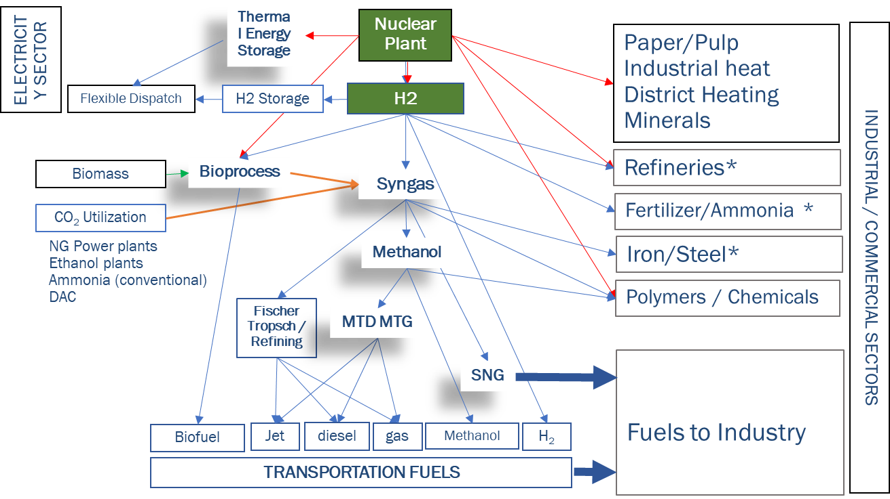

Fig. 1: Future nuclear energy currencies are chemical feedstocks (Syngas, Fischer-Tropsch fuels, Methanol, H2). Hydrogen is the key chemical feedstock.

This paper will first outline the capabilities of the modelling and simulation framework FORCE, give an overview of the heat and power requirements for different industries, and then present a few key applications of FORCE demonstrating how advanced reactors could supply heat and power to these industries.

## Simulation environment

Assessing the potential economic uses of nuclear energy required a shift from traditional electric baseload operation of nuclear to modelling nuclear energy as a flexible source of both heat and electricity, and then tracking downstream use of both resources to various commodity markets. Traditional economic optimization and analysis tools, such as capacity expansion models (CEMIES), only consider the electric applications of nuclear and do not capture other heat uses. Further, many electricity analysis tools were designed using dispatchability assumptions, which does not consider the variability of renewable energy sources such as wind and solar. Traditional methods also assume simplifications for energy storage, such as analysing several “time slices” and treating storage as additional dispatchable sources. These three assumptions (electric-only markets, dispatchable wind and solar, and time-independent storage) do not hold in markets with significant renewable energy penetration with elements such as nuclear energy contributing to multiple commodity markets.

To improve modelling and simulation of nuclear energy, the FORCE modelling framework was developed by the U.S. Department of Energy’s IES program [4]. FORCE is designed to improve analysis of advanced and existing nuclear technology to include multiple commodity markets, the uncertainty of variable renewable energy storage, and accurate portrayal of energy storage. FORCE incorporates high-resolution models for static and second-by-second transient physics and chemistry models. Analysis of these physical models can then be used in either of FORCE’s analysis pathways: project life system economic viability analysis using the Holistic Energy Resource Optimization Network (HERON) [5], or real-time optimal economic operation via digital twin with the Optimization of Real-time Capacity Allocation (ORCA) [6].

HERON is designed to flexibly handle an arbitrary set of “components” (commodity consumers, generators, and storage technologies) along with markets for commodities. HERON operates in a two-level leader-follower optimization structure, where the leading “outer” optimization seeks to size components optimally for expected values of select economic metrics, such as minimizing expected cost or maximizing expected profit. The expected value of economic metrics is evaluated by considering the uncertainty in economic factors such as tax incentives and technology construction, operating, and fuel costs, as well as uncertainty in “scenarios” defined by weather patterns such as wind and solar availability, commodity demand, and market pricing. For each scenario, the portfolio of components selected by the leader optimization is dispatched to optimize the economic metric. Statistics are then collected across scenarios to evaluate the economic efficacy of the leader-chosen portfolio, and the statistics are provided to the leader to search for an optimal portfolio. Due to its flexible design, HERON can also be used to track other metrics such as greenhouse gas production.

ORCA is designed to accelerate the deployment of digital twins to operate elements of an IES autonomously and remotely in concert. As the complexity of couplings between multiple generation technologies increases, the need for rapid and optimal decision-making tools becomes pronounced. Optimal control via digital twins extends the principles of model predictive control, which uses digital twins to align physical systems with desired outcomes. Those same digital twins can be used to optimize outcomes such as economics based on variables such as wind, solar, electricity demand, and market prices. By characterizing the performance of IES in FORCE, those characterizations can be used to create physics- and/or data-based surrogate models that are much faster than real time, which allows for optimal decision-making control. In practice, these surrogates and optimization algorithms are coupled to the physical IES via a data warehouse. A feedback loop is then followed. First, the physical system reports key characteristics about the system state to the data warehouse. Second, the ORCA digital twin reads in the physical state, updates its internal surrogate state, and optimizes the desired performance of the physical system to meet a target of interest, such as balancing electricity and heat production from a nuclear plant to produce both electricity as well as hydrogen from an electrolyser. ORCA then provides the requested performance to the data warehouse, and then finally, the physical system accepts provide information form the data warehouse and attempts to follow the provided performance set points. This cycle continues while the physical system is under active control using guidance from the ORCA digital twin.

## INdustrial requirements

The IES program is evaluating nuclear integration with the major industries which primarily use fossil fuels to meet their demands, including oil and petroleum refining, methanol production and the manufacturing of chemicals and derivative products, iron and steel, polymers, ammonia and fertilizers, and pulp and paper. The objective is to identify and analyse opportunities for integrating and substituting nuclear energy to sustainably and cost competitively meet these large heat and power demands while reducing the carbon emissions generated from the processes. In recent work, opportunities for integrating SMRs were investigated for each of the industrial process configurations. Physical (as part of the HYBRID model repository within FORCE) and HERON models for a HTGR were developed to evaluate the proposed integration. This introductory evaluation provides a general description and assessment of the operating principles, reactor coolant core outlet temperature, and reactor size to be integrated with industry.

Refinery work results showed that refining industry is a leading consumer of fossil ‑fuel-based heat, power, and hydrogen in the U.S. industrial sector, generating over 164 MMT of CO2 emissions in 2023 [7]. The overall mass and energy pertaining to a generalized complex refinery in the United States is reflected in our study [8], along with energy metrics regarding integration with a nuclear power plant (NPP). Data sheets were developed to indicate the energy requirements for the overall refinery and each refinery process, and the nuclear integration models shows that nuclear can supply the entire steam and electricity demands through a combined heat and power system. Most of the high-temperature heat was sourced from the combustion of refinery fuel gas (RFG), which is a byproduct off-gas that would otherwise be of very limited practical use. As a result, the emphasis was on supplying power, heat, and hydrogen via high-temperature steam electrolysis (HTSE). When providing all three commodities, the reference plant would require three or four HTGR Xe‑100 units, depending on the required net electricity for import/export.

Methanol is a chemical with versatile applications across a variety of industries, both as a feedstock and as a standalone product. The major downstream products derived from methanol are acetic acid, formaldehyde, and dimethyl ether. The derivative chemicals can be used to produce plastics, adhesives, and olefins such as ethylene and propylene, and to produce synthetic fuels such as gasoline, diesel, and jet fuel. The annual methanol demand in the United States is forecasted to reach 8.4 MMT by 2027. The annual direct CO2 emissions from the methanol sector total 2.85 MMT [9]. The methanol plants in the United States are energy intensive due to the high temperatures required for the endothermic reaction that produces synthesis gas (syngas) feedstock. These plants are heat integrated to recover the heat from the reforming process furnace and exothermic methanol reactor, and to maximize plant energy efficiency. Current results show that the nuclear integration potential may be limited for these conventional methanol plants. However, future plants (already commercialized at a smaller scale) capable of hydrogen production utilizing nuclear energy or other low-carbon power for HTSE can foster decarbonization of the methanol production process.

Manufacturing of pulp and paper requires large amounts of low-pressure (LP) steam to digest and wash wood fibers and to press dry pulp into paper. Most of the LP steam is taken from extraction or backpressure turbines that produce power from the high-pressure (HP) steam. HP steam is generated from burning wood waste material; bark is burned in hog boilers and lignin is boiled in the black liquor recovery boiler. In a typical integrated pulp and paper mill, 50%–100% of the steam is produced from these sources, and additional steam is produced in a natural gas (NG), fuel oil, or coal boiler. The other energy‑intensive process in the plant is the lime kilns, which require high temperatures from NG combustion to convert the compounds needed for the chemical recovery process. An NPP could replace the steam and electricity generated from wood waste and additional fuel enabling lignin and bark to be processed into bio-based chemicals or fuels. The annual CO2 emissions from the pulp and paper sector total 96.6 MMT/yr [9].

Iron and steel is another industry the IES program is evaluating. The United States produced approximately 82 MMT of steel in 2022, from production processes that are heat- and carbon-intensive and consuming large quantities of fossil fuel. As a result, this industry emits about 41.6 MMT/yr [10]. The iron and steel industry has begun adding new processes (e.g., direct reduced iron [DRI]) to reduce carbon emissions and improve efficiency. Carbon emissions from the DRI process can be reduced by 30%–70% with the addition of carbon‑free hydrogen supplied by integrating a SMNR with an electrolysis unit. Regarding steel production, an electric arc furnace (EAF) consumes large amounts of electricity but has a rather volatile load profile. The IES program is reviewing several pathways for integration with nuclear power, which may require additional balancing, such as grid connection, supercapacitors, flywheels, and battery or thermal energy storage.

### Thermal energy storage

Thermal energy storage can be integrated into various points within combined heat and power systems (CHP), i.e., before/after energy conversion system as shown in Fig. 2. The suitability of a given technology varies by application, each introducing its own limitations and exergy losses. Even if the nuclear power source is primarily generating heat at constant rate, thermal storage with power conversion system can be incorporated to flexibly delivery heat and electricity for the industrial process. Fig. 2 shows a generic layout for a CHP system, highlighting potential TES integration points.

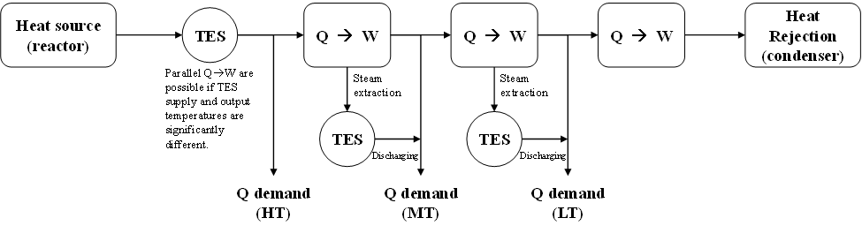

Fig. 2: Possible integration points for implementing TES into a nuclear/CHP system. HT, MT, and LT stand for high, medium, and low temperature, respectively. Q and W represent heat (Q) that is converted to work (W).

FORCE tools are currently used to study heat and power dispatch from TES-nuclear systems, controlled by switching the conversion system between heat and power, and by adjusting the total discharge rate. Fig. 3 illustrates an example showing the coverage of thermal and electrical demands via the integration of HTGRs with dedicated conversion systems in a chemical plant. The CHP plants utilize steam extraction from a turbine to adjust the heat output to its maximum capacity. The total thermal demands are fulfilled with a backpressure plant with constant output all the time and a two extraction-condensing turbine CHP plants meeting thermal load fluctuation. Together with a power-only production unit, the results show that a set of four Xe-100 reactors can supply all necessary heat and electricity most of the time, with a median export of 27 MWe—as indicated by the net electricity balance seen in Fig. 4 to the left. It is important to mention that peaks in electricity production (export) can be mitigated through curtailment, and extended periods of decreased demand can be accommodated by adjusting the reactor output. These results conclude that TES is crucial for balancing the system. In plants like these, while a nuclear-CHP system could meet all the required fluctuating heat demand and most of the required electricity demand without TES, the value of TES integration is offering a constant output to the grid, improving the reactor economics and minimizing the need for grid ancillary services. By implementing TES, the system can provide a predictable net power output of 25-35 MWe into the grid (see Figure 4 to the right) 48% of the time. Implementing more complex dispatch algorithms using demand prediction can further reduce the number and magnitude of peaks. Furthermore, these positive (export) peaks can be reduced by curtailment, rejecting heat to the environment by utilizing the process steam system.

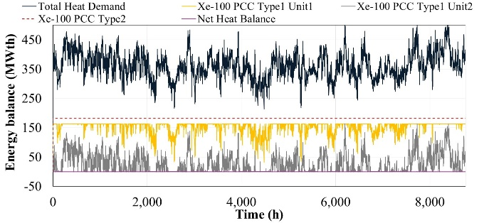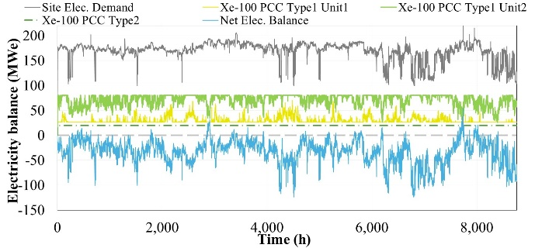

Fig. 3: Heat and electricity demand and supply from HTGRs and various power conversion system types and extraction points for chemical plant. Left: heat demand and supply. Right: electricity demand and supply.

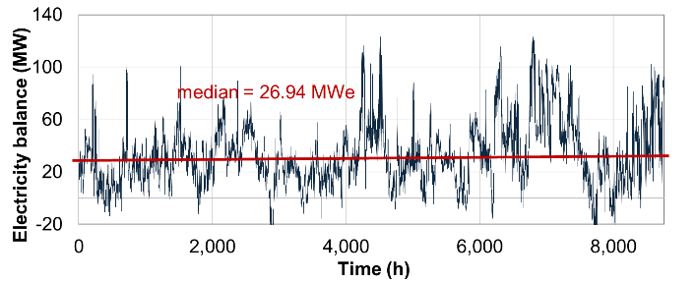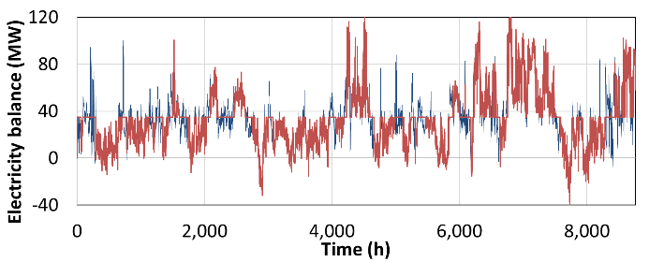

*Fig. 4: Left figure showing net excess (positive) or deficit (negative) electricity after providing all heat demands.* Right figure showing *net electricity balance both with and without TES (positive sign = export; negative sign = import).*

In future work, several industries integrating with nuclear-TES systems will be investigated using HERON under various market and technical contexts and using regional electricity price signals and variable renewable energy generation. This will involve examining three scenarios: (1) using generated electricity primarily for onsite needs (“behind the meter”), (2) providing a constant electricity supply to the grid under contract, and (3) optimizing operations in electricity markets by responding to electricity pricing and incorporating variable renewable energy generation.

### Refineries

#### Demands of steam-driven thermal systems

Many chemical facilities distribute energy via steam systems at site-specific pressures, although typically at multiple levels within a given facility. Work in the IES program has shown that integration of SMRs into these steam networks should be straightforward and offer an opportunity to replace fossil on-demand generation units with SMRs, frequently of any of the nuclear fission technologies. When specifically looking at oil refineries, analysis must begin by characterizing the net external energy requirements for a given facility. The entire energy consumption within a facility like a refinery is unlikely to be converted to using nuclear power due to the thermal integration existing within refineries as well as the application of refinery waste products to provide process heat throughout the system. Based on analysis via the deconstruction of the PRELIM model, a 100,000 barrel-per-day refinery using Arab Medium Stratiev crude oil requires 28 MWe and 36.3 kg/s of steam at 42.4 bar and 300°C [11][12]. Given an assumption of condensate entering the nuclear-refinery heat exchanger at 87°C and 42.4 bar, about 93.9 MWt are needed to generate the necessary steam. This combined 93.9 MWt and 28 MWe should be possible to be generated using a single SMR.

#### Clean and reliable energy for industrial systems must be dispatchable to match demand patterns.

Establishing a combined heat and power configuration that can meet the requirements of a facility at nominal conditions is only the initial step of establishing that an SMR can be dedicated to meet facility demands. While “24/7” operation may be the overall facility up-time, operational data from chemical facilities show highly variable behaviour on a short-term basis. Fig. 5 shows the dynamic nature of steam and electrical demand at chemical facilities. While the associated data is not directly from an operating oil refinery, the dynamic nature is anticipated to be similar especially as refineries will shift specific fuel production to meet current demand. Determining how to meet these kinds of high-reliability and high-variation loads is likely a project-specific task undertaken on an as-needed basis. Initial concepts, that may be able to avoid rapid and repeated changes in the nuclear system, investigated include leveraging energy storage to smooth the load variations, using grid integration to absorb electrical variability, or combining the system with another load-absorbing process that can accept the remaining system energy such as water desalination or water electrolysis.

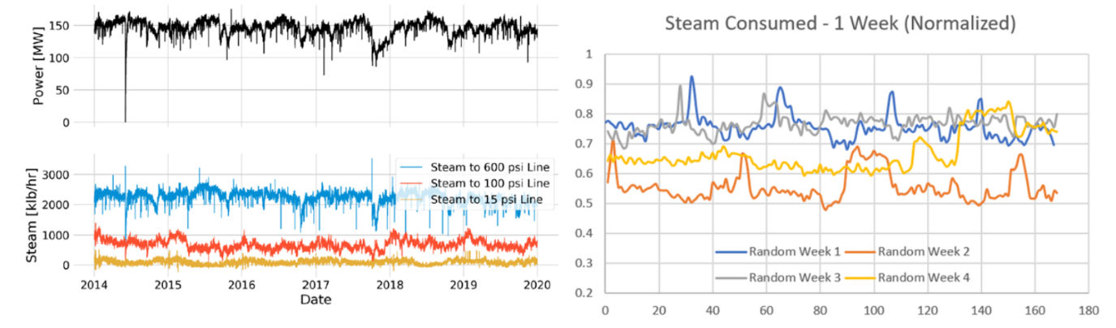

Fig. 5: Steam and electricity demand from Eastman Chemical facility [13] and normalized acquired proprietary data.

Refineries and many other chemical facilities already operate one or more steam systems to manage thermal energy distribution among processes. These systems present a “simple” entry point for nuclear energy to be introduced so long as reliability and variability constraints are well-accounted for during the design of the physical and control processes of the system. Depending on the design details and requirements, FORCE tools used for integration analyses include HERON and HYBRID modelling.

### Nuclear integrated synthetic fuels production

The IES program is investigating nuclear energy use and integration in the conceptualization, modelling and analysis of future synthetic fuels energy park. Liquid transportation fuels currently in use in the US economy have the advantages of being highly energy dense, easily transported in simple tanks, easily and quickly dispensed during refuelling, and indispensable in applications such as aviation fuel. For energy security, liquid fuels can be moved to any location accessible by trucks, providing the population with a versatile and powerful source of energy.

Combustion fuels in industry provide high temperature heat that cannot be accessed by standard nuclear light water reactors (LWRs) or high temperature advanced SMRs.

Transportation, aviation and even combustion fuels can be made synthetically, given basic chemical building blocks, including hydrogen, carbon dioxide and carbon monoxide. In addition to fuels, a wide variety of synthetic chemicals, products and materials can be made which our society depends on. The mixture of hydrogen and carbon monoxide in certain ratios for chemical synthesis is termed synthesis gas or syngas. In nature, the process of photosynthesis in plants combines carbon and hydrogen to form molecular chains of needed carbohydrates and proteins to sustain life on earth. Similarly, but using different processes and methods, carbon and hydrogen can be combined synthetically to form useful fuels and products.

Hydrogen can be provided by using water as a feedstock and using nuclear electricity and heat to power high temperature steam electrolysis (HTSE). Points of mention

1. Chemical building blocks of H2 and CO2 / CO can be used to synthesize valuable fuels, products and materials.
2. When using nuclear energy (heat and electricity) and biogenic carbon sources for hydrogen and synthetic fuels production, the fuels produced can be net zero carbon fuels.
3. Liquid fuels will continue to form the bedrock of modern transportation because of their energy density, ease of storage and transportation, and their ability to provide energy security and independence.
4. Synthetic fuels can be purpose designed and synthetizied to have the molecules and chemical characteristics desired for different engines, meaning that only the molecules needed can be included in the fuel and other contaminants that would exist in petrouleum derived fuels.

## Conclusions

This paper presents the necessity to develop time dependent, multi-commodity techno-economic and overarching real time control tools and presents the DOE IES FORCE tool suite that satisfies this need. Furthermore, the papers shows industrial requirements for various industries and demonstrates how SMRs could fulfil those requirements using the FORCE tools. Special emphasis is given on how much green house gases could be avoided by integrating nuclear power into these traditionally fossil fuel consuming industries.

References

1. Bragg-Sitton, S., C. Rabiti, R. Boardman, J. O’Brien, T. Morton, S. Yoon, J. Yoo, K. Frick, P. Sabharwall, T. Harrison, M. Greenwood, and R. Vilim, “Integrated Energy Systems: 2020 Roadmap.” INL EXT-20-57708, Revision 1, Idaho National Laboratory 2020.
2. Epiney, A., P. Talbot, R. M. Saeed, D. Wendt, F. Joseck, L. Lin, M. Abdo, R. Yoshiura, J. Yoo, D. Mikkelson, J. Hansen, E. Worsham, S. Bragg-Sitton, H. Wang, R. Ponciroli, R. Vilim, A. Yigitoglu, S. Sabatino, “Roadmap for IES Modeling and Simulation Activities: Update 2023”, INL INL/RPT-22-69204, 2023.
3. Bragg-Sitton, S., R. Boadman, A. Epiney, “Shifting the Paradigm: Nuclear-based Integrated Energy Systems to Achieve Net Zero Solutions”, National Academy of Engineering, The Bridge vol 53 issue 2, 2023.
4. FORCE: <https://github.com/idaholab/FORCE>
5. HERON: <https://github.com/idaholab/HERON>
6. ORCA: <https://github.com/idaholab/ORCA>
7. EPA, “2022 Greenhouse Gas Emissions from Large Facilities.” Environmental Protection Agency. Accessed October 13, 2023.
8. Joseck, F., V. Novotny, E. A. Reyes Molina, K. P. Sweeney, E. K. Worsham, B. Choi, S. Root, J. Toman, N Popli, W. Cheng, K. Vedros, T. Knighton, “Thermal Integration of Advanced Nuclear Reactors with a Reference Refinery, Methanol Synthesis, and a Wood Pulp Plant.” 2024. INL PRT‑23-03951
9. EPA. “Facility Level Information on Greenhouse gases Tool (FLIGHT).” Environmental Protection Agency, 2022.
10. EPA, “Inventory of U.S> Greenhouse Gas Emissions and Sinks: 1990-2021.” U.S. Environmental Protection Agency, EPA 430-R-23-002, 2023.
11. Abella, J.P., J. Guo, K. Cousart and J. A. Bergerson, PRELIM: Petroleum Refinery Life Cycle Inventory model v1.4, vol. v1.4 ed, Calgary: University of Calgary, 2020.
12. Novotny, V., J. Kim, S. Creasman, L. D. Williams, D. M. Mikkelson, “Preliminary Process and Instrumentation Design of Advanced Reactor Integration with Refineries and Hydrogen Production Facilities.” United States: N. p., 2024. Web. doi:10.2172/2305387.
13. Greenwood, M. S., A. G. Yigitoglu, J. D. Rader, W. Tharp, P. Whitney, M. Poore, R. Belles, B. Zhang, R. Cumberland, M. Muhlheim, “Integrated Energy System Investigation for the Eastman Chemical Company”, Kingsport, TN Facility. United States: N. p., 2020. Web. doi:10.2172/1643929.