# Techno-Economic Analysis of SMR Cogeneration with Desalination: A Case Study in Türkiye

O.Y.KUTLU

Turkish Energy Nuclear and Mineral Research Agency

Küçükçekmece/İstanbul, Türkiye

Email: osmanyucehan.kutlu@tenmak.gov.tr

**Abstract**

In the face of escalating global water scarcity, integrating Small Modular Reactors (SMRs) with desalination emerges as a promising solution. The study assesses the feasibility and economic viability of SMRs for cogeneration with desalination, focusing on Türkiye. The paper investigates the SMR and desalination system coupling in technical and geological aspects. Different desalination technologies analyzed for different locations. In scope of the paper, three possible Nuclear Power Plant (NPP) sites considered for SMR and desalination plant deployment. Two of these sites, Igneada and Sinop are at black sea coast whereas remaining site Akkuyu is at Mediterranean coast. Aim of the study is to find best option for desalination with SMR at these mentioned locations. For this purpose three different desalination technologies; Multi Stage Flash (MSF), Multi Effect Distillation (MED) and Reverse Osmosis (RO) coupled with SMART SMR and economic performance was analyzed with DEEP software. Results showed that Black sea region offers better desalination economy than the Mediterranean region. Thus RO offered the lowest water cost between coupled desalination plants.

## INTRODUCTION

In the face of global water scarcity, desalination technologies emerge as viable solution for world potable water need. Desalination is a power extensive process and using fossil fuelled energy sources causes increase in greenhouse gas emissions. Nuclear desalination is gaining interest as nuclear heat can replace the use of fossil fuels in energy requirement of the desalination process. In nuclear desalination, potable water produced from sea water by using nuclear reactor as source of energy[1]. Currently, small modular reactors (SMRs) as a carbon free, reliable source of nuclear energy are attracting attention in transition of fossil fuel energy sources. SMRs are innovative nuclear reactor that can produce power up to 300 MW(e). More than 80 commercial designs for Small Modular Reactors (SMRs) are presently in development worldwide, with the aim of fulfilling various needs and applications, including electricity generation, hybrid energy systems, heating, water desalination, and industrial steam production.[2]. Desalination as a coupling option is viable alternative for countries with water scarcity. Several studies assessed the technical and economic performance of nuclear desalination with SMRs [3], [4], [5]. These researches highlight the potential benefit of desalination with SMR for their focus locations. The paper considers different coupling options for the selected SMR type and assesses the potential locations for the deployment in Türkiye with regard to water production cost.

## smr deployment locations

Efficiency of Desalination can be affected by conditions of the location such as water stress, high water costs and natural parameters (sea water salinity and temperature). For instance, energy intensity of membrane process can be decreased by high water temperatures and low water salinity[6]. Location of the SMR site affect the efficiency of the desalination plant coupled in SMR if the natural conditions of the location are different. Therefore a detailed analysis must be made in location selection process to have better desalination efficiency. Türkiye borders three different seas: the Black Sea to the north, the Aegean Sea to the west, and the Mediterranean Sea to the south, covering the country. The Black Sea water has lower salinity and average temperature compared to the seawater of the Mediterranean and Aegean Seas.

In scope of this paper, three locations were selected for deployment of a SMR coupled with desalination system. Akkuyu, Sinop and Igneada are the nuclear power plant locations in consideration at Türkiye. Akkuyu site has already housing a VVER-1200 nuclear power plant close to commissioning, Sinop site is already licensed for NPP and discussions for Igneada are in progress. Fig. 1. shows the locations of these sites where water intake conducted for desalination systems.

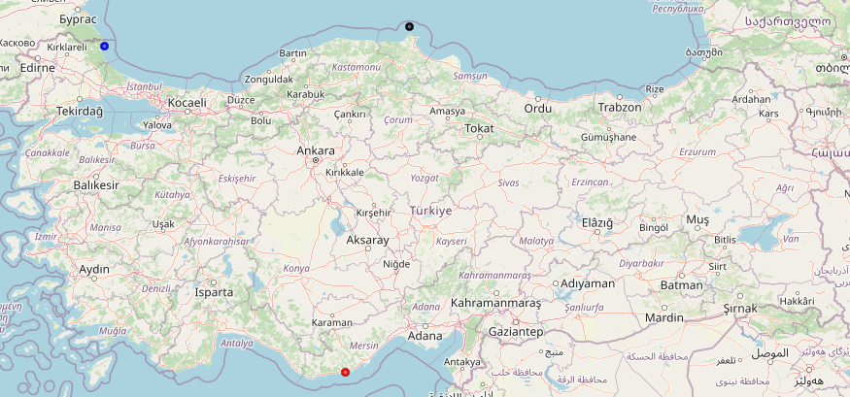

*FIG. 1. Desalination locations (Red: Akkuyu, Blue: Igneada, Black: Sinop)*

Average seawater temperature and salinity distributions of these locations are retrieved from NASA satellite image system with using Google earth engine (gee)[7], [8]. Each location has a different salinity but salinity values are nearly constant during the year. Mediterranean Sea is a salty sea and seawater at Akkuyu coast is quite salty comparing the seawater at other locations. Table 1. shows the yearly average seawater salinity and seawater surface temperature values for each site.

TABLE 1. Yearly average salinity and seawater temperature values.

|  |  |  |
| --- | --- | --- |
| Site | Salinity [psu] | Seawater Temp[C] |
| Akkuyu | 39.15 | 24.04 |
| Igneada | 18.77 | 18.99 |
| Sinop | 18.48 | 19.48 |

Distribution of daily averaged sea surface temperature values for each site over year 2022 was presented at Fig. 2. Yearly averaged values for 2022 were used in the analysis. Further analysis concerning a better economical dispatch could use hourly temperature values for assessment of economic performance.

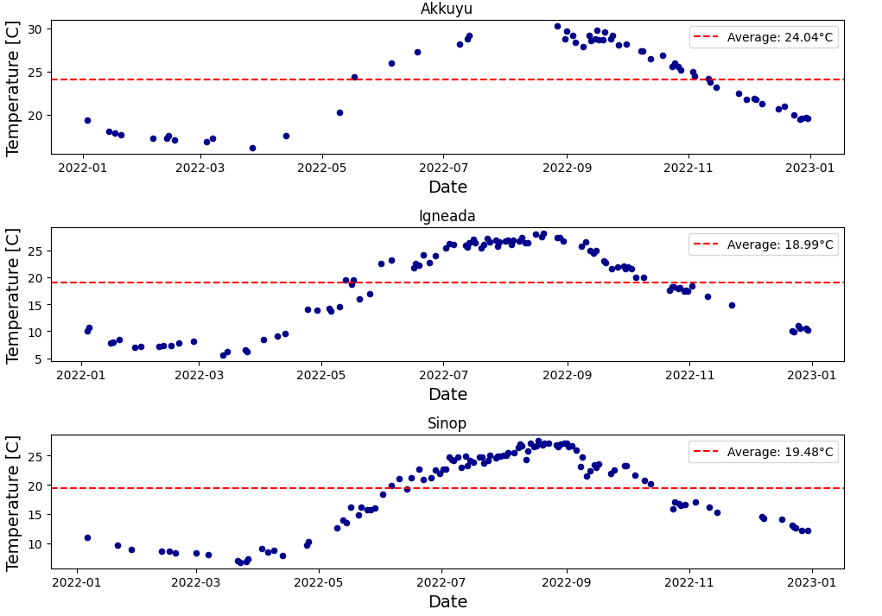

*FIG. 2. Daily averaged seawater surface temperatures for year 2022 in deployment sites.*

## system overview

### SMR

In the analysis a light water pressurized small modular reactor; System Integrated Modular Advanced Reactor (SMART) is chosen regarding its availability to multi-purpose applications including seawater desalination. SMART power plant data that has been used in calculations is shown in the Table 2.

TABLE 2. SMART SMR parameters for economical evaluation[5].

|  |  |
| --- | --- |
| Parameter | Value |
| Main Steam Temperature [C]  Net Efficiency[%] | 296  32 |
| Auxiliary loads [%] | 5.3 |
| Specific Construction Cost [$/kW] | 1714 |
| Specific Fuel Cost [$/kW] | 8 |
| Specific O&M Cost [$/kW] | 5.59 |
| Discount rate [%] | 6 |
| Interest rate [%] | 6 |

### Desalination Plants

Commercial seawater desalination processes that are proven and reliable for large scale freshwater production are multi-stage flash (MSF) and multi-effect distillation (MED) for evaporative desalination and reverse osmosis (RO) for membrane desalination. MSF and MED desalinate water through evaporation and condensation, RO uses osmotic membranes separation of the salt from the water [1]. Properties of these systems that used in calculation is presented in Table 3.

TABLE 3. SMART SMR parameters for economical evaluation[5].

|  |  |  |  |
| --- | --- | --- | --- |
| Desalination plant | MSF | MED | RO |
| Max Brine Temperature [C] | 110 | 65 | N/A |
| Membrane Pressure [bar] | N/A | N/A | 69 |
| In/Outfall Specific Cost Factor [%] | 10 | 7 | 7 |
| Operational Availability [%] | 90 | 90 | 90 |
| Base Unit Cost [$/m3] | 1000 | 900 | 900 |
| Water Capacity [m3/d] | 40000 | 40000 | 40000 |

## Economic Assessment

Thermodynamic and economic analysis conducted with using IAEA Desalination Economic Evaluation Program (DEEP version 5.1). The DEEP program has both nuclear and fossil power options, heating and power plants and also heat-only plants can be coupled with distillation processes of MSF and MED and membrane process of RO in DEEP software and for each case the performance and economic evaluation is made automatically for selected desalination technology[9].

In the analysis SMART SMR is coupled with desalination systems of MSF, MED and RO. MSF and MED systems both connected with thermal and power lines. The main difference between nuclear and fossil fueled power plants in case of thermal coupling of distillation desalination plant is the requirement of installation of an intermediate loop in case of a nuclear plant. This intermediate loop provides a barrier against mitigation of radioactivity to the desalination system [10].In the analysis intermediate loop was used for MSF and MED, which in turn slightly increased the cost of desalination in these systems.

Thermal coupling of SMRs with desalination systems by cogeneration requires steam extraction from turbine, this extraction can be seen in Fig. 3. and Fig. 4. since both MSF and MED systems thermally connected to SMR. RO system only connected electrically since it does not require hot steam from turbine as can be seen from Fig. 5.

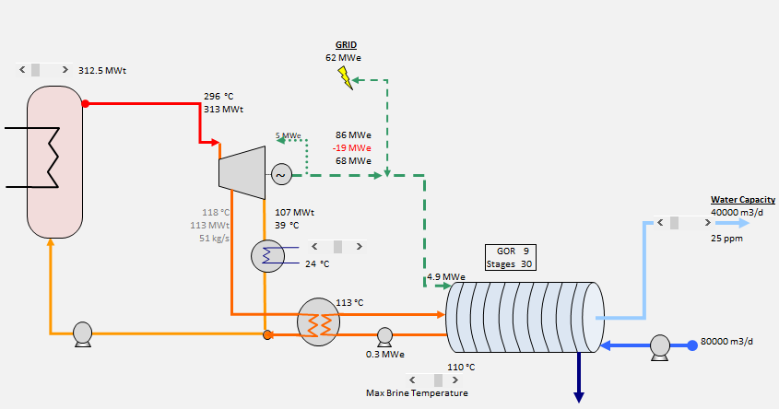

*FIG. 3. SMART-MSF coupling in DEEP.*

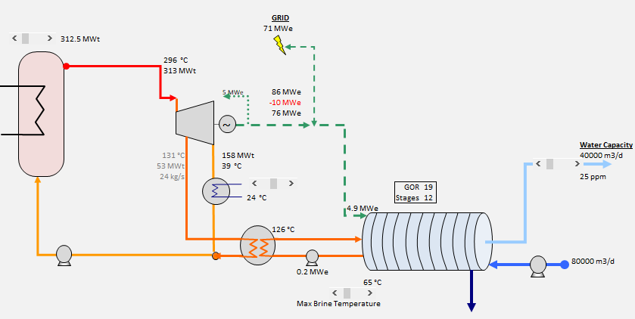

*FIG. 4. SMART-MED coupling in DEEP.*

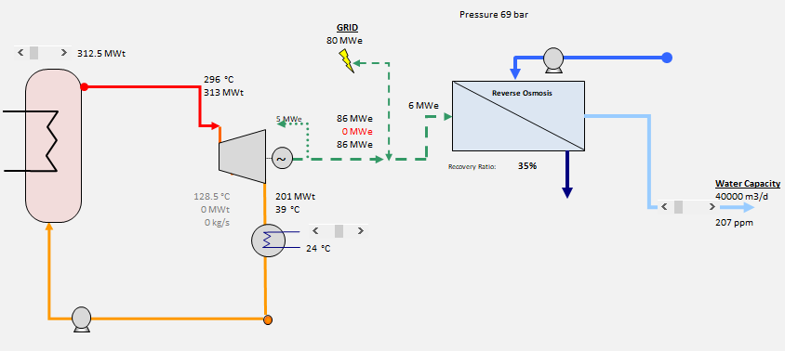

*FIG. 5. SMART-RO coupling in DEEP.*

Each coupling assessed separately for Akkuyu, Igneada and Sinop. Water cost for all desalination systems at proposed SMR locations is shown in Fig. 6. Biggest costs derive from O&M for MED and RO, cost of heat is dominant for MSF. Fig 6. shows that RO system offers the lowest water cost for all regions. Desalination in Akkuyu costs more than Igneada and Akkuyu for all desalination technologies.

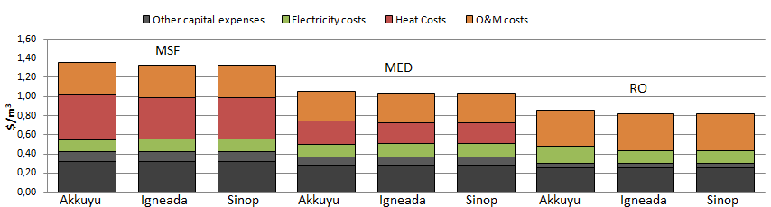

In RO plants, increase in water temperature increases the viscosity of the water which in turn eases the permeability through the membrane but on the other hand high water temperature causes high osmotic pressure which reduces the permeability of the water through the membrane. Also in RO plants electricity required for the process rises with the salinity of the water [9]. Therefore, high water cost in Akkuyu indicated that salinity differences in sea waters have a more dominant effect than temperature differences at RO plants in Türkiye.

*FIG. 6. Comparison of water costs*

## CONCLUSION

Aim of the study was to find best option for desalination with SMR at NPP site locations in Türkiye. Igneada and Sinop both has a coast on the Black Sea, whereas Akkuyu is located near the Mediterranean Sea, which has a much higher salinity compared to the Black Sea. Mediterranean seawater is also hotter than Black Sea water which instead comes handy in desalination process. But analysis showed us that the advantage of using hot water in desalination is low against the salinity value of the seawater. Salty seawater of Akkuyu caused higher costs for water desalination in all desalination plants. Therefore Black Sea region offers a more advantageous seawater for the desalination in Türkiye.

While RO offers the minimum cost, total dissolved solids (TDS) in product water of RO is the higher than MSF and MED. Also for RO plant, cost of electricity is an important factor in determination of cost of water thus the water cost in RO would be more sensitive to changes in electricity prices. Consequently a careful analysis must be made by also considering special agreements for electricity market when making the decision about desalination plant technology selection.

References

[1] *Introduction of Nuclear Desalination*. in Technical Reports Series, no. 400. Vienna: INTERNATIONAL ATOMIC ENERGY AGENCY, 2001. [Online]. Available: https://www.iaea.org/publications/5925/introduction-of-nuclear-desalination

[2] “What are Small Modular Reactors (SMRs)?” Accessed: May 29, 2024. [Online]. Available: https://www.iaea.org/newscenter/news/what-are-small-modular-reactors-smrs

[3] D. T. Ingersoll, Z. J. Houghton, R. Bromm, and C. Desportes, “NuScale small modular reactor for Co-generation of electricity and water,” *Desalination*, vol. 340, pp. 84–93, May 2014, doi: 10.1016/j.desal.2014.02.023.

[4] K. Sadeghi *et al.*, “Towards net-zero emissions through the hybrid SMR-solar cogeneration plant equipped with modular PCM storage system for seawater desalination,” *Desalination*, vol. 524, p. 115476, Feb. 2022, doi: 10.1016/j.desal.2021.115476.

[5] R. Buzzetti, R. Lo Frano, and A. S. Cancemi, “Feasibility study of desalination plant powered by SMR,” *Nucl. Eng. Des.*, vol. 418, p. 112897, Mar. 2024, doi: 10.1016/j.nucengdes.2023.112897.

[6] E. A. Grubert, A. S. Stillwell, and M. E. Webber, “Where does solar-aided seawater desalination make sense? A method for identifying sustainable sites,” *Desalination*, vol. 339, pp. 10–17, Apr. 2014, doi: 10.1016/j.desal.2014.02.004.

[7] Y. Kurihara, “GCOM-C/SGLI Sea Surface Temperature (SST) ATBD,” 2021.

[8] J. A. Cummings and O. M. Smedstad, “Variational Data Assimilation for the Global Ocean,” in *Data Assimilation for Atmospheric, Oceanic and Hydrologic Applications (Vol. II)*, S. K. Park and L. Xu, Eds., Berlin, Heidelberg: Springer Berlin Heidelberg, 2013, pp. 303–343. doi: 10.1007/978-3-642-35088-7_13.

[9] *Desalination Economic Evaluation Program (DEEP)*. in Computer Manual Series, no. 14. Vienna: INTERNATIONAL ATOMIC ENERGY AGENCY, 2000. [Online]. Available: https://www.iaea.org/publications/6049/desalination-economic-evaluation-program-deep

[10] *Environmental Impact Assessment of Nuclear Desalination*. in TECDOC Series, no. 1642. Vienna: INTERNATIONAL ATOMIC ENERGY AGENCY, 2010. [Online]. Available: https://www.iaea.org/publications/8262/environmental-impact-assessment-of-nuclear-desalination