Nuclear safeguards assessments

of molten salt reactor spent fuel

V. Mishra

Uppsala University

Department of Physics and Astronomy

Applied Nuclear physics Division

Uppsala, Sweden

Email: vaibhav.mishra@physics.uu.se

E. Branger, Zs. Elter, S. Grape, D. Trombetta

Uppsala University

Department of Physics and Astronomy

Applied Nuclear physics Division

S. Mirmiran

Formerly at Seaborg Technologies

Copenhagen, Denmark

**Abstract**

Molten salt reactors are a novel reactor design concept where the fuel is often used in a molten form. These reactors are believed to be safer and more efficient than the conventional light water reactors operating today. They also differ significantly in their design and operation and pose unique safeguards challenges many of which remain to be overcome. Some of these challenges arise from the fact that safeguards guidelines that exist today apply mainly to itemizable fuel whereas nuclear material from these advanced reactors is usually in a molten matrix form. A deeper understanding of these aspects of the spent fuel is imperative to effectively implement safeguards measures for these reactors. Traditional safeguards guidelines and practices may not be directly applicable and could require significant changes, something which motivates research on this topic.

Over the last two years, as a result of a collaboration, researchers at Uppsala University have looked into nuclear safeguards-related challenges of molten salt reactors using the Compact Molten Salt Reactor by Seaborg as an example. The concept is envisioned to be an alkali-fluoride fueled reactor that can be placed on a transportable floating barge designed specially to house one or more units of the reactor. We present here results on assessments of material attractiveness of molten salt fuel, development of fuel isotopics datasets and implementation of machine learning algorithms for the prediction of salt's burnup, initial enrichment, and cooling time. The paper sheds some light on the research that has already been done and the ongoing and future work planned for floating type molten salt reactors.

## INTRODUCTION

A concept that’s been tried and tested at the research reactor scale, the Molten Salt Reactor (MSR) is centerstage again after several decades of being pushed aside for other reactor concepts [1]. These reactors have many unique benefits in terms of safety, economy, and efficiency [2]. The enhanced safety comes from the fuel being part of a molten mixture which rules out any dangers of a meltdown while the improved economics of these reactors arise from for instance, the use of sCO2 cycles [3] which are more efficient, cheaper, and use less water than conventional steam generation. Despite these advantages, there are numerous challenges [4, 5] associated with these reactors some of which include material constraints when working with corrosive salt mixtures, lack of operational experience and expertise of any commercial MSRs, and until recently, unavailability of modeling and simulation software for molten (and moving) fuel material. The fact that the rest of the fuel cycle logistics are not at a matured state and that there are no licensed reactors and no safeguards in place complicates matters further. These challenges, while significant, have not deterred the numerous privately held companies to pursue this novel reactor concept and it is likely that a commercial MSR may enter operation in the coming decades.

In the paper, we summarize findings from assessments carried out as part of a doctoral dissertation on safeguards challenges of Generation-IV (or Gen-IV) reactors and MSRs in specific. We look at one MSR design that is being researched and developed by Seaborg Technologies in Copenhagen, Denmark. The concept is named the Compact Molten Salt Reactor (CMSR) [6] and is designed as a 100 MWe, liquid FUNaK-fuelled reactor that can be placed on a specially designed barge. This barge can house one or multiple units of the reactor and can be towed to power delivery location. Some of the key specifications of the reactor concept are available in [7, 9, 10]. The concept is currently in the detailed design phase, and it is foreseen that the first unit will enter operation in 2030. At the time of our assessments, the reactor was planned to be fuelled with High Assay-Low Enriched Uranium (HA-LEU) and moderated by molten sodium hydroxide. Since then, the design has undergone changes, and the latest updates can be followed on the company’s website. The assessments of the CMSR concept presented in the paper include the following nuclear safeguards relevant studies:

1. Production of two fuel data libraries to represent a MSR with and without online removal of gaseous and volatile fission products.
2. Assessments of radiation emission from irradiated fuel salts and its comparison to radiation from conventional Light Water Reactors (LWR) and to another novel Gen-IV reactor concept.
3. Evaluating the attractiveness of fuel salts from the CMSR using an attractiveness metric developed for molten salts.
4. Application of machine learning methods for predicting safeguards-relevant properties of the primary fuel salt.

Each of these assessments make use of data that was generated with the help of burnup calculations carried out in Serpent2 [8] Monte-Carlo particle transport code. With the help of such simulations, the two unique libraries that contain safeguards-relevant data (such as isotopics, gamma activities, neutron emissions etc) for the CMSR [9, 10] were produced and published. Wherever comparisons were drawn with other fuel types such as LWRs, a different dataset representing LWR fuel irradiation was used [11].

## FUEL LIBRARIES USED IN THE ANALYSES

The data used in the assessments of radiation emission has been produced using a combination of various calculation codes such as Serpent2 [8], SOURCES 4C [12], and SCALE [13] for the different fuel types. We have compared the nature of emitted gamma and neutron radiation from irradiated salts with another type of Gen-IV reactor namely, MYRRHA [14] and with more conventional LWR spent fuel (of UOX and MOX type) from a PWR. For the Seaborg CMSR, the fuel data has been used from [9, 10] while for the other Gen-IV reactor i.e. the MYRRHA reactor, the data used has been taken from [14]. For the LWR fuel (both UOX and MOX type), the data has been obtained from [11].

## ASSESSMENTS OF RADIATION EMISSION

This section will provide details of the nature of gamma and neutron radiation emission from the four different fuel types i.e. CMSR irradiated salts and MYRRHA spent fuel when compared to more conventional LWR spent fuel (of UOX and MOX type). The key specifications of the fuels are listed in the table below.

TABLE 1. KEY SPECIFICATIONS OF THE FUEL TYPES STUDIED IN THIS ASSESSMENT. [7]

|  |  |  |  |
| --- | --- | --- | --- |
| Fuel Type | BU (in MWd/kg-U) | IE | CT |
| MYRRHA | 50 | 30.0 % IPC | 0-40 yr. |
| CMSR | 15 | 12 wt. % U-235 | 0-40 yr. |
| LWR-UOX | 50 | 5.0 wt. % U-235 | 0-40 yr. |
| LWR-MOX | 50 | 5.0 % IPC | 0-40 yr. |

* IPC: Initial Plutonium Content

As mentioned before, the results in the study are provided in a way to facilitate a comparative assessment to highlight the differences in the key emitters of gamma and neutron radiation from the spent fuel. Knowledge of such differences can be useful in the future for safeguards activities for these fuels as inspectors can devise safeguards verification strategies with this information tailored for the specific system. While the results in the following sections may only be cursorily explained, further details and nuances are provided in [7].

### Gamma emissions

### Some of the main gamma emitters in spent fuel that are often relied upon for safeguards verification owing to their relative abundance were investigated. Fig. 1 shows the relative contribution to overall gamma emission from the spent fuel for the four fuel types from the most significant gamma emitting nuclides.

### From Fig. 1, one of the major differences noticeable in observed trends in gamma emission across the four fuel types includes the prevalence of Cs-137 as the dominant gamma emitter in case of CMSR across the entire CT range. This is not observed for the other 3 fuel types i.e. MYRRHA, PWR-UOX, and MOX where at CT<1 year, isotopes such as Ru-106, Ce-144, and Cs-134 contribute more to the gamma emissions than Cs-137. From the point of view of safeguards verification of irradiated salts using gamma signatures, it may be more difficult to measure the other isotopes as compared to other reactors, meaning techniques relying on them will need revision.

*FIG. 1. Some of the main gamma emitters often targeted in a safeguards verification and their contribution to overall gamma emission in the different fuel types.*

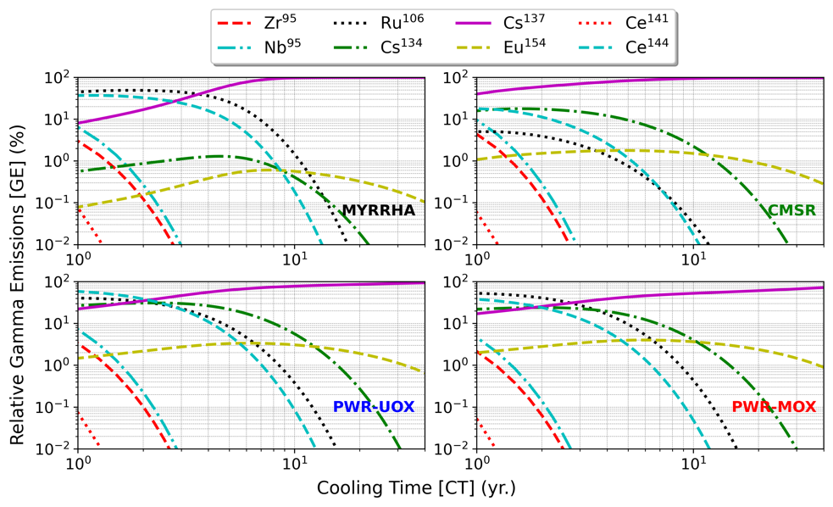

### Neutron emissions

The trends in neutron emissions from spontaneous fissions from various nuclides for the 4 fuel types is shown in Fig. 2. It is evident that overall trends in SF neutron emission are very similar in case of PWR-UOX and MOX type fuels where nearly all SF neutrons are produced by Cm-244. In the case of MYRRHA fuel, Pu-240 and Cm-242 contribute most SF neutrons for short CT and for longer CT (> 0.1 year), it is solely dominated by Pu-240 as heavier isotopes build up at a slower rate in a fast spectrum environment. For CMSR, the trends are similar to MYRRHA but it is only after CT>1 year that the contribution from Cm-242 falls below 10%. The contribution from Cm-244 isotope never exceeds 10% in either fuel type.

A second (first being total neutron emission from SF and (α, n)) derived metric called the α-ratio which is ratio between neutron emissions from (α, n) to those from SF has been shown as a function of CT in Fig. 3. It can be seen that while the α-ratios for LWR-UOX, MOX, and MYRRHA fuels are always below unity i.e. more neutrons are emitted from SF than from (α, n) in these oxide-based fuels, for the CMSR, the α-ratio is always well above unity for all BU and CT. This implies that for CMSR fuel, (α, n) is the dominant mode of neutron emission due to presence of more low-Z nuclei in the salt (such as Na and F) which act as target sites for (α, n) reactions. A few safeguards implication could arise from the fact that previously neutron emissions depended on Cm, which depends on BU, but now it depends on a combination of isotopes such as Pu-240, Cm-242, and to a lesser extent on Cm-242.

*FIG. 2. Some of neutron emitting nuclides (from spontaneous fission) and their contribution to overall neutron emissions as a function of fuel CT in the different fuel types.*

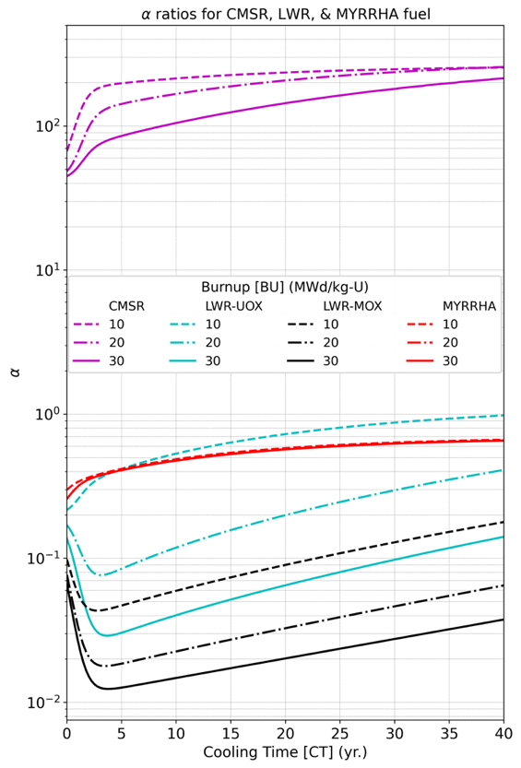

*FIG. 3. Computed α-ratios as a function of fuel CT for the three different fuel types.*

## ASSESSMENTS OF MATERIAL ATTRACTIVENESS

Knowledge of material attractiveness is often useful for effective implementation of safeguards measures in the nuclear fuel cycle allowing safeguards efforts to be focused wherever the material is most desired for a proliferator. The attractiveness of a nuclear material is defined as its perceived desirability over others from the point of view of manufacture of a nuclear explosive device or an NED. Some materials are more desirable than others and there are a number of properties that are universally agreed upon when defining a material’s attractiveness. That being said, the attractiveness of a material can be quantified using both, qualitative (based on properties of the material) and quantitative (using metrics) methods and a brief survey of the different approaches as well as more details on the results from the assessments are provided in [15].

The paper discusses the application of a metric-based approach to quantify the attractiveness of irradiated fuel salts using a metric that is named as the Overall Attractiveness (or OA). The idea behind this metric is to be able to quantify the attractiveness of desirable nuclear material while it is still a part of the molten salt mixture. This approach is novel since heretofore, the attractiveness of nuclear materials has been defined either in separated form or in elemental form (such as plutonium, or high enriched uranium or HEU). The ability to quantify the attractiveness of the salts themselves has several uses which includes being able to factor in this information into deciding the container sizes before transport and disposal of irradiated salts. Additionally, knowledge of the salt attractiveness can also help in reinforcing safeguards measures wherever the attractiveness is the highest during the fuel cycle. Mathematically, the OA metric is defined as:

$$OA= \sum_{i=1}^{4}{m_{i}}-\sum_{i=1}^{4}{d_{i}}$$

The expression for OA given above has two terms: the first term (indicated as a sum over masses or m) denotes all masses of isotopes that are usable in a nuclear weapon (such as Pu-239, U-235, Am-241, and Np-237), and the more abundant they are, the more attractive the material is. The second (indicated by ‘d’ or intrinsic parameters that deter material misuse) denotes terms that collectively reduce the attractiveness (or increase the barrier to proliferation) of the fuel salt such as gamma emissions, neutron emissions (from SF and α, n), and decay heat. The perceived deterrence posed by these factors arises from the difficulty they create during handling, transport, and workability. For instance, a high decay heat and gamma dose make a material self-protecting from misuse as it can be a safety hazard for personnel and equipment, and requires careful handling. Similarly, a high neutron emission rate from the material not only leads to radiation exposure for the personnel and equipment but can also increase risks of unintended detonation of the desired explosive device making its yield unreliable. Therefore, these factors require a thorough investigation as they can inherently deem the material unusable if their values are sufficiently prohibitive.

Using the data available from simulations in [9], the OA was computed over a wide range of burnups, initial enrichments, and cooling times (or collectively, BIC). This OA was thereafter also computed for LWR fuel types (UOX and MOX) for sake of comparison using data from [11]. The results for OA as a function of fuel BIC are presented in Table 2.

TABLE 2. KEY STATISTICAL DESCRIPTORS OF THE OA DATA FOR THE 3 FUEL TYPES. DATA FROM [15]

|  |  |  |  |  |  |
| --- | --- | --- | --- | --- | --- |
| Fuel Type | Q1 | Q2 | Q3 | μ | σ |
| CMSR | **0.55** | **0.61** | **0.74** | **0.64** | **0.64** |
| LWR-UOX | 0.20 | 0.38 | 0.56 | 0.39 | 0.23 |
| LWR-MOX | 0.27 | 0.42 | 0.61 | 0.44 | 0.22 |

*Here *Qi* implies the quartile of the distribution, μ: mean, σ: standard deviation

From Table 2, one may see that the mean OA for the CMSR is comparatively much higher than that of LWR-UOX and MOX type fuels. It was also observed that the OA for the UOX fuels (PWR UOX and CMSR) become more attractive with irradiation (due to buildup of isotopes such as Pu-239, Np-237 etc). While the attractiveness of MOX type fuel generally was found to decrease with increasing irradiation as isotopes such as Pu-239 get burned off and the attractiveness is further reduced due to increasing emissions (both gamma and neutron) and by the increase in production of decay heat. It must however be pointed out that a one-to-one comparison between fuel types may be skewed by the differences in initial fissile inventories and fuel types (HA-LEU vs, LEU) or due to the difference in reactor power levels so the results from these assessments are to be interpreted with due discretion. Lastly, the sensitivity of the OA metric w.r.t the various terms in the mathematical expression was also investigated for the three fuel types using a statistical measure called the SHAP (SHapley Additive exPlanations) [16] and details of the assessment are available in [15].

## APPLICATION OF MACHINE LEARNING METHODS FOR SAFEGUARDS VERIFICATION

One of the goals of the IAEA moving forward is the increased reliance on more data-driven approaches for day-to-day safeguards verification activities in the interest of increasing efficiency and reducing effort [16]. The increase in availability of data and the advancements in fields of data science have opened up many interesting avenues for the implementation of machine learning (or ML) methods for safeguards purposes. There are numerous past works [18-23] on the successful use of ML on safeguards-relevant data for prediction of spent fuel’s BIC parameters (among other quantities of interest such as fissile content, decay heat etc).

In the same vein, the paper discusses several such applications of ML methods trained on simulated data [10] consisting of information such as fuel salt composition at various combinations of salt BIC. Since this dataset was created considering removal of gaseous and volatile effluents from the primary salt to an off-gas tank, the dataset also contains off-gas tank’s isotopic composition for the same BIC combinations as the primary salt. Apart from isotopic composition of the fuel salt and the off-gas mixture, this dataset also includes data about total gamma activity, neutron emission rates, and the decay heat production.

It is well-known that a model trained on isotopics and signatures from the fuel material can predict fuel’s BIC with reasonable success [18-23]. Since MSRs have many unique features such as online removal of fission products, among the main objectives of this work was to assess if the safeguards-relevant parameters i.e. BIC of fuel salts can be deduced from non-fuel signatures. This could possibly include properties of materials that are constantly removed from the primary circuit such as off-gas effluents. Therefore, in the evaluation we trained a ML model (a tree-based algorithm to be specific) on input features that consisted of isotopic composition of the off-gas and its properties such as gamma activity and decay heat to predict the primary salt’s BIC. This approach, if successful, would present several benefits such as not having to rely on the highly radioactive, corrosive, and hot primary salt for predicting the salt’s BIC. This is advantageous for several reasons as the instrumentation is often not able to withstand such a hostile environment in the fuel salts, secondly it can reduce worker exposure to such environments, and lastly it reduces access to the fuel material which may have large amounts of attractive material. The results of fuel salt BIC prediction using off-gas signatures in the ML model are presented below in Fig. 4. The figures show scatter plots between the true (from Monte Carlo simulations) and predicted (by the ML model) values and a linear dependence (with a 45 degree slope) between the two indicates that the ML model can perfectly predict the BIC values for the fuel salt. In the future, such ML models are expected to aid the IAEA inspectors to independently verify operator declarations during a safeguards verification by relying on models trained on safeguards signatures such as those used in our evaluation.

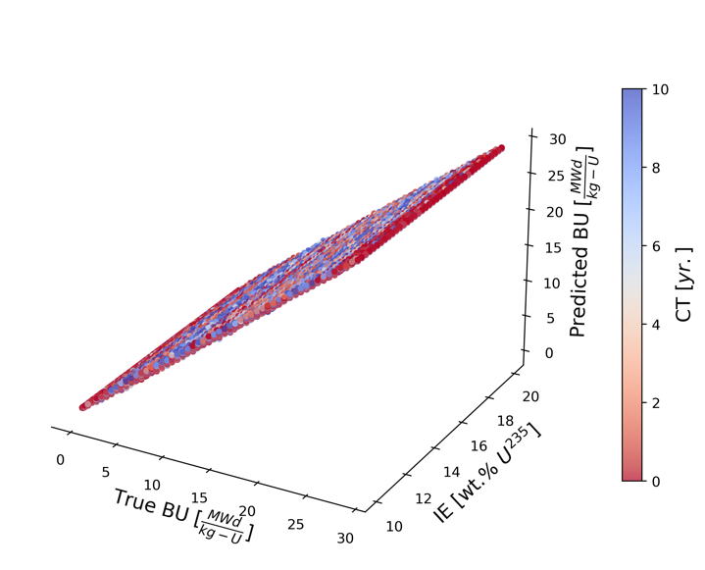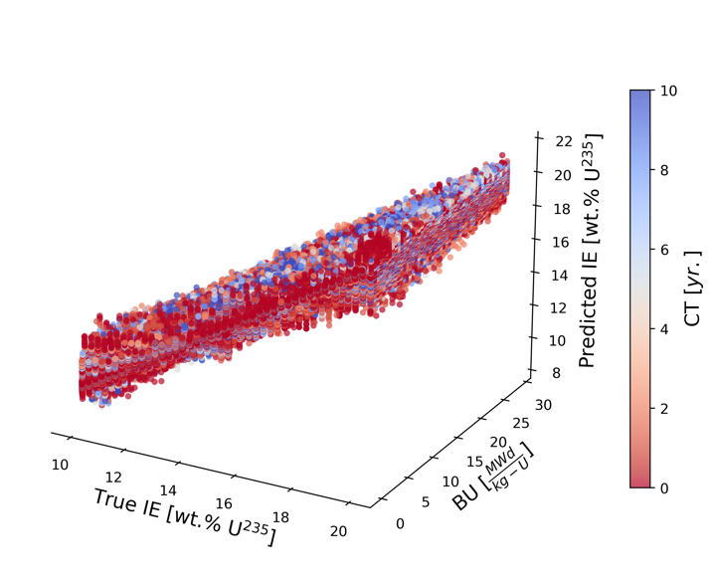

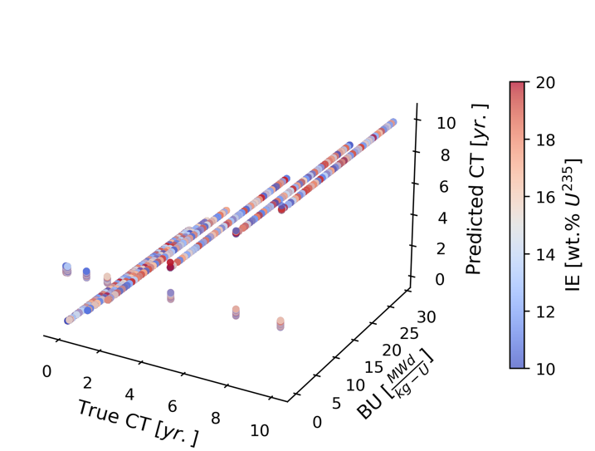

*FIG. 4. 3D scatter lots showing the true vs. predicted Top left: BU as a function of IE and CT, Top Right: IE as a function of BU and CT and Bottom: CT as a function of BU and IE. These figures show how well the ML model can predict the fuel salt’s BIC.*

From the results shown in Fig. 4, it can be seen that it is indeed feasible to deduce the primary salt’s BIC using solely off-gas signatures. With regards to the BU prediction, we see that the model performs well across the entire IE-CT space with a root mean squared error or RMSE of 0.1 MWd/kg-U. For prediction of IE[1], the model performs reasonably well for high BU cases while cases with low BU (coupled with high CT) being the ones with the highest RMSE (with avg. RMSE being 0.4 wt. % U-235). For CT prediction, we found that the model was able to predict all CT values with low RMSE (0.1 yr.) for data with high BU while for low BU, the RMSE was significantly higher (0.8 yr.) where we observed that the model was unable to make predictions and produced an output which was an average of the predicted variable’s range (approx. 5 yr.). This can possibly be mitigated by adding more relevant signatures for the model. Since this work is still ongoing, further details of this work will be published in a future publication [24].

## CONCLUSIONS

In the paper we have presented our findings on the different evaluations of CMSR spent fuel. We foresee that our assessments of the nature of radiation emission from irradiated molten salts from the CMSR and information of the prominent contributors to each type of radiation will be useful for the larger safeguards community in the future when reactors of a similar design and operation enter commissioning and operation. Sufficient knowledge of the source of neutron radiation from these irradiated salts (i.e. from SF or α, n reactions) will be of use in designing measurement strategies and selecting instrumentation for effective material accountancy for irradiated salts. Our assessments of material attractiveness using the OA metric has helped underscore how attractive the spent fuel material from molten salt reactors can be when compared to spent fuel from conventional LWRs. It also provides much needed insight into how the attractiveness of the salts themselves (and not just the attractive material it contains) changes with burnup, enrichment and with cooling time after discharge from the reactor. This information can be crucial in the future to strengthen safeguards measures at points in the fuel cycle where the salts are most attractive or for designing diversion-resisitant solutions for salt storage and transport. Lastly, our work on the application of ML to predict fuel salt’s BIC parameters using non-salt signatures such as those derived from the off-gas system of the CMSR is novel and presents unique benefits such as foregoing the reliance on the highly radioactive, corrosive (also hot), and attractive (from diversion point of view) material for safeguards verification. Therefore, using signatures from the off-gas presents safety and safeguards benefits. As a part of this ongoing investigation, we have also created and published two datasets of safeguards-relevant data that are available online for public use.

ACKNOWLEDGEMENTS

We are grateful to the Swedish Radiation Safety Authority (SSM), Sweden for the financial support under the contracts SSM2022-4698, SSM2017-5980, and SSM2023-4386 that made this work possible.

References

1. MACPHERSON HG. The molten salt reactor adventure. Nuclear Science and engineering. 1985 Aug 1;90(4):374-80.
2. ELSHEIKH BM. Safety assessment of molten salt reactors in comparison with light water reactors. journal of radiation research and applied sciences. 2013 Oct 1;6(2):63-70.
3. CRESPI F EAT AL. Supercritical carbon dioxide cycles for power generation: A review. Applied energy. 2017 Jun 1;195:152-83.
4. WORRALL A ET AL. Molten salt reactors and associated safeguards challenges and opportunities.
5. KOVACIC DN ET AL. Safeguards challenges for molten salt reactors. Oak Ridge National Lab.(ORNL), Oak Ridge, TN (United States); 2018 Aug 1.
6. SCHØNFELDT T ET AL. Seaborg technologies ApS—compact molten salt reactor power barge. In Molten Salt Reactors and Thorium Energy 2024 Jan 1 (pp. 907-918). Woodhead Publishing.
7. MISHRA V ET AL. Assessments of radiation emission from molten salt reactor spent fuel: Implications for future nuclear safeguards verification. In INMM & ESARDA Joint Annual Meeting, Vienna, May 22-26, 2023 2023.
8. LEPPÄNEN J. Serpent–a continuous-energy Monte Carlo reactor physics burnup calculation code. VTT Technical Research Centre of Finland. 2013 Mar 6;4(455):2023-09.
9. MISHRA V ET AL. Irradiated fuel salt data library for a molten salt reactor produced with Serpent2 and SOURCES 4C codes. Data in Brief. 2024 Feb 1;52:109817.
10. MISHRA V ET AL. Data library of irradiated fuel salt and off-gas tank composition for a molten salt reactor concept produced with Serpent2 and SOURCES 4C codes. Data in Brief. 2024 Jun 1;54:110314.
11. ELTER Z ET AL. Pressurized water reactor spent nuclear fuel data library produced with the Serpent2 code. Data in brief. 2020 Dec 1;33:106429.
12. WILSON WB ET AL. SOURCES: a code for calculating (α, n), spontaneous fission, and delayed neutron sources and spectra. Radiation protection dosimetry. 2005 Dec 20;115(1-4):117-21.
13. Rearden BT, Jessee MA. SCALE code system. Oak Ridge National Lab.(ORNL), Oak Ridge, TN (United States); 2016 Apr 1.
14. PRESTON M ET AL. Analysis of radiation emission from MYRRHA spent fuel and implications for non-destructive safeguards verification. Annals of Nuclear Energy. 2021 Dec 1;163:108525.
15. MISHRA V ET AL. Material attractiveness of irradiated fuel salts from the Seaborg Compact Molten Salt Reactor. Nuclear Engineering and Technology. 2024 May 7.
16. LUNDBERG SM, LEE SI. A unified approach to interpreting model predictions. Advances in neural information processing systems. 2017;30.
17. BROUSSARD E. The Future of Atoms: Artificial Intelligence for Nuclear Applications (Chinese Edition). IAEA Bulletin (Online). 2020;61(4):34-5.
18. GRAPE S ET AL. Determination of spent nuclear fuel parameters using modelled signatures from non-destructive assay and Random Forest regression. Nuclear Instruments and Methods in Physics Research Section A: Accelerators, Spectrometers, Detectors and Associated Equipment. 2020 Jul 21;969:163979.
19. MISHRA V ET AL. Comparison of different supervised machine learning algorithms to predict PWR spent fuel parameters. In Proceedings of the Joint Institute of Nuclear Materials Management and European Safeguards Research & Development Association Annual Meeting 2021.
20. BACHMANN AM, COBLE JB, SKUTNIK SE. Comparison and uncertainty of multivariate modeling techniques to characterize used nuclear fuel. Nuclear Instruments and Methods in Physics Research Section A: Accelerators, Spectrometers, Detectors and Associated Equipment. 2021 Mar 1;991:164994.
21. AVDIC S ET AL. Item identification with a space-dependent model of neutron multiplicities and artificial neural networks. Nuclear Instruments and Methods in Physics Research Section A: Accelerators, Spectrometers, Detectors and Associated Equipment. 2023 Dec 1;1057:168800.
22. HELLESEN C ET AL. Nuclear spent fuel parameter determination using multivariate analysis of fission product gamma spectra. Annals of Nuclear Energy. 2017 Dec 1;110:886-95.
23. LINDELL MÅ ET AL. Discrimination of irradiated MOX fuel from UOX fuel by multivariate statistical analysis of simulated activities of gamma-emitting isotopes. Nuclear Instruments and Methods in Physics Research Section A: Accelerators, Spectrometers, Detectors and Associated Equipment. 2018 Mar 21;885:67-78.
24. MISHRA V ET AL. Application of machine learning to predict safeguards parameters for irradiated salts from a molten salt reactor concept [manuscript]. Available from: https://urn.kb.se/resolve?urn=urn:nbn:se:uu:diva-513283

1. Prediction of IE requires neutron signatures from the primary salt as the off-gas has no neutron emitting nuclides