# WESTINGHOUSE ELECTRIC COMPANY: DECARBONIZATION OF THE ELECTRIC POWER SECTOR AND THE CHALLENGES FACING ADVANCED REACTORS TO INCORPORATE SAFETY, SECURITY AND

# SAFEGUARDS MEASURES

JO ANNA BREDENKAMP

Westinghouse Electric Company

Nivelles, Belgium

Email: JoAnna.Bredenkamp@westinghouse.com

IBRAHIM EZELARAB

Westinghouse Electric Company

Pittsburgh, USA

Email: ezelarib@westinghouse.com

THOMAS GRICE

Westinghouse Electric Company / Consultant

Vandalia, USA

Email: thomas.grice@westinghouse.com

**Abstract**

The world is facing a significant challenge of drastically reducing emissions of greenhouse gases while simultaneously expanding energy access and economic opportunity to billions of people [1]. The energy sector, specifically the generation of electric power, has been widely identified as an early candidate for decarbonization [2]. In most regions, serving the projected electricity demand while simultaneously reducing emissions will require a mix of electrical generation assets different from the traditional systems based on fossil fuels. Although a variety of low- or zero-carbon technologies can be employed, the potential contribution that the nuclear sector can make as a low-carbon technology for the generation of electric power is enormous [3].

There are strong incentives for the nuclear industry to reduce the cost of new nuclear plants. However, deploying a first of a kind nuclear technology introduces inherent financial, technical, and licensing challenges. To accelerate the design and licensing processes, system developers must understand the technical interfaces and identify both opportunities for integration and challenges that require reconciliation and novel solutions. Identifying and training qualified personnel in the subject of international safeguards is a challenge for established and proven designers. Reactor physics and thermal hydraulics engineers, experts in physical protection measures, threat analysis and security assessments; and others who understand IAEA safeguards require familiarization with the objectives and constraints of the various program elements to enable early and frequent collaboration in the design campaign.

Westinghouse Electric Company (Westinghouse) is developing a corporate Safeguards by Design program for the **eVinci**™ microreactor. In doing so, Westinghouse is accepting risk into the reactor design process to comply with a set of requirements, which traditionally are based upon the facility location and final design [4, 5]. Reconciling this fundamental change in the process for applying safeguards requires close and meaningful interaction between national, regional, and international safeguards stakeholders and industry in new and challenging ways. The incorporation of international safeguards considerations and technology into the microreactor design forces the integration of the traditionally separate disciplines of safety, security, and safeguards.

## Challenges for Advanced Reactor Designers

As advanced reactors - including microreactors such as eVinci microreactor - enter the nuclear power reactor marketplace, there will be significant differences from earlier generations of power reactors which create new challenges for the IAEA and requires active and early participation of designers and vendors in the safeguards approach and potential verification technology development. Many advanced reactors utilize the constant flow of fuel through the reactor core, making the nuclear material accountancy for the reactor like a bulk handling facility instead of an item facility. Small modular reactors and microreactors may include sealed cores which are fully fabricated at a separate facility and delivered to the owner/operator as a completed reactor, with some being small enough to allow the option of mobility or potential relocation versus remaining at a fixed site. Many advanced reactor designs are inherently safer by using passive controls and safety systems, allowing on-site staff to be minimized or allowing remote operation. Safeguards approaches have historically been analogous to “first of a kind” approach; each reactor’s safeguards approach being a negotiation based on a specific set of facts and circumstances. However, in the case of many advanced reactors, the location of end user/operator will not be known before final design. Each varying aspect of the advanced reactor designs will require careful consideration by the IAEA when developing the specific safeguards approach for these new advanced reactors and their facilities.

### Variable of Unknown Regulatory Requirements

Depending on the country where an advanced reactor is deployed, the domestic and IAEA safeguards requirements can vary. Nuclear facilities, including power reactors located in Nuclear Weapons States with voluntary offer agreements with the IAEA are sometimes subjected to different safeguards measures than similar facilities located in Non-Nuclear Weapons States. There are also differences between the established domestic requirements. For example, the domestic nuclear material accounting and control program in the United States implemented by the U.S. Nuclear Regulatory Commission is designed to strengthen the overall nuclear security program and is focused on detecting and deterring the theft or diversion of nuclear material. However, in the Republic of Korea the program implemented by the Korea Institute of Nuclear Non-proliferation and Control (KINAC) is mainly focused on nuclear transparency and ensuring adequate nuclear material accountancy and control programs for compliance with IAEA requirements. From the aspect of physical protection and safeguards, there are location specific issues directly related to the siting of the reactor which remain unknown until identified by the owner/operator purchasing the power reactor. With the options of urban, rural, industrial and remote deployment, there can be significant differences in readily available resources (infrastructure, trained labor pool, etc.), response times for off-site support, and convenience of physical access. The size and cost of the microreactors mean that deployment will likely include countries that currently have no existing nuclear program or regulatory infrastructure. In such cases, the regulations applicable to the facility may not have even been established. Finally, factory-built reactors may be built and refuelled in a different country than where they are deployed, and the NPT status (weapons or non-weapons) of the two countries may differ. Each if these issues present challenges when trying to devise a strategy for safeguards and security by design concept. Ideally, a harmonized baseline of requirements acceptable to all parties which could be consistently implemented across a wide variety of deployment sites, or a standardized baseline requiring minimal modifications which would be devised and installed during fabrication.

### Interfaces between Safety, Security and Safeguards

There are typically tensions between the safety, security, and safeguards programs resulting from their individual specific goals. Safeguards staff, both IAEA and domestic regulators, need physical access to areas containing the nuclear materials. This access is required to verify the conduct of physical inventories, verify seals, take measurements, and perform regular maintenance of safeguards equipment. Each time these areas are physically accessed, personnel receive radiation exposures, and the nuclear materials are subjected to the increased risk of theft, diversion, or sabotage. Similarly, routine reactor surveillance and maintenance activities, such as plant maintenance, regular radiation surveys, and other safety-related activities present safeguards and security risks. The challenge of ensuring IAEA data independence and integrity, and how IAEA data is transmitted from the facility to the IAEA continue to be a security issue which needs to be carefully and thoughtfully addressed. Concerns over regulatory-related cyber security requirements and concerns over the protection of proprietary information have increased because of the vulnerabilities of using internet as the platform for data transmission. Finally, there could be significant differences in economic, political, and military stability depending on the region and country of deployment. These differences create varying threat levels, requiring tailored security and safeguards measures, and often result in different levels of acceptable risks between States. Many of these issues may be addressed through increased cooperation, coordination, and participation between the safety, security, and safeguards organizations. As each organization becomes more aware of the needs and practices of the other organizations regulatory requirements, the opportunity to find mutually agreeable methods to achieve the necessary goals for each program increase. Ideally, improved engineering solutions, such as improved battery life, higher resolution cameras, and improvements in remote sensors, will provide solutions to some of these issues in the future but new technological solutions will need investment corresponding to the reactor development phase.

### Educating Stakeholders and Necessary Training

In many cases, additional training is necessary to facilitate the interactions between the safety, security, and safeguards program staff. Usually, these groups have very specialized expertise in their particular field, but limited understanding of their counterparts' regulatory requirements and programs elements. The staff on advanced reactor design teams usually consist of physicists and nuclear engineers who understand the nuclear physics, thermal hydraulics, and structural and mechanical systems necessary for the design and safe operation of the advanced reactor but have little or no knowledge related to security or safeguards. Similarly, individuals with experience in physical protection systems, such as barriers and access controls, information security, and threat evaluation, are limited in their knowledge of the nuclear and mechanical engineering disciplines and typical nuclear material accountancy and control program elements and typical IAEA safeguards practices. Finally, many domestic safeguards staff are likewise limited in their knowledge of the nuclear and mechanical engineering disciplines and often lack an appreciation for the controls and requirements established by the security programs. This issue can be addressed through cross-training and increased coordination between organizations.

## Safeguards by DESIGN Implementation

While safeguards by design can be viewed as a part of the solution to the challenges described above, successfully implementing safeguards by design also poses its own challenges. The traditional process for incorporation of safeguards in a reactor installation, in which known design features (as described in a DIQ (Design Information Questionnaire)) are the starting point for a dialogue with IAEA, cannot simply be inserted into the design-development sequence for an advanced reactor without increasing the already substantial degree of schedule and economic risk. Successful implementation of safeguards by design will require greater coordination and integration between the designers and developers, the SRA, and the IAEA, and their respective engineering, safety, security, and safeguards programs, to ensure adequate measures are incorporated into the features of the reactors and associated facilities during the initial design phase to allow each program (operations, safety, security, and safeguards) to achieve their specific missions. The safeguards and to a lesser extent the security discussions have been between regulators and the IAEA with little input or access to industry/designers. The efficient development of more robust interaction with and inclusion of designers in the safeguards discussions is critical to ensuring that the IAEA is able to effectively and efficiently verify the use of nuclear material and maintain the confidence in the effectiveness of safeguards.

A conceptual model of safeguards by design for an advanced reactor design should seek to minimize the incremental schedule and economic risk [4]. Such a model is being developed and pioneered within the Westinghouse eVinci microreactor program, applying three guiding principles:

* Safeguards by design should not interfere substantially with the design, development, or commercialization schedules, or the design of safety-critical systems, for new products.
* Safeguards by design processes should allow the design organization to pursue innovative, non-traditional safeguards concepts that complement the physical designs and business models for new products.
* Safeguards by design processes should seek to minimize incremental schedule and economic risk by identifying, clarifying, and resolving uncertainty early in the design and commercialization sequence.

Together, these principles suggest that there is an ideal phase of reactor design at which the major systems are well-enough defined to allow safeguards features to be conceptualized and yet flexible enough to allow joint optimization to meet both reactor functional and safeguards regime requirements. The highly structured requirements definition and allocation process employed in a competitive advanced reactor program also implies that there is an optimal process for describing and introducing safeguards requirements rather than specific design features. Such an approach should allow implementation of safeguards by design with design flexibility and minimal incremental economic risk.

## eVinci Microreactor Design High Level Overview

Microreactors offer flexibility and potential to revolutionize how carbon-free energy is delivered. Westinghouse’s eVinci microreactor high temperature, heat pipe microreactor is a revolutionary design that can address many challenges standing in the way of carbon-free energy. It is designed for safe and reliable electricity and heat generation and based on the most advanced nuclear technology with a cost-competitive life cycle.

The eVinci microreactor is a transportable microreactor that is inherently simpler, smaller, and more reliable than Generation III reactors due to its solid-state design. There are a limited number of moving parts within the microreactor and minimal required maintenance between refuelling. Decay heat is removed via conduction, natural convection, and radiation heat transfer. The eVinci microreactor design minimizes construction costs and labor because the plant can be installed and placed into operation in less than 30 days for a commercial application. Reactor operation is intended to be automatic.

An eVinci microreactor facility can be installed on a one-acre footprint without deep excavations. The entire facility design is comprised of four containers that house the microreactor and other systems are transportable via existing infrastructure (road, rail, or sea).

*Fig. 1. Containers making up a standard eVinci microreactor facility*

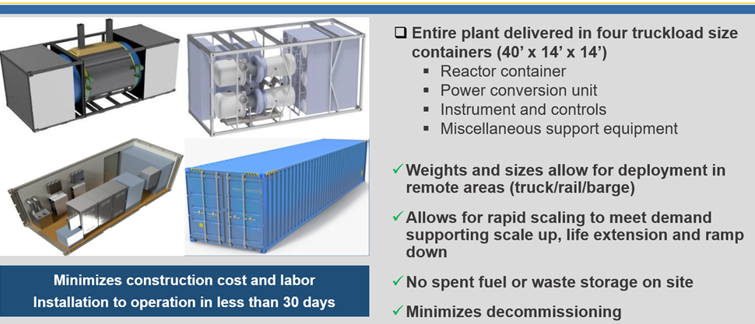

The eVinci microreactor is a thermal neutron spectrum reactor that delivers high temperature heat from the reactor core through passive heat pipes to a primary heat exchanger and in the electrical generation configuration, onward to an open-air Brayton cycle power conversion system. The eVinci microreactor uses HALEU TRISO fuel and each core of fuel will run for at least eight years of full power operation.

The reactor core is enclosed within a canister filled with an inert gas to protect reactor components from oxidation while enhancing heat transfer. The core design consists of a graphite block with repeated, segmented, hexagonal unit cells oriented horizontally along the length of the core. The unit cells contain channels for fuel, alkali metal heat pipes, and shutdown rods. The core is surrounded by a thick radial reflector which houses the control drums. The core alone, without the radial reflector, is subcritical, requiring the radial reflector to achieve criticality. Shielding is used to attenuate gamma and neutron radiation to protect site personnel and the public during operation and transportation. An overview of the reactor is depicted in Figure 2.

*Fig. 2. eVinci Microreactor Overview*

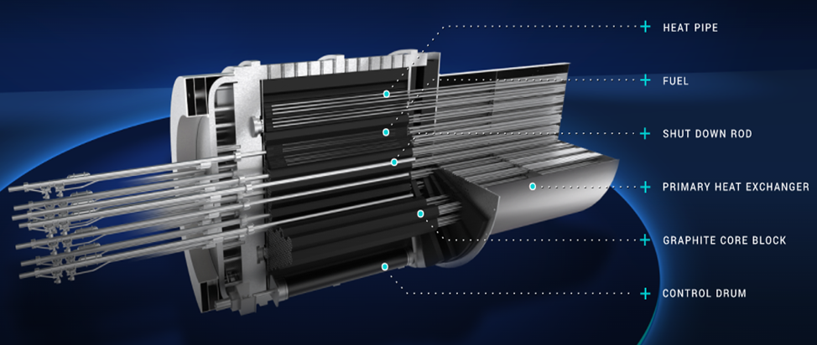

Reactivity control is accomplished using control drums located on the periphery of the core and a burnable absorber incorporated into the matrix material of the fuel compacts. Reactivity is monitored using the power range and source range neutron detectors. Shutdown can be achieved by two diverse and independent means: the shutdown rods and the control drums. Additional shutdown rods are available for postulated accident conditions and to maintain a sub-critical reactor during transportation.

The microreactor is contained within a canister containment system which provides a helium environment for the reactor components and structural support for the reactor. The design of the microreactor allows for decay heat removal through the core block, radial reflector, canister containment system, and shielding. Several layers of the TRISO fuel and the canister together provide barriers to the release of fission products to the environment.

Following approximately eight years of full power operation, a replacement microreactor can be brought onsite and installed in an adjacent reactor container. The depleted reactor is shut down and allowed to cool before transport for disposal while the new reactor is started up and connected to the infrastructure already in place. Spent fuel is not required to be stored onsite.

An example planned layout and configuration for a standard facility is depicted in Figure 3. This configuration is based on a standard one-unit facility with a second replacement enclosure to allow for rapid changeover from one used microreactor to a replacement unit. This concept relies on a single set of support containers (instrumentation, control & electrical; power conversion; and battery storage for load follow applications, see Figure 1). Piping chases are used to connect the reactor with the power conversion system. For multi-unit applications, the units can be replicated identically and installed next to each other, reducing the required footprint/unit.

*Fig. 3. Overview of an example one-unit standard facility*

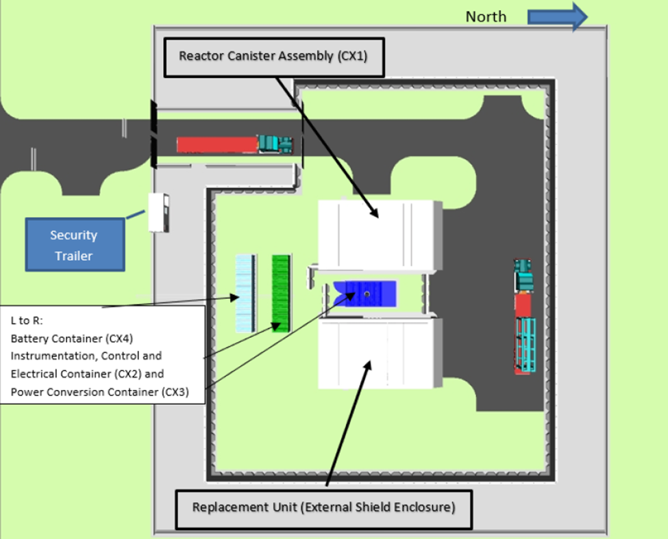

## Safeguards and 3S DESIGN Considerations for eVinci MIcroreactor

Westinghouse is incorporating the 3S concept into the eVinci microreactor design change process. Our Safeguards Integration engineer has identified four areas that require consideration of safety, security and safeguards integration for the eVinci microreactor. These areas present challenges in meeting the safeguards objectives and potential require creative approaches and technical solutions.

### Remote Locations

One potential deployment model of the eVinci microreactor is predicated on installing the eVinci facility at remote locations where there is no access to a utility grid [6]. The remote location in and of itself will present a challenge to provide timely access to IAEA inspectors to perform short-notice inspections. In addition, transporting the reactor from an assembly facility to a remote location for installation and transporting it back for decommissioning could potentially present a greater opportunity for diversion requiring shorter inspection periods.

### Reactor Operations with Limited Operations Staff

The eVinci microreactor will be operated primarily automatically with human oversight through a combination of both onsite staff and offsite monitoring. Safe operation of the eVinci microreactor includes a centralized Remote Monitoring System (RMS). The primary function of the RMS is to monitor the operational unit(s) at all deployment sites. Data captured from the operations can be used to improve operations and to apply advanced technologies such as machine learning. The RMS will provide plant operational information to qualified operations staff who can provide remote assistance to onsite operations staff.

Reactor operation via the Automatic Control System, housed in the Instrumentation, Control, and Electrical Container will take place onsite. The RMS is designed to function as data and process historian of the eVinci microreactor facilities’ operations and to provide analyses of plant response data after an event has occurred. The intent of this operational philosophy is to minimize the size of the operational staff located at site. The limited staff at site will make it difficult to provide support to IAEA staff during planned or unplanned inspections. In addition, it may add increased cost and add an additional burden on the operator of the eVinci microreactor.

### Lack of Space

To be able to fit the entire eVinci microreactor facility in four shipping containers transportable by road, rail, or sea means that space utilization is a significant challenge facing the deployment model. Creative solutions must be incorporated to be able to fit all the necessary systems, structures, and components without violating separation and segregation requirements that are industry standards. The lack of space presents a significant challenge to accommodate additional IAEA sensors and interfacing equipment to support surveillance and monitoring requirements.

### Non-Electrical Applications and Intermittent Operations

The IAEA must confirm that nuclear fuel is not diverted during non-operational modes. However, if the deployment model is predicated on shipping a fuelled reactor to a remote location for operation, it will complicate that task and make it more difficult to compare operating history with content of special nuclear material. Especially, if the reactor is transported mid-core life from one location to a new one for operation. Another consideration for advanced reactors is coupling electrical power generation with industrial uses or power cogeneration for electrical and high-grade heat to support industrial uses. This would increase the number of stakeholders and may impact the facility operations and customers (i.e., increase safeguards burden). In addition, the cogeneration model may also impact the safety & security case due to proximity to other industrial facilities.

## Actions taken by WEC to facilitate the application of safeguards for the eVinci microreactor

Westinghouse has long recognized the importance of the global non-proliferation regime and its importance to enable global nuclear commerce. It also recognized its corporate responsibility and role as a global leader in the nuclear industry to “lead by example” as the need to improve the efficiency of IAEA safeguards drives the need for SBD. To this end, Westinghouse established the Global Nuclear Safeguards and Strategic Export programs to ensure compliance with The International Atomic Energy Agency (IAEA) and country-specific nuclear material and activity requirements and adherence to laws and regulations controlling the export and import of goods, software, and technology. To facilitate the implementation of the SBD concept for the eVinci™ microreactor, the Westinghouse Global Nuclear Safeguards program has devoted considerable time and resources to educate multiple reactor design related disciplines and consistently worked to seek early engagement with State regulators and the IAEA.

To accelerate the design and licensing processes, system developers must understand the technical interfaces and identify both opportunities for integration and challenges associated with 3S that require reconciliation and novel solutions. Identifying and training design engines in the subject of international safeguards and facilitating the integration of Safety, Security, and Safeguards (3S) requirements was a crucial first step in this process. In 2022, a team of Westinghouse engineers participated in a three-day International Safeguards training to develop the safeguards approach for the eVinci™ microreactor at Los Alamos National Laboratory [7]. Westinghouse also established a Cooperative Research and Development Agreement (CRADA) with multiple U.S. National Laboratories and participated with the DOE/NNSA Advanced Reactor International Safeguards Engagement (ARISE) program to review and identify safeguard measures likely to be employed by the IAEA at a generically designed eVinci™ microreactor facility [8–12]. This effort included the preparation of a draft design information questionnaire (DIQ) for the eVinci™ microreactor at the generic facility to provide the team with insights into the expectations of the IAEA and potential safeguards technical measures that could potentially be applicable for the eVinci™ microreactor and the generic facility which could be impacted by their designs. These training activities are part of a more significant cooperative effort between Westinghouse and the U.S. Department of Energy (DOE), including its National Nuclear Security Administration (NNSA)'s Office of International Nuclear Safeguards and Office of International Nuclear Security, as well as the DOE Office of Nuclear Energy Domestic Safeguards programs.

## Westinghouse long-term actions to institutionalize safeguards by design

Westinghouse has initiated the Joint Licensing Process for eVinci™ microreactor with the United States Nuclear Regulatory Commission (U.S. NRC) and the Canadian Nuclear Safety Commission (CNSC) [13]. This process affords an opportunity for early engagement not just for the safety and security aspects of the licensing process but also for discussion of domestic and IAEA safeguards features. More specifically, in May 2022 Westinghouse and the Saskatchewan Research Council (SRC) signed a Memorandum of Understanding to jointly develop a project to locate an eVinci™ microreactor in Saskatchewan to further explore industrial, research and energy use applications.  As the Westinghouse design team customizes the final design of the eVinci™ microreactor and its facility, they will be able to place into practice the formal Westinghouse SBD process and incorporate all elements of the 3S programs in the design and receive valuable feedback and insights from the U.S. NRC and CNSC on anticipated safeguards technical measures and associated design requirements. Additionally, Westinghouse has been working to establish a non-traditional agreement directly with the IAEA. This agreement seeks to create a mechanism to allow Westinghouse to provide early design information, preliminary DIQs, and additional documentation (as agreed upon) to the IAEA for their evaluation, and feedback as appropriate. The goal of these early engagement efforts is to establish a solid baseline of 3S requirements allowing the eVinci™ microreactor design team to utilize the SBD process to make any necessary design modification required to facilitate the actual implementation of IAEA safeguards technical measures at the site. Establishing this baseline allows standardization of the generic eVinci™ microreactor and facility, a crucial step in allowing the modular manufacturing process and minimizing the financial risks associated with the persistent need for customization based on the eVinci™ microreactor’s location and operating parameters.

To institutionalize this commitment to the SBD concept, Westinghouse has formally incorporated SBD and the integration of 3S into the formal eVinci™ microreactor design, review, and approval process. This ensures that along with required safety measures, both security and safeguards aspects are given full consideration throughout the design process allowing much greater collaboration and integration of the safety, security, and safeguards aspects related to the eVinci™ microreactor and facility designs. Furthermore, Westinghouse is incorporating the SBD process and the integration of 3S into its AP300 and AP1000 reactor programs. This had included engaging in safeguards discussions and providing safeguards training to customers and future operators to ensure they are cognizant of safeguards obligations, understand the anticipated safeguards technical measures, and establish contractual pathways for ongoing engagement and assistance.

## Conclusion

Westinghouse has identified both opportunities and challenges incorporating safeguards by design into the eVinci microreactor. In our experience, stakeholders in safeguards often use different terminology and language to express common objectives. In the case of international safeguards, bridging the language differences was the initial step to developing internal support for a corporate safeguards program. Westinghouse focussed on executive training to articulate the value of supporting the non-proliferation regime, which is the legal framework that enables commercial nuclear trade. Safeguards by design was presented as a long-term economic investment that could reduce risk to future budget and schedules and provide market access as a competitive advantage. The next step was to cross train a broad spectrum of technical staff on international safeguards objectives and technologies. The technical training provided the different perspectives to understand the requirements impact on their specific disciplines for current and advanced designs. The new requirements will result in additional risk and design cost increases in the short term. However, initial reviews have identified technical areas that will require new approaches and or technologies to meet the objectives of safeguards that would have required fundamental redesigns in the future.

In summary, the eVinci™ microreactor brings a plethora of unique features into the realm of power reactor designs. From its sealed core and utilization of heat pipe technology to its compact size and transportability, it creates both plentiful prospects for deployment and novel challenges for the integration of 3S and SBD concepts. Westinghouse has recognized the need for integrating the 3S elements and using the SBD process for facilitating the implementation of IAEA safeguards technical measures at their reactor facilities and taken positive steps to make certain the 3S needs of the global non-proliferation regime can be addressed by Westinghouse and its customers.

References

1. Buongiorno, Jacopo et al. Nuclear energy in a carbon-constrained world: Big challenges and big opportunities, IEEE Power and Energy Magazine, 17, 2 (February 2019) 69-72.
2. International Atomic Energy Agency. (2022), Climate Change and Nuclear Power 2022. Retrieved from International Atomic Energy Agency: <https://www.iaea.org/resources/brochure/climate-change-and-nuclear-power-2022/>
3. National Academies of Sciences, Engineering, and Medicine. 2024. Accelerating Decarbonization in the United States: Technology, Policy, and Societal Dimensions. Washington, DC: The National Academies Press
4. Wood, T., Bredenkamp, J., Grice, T., Implementing Safeguards by Design for an Advanced Reactor (Proc. 64th Institute of Nuclear Materials Management Annual Meeting, Vienna, 2023), Institute of Nuclear Materials Management, New Jersey, USA (2023)
5. Grüum, H., IAEA safeguards: Milestones in development & implementation, International Atomic Energy Agency. IAEA BULLETIN, 3/1987 (1987) 29-34, https://www.iaea.org/sites/default/files/29303452934.pdf
6. Westinghouse Electric Company, eVinci™ Microreactor Clean Energy Solution for Mining, (2023), https://westinghousenuclear.com/data-sheet-library/evinci-microreactor-clean-energy-solution-for-mining/
7. Bredenkamp, J, Westinghouse Electric Company, LinkedIn post, (2022). https://www.linkedin.com/posts/jo-anna-bredenkamp-4140a9200_proud-to-be-part-of-westinghouse-and-leading-activity-6950534731276951553-rpJa/
8. U.S. Department of Energy, Office of General Counsel, DOE Order 483.1B, DOE COOPERATIVE RESEARCH AND DEVELOPMENT AGREEMENTS, (2019), <https://www.directives.doe.gov/directives-documents/400-series/0483.1-BOrder-b-chg2-ltdchg/@@images/file>
9. U.S. Department of Energy, e Technology Transfer Working Group, Guide to Partneing with DOE’s National Laboratories, (2013), https://www.energy.gov/sites/default/files/2020/10/f80/ttwg-partnering-guide.pdf
10. U.S. Department of Energy/National Nuclear Security Administration, Office of Nonproliferation and Arms Control, Advanced Reactor International Safeguards Engagement Program, (2022), <https://nuclear-nexus.anl.gov/nexus/files/ARISE_Flyer.pdf>
11. Scott, L., ARISE Program Overview (2024), https://energy.sandia.gov/wp-content/uploads/2024/05/04-Scott-ARISE-Program-Overview-1.pdf
12. Cipiti, B., “Advanced Reactor Safeguards ARS Program Overview & FY23 Planning”. Presented at the ARS Spring Meeting, Albuquerque, New Mexico, USA, 2022
13. Westinghouse Electric Company, Westinghouse Begins Joint Licensing Process with U.S. and Canadian Regulators for eVinci™ Microreactor (2023), <https://info.westinghousenuclear.com/news/westinghouse-begins-joint-licensing-process-with-u.s.-and-canadian-regulators-for-evinci-microreactor>

***eVinci*** *is a trademark or registered trademark of Westinghouse Electric Company LLC, its affiliates and/or its subsidiaries in the United States of America and may be registered in other countries throughout the world. All rights reserved. Unauthorized use is strictly prohibited. Other names may be trademarks of their respective owners.*

©2024.  Westinghouse Electric Company LLC.  All Rights Reserved