# Decarbonizing Refining Processes:

# SMR deployment paving the way to Synthetic Fuels

FABIO NOUCHY

Tractebel

Brussels, Belgium

Email: Fabio.nouchy@tractebel.engie.com

CELESTIN PIETTE

Tractebel Inc.

Toronto, Canada

LUDOVIC FERRAND

Engie Lab Crigen

Stains, France

REEYADH KHAN

Tractebel Inc.

Toronto, Canada

JO REGA

Tractebel

Brussels, Belgium

**Abstract**

While petroleum-based products constitute a primary contributor to global carbon emissions, our current lifestyle will remain reliant on them for decades to come due to their high energy density and the established infrastructure. Fossil fuels are also integral to various non-energy sectors as they serve as key raw materials in the production of a wide range of products, including plastics, fertilizers, and other industrial chemicals.

However, there is an opportunity to mitigate their environmental impact by focusing on the decarbonization of the crude oil value chain: from the upstream extraction to the downstream retrofit of refining processes to lower products carbon footprint. A more ambitious approach involves repurposing existing installations to facilitate the production of synthetic fuels.

The whole process can be planned in the framework of a nuclear Small Modular Reactor (SMR) deployment strategy, with the goal of co-locating these advanced technologies in proximity to refineries, capitalizing both on the benefits of high-temperature steam for diverse applications and on a reliable supply of electricity.

This paper presents a case study focusing on an oil refinery, delineating the challenges and opportunities associated with transitioning away from fossil fuels. After a brief introduction on the challenge ahead, the study will describe key aspects such the intricacies of typical streams, products, and processes within refineries. Then it will address the considered scenarios for decarbonizing existing installations through the use of SMRs, and conclude with a hazard assessment on the co-location. This exploration provides insights into the feasibility of transitioning towards sustainable alternatives in the refining industry.

## INTRODUCTION

To achieve long-term sustainability, the energy transition must address the challenges known as the energy trilemma:

* Limit human impact on the environment without compromising future generations’ options, in particular: land use, biodiversity, comfort (landscape, noise, etc.), water use, waste accumulation, pollutant rejection and greenhouse gas emissions;
* Secure energy supply: the COVID crisis and the current European energy crisis have reminded us that shortages of critical resources such as medical supplies or energy can jeopardise a whole country’s autonomy and paralyse its activities;
* Ensure affordable energy access: as our entire economy is based on transformed energy, this is a prerequisite to societal prosperity.

According to IEA 2021’s numbers, out of 168,000 TWh of final energy consumption, ~80% are supplied by the combustion of fossil fuels [1], with oil in the leading position accounting for approximately 31% of global primary energy consumption in 2021 [2]. Moreover, oil is integral to various non-energy sectors: it is a key raw material in the production of plastics and synthetic materials found in a wide range of products, from packaging to clothing to electronics, an ingredient in mainstream cosmetics, personal care products, chemicals, and pharmaceuticals, it is used in the production of pesticides and fertilizers for agriculture and construction material like roads.

Despite the efforts in reducing our dependence on petroleum-based products during last century, the path to a more sustainable economy is still long and will start by decarbonising the existing petroleum value chain: extraction and production of crude oil, transportation, refining, manufacturing of (alternative) derivatives and distribution.

While an analysis of the upstream decarbonization with SMR has been performed by Hatch [3], this paper will focus on the downstream part of the crude value chain, especially on the future role that Small Modular Reactors (SMRs) can play in decarbonizing refining processes. Since refineries are complex installations, a first chapter synthesizes the key observations on challenges, high-level energy balance and CO2 balance to frame the discussion. The consequent main considerations are outlined in the subsequent chapter.

Furthermore, as stated in [4], the major contribution of total life cycle emissions of crude oil are associated with the end-use of its derivative; namely fuels used in the transportation sector. Therefore it is further discussed about the way to produce sustainable fuels for those hard-to-abate sectors, such as aviation.

### The reason for SMRs

Several low-carbon solutions to deliver industrial heat are under investigation to transition away from fossil fuels:

* *Direct Electrification* via the exemplar application of heat tracing systems to maintain or raise the temperature of pipes and vessels or the use of torch plasma in several applications needing a high-temperature heating source. This solution requires flexible and reliable supply of low-carbon electricity.
* *Heat pumps*, also powered by electricity, are good solutions for low temperature heat applications, but cannot reach the high temperatures needed for industrial processes. Current state-of-the-art of large industrial heat pumps covers a temperature range in between 80 to 200°C.
* *Fossil fuels* coupled with carbon capture, a proven technology that has strategic importance when using the captured carbon molecules to produce synthetic fuels. On the other hand, carbon storage technologies do not have yet a good record of successful projects and raise the question of effectiveness of long-term storage [5].
* Hydrogen-based *synthetic fuels*, like hydrogen itself through water electrolysis or more complex molecules like eMethane by complementing the transformation process with the Sabatier reaction. The sustainable and scalable sourcing of both electricity and CO2 is a non-trivial equation to answer for this solution.
* *Nuclear heat* is discussed hereunder.

The output of a nuclear reactor is essentially heat, which historically has been converted into electricity. However, enhanced by specific features of SMRs, namely higher operating temperature, and better size compatibility leading to high-availability factor via N+X redundancy and smaller footprint, nuclear energy can offer both low-carbon electricity and process. In fact, smaller footprints allow the opportunity to place the SMRs near existing industrial areas, either on the same brownfields where the current technology is, or on nearby greenfield sites.

More specifically, High Temperature Reactors, can deliver useful steam in a range between 500-600°C which is widely needed in distillation steps of chemical and petrochemical processes. While a few years ago SMRs were a concept that was only presented at conferences, there are not anymore theoretical solution as two prototypes were constructed in Russia and China, while other projects are well under development in different countries around the world, sometimes driven by industrial stakeholders.

## OBSERVATIONS on refining processes

### The challenge to decarbonize refining processes

Refinery installations are industrial complexes where crude oil, which is virtually unusable in its natural state, is transformed into valuable and usable commodities such as gasoline, diesel fuel, asphalt base, heating oil, kerosene, and liquefied petroleum gas. This is achieved through a series of chemical processes such as distillation, cracking, coking, reforming, and treating, that separate the oil into its component parts and then refine these parts into end products. Every process requires huge quantities of heat, as high as dozens of megawatts. It is not the purpose of this paper to describe them in detail, whereas in the bibliography one can find a complete overview of the processes. The complexity of refinery installations lies in the intertwined and interconnected series of chemical processes involved, separated in various separated units further compounded by the need for environmental compliance, waste management, and the handling of by-products. Due to the nature of their processes, refineries must adhere to strict environmental regulations to minimize their impact on the environment.

The primary source of CO2 emissions is considered “inherent” as it is a co-product of the catalyst regeneration process that occurs in the cracking unit. During this process, heavy hydrocarbons are cracked into lighter ones, leading to the formation of coke on the catalyst. The subsequent regeneration of the catalyst results in the release of carbon dioxide. The resulting emission stream, i.e. a dilute mix of CO and CO2 due to the large nitrogen content of air, challenges valorization efforts.

On the other hand, some “inherent hydrogen” is also produced by reforming units, upgrading fractions of crude oil into high-octane reformates. This hydrogen has the intrinsic potential for valorization into production of synthetic fuels, although it needs to undergo a purification system. Besides, partly can be used for the processes of desulfurization, hydrocracking, hydrogenation, catalysis, etc. within the refinery.

The other greenhouse gas emissions in a refinery originate from the combustion of fossil fuels such as methane or other heavier volatile fraction, which are used as energy sources in various process units, such as boilers and fired heaters, using radiative heat from combustion flames to render the units more compact and efficient.

The most important parameter to consider while planning to decarbonize heat-driven processes and assess the viability of SMR as a solution is the temperature. Table 1 gives a few examples of units, with their temperature ranges. It is observed that the useful heat spans a temperature range from ~100°C to ~750°C. Although this range is mostly covered by advanced nuclear technologies, this heat is mainly conveyed via fired heaters that transfer heat via radiation and convection onto tubes. These tubes circulate crude or other derivatives, effectively transferring the heat. This method ensures direct and efficient heat transfer to the fluid being processed, allowing for more compact heat exchangers.

TABLE 1. TYPICAL TEMPERATURE RANGES OF MAIN REFINING PROCESSES

|  |  |
| --- | --- |
| Unit type | Indicative temperature range [°C] |
| Boiler | 100-400 |
| Hydrofiners / hydrotreaters | 250-350 |
| Reforming | 200-550 |
| Vacuum | 400-500 |
| Cracking | 300-750 |

### Energy balance

At a macro level, most of the energy content (well above 90%) inherent in the main input for the processes, crude oil, is preserved within the refined and transformed products. The remaining energy of the initial crude oil primarily consists of light volatile fractions and is utilized either as a heat source for the transformation processes within the refinery or for as a feedstock, e.g. for hydrogen used for desulfurization. It is worth mentioning that refineries do not necessarily operate independently but rely sometimes on external intrant of natural gas, either to be used as back-up (as reliability is paramount for such asset) or to enrich the calorific content of some off-gas valorized on-site.

When examining more closely the process ensemble, it becomes evident that the energy consumption is unevenly distributed across the process units, varying significantly from a few MW to about 100 MW. However, the distribution of heat quality – or temperature – is more uniform. As said above, the range of temperatures spans from ~200°C to ~500°C, which would allow clustering of processes under the same initial heat source and that are reachable by most Gen-IV reactors.

### Carbon dioxide balance

As mentioned in section 2.1, the cracking unit is the single largest source of CO2 emissions. The process consists of transforming a diversity of heavy fractions into lighter products, with a larger H/C ratio. Excess carbon (coke, ≈5% of the heavy fraction load) binds to the catalyst that circulates in the reactor. This catalyst loops from the reactor to the regenerator, where coke is oxidized into CO and CO2 by an air feed. The off-gas from the cracking unit being rich in carbon monoxide, it is then brought to a utility boiler where CO is fully burnt. The final CO2 emission point from the cracking unit is thus the stack of this dedicated utility boiler.

CO2 emissions from combustion used for heat supply (such as in boilers and fired heaters) can be mitigated by substituting the heat source. However, the coke and then carbon oxides generated during fuel cracking catalyst regeneration is inherent and unavoidable, as it is an integral part of the chemical process.

The other sources of CO2 emissions of the refineries come from the combustion of the so-called fuel gas or tail gas, which are produced in the different refining processes and include methane, ethane, propane, butane and hydrogen. Instead of simply flaring the fuel gas, they are collected and burnt to supply heat for the different processes of the refinery, releasing CO2 emissions at boilers and fired heaters stacks.

It is therefore important to address both the inherent carbon content in the form of off-gas and the heat source of the different processes. The former can become a resource for synthetic fuels for harder-to-abate uses, while the latter can be supplied by low-carbon heat sources instead.

## DISCUSSION

### Macro-considerations on SMR deployment

Nuclear energy is a new technology to be introduced within petrochemical ecosystems, hence the “path of least resistance” principle should be applied: a graded step approach is desirable over large investments in support of one or a few conversion campaigns to achieve the decarbonisation targets (concept depicted in Figure 1). This means that:

1. The planification of energy assets transition should be graded as to leave room for “learning by doing”;
2. Priority should be put on the conversion of assets requiring few to no re-engineering as to minimize complexity and CAPEX investment;
3. With the disruption of the current Product & Energy balance, applications bringing additional value (new cash-flow streams) should be prioritized.

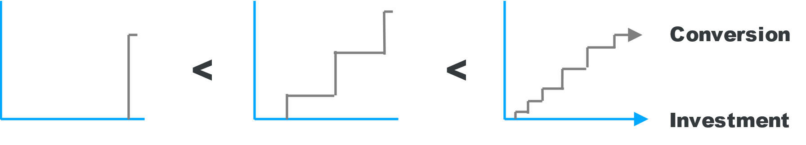

*FIG. 1. Conversion approaches of energy assets.* *The asset conversion is plotted against the investment effort for three different cases, starting from the least desirable (one conversion campaign, left plot), followed by campaigns grouping assets in only a few categories (central plot), ending with the approach recommended by this paper (right plot).*

As the future market of refined products is changing and uncertain (e.g. expected decrease of gasoline consumption vs. expected increased demand for Sustainable Aviation Fuel), special attention should be put on: scalability, options and exit doors.

From a technical perspective, nuclear heat cannot directly replace fired heaters. However, the combustion flames are not directly interacting with the substrate undergoing transformation, contrary to a concrete kiln as an example. Indeed, the better thermal transfer of radiative heat allows for more compact equipment.The heating phase precedes the material's transfer to a separate unit for further physical or chemical processing. Hence, alternative heat transfer methods, such as convective transfer using fluids like steam, or thermal oil could offer better compatibility with nuclear heat sources.

### A way to synthetic fuels

With a reliable low-carbon source such as nuclear, the way towards a circular carbon economy, although arduous, is at reach when combined with technologies of Carbon Capture and Usage and conversion of biomass and plastic waste into polymers. Reference [6] made a comprehensive perspective on these processes around the refinery of the future, that is an important complement to this paper for further knowledge expansion.

The processes that can enable production of synthetic fuels are:

* For Diesel/kerosene
  + Carbon Capture from point sources (available at industrial scale) and Direct Air Capture. Pyrolysis of biomass and plastic waste could also become sources of CO2;
  + Electrolysis for H2 production;
  + Reverse water gas shift or CO2 Reduction Reaction – to obtain CO from CO2. Biomass gasification can also become a source of CO;
  + Fischer-Tropsch synthesis, producing a mixture of linear hydrocarbons that can then be converted into the required carbon range
* For methane, the Sabatier reaction that combines carbon dioxide and molecular hydrogen is a proven process.
* Other functional molecules such as aromatics (which are required molecules for jet fuels) can be obtained by the methanol-to-hydrocarbon process, or after depolymerisation of biomass.

Figure 2 shows an example of an integrated system using the abovementioned processes in a future refinery. In the existing FCC units, a constant stream of Oxygen from nuclear-powered electrolysers will replace air, hence producing a concentrated stream of CO2 and water vapour, simplifying Carbon capture and reducing NOx emissions. The stream of CO2 can yet feed a reverse water-gas shift reaction and be converted to CO, which in its turn becomes the main input of the Fischer-Tropsch reaction, producing synthetic fuels. In parallel, exhaust gases (so-called fuel gases that are a mix of co-products from different processes), are the input into membranes that can separate H2 content from the hydrocarbons matrix. This exhaust gases are usually burnt in boilers or fired heaters to satisfy the refinery heat requirements: these heat needs being replaced by SMR heat supplies, leaving exhaust gases available for other usages, while avoiding CO2 emissions. To achieve this goal, we propose to mobilize low-carbon electricity to be used in future pyrolytic units, fed with the hydrocarbons gases, to further obtain high-quality hydrogen for other uses, potentially external, leaving solid carbon as only side product.

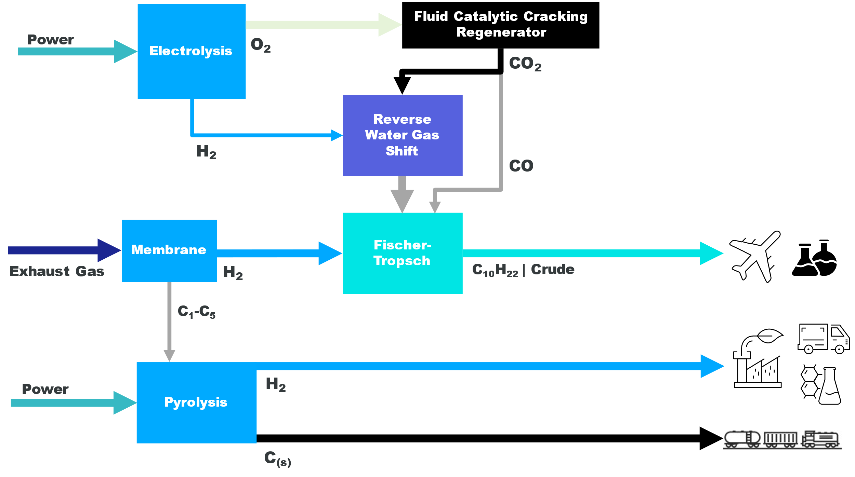

*FIG. 2. Simplified process for a first repurposing of an existing asset (FCC) and a waste stream (exhaust gas) from a refinery to produce synthetic fuels.*

Reference [6] implied a need for power of around 5.5 GW for one average future refinery, that could be covered by areas of 104 km² for solar PV panels and 722 km² for wind turbines. The same demand would require only a few km² from a nuclear energy plant, while leveraging the proximity of the power plant to the refinery. As co-locating two hazardous installations raises questions in terms of risks, we discuss these in the next section.

### Hazard assessment

When co-locating an SMR and a refinery, attention must be paid to the potential for harmful effects between both entities, including the potential interactions introduced at the interface between SMR and end user. As an example, any harmful events like a pool fire or vapor cloud explosion originating from the refinery shall be considered in the SMR’s design and safety demonstration; meanwhile the vicinity of the SMR should not impair the safety of the refinery.

Historically, such scenario’s have been included as an external human-induced hazard in the safety demonstrations of large nuclear power plants that were constructed near industrial facilities, like the Belgian NPP of Doel, which is located in the Antwerp harbour, one of the largest petrochemical clusters in the world. Documents like IAEA SSR-1 and IAEA SSG-68 can be cited to provide guidance in characterizing the hazardous events and design the reactor against direct and indirect effects, like heat, smoke, root, pressure wave, explosion induced missiles, etc. In general, the spacing requirement to prevent damages to buildings important for Nuclear Safety is limited to a few hundreds of meters, thanks to a rapid reduction of the explosion overpressure, roughly inversely proportional to the separation distance to the third power [7]. A distance below 100m has been found in an internal study considering the full hydrogen content explosion in a 100 MW electrolyser facility [8].

These approaches can be used for an SMR, considering a graded approach and the specific design features (e.g. underground construction of the nuclear island and protection of passive safety features).

The application of such approaches typically results in a robust building design, using design loads derived from a specific hazard assessment and considering the layout of both entities and their geographical separation. A particular point of attention would be to avoid explosive gas from entering the nuclear buildings, e.g. by using gas detection that close the air intakes in case such cloud is passing by.

## CONCLUSION

Refineries are the backbone of the fossil-fuel based society that powered the 3rd industrial revolution. In order to make the 4th industrial revolution reliant on carbon-neutral energy sources, refineries need to undergo a deep and thorough conversion process. This paper gives an overview of the main processes within refineries while highlighting the challenges of the transformation. Although processes and technologies are available to shift towards decarbonised crude industrial derivatives and synthetic fuels, a major challenge is imposed by the need for reliable and abundant energy supply, where Small Modular Reactors can be a major solution.

Tractebel, when mandated to conduct investigation on existing assets, did not identify red flags for the integration of SMRs with refineries, neither from a technical standpoint nor from a regulatory standpoint. Several options exist, however the transformation process should follow the “path of least resistance”, converting first the power supply of assets requiring no re-engineering to minimize complexity and CAPEX investment.

References

1. INTERNATIONAL ENERGY AGENCY, World Energy Balances: Overview – Analysis (2021), <https://www.iea.org/reports/world-energy-balances-overview/world>
2. BP, Statistical Review of World Energy, internal report, 2021
3. Hatch, “Small Modular Reactors: Feasibility Study for Oil Sands Applications (SAGD Facility)”, internal report, 2023
4. Hatch, “Navigating the path to decarbonization: strategies for oil refineries” (2023), <https://www.hatch.com/About-Us/Publications/Blogs/2023/09/Navigating-the-path-to-decarbonization-strategies-for-oil-refineries>
5. ROBERTSON, B., MOUSAVIAN, M., “The Carbon Capture Crux: Lessons Learned”, Institute for Energy Economics and Financial Analysis, internal report, 2022
6. VOGTL & WECKHUYSEN. “The refinery of the future”, <https://doi.org/10.1038/s41586-024-07322-2>, Springer Nature Limited (2024)
7. American Institute of Chemical Engineers, Inc., Guidelines for Evaluating Process Plant Buildings for External Explosions, ISBN 978-0-470-64367-9, John Wiley & Sons, Inc New York, NY (2012)
8. SEYS, D., “100 MW – 1GW Electrolyzer External Hazards – Preliminary assessment”, Tractebel internal note, 2020

BIBLIOGRAPHY

TREESE, S., Handbook of Petroleum Processing, ISBN 978-3-319-14529-7, Springer International Publishing Switzerland (2015)