Evaluating the Viability of Small Modular Reactors for Non-Electric Applications in Kuwait: A Preliminary Assessment

B. Almutairi

Kuwait Institute for Scientific Research

Shuwaikh, Kuwait

Email: bamutairi@kisr.edu.kw

S. Alsanad

Kuwait Institute for Scientific Research

Shuwaikh, Kuwait

**Abstract**

Small Modular Reactors (SMRs) are at the forefront of nuclear technology innovation. They present a potential solution to the increasing energy demand while achieving net zero emissions by 2050. The operational flexibility of SMRs is a key focus, as they provide power for processing heat for industrial applications, desalination, hydrogen production, and electricity generation.

In the context of Kuwait, which presently lacks a nuclear power infrastructure, SMRs emerge as a potential solution for meeting the nation’s specific energy requirements and sustainability ambitions, including achieving the goal of net zero emissions by 2050. Our analysis leverages the IAEA comprehensive database on SMRs to provide policymakers with the latest advancements in SMR technologies if Kuwait decides to pursue a nuclear power program. While acknowledging that a Reactor Technology Assessment (RTA) requires an extensive, multidisciplinary effort and continuous stakeholder engagement that can evolve over the course of developing a nuclear power program, a preliminary RTA was conducted. This assessment aimed to determine the most suitable SMR technologies for Kuwait, focusing on reactor types and operational temperatures for cogeneration applications that could contribute to decarbonizing the desalination and oil/gas sectors.

Our findings indicate that Pressurized Water SMRs (PW-SMRs) are especially well-matched for lower-temperature applications, making them an ideal option for Kuwait’s desalination industry. PW-SMRs can supply electricity for desalination plants employing reverse osmosis technology and serve thermal processes in multi-stage flash distillation (MSF) and multiple-effect distillation (MED) plants. Concurrently, SMRs designed as high-temperature gas-cooled reactors are recognized for their potential to facilitate high-temperature industrial processes that can be utilized in the upstream and downstream oil sectors and for hydrogen production.

## INTRODUCTION

Kuwait, strategically located in the northeastern Arabian Peninsula, has substantial hydrocarbon reserves owing to its advantageous geological conditions. Spanning an area of approximately 17,820 km² and housing a population of around 4.2 million, Kuwait boasts one of the world's largest crude oil reserves, establishing itself as a pivotal player in global oil production [1-4]. Despite this, Kuwait is shifting its focus towards a diversified, sustainable energy future aligned with evolving global energy narratives.

The Ministry of Electricity, Water, and Renewable Energy (MEWRE) manages Kuwait’s extensive provision of subsidized electricity and water, resulting in one of the highest per capita energy consumption rates globally, recorded at 17.3 MWh in 2021. Since 2002, the average electricity consumption per capita has stabilized around 16 MWh, significantly higher compared to the per capita electricity consumption in the Middle East (4.3 MWh), Europe (5.6 MWh), and OECD countries (7.9 MWh) [5-7].

In 2022, Kuwait's peak electricity demand peaked at 16.18 GW, against an installed capacity of 20.25 GW, marking a 2.5% annual growth from 2021 [8-9]. This increasing peak load, as illustrated in Fig. 1, signals higher consumption and/or an expanding consumer base. Continuing this trend could constrain Kuwait's energy export capabilities, underscoring the critical need to explore alternative energy sources.

FIG. 1. Peak Load vs Total Installed Capacity in Kuwait (1993-2022).

The 1970s saw Kuwait’s initial exploration into establishing a Nuclear Power Plant (NPP), a plan deferred due to economic factors and the 1986 Chornobyl incident. Renewed interest in nuclear energy emerged in the early 21st century, driven by rising oil prices and advancements in nuclear technology [10]. In 2009, the Kuwait National Nuclear Energy Committee (KNNEC) was formed to study nuclear reactor options, but the Fukushima-Daiichi disaster in 2011 led to the committee’s dissolution [11-15]. This incident promoted stricter global safety standards, promoting passive safety systems and Small Modular Reactors (SMRs) [16-18].

Historically, Kuwait’s nuclear ambitions centered on large traditional water-cooled reactors. However, SMRs now present a versatile alternative with various cooling methods and non-electric applications. Neighboring countries like Saudi Arabia and Jordan are also investigating SMR technology for diverse uses [19-23]. Globally, nations including the USA, UK, Canada, China, Russia, Korea, and Argentina are advancing SMR designs, reflecting a growing international interest in this innovative technology.

Kuwait’s MEWRE forecasts indicate an installed capacity of 31.3 GW by 2028, with peak load expectations reaching 20.9 GW by 2030 and anticipated electricity generation of 155.7 TWh, a 72.2% increase from the 2023 level of 90.3 TWh, as indicated in Table 1 [9]. These projections highlight the urgent need for strategic planning and substantial energy sector investments to meet future demands.

TABLE 1. FUTURE ESTIMATES OF PEAK LOAD AND GENERATION OF ELECTRICAL ENERGY DURING 2023–2030

|  |  |  |
| --- | --- | --- |
| Year | Expected Electrical Energy Generation  (M. kWh) | Peak Load  (MW) |
| 2023 | 90311 | 16707 |
| 2024 | 97626 | 17250 |
| 2025 | 105534 | 17812 |
| 2026 | 114082 | 18391 |
| 2027 | 123323 | 18990 |
| 2028 | 133312 | 19608 |
| 2029 | 144110 | 20246 |
| 2030 | 155783 | 20905 |

Furthermore, Kuwait is diversifying its energy portfolio by embracing renewable energy. The Shaqaya Renewable Energy Plant (SREP), comprising 10 MW of photovoltaic, 10 MW of wind energy, and a 50 MW concentrated solar power plant, contributes less than 0.3% of the total installed capacity. However, it marks a significant step towards reducing reliance on oil and gas. Kuwait aims to reach a 15% share of renewable energy in electricity generation by 2030, with a target capacity of 4.5 GW [10, 11]. Nonetheless, the ambitious SREP project experiences significant delays, pushing the target of reaching 4.5 GW to 2035 or even 2040.

Moreover, Kuwait is committed to achieving net zero emissions by 2050 in the oil and gas sector and by 2060 in all other sectors, as per the Paris Climate Agreement. This commitment emphasizes Kuwait's need to decarbonize its sectors, taking effective measures to pursue the net-zero emission targets. One such sector is the energy-intensive desalination industry, which produces significant CO2 emissions. Kuwait faces severe water scarcity due to its location in the arid Middle East and North Africa and the lack of easily accessible surface water. There is only a low level of brackish to salty groundwater in the north of Kuwait. The country has a substantial annual expenditure on direct water supply and distribution, which burdens its economy. Therefore, Kuwait heavily relies on seawater desalination. SMRs have the potential to help decarbonize the desalination sector, address the intermittency of renewable energy, and facilitate the transition away from the oil and gas industries due to their cogeneration capabilities.

As Kuwait navigates crucial energy policy decisions, SMRs emerge as promising, offering safe, sustainable, and economically viable energy solutions compatible with global trends towards smaller, flexible power systems. If Kuwait pursues a nuclear power program, conducting a Reactor Technology Assessment (RTA) is essential for developing the necessary infrastructure and informed decision-making, as outlined by the IAEA milestones framework.

While acknowledging that an RTA requires an extensive, multidisciplinary effort and continuous stakeholder engagement that can evolve over the course of developing a nuclear power program, a preliminary RTA assessment was conducted. This assessment aimed to determine the most suitable SMR technologies for Kuwait, focusing on reactor types and operational temperatures for non-electric applications that could contribute to decarbonizing the electrical grid, desalination, and oil/gas sectors. The desalination and oil/gas sectors require different temperatures and, consequently, different reactor types.

Recognizing that an RTA entails extensive multidisciplinary efforts and ongoing stakeholder engagement, a preliminary assessment was conducted to identify suitable SMR technologies for Kuwait. This assessment focused on reactor types and operational temperatures suitable for non-electric applications like desalination and the oil/gas sectors. Different desalination technologies—multi-effect distillation (MED), multi-stage flash distillation (MSF), and reverse osmosis (RO)—require varying temperature ranges, influencing reactor type suitability. As a result, the preliminary RTA assessment study considered two SMRs: water-based SMR and high-temperature-based SMR.

## Materials and Methods

As the global community grapples with the urgent need to mitigate and adapt to the impacts of climate change, nuclear power emerges as a frequently recommended low-carbon energy source. Its potential to significantly reduce greenhouse gas emissions positions it as a critical component in the fight against climate change. However, the financial challenges associated with nuclear power projects are often underestimated, especially for low- and middle-income countries. These projects demand substantial initial investments, with the complexities and high costs of constructing nuclear power plants posing significant barriers to entry. Countries with limited financial resources find it particularly difficult to shoulder these initial costs. Additionally, the ongoing operational and maintenance expenses add to the financial burden, making it even more challenging to sustain nuclear power projects over the long term. Despite these hurdles, the potential benefits of nuclear power in reducing carbon emissions are undeniable. Therefore, it is essential to acknowledge and address these financial obstacles, developing innovative solutions that facilitate broader access to nuclear energy for countries aiming to transition to low-carbon electricity generation.

**2.1. The Reactor Technology Assessment Methodology**

The study utilized the IAEA’s toolkit for reactor technology assessment [25]. The RTA methodology involved several stages to evaluate the suitability of SMRs for Kuwait’s proposed nuclear power program.

In the initial stage, the assessment focused on the country's nuclear energy policies and regulations and their alignment with SMR deployment. Kuwait did not have a finalized nuclear law, which had been under development in collaboration with the IAEA. Public perception and acceptance of nuclear energy and SMR technology in Kuwait were also considered. Due to the lack of extensive public acceptance studies on nuclear energy in Kuwait, a preliminary qualitative survey was conducted by interviewing experts within the State of Kuwait.

In the second stage, we evaluated several key criteria to determine the feasibility of deploying SMRs in Kuwait. The methodology we used included 6 key elements out of the 10 key elements, as indicated in Table 2. These elements were used to assess the country's current and future electricity demand, evaluate energy security and vulnerability to supply disruptions, measure the potential environmental impact and greenhouse gas emission reductions from SMR adoption compared to other energy sources, consider safety and security implications associated with SMR technology integration, and take into account public perception and acceptance of nuclear energy and SMR technology.

TABLE 2. THE RTA KEY ELEMENTS AND TOPICS ASSOCIATED WITH EACH KEY ELEMENT

|  |  |
| --- | --- |
| Key Element | Number of Topics |
| KE1: Site and Environment | 8 |
| KE2: Fuel Cycle | 9 |
| KE3: Nuclear Safety | 12 |
| KE4: Nuclear Island Design and Performance | 10 |
| KE5: Balance of Plant (BOP) Design and Grid Integration | 6 |
| KE6: BOP Design for Purposes Other Than Electricity Production | 6 |
| KE7: Safeguards and Protection | 4 |
| KE8: Technology Readiness | 3 |
| KE9: Project Delivery | 7 |
| KE10: Economics and Financing | 6 |

Furthermore, Kuwait lacked a nuclear energy policy, infrastructure, and an established nuclear power program, so only several key elements (KE) were considered. These included KE1 (site and environment), KE3 (nuclear safety), KE4 (nuclear island design and performance), KE5 (balance of plant), KE6 (design for other than electricity production), KE7 (safeguards and protection), and KE8 (technology readiness).

During the third stage of the study, comprehensive data on NuScale and HTR-PM were gathered to cover all essential criteria and elements. Finally, each SMR technology was evaluated based on the importance of each criterion using a rating scale. The RTA tool multiplied the score by its corresponding weight to calculate the weighted score for each technology. These weighted scores were then compared to determine the most suitable option for Kuwait.

**2.2. SMR Technologies**

SMRs are advanced nuclear reactors designed for modular manufacturing in factories, allowing for transportation and assembly on-site. This method reduces construction costs and timelines by leveraging manufacturing efficiencies and minimizing extensive on-site work. While factory manufacturing involves fewer components and enhances worker safety, significant supply chain costs arise from transportation, logistics, and coordination. Therefore, efficient supply chain management is crucial for overall cost-effectiveness.

SMRs are characterized by compact design, integrating components like reactor coolant pumps, pressurizers, and steam generators into a single-reactor vessel, leading to efficient space utilization. The modularity of SMRs offers several benefits, including reduced initial capital investment, scalability, and flexibility in site selection. Modular plants can co-site multiple reactors, enabling cogeneration, quicker learning, and enhanced operational flexibility. Additionally, functional and system testing during manufacturing and assembly stages shorten project timelines, drawing on techniques from shipbuilding, aircraft manufacturing, and the automotive sector.

A significant challenge in deploying SMRs is the ability of national regulatory bodies to assess and approve these innovative designs. The shift to factory-based manufacturing means many licensing tasks can occur at factory sites, with regulatory bodies focusing on component traceability throughout the supply chain. The IAEA identifies challenges in licensing and design certification of SMRs, including unique engineering aspects, multi-module deployment, proliferation resistance, security concerns, control room staffing, emergency planning zones, technology transfer, and protection of proprietary design information. These complexities necessitate comprehensive regulatory frameworks and international cooperation to address the unique characteristics and demands of SMRs.

SMR design and engineering are typically finalized once they have undergone regulatory reviews and received permission for construction within a given nation. Only a few SMR designs, such as the American NuScale, have achieved regulatory clearance or are under construction globally. This regulatory approval marks significant progress towards their operational status and contribution to the global nuclear energy landscape.

The RTA study focused on two different SMR technology designs for Kuwait: HTR-PM (R#1) and NuScale (R#2). Table 3 contains basic information about these two reactor types.

TABLE 3. BASIC INFORMATION ABOUT THE TWO SMRS CONSIDERED IN THE STUDY FOR KUWAIT

|  |  |  |
| --- | --- | --- |
| Reactor | HTR-PM | NuScale |
| Designer | Tsinghua University | NuScale Power LLC |
| Status | In operation | Received US NRC certification |
| Type | HTGR | Integral PWR |
| Power (Net Electric Output) | 210 MWe | 77 MWe |
| Country of Origin | China | USA |

## Results

The final scores of the two SMRs considered for Kuwait were 3.50 for HTR-PM (R#1) and 3.48 for NuScale (R#2). The RTA indicated that the HTR-PM reactor is the most suitable for Kuwait's nuclear plan. Despite the close final scores, HTR-PM was preferred due to its high thermal efficiency, beneficial for the oil and gas industry. If the focus were solely on electricity output and desalination, NuScale would be more suitable.

Both SMR technologies scored similarly in KE1 (site and environment) due to comprehensive subtopic coverage, including environmental and radiological impact. NuScale scored slightly higher due to NRC's stringent regulations covering more subtopics.

Both technologies scored similarly regarding nuclear safety (KE3), meeting necessary safety features, including the defense-in-depth philosophy, protection against hazards, and severe accident mitigation. For KE4 (nuclear island design and performance), NuScale excelled, meeting all requirements and providing sufficient data. Factors influencing this score included a high-capacity factor and the ability to achieve constructability as a first-of-a-kind (FOAK) within 24 months.

HTR-PM scored the highest in KE6 (designed for other than electricity production) due to its exclusive focus on electricity production and ongoing plans for cogeneration capabilities. Both technologies scored similarly in KE7 (safeguards and protection) due to a high degree of safeguards. For KE8 (technology readiness), NuScale scored highest, having passed phase two from the NRC and preparing for a pilot plant at Idaho National Lab (INL). Although HTR-PM is operational, its commercialization and readiness are focused on the medium term. NuScale secured the second position, while HTR-PM obtained the first spot, as illustrated in Fig. 2 and 3.

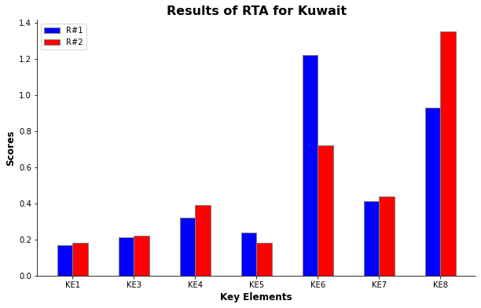

FIG. 2. Preliminary RTA results for Kuwait.

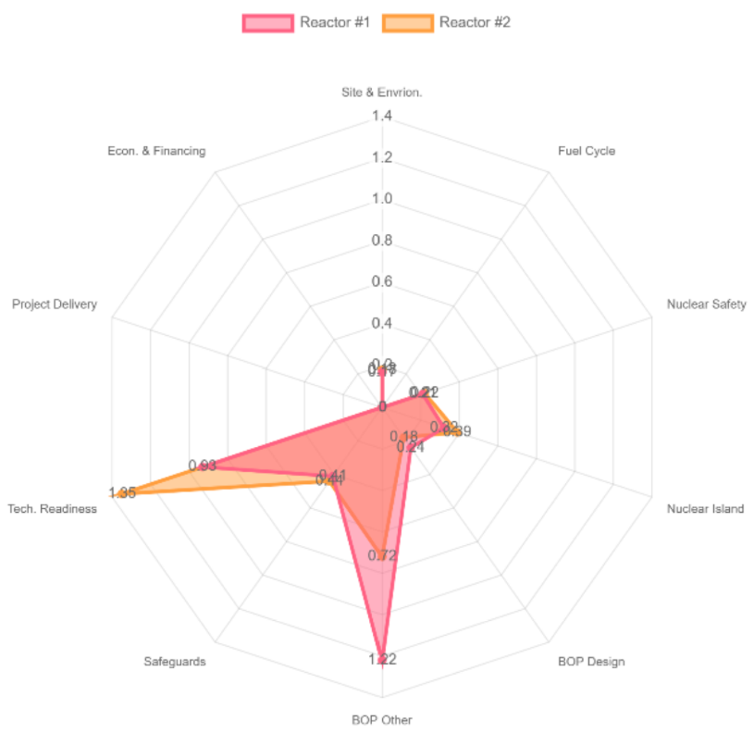

FIG. 3. Final Preliminary RTA results for all Kes considered for Kuwait.

## Conclusion

The nuclear RTA is crucial for countries interested in developing nuclear power programs. The IAEA offers a method for evaluating and selecting the most suitable reactor technology based on safety, performance, economics, and environmental impact. The assessment thoroughly explores design characteristics, safety systems, operational performance, and fuel types. It considers safety features, risk assessment, emergency response capabilities, power output, efficiency, operational flexibility, and economic factors such as capital costs, construction timelines, and maintenance expenses. Environmental considerations focus on greenhouse gas emissions, waste management, and biodiversity impacts. Regulatory compliance and adherence to safety and security guidelines are also important. This method allows stakeholders to make informed decisions by weighing the benefits and challenges of various reactor technologies in accordance with project goals, safety requirements, and economic viability.

However, since Kuwait lacks a nuclear energy policy, a preliminary RTA assessment was conducted, considering only seven out of the ten key elements (KEs). These included KE1 (site and environment), KE3 (nuclear safety), KE4 (nuclear island design and performance), KE5 (balance of plant), KE6 (design for other than electricity production), KE7 (safeguards and protection), and KE8 (technology readiness). The SMR technologies investigated were HTR-PM and NuScale SMR designs for Kuwait. Based on the preliminary RTA, HTR-PM was chosen for Kuwait due to its high-temperature output (net thermal efficiency) suitable for the oil and gas industries, with a final score of 3.50 compared to NuScale's 3.48.

References

1. World Population Prospects - Population Division - United Nations. https://population.un.org/wpp/Graphs/DemographicProfiles/Line/414 (accessed Dec 14, 2023).
2. Kuwait Population (2023) - Worldometer. https://www.worldometers.info/world-population/kuwait-population/ (accessed Dec 1, 2023).
3. Kuwait: country data and statistics. https://www.worlddata.info/asia/kuwait/index.php (accessed Dec 14, 2023).
4. The Public Authority for Civil Information. Statistical Reports - Population. http://stat.paci.gov.kw/englishreports/#DataTabPlace:view1ArcGISRegionMap (accessed Dec 22, 2023).
5. Ministry of Electricity & Water & Renewable Energy. MEW Kuwait: Historical overview. https://www.mew.gov.kw/en/about/historical-overview/ (accessed Dec 14, 2023).
6. IEA. Kuwait - Countries & Regions - International Energy Agency. https://www.iea.org/countries/kuwait#data-browser (accessed Dec 14, 2023).
7. IEA. Energy Statistics Data Browser – Data Tools - IEA. https://www.iea.org/data-and-statistics/data-tools/energy-statistics-data-browser?country=WEOMIDEAST&fuel=Energy%20consumption&indicator=ElecConsPerCapita (accessed Dec 15, 2023).
8. Al-Abdullah, Y. M.; Al-Saffar, M.; Al-Yakoob, A.; Sahraei-Ardakani, M. Impacts of Kuwait’s Proposed Renewable Energy Goals on Grid Operations. International Journal of Sustainable Energy 2023, 42 (1), 776–792. https://doi.org/10.1080/14786451.2023.2234057.
9. Ministry of Electricity Water and Renewable Energy. Electrical Energy: Statistical Year Book 2022; Statistics Department, Ed.; Ministry of Electricity, Water, and Renewable Energy: Kuwait City, 2023.
10. Shihab-Eldin, A. Kuwait Nuclear Power Program; Proceedings of the Conference on Transfer of Nuclear Technology, Persepolis, Iran, 1977.
11. Alsayegh, O. Country Nuclear Power Profiles: Kuwait. https://www-pub.iaea.org/MTCD/Publications/PDF/cnpp2018/countryprofiles/Kuwait/Kuwait.htm (accessed Dec 15, 2023).
12. Almutairi, B.; Jaradat, S.; Kumar, D.; Goodwin, C. S.; Usman, S.; Alajo, A.; Alam, S. B. Weight Loss and Burst Testing Investigations of Sintered Silicon Carbide under Oxidizing Environments for next Generation Accident Tolerant Fuels for SMR Applications. Mater Today Commun 2022, 30, 102958. https://doi.org/10.1016/J.MTCOMM.2021.102958.
13. Almutairi, B.; Kumar, D.; Ridwan, T.; Alam, S.; Parks, G.; Goodwin, C.; Usman, S. Reactor Physics Analysis of Thorium-Based Fuel for Long-Life SMR Cores Using Seed-Blanket Fuel Concept. Trans Am Nucl Soc 2019, 120.
14. Alam, S. B.; Ridwan, T.; Kumar, D.; Almutairi, B.; Goodwin, C.; Parks, G. T. Small Modular Reactor Core Design for Civil Marine Propulsion Using Micro-Heterogeneous Duplex Fuel. Part II: Whole-Core Analysis. Nuclear Engineering and Design 2019, 346, 176–191. https://doi.org/10.1016/J.NUCENGDES.2019.03.004.
15. Bahauddin Alam, S.; Kumar, D.; Almutairi, B.; Bhowmik, P. K.; Goodwin, C.; Parks, G. T. Small Modular Reactor Core Design for Civil Marine Propulsion Using Micro-Heterogeneous Duplex Fuel. Part I: Assembly-Level Analysis. Nuclear Engineering and Design 2019, 346, 157–175. https://doi.org/10.1016/J.NUCENGDES.2019.03.005.
16. INTERNATIONAL ATOMIC ENERGY AGENCY. Lessons Learned in Regulating Small Modular Reactors Challenges, Resolutions and Insights, IAEA-TECDOC-2003; IAEA: Vienna, (2022).
17. INTERNATIONAL ATOMIC ENERGY AGENCY. A Decade of Progress After the Fukushima Daiichi NPP Accident Building on Lessons Learned to Further Strengthen Nuclear Safety. In Proceedings Series - International Atomic Energy Agency; IAEA: Vienna, 2023.
18. INTERNATIONAL ATOMIC ENERGY AGENCY, Format and Content of the Safety Analysis Report for Nuclear Power Plants, IAEA Safety Standards Series No. SSG-61, IAEA, Vienna (2021).
19. Korea, Saudi Arabia Progress with SMART Collaboration - World-Energy. https://www.world-energy.org/article/6016.html (accessed Dec 22, 2023).
20. Doosan. Korea SMART Reactor: Small Modular Reactors : New Energy Solutions. https://www.doosanenerbility.com/en/business/smr_smart (accessed Dec 22, 2023).
21. Noura, M. The Saudi Nuclear Energy Project. KS—2020-CO17.; Riyadh, 2020.
22. INTERNATIONAL ATOMIC ENERGY AGENCY. Jordan Advances Nuclear Power Programme with Support from IAEA SMR Platform. https://www.iaea.org/newscenter/news/jordan-advances-nuclear-power-programme-with-support-from-iaea-smr-platform (accessed Dec 22, 2023).
23. Jordan Atomic Energy Commission. Jordan Nuclear Power Plant Project. https://jaec.gov.jo/Pages/viewpage?pageID=33 (accessed Dec 22, 2023).
24. *INTERNATIONAL ATOMIC ENERGY COMMISSION.* Available at: https://iris.iaea.org/public/survey?cdoc=UTZ10103 (Accessed: 09 March 2024).