# IDNES a CEA project dedicated to SMR concept for decarbonization beyond pure power generation

Philippe AMPHOUX

CEA IRESNE-DER/SESI

13108 Saint-Paul-lez-Durance, France

Philippe.amphoux@cea.fr

Jean-Michel RUGGIERI, Eric HANUS, Claire VAGLIO-GAUDARD, David HAUBENSACK, Nicolas ALPY, Clément LIEGEARD, Franck MORIN, Jean-Baptiste DROIN, Charly BOUDOT

CEA IRESNE

13108 Saint-Paul-lez-Durance, France

Pierre GAVOILLE

CEA DES/DPE

91190 Gif-sur-Yvette, France

Nicolas TAUVERON, Fabrice BENTIVOGLIO, Frédéric DUCROS, Luc BERTIER, Coralie QUADRI

CEA DES/DTCH/SSETI

38054 Grenoble, France

**Abstract**

Launched in 2021 within the French Alternatives energies and Atomic Energy Commission (CEA), the Innovative Decarbonized Nuclear Energy Systems project (IDNES) aims to take a new approach to the use of civil nuclear power generation, expanding its role beyond power production to provide other energy carriers by developing energy system concepts that include Small Modula Reactor (SMR) technology. The work program was initially designed with a 15-year vision aligned with the carbon-neutrality objective by 2050. It has focused primarily on energy markets where decarbonization is a major challenge. This work has identified two markets to be potentially addressed by SMR technology: heat and hydrogen that can be produced by cogeneration. Beyond hydrogen production, this work has led to the emergence of integrated concepts that make it possible to envisage the mass production of synthetic molecules such as e-fuels. The paper presents the main results and proposes a vision of the architecture of an energy system based on SMR technology for decarbonization.

## INTRODUCTION

As a low-carbon energy source, nuclear power has its rightful place in energy system, and required to be considered as a large potential to decarbonize and to reach net zero target in 2050. However, nuclear power will need to be adapted and integrated into new, more diversified energy systems, with a significant part of Intermittent Renewable Energies (IRE) and regarding the different forms of use of energy to be decarbonized.

The aim of the Innovative Decarbonized Nuclear Energy Systems project (IDNES) launched in 2021 is to look at the use of civil nuclear power generation in a different way from the past using the SMR technology. By extending its role beyond pure power generation. In this context, two major routes were initially explored:

* The production of heat in cogeneration with electricity with a first use case dedicated to the production of hydrogen using the High Temperature Steam Electrolysis (HTSE);
* The production of hot water or steam at low temperature (150°C), for industrial, domestic use and emerging needs using a nuclear reactor of the Light Water Reactor (LWR) type.

For these so-called local applications, because of the difficulty of transporting the heat in particular, the range of power of SMR technology appears relevant regarding local energy on the scale of industrial zones. And as heat can be easily stored and the characteristics of SMR is adapted to storage in terms of power and temperature, studies were performed to introduce storage systems in order to increase flexibility, safety and profitability.

The development process adopted is based on a market driven approach with a systematic analysis of generic markets meeting decarbonised energy needs that must be met by 2050 to achieve carbon neutrality.

After a 3 years phase of the project a global view of the role of SMR for decarbonization is shown in Fig. 1. Each application reach to perform studies to evaluate the relevance of using the SMR technology and to develop both specific configuration for the reactor and technological bricks for coupling the systems.

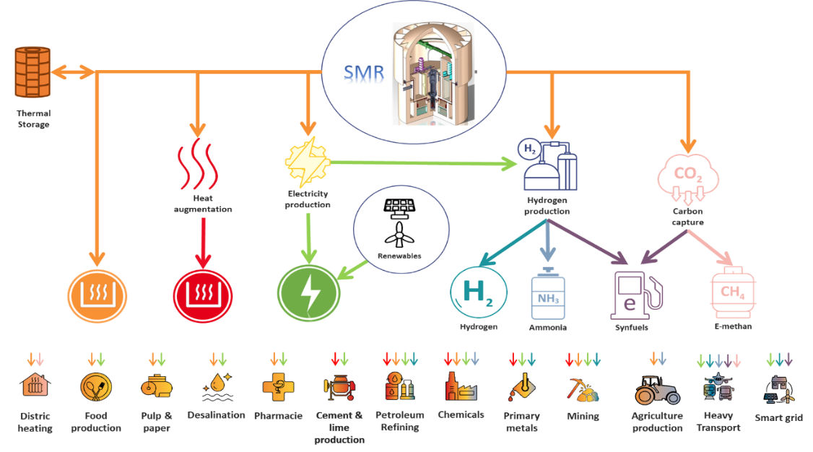

*FIG. 1:Potential application using SMR technology for decarbonization.*

The objective of this paper is to share the progress status of the different configurations studied in relation to the main applications selected, with a focus on pure heating SMR called ARCHEOS concept, coupled system in cogeneration between SMRs and HTSE for hydrogen production and kerosene synthesis for aviation and SMR coupled with massive heat storage for flexibility. Lastly, European cooperation through EURATOM projet industrial prospects will be presented.

## FIRST SMR use cases for decarbonization and flexibility

### 2.1. Pure heating SMR: ARCHEOS concept

Heat is the first use of primary energy in the world and is massively carbon-based. To accompany the decarbonization of this market the CEA has been developing Smaller Modular Reactors dedicated to heat production. This market requires two specificities, heat production unit need to be located next to the consumption sites as heat cannot be transported on long distances and the heat uses vary with the temperature provided.

Our choice was to design a SMR able to answer the heat needs as soon as possible. By mixing nuclear regulation rules and the specificities of the heat market, we designed ARCHEOS as a true compromise between a large enough reachable market and a very simplified SMR: we limited by design the temperature of the heat produced to be used offsite at 150°C. This compromise allows ARCHEOS to operate at low pressure and to reach high safety objectives associated to low energy costs. By reusing proven technologies, we limit technical and regulatory risks so that ARCHEOS could reach the market at the beginning of the 2030s with a high confidence.

The 100-150°C market targeted by ARCHEOS is mainly dedicated to food industry for drying and sterilization operations and industries that require low temperature steam such as wood industry and rubber.

ARCHEOS is a 50MWth LWR operated at 14 bar. The primary circuit operates between 125°C to175°C: it includes the core made of 45 LWR assemblies, control rods and its drive mechanism, an integrated pressurizer and heat exchangers. The secondary circuit is, by design, at a higher pressure (14.5 bar) and remains liquid. The secondary is mainly made of one volume around the primary vessel, separated by a thermocline between a hot zone at the top and a cold zone at the bottom. This innovative design creates a high inertia for the circuits and an important inherent safety for all operating conditions.

The core operates for 10 years before a batch refuelling. This feature enables to have a very low residual heat after the reactor shutdown and a fast transport to an external storage or to retreatment. Therefore there is no spent fuel pool dedicated building on an ARCHEOS facility and that allows to reach the economic goals.

To be appropriate for the targeted market, ARCHEOS has a high inherent safety to eliminate all the offsite radioactive releases to facilitate public acceptance. Also, it does not use external water as heat sink so that it can be located anywhere next to the end-users.

A preliminary sketch of ARCHEOS concept is shown in Fig. 2 and illustrate an optimized footprint limited to less than one hectare. The project is currently under its pre-conceptual design phase in the CEA and may be developed by an external structure gathering the CEA and industrial partners until 2029 when the building of the First-Of-A-Kind (FOAK) is planned.

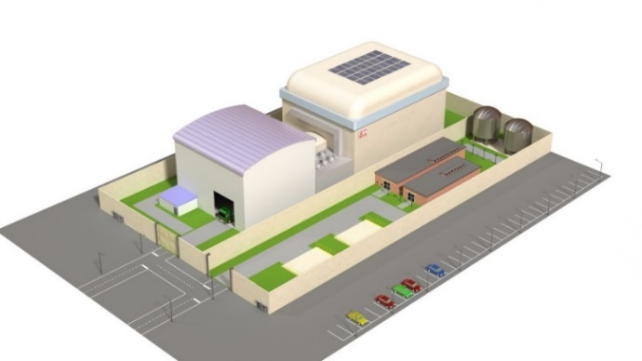

*FIG. 2: typical ARCHEOS site with the reactor bulding at the back*

### 2.2. SMR in cogeneration for hydrogen production

This subsection addresses the clean and massive hydrogen production through the coupling of a SMR nuclear unit to a hydrogen production process using HTSE. As HTSE requires power and thermal energy as inputs, this technology is an attractive solution to produce clean hydrogen as it is connected to clean energy source. Temperatures of thermal coupling circuits are moderate and the distance between LWR and HTSE is supposed to be short: for example, the distance from the nuclear reactor to the HTSE plant is of 1000 m in [1]. In details we investigated various architectures of optimized thermal coupling to increase the global energetic efficiency, but all rely on two distinct circuits (Fig. 3):

* Heat from SMR to HTSE unit: this system consists of an heat exchanger added to the Rankine cycle (HX1). In main cases, this exchanger is located parallel to the high pressure preheater extraction (PHH) at the exhaust of the high pressure turbine. In some variant cases, it can be located at the outlet of the steam generator, or connected to an extraction line inside the low pressure turbine. This exchanger transfers its heat to an intermediate pressurized water loop (HT-COCIR circuit) that transports the extracted heat to the HTSE site, where one steam generator (HX2) responds to the HTSE demand, in conjunction with a steam generator (S1 circuit) exploiting some waste heat coming back from the HTSE system. This system has as an objective to produce superheated steam needed at the inlet of the HTSE. Preliminary technical studies have concluded that such circuit will work between 25°C and 115-150°C depending on the configuration.
* Heat from HTSE unit back to SMR: this system consists of several heat exchangers (S2) returning waste heat to the SMR, using a pressurised water intermediate loop (LT-COCIR circuit). This loop transfers its heat to the SMR through an exchanger (HX3) mounted in parallel to the first preheater (PHL). For sake of simplicity, a unique recovery loop is used. Preliminary optimization studies have concluded that such circuit will work between 40°C and 90-110°C depending on the configuration.

|  |  |
| --- | --- |
|  | CD Condenser  FWT FeedWater Tank  HPP High Pressure Pump  HPT High Pressure Turbine  HT-COCIR High Temperature  COupling CIRcuit  HTSE High Temperature Steam Electrolysis  LPT Low Pressure Turbine  LPP Low Pressure Pump  LT-COCIR Low Temperature COupling CIRcuit  PHH High Pressure preHeater  PHL Low Pressure preHeater  PU Pumping Unit  RH ReHeater  SEP liquid-steam SEParator  SG Steam Generator |

*FIG. 3: SMR-HTSE reference simulation coupling architecture.*

The different possible coupling architectures and their energetic performance were investigated through numerical simulations (CYCLOP, internal tool developed in CEA was used to model SMR Rankine cycle; EES was used to model HTSE [2]). The results obtained on the reference simulation configuration show that it is possible to obtain a gain of over 13% compared with the solution involving no thermal coupling between SMR and HTSE (i.e. when HTSE heat is provided through electrical heaters). We underline that all simulations were performed with a set of hypotheses which can be debatable due to the level of technological development and complexity of the system; results must be taken with caution. A validation and verification program is in progress.

These encouraging energy results were supplemented by other technical criteria, such as those relating to safety, technological maturity, control and flexibility (the last two points were supported by preliminary Dymola simulations of the Rankine cycle, calculating the switchover between a pure electricity production mode and a cogeneration mode.). An initial methodology for developing a grid of qualitative and quantitative criteria has been deployed. This methodology is intended to be enriched over the coming years. Economic considerations are also under consideration.

### 2.3. SMR in cogeneration for kerosene production for aviation

This subsection addresses a full-chain integrated production of e-fuel from nuclear energy, with a particular focus on the energy integration. The project has initially focused on the production of kerosene for aviation regarding the European roadmap for Sustainable Aviation Fuel (SAF) but alternative molecules can be further considered such as methanol. The main challenge of the studies was to carry out a parallel assessment of mass balances, taking into account the stoichiometry of the reactions, and energy balances on heat and electricity, with the aim of maximizing paraffin production.

The studied system (Fig. 4) includes:

* A SMR nuclear reactor with a LWR reference and a variation with Advanced Modular Reactor (AMR);
* A Energy Conversion System (ECS) to transform heat to electricity with the Rankine cycle reference;
* A HSTE;
* A Direct Air Capture (DAC) source unit to supply CO2 from atmosphere Despite the current development, the high cost and energy requirement, DAC technology was selected as it allows the production of carbon neutral fuels and its share should gradually be increased . [3] [4];
* The chemical conversion system bricks. The Fischer-Tropsch (FT) pathway was selected as it is the most mature and studied route. [5] [6] It typically includes catalytic RWGS (Reverse Water Gas Shift) and FT reactions and potential reforming of by-products;
* The fuel refining unit (product separation).

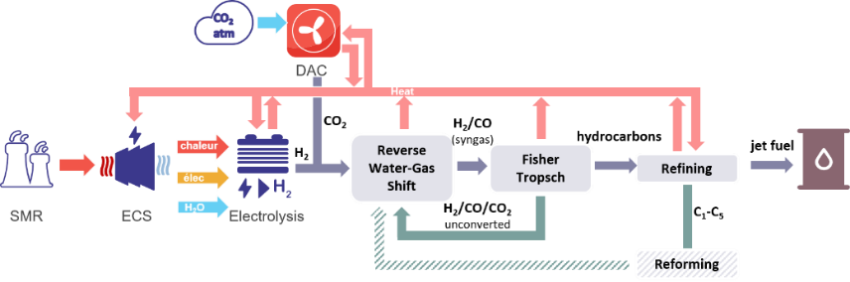

*FIG. 4: Generic full-chain integrated production of e-fuel from nuclear energy*

The chemical pathway is alternatively composed of exothermal (FT) and endothermal (electrolysis, RWGS, refining…) components operating at different temperatures. The major interest of the integration is to valorise a large amount of heat between units. The most energetically efficient heat integration is obtained when:

* Heat from exothermic reaction is valorised through steam generation;
* Heat from gas cooling is valorised in DAC or refining operations;
* Heat is extracted from ECS to complete steam generation and DAC needs at the adapted temperature;
* Low temperature (<100°C) from product cooling and condensation is valorised in the ECS at low temperature for water heating;

Coupling and process architectures have been simulated with CYCLOP for the ECS and ProSimPlus for the chemical processes. The simulation results of an integrated system (configuration 3) are compared with the two following scenarios and shown on Fig. 5:

* Configuration 1 (reference): the SMR has a standard design and only provide electricity to the system. Electricity is used for both heat and power electrolysis needs
* Configuration 2 (ideal): the SMR has a standard design and only provide electricity to the system. A supposed heat source provide “free” heat to the supply all the different requirements of the system.

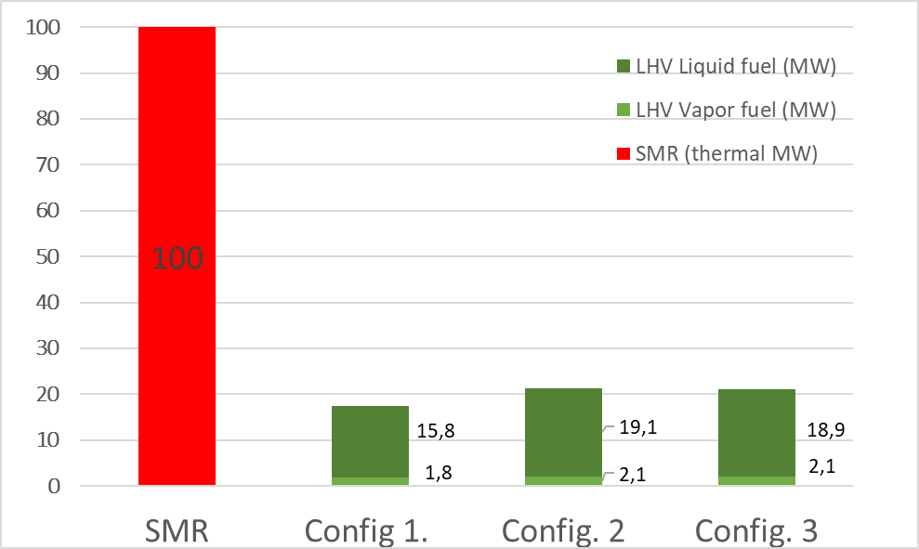

*FIG 5: Comparison between an example of unintegrated SMR (conf. 1), unintegrated SMR with “free” heat available (conf. 2) and integrated system (conf. 3). LHV: Lower Heating Value*

This comparison illustrates the increase of the production of liquid hydrocarbon from 15.8 MW to 18.9 MW (+20%) with the integrated system compared to the unintegrated system reference for a SMR of 100 MW. Interestingly, the heat extraction from the ECS has a low impact on electricity production, from 33.7 MW to 33.3 MW (–1%), allowing the integrated system to reach a fuel production close to the ideal case (+20% against +21%).

Simulations of the integrated SMR-to-kerosene system have shown promising results, demonstrating the potential of the coupling of the nuclear reactor with the process to produce e-fuels. The methodology will be further applied for others process configurations (chemical pathways, refining configurations) in order to identify the most promising system in an energetic point of view but also regarding economic and environmental criteria.

### 2.4. Thermal storage for flexibility and industry heat supply

Due to the increasing part of renewables and intermittent power sources on the grid, the need for more flexible nuclear plants lead CEA to propose new design options. In particular, the coupling between nuclear reactors and heat storage devices is studied since 2018, first in the frame of Gen-IV reactor designs [7], and then for PWR technologies. These studies demonstrated that such a coupling results in many benefits for nuclear reactors in terms of potential flexibility, economy and safety issues.

The energy storage is based on a two-tanks installation, filled with molten salt. This storage loop is implemented between the primary circuit and the power conversion system. During storage periods (night-time, when the price for electricity is low), the mass flow rate in the steam generator is lower that the one in the primary heat exchanger. The salt inventory in the hot tank increases: energy is stored. Conversely, when the price for electricity is high (daytime), the mass flow rate in the steam generator is higher than the one in the primary heat exchanger: the electricity production is instantaneously increased without any impact on the primary circuit. This is illustrated in Fig. 6.

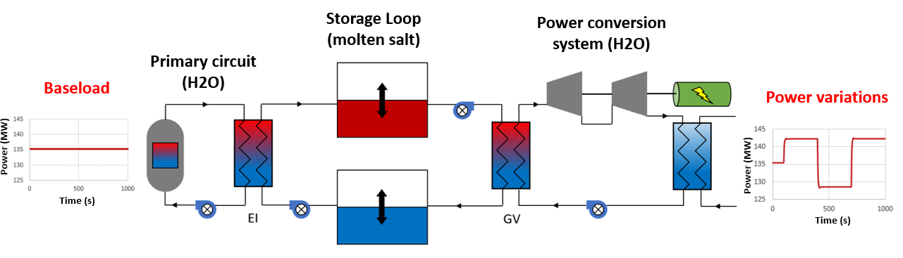

*FIG. 6: Schematic layout of the considered coupling between a SMR and a two tanks heat storage*

The technical specifications aimed at satisfying a daily load following transient (low power delivery during the night: 40% of nominal power during 8h; and high power delivery during the day: 130% of nominal power during 16h). This lead to an energy storage objective close to 2600 MWth.h. The Rankine cycle optimization studies enabled to maximize the temperature difference in the storage loop up to 65°C (310°C in the hot tank versus 245°C in the cold one).

Considering the storage capacity needed and as described earlier, the storage temperatures expected and the maturity level projected, the two tanks technology with melted salts as storage media has been chosen. This technology has proven its efficiency and maturity in different Concentrated Solar Plants (CSP) currently under operation, as presented in [8].

The Solar Salt (60%NaNO3-40%KNO3 [9]), generally used in the CSP technology, has a too high melting temperature (Tmelting = 220°C [8][10] to 240°C [9][11]) considering the cold storage temperature of this project (245°C). The margin between cold temperature and melting temperature would be too low considering freezing issues in pipes, vessels and heat exchangers. The HITEC salt (7%NaNO3-53%KNO3-40%NaNO2 [9]), presented in the TABLE 1, is more appropriate.

TABLE 1. Thermal characteristics of HITEC salt

|  |  |  |  |  |
| --- | --- | --- | --- | --- |
| HITEC | T melting (°C) | Tmax (°C) | Cp - 300°C (J/Kg/K) | ρ - 300°C (kg/m3) |
| Gonzalez Roubaud [8] | 142 | 450-538 | 1560 | 1860 |
| Fernandez [10] | 142 | 535-600 | 1560 | 1700 |
| Caraballo [9] | 142 | 450 | 1559,7 | 1718,4 |
| Bauer [11] | 142 | 450 | 1540 | 1790 |

A preliminary design using HITEC salt is proposed, considering a maximum size of 40m for the diameter and 14m for the height of the tanks (derived from [8]). This preliminary design leads to a storage system composed of 3 cold tanks and 3 hot tanks, as presented in the TABLE 2.

TABLE 2. Heat storage characteristics

|  |  |  |  |  |  |
| --- | --- | --- | --- | --- | --- |
| Energy | Storage Media | Total mass of salt | Volume of a tank  (h =14m - ϕ = 39m) | Tanks number | Heat Exchangers power |
| 2592 MWth | HITEC | 104774 tons | 16410 m3 | 6 | 324MWth |

## Support for european intiatives

Beyond the management of technical activities in the French national framework, the IDNES project also supports international collaborative initiatives, such as the TANDEM (Small Modular ReacTor for a European sAfe aNd Decarbonised Energy Mix) [13] project, to develop an integrated vision of the energy systems within the European technical and scientific community. TANDEM (2022-2025) is a Horizon-Europe project funded under the Euratom program and coordinated by CEA. It gathers 18 partners from 8 European countries. It aims to develop methodologies and tools to facilitate the safe and efficient integration of light-water SMRs into smart low-carbon hybrid energy systems, and to provide illustrative results from the assessment of hybrid energy systems from various standpoints: nuclear safety, techno-economics, environmental impact, system operability and citizen engagement. All the TANDEM activities contribute to support the near-term deployment of multipurpose SMRs in Europe for the energy transition, by highlighting the benefit of integrating SMRs in the future European low-carbon energy mix. The increasing importance of the TANDEM objectives is recognized by the *Sustainable Nuclear Energy Technological Platform[1]* (*SNETP) label* that was awarded to the TANDEM project by the governance of the SNETP Association.

In parallel with the technical studies carried out throughout the project [14], TANDEM encourages stakeholder engagement: an end-user group, which involves a dozen of members[2] today has been set up since the beginning of the project. The objective is to engage in a constructive dialogue between the project and the end-user group about i) the technological feasibility of the hybrid systems incorporating SMRs, ii) the different energy markets and their particularities, and iii) regulatory, societal and economic issues related to implementation of such systems. TANDEM is also organizing Education & Training events (one international summer school in 2024, two technical workshops in 2024 and 2025, several webinars) for the development of skills and competences identified as necessary in the domain of SMR safety and SMR integration in hybrid energy systems, and for the dissemination of TANDEM all the results is available on the TANDEM website (<https://tandemproject.eu/>).

As part of the international collaborative activities of the IDNES project, CEA will be involved in another Euratom project, SANE (**S**afety **A**ssessment of **N**on-**E**lectric uses of nuclear energy), coordinated by VTT (Finland). The project will start in September 2024, for a 3-year period.

## CONCLUSION

The aim of the IDNES project is to develop concepts for using SMRs to produce more than pure power. All the explored use cases have demonstrated the relevance of using SMRs technology. With different levels of maturity, some are in the industrial consolidation phase, such as the ARCHOES concept, while others will require experimental qualification, such as cogeneration coupling for hydrogen production. But the search for new applications is not over yet, and reflexions are already underway to produce other synthetic molecules and to open up to new industrial needs in the service of decarbonisation and energy sovereignty.

References

1. Boardman, R., Kim, Jong S., Hancock, S., Hu, Hongqiang, F., Konor, W., D., Rabiti, C., Bragg-Sitton, S., Elgowainy, A., Weber, Robert and Holladay, J. “Evaluation of Non-electric Market Options for a Lightwater Reactor in the Midwest”, Technical Report No. INL/LTD-19-55090. 2019.
2. Tauveron, N., Haubensack, D., Dumoulin, P., Alpy, N.,“Hydrogen production by high temperature steam electrolysis coupled with a small modular reactor: cross-comparison between various thermal architectures”, ICONE-31 (Proc. Int. Conf. Prague, 2024), ASME (2024).
3. Role of DAC in e-fuels for aviation report. E4tech (UK) Ltd for T&E. 2021
4. Direct Air Capture. IEA. 2022
5. A Techno-Economic Assessment of Fischer–Tropsch Fuels Based on Syngas from Co-Electrolysis. Peters, R. 2022, Processe
6. Fischer–Tropsch Synthesis as the Key for Decentralized Sustainable Kerosene Production. Meurer, A. 2021, Energies
7. J.B. Droin, D. Haubensack, D. Barbier, L. Brissonneau, P. Dienot, P. Gauthe, *«* Two-tanks heat storage for variable electricity production in SFR: preliminary architecture and transient results », ICAPP 2019 – International Congress on Advances in Nuclear Power Plants, Juan-les-pins, France, 2019
8. E.Gonzalez-Roubaud & al., “Review of commercial thermal energy storage in concentrated solar power plants: Steam vs molten salts”. Renewable and Sustainable Energy Reviews 80 (2017) 133-148.
9. A.Caraballo & al.,”Molten Salts for sensible thermal energy storage: a review and an energy performance analysis.” Energies 2021, 14, 1197.
10. A.G.Fernandez & al. “Mainstream commercial CSP systems: A technology review ». Renewable Energy 140 (2019) 152-176.
11. T.Bauer & al. “Molten Salts chemistry: from lab to application”, Book edited by Lantelme, F.and Groult, H., Elsevier, 2013, Chapter 20.
12. N.Boerema & al., “Liquid sodium versus Hitec as a heat transfer fluid in solar thermal central receiver systems”. Solar Energy 86 (2012) 2293-2305.
13. VAGLIO-GAUDARD, C., et al, The TANDEM Euratom project: Context, objectives and workplan, Nuclear Engineering and Technology, **56**, 3, 993-1001, 2024.
14. VAGLIO-GAUDARD, C., et al, The TANDEM Euratom project to study the integration of SMRs into low-carbon hybrid energy systems: progress status at mid-term, Proc. Int. Conf. on Small Modular Reactors and their applications, IAEA, Vienna, Austria, 2024.

1. <https://snetp.eu/>
2. Including SMR designers, non-nuclear technology developers, technical organization for industrial security and energy-intensive industry