# Poly-generation of power and desalinated water by Small Modular Reactors

M. CIOFFI

Ansaldo Energia

Genoa, Italy

Email: marco.cioffi@ansaldoenergia.com

**Abstract**

The nuclear energy has been even recently confirmed to be one of the key technologies required for the fulfilment of the energy transition targets. Small Modular Reactors (SMR) are indeed a principal element of last years' "Nuclear Renaissance", where new design and execution models are being developed in order to facilitate the achievement of fruitful time and cost targets of nuclear power plants projects. The SMR concept is often coupled with the hybridization of nuclear generation plants with other services, such as the concurrent generation of power with heat, hydrogen, or desalinated water. This approach has the additional purpose of providing flexibility in the nuclear plant operation on power grids influenced by not programmable renewable energy sources. One of the most promising uses of SMR is for the desalination of seawater for agriculture, industrial or civil use. The request for drinkable and industrial water has steadily increased during the last decades, following the fast development and urbanization in areas such as the Middle East and due to the effect of climate change. In this context, the choice of desalination technology should fit with the inlet water characteristics and output water requirements by properly utilizing SMR power and/or heat. The paper presents an economic analysis for the supply of water for the Abu Dhabi city. The examined 340 MW SMR plant, hybridized with a reverse osmosis desalination system, is able to provide at least 800,000 m3/day of drinkable water, almost 1/3 of the water daily used by the city.

## INTRODUCTION

Many energy analysts, governments, and investors agree today to set nuclear power generation as a strategic and essential component toward the energy transition targets and the fulfilment of the climate pledges. During the last years, nuclear power generation has been finding a renewed interest in different countries, which were lacking since a long period of new projects for the construction of Nuclear Power Plants (NPPs) or where political and public discussions were in progress or even already completed about the phase-out of the existing NPPs in operation.

This movement is sometimes indicated as the "Nuclear Renaissance" and it got a relevant push during the last 28th United Nations Climate Change Conference (COP28), where nuclear generation was included, maybe for the first time, among other low-emission technologies in the pathway for a deep, rapid, and sustained reductions in greenhouse gas emissions [1*COP28*]. During COP28, a group of 22 countries committed and signed a declaration to make efforts to triple nuclear energy by 2050.

### New NPP construction and operation

When talking about the Engineering, Procurement, and Construction (EPC) of a new NPP, there are two main and very relevant keywords that must drive the project: time and cost. Some of the last main new NPPs showed clearly it is often quite difficult to maintain and keep time and cost during construction and the following operation, and therefore to respect the initial economic balance of the project.

Two relevant examples of the issues are two large plants, which present different nuclear technologies, different local regulations and constraints, and different contractors but similar troubles: the plant of Olkiluoto 3 in Finland and the plant of Vogtle 3 in the USA.

For Olkiluoto 3, the construction started in 2005, and the expected operation start was in 2010, but the actual start of the operation was in 2023, with a delay of 13 years, equal to an increase of 260% in time [2-3]. About the construction cost, the initial expected total cost was 3 B€, but the actual cost is estimated to be almost 11 B€, with a cost increase of 8 B€ or +267%.

Similar figures appear for the Vogtle 3 power plant, with almost doubling of timing and cost. The construction started in 2009, and the expected operation start was in 2016 but the actual start of the operation was in 2023, with a delay of 7 years equal to an increase of 100% in time [4]. About the construction cost, the initial expected total cost was 14 B€, but the actual cost is estimated to be almost 30 B€, with a cost increase of 16 B€ or +114%.

## THE SMALL MODULAR REACTOR CONCEPT

In order to mitigate the issues that occurred in some of the recent nuclear projects, a different design and execution model for nuclear plants is gaining renewed interest. The concept of Small Modular Reactor (SMR) is not new, and it has been already adopted in the past, mainly for military applications. It today indicates a model aimed at effective cost and risk management and project control. The main items of an SMR are small size and the modular approach:

modularity centralizes the manufacture of components, allowing for mass production and standardization; small projects are aimed at easier cost and time control.

The SMR model includes the switch to a standardization of the plant's project. The model of “First of a Kind” or “FOAK” describes the case where a single nuclear power plant (unique plant with customized design, tailored to a specific site) costs much more than later versions, named “Nth of a Kind” or “NOAK”. Each NOAK project will therefore have to keep the large majority of the FOAK Detailed Design results, drawing, technical specifications, and even supply-chain: site-specific requirements, local national regulations and specific localized suppliers could differ, and they will require a limited fine-tuning of the project.

The SMR model is going to be adopted for all sections of the plant, even, of course, for the conventional Steam Power Island.

## SMR FLEXIBLE AND RESILIENT OPERATION

Today, large nuclear plants usually operate with a high-capacity factor: in the USA, the mean NPP capacity factor during 2022 was 92.7% [5*EIA*]. With the spreading of not programmable Renewable Energy Sources (RES), power generation flexibility is a must even for SMR operation, aiming to comply with the grid requirements and be profitable on the electricity market dynamics.

The typical lifecycle of an SMR is designed to be 60 years. The International Atomic Energy Agency (IAEA) has estimated that a nuclear plant can load cycle 100,000 times between 100% to 90% of the rated thermal power, but it drops to 15,000 if cycling between 100% and 60% [6IAEA-life]. If cycling once per day, this would reduce the plant's lifetime from 60 to 40 years. Newer nuclear plants are already designed with a daily load cycle that can adopt a 100%-50%-100% power scheme: see, for instance, some recent Korean projects based on OPR-1000 reactor design [7 power].

NPPs have already demonstrated their ability to operate during extreme weather events that either degraded or completely shut down operations at fossil-fired generating plants: for instance, for the recent cold events in Texas during the last years [8*Greene*]. SMRs can be tailored to enhance the power grid's resilience to weather events and the ability to provide grid support and recovery. For the conventional island, some of the tools and adds-on for such tasks include: a steam bypass, suitable sizing and protection of the condenser, the ability for island operation and black start, the hybridization with battery storage systems and the adoption of advanced control system schemes with the ability to avoid plant shutdown in response to large grid anomalies.

## SMR Conventional Island Design PRINCIPLES

For the SMR's conventional island, specific design criteria have to be adopted to increase steam turbine flexibility and availability: variable operation mode may include load following, frequency control or other actions to change the power output of the plant and to provide ancillary services to the grid. Operation at reduced loads increases the steam's moisture content in the lower pressure stages of the Low-Pressure turbine, with increased wear and enlarged seal clearances. A possible solution for controlling these impacts is to maintain the ramp rate and depth of load manoeuvres below the turbine design and warranty limits, or to install turbine stress monitors.

To extend the maintenance intervals of the steam turbines and generators and in order to fit them with the reactor overhaul schedule, some hints include the adoption of predictive maintenance digitals and Artificial Intelligence based tools able to increase the plant availability.

The main design goals of the Steam Power Island can be summarized in such a way:

* fit for purposes: which means base load and flexible operation, largest availability, major resilience to grid instabilities and extreme weather, non-nuclear services, black start capability.
* fit in time: which means NOAK-based design, modular approach, supply chain optimization and localization.
* fit in cost: design to lifecycle cost (from Design to Execution to Operation to Maintenance) and optimization of the supply-chain.
* tailored design and execution strategies, by adopting advanced Project Management procedures and quality.

These concepts influence the general architecture of the Turbine Hall. Of course, safety in a nuclear plant is the main concern: the concept here is no issue or accident on the conventional island (for instance, a fire event) must have any impact on the nuclear side. A way to increase the safe operation of the steam cycle equipment and increase availability is to allocate the steam turbine hall to a building separated from the nuclear island.

In addition, the project should be suitable for different siting and local standards, in terms of safety requirements and, for instance, different steam condensing boundary conditions. The Turbine Hall design and footprint should be kept therefore standard as much as possible among different sites.

Another feasible approach able to increase the plant's availability is the adoption of a modular assembly of the Balance of Plant equipment (BOP) and auxiliaries or the fitting of the conventional components' outages with the nuclear servicing timing.

For the reference reactor technology, which in the paper is the Pressurized Water Reactor, no nuclear-grade steam components are required: this allows the possibility to reuse the supply-chain already adopted for non-nuclear power projects.

The Steam Turbine shaft-line arrangement has to be tailored to the actual power output range and thermodynamic cycle conditions: for example, by adopting a single cylinder (which is a combined high- and low-pressure sections) or multi cylinders. The boundary conditions at the connection point between the nuclear and the conventional islands are typical of the different SMR projects and reactor technologies.

Usually, the steam provided by the SMR Steam Generator has quite low steam pressure and lower temperature with respect, for instance, to combined cycle plants. This requires the implementation of erosion-resistant materials or suitable erosion protection features, to have a reliable operation.

The typical Steam Turbine configurations are with a power range in general between 50-200 MW, non-reheat reaction type, full speed at 3000 rpm (for a 50 Hz grid), and two pressure levels. Vertical or lateral steam exhaust can be adopted in order to optimize the overall footprint.

## SMR POLY-GENERATION

The SMR model is often coupled with the hybridization of the NPP with the concurrent generation of power with heat, hydrogen, or water. This approach has the additional purpose of providing flexibility on the NPP operation in a power grid influenced by not programmable RES, by utilizing some of the power when grid load is low or when electricity prices are not profitable for SMR full operation. Therefore, in order to reduce the requirement for the plant of grid load following and to deal with the changing electricity market, SMRs can be designed to provide additional services, such as:

* The concurrent generation of power with heat, hydrogen, or purified water.
* The hybridization with a storage system, for instance with a Battery Energy Storage System (BESS).

Steam can be directly spilled from the thermal cycle and used for different scopes, such as:

* + Hydrogen production, by using, for instance, high-temperature electrolyser or pyrolysis systems.
  + Combined Heat & Power (CHP), to provide industrial heat or district heating.
  + Desalination: one of the main options in different areas is the production of fresh water from the sea.

This poly-generation grants many technical and economic benefits to the customers and the power grid:

* + Reduce the cycling, fatigue, and aging of the components.
  + Increased resilience and fitting to the market requirements.
  + Allow participation in the grid balancing and ancillary services.
  + Provide improved robustness to grid instabilities.

## SMR ACCESS to the electricity market

SMRs profitable operation relies, of course, on the sale of electricity to the market. Therefore, the local electricity market structure sets the economic balance of the plant and is the base for its generation schedule. In the liberalised electricity market, the Day-Ahead Spot market is an auctions system where:

* + - The Producers offer electricity for each hour of the next day with the quantity and a minimum selling price.
    - The Consumers bid hourly demand for electricity with the quantity and a maximum purchase price.
    - The Market Operator sorts the supply offers for the economic Merit Order by increasing unit price and defines the Supply Curve. The different generation technologies are therefore naturally sorted by their operative short-term costs as: Renewables, then Nuclear, then Lignite, Hard Coal, Natural Gas Base Load, and Peakers (Fig. 1, left).
    - The demand bids are sorted too, by decreasing unit price, on the Demand Curve.
    - At the intersection of the curves, the Marginal Clearing Price is set (Fig. 1, right). This is the price all producers are finally paid for their electricity, and therefore it is fixed by the most expensive cleared technology (pay-as-cleared model).

Subsidized renewables often offer at negative prices (so, they actually offer to pay to sell power). Therefore, the Marginal Cleared Price can sometimes get negative, in case of high RES generation share: consumers are paid to consume.

Other sales models for nuclear plants, for instance based on long-term contracts, can be adopted, able to subsidy the nuclear producers or regulate and balance the electricity market. In the Contract for Difference scheme, governments compensate electricity producers when the selling price of electricity falls below a set threshold and compensate consumers when prices go above. These topics are included in the electricity Market Design reform, which is now under discussion at the European level.

The ability to profitably participate in the electricity market and compete with the other technologies (usually referred to as dispatchability) must be carefully evaluated even during the preliminary SMR design phases and for the definition of the project's economic balance.

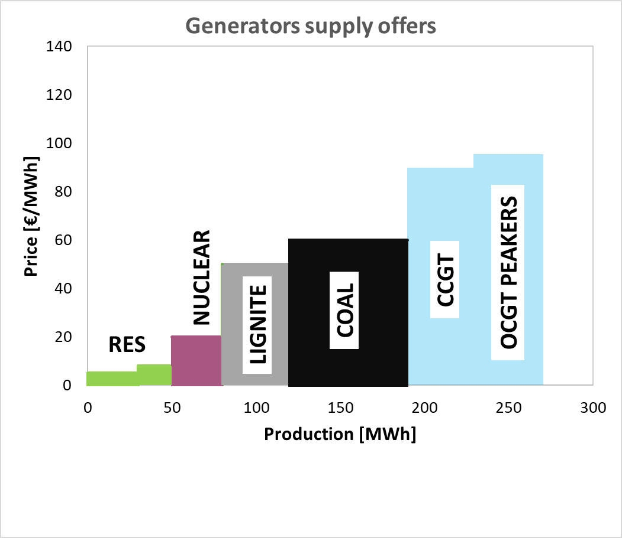 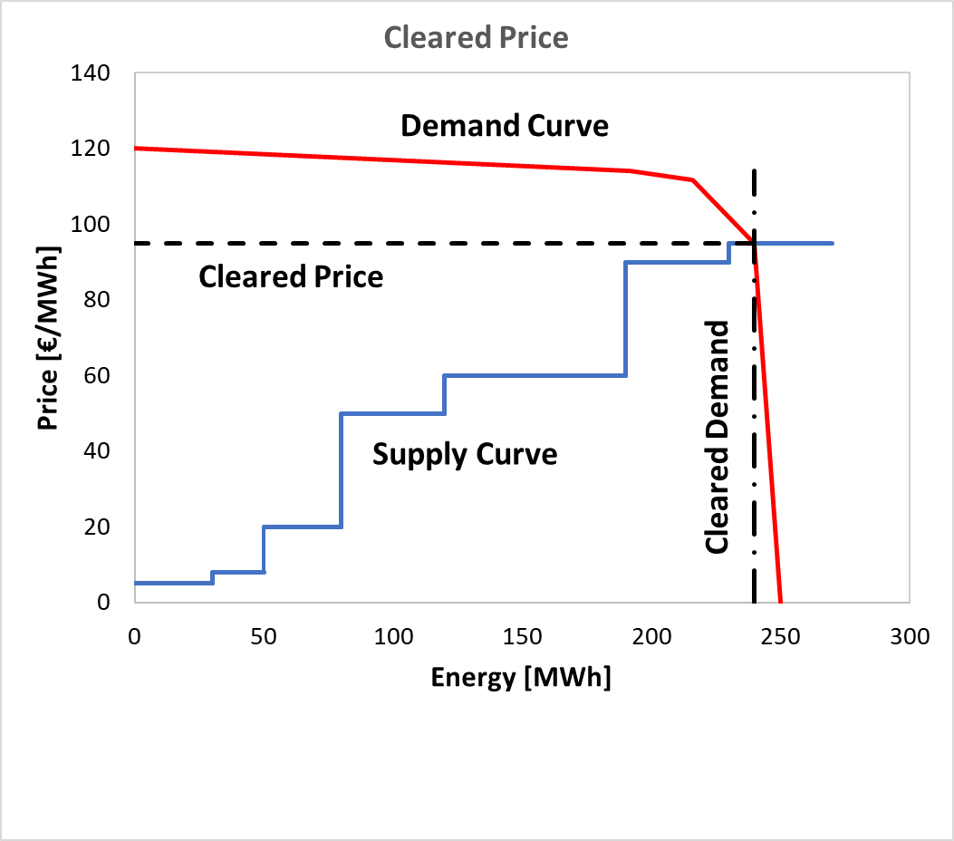

*FIG. 1. Typical scenario in the Day-Ahead electricity market. Left: offers sorted by generation technology. Right: supply and demand curves, whose intersection fixes the marginal cleared price.*

## SEA WATER Desalination

The International Energy Agency (IEA) recently stated the energy demand for water desalination is expected to double by 2030 [9-10*IEA1, IEA2*]. A particular focus must be adopted for the Middle East region, which has one of the lowest levels of freshwater use per capita in the world and where desalinated water covers the majority of daily needs. The desalination process is energy-intensive, often requiring more than 15 kW(e)h per cubic metre of treated water. In 2023, the energy used by desalination services in the Middle East was equivalent to almost half of all energy consumed by the region’s residential sector.

In the Middle East, new projects are underway in order to expand the desalination capacity. Jordan is planning a major plant on the Gulf of Aqaba to increase the present capacity from 4 billion to 350 billion litres each year. Saudi Arabia plans to construct a new city with 9 million people in the northwest part of the country by 2045 that will depend on desalinated water from the Red Sea and the Gulf of Aqaba [11 *IAEA1*].

A recent report by the Oxford Institute for Energy Studies Energy focused on desalination projects in the Arabic Gulf States [12 *OIES*]. The report underlines that, up until recent years, projects were limited to a few countries due to their related high costs and energy consumption. However, technological advancements and the availability of cheaper electricity can pave the way for larger utilization of desalination projects.

In this scenario, one of the most promising uses of SMR is therefore for the desalination of seawater for agriculture, industrial or civil use. The adopted process technology should fit with the inlet water characteristics and output water requirements (for instance, Inverse Osmosis, Multi-Stage distillation) by utilizing SMR power and/or heat or steam. The choice mainly refers to the different chemical, physical and biological parameters of the seawater to process [9*IAEA1*], such as: temperature, salinity, pH, total dissolved solids, total suspended solids, and biochemical oxygen demand. In the Arabic Gulf, the water temperature during summer can exceed 36 °C while winter water temperature can fall below 15 °C. For the present study, the adopted parameter is the seawater salinity: in the Arabic Gulf, salinity is usually in the range of 40000-43000 ppm.

The Multi-Stage Flash (MSF) distillation process is a mature and reliable technology for large plants. Typical MSF total energy consumption is in the range of 15 to 24 kW(e)h/m3. In the MSF process, seawater feed passes through tubes in multiple evaporation stages where it is heated progressively [11 *IAEA1*].

The Sea Water Reverse Osmosis (SWRO) technology achieved record low prices for desalinated water, making it a feasible solution for water supply [13*SAEED*]. In addition, SWRO technology has achieved remarkable energy efficiency gains in the past years making it the preferred technology for seawater desalination in many areas. In SWRO, the seawater is forced out of a concentrated saline solution by flowing through a membrane at a static pressure difference, which is higher than the osmotic pressure between the pure water and the solution. SWRO plants have a typical electricity consumption in the range of 4 to 7 kW(e)h/m3.

A significant point for the economic evaluation of the investment is a suitable fitting of the expected lifetime of the desalination plant with respect to the SMR power plant's lifetime. Typical life values are 60 years for the SMR and 30 years for the desalination plant. This mismatch has indeed a relevant effect on the overall plant's cash flows: for the sake of simplicity, in the paper, a desalination plant lifespan of 60 years is adopted, by following, for instance, a similar "modular" approach in the design of this asset (to increase serviceability) or a possible technology improvement, able to reduce the components' degradation during the operation.

## Case Study: Abu Dhabi PLANT economic analysis

In the following, an economic analysis of the supply of civil water for Abu Dhabi city is presented. Abu Dhabi is the capital metropolitan of the United Arab Emirates (UAE) and the country's second-most populous city after Dubai: as of 2021, Abu Dhabi's urban area had an estimated population of 1.5 million.

Water produced by seawater desalination in Abu Dhabi reaches almost 1.3 billion cubic meters per year, which equates to an average of 3.32 million cubic meters per day. Eighty-four per cent of desalinated water in Abu Dhabi is produced by using the thermal desalination method, while 67% of the production is by MSF distillation technology and 17% via Multiple-Effect Distillation technology (MED). The remaining 16% is produced by SWRO technology [14 UAE].

In the paper, the analysed 340 MW(e) SMR plant, hybridized with a reverse osmosis desalination system, is sized in order to be able to provide 800,000 m3/day of drinkable water, almost 1/4 of the water daily used by the city. The reference Small Modular Reactor is a Pressurised light Water Reactor (PWR) co-generation plant, with two reactors and with a total thermal output = 1080 MW(th) and a total power output (in pure electricity mode) = 340 MW(e): see Table 1. This configuration is typical of the EDF Nuward SMR plant [15 *NEA*].

The financial economic analysis of the desalination plant has been performed by adopting the "Desalination Economic Evaluation Program DEEP" code, Release 5.1, developed by the International Atomic Energy Agency (© IAEA) [16-18 *DEEP1-3*]: this tool is able to analyse the performance and cost evaluation of different power and seawater desalination co-generation configurations. The adopted hypothesis and parameters for the performed analysis are:

* Power Plant construction = 48 months;
* Power Plant lifetime = 60 years;
* Desalination Plant construction = 12 months;
* Desalination Plant lifetime = 60 years;
* Water salinity = 42000 ppm
* Feed water temperature = 25 °C

The adopted discount rate is the Weighted Average Cost of Capital (WACC), which here has been set equal to 5%, which in line with the ranges indicated by the Department of Energy of Abu Dhabi [19wacc]. The currency reference year is 2024.

The specific nuclear plant construction cost (also referred to as overnight construction cost, excluding site related cost, contingencies, escalation and interest during construction) is set to 4000 US $/kW(e). For NPPs, this cost is the main contributor to the electricity generation cost. For the distillation RO plant, the adopted value for the base unit cost is 1177 US $/m3/d. This value is calculated from empirical relations [16] starting from 1000 US $/m3/d for 24000 m3/d unit size: this price is conservative and information on recent projects indicates up to 20% lower cost.

In the Abu Dhabi area, these typical values for water and electricity prices apply:

* Price for water (User Industry): 7.84 AED/m3 = 1.97 €/m3;
* Price for electricity (User Industry, more than 1 MW): 27 fils/kWh = 0,068 €/kWh;
* Price for electricity (between 10:00AM-10:00PM, in the period 1 June – 30 Sept) = 36.6 fils/kWh   
  = 0,092 €/kWh.

Three test cases have been evaluated: Case A, with a water production of 800,000 m3/day; Case B, with a water production of 1,600,000 m3/day; Case C, a reference case with no water production (pure power generation). Data of SMR and desalination plants are reported in Table 1.

### Results

The sensibility of the water cost with the capacity of water production in plotted in Fig. 2: the water cost decreases by increasing production and it is 0,68 $/m3 for Case A and $/mc for Case B.

The main economic results of the performed analysis are presented in Table 2 for the three test cases. The Simple Payback Time is 8.4 years for the Case A and 7.9 years for the Case B, with a Net Present Value (@6%) of 3,153 M$ for Case A and 5,419 M$ for Case B. For the Reference Case C, with no water production and pure electricity plant, the Simple Payback Time is 9.2 years, and the Net Present Value (@6%) 1,363 M$. The water Levelized Operating Cost is 0.68 $/m3 and 0.65 $/m3 for the Case A and the Case B, respectively. These presented water costs are in line with the price race in progress during the last years in the Middle East region, where the production costs for water desalination are continuing to fall by the combined effect of improvements in energy efficiency of the plants, economic push by low interest rates, and low-priced RES generation [20 MEED].

TABLE 1. SMR DATA FOR DEEP ANALYSIS

|  |  |  |  |
| --- | --- | --- | --- |
| **SMR Power Plant** |  | | |
| Reference thermal output | 1,080 MW(th) | | |
| Reference electricity output | 340 MW(e) | | |
| Electricity Production | 2,203 MWh/yr | | |
| Availability | 90% | | |
| **Desalination Plant** | **Case A** | **Case B** | **Case Ref** |
| Type | RO | RO | n.a. |
| Total Capacity | 800,000 m3/d | 1,600,000 m3/d | 0 |
| Feed Salinity | 42,000 ppm | 42,000 ppm | n.a. |
| Power used for desalination | 127 MW(e) | 255 MW(e) | 0 |

TABLE 2. RESULTS OF THE DEEP ANALYSIS

|  |  |  |  |
| --- | --- | --- | --- |
|  | **Case A** | **Case B** | **Case Ref** |
| Simple Payback Time | 8.2 years | 7.9 years | 9,2 |
| Net Present Value (@6%) | 3,386 M$ | 5,419 M$ | 1,363 M$ |
| Levelized operating cost (water) | 0.43 $/m3 | 0.43 $/m3 | n.a. |
| **Total water cost** | **0.65 $/m3** | **0.65 $/m3** | **n.a.** |

From the analysis of DEEP data of the SMR plant for the Case A, reported in Table 3, it is possible to observe that globally: 1) the annual capital cost shares 78 %, 2) the fuel cost shares 7 %, and 3) the O&M cost shares 15 % of the annual management expenses. Data of the RO Desalination plant for the Case A in Table 4 show that globally: 1) the annual capital cost shares 35 %, 2) the energy cost shares 36 %, 3) the O&M cost shares 30% of the annual management expenses.

TABLE 3. CASE A: CAPITAL AND OPERATING COSTS OF THE NUCLEAR PLANT

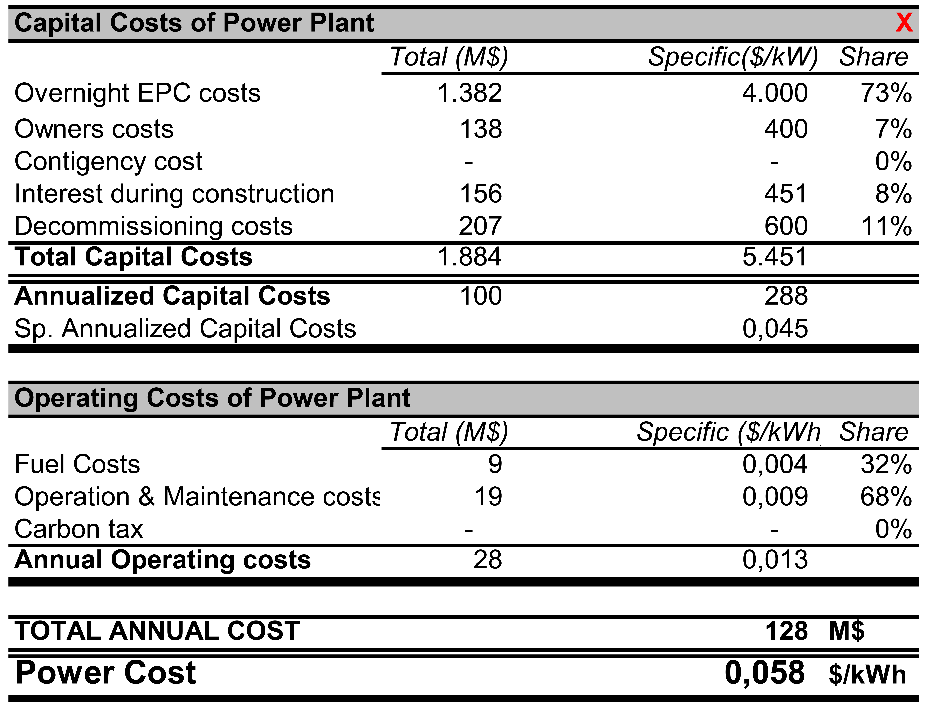

## Conclusions

The Small Modular Reactors concept, design and building architecture apply to the entire power plant and therefore affect the conventional power island design. Steam and Generator Equipment manufacturers and designers have to develop and provide suitable solutions for the steam turbine and synchronous generator machines, and their auxiliary systems to be tailored for the specific boundary conditions and operative profile of SMRs.

The target lifetime of 60 years requires a specific focus on the design for maintenance of all systems to optimize the plant availability, reduce Operational Costs (OPEX), and increase therefore profitability.

With the presented analysis, the poly-generation of electricity and desalinated water by SMR has been shown to be a valuable path to efficiently increase the Net Present Value and reduce the Payback Period of the investment, while providing low-carbon power and cheap fresh water for civil use.

TABLE 4. CASE A: CAPITAL COSTS AND OPERATING OF THE DESALINATION PLANT

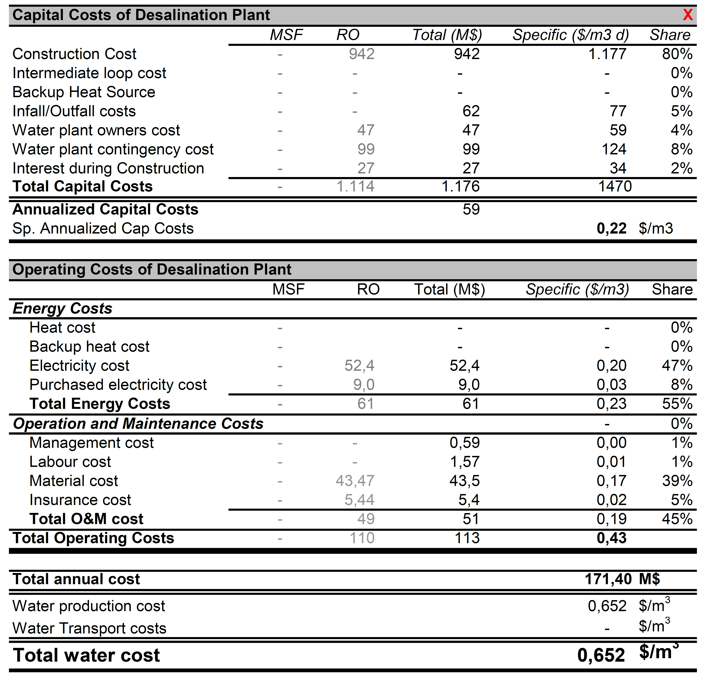

References

1. United Nations Climate Change COP28, "The COP28 Global Renewables and Energy Efficiency Pledge", 2023, https://www.cop28.com/en/global-renewables-and-energy-efficiency-pledge.
2. Le Monde, "Europe's largest nuclear reactor enters service in Finland after months of delays", 2023, https://www.lemonde.fr/en/europe/article/2023/04/16/europe-s-largest-nuclear-reactor-enters-service-in-finland-after-months-of-delays_6023126_143.html#.
3. Reuters, "After 18 years, Europe's largest nuclear reactor starts regular output", 2023, https://www.reuters.com/world/europe/after-18-years-europes-largest-nuclear-reactor-start-regular-output-sunday-2023-04-15/.
4. (*CNBC*)CNBC, "America’s first new nuclear reactor in nearly seven years starts operations", 2023, https://www.cnbc.com/2023/07/31/vogtle-unit-3-nuclear-reactor-long-delayed-starts-delivering-power.html.
5. *(EIA)* U.S. Energy Information Administration (EIA), "Electric Power Monthly", April 2024, https://www.eia.gov/electricity/monthly/epm_table_grapher.php?t=epmt_6_07_b.
6. *(IAEA-life)* International Atomic Energy Agency (IAEA), "Non-baseload Operation in Nuclear Power Plants", IAEA Nuclear Energy Series No. NP-T-3.23, (2018).
7. *(Power)*PATEL, S., "Flexible Operation of Nuclear Power Plants Ramps Up", Power, 2019, https://www.powermag.com/flexible-operation-of-nuclear-power-plants-ramps-up/.
8. *(Greene*) GREENE, S. R., "Enhancing Electric Grid, Critical Infrastructure, and Societal Resilience with Resilient Nuclear Power Plants (rNPPs)", Nuclear Technology, 205(3), 397–414, (2019).
9. (*IEA1*) International Energy Agency (IEA), "Energy and Water", https://www.iea.org/topics/energy-and-water.
10. (*IEA2*) International Energy Agency (IEA), "Energy is vital to a well-functioning water sector", 2024, https://www.iea.org/commentaries/energy-is-vital-to-a-well-functioning-water-sector.
11. *(IAEA1*) International Atomic Energy Agency (IAEA), "Design Concepts of Nuclear Desalination Plants", IAEA-TECDOC-1326, (2002), https://www.iaea.org/publications/6368/design-concepts-of-nuclear-desalination-plants.
12. (*OIES*) KHASHMAN A., "The impact of desalination projects on the power grid: Insights from Gulf states", Energy Insight n. 149, The Oxford Institute for Energy Studies, Oxford (UK), (2024).
13. SAEED, M.O., AL-NOMAZI, M.A., AL-AMOUDI, A.S., "Evaluating suitability of source water for a proposed SWRO plant location", Heliyon 5 (2019) e01119.
14. (UAE) Abu Dhabi Department of Energy, "Nine major water desalination plants enhance Abu Dhabi's water security", 2020, https://www.doe.gov.ae/en/Media-Centre/News/Nine-major-water-desalination-plants-enhance-Abu-Dhabis-water-security
15. (*NEA*) Nuclear Energy Agency (NEA), "NEA Small Modular Reactor Dashboard", OECD Publishing, Paris (2023).
16. (*DEEP1*) DEEP, “Desalination Economic Evaluation Program (DEEP), User’s Manual”, International Atomic Energy Agency, Computer Manual Series No. 14, September 2000.
17. (*DEEP2*) BUZZETTI, R., LO FRANO, R., CANCEMI, A.S., “Feasibility study of desalination plant powered by SMR”, Nuclear Engineering and Design, Vol. 418, March 2024, 112897.
18. (*DEEP3*) KAVVADIAS, K.C., KHAMIS, I., “The IAEA DEEP desalination economic model: A critical review”, Desalination, 257 (1–3), 150–157, 2010. https://doi.org/10.1016/j.desal.2010.02.032.
19. [wacc] Department of Energy of Abu Dhabi, “Review of Regulatory Controls of AADC, ADDC, ADSSC and TRANSCO for 2023 onwards, Revenue Control 2 (RC2) Final Decision”, 12 June 2023, DoE/PC/E02/006.
20. (MEED) BRYNIAK, R.M., "Desalination tariffs and the race to the bottom", MEED Middle-East Business Intelligence, 2022, https://www.meed.com/desalination-tariffs-and-the-race-to-the-bottom.