# release-category-based emergency planning zone calculation applied to a light-water small modular reactor design

J. C. DE LA ROSA BLUL

Joint Research Centre

Petten, The Netherlands

Email: Juan-Carlos.DE-LA-ROSA-BLUL@ec.europa.eu

A. GUGLIELMELLI

Joint Research Centre

Ispra, Italy

Email: Antonio.GUGLIELMELLI@ec.europa.eu

**Abstract**

Emergency planning zones are areas around a nuclear or radiological facility where arrangements are made to protect the public in the event of a nuclear emergency. The paper presents and discusses a new method for identifying and classifying the source term for accidents with total or partial fuel damage in order to pinpoint a series of release categories useful to find the extension of an Emergency Planning Zone. This approach is deterministic as far as it starts with the postulation of a set of Plant Damage States (PDSs), rather than frequency-based. It is complemented by a methodological application for the analysis of the accident progression based on the facility response assessment, similar to the logic behind Containment Event Trees. This extension of the deterministic postulation of PDSs stems from the recognition that deterministic approaches may lead to incompleteness in the selection of accident scenarios due to strongly relying on expert judgement. The case study applies to a 1000 MWth integral Pressurized Water Reactor SMR.

## INTRODUCTION

Nuclear safety applied to nuclear installations is informed by the Defence in Depth (DID) approach, which consists of a set of measures and barriers to prevent, detect, correct and mitigate the evolution and consequences of accident scenarios. DID Level 5 focuses on offsite Emergency Preparedness and Response (EPR), namely on the protection of the outside population against radiation exposure, especially when all the previous onsite DID levels have failed.

The extension of offsite protective arrangements and provisions to be implemented in case of nuclear emergency is driven by the calculation of so-called Emergency Planning Zone (EPZ) distances. EPZ determination for existing NPPs relies on generic methodologies imposing similar EPZ distances and areas, assuming that different nuclear facilities share similar accident evolutions and source terms. Such generic approach is acceptable since existing nuclear facilities have many common safety and plant features, which is not the case of SMR designs give the strong differences in SMR technologies (e.g., plant design, reactor safety margin, engineer safety system, core inventory, and power level) [1,2].

The most relevant, debatable and sensitive step informing any EPZ methodology is the quantification of the source term via the **identification of accident scenarios for the computation of the radionuclide releases to the environment**. DID applications so far sharply distinguish between onsite and offsite approaches to nuclear safety in their hypothesis, methods and tools. Such distinction grounds on multiple reasons such as an increasing level of uncertainty once the accident progresses through the DID Levels, different emergency and nuclear safety standpoints, different staff in charge of onsite and offsite safety provisions, etc. The key consequence of implementing an independent onsite and offsite DID approach in dealing with EPZ distance calculation is that the representative list of challenging scenarios informing onsite safety, e.g. Design Basis Accident (DBA) and Design Extended Condition (DEC) scenarios, has not been taken to inform offsite arrangements and provisions. Such an approach has been accepted so far mainly because of the limited number of nuclear installations and in recognizing that current nuclear installations feature major nuclear hazards needing large areas around them where planning of provisions is highly advisable.

The latter condition is yet currently questioned by many SMR and advanced design vendors who claim that the much higher levels of nuclear safety make DID Level 5 unnecessary and hence no EPZ should apply to their designs. The validity of such a strong statement greatly relies on the methods and hypothesis used for the identification of accident scenarios leading to radionuclide releases. Such statement implicitly assumes that the previous distinction between onsite and offsite DID approach is not applicable to SMRs and advanced reactors, so that those accidents informing safety measures onsite should also be valid offsite. Such an implicit consideration may in turn be questionable due to the intrinsic limitations of the methods for onside accident identification, e.g. via expert judgement or cut-off frequencies, leading to discarding events that might lead to significant radionuclide releases, such as the accident in Fukushima. The Fukushima accident revealed weakness in the current implementation of DiD primarily by exposing the sensitivity of different levels of defence to the same hazard (i.e., the lack of independence, the inadequate design basis and the insufficient safety margins), resulting in a common-mode failure [3]. A more conservative approach for the determination of EPZ areas and distances, where the screening out of accidents, necessary for a balanced, graded-approach application onsite, is not applicable offsite, is discussed in this paper. Such approach goes in line with the concept of “practically eliminated conditions”, where screening-out criterion is limited to the physical impossibility to occur, or that the condition can be considered with a high degree of confidence to be extremely unlikely to arise, or that the best-estimate analysis can demonstrate the efficacy of the design features established through practical elimination assessment [4]. Such an approach goes also in line with the perspective of including all plausible accident scenarios when it comes to DID Level 5 [5, 6].

The paper presents a novel approach for the analytical identification of the source term from severe accidents with total or partial fuel damage (i.e., DEC-B) that allows considering a wide range of severe accidents events including all conservative scenarios that would be excluded using a purely deterministic or probabilistic approach. This approach would also provide a more comprehensive, logical, and conservative EPZ evaluation that is suitable for its application in SMRs design.

An application of the proposed methodology to five case studies was also implemented to demonstrate their capability on evaluating parameters useful for the quantification of EPZ distances.

## METHODOLOGY

The proposed release-category-based methodology (RCBM) for source term quantification combines deterministic and probabilistic techniques in order to identify the plausible bounding sequence. The RCBM starts by taking the Plant Damage States (PDS) drawn from Level 1 Probabilistic Assessment Analysis (PRA) and develop them further through Containment Event Tree (CET) application yet with no consideration to the numerical risk assigned to each outcome sequence as means for sequence elimination. In other words, each plausible sequence is taken into consideration for EPZ distance quantification provided it is plausible and regardless of the potential associated frequency of occurrence. The resulting source term is then further coupled with an atmospheric dispersion calculation for the radiological consequence analysis against which acceptance criteria for the EPZ will eventually lead to the determination of EPZ distances and areas. Figure 1 reports a synthetic flow chart that includes each step of the novelty methodology (i.e., from the PDS to the EPZ sizing)

*FIG. 1. Synthetic flow chart of the proposed Release-Category-Based Methodology*

The plausibility criterion implemented in RCBM consists of crediting all possible accidental sequences with the potential of offsite releases as long as they cannot be practically eliminated [7, 8]. The accident analysis starts from postulating core damage and it progresses according to a design-specific Containment Event Tree (CET) [9, 10]. CET is characterised by the main physicochemical phenomena including the potential for containment failure. Figure 2 illustrates the CET implemented in the case study.

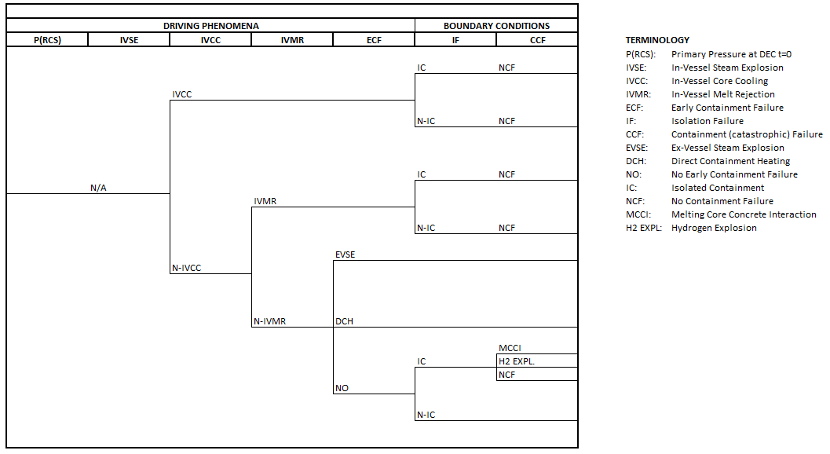

*FIG. 2. General Containment Event Tree*

Figure 3 illustrates the Design Event Tree (DET) used to analyse the occurrence or non-occurrence of the events that define the success or failure of the three driving complex phenomena and the two boundary conditions contained in the CET.

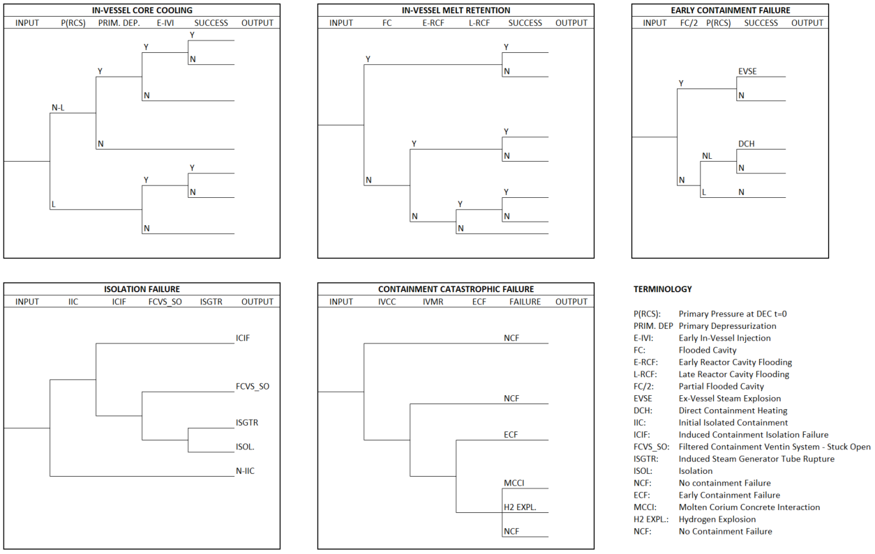

*FIG. 3. General Design Event Tree*

## CASE study

For illustration purposes, the methodology is here applied to five different sequences, all of them connected to the same PDS: LOCA in the Direct Vessel Injection line with failure of primary depressurization and unavailability of the Emergency Heat Removal System (EHRS).

The first case postulates the failure to prevent vessel lower head failure both by In-Vessel Core Cooling (IVCC) and In-Vessel Melt Rejection (IVMR), with further postulation of Induced Containment Failure (ICF) driven by high temperature.

The second case postulates the failure to prevent vessel lower head failure both by IVCC and IVMR, with the Filtered Containment Venting System stuck open after a certain number of venting cycles is reached (even if the stuck-open probability is low, e.g. 5%, the probability of failure is already of 40% after 10 cycles). In this case the Containment is successfully isolated.

The third case postulates the success to prevent vessel lower head failure via IVMR (thanks to the cavity flooding activation) together with the success of the Containment isolation, no induced isolation containment failure and availability of the Filter Containment Venting System.

The fourth case postulates the failure to prevent vessel lower head failure by the failure of the IVCC and the IVMR, and the success of the Containment isolation with a Late Reactor Cavity Flooding.

The five case postulates the failure to prevent vessel lower head failure both by the IVCC and IVMR failure, with the success of Containment Isolation.

Table 1 show the Boolean logical equations that model the five cases both for CET and for DET.

TABLE 1. DEPICTION OF CET AND DET IN BOOLEAN LOGIC

|  |  |  |
| --- | --- | --- |
| Case | Containment  Event Tree | Design  Event Tree |
| 1 | $$\overline{IVCC}∙\overline{IVMR}∙\overline{ECF}∙\overline{IC}$$ | $$IVCC:P\left(RCS\right)∙\overline{PRIM.DEP} ∙\overline{SUCCESS}$$ $$IVMR:FC∙\overline{SUCCESS}$$ $$ECF:FC/2∙\overline{ECF }$$ $$IF:IIC∙ICIF$$ $$CCF:\overline{IVCC}∙\overline{IVMR} ∙\overline{ECF} ∙\overline{NCF}$$ |
| 2 | $$\overline{IVCC}∙\overline{IVMR}∙\overline{ECF}∙\overline{IC}$$ | $$IVCC:P\left(RCS\right)∙PRIM. DEP ∙\overline{E–IVI}∙\overline{SUCCESS}$$ $$IVMR:FC∙\overline{SUCCESS}$$ $$ECF:\overline{FC/2}∙P\left(RCS\right)∙\overline{ECF }$$ $$IF:IIC ∙\overline{ICIF}∙FCVS_SO$$ $$CCF:\overline{IVCC}∙\overline{IVMR} ∙\overline{ECF} ∙\overline{NCF}$$ |
| 3 | $$\overline{IVCC}∙IVMR∙\overline{ECF}∙IC$$ | $$IVCC:P\left(RCS\right)∙PRIM. DEP ∙\overline{E–IVI}∙\overline{SUCCESS}$$ $$IVMR:FC∙SUCCESS$$ $$ECF:\overline{FC/2}∙P\left(RCS\right)∙\overline{ECF }$$ $$IF:IIC∙ICIF$$ $$CCF:\overline{IVCC}∙\overline{IVMR} ∙\overline{ECF} ∙\overline{NCF}$$ |
| 4 | $$\overline{IVCC}∙\overline{IVMR}∙\overline{ECF}∙IC$$ | $$IVCC:P\left(RCS\right)∙\overline{PRIM. DEP} ∙\overline{SUCCESS}$$ $$IVMR:L–RCF∙\overline{SUCCESS}$$ $$ECF:FC/2∙\overline{ECF }$$ $$IF:IIC∙\overline{ICIF} ∙\overline{FCVS_SO}∙ISOL$$ $$CCF:\overline{IVCC}∙\overline{IVMR} ∙\overline{ECF} ∙\overline{NCF}$$ |
| 5 | $$\overline{IVCC}∙\overline{IVMR}∙\overline{ECF}∙IC$$ | $$IVCC:P\left(RCS\right)∙PRIM. DEP∙\overline{E–IVI}∙\overline{SUCCESS}$$ $$IVMR:FC∙\overline{SUCCESS}$$ $$ECF:\overline{FC/2}∙P\left(RCS\right)∙\overline{ECF }$$ $$IF:IIC∙\overline{ICIF} ∙\overline{FCVS_SO}∙ISOL$$ $$CCF:\overline{IVCC}∙\overline{IVMR} ∙\overline{ECF} ∙\overline{NCF}$$ |

The acronyms presented on Table 1 bear identical significance to the terminology depicted in Figures 2-3. Terms with an upper side bar stands for failure to accomplish of the event.

## results

The Modular Analysis Accident Program (MAAP, ver. 5.06), was used for the accident simulation and calculation of the source term [11]. Figures 4-5 provide an example of the cumulative activity releases for Cs-137 and I-131 for the five cases considered in this work.  Figure 4-5 also show the base case that refers to a scenario in which a Loss of Coolant Accident occurs with the Direct Vessel Injection system activated and the unavailability of the Emergency Heat Removal System and the Automatic Depressurization System.

|  |  |
| --- | --- |
| *FIG. 4. Cumulated activity released (Cs-137) – MAAP code* | *FIG. 5. Cumulated activity released (I-131) – MAAP code* |

The five source term were then imported into the JRODOS system [12] to evaluate the radionuclides atmospheric dispersion on a fictional location. The main objective of this paper is to present a novel methodology for EPZ evaluation, therefore a sensitivity analysis to find the best-estimate weather condition based on a cluster or statistical analysis (usually the 95/95 worst case among a wide spectrum of realistic weather conditions) was not performed. The time of emission was set on a random fixed data (i.e., 15/11/2023 - 00:00) using the ECMWF high-resolution (10×10 km) forecast atmospheric data. The domain was set equal to 96×96 km, with the unit cell equal to 500 m. The height of release was set to be equal to 20 m for all cases. The simulation time was set to 24 hours from the start of the release. Figures 6-11 present the radionuclides distribution map in terms of Total Effective Dose Equivalent and Thyroid Equivalent Dose for the first three cases. Specifically, the yellow area corresponding to an effective dose major than 10 mSv, the red area to an effective dose major than 50 mSv and the green area to an equivalent thyroid dose major than 100 mSv.

|  |  |
| --- | --- |
|   *FIG. 6. Total Effective Dose Equivalent map – CASE 1* |   *FIG. 7. Thyroid Equivalent Dose map – CASE 1* |
|   *FIG. 8. Total Effective Dose Equivalent map – CASE 2* |   *FIG. 9. Thyroid Equivalent Dose map – CASE 2* |

|  |  |
| --- | --- |
|   *FIG. 10. Total Effective Dose Equivalent map – CASE 3* |   *Figure 11: Equivalent Thyroid Dose map – CASE 3* |

Table 2 presents the maximum distance at which protective action should be taken, based on the IAEA recommended dose intervention levels for the introduction of protective action in an early phase of a nuclear emergency [13].

TABLE . MAXIMUM DISTANCE FOR PROTECTIVE ACTIONS IMPLEMENTATIONS

|  |  |  |  |
| --- | --- | --- | --- |
| CASE | Sheltering | Iodine Pills | Evacuation |
| (km) | (km) | (km) |
| 1 | 44 | 54 | 31 |
| 2 | 12 | 10 | 3.5 |
| 3 | 18 | 13 | 5.5 |
| 4 | 1 | 2 | - |
| 5 | - | - | - |

Table 2 presents values that are to be taken for merely illustrative purposes, namely as an RCBM case study, since only a detailed analysis of the nuclear design will be in the position to confirm which events can be credited and which can be practically eliminated. Therefore, all the numerical results included in the current paper only serve to illustrate the suggested RCBM as suitable method for EPZ distance and area quantification.

An analysis of the distance at which a fixed threshold dose value is reached during the ST emission time was also performed on a bounding radiological consequences scenario. The bounding scenario was obtained from the convolution of the atmospheric dispersion results for the five cases analysed selecting the highest value between each of the results for each time step and each cell of the simulation domain.

Figures 12-13 present the results for a 50 mSv Total Effective Dose Equivalent value (evacuation protective action threshold)) and for a 100 mSv Thyroid Equivalent Dose value (iodine pills protective action threshold).

|  |  |
| --- | --- |
|   *FIG. 12. EPZ maximum distance for a 50 mSv TEDE threshold – Bounding Scenario* |   *FIG. 13. EPZ minimum distance for a 100 mSv thyroid equivalent dose threshold – Bounding scenario* |

## conclusion

The paper presents the Release-Category-Based Methodology (RCBM) for accident sequence identification aimed at EPZ distance calculation. The RCBM is consistent with the concept of practical elimination condition and bridges the gap between the online and offsite domains applied to nuclear safety under the application of the DID approach. The methodology was applied to five different sequences for a two inches DVI LOCA in a 1000-MWth integrated PWR SMR design.

REFERENCES

1. IAEA, Actions to Protect the Public in an Emergency due to Severe Conditions at a Light Water Reactor, EPRNPP-PPA, Vienna (2013).
2. IAEA SMR Regulators’ Forum Pilot Project Report, Report from Working Group on Emergency Planning Zone, (2018).
3. OECD-NEA, Implementation of Defence in Depth at Nuclear Power Plants, Lesson Learnt from the Fukushima Daiichi Accident, Nuclear Regulation No. 7248, (2016).
4. IRSN, The “practical elimination” approach of accident situation for water-cooled nuclear power reactors, Safety Approaches, 2017.
5. IAEA, Assessment of Defence in Depth For Nuclear Power Plants," Safety Report Series No. 46, Vienna, (2005).
6. Andrew J. Ckark and Michael T. Rowland, Safety and Security Defence-in-Depth for Nuclear Power Plants, SANDIA Report, SAND2021-14591, September (2021).
7. M. K. Dhami, L. Wicke, D. Onkal, Scenario generation and scenario quality using the cone of plausibility, Futures, 102995 (2022).
8. C. W. Taylor, Alternative World Scenarios For Strategic Planning, Strategic Studies Institute U.S. Army War College, Carlisle Barracks, Pennsylvania 17013-5050, (1988).
9. IAEA, Developing and Application of Level 2 Probabilistic Safety Assessment for Nuclear Power Plant, Specific Safety Guide, No. DS528, (2023), draft.
10. Yehia F. Khalil, Nuclear Engineering handbook, “Risk Assessment and Safety Analysis for Commercial Nuclear Reactors”, CRC Press, Florida, (2017).
11. FAUSKE & ASSOCIATED, MAAP – Modular Accident Analysis Program

[www.fauske.com/maap-modular-accident-analysis-program](https://www.fauske.com/maap-modular-accident-analysis-program)

1. KARLSRUHER INSTITUTE OF TECHNOLOGY, JRODOS – Decision Support Systems

https://www.ites.kit.edu/english/294.php

1. IAEA, Arrangements for Preparedness for a Nuclear or Radiological Emergency, Safety Guide GS-G-21, Vienna, (2007).