# BENCHMARKING NEAR-FIELD RADIONUCLIDE DISPERSION WITH CFD AND GAUSSIAN MODEL

SREEYUTH LAL

Canadian Nuclear Laboratories

Chalk River, Canada

Email: sreeyuth.lal@cnl.ca

ANEESH JOHN

Canadian Nuclear Laboratories

Chalk River, Canada

LUKE LEBEL

Canadian Nuclear Laboratories

Chalk River, Canada

**Abstract**

There is increasing interest in locating small modular reactors (SMRs) closer to potential end users for a variety of purposes, which is making it more important to understand the near-field atmospheric dispersion behavior of routine or accidental radionuclide emissions. Traditional codes have known limitations in predicting near-field dispersion especially when there are built-up features and/or complex terrain topologies in the near-field area. This work addresses these limitations and complement existing practices by using high-fidelity computational fluid dynamics (CFD) modeling for a realistic assessment of near-field radionuclide dispersion on a complex site. The terrain and building geometries of the chosen site are reconstructed from detailed aerial scans. The CFD results are compared to those from RASCAL, a consequence analysis code which uses classical Gaussian dispersion models and empirical parametrizations of building wake effects to calculate near-field dispersion. Finally, a discussion on the use of these two approaches, both individually and complementarily, for calculating radiological consequences of postulated SMR accidents is presented.

## INTRODUCTION

Small modular reactors (SMRs), due to their smaller size and enhanced safety features, will have smaller accident source terms than conventional large nuclear reactors. As a result, reduced offsite emergency preparedness and response requirements, including smaller emergency planning zones (EPZs), may be justifiable considering the reduced risk [1]. This may enable SMR the deployment of SMRs in different use cases, including those in close proximity to potential end users, like industrial or district heating applications [2] in populated and heavily built-up areas. However, in case of postulated accidents in SMRs in urban or semi-urban areas, a significant knowledge gap exists in terms of modelling atmospheric dispersion of radionuclides in the near-field (i.e., generally within 500 m of the source), especially when compared to modelling far-field atmospheric dispersion that has characterized off-site consequence analysis for large reactors. Complex topology or built-up areas around SMRs can have significant impacts on near-field atmospheric dispersion that is beyond the modelling capability of common Gaussian or Lagrangian plume models [3].

Gaussian plume models (GPMs) such as RASCAL [4] are consequence analysis tools that are typically used to obtain rapid estimates of time-averaged radionuclide concentrations and resulting dose consequences in the event of a postulated nuclear accident. RASCAL is widely used for emergency response planning and the determination of emergency planning zones (EPZs) around nuclear power plants in many countries [5]. Phenomena that are pertinent to the near-field such as dispersion due to building wakes, plume rise in the vicinity of buildings, turbulence-driven dispersion in low wind speeds, are accounted for in RASCAL and other GPMs using empirical correction factors [4]. However, there is limited data on the extent of GPMs’ underperformance in the near-field in comparison with experiments or more detailed computer models, with notable exceptions as detailed below.

Demael and Carissimo [6] compared near-field dispersion modelling of CFD and two GPMs in case of a simple terrain (prairie grass) to field experiments and noted that the GPMs fared better in that instance only because the turbulence parameters in the GPMs were fitted to match field observations. A similar comparison of GPMs (Gaussian plume and puff, as well as Lagrangian particle) with field experiments on simple terrain within 10-500 m was also done by Lebel et al. [7]. A recent report [8] compares the performance of MACCS, a probabilistic safety assessment tool that incorporates GPM dispersion, in the near-field to other GPM codes such as ARCON96 and AERMOD and also to QUIC, a simplified computational fluid dynamics (CFD) code. However, similar to the aforementioned study of Demael and Carissimo [6], the MACCS benchmarking study also involved simple geometries of up to two buildings around the source. There is a need, however, to demonstrate the capabilities of these different model types in the context of more complex local topologies and urban/suburban built up environments.

In terms of accuracy in modelling atmospheric dispersion, CFD is generally considered to have the highest fidelity [8] as it uses much higher resolution mechanistic fluid dynamics models. However, this accuracy comes with significant computational and modelling costs. Consequently, although CFD has been extensively used to model wind flows and pollutant dispersion in complex terrains [9-12], there are only limited examples of its application in dispersion studies in the context of nuclear accidents. Wu et al. [3] used CFD to assess the influence of mountainous terrain on radionuclide dispersion around a nuclear power plant in China and made recommendations to determine the emergency evacuation route in the event of an accident. Tang et al. [13] presented high-resolution CFD simulations of pollutant dispersion around a nuclear power plant; their comprehensive model spanned 64 km2 and included several topological features such as hills, valleys and buildings. However, both the aforementioned studies focused on macroscale dispersion patterns and did not focus on the near-field.

In this study, dispersion of radionuclides on a complex terrain, especially in the near-field, is analysed using RASCAL and a comprehensive CFD model. The atmospheric dispersion factor, (s/m3), a parameter often presented in literature to characterize dispersion [8], is used in this study to compare the two modelling approaches. In this parameter, the concentration of a pollutant, (kg/m3 or Bq/m3), at a downwind location is normalized by the release rate, $Q$ (kg/s or Bq/s), to make concentration independent of the source release rate.

The site details and the recorded meteorological data on the site are presented first, followed by descriptions of the RASCAL and CFD models. The results from the two modelling approaches and its implications for dose measurements are then discussed.

## sITE and meteorological data

The site selected for this study is the Chalk River site of Canadian Nuclear Laboratories (Fig. 1). The complex terrain of the site and its surroundings, including dense vegetation, hills, the Ottawa river, and multiple low-rise buildings, makes it a good candidate for this benchmarking study. The availability of high-quality meteorological data recorded directly at the site was also a key factor that influenced this site selection. As discussed in detail in the next sections, a fictitious point source of radionuclides from one of the buildings on the site is considered as the source term for the dispersion calculations in this study.

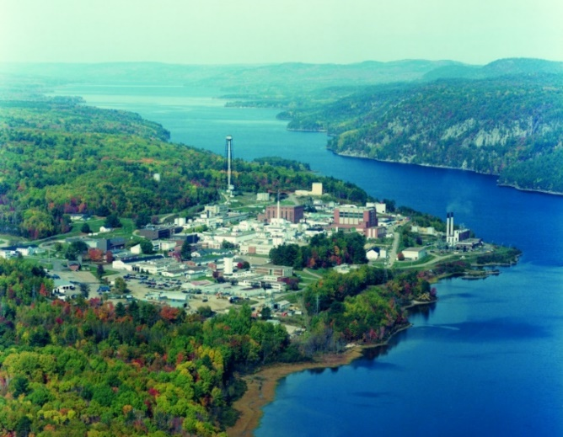

*FIG. 1*. *Aerial photograph of the Chalk River site of Canadian Nuclear Laboratories.*

Meteorological data is obtained from a 10 m tall station on the roof of one of the buildings (30 m from ground) on the Chalk River site. The system collects data continuously with a frequency of once every 10 s. The hourly averaged data over the 2019 calendar year is used to determine the frequency of common weather conditions. Data is divided into unstable, neutral, or stable atmospheric stability classes based on the Pasquill Stability classification [14], with the added simplification that classes A and B can be grouped into the unstable class, C and D into the neutral class, and E, F, and G into the stable class. The windiest conditions (mean wind speed > 2.2 m/s) within each of the three classes are chosen for the simulations in this study, with additional parameters given in Table 1 below. For the RASCAL simulations, the only meteorological inputs required are the stability class and the wind speed at 10 m above the ground, as discussed in Section 4. The CFD simulations require additional input parameters, including the friction velocity and the Monin-Obukhov length listed in Table 1, as discussed in Section 3.

TABLE 1. METEROLOGICAL CONDITIONS

|  |  |  |  |  |  |  |  |  |
| --- | --- | --- | --- | --- | --- | --- | --- | --- |
| Stability class | Median wind speed at 30 m (m/s) | | Median temperature gradient  (°C/100 m) | | Wind speed at 10 m (m/s) | Friction velocity (m/s) | Monin-Obukhov length (m) |  |
| B (unstable) | 2.68 | -1.9 | | 2 | | 0.388 | -110 |  |
| D (neutral) | 3.16 | -1.5 | | 2.2 | | 0.387 | ∞ |  |
| F (stable) | 2.63 | 1.5 | | 1.5 | | 0.201 | 74 |  |

## COMPUTATIONAL FLUID DYNAMICS MODEL

The CFD simulations in this study are performed using the commercial CFD software package STAR-CCM+ v17.06.007 [15]. The computational model, as shown in Fig. 2a, consists of the building with the fictitious point source of pollutants, and the buildings and terrain around the facility. The terrain and building geometry are obtained from aerial drone scans. A ‘photogrammetry’ technique employing many aerial photos was used to map the elevation of buildings and structures and develop a 3D model of the built-up area. This elevation data was converted into a Esri Raster file which was subsequently formatted into an STL file and implemented in STAR-CCM+ to develop the simulation domain. The terrain was smoothed using the Taubin method, and the building topology was simplified into shapes of uniform elevation using a CAD utility to ensure high-quality grid generation and stability in the convergence of the governing equations.

The setup of the computational domain followed the guidelines from Blocken (2015) [16] for specifying the height, width, upwind length, and downwind length of the domain containing the built-up area. The domain boundaries in Fig. 2a, with distances expressed relative to the height of the tallest building ($H_{max}=25 m$) on the site, were far enough from the built-up area to limit artificial acceleration in the flow, avoid numerical artifacts from nearby boundaries, and ensure that the flow is properly developed. The spatial orientation of the domain is configured such that the approaching wind aligns normal to the domain inlet. The mesh, shown in Fig. 2b, consists of a fully structured grid topology with orthogonal hexahedral elements aligned in the flow direction and used a characteristic surface size of 2 m for spatial resolution. A refinement region with a finer mesh size of 1 m was implemented in the vicinity of the source (indicated by the yellow box in Fig. 2b) to ensure good resolution of the flow field around the source and the site of the initial dispersion.

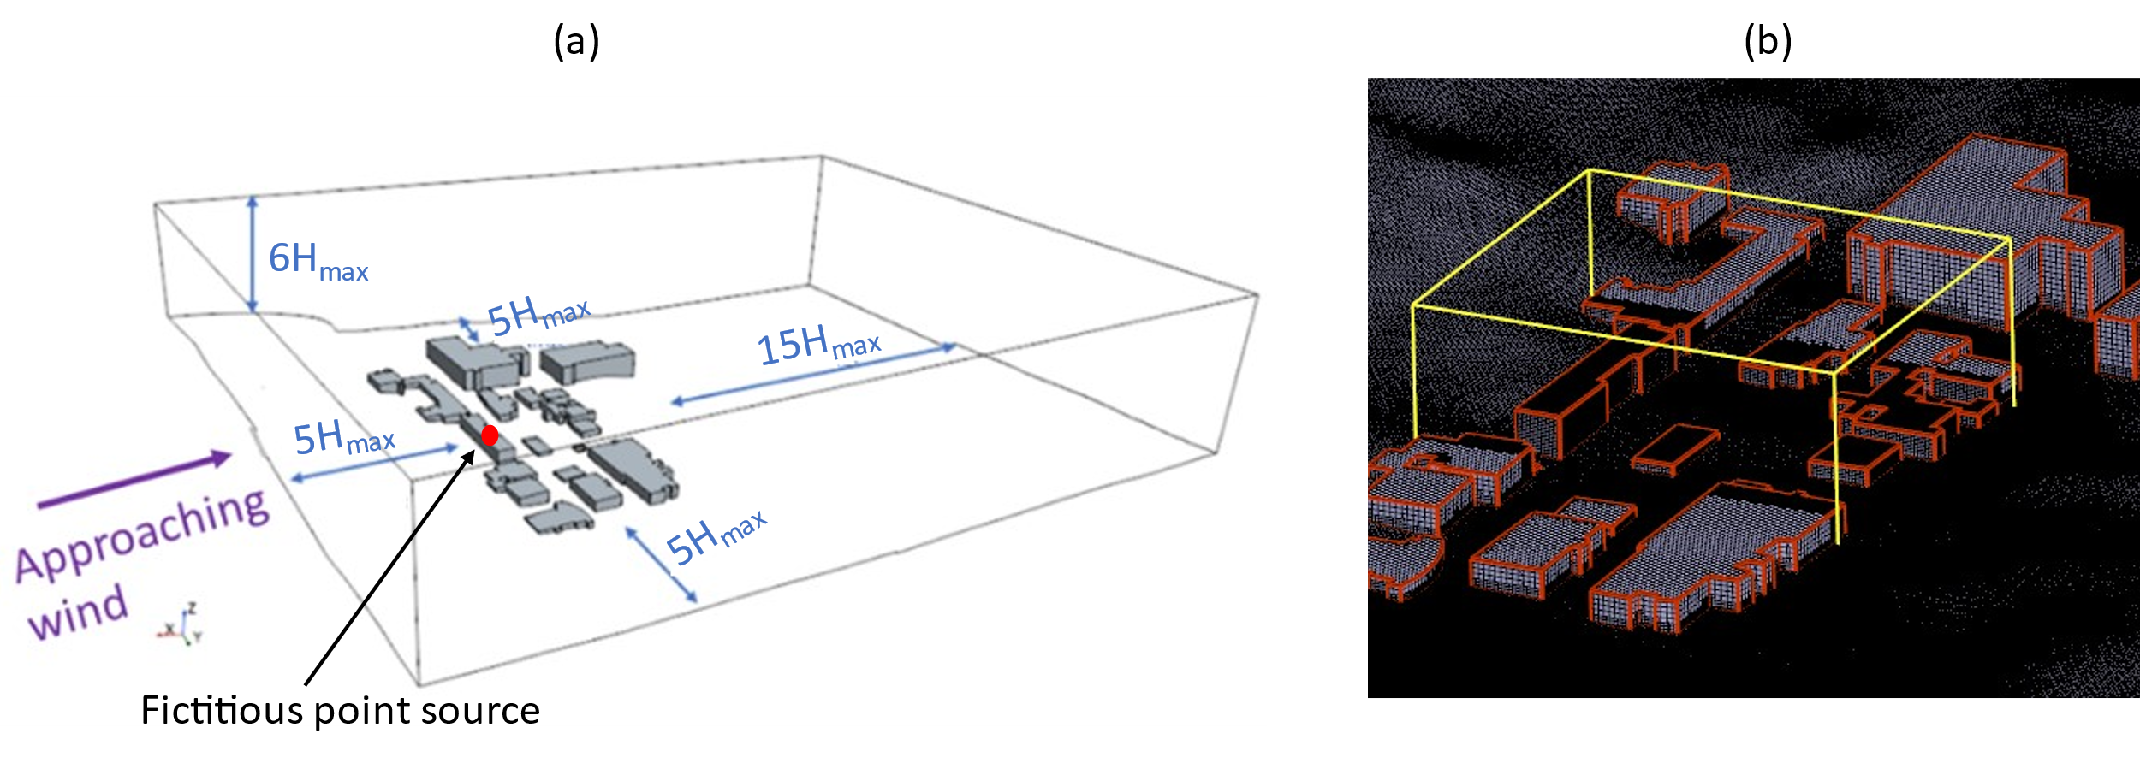

*FIG. 2. (a) Computational domain for CFD calculations, and (b) close-up of mesh with the yellow box indicating the refinement region.*

Steady-state solutions of pollutant dispersion around the source building are computed, and the Reynolds-averaged Navier-Stokes (RANS) 𝑘-𝜖 turbulence model is employed. The air is modelled as a constant density fluid with the Boussinesq model included so that buoyancy and the stability/instability of temperature stratification effects are considered. The source term is modelled as a passive (non-interacting) scalar from a point source at the roof of one of the buildings (red dot in Fig. 2a) at a height of 13 m above ground, with a release rate of 0.1 kg/s (selected to limit momentum introduced by the plume), and a source of 1 arbitrary concentration unit (acu).

The vertical profiles of average wind speed and temperature that are applied to the inlet boundary condition are given by Equations (1) and (2) below, according to Arya (1999) [14] and Vendel (2011) [17]:

|  |  |
| --- | --- |
| $$\frac{\overline{u}(z)}{u_{*}}=\frac{1}{κ}\left[\ln\left(\frac{z+z_{0}}{z_{0}}\right)-ψ_{m}\left(\frac{z}{L}\right)\right]$$ | (1) |
| $$\frac{\overline{θ}(z)-T_{0}}{θ_{*}}=\frac{1}{κ}\left[\ln\left(\frac{z+z_{0}}{z_{0}}\right)-ψ_{h}\left(\frac{z}{L}\right)\right]$$ | (2) |

Here, $u_{*}$ is the friction velocity, $θ_{*}=q/{c_{p}ρ_{0}u_{*}}$ is the friction temperature, $κ=0.42$ is the Von-Karman constant, $z_{0}$ is the roughness length, $T_{0}$ is the surface temperature, and $L={{u_{*}}^{2}}/{\left[κ\left(g/T\right) θ_{*}\right]}$ is the Monin-Obukov length. The value $q$ is the heat flux from the ground, and $c_{p}$ and $ρ_{0}$ are the heat capacity and density of the air, respectively. The functions $ψ_{m}\left(\frac{z}{L}\right)$ and $ψ_{h}\left(\frac{z}{L}\right)$ are influenced by the temperature gradient in the atmosphere and are zero when the atmosphere is neutral [18]. The shapes of each of the profiles can be described using four parameters: $u_{*}$, $z_{0}$, $L$, and $T_{0}$. These parameters, used in the CFD boundary condition definitions, are selected to match the onsite meteorological data. The values of $u_{*}$ and $L$ are given in Table 1; with $z_{0}$ = 1 m and $T_{0}$ = 5 °C. The plume temperature is assumed to be 300 K. From the simulations, the pollutant concentration $χ_{i}$ (acu) at 1 m above ground level is calculated, from which $χ/Q$ is calculated as $χ/Q= {\left({χ_{i}}/{χ_{o}}\right)}/{\left({\dot{m}}/{ρ_{a}}\right)}$, where $χ_{o}$ is the source concentration (1 acu), $\dot{m}$ is the release rate (0.1 kg/s), and $ρ_{a}$ is air density (1.23 kg/m3).

## RASCAL MODEL

Three simulations are performed in RASCAL as per the meteorological conditions listed in Table 1. The simulation parameters are matched to those of the CFD model as much as possible. The source release is at a height of 13 m in agreement with the CFD model. As RASCAL requires wind speed at the 10 m height, the corresponding wind speeds listed in Table 1 are used as the inputs. RASCAL internally converts the 10 m wind speed to that at the release height (13 m) with the same profile used in the CFD simulations and given in Eq. (1). As RASCAL works only in sectors of 10° angles, wind approaches the source at an angle of 260° relative to true north (as compared to 255° for the CFD cases). For the source term, a release rate of 2×1012 Bq/s of I-131 is assumed, which is from a MELCOR calculation of a generic water-cooled SMR’s station blackout severe accident sequence with loss of containment isolation [19]. The release is assumed to be steady and in steady, uniform meteorological conditions for 8 h, and the ambient temperature at release is 300 K. The concentrations that result from the RASCAL simulation are not directly compared to the CFD model, but are first converted into $χ/Q$. In RASCAL, $χ/Q$ is internally computed and is not a standard output of the code. However, the STDose module of RASCAL can be used to determine the organ-committed dose equivalent caused by inhalation for 15-minute periods, $D_{15}$ (Sv), which is related to $χ$ as:

|  |  |
| --- | --- |
| $$D_{15}=V_{b}\sum_{n}{\left[{DCF}_{n}\int_{t}^{t+15}{χ_{n}\left(t\right)dt}\right]}.$$ | (3) |

Here, =3.33×10-4 m3/s is the breathing rate, ${DCF}_{n}$ (Sv/Bq) is the organ-specific dose conversion factor for radionuclide *,* (Bq/m3) is the radionuclide $n$ concentration, and $t$ is time. Since I-131 is the only radionuclide considered in the source term in this study, the summation in the above equation is not applicable, and $DCF$ of I-131 = 8.89×10-9 Sv/Bq as per ICRP-26 [4]. Ground-level doses (assumed to be at a height of 1 m in RASCAL) are calculated at eight downwind locations: 25 m, 50 m, 75 m, 100 m, 250 m, 500 m, 750 m and 1000 m from the source. The concentration $χ$ at these locations are calculated from the doses using Equation (3), which is then normalized by the release rate of = 2×1012 Bq/s to get $χ/Q$ values. RASCAL warns that dose calculations at locations closer than 100 m to the source should be used with caution as it may violate the point source assumption. However, as the main goal of this study is precisely highlighting the shortcomings of Gaussian dispersion codes in the near-field, RASCAL calculations at these locations are used as is and compared with CFD calculations.

## RESULTS AND DISCUSSION

### CFD results

The passive scalar concentration, unitless as it is normalized by the source concentration, is shown in Fig. 3. The strongest dispersion is for the unstable case as the buoyancy-generated turbulence from the unstable air temperature gradients enhances diffusion. Moreover, in the unstable case, and to a lesser extent in the stable case, the plume has a notable deflection towards the north. This is due to suction from the low-pressure zone created by a hill to the northwest of the point source. In the stable case, the plume remains closer to the ground level where, due to the low-lying buildings, it experiences increased mixing and enhanced spreading in the built-up area. In general, the plume behaviour clearly deviates from a standard Gaussian assumption in the near-field due to the surround buildings and spatially varying terrain that enhance mixing.

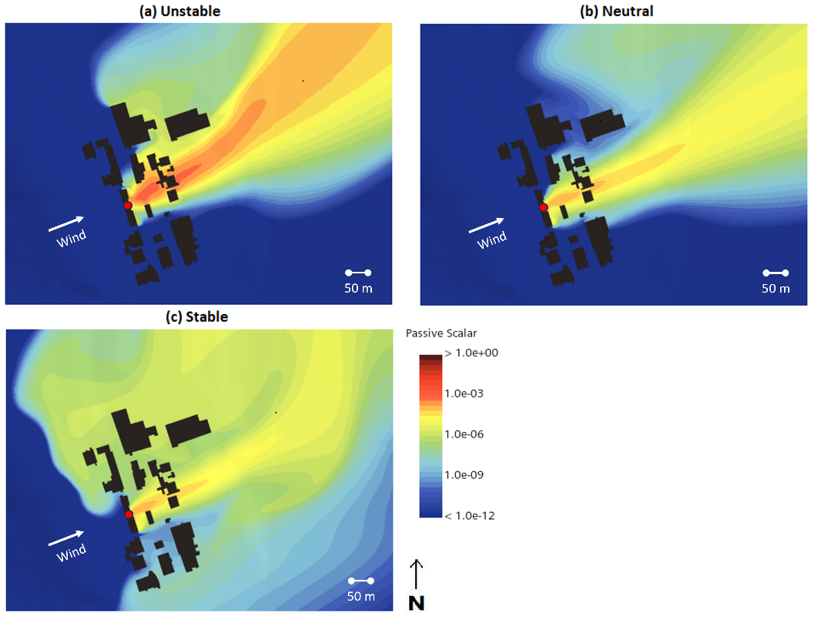

*FIG. 3*. *Near-field passive scalar distribution calculated by CFD for* *(a) unstable, (b) neutral, and (c) stable environmental conditions at 1 m above ground. The approaching wind direction and fictitious point source (red dot) are also shown.*

### RASCAL results

The near-field inhalation doses computed by RASCAL for the three considered environmental conditions is given in Fig. 4. Since winds are approaching from an angle of 260° relative to the true north, the plume is dispersed within the northeast and southeast quadrants, with the highest lateral spread in the unstable case and the least in the neutral case. The strongest dispersion (zones with doses > 50 mSv) is for the unstable case. These trends are broadly consistent with those of the CFD simulations.

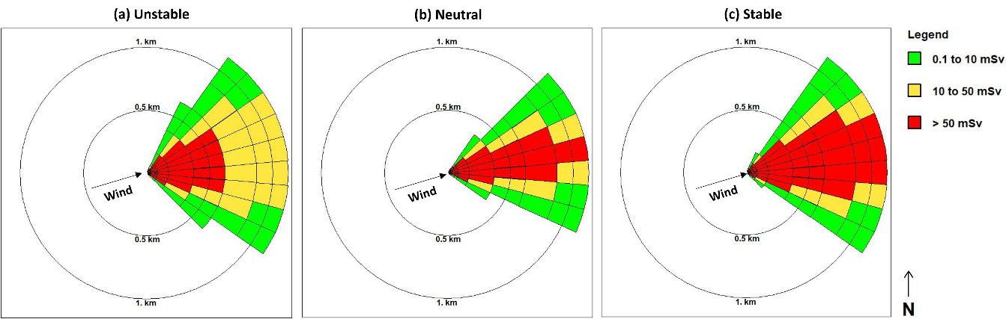

*FIG. 4. Near-field inhalation dose calculated by RASCAL for* *(a) unstable, (b) neutral, and (c) stable environmental conditions.*

### Benchmarking near-field atmospheric dispersion with RASCAL and CFD

The atmospheric dispersion factor, $χ/Q$, as calculated by RASCAL and CFD are compared in Fig. 5. Results are presented along the plume centreline and ± 30° for both models, and additionally along ± 60° for just CFD (RASCAL does not show any dispersion that far laterally). As approaching winds are offset by 5° in RASCAL and CFD, the same offset is also applied while analysing the results. In the near-field (less than 100 m from source), along the plume centreline (75°), CFD calculates marginally higher $χ/Q$ values for the neutral and stable cases while the difference is much higher for the unstable case. As ground level concentrations are being reported but for an elevated release point, the CFD results are able to better reflect the elevated concentrations that occur as radionuclides are trapped in the building wake, especially in the unstable case where vertical dispersion is the highest. To the northeast of the centreline (45°), CFD calculates considerably higher $χ/Q$ values, while to the southeast (105°), RASCAL calculates generally higher values; this asymmetry is largely due to the northward deflection of the plume by the hill, underlining the importance of geographical features of the site when considering the overarching plume direction. Outside of the near-field, CFD calculates generally higher $χ/Q$ values along the plume centreline and significantly lower values to the southeast (105°). To the northeast (45°), CFD $χ/Q$ values are consistently lower only in the neutral case where the plume deflection due to the hill is the weakest (see Fig. 3), while it is comparable or higher in the unstable and stable cases.

The implications of these results for SMR emergency preparedness applications are clear. Gaussian plume-based codes cannot replicate the subtleties of flow dynamics caused by buildings and terrain in the vicinity of a release, and results can be conservative or non-conservative depending on the situation. For a realistic determination of near-field dose estimates, and therefore for effective planning of emergency planning zones and response measures, high-fidelity methods such as CFD should be considered, especially if there are abrupt terrain variations or mid-size/tall buildings in the vicinity of SMRs, which is likely the case for many SMRs, particularly those that are part of a hybrid energy system zone [20].

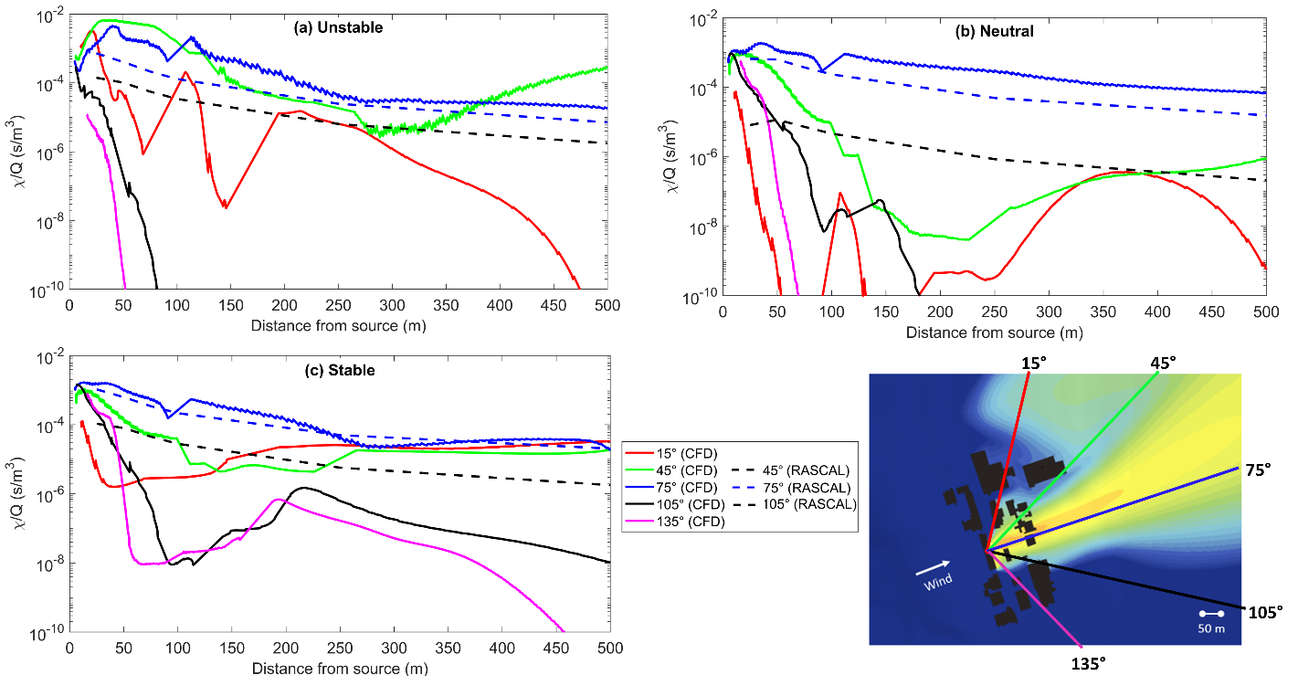

*FIG. 5*. *Comparison of near-field atmospheric dilution factors computed by CFD and RASCAL for (a) unstable, (b) neutral, and (c) stable environmental conditions. Angles are relative to true north and superimposed on CFD contour plot.*

## CONCLUSIONS

Atmospheric dispersion factors calculated by a computational fluid dynamics (CFD) code and RASCAL, a Gaussian dispersion code, are compared for three atmospheric stability cases. Simulations are performed for a fictitious point source emission from a building on a complex site with multiple buildings and terrain elevation variations. Based on the environmental conditions and distance from the source, notable variations in pollutant dispersion are observed between the two codes, especially in the near-field. The results indicate that Gaussian dispersion codes provide conservative dose estimates only in limited scenarios where terrain variations and building geometries do not significantly influence pollutant dispersion, which is unlikely for locations of future SMRs in industrial or semi-urban areas. Detailed modelling methods such as CFD are recommended to obtain more realistic dose assessments that could better inform emergency planning measures around SMRs [20].

ACKNOWLEDGEMENTS

Funding for this work was provided by Atomic Energy of Canada Limited under the auspices of the Federal Nuclear Science and Technology Program.

References

[1] D. W. Hummel, S. Chouhan, L. Lebel, and A. C. Morreale, "Radiation dose consequences of postulated limiting accidents in small modular reactors to inform emergency planning zone size requirements," *Annals of Nuclear Energy,* vol. 137, 2020, doi: 10.1016/j.anucene.2019.107062.

[2] B. Poudel and R. Gokaraju, "Small Modular Reactor (SMR) Based Hybrid Energy System for Electricity & District Heating," *IEEE Transactions on Energy Conversion,* vol. 36, no. 4, pp. 2794-2802, 2021, doi: 10.1109/tec.2021.3079400.

[3] Nan Wu, Na Xue, and X. Liu, "Research on the influence of complex errain on atmospheric dispersion after accident," in *Proceedings of the 2018 26th International Conference on Nuclear Engineering ICONE26*, London, 2018.

[4] J. V. Ramsdell Jr., G. F. Athey, and J. P. Rishel, "RASCAL 4.3: Description of Models and Methods, NUREG-1940 Supplement 1," U.S. Nuclear Regulatory Commission, 2015.

[5] M. A. Khaer, M. A. Hoq, S. M. T. Hassan, M. T. Chowdhury, and M. M. Rahman, "Assessment of radiological dose and emergency planning zones of TRIGA Mark-II research reactor of Bangladesh due to a postulated severe accidental condition," *Nuclear Engineering and Design,* vol. 415, 2023, doi: 10.1016/j.nucengdes.2023.112727.

[6] E. Demael and B. Carissimo, "Comparative Evaluation of an Eulerian CFD and Gaussian Plume Models Based on Prairie Grass Dispersion Experiment," *Journal of Applied Meteorology and Climatology,* vol. 47, no. 3, pp. 888-900, 2008, doi: 10.1175/2007jamc1375.1.

[7] L. Lebel *et al.*, "The Sensitivity of Atmospheric Dispersion Calculations in Near-field Applications: Modeling of the Full Scale RDD Experiments with Operational Models in Canada, Part I," *Health Phys,* vol. 110, no. 5, pp. 499-517, May 2016, doi: 10.1097/HP.0000000000000365.

[8] Daniel J. Clayton and N. E. Bixler, "Assessment of the MACCS Code Applicability for Nearfield Consequence Analysis," Sandia National Laboratories, SAND2020-2609, 2020.

[9] G. Ioannidis, C. Li, P. Tremper, T. Riedel, and L. Ntziachristos, "Application of CFD Modelling for Pollutant Dispersion at an Urban Traffic Hotspot," *Atmosphere,* vol. 15, no. 1, 2024, doi: 10.3390/atmos15010113.

[10] X. Wei, E. Dupont, E. Gilbert, L. Musson-Genon, and B. Carissimo, "Experimental and Numerical Study of Wind and Turbulence in a Near-Field Dispersion Campaign at an Inhomogeneous Site," *Boundary-Layer Meteorology,* vol. 160, no. 3, pp. 475-499, 2016, doi: 10.1007/s10546-016-0148-7.

[11] H. F. Bonifacio, R. G. Maghirang, and L. A. Glasgow, "Numerical Simulation of Transport of Particles Emitted From Ground-Level Area Source Using Aermod and CFD," *Engineering Applications of Computational Fluid Mechanics,* vol. 8, no. 4, pp. 488-502, 2015, doi: 10.1080/19942060.2014.11083302.

[12] U.-H. Yeo *et al.*, "Impact Analysis of Environmental Conditions on Odour Dispersion Emitted from Pig House with Complex Terrain Using CFD," *Agronomy,* vol. 10, no. 11, 2020, doi: 10.3390/agronomy10111828.

[13] B. Tang, H. Wang, J. Xu, J. Lin, J. Hu, and R. Chen, "High-Resolution Simulation of the Near-Field Pollutant Dispersion in a Nuclear Power Plant Community with High-Performance Computing," *Journal of Nonlinear Mathematical Physics,* vol. 31, no. 1, 2024, doi: 10.1007/s44198-024-00171-7.

[14] S. P. Arya, *Air pollution meteorology and dispersion*. New York: Oxford University Press, 1999.

[15] *Simcenter STAR-CCM+, version 17.06*. (2023). Siemens Industries Digital Software.

[16] B. Blocken, "Computational Fluid Dynamics for urban physics: Importance, scales, possibilities, limitations and ten tips and tricks towards accurate and reliable simulations," *Building and Environment,* vol. 91, pp. 219-245, 2015, doi: 10.1016/j.buildenv.2015.02.015.

[17] F. Vendel, "Modélisation de la dispersion atmosphérique en presence d’obstacles complexes : application à l’étude de sites industriels," University of Lyon, 2011.

[18] L. Lebel, K. Vu, A. John, and V. Korolevych, "Method for assessing radon Re-Entrainment risks from above ground level discharges from sub-slab depressurization systems," *Building and Environment,* vol. 215, 2022, doi: 10.1016/j.buildenv.2022.108942.

[19] John Cui, Luke Lebel, Andrew Morreale, and D. Hummel, "MELCOR Model of iPWR and Application to Emergency Planning Zone Study," presented at the 14th International Topical Meeting on Nuclear Reactor Thermal-Hydraulics, Operation and Safety (NUTHOS-14), 2024.

[20] M. Temiz and I. Dincer, "Development of a hybridized small modular reactor and solar-based energy system for useful commodities required for sustainable cities," *Energy,* vol. 286, 2024, doi: 10.1016/j.energy.2023.129562.