Determining Emergency Planning Zone size through

JRODOS calculated radiation dose consequences in

High-Temperature Gas-Cooled Reactors

KOPKA, Piotr

National Centre for Nuclear Research

Otwock-Swierk, Poland

Email: Piotr.kopka@ncbj.gov.pl

SKRZYPEK, Maciej , SKRZYPEK, Eleonora, KASZKO, Aleksiej

National Centre for Nuclear Research

Otwock-Swierk, Poland

**Abstract**

The conceptual design of the High-Temperature Gas-Cooled Reactor (HTGR) research reactor was developed by the team at the Division of Nuclear Energy and Environmental Analysis of the National Centre for Nuclear Research (NCBJ). Emergency Preparedness and Response (EPR) analysis is essential, leading to the designation of an Emergency Planning Zone (EPZ), which is crucial for advancing the project. Due to characteristics like the effective heat removal by HTGR cores and the significant reduction of dust-containing sorbed fission products by TRISO particles, the EPZ size is reduced. These zones are established based on safety analysis results, considering potential emergency scenarios with the worst possible consequences and probability of occurrence equal to or greater than once in 107 years calculated using severe accident code (MELCOR). Radiological analysis, utilizing JRODOS, was conducted for various accident scenarios (e.g., D-LOFC), incorporating a range of weather scenarios. The analysis demonstrated that the limited radionuclide inventory available for release and specific security-enhancing rector design inherently mitigates the dose consequences. Statistical analyses were performed for the surrounding NCBJ institute area, highlighting the distribution and risk factors for populated areas. The observed decrease in consequences indicates that smaller EPZs could be viable without raising risks to public safety.

## INTRODUCTION

The National Centre for Nuclear Research (NCBJ) in Świerk, Poland, has engaged in various national and international projects, such as HTR-PL, GEMINI Plus, and GOSPOSTRATEG-HTR, focusing on the development of small-scale High-Temperature Gas-cooled Reactor (HTGR) technology. The primary goal is to replace existing fossil fuel plants in the chemical and petrochemical industries with nuclear reactors, aiming to decrease CO2 emissions in Poland and Europe in the near future.

As part of the GOSPOSTRATEG-HTR project, the pre-conceptual design of the 40 MWth research High-Temperature Gas-cooled Reactor (HTGR) named TeResa was developed, featuring 31 fuel blocks in a single layer [1]. However, during subsequent design phases, it was determined that the maximum thermal power should be reduced to 30 MWth. Consequently, a new design was introduced under the feminine name POLA [2]. Unlike TeResa, POLA incorporates only 19 fuel blocks in a single layer within the core. The design of HTGR-POLA prioritizes safety, emphasizing efficient heat removal from the core during accident conditions rather than focusing solely on neutronic characteristics. Consequently, the HTGR-POLA configuration is characterized by its thin and tall structure, resulting in a large height-to-diameter ratio (H/D = 2.169) and a significant surface-to-volume ratio, facilitating optimal passive cooling during accidents. The core of HTGR-POLA comprises fuel columns arranged in a triangular grid with uniform pitch, forming three rings around the central fuel column, with a 2 mm gap width between individual columns. Each fuel column consists of six fuel blocks, including standard blocks and blocks featuring dedicated channels for reactor reactivity control systems such as Control Rods (CR) and the Reserve Shutdown System (RSS). Notably, the reactor operates in cogeneration mode, producing electricity up to 10 MWe, high-temperature heat up to 25 t/h, and district heat for NCBJ's purposes up to 16.5 MWth.

This research aimed to assess the radiological impacts of limiting accidents for HTGR technologies. The goal involved identifying the limiting accident, estimating the accident source term, and conducting dispersion and dose consequence calculations using JRODOS. The study focused on the research type, specifically the High-Temperature Gas-cooled Reactor (HTGR). Source term estimates were derived from the results of the MELCOR code, including initial radionuclide inventories and release rates. These source terms were used as inputs for dispersion and dose calculations, which will be implemented by the JRODOS system. After calculating the doses, significant EPZ zones will be designated.

## POSTULATED SEVERE accident OF THE HTGR REACTOR

Analysed High-Temperature Gas-cooled Reactor (HTGR) [1] with prismatic fuel assemblies and TRISO fuel is similar to the High-Temperature Engineering Test Reactor (HTTR) operated by the Japan Atomic Energy Research Institute (JAERI) [3].  The Depressurized Loss of Forced Cooling (DLOFC) accident is a commonly studied Design Basis Accident (DBA) and poses significant challenges to reactor safety measures. It's a focal concern because it leads to higher maximum fuel temperatures than other DBAs. When a large 65 mm break occurs, the reactor rapidly loses pressure, causing the coolant to escape from the reactor coolant loop, thus compromising the ability to cool the heated structures within the reactor core. Within a short timeframe of approximately 500 seconds, the system undergoes nearly complete depressurization, with flow through the break coming to a halt.[4]Following SCRAM (Safety Control Rods Actuation Mechanism), reactor power is dictated by decay heat curves derived from data provided by NRG and computed using 11-group calculations. These calculations stem from neutronic simulations using the MELCOR code, which furnishes constants for neutron precursors groups.

Post-reactor shutdown, decay heat is transferred from the core to the Reactor Pressure Vessel through conduction, convection, and radiation. In HTGR cores, conduction primarily facilitates heat transfer. Unlike water reactors, solid structures within the core extract heat. The graphite blocks absorb heat from the fuel pellets and transfer it through helium gaps to the core's outer walls. The reactor cavity cooling system (RCCS) cools the reactor vessel. Due to the high heat capacity of graphite, the core's temperature rises relatively slowly, thereby moderating the maximum fuel temperature. The safety and licensing experience of the HTTR provides a relevant foundation for estimating radionuclide release fractions in the worst-case reactor accident scenarios. Initially, the Japanese regulator reviewed JAERI's proposal, which suggested that 30% of noble gases and 15% of iodine would be released to the environment [5]. These estimates assumed that all Oxygen entering the core would directly attack the fuel rather than oxidize other graphite structures within the reactor vessel.

However, the Japanese regulator did not accept these estimates due to insufficient supporting evidence, leading to more conservative radionuclide release fractions based on the experience with Light Water Reactors (LWR) [5]. A study by Idaho National Laboratory also provided source terms for a different HTGR accident scenario without significant fuel failure, specifically a D-LOFC with scram and without air ingress [6]. In this study, release fractions for each chemical group were calculated based on 95% confidence long-term releases and then scaled relative to the assumed 15% release of 131I The original release fractions proposed by MELCOR simulations were considered appropriate for this study. The release fractions for all relevant elements in the HTGR accident are summarized in Table 1.

TABLE 1. *Source term for HTGR TeResa after DLOFC accident. Data is calculated using the MELCOR code.*

|  |  |  |  |  |  |
| --- | --- | --- | --- | --- | --- |
| **Isotope** | **[Ci]** | **[Bq]** | **Isotope** | **[Ci]** | **[Bq]** |
| Ag110m | 4,42E-03 | 1,64E+08 | Kr85m | 1,43E+00 | 5,29E+10 |
| Ba139 | 2,12E-04 | 7,84E+06 | Kr87 | 2,88E+00 | 1,07E+11 |
| Ba140 | 2,16E-04 | 7,99E+06 | Kr88 | 3,59E+00 | 1,33E+11 |
| Cs134 | 5,25E+00 | 1,94E+11 | Rb86 | 6,24E-02 | 2,31E+09 |
| Cs136 | 1,20E+00 | 4,44E+10 | Rb88 | 6,37E+01 | 2,36E+12 |
| Cs137 | 6,97E+00 | 2,58E+11 | Sr89 | 1,61E-04 | 5,96E+06 |
| I131 | 8,03E-01 | 2,97E+10 | Sr90 | 1,56E-05 | 5,77E+05 |
| I132 | 1,04E+00 | 3,85E+10 | Sr91 | 2,00E-04 | 7,40E+06 |
| I133 | 1,21E+00 | 4,48E+10 | Sr92 | 2,06E-04 | 7,62E+06 |
| I134 | 1,25E+00 | 4,63E+10 | Xe131m | 4,22E-02 | 1,56E+09 |
| I135 | 1,10E+00 | 4,07E+10 | Xe133 | 5,59E+00 | 2,07E+11 |
| Kr83m | 5,89E-01 | 2,18E+10 | Xe133m | 1,80E-01 | 6,66E+09 |
| Kr85 | 6,90E-02 | 2,55E+09 | Xe135 | 1,91E+00 | 7,07E+10 |

## JRODOS (Real-time On-line DecisiOn Support)

The JRODOS system, developed within various Euroatom projects [7, 8, 9], constitutes a sophisticated computational tool applicable within national or regional emergency control centers across all stages of a nuclear incident. Its primary objective is to assist decision-makers in implementing a diverse array of measures aimed at mitigating the repercussions stemming from the release of radioactive substances into the environment after a nuclear mishap. To ensure its efficacy, the system necessitates seamless integration with meteorological services and radiological monitoring networks, alongside customization to suit local, regional, and national contexts.

In the event of an inadvertent atmospheric release, the system can function either diagnostically, utilizing real-time local meteorological data sourced from monitoring masts, or prognostically, employing a suite of atmospheric dispersion models spanning from local to continental scales. The local-scale models (LSMC) embedded within the JRODOS system encompass the meteorological pre-processor RMPP [10], the puff diffusion model RIMPUFF [11, 8, 12], and the Lagrangian model Dipcot [13]. For long-range dispersion, options include the Eulerian model MATCH [14, 15, 16] and, with certain constraints, the Lagrangian DWD-L LASAT [17]. The atmospheric dispersion models within the JRODOS system have been validated through numerous experiments and exercises [18, 15].

The modeling of radionuclide transfer from the cloud to ground deposition and subsequently to food products is facilitated by the Food Dose Module Terrestrial (FDMT) [19]. Activity concentration calculations are performed in the deposition module DEPOM based on the outputs of the atmospheric dispersion model. The food chain transfer module is contingent upon regional attributes relating to climate and agriculture, necessitating customization of model parameters. This is achieved through delineating radioecological regions outlining predominant agricultural practices, vegetation cycles, harvesting periods, dietary habits, food, and feed sources, among other factors.

It is necessary to establish reference meteorological conditions to perform calculations regarding the transport of radionuclides following a potential severe accident. For the National Centre for Nuclear Research location, meteorological measurement data from the weather station in the Okęcie area were used. The wind rose is presented in Fig. 1. Atmospheric dispersion data for this location, collected over a period of 10 years, outlines temperature-based release characteristics. The standard deviation of the wind direction was averaged over 0.5-hour periods. For this study, the adult dose was determined based on a residence time of 7 days from the start of the release. We can observe two predominant wind directions: from the west and the southeast.

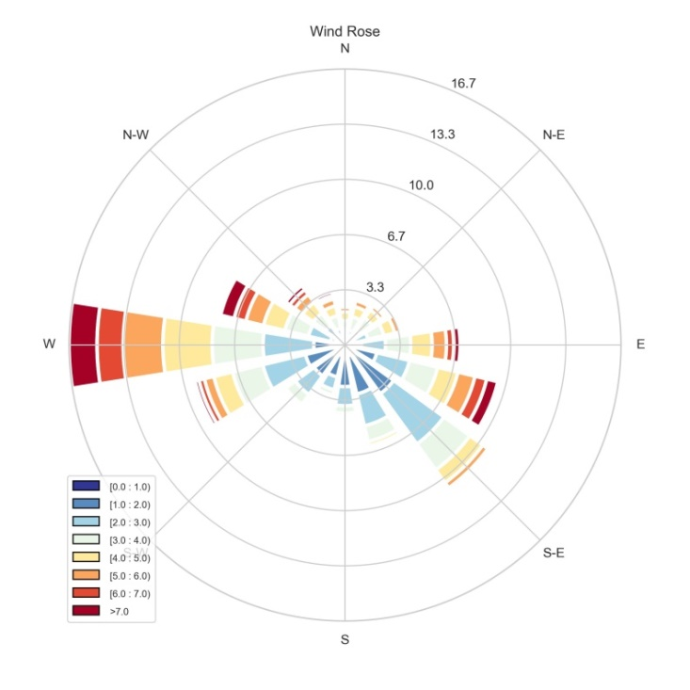

FIG1. *Wind rose from the Otwock Swierk location. Observation data from a period of 10 years.*

TABLE 2. *Postulated worst/conservative weather conditions obtained from measurement data and literature*

|  |  |  |  |  |  |
| --- | --- | --- | --- | --- | --- |
| **Weather scenario name** | **Wind Speed [m/s]** | **Wind direction** | **Pasquill Stability Classes** | **Total rainfall 6h [mm]** | **Reference** |
| EPA_1 | 1,50 | 275,00 | F | 0,00 | [18] |
| EPA_2 | 3,00 | 275,00 | D | 0,00 | [18] |
| Mdata_Comm | 3,90 | 273,00 | C | 0,10 | Fig.1 |
| Mdata_Wwind | 0,10 | 130,00 | A | 0,00 | Fig.1 |
| Mdata_Swind | 15,00 | 270,00 | D | 6,00 | Fig.1 |

The most common potential weather scenario *Mdata_Comm* was identified, along with two extreme cases derived from the data. The *Mdata_Wwind* scenario represents historical data with very weak winds (average 0.1 m/s), while the *Mdata_Swind* scenario features very strong winds and precipitation. Stability classes and wind directions were determined based on the measured data. Additionally, two reference scenarios representing the worst weather conditions for the transport of toxic gases, as recommended by the EPA [20], were included. The wind direction most frequently observed at this location was considered for these scenarios. The summarized parameters of the weather conditions for the proposed scenarios are shown in Table 2.

## Emergency Planning Zone

Determining the emergency planning zone area and extended distances, such as extended planning and ingestion and commodities control planning, around an organizational unit performing activities classified under Category I or II hazards, is crucial for ensuring the safety of the general population residing in the adjacent areas. Category II includes the commissioning, operation, and decommissioning of a nuclear facility, such as a reactor with a thermal power between 2 MW and 100 MW, encompassing most SMR reactors. The President of the National Atomic Energy Agency (PAA) is the main authority in the government responsible for nuclear safety and radiological protection [21]. According to PAA guidelines for Category II facilities, which include research reactors, fuel processing plants, isotopic enrichment and nuclear fuel production facilities, and radioactive waste repositories, specific zones with defined limits are assessed:

* The Urgent Protective Action Planning Zone (UPZ): An external zone designated for immediate intervention planning. This zone encompasses effective doses from both external and internal exposure, excluding the ingestion of radioactive substances (≥ 100 mSv) and an equivalent dose to the thyroid from the ingestion of radioactive iodine isotopes (≥ 50 mSv).
* The Extended Planning Distance (EPD): A zone for expanded planning, which involves an effective dose greater than or equal to 100 mSv from both external and internal exposure, including the ingestion of radioactive substances.
* The Ingestion and Commodities Planning Distance (UCPD): A zone for consumption planning and commodity control, which includes a dose of 10 mSv or more from the ingestion of food and drinking water, considering the local dietary habits of the population in the area.

## RESULTS

Fig. 2 illustrates the values of the equivalent dose to the thyroid resulting from ingesting radioactive iodine isotopes, specifically for the HTGR TeResa reactor located in Świerk, under the meteorological conditions outlined in Table 2. The variations in the directions of the prevailing winds are due to the methodology employed in selecting these conditions; however, these variations do not significantly impact the distances obtained. Table 3 presents the maximum dose values, and since the limit values were exceeded only for the Mdata_Wwind condition, the table shows the distance to the value of 1 mSv. The predetermined threshold values were exceeded for the weather scenario named Mdata_Wwind, which assumes very weak wind conditions and a stability class of A. The resulting zones were calculated as follows: the Urgent Protective Action Planning Zone (UPZ) extended to 141 meters, and the Ingestion and Commodities Planning Distance (ICPD) reached 70 meters. This underscores the importance of accurately specifying weather conditions when

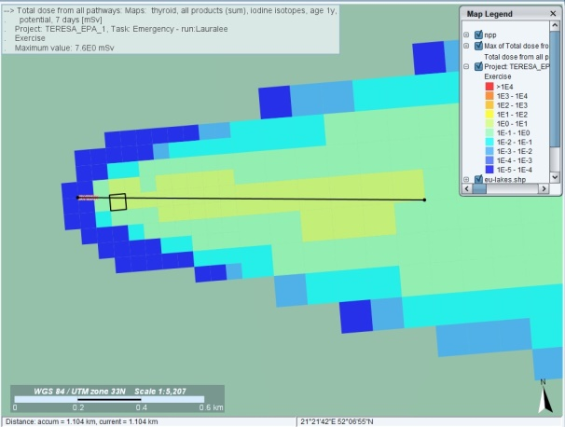 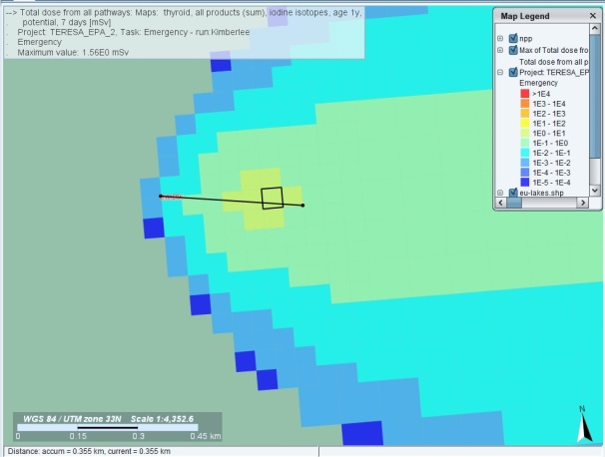

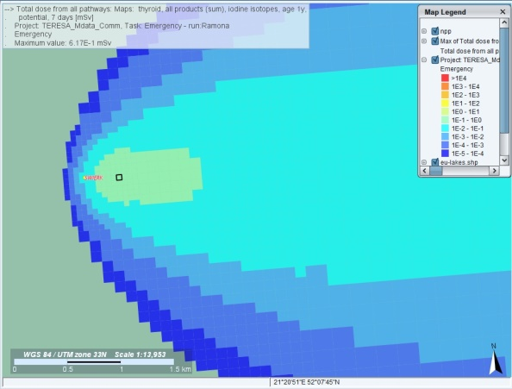 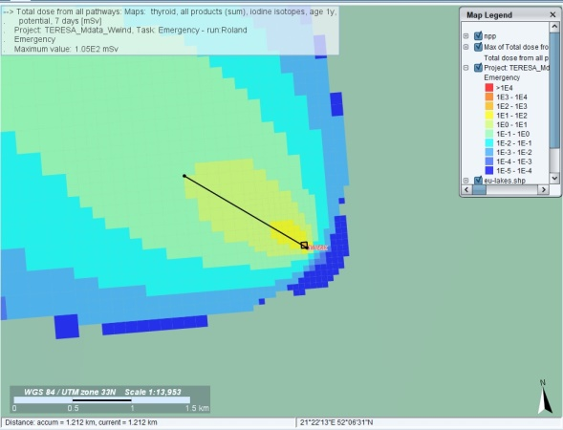

|  |
| --- |
| FIG2. *Total dose map from all pathways for thyroid exposure due to all iodine isotopes for a 1-year-old child over a 7-day period, based on the scenarios in Table 2. The results were generated using the JRODOS system.* |

TABLE 3. *Maximum values (MD) ​​of different doses for different types of scenarios. The dose types correspond to the specific zones described in the Section 4. Additionally, the maximum distance (DIS) obtained to a dose of 1mSv is presented.* *Red color means the values are above the limits from Section 4*

|  |  |  |  |  |  |  |  |  |  |  |  |  |  |  |  |  |  |  |  |  |  |  |  |  |  |  |  |  |  |  |  |  |  |  |  |  |  |  |  |  |  |  |  |  |  |  |  |  |  |  |  |  |  |  |  |  |  |  |  |  |  |  |  |  |  |  |
| --- | --- | --- | --- | --- | --- | --- | --- | --- | --- | --- | --- | --- | --- | --- | --- | --- | --- | --- | --- | --- | --- | --- | --- | --- | --- | --- | --- | --- | --- | --- | --- | --- | --- | --- | --- | --- | --- | --- | --- | --- | --- | --- | --- | --- | --- | --- | --- | --- | --- | --- | --- | --- | --- | --- | --- | --- | --- | --- | --- | --- | --- | --- | --- | --- | --- | --- |
| |  |  |  |  |  |  |  |  |  |  |  | | --- | --- | --- | --- | --- | --- | --- | --- | --- | --- | --- | |  | **EPA_1** | | **EPA_2** | | **Mdata_Comm** | | **Mdata_Wwind** | | **Mdata_Swind** | | | Dose type | MD  [mSv] | DIS  [km] | MD [mSv] | DIS  [km] | MD [mSv] | DIS  [km] | MD [mSv] | DIS [km] | MD [mSv] | DIS  [km] | | Total effective dose from all exposure except ingestion | 7.46E-2 | - | 1.65E-2 | - | 5.69E-3 | - | 1.25E0 | 0.05 | 2.77E-3 | - | | Total dose from all pathways Thyroid iodine | 7.60E0 | 1.1 | 1.56E0 | 0.3 | 6.17E-1 | - | 1.05E2 | 1.212 | 6.19E-2 | - | | Total dose from all pathways | 9.29E-1 | - | 1.99E-1 | - | 8.88E-2 | - | 1.45E1 | 0.494 | 1.21E-2 | - | | Ingestion dose all nuclides | 8.53E-1 | - | 1.82E-1 | - | 8.20E-2 | - | 1.32E1 | 0.458 | 9.32E-3 | - | |

determining safe distances and zones around nuclear installations. The data highlights the critical role meteorological factors play in establishing safety parameters, as these conditions directly influence the dispersion of radionuclides and, consequently, the exposure risks to the public. The highest dose, reaching 1.05E2 mSv, was observed in the Mdata_Wwind scenario. However, the maximum distance to the 1 mSv threshold was similar for both the EPA_1 and Mdata_Wwind scenarios. For reactors with higher power and larger radionuclide inventories, the critical dose will likely predominantly affect the thyroid due to iodine exposure. Although no dose limits were exceeded, it is evident that the distances vary significantly depending on the selected weather conditions.

## SUMMARY AND CONCLUSIONS

Selecting an appropriate weather scenario is crucial when calculating zones and areas. A conservative approach, such as stability class A and an average wind speed of around 0.1 m/s, significantly impacts the obtained dose values and potential distances. The weather conditions scenario should be chosen with great care, as it can be a critical and potentially contentious point between the investor and the regulator. A prudent solution would be for the regulator to define precise weather scenarios, which may vary for different locations. This would eliminate issues with the interpretation of so-called worst-case weather scenarios.

For the HTGR TeResa reactor, the threshold dose values for zones, including UPZ and ICPD, were reached only for scenarios with very weak wind (about 0.1 m/s) and the corresponding Pasquill A stability class. This is due to the reactor's low power and the technologies employed in this reactor (e.g., TRISO fuel). A key element is the precise determination of the source term, which significantly influences the determination of zones and areas. The source term obtained from simulations using the MELCOR code is significantly smaller than that proposed in publications for HTGR reactors. However, the source term from these publications is estimated and, as stated by the authors, very conservative. Several elements were conservatively estimated to have release fractions similar to that of iodine, including cesium, tellurium, and strontium. The publication notes that some elements should have much lower fractional releases than 15%, although this was not specified in JAERI's published assumptions.

Further insights are provided by a study from the Idaho National Laboratory, which examines source terms for a different HTGR accident scenario involving a D-LOFC with scram but without air ingress. This study calculated the release fraction for each chemical group based on the 95% confidence long-term releases and then scaled these values relative to the assumed 15% release of iodine-131. It is essential to conduct precise calculations and verify whether the proposed source term corresponds to the worst possible predicted accident using the best and most recent computational codes. Simulations with a code competitive to MELCOR would allow for accurate verification of the obtained source term. For HTGR reactors with relatively low power, it is recommended that precise calculations of radionuclide transport following severe accidents in the immediate vicinity be conducted utilizing CFD-class codes. This would enable a more accurate determination of potential hazards.

Due to the planned large number of Small Modular Reactor (SMR) installations, it seems that the IAEA should provide specific recommendations. The authors of the article recommend establishing a precise list of required weather conditions for which Emergency Planning Zones and distances should be calculated, to prevent the possibility of selecting conditions that are "too favorable". It also appears appropriate to divide areas of interest into groups with similar weather conditions. Similar to the weather conditions recommended by the EPA for dispersion models, such recommendations should also be provided for the analysis of severe accidents, considering the specifics of releases in nuclear installations.

ACKNOWLEDGEMENTS

This work was supported under the project “Technical description of the HTGR gas-cooled high-temperature research nuclear reactor” (Contract No 1/HTGR/2021/14) funded by the Ministry of Education and Science (MEiN) of Poland (2021-24). Part of the calculations were carried out using the HPC cluster of the Swierk Computing Centre (CIS), National Centre for Nuclear Research (NCBJ), Poland. This work is part of the studies in the strategic Polish program of scientific research and development work “Social and economic development of Poland in the conditions of globalizing markets GOSPOSTRATEG”, part of “Preparation of legal, organizational and technical instruments for the HTR implementation” financed by the National Centre for Research and Development (NCBiR) in Poland.

References

1. SKRZYPEK, E., MUSZYŃSKI, D., SKRZYPEK, M., DARNOWSKI, P., MALESA, J., "Pre-conceptual Design of the Research High-Temperature Gas-Cooled Reactor TeResa for Non-Electrical Applications", Energies, 15(6), 2084 (2022).
2. DĄBROWSKI, M., et al., “Concept of the polish high temperature gas-cooled reactor HTGR-POLA”, Nuclear Engineering and Design, Volume 424, 2024,
3. KUNITOMI, K., SHIOZAWA, S., "High Temperature Engineering Test Reactor (HTTR)", Japan Atomic Energy Research Institute (JAERI) (2004).
4. SKRZYPEK, M., et al., “Study on the DLOFC accident of the GEMINI+ conceptual design of HTGR reactor with MELCOR and SPECTRA” J. Phys.: Conf. Ser. 2048, 2021
5. KUNITOMI, K., et al., "Safety and Licensing Experience of the HTTR" (2004).
6. IDAHO NATIONAL LABORATORY, "Source Terms for a Different HTGR Accident" (2012).
7. SINKKO, K., MIKKELSEN, T., PÄSLER-SAUER, J., "RODOS: Decision Support System for Off-site Nuclear Emergency Management in Europe", Radioprotection, 35(1), 81-87 (2000).
8. EHRHARDT, J., WEIS, A., "Development of RODOS, a Comprehensive Decision Support System for Nuclear Emergencies in Europe—An Overview", Radiation Protection Dosimetry, 50(2-4), 195-203 (1993).
9. BARESCUT, J., LARIVIERE, D., STOCKI, T., RASKOB, W., TRYBUSHNYI, D., IEVDIN, I., ZHELEZNYAK, M., "JRODOS: Platform for Improved Long Term Countermeasures Modelling and Management", Radioprotection, 46(6), S731-S736 (2011).
10. ANDRONOPOULOS, S., BARTZIS, J. G., GARIAZZO, C., DE SMET, K., "The RODOS Meteorological Pre-processor RMPP", Radiation Protection Dosimetry, 134(3-4), 173-179 (2009).
11. THYKIER-NIELSEN, S., MIKKELSEN, T., ASTRUP, P., "Description of the Atmospheric Dispersion Module RIMPUFF", Riso National Laboratory, Riso-R-995(EN) (1999).
12. EHRHARDT, J., WEIS, A., "RODOS: Decision Support System for Off-site Nuclear Emergency Management in Europe", European Commission, Brussels (1997).
13. ANDRONOPOULOS, S., BARTZIS, J. G., GARIAZZO, C., DE SMET, K., "RODOS: Real-time On-line Decision Support System for Off-site Emergency Management After Nuclear Accidents", Radioprotection, 44(5), 879-884 (2009).
14. ROBERTSON, L., LANGNER, J., ENGARDT, M., "An Eulerian Limited-area Atmospheric Transport Model", Journal of Applied Meteorology, 38(2), 190-210 (1999).
15. RASKOB, W., GERING, F., "MATCH: A Model for Long-range Atmospheric Transport of Radionuclides", Radiation Protection Dosimetry, 141(1), 17-22 (2010).
16. PERSSON, C., GIDHAGEN, L., "The MATCH Model—Meteorological Synthesizing Dispersion Model, Applied to Air Pollution from Road Traffic in Stockholm", Proceedings from the 20th NATO/CCMS International Technical Meeting on Air Pollution Modeling and Its Application, Valencia, Spain, 1994.
17. JANICKE, U., JANICKE, L., "Dispersion Modeling with the Lagrangian Particle Model LASAT", Proceedings of the International Workshop on Long-Range Transport and Environmental Impact Assessment, Austria, 2003.
18. CONNAN, O., HÉBERT, D., LAURENT, O., "Comparison of Different Atmospheric Dispersion Models for Radiological Emergency Preparedness", Journal of Environmental Radioactivity, 124, 15-29 (2013).
19. MÜLLER, H., PRÖHL, G., "ECOSYS-87: A Dynamic Model for Assessing Radiological Consequences of Nuclear Accidents", Health Physics, 57(6), 883-898 (1999).
20. US EPA: “Risk Management Program Guidance for Offsite Consequence Analysis” (2009).
21. PREZES PAŃSTWOWEJ AGENCJI ATOMISTYKI, "Wyznaczanie Stref Planowania Awaryjnego Oraz Rozszerzających Je Dystansów Wokół Jednostki Organizacyjnej Wykonującej Działalność Zakwalifikowaną do I Lub II Kategorii Zagrożeń: Zalecenia Organizacyjno-Techniczne", Warszawa (2021).
22. HUMMEL, D. W., CHOUHAN, S., LEBEL, L., MORREALE, A. C., "Radiation Dose Consequences of Postulated Limiting Accidents in Small Modular Reactors to Inform Emergency Planning Zone Size Requirements", (2020).
23. LOWRY, P., "Scoping Analysis of Source Term and Functional Containment Attenuation Factors", Idaho National Lab. (INL), Idaho Falls, ID, United States (2012).