# A Method for Sizing Emergency Planning Zones around Small Modular Reactors and New Reactor Technologies

D. Hummel

Canadian Nuclear Laboratories

Deep River, Canada

Email: david.hummel@cnl.ca

L. Lebel

Canadian Nuclear Laboratories

Deep River, Canada

J. Cui

Canadian Nuclear Laboratories

Deep River, Canada

S. Chouhan

Canadian Nuclear Laboratories

Deep River, Canada

**Abstract**

Off-site emergency protective actions are the fifth and final level of defence in depth against the consequences of nuclear accidents. The area around the site where pre-planned precautionary or urgent protective actions are ready to be taken in the event of an emergency is the emergency planning zone (EPZ). Stakeholders for small modular reactor (SMR) and advanced reactor technologies have advocated that, considering the risks relative to contemporary large nuclear power plants, the EPZ around these new reactor technologies may be reduced in size or outright eliminated. However, past investigations have revealed lack of clarity or uncertainty in the technical criteria that determine the necessary EPZ size. To that end, Canadian Nuclear Laboratories has been developing a decision-making framework to identify the events that should be considered in the off-site planning basis and what is the necessary extent of the urgent protective action planning zone. The proposed method is based on some principals of Level 3 probabilistic safety assessment as well as an evaluation of public health risks in units of adjusted life years. The study develops the method and demonstrates its application with a simplified case study.

## Introduction

Defence in depth is one of the fundamental concepts of nuclear safety. According to the IAEA, it refers to a combination of several consecutive and independent levels of protection that would have to fail before harmful effects could be caused to people or the environment [1]. The fifth, and final, level of defence mitigates the consequences of significant releases of radioactive material by implementing emergency measures outside the boundary of the licensed site. These emergency preparedness and response (EPR) measures can range from enhanced monitoring to evacuation of the population that resides near the nuclear power plant (NPP).

Discussion on EPR requirements for small modular reactors (SMRs) commonly reference the size of the emergency planning zone (EPZ) [2]. The EPZ can be defined as the region encapsulating any advanced planning areas around a NPP where there are EPR measures ready to avoid or mitigate the consequences of an accident. There are differences in EPZ nomenclature between national jurisdictions. This study uses the definition provided in Canadian standards [3] while referencing the nearest IAEA equivalent [4]. Four types of emergency planning zones (or distances) may thus be considered:

1. *Automatic action zone* (AAZ): the area immediately surrounding the NPP where pre-planned actions are taken by default upon the declaration of a general emergency and some on-site emergencies. The AAZ is analogous to the *precautionary action zone* (PAZ) in IAEA safety standards.
2. *Detailed planning zone* (DPZ): the area around a plant, encompassing the AAZ, where pre-planned protective actions are taken as needed based on known plant conditions, predictive modelling, and environmental monitoring. The DPZ is analogous to the *urgent protective action zone* (UPZ) in IAEA safety standards.
3. *Contingency planning zone* (CPZ): a pre-designated area beyond the DPZ where contingency plans are made so that, during an emergency, protective actions can be extended beyond the DPZ as necessary. The CPZ is analogous to the *extended planning distance* (EPD) in IAEA safety standards.
4. *Ingestion planning zone* (IPZ): a pre-designated area around the NPP where plans are made to protect the food chain and restrict consumption and distribution of potentially contaminated products. The IPZ extends the furthest from the NPP site among all the different zones. It is analogous to the *ingestion and commodities planning distance* (ICPD) in IAEA safety standards.

## Optimisation of Emergency Response Actions

### Justification

Safety standards describe the projected radiation doses that should be used to trigger protective actions during a nuclear emergency, with the triggers referred to as “generic criteria” [5][6], and urgent protective actions including stable iodine thyroid blocking, sheltering, and evacuation. Fundamental to the guidance for implementing protective actions is that they are considered justified when a net benefit is achieved, and that the net benefit should be maximised given the prevailing circumstances and taking non-radiological factors into account [6]. Protective actions are almost always justified when projected doses are above the reference level of 100 mSv (acute or annual) because this is considered the lower threshold for deterministic health effects [7]. The generic criteria are therefore set at or below this reference level to facilitate optimisation of protection [6]. Other competing non-radiological hazards could be present, including from the protective actions themselves [8][9], and so there is a clear need to optimise nuclear emergency protective actions. Over-prescription of protective actions would have negative consequences if the same-sized EPZ as contemporary large NPPs were also applied to SMRs and advanced reactors. These consequences should be considered while also avoiding alternative frameworks that may incorrectly downplay the radiological hazard. A risk-based framework to evaluate the necessary size of the EPZ that uses a holistic measure of public health outcomes has been proposed to meet this need [10].

### Measurement of Health Outcomes

Several metrics are available to measure health outcome optimisation and impacts of interventions. The disability-adjusted life year (DALY) metric [11], selected in this study, has been used extensively including by the World Health Organization (WHO). DALY measures the loss of life or loss of healthy life in a population. It is calculated as the weighted sum of years of life lost ($YLL$) from mortality (early death) and years lived with a disability ($YLD$), where $YLD$ is equivalent to years of life with the morbidity (deterioration in health). One $DALY$ can be thought of as one lost year of healthy life without the burden of disease, or as a measure of the gap between current health and the ideal situation where one lives free from disease and disability [11]:

|  |  |  |
| --- | --- | --- |
|  | $$DALY=YLL+YLD$$ | (1) |

### Parameterization of Consequences

Vaillant et al. [12] used the types of disease, their incidence, and their lethality fraction, as a function of the radiation dose received, that is provided by the International Commission on Radiological Protection (ICRP) to tabulate DALY values for exposure to several different organs. They combined the detriments from individual organ exposures to calculate an overall radiological determinant of 9928.625 $DALY$ to 10,000 members of the public each receiving 1 Sv effective dose[1]. DALY for exposure to other hazards are relatively well established and available in global health statistics. A commonly cited database is the results of the 2019 Global Burden of Disease Study [13], which contains data on many causes of death and disability, their incidence and prevalence, and the associated $DALY$, as a measure of the global burden of disease (GBD).

As an example of how this data may be interpreted, Adams et al. [8] provides an assessment of the health consequences from evacuations during nuclear emergencies. Adams et al. [8] conclude that displaced people experience incidences of about 18% for depression, 11% for post-traumatic stress disorder, 3% for diabetes, and 2% for substance abuse. Using the DALY values from the GBD database [13] and summing the individual contributions, the permanent relocation would result in 645 $DALY$ per 10,000 population. The thesis of this work is that assessing DALY for both radiological and non-radiological consequences is a possible basis for optimising the size of the EPZ. Subsequent sections demonstrate the feasibility of this optimisation basis through a simplified case study.

## Method

### Source Term Prediction

A critical component in the prediction of nuclear accident consequences is the estimation of the accident source term [14], with the present case study considering an integral pressurized water reactor (iPWR) concept. The source term calculations were performed using a recent iteration of a model of a generic 160 MWth iPWR created with the computer code MELCOR[2] [15][16][17]. Of course, deterministic calculations with computer codes like MELCOR do not offer any insight on whether the underlying event sequences are credible, only what the releases would be. Optimisation of emergency preparedness for SMRs thus implies identification of relevant credible accidents in SMRs. In general, the planning basis for offsite emergency response should include possible accidents that cannot be practically eliminated, as well as estimates of the probability of such accidents occurring, as estimated in a probabilistic safety assessment (PSA). This study posits that any risk-*based* approach to size the EPZ (as opposed to merely risk-*informed*) would incorporate many features of Level 2 and Level 3 PSA [14].

Considering that the generic iPWR that has been modelled in MELCOR is not based on any particular or complete design, it would not be possible to complete a proper Level 2 PSA. Prototypical results were generated by assuming specific system failure frequencies and the resulting frequencies of a few representative event sequencies as summarized in Table 1. Event sequences that result in zero releases are omitted from the table. An accidental “large release” may be defined as one greater than 100 TBq 137Cs, among other radionuclides, into the environment [18]. Cases with predicted releases higher than this value have been highlighted red.

TABLE 1. PERMUTATIONS OF THE iPWR STATION BLACKOUT MODELLED WITH MELCOR.

|  |  |  |  |  |  |  |  |  |  |  |  |  |  |
| --- | --- | --- | --- | --- | --- | --- | --- | --- | --- | --- | --- | --- | --- |
| **Case** | **SGFW** | **DHRS** | **CV Brk. [cm2]** | **OP Brk. [cm2]** | **Freq. [y-1]** | **137Cs [Bq]** | **Case** | **SGFW** | **DHRS** | **CV Brk. [cm2]** | **OP Brk. [cm2]** | **Freq. [y-1]** | **137Cs [Bq]** |
| 1A | - | - | - | - | 1.0E-9 | 3.9E11 | 2J | - | 100% | - | 20 | 1.0E-10 | 1.0E14 |
| 1D | - | 10% | - | - | 5.0E-9 | 3.4E11 | 2K | - | 50% | - | 20 | 1.0E-13 | 4.6E13 |
| 1H | $t$ ≥3 h | - | - | - | 5.0E-9 | 2.5E11 | 2L | - | 10% | - | 20 | 5.0E-14 | 9.4E12 |
| 1I | $t$ ≥6 h | - | - | - | 1.5E-8 | 4.4E11 | 3A | - | - | 10 | - | 1.0E-15 | 4.1E15 |
| 1J | $t$ ≥12 h | - | - | - | 2.4E-8 | 2.8E11 | 3D | - | 10% | 10 | - | 5.0E-15 | 3.0E15 |
| 2A | - | - | - | 1000 | 1.0E-15 | 1.6E15 | 3E | $t$ ≥3 h | - | 10 | - | 5.0E-15 | 4.2E15 |
| 2B | - | 100% | - | 1000 | 1.0E-11 | 1.2E15 | 3F | $t$ ≥6 h | - | 10 | - | 1.5E-14 | 4.1E15 |
| 2C | - | 50% | - | 1000 | 1.0E-14 | 1.5E15 | 3G | $t$ ≥12 h | - | 10 | - | 3.5E-14 | 3.9E15 |
| 2D | - | 10% | - | 1000 | 5.0E-15 | 1.4E15 | 3H | - | - | 1 | - | 1.0E-14 | 6.7E14 |
| 2E | - | - | - | 100 | 5.0E-15 | 7.2E14 | 3K | - | 10% | 1 | - | 5.0E-14 | 1.4E15 |
| 2F | - | 100% | - | 100 | 5.0E-11 | 9.4E14 | 3L | $t$ ≥ 3h | - | 1 | - | 5.0E-14 | 4.2E15 |
| 2G | - | 50% | - | 100 | 5.0E-14 | 9.8E14 | 3M | $t$ ≥6 h | - | 1 | - | 1.5E-13 | 4.1E15 |
| 2H | - | 10% | - | 100 | 2.5E-14 | 7.6E14 | 3N | $t$ ≥12 h | - | 1 | - | 3.5E-13 | 3.9E15 |
| 2I | - | - | - | 20 | 1.0E-14 | 2.8E13 |  |  |  |  |  |  |  |

SGFW = alternative steam generator feedwater available; DHRS = decay heat removal system functional capacity; CV Brk = size of break in the containment vessel; OP Brk. = size of break in the operating pool.

### Atmospheric Dispersion and Dose Consequence

Source terms predicted by MELCOR for the different event sequences were provided as input to the ADDAM[3] computer code for atmospheric dispersion and dose analysis [19], based on a Gaussian plume model. ADDAM is part of the industry standard toolset for nuclear safety analysis in Canada and satisfies the Canadian standard N288.2:19 [20], which provides guidelines for calculating consequences from NPP accidents. ADDAM can output cumulative whole-body effective dose and organ-specific doses from the combination of cloudshine and inhalation from the passing plume as well as the groundshine from deposited contamination. The conversion from radionuclide concentrations to doses are facilitated by dose conversion factors based on ICRP recommendations [21].

The same meteorological data described by Hummel et al. [22] was used. Building wake and entrainment effects were included, assuming a 120 m × 20 m footprint structure with 10 m height. The release height was 5 m (half the height of the assumed reactor building). The ADDAM calculation was performed over 16 sectors and 24 radial distances (from 100 m to 40 km), together corresponding to 384 dose receptor mesh points. The population was assumed to be uniform in the calculation domain for the present case study, but such a simplifying assumption is not required by the ADDAM code.

### Risk Estimation

The output of the ADDAM code is specifically dose to members of the public, not risk. A typical concept of risk is the product of consequence and probability. This risk-based case study must therefore calculate risk from the dose (consequence) and associated accident frequency (probability), considering all possible events sequences that can lead to significant offsite consequences.

Risk is parameterised as $R$, the expected value of DALY at a dose receptor, calculated as:

|  |  |  |
| --- | --- | --- |
|  | $$R=\sum_{i}{\left(D_{i}f_{i}\right)}×L×C_{DALY}×S$$ | (2) |

where $D_{i}$ is the predicted dose for the receptor and $f_{i}$ is the frequency of case $i$, $L$ is the lifetime of the plant in years, and $C_{DALY}$ is the factor for converting between consequence in dose and $DALY$, for example, using the factors proposed by Vaillant et al. [12]. $S$ is a scaling factor that may be applied either to the risk or the frequency.

For this case study, it must be acknowledged that the event sequences in Table 1 are not complete Level 2 PSA results and there are very likely to be other sequences leading to notable releases that are not included in the table. The risk calculated by Equation (2) is therefore very likely to be underestimated using just the cases in Table 1 without scaling. The total frequency of the large releases (>100 TBq 137Cs, red in Table 1) was proposed as a basis for this scaling. An acceptability limit of 1.00E-6 y-1 for the sum of all event frequencies that lead to large releases has been defined for Level 2 PSA results [18]. The sum of the relevant un-scaled frequencies in Table 1 is 1.61E-10 y-1. A factor of $S$ = 6.23E+03 applied to every event sequence frequency in Table 1 will make the sum of the large release cases equal to 1.00E-6 y-1. The so-scaled event frequencies must represent the upper limit for acceptable Level 2 PSA results and therefore the value of $S$ = 6.23E+03 was used in the present case study to bound the risk results.

There are other event sequences not explicitly listed Table 1 that may have significantly greater frequency and much smaller, but not necessarily zero, resulting doses. Such cases, including anticipated operational occurrences (AOO), design basis accidents (DBA), and some design extension conditions without severe core damage, would not typically be considered when sizing the EPZ because they have their own associated dose limits that should preclude the need for off-site emergency response. Nevertheless, their exclusion from the summation in Equation (2) is potentially under-representing the risk at each receptor as well. This is explored further in the following section.

## Results and Discussion

Fig. 1 summarises the risk predictions in the vicinity of the plant. The specific dose pathways and residence times were selected from the first three generic criteria to trigger protective actions that control exposure [6]. These are, in order, 50 mSv dose to the thyroid in the first 7 days (stable iodine thyroid blocking), 100 mSv effective dose in the first 7 days (evacuation), and 10 mSv effective dose in the first 2 days (sheltering). The risks are greatest in the northwest and southeast directions, consistent with the dominant wind directions present in the meteorological records [22].

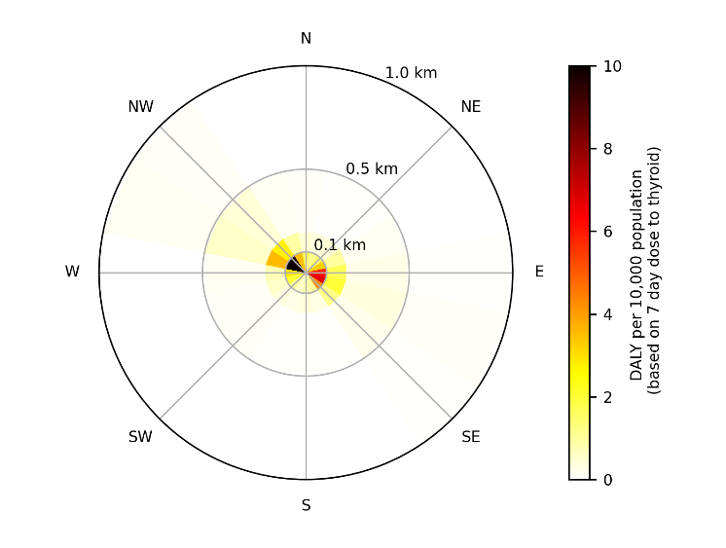(a)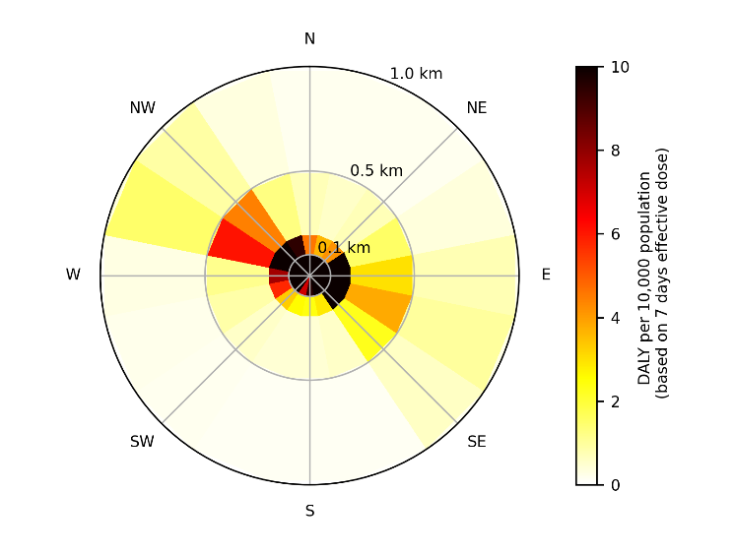 (b)

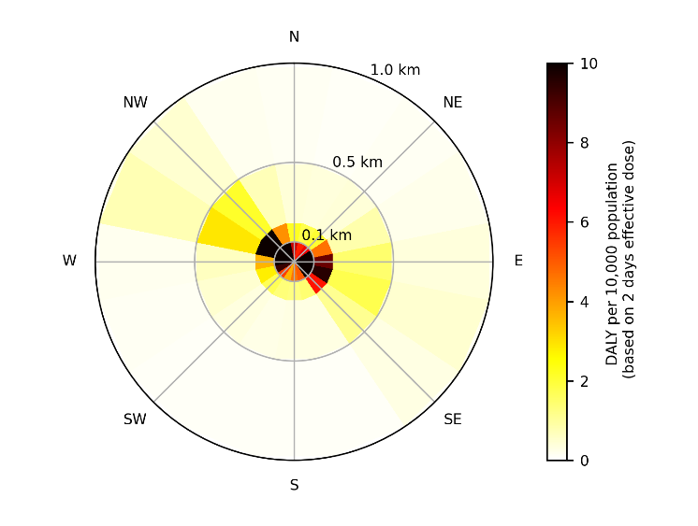(c)

*FIG. 1. Spatial distribution of risk around the plant in $DALY$ per 10,000 population. (a) uses the factor of 433.875 DALY for 104 persons receiving 1 Sv thyroid dose, whereas (b) and (c) use 9928.625 DALY for 104 persons receiving 1 Sv effective dose reported by Vaillant et al. [12]*.

The risk-based approach considers every event sequence present in Table 1 and integrates the results according to Equation (2). Whereas an individual large release may result in unacceptably large doses to the public (consequence), when these doses are weighted by the likelihood of the release occurring (probability), the risk is relatively low. This result is expected from the magnitude of the frequencies listed in Table 1. The integrated risk from all event sequences is summarised in Table 2, which shows the predicted consequences 100 m from the release location (the closest dose receptor in the ADDAM calculation). The calculated DALY equivalent of the generic criteria are also shown not to be exceed at 100 m.

TABLE 2. RISK-BASED HEALTH CONSEQUENCES AT 100 M CONSIDERING ALL EVENT SEQUENCES IN TABLE 1.

|  |  |  |
| --- | --- | --- |
| Criterion | Calculated $DALY$ per 10,000 population | $DALY$ per 10,000 population equivalent to generic criterion [7] |
| Dose to thyroid in 7 days | 12.0a | 21.7a |
| Effective dose in 7 days | 126.5b | 992.8b |
| Effective dose in 2 days | 55.7b | 99.3b |

a using the factor of 433.875 for 104 persons receiving 1 Sv thyroid dose reported by Vaillant et al. [12].

b using the factor 9928.625 for 104 persons receiving 1 Sv effective dose reported by Vaillant et al. [12].

Section 3.6 mentioned how integrating the risk across all cases in Table 1 likely omitted some high-frequency, low-consequence, sequences not typically considered when determining the extent of the EPZ. To explore this further, consider that 100 m is near the likely minimum distance to the site boundary for a SMR because the boundary should encompass the reactor building. Regulations may specify maximum event frequencies and dose consequences at the site boundary for AOOs and DBAs. For example, in Canada[4], AOOs have frequencies greater than 1.00E-02 y-1 and must result in no more than 0.5 mSv effective dose at the site boundary, and DBAs have frequencies between 1.00E-05 y-1 and 1.00E-02 y-1 and must not result in doses greater than 20 mSv at the site boundary [23]. Assuming frequencies for both AOO (1.00 y-1) and DBA (1.00E-02 y-1), in the 60 y lifetime of the plant the acceptable risk for an AOO must be 297.9 $DALY$  per 10,000 population, and for a DBA the acceptable risk must be no greater than 119.1 $DALY$ per 10,000 population. These are of similar magnitude or greater than the probability-weighted expected DALY for the large release scenarios, and as described earlier, emergency response should be precluded in AOO and DBA.

The next step in the proposed EPZ method is to contextualize the health consequences of the radiation dose to the consequences of the proposed protective actions. This requires DALY associated with the protective actions be known, or at least are capable of being estimated. Side effects are unlikely from short-term use of potassium iodide as a stable iodine thyroid blocker in emergency situations, and the available literature does not support and reliable estimation of DALY from its use. There may be direct consequences from sheltering in place if the nuclear accident is coincident with another natural disaster, which is likely because major nuclear accidents may be preceded by external events like earthquakes or floods. The DALY will depend on the hazards of the specific event, so general evaluations are impossible. The prior work of Adams [8], however, does provide clear estimation of some health consequences associated with long-term relocation. The 645 $DALY$ per 10,000 population are obviously not exceeded by the DALY associated with the risk-based dose at 100 m, and so sustained relocation would not be clearly justified according to optimisation of protection. This is merely one consideration in the proposed size of the EPZ, but the potential of the proposed method is shown.

## Conclusions and Next Steps

Appropriate sizing of EPZs around SMRs has been a topic of extensive discussion and recent research. Underpinning this work has been the concept of risk and the principle of optimisation of protection.

To assist in this optimisation, this study introduced the use of the DALY metric to nuclear EPR evaluation. DALY, originally proposed by the WHO, has been used to characterise overall public health and the impact of interventions. The works of Vaillant et al. [12] and Adams et al. [8], among others, were used as the basis to calculate $DALY$ values associated with the consequences of reactor accidents.

A case study for determining the size of an EPZ was subsequently performed. This case study made use of a model of a generic 160 MWth iPWR made using the MELCOR computer code to calculate source terms, and a model of atmospheric dispersion made using the ADDAM computer code to calculate dose consequences. The combined MELCOR and ADDAM models enabled the calculation of the dose consequences from several hypothetical event sequences. Using scaled event frequencies from a Level 2 PSA-like analysis, and the conversion factors proposed by Vaillant et al. [12], the integrated risk associated with the severe accident scenarios was determined around the plant site in units of $DALY$. The integrated DALY values were compared against triggers for protective actions in equivalent units. If the negative health consequences associated with the protective actions were known, this method could be useful towards determining the necessary size of the EPZ around the plant.

The greatest limitation in the present work was the lack of reliable literature that could be used as a basis to evaluate $DALY$ for the non-radiological health consequences of protective actions taken in response to an emergency. Although compilations like the GBD database are thorough in describing DALY for most health detriments, there is a paucity of research quantifying how those detriments are created by the protective action measures, at least in a manner that readily facilitates calculation of DALY. For example, the DALY associated with the act of evacuation (rather than the resulting relocation), or the hazards associated with sheltering, may be very specific to the site or event, but that does not preclude development of estimation models or more generally applicable guidelines. Further research into quantifying DALY for protective actions is highly recommended because this will enable more detailed evaluation in risk-informed and risk-based assessment methods. Greater knowledge in this area would also facilitate holistic assessment of protective action strategies in mixed hazard emergencies, such as nuclear accidents in combination with other natural disasters.

ACKNOWLEDGEMENTS

This work was supported by Atomic Energy of Canada Limited’s Federal Nuclear Science & Technology Work Plan.

References

1. IAEA, Fundamental Safety Principles, IAEA Safety Standards Series No. SF-1, IAEA, Vienna (2006).
2. SMR Regulators Forum, Pilot Project Report: Considering the Application of a Graded Approach, Defence-in-Depth and Emergency Planning Zone Size for Small Modular Reactors, IAEA, Vienna (2018).
3. CSA GROUP, General Requirements for Nuclear Emergency Management Programs, CSA N1600:21, Canadian Standards Association, Toronto (2021).
4. IAEA, Actions to Protect the Public in an Emergency due to Severe Conditions at a Light Water Reactor, EPR-NPP Public Protective Actions 2013, IAEA, Vienna (2013).
5. IAEA, Preparedness and Response for a Nuclear Radiological Emergency, General Safety Requirements No. GSR Part 7, IAEA, Vienna (2015).
6. Health Canada, Generic Criteria and Operational Intervention Levels for Nuclear Emergency Planning and Response, Health Canada, Ottawa (2018).
7. ICRP, The 2007 recommendations of the International Commission on Radiological Protection, ICRP Publication 103, Ann. ICRP **37** 2-4 (2007).
8. ADAMS, T., MACMILLAN, L., CASAGRANDE, R., OSBORN, M., HUFF, A., SMITH, T., Nonradiological Health Consequences from Evacuation and Relocation, NUREG/CR-7285, United States Nuclear Regulatory Commission, Washington DC (2021).
9. HASEGAWA, A., OHIRA, T., MAEDA, M., YASUMURA, S., TANIFAWA, K., Emergency responses and health consequences after the Fukushima accident; evacuation and relocation, Clin. Oncol. **28** 4 (2016) 237-244.
10. HUMMEL, D., LEBEL, L., “Challenges in defining emergency planning zones for small modular reactors and advanced reactors: review of Canadian practices and research at Canadian Nuclear Laboratories”, International Conference on Topical Issues in Nuclear Installation Safety: Strengthening Safety of Evolutionary and Innovative Reactor Designs (IAEA TIC2022), IAEA, Vienna (2022).
11. LOPEZ, A.D., MATHERS, C.D., EZZATI, M., JAMISON, D.T., MURRAY, C.J.L, “Measuring the global burden of disease and risk factors, 1990-2001”, Global Burden of Disease and Risk Factors, Oxford University Press, New York (2006).
12. VAILLANT, L., MAITRE, M., LAFRANQUE, E., SCHNEIDER, T., WASSELIN, V., Proposal of a quantitative approach integrating radioactive and chemical risks, Radioprotection **58** 2 (2023) 147-155.
13. GLOBAL HEALTH DATA EXCHANGE, Global Burden of Disease Study 2019 (GBD 2019) Data Resources (2020), https://ghdx.healthdata.org/gbd-2019
14. IAEA, IAEA Nuclear Safety and Security Glossary 2022 (Interim) Edition, IAEA, Vienna (2022).
15. MORREALE, A.C., Severe accident analysis of a generic integral pressurized water reactor with MELCOR, The Fourth International Conference on Generation IV & Small Reactors (G4SR-4), Canadian Nuclear Society, Toronto (2022).
16. SNL, Sandia Nuclear Safety Technology (2024), https://www.sandia.gov/MELCOR/
17. CUI, J., LEBEL, L., MORREALE, A., HUMMEL, D., MELCOR model of iPWR and application to emergency planning zone study, The 14th International Topical Meeting on Nuclear Reactor Thermal-Hydraulics, Operation, and Safety (NUTHOS-14), Canadian Nuclear Society, Vancouver (2024).
18. CNSC, Design of Reactor Facility, REGDOC-2.5.2 Version 2.1, CNSC, Ottawa (2023).
19. CHOUHAN, S., “ADDAM (Atmospheric Dispersion and Dose Analysis Method)”, IAEA Environmental Modelling for Radiation Safety (EMRAS-II) Technical meeting, IAEA, Vienna (2010).
20. CSA GROUP, Guidelines for Calculating the Radiological Consequences to the Public of a Release of Airborne Radioactive Material for Nuclear Reactor Accidents, CSA N288.2:19, Canadian Standards Association, Toronto (2019).
21. ICRP, Compendium of dose coefficients based on ICRP Publication 60, Ann. ICRP **41** (2007).
22. HUMMEL, D.W., CHOUHAN, S., LEBEL, L., MORREALE, A.C., Radiation dose consequences of postulated limiting accidents in small modular reactors to inform emergency planning zone size requirements, Ann. Nucl. Energy **137** (2020) 107062.
23. CNSC, Deterministic Safety Analysis, REGDOC-2.4.1, CNSC, Ottawa (2014).

1. The work of Vaillant et al. [12] considered stochastic health effects only and not the deterministic effects that would be expected for individuals receiving such high doses.
2. MELCOR is an integral severe accident code developed by the Sandia National Laboratories (SNL) to assess accidents at nuclear facilities and the resulting radionuclide releases [16]. It is used by the United States Nuclear Regulatory Commission (USNRC) and other organisations around the world.
3. Atmospheric Dispersion and Dose Analysis Method.
4. The maximum allowable doses for AOOs and DBAs specified in Canadian REGDOC-2.4.1 [23] are committed 30 days after the event, which is significantly greater duration than the maximum 7 days considered elsewhere in this paper for triggering prompt or urgent protective actions. However, the calculation of DALY does not distinguish between a dose committed in 7 days or 30 days, so the comparison is still valid.