Electricity and Water cogeneration using

a Small 75 MW(th) PWR

P.A.B. DE SAMPAIO
Nuclear Engineering Institute/CNEN
Rio de Janeiro, Brazil

L.F.R. ALVES
Nuclear Engineering Institute/CNEN
Rio de Janeiro, Brazil

M.L. MOREIRA
Nuclear Engineering Institute/CNEN
Rio de Janeiro, Brazil
Email: malu.moreira@ien.gov.br

Abstract

The demand for freshwater, either from agriculture, industry, or domestic use, is rapidly rising as the world population continues to grow. Desalination technologies can help mitigating the water scarcity problem facing humankind. However, desalination plants need energy to operate and, in view of climate change, it is of foremost importance to choose energy sources with low carbon footprint. In this context, nuclear cogeneration systems of electricity and water can make relevant contributions towards the United Nations sustainable development goals. Although, in comparative terms, Brazil cannot be considered poor in water resources, there are problems related to their distribution and demand in the large and varied Brazilian territory. Activities such as agriculture, animal husbandry and mining, with high demands on water resources, represent a large part of the country Gross National Income and contribute significantly to the Brazilian Balance of Trade. Here we investigate a hybrid desalination strategy, using both Direct Contact Membrane Distillation (DCMD) and Sea Water Reverse Osmosis (SWRO), for cogeneration of water and electricity using a small PWR of 75 MW(th). The simplest hybrid desalination solution is considered, where the DCMD and the SWRO desalination plants operate independently. The small PWR provides the heat and the electrical power required by both desalination plants, besides generating electricity for either the grid or local use. Finally, estimates of water and electricity production are presented, considering the mean seawater temperature of the Brazilian northeast, a region where rainfall is insufficient to meet the needs of the local population.

INTRODUCTION
More than 97% of the water on planet Earth is seawater, with only 0.5% of the world’s water being available for use by humans [1]. As water resources become scarce due to increased demand and pollution, desalination technologies can help to mitigate the problem by producing freshwater from seawater. However, desalination plants need energy to operate and, in view of climate change, it is of foremost importance to choose energy sources with low carbon footprint.
Although, in comparative terms, Brazil cannot be considered poor in water resources, there are problems related to their distribution and demand in the large and varied Brazilian territory. For instance, 85% of the water resources are in the Amazon and Tocantins hydrographic basins, areas inhabited by only 10% of the Brazilian population. In fact, there are problems affecting the northeast, southeast and south regions of Brazil. In the northeast rainfall is insufficient to meet the needs of the population. In the southeast, the most industrialized and inhabited region, water resources have been fully exploited and suffer pressure from industrial pollution and sewage. And, in the south region, there is intensive use of water for irrigation. It is also important to remark that water resources are of foremost importance for the Brazilian Economy. Activities such as agriculture, animal husbandry and mining, with high demands on water resources, represent a large part of the country Gross National Income and contribute significantly to the Brazilian Balance of Trade.
Cogeneration systems of electricity and water based on nuclear energy have recently gained renewed attention [2-3]. In fact, such cogeneration systems can contribute towards the United Nations sustainable development goals such as Clean Water and Sanitation, Affordable and Clean Energy and Climate Action [4]. Even though the global nuclear desalination accumulated experience exceeds 250 reactor years [5], only a small fraction of the thermal energy generated by the nuclear reactors is used for producing freshwater through desalination in present day nuclear cogeneration plants.
Not surprisingly, the desalination technologies adopted in nuclear cogeneration plants worldwide are well established techniques such as Multistage Flashing (MSF), Multi-Effect Distillation (MED), and Sea Water Reverse Osmosis (SWRO). Among these, SWRO attains the lowest specific electricity consumption, approximately 3.5 to 4.5 kW(e)h/m³, and has become the most widespread technology for desalination [6].
On the other hand, Membrane Distillation (MD) is an emerging desalination technology which is becoming increasingly attractive for its adequacy to use low-grade waste heat or renewable energy sources [7-10]. In the Direct Contact Membrane Distillation (DCMD) concept, the feed and the permeate flows are separated by hydrophobic porous membranes. The driving force for mass transfer is the difference of vapour pressure between the hot and cold sides of the membrane [11-12]. After evaporating at the feed side, water vapour crosses the membrane and condenses at the permeate side. There are also some specific advantages regarding the use of MD. Essentially, no additives are needed to prevent fouling of the MD module, in contrast to SWRO technology [13]. Moreover, the environmental impact of a brine discharge directly to the sea can, in most cases, be considered low or negligible, as MD produces less than 10% of the feed stream as distillate in a single pass system [13].
Here we investigate a hybrid nuclear desalination strategy, using both Direct Contact Membrane Distillation (DCMD) and Sea Water Reverse Osmosis (SWRO), for cogeneration of water and electricity using a small PWR of 75 MW(th). Blending the water produced by SWRO with that produced by DCMD has two main advantages. One is the improvement of the quality of the water produced, as compared to that obtained with the SWRO plant. The other is the reduction of the cost of water production, as compared to that attained by the DCMD plant alone [2].
The SWRO plant uses the electricity generated on site by the small PWR. On the other hand, to provide heat to the DCMD plant, the steam produced in the steam generator is divided into two parallel Rankine cycles, a strategy devised by the authors to use all the power plant waste heat [14]. Using this arrangement, a specific electricity consumption of 8.47 kW(e)h/m³ has been obtained for the DCMD process [14].

Hybrid Nuclear Desalination
Sadeghi et al. [2] analysed hybrid desalination schemes involving thermal and reverse osmosis desalination technologies, dividing them into two categories: the simple scheme and the integrated scheme. In this work we consider the simplest nuclear hybrid desalination solution, where the DCMD and the SWRO desalination plants operate in parallel and independently. The small PWR provides the heat and the electrical power required by both desalination plants, besides generating electricity for either the grid or local use.

The SWRO desalination plant
Sea Water Reverse Osmosis (SWRO) has the lowest specific electric consumption, about 3.5 to 4.5 kW(e)h/m³, and is currently the most widespread technology for desalination [6], [15]. The coupling between the small PWR and the SWRO plant is exclusively through the electrical power generated and provided by the small PWR on site. Thus, all the electricity needed by the SWRO system, especially the power required to operate high pressure pumps, is provided by the nuclear power plant.
Fig. 1 depicts a schematic representation of the SWRO desalination plant. The pre-treatment of seawater has been omitted in the simplified scheme shown in Fig. 1. The SWRO technology is based on the use of a semi-permeable membrane which allows water molecules to permeate while dissolved solids are blocked [15]. However, to overcome the osmotic pressure across the semi-permeable membrane, the SWRO process requires the use of very high pressure on the feed side. Fig. 1 shows that the feed (seawater) has its pressure elevated by the high-pressure pump (HPP) before it enters the RO system, where the permeate (freshwater) and the brine are separated. It is important to remark that the brine leaving the RO system still has some considerable pressure that can be harnessed to save energy. This is done by energy recovery devices (ERD), shown in Fig. 1, which transfer pressure from the brine to the feed (seawater). However, as the pressure gained by the feed in the ERD is insufficient to match the required pressure at the entrance of the RO system, the feed stream pressure is supplemented by a booster pump (BP), as depicted in Fig. 1.

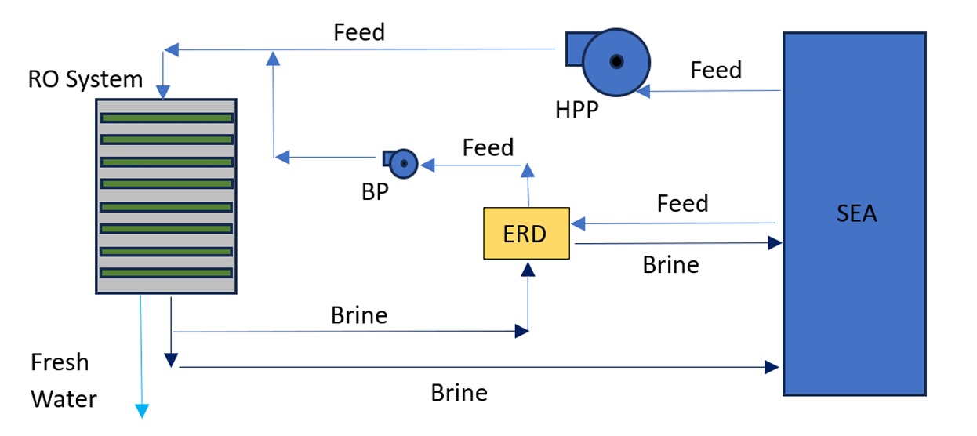

FIG 1. Schematic representation of the SWRO desalination plant.

The DCMD plant with heat recovery
In reference [14] the authors proposed a cogeneration system to produce electricity and water using a DCMD plant with heat recovery coupled to a small PWR of 75 MW(th). The coupling of the DCMD plant with heat recovery and the small PWR of 75 MW(th) is illustrated in Fig. 2, where the secondary loop of the small PWR is on the left and the DCMD plant is on the right. Referring to Fig. 2, note that the steam produced in the steam generator is divided into two parallel Rankine cycles.

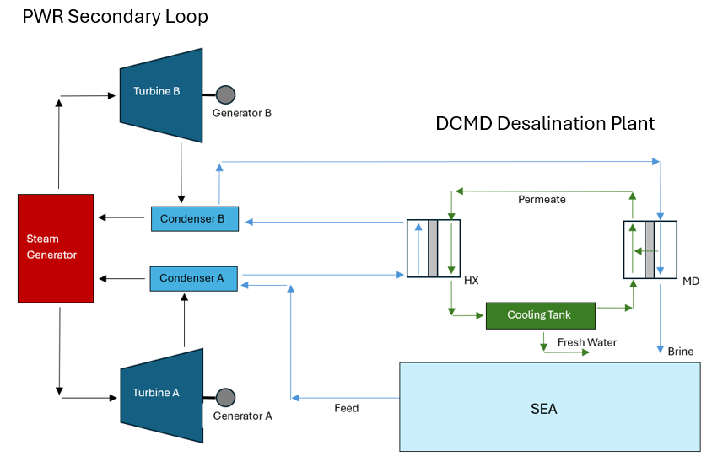
FIG 2. Schematic representation of the coupling using two parallel Rankine cycles.

Cycle ‘A’ operates at pressures and temperatures that are typical of a Rankine cycle optimized for electricity generation. Condenser ‘A’ operates at the pressure of 0.063 bar, with steam condensation at 37 ºC. We consider that the feed (seawater) enters the condenser ‘A’ at 26 ºC, which is the mean seawater temperature at the Brazilian northeast [16]. The feed, as it cools condenser ‘A’, is heated up to 32 ºC. Because the desalination plant collects warm seawater from the power plant condenser ‘A’, instead of colder water directly from the sea, a large amount of power plant waste heat is used to pre-heat the feed [2]. On the other hand, in cycle ‘B’ steam expansion in the turbine ‘B’ is shortened to a pressure just below the atmospheric pressure. Indeed, condenser ‘B’ operates at 0.911 bar and, at such pressure, steam condenses at 97 ºC. We consider a margin of 5 ºC between the steam condensation temperature and the temperature of the feed at the condenser exit. Thus, in condenser ‘B’ the feed temperature can be elevated up to 92 ºC before the feed enters the DCMD desalination unit, indicated as MD in Fig. 2. Inside the MD unit, mass and heat are transferred from the feed to the permeate at rates ${\dot{M}}_{MD}$ and ${\dot{Q}}_{MD}$, respectively. Fig. 2 also shows the recovery heat exchanger HX, where part of the heat that had been transferred to the permeate in the MD unit is reused, at rate ${\dot{Q}}_{HX}$, to help rising the temperature of the feed.
It is important to remark that the external heating required for the desalination process comes exclusively from cooling the two Rankine cycle condensers. Because both condensers operate at pressures that are lower than the atmospheric pressure, there is no risk of radioactive contamination of the seawater with water leaking from the PWR secondary loop. Thus, there is no need to introduce isolation loops between the secondary loops of the PWR and the desalination plant. Indeed, in the power industry the concern is quite the opposite: the contamination of the secondary loop with the seawater used for cooling the condensers [17].
As detailed in reference [14], the coupling of the DCMD plant with heat recovery with the small PWR of 75 MW(th) was modelled using two computational programs, namely, the DESAL-PLANT program and the DE-TOP program. The amount of desalinated water produced by the DCMD plant was computed using the DESAL-PLANT program developed at IEN/CNEN [18]. On the other hand, the program DE-TOP of the International Atomic Energy Agency (IAEA) was used to simulate the Rankine cycles of the small PWR [19].
The DE-TOP program models the secondary loop of a generic Pressurised Water Reactor (PWR). More precisely, it models the regenerative Rankine cycle with reheat [20-22]. The IAPWS-IF97 industrial formulation is used to represent the thermodynamic properties of water and steam. DE-TOP has a flexible system configuration. Indeed, the user can choose the number of regenerative heaters, including the deaerator, and the deaerator position along the feedwater line.
The DESAL-PLANT program adopts a multiscale approach to model a Direct Contact Membrane Distillation (DCMD) desalination plant with heat recovery [18]. The desalination unit comprises several DCMD modules, each of a shell and hollow fibre tube bundle type [23]. A detailed presentation of the modelling employed in the DESAL-PLANT program can be seen in [18]. DESAL-PLANT was assessed to compare its predictions with the experimental results presented in [23] and in [24]. As shown in [18], good agreement was obtained for both sets of data.

the reference power plant
The reference power plant considered in this work is a small PWR of 75 MW(th). Fig. 3 illustrates the use of DE-TOP to model the secondary loop of the reference power plant. The steam generator pressure is 54 bar. We have 6 regenerative heaters, with the deaerator occupying position 5 along the feedwater line. For the computations using DE-TOP we accepted the heater pressures suggested by the program.

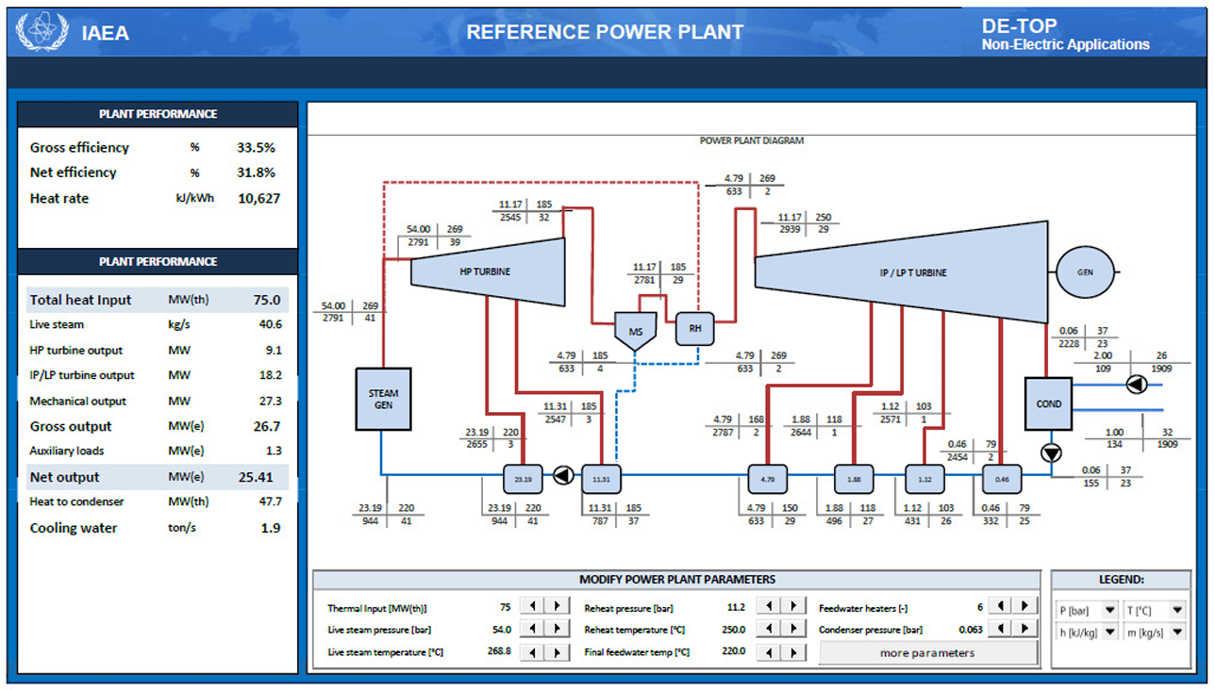

FIG 3. DE-TOP schematic representation of the reference 75 MW(th) PWR.

Note that, as shown in Fig. 3, DE-TOP presents pressure, temperature, enthalpy, and mass flowrate at various points along the PWR secondary loop. For the reference power plant considered here, we used the default values of DE-TOP for the following parameters: high-pressure turbine efficiency 0.85, low-pressure turbine efficiency 0.83, pump efficiency 0.85, generator efficiency 0.98. Using DE-TOP with these values, the PWR reference plant of 75 MW(th) yields a net electric output of 25.41 MW(e).

Performance of the cogeneration system
In this section we present the performance of the cogeneration system comprising the small PWR of 75 MW(th) and the hybrid desalination arrangement involving the SWRO and the DCMD desalination plants. As mentioned previously, the simplest hybrid configuration is considered, where the DCMD and the SWRO plants operate in parallel and independently.
We deal first with the DCMD plant with heat recovery and the coupling strategy described in section 2.2. Employing DE-TOP and DESAL-PLANT, we obtain the freshwater production of the DCMD plant (m³/day) and the electric power loss due to pumping and due to the coupling between the DCMD plant and the small PWR. After obtaining the electric power loss and the freshwater production, the specific electricity consumption of the DCMD plant (kW(e)h/m³) can be determined.
Here we consider a blend of equal parts of the freshwater produced by the DCMD and the SWRO plants. Thus, the SWRO plant is dimensioned in such a way that its freshwater production equals that of the DCMD plant. The electric power demand of the SWRO desalination plant is obtained using the specific electricity consumption of 4 kW(e)h/m³, which is a value typical of a real-scale commercial SWRO plant, including pre- and post-treatment processes [15].

Performance of the DCMD plant
The performance of the DCMD plant with heat recovery depends on operational factors, such as temperatures and flowrates of both feed (seawater) and permeate, and also on the DCMD module characteristics such as dimensions, number of hollow fibres per module, membrane material, porosity, etc [18]. These data, for the DCMD plant considered in this work, are detailed in reference [14].
The issue concerning how to split the total thermal power available in the steam generator (SG) between Rankine cycles ‘A’ and ‘B’ was addressed in [14]. Indeed, a steam splitting that allows the use of all the power plant waste heat was presented by the authors in [14]. Such steam splitting depends on the thermal efficiency of each of the Rankine cycles and on the temperature increase of the feed in each of the condensers. The reader is referred to reference [14] for details.
For the 75 MW(th) PWR considered here, the steam splitting is such that cycles ‘A’ and ‘B’ receive 47.08 MW(th) and 27.92 MW(th), respectively. Table 1 presents the data obtained running DE-TOP for the conditions specified for cycles ‘A’ and ‘B’.

TABLE 1. PARALLEL RANKINE CYCLES DATA

 | Cycle ‘A’ | Cycle ‘B’
Thermal power (MW(th)) | 47.08 | 27.92
Net electric power (MW(e)) | 15.95 | 6.93
Heat to condenser (MW(th)) | 29.95 | 20.48
Feed temperature increase in condenser (ºC) | 6.0 | 4.1
Feed mass flowrate (ton/s) | 1.25 | 1.25

Having determined that the heating power delivered to the desalination plant by condenser ‘B’ was 20.48 MW(th), the program DESAL-PLANT was run to determine the freshwater production of the DCMD plant. As shown in [14], the freshwater production is 315.7 m³/h or 7577 m³/day.
The main price paid for this freshwater output was the reduction of electricity production from 25.41 MW(e) (reference plant) to 22.88 MW(e) (15.95 MW(e) from cycle ‘A’ plus 6.93 MW(e) from cycle ‘B’), thus a loss of 2.53 MW(e). The pumping power required to circulate both feed and permeate inside the DCMD modules should also be added to the electricity cost.
The pumping power computed by DESAL PLANT (assuming a pump efficiency of 0.85) is 0.1443 MW(e), and thus the net electricity production drops to 22.74 MW(e). Therefore, we have a specific electricity consumption of 8.01 kW(e)h/m³ due to the loss of electricity production plus 0.46 kW(e)h/m³ due to pumping, totalling 8.47 kW(e)h/m³.

Freshwater and electric power outputs of the cogeneration system
In this work we consider a blend of equal parts of the freshwater produced by the DCMD and the SWRO plants. Therefore, as the DCMD plant produces 7577 m³/day of freshwater, the SWRO plant must match that output, and the overall freshwater production of the hybrid desalination arrangement will reach 15154 m³/day.
The electric power needed by the SWRO plant to produce the required 7577 m³/day i.e., 315.7 m³/h, is estimated using the specific electricity consumption of 4 kW(e)h/m³, which is a value typical of a real-scale commercial SWRO plant, including pre and post-treatment processes [15]. Therefore, the SWRO plant will consume 1.2628 MW(e) that must be provided by the nuclear power plant. As a result, the electricity output of the cogeneration system drops from 22.74 MW(e) (when we have DCMD only) to 21.48 MW(e). Thus, compared to the reference power plant shown in Fig. 3, which produces 25.41 MW(e), we have a total loss of 3.93 MW(e). This is the cost to produce 15154 m³/day (631.4 m3/h). Table 2 summarises the performance data of the cogeneration system comprising a small PWR of 75 MW(th) and the DCMD and SWRO desalination plants. The overall specific electricity consumption of the hybrid DCMD + SWRO arrangement is 6.235 kW(e)h/m³.

TABLE 2. COGENERATION SYSTEM PERFORMANCE DATA

Steam generator thermal power (MW(th)) | 75.00
Reference power plant electric output (MW(e)) | 25.41
Electric power loss due to coupling with the DCMD plant (MW(e)) | 2.53
Generators ‘A’ and ‘B’ electric output (MW(e)) | 22.88
Power consumed by pumping (DCMD plant) (MW(e)) | 0.1443
Total heat transferred to the DCMD plant (MW(th)) | 50.43
DCMD plant freshwater production (m³/h) | 315.7
SWRO plant freshwater production (m³/h) | 315.7
SWRO plant electric power demand (MW(e)) | 1.2628
Cogeneration system electric power output (MW(e)) | 21.48
Cogeneration system freshwater production (m³/h) | 631.4
Cogeneration system specific electricity consumption (kW(e)h/m³) | 6.235

concluding remarks
A nuclear cogeneration system to produce electricity and freshwater through desalination was presented. The system comprises a small PWR of 75 MW(th) and a hybrid desalination arrangement involving a Direct Contact Membrane Distillation (DCMD) plant with heat recovery and a Sea Water Reverse Osmosis (SWRO) desalination plant. The small PWR provides the heat and the electrical power required by both desalination plants, besides generating electricity for either the grid or local use.
We consider the simplest nuclear hybrid desalination solution, where the DCMD and the SWRO desalination plants operate in parallel and independently. It is important to stress that blending the water produced by SWRO with that produced by DCMD has two main advantages. One is the improvement of the quality of the water produced, as compared to that obtained with the SWRO plant. The other is the reduction of the cost of water production, as compared to that attained by the DCMD plant alone [2].
In our computer simulations, using the programs DE-TOP and DESAL-PLANT, we assumed the seawater temperature of 26 ºC, which is the mean temperature of the seawater at the Brazilian northeast [16]. These simulations indicate that the cogeneration system studied here can deliver 21.48 MW(e) of electricity, simultaneously with 15154 m³/day of freshwater, with a specific electricity consumption of 6.235 kW(e)h/m³.
ACKNOWLEDGEMENTS
This work has the support of FINEP No. 000298/16 and CAPES-PROCAD-DEFESA No. 88887.387824/2019-00.
References
- KUCERA, J. (Ed.), Desalination, John Wiley & Sons, Inc., New Jersey, USA (2014).
- SADEGHI, K., GHAZAIE, S.H., SOKOLOVA, E., FEDOROVICH, E., SHIRANI, A., Comprehensive techno-economic analysis of integrated nuclear power plant equipped with various hybrid desalination systems, Desalination 493 (2020), 114623.
- DA SILVA, G.C.G.R., LISBOA, K.M., SU, J., NAVEIRA-COTTA, C.P., COTTA, R.M., “Assessment of desalination via membrane distillation using low-grade waste heat in small modular reactors”, 19th Brazilian Congress of Thermal Sciences and Engineering (Proc. of the 19th Brazilian Congress of Thermal Sciences and Engineering, Bento Gonçalves, Brazil, 2022), Brazilian Association of Engineering and Mechanical Sciences – ABCM, Rio de Janeiro, Brazil (2022).
- UN, The Sustainable Development Goals Report, United Nations, New York, USA (2022).
- IAEA, Opportunities for Cogeneration with Nuclear Energy, In: Nuclear Energy Series, (No. NP-T-4.1), International Atomic Energy Agency, Vienna (2017).
- CURTO, D., FRANZITTA, V., GUERCIO, A., A review of the water desalination technologies, Appl. Sci. 11 2 (2021), 670.
- GUAN, G., YANG, X., WANG, R., FANE, A.G., Evaluation of heat utilization in membrane distillation desalination system integrated with heat recovery, Desalination 366, (2015) 80–93.
- DOW, N., GRAY, S., LI, J.D., ZHANG, J., OSTARCEVIC, E., LIUBINAS, A., ATHERTON, P., ROESZLER, G., GIBBS, A., DUKE, M., Pilot trial of membrane distillation driven by low grade waste heat: Membrane fouling and energy assessment, Desalination 391 (2016) 30–42.
- CHRISTIE, K.S.S., HORSEMAN, T., LIN, S., Energy efficiency of membrane distillation: Simplified analysis, heat recovery, and the use of waste-heat, Environ. Int. 138 (2020) 105588.
- CIPOLLINA, A., DI SPARTI, M.G., TAMBURINI, A., MICALE, G., Development of a membrane distillation module for solar energy seawater desalination, Chem. Eng. Res. Des. 90 (2012) 2101–2121.
- SCHOFIELD, R.W., FANE, A.G., FELL, C.J.D., Heat and mass transfer in membrane distillation, J. Membr. Sci. 33 (1987) 299–313.
- ALKHUDHIRI, A., DARWISH, N., HILAL, N., Membrane distillation: A comprehensive review, Desalination 287 (2012) 2–18.
- JANSEN, A.E., ASSINK, J.W., HANEMAAIJER, J.H., VAN SONSBEEK, E., Development, and pilot testing of full-scale membrane distillation modules for deployment of waste heat, Desalination 323 (2013) 55–65.
- DE SAMPAIO, P.A.B., ALVES, L.F.R. AND MOREIRA, M.L., Electricity and water cogeneration using a small PWR of 75 MW(th) coupled to a DCMD desalination plant with heat recovery, Nucl. Engrg. and Design 415 (2023) 112658.
- KIM, J., PARK, K., YANG, D.R. AND HONG, S., A comprehensive review of energy consumption of seawater reverse osmosis desalination plants, Applied Energy 254 (2019) 113652.
- IBGE, Atlas Geográfico das Zonas Costeiras e Oceânicas do Brasil, Instituto Brasileiro de Geografia e Estatística, Rio de Janeiro (2011).
- EPRI, Steam plant surface condenser leakage study, NP-481, Electric Power Research Institute, USA, 1977.
- DE SAMPAIO, P.A.B., Computational model and simulation of DCMD desalination systems with heat recovery, Desalination 533 (2022) 115769.
- SÁNCHEZ-CERVERA, I.G., KAVVADIAS, K.C. AND KHAMIS, I., DE-TOP: A new IAEA tool for the thermodynamic evaluation of nuclear desalination, Desalination 321 (2013) 103–109.
- EL-WAKIL, M.M., Powerplant Technology, McGraw-Hill Science, USA (2002).
- TEYSSEDOU, A., DIPAMA, J., HOUNKONNOU, W. AND AUBE, F., Modelling and optimization of a nuclear power plant secondary loop, Nucl. Engrg. and Design 240 (2010) 1403–1416.
- MEDINA-FLORES, J.M. AND PICON-NUNEZ, M., Modelling the power production of single and multiple extraction steam turbines, Chem. Engrg. Sci. 65 (2010) 2811–2820.
- SCHOFIELD, R.W., Membrane Distillation, Ph.D. thesis, University of New South Wales. Australia, 1989.
- WANG, K.Y., CHUNG-GIL, T.S. AND GRYTA, M., Hydrophobic PVDF hollow-fiber membranes with narrowpore size distribution and ultra-thin skin for the freshwater production through membrane distillation, Chem. Engrg. Sci. 63 (2008) 2587–2594.

