Enabling versatile nuclear deployments of the evinci™ microreactor

GABRIEL IVORY
Westinghouse Electric Company
Etna, PA, USA
Email: gabriel.ivory@westinghouse.com

JOE HALACKNA
Westinghouse Electric Company
Etna, PA, USA
Email: halackj@westinghouse.com

Abstract

Westinghouse is developing the eVinci™ microreactor, a 5MWe, 15MWth microreactor with the intention of having the most versatile and flexible microreactor on the market. The reactor is to be factory built and deployed fully fueled to the site, transported by rail, road, or barge. Westinghouse is also investigating deployment through a TNPP together with their partnership with Prodigy Energy. The paper will present various aspects of the design which enable a transportable size and weight including utilization of TRISO fuel, heat pipes and open-air Brayton power conversion system. In addition, it contains various passive safety features which facilitate deployment and operation in remote locations which requires minimal personnel for monitoring, maintenance, or operations. These design features are also coupled with a simplified site layout requiring limited construction, above ground installation and return to greenfield. The paper will also discuss the challenges from a social and regulatory pathway which will need to be overcome to allow for a novel way of deployment for microreactors, to enable a green-energy transition for remote and hard to reach locations.

INTRODUCTION
The purpose of the paper is for Westinghouse to provide additional information and plans associated with its transportation strategy of the commercial eVinci microreactor. The paper also provides discussions regarding example transportation planning and security plan scenarios. The document has been segmented into the following sections:
- Section 2 provides a summary of the eVinci microreactor design and facility description.
- Section 3 provides an overview of the eVinci microreactor deployment, transportation, and packaging plan.
- Section 4 provides an overview of the security, route planning, and social challenges.

Westinghouse plans to manufacture, assemble, and load fuel in the eVinci microreactor at a manufacturing facility located in the United States. Performing these activities at a manufacturing facility, as opposed to an operating site, is a key element of the eVinci microreactor deployment model. The paper provides Westinghouse’s strategy for transportation of the fuelled eVinci microreactor to deployment sites in Canada and the United States from the U.S. manufacturing facility, as well as the consideration of regulatory requirements to enable such transportation. The paper also discusses transportation of eVinci microreactors that have completed their designed operating life from the deployment site to a centralized facility for refurbishment and refuelling.

EVINCI MICROREACTOR DESIGN AND FACILITY DESCRIPTION
The eVinci microreactor is a 15 MWth thermal neutron spectrum reactor that delivers high temperature heat from the reactor core through heat pipes and a primary heat exchanger (PHX) to an open-air Brayton power conversion system (PCS). The reactor system (RXS) design is shown in FIG. 1.
The reactor core is enclosed within a canister filled with an inert gas just above atmospheric pressure to protect reactor components from oxidation while enhancing heat transfer. The core design consists of graphite blocks with repeated, segmented, hexagonal unit cells oriented horizontally along the length of the core. The unit cells contain channels for fuel, burnable absorbers, alkali metal heat pipes, and shutdown rods.
The reactor uses high-assay, low-enriched uranium (HALEU) tristructural isotropic (TRISO) fuel. The core is surrounded by a thick radial reflector that houses the control drums. The core alone, without the radial reflector, is subcritical, requiring the radial reflector to achieve criticality. Shielding attenuates gamma and neutron radiation to protect site personnel and the public during operation and transportation. The PCS receives reactor heat from the PHX and converts it from 15 MWth to 5 MWe (nominal) with an open-air Brayton cycle.
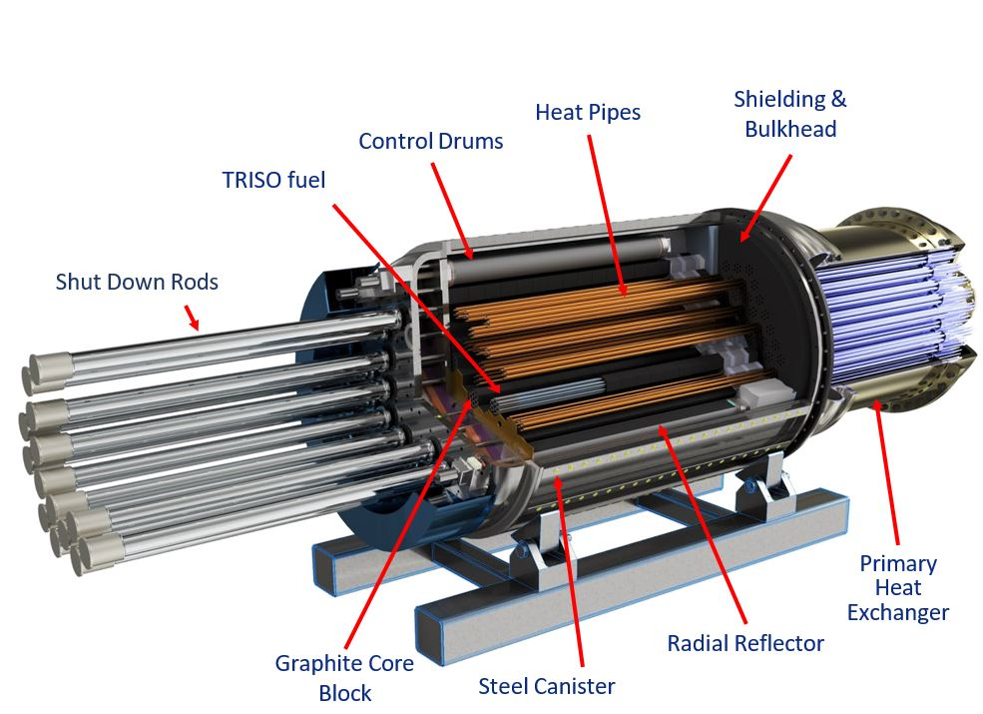
FIG. 1. eVinci Microreactor Cutaway
The canister system does not function as a pressure vessel but instead as an element of the functional containment. During normal operation, the canister is pressurized just above atmospheric pressure with helium to eliminate oxidation of core components and increase thermal gap conductance. The design of the microreactor allows for decay heat removal through the core block, radial reflector, canister system, and shielding. Several layers of the TRISO fuel and the canister together represent the barriers that exist to preclude the release of fission products to the environment and collectively represent the functional containment.
Reactivity control is accomplished using control drums located on the periphery of the core and burnable absorbers in the core. Reactivity is monitored using the power range and source range neutron detectors. Shutdown can be achieved by two diverse and independent means: the shutdown rods and the control drums. Additional shutdown rods are used to address hypothetical accident conditions associated with the transportation of a fuelled reactor and maintain a subcritical reactor during transportation.
The reactor is installed in a transportation cask for transportation. The secondary system (i.e., the power conversion system) and support systems, including instrumentation, control, and electrical (ICE) systems, are transported in separate shipping containers. The shipping containers can be transported to remote locations via truck, rail, or waterway.
The site will be prepared prior to shipment of the reactor and support systems. Prior to the reactor arriving to the site, construction and installation activities will commence and continue after the reactor’s arrival to the site. Any necessary criticality testing will be performed after site construction and installation of the reactor. The site layout and connection between containers are designed to enable quick deployment. An illustration of the site layout is shown in FIG. 2.

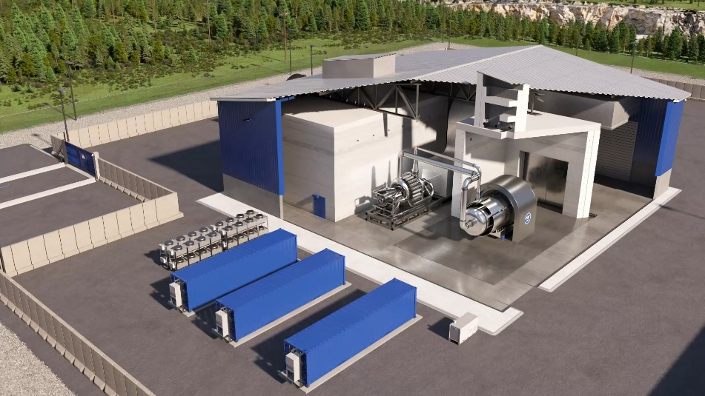
FIG. 2. eVinci Microreactor Site Layout Rendering
Limited onsite staff is needed to perform the necessary site activities such as operations, maintenance, and security. A remote monitoring station will be used to allow remote personnel to monitor reactor power operations. A replacement reactor will be shipped to, and installed at, the site as the operating reactor reaches its end of fuel life. Once the primary reactor reaches its end of fuel life, it is shut down and the replacement reactor will begin operation and become the new primary reactor. The shutdown reactor is allowed to cool before being transported off site for refurbishment and refuelling or for decommissioning. Spent fuel is not required to be stored on site.

Deployment model, TRANSPORTation, and packaging

Deployment Model
FIG. 3 shows the deployment strategy for a single reactor. The deployment of the microreactor consists of the five main steps described below and shown graphically in FIG. 3.

Assemble in Factory
Multiple microreactors will be manufactured within the manufacturing facility. Fuel will be received and stored at the manufacturing facility in preparation for loading it into the reactor. Each reactor will undergo non-criticality testing throughout the manufacturing process, both before and after loading fuel. Once the reactor is manufactured, non-criticality testing is complete, and a licensee and site are identified, the reactor will be prepared for shipping.

Transport to Site
As licensees are identified, each reactor will be shipped from the manufacturing facility to a site. Modularized packaging in transportable shipping containers enables the reactor to be shipped via truck, train, and/or waterway. The complete facility design will be transported inside a combination of custom designed transport containers and International Standards Organization (ISO) shipping containers. The reactor container will be a custom designed transport container and will function as the approved Type B shipping container for the fuel within the core.

Install and Operate Reactor at Site
The site will be prepared prior to shipment. Prior to and after arrival at site, construction and installation activities will commence. Any necessary criticality testing will be performed after site construction and installation of the reactor. The site layout and connection between containers are designed to enable quick deployment.
A limited on-site staff is needed to perform the necessary site activities such as operations, maintenance, and security. A remote monitoring station will be used to allow remote personnel to monitor reactor health and safety.

A replacement reactor will be shipped to and installed at the site as the primary reactor reaches its end of fuel life. Once the primary reactor reaches its end of life, it is shut down and the replacement reactor will begin operation and become the new primary reactor. It is anticipated this reactor turnover will occur in 24 hours as the replacement reactor will have undergone performance testing and system turnover prior to shutdown of the primary reactor as it is sited and commissioned in an adjacent structure.

Transport Away from Site
The reactor with depleted fuel remains at site for a certain period of time for cooldown. After this waiting period, the depleted reactor is transported away from the site to a facility to be either refuelled and refurbished or decommissioned. Again, the reactor container will act as the approved Type B shipping container for the fuel within the core.

Refuel/Refurbish or Decommission
As stated above, the depleted reactor can either be refuelled and refurbished or decommissioned at a dedicated facility separate from the operating site. If refuelled and refurbished, it will be transported back to a site for future operations.
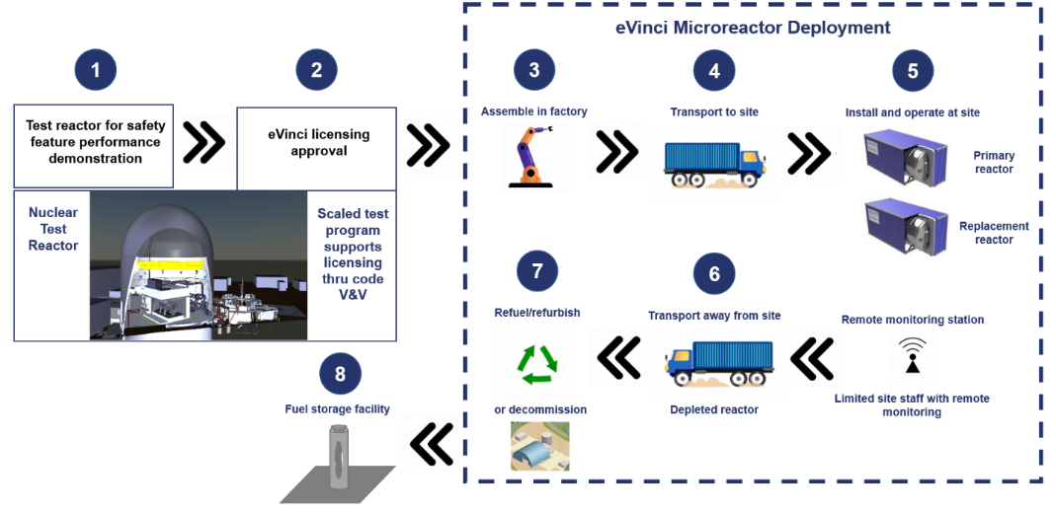
FIG. 3. Deployment Model

Transportation and Packaging
As described in Section 2, the fully fuelled reactor will be assembled and tested (non-criticality testing) at a manufacturing facility. Prior to shipment, the site to which the reactor will be installed and operated will be prepared. The reactor will then be transported to site by the safest and most efficient route possible. The reactor will be installed, commissioned, and operated. As the fuel is depleted, a replacement reactor will be assembled at the manufacturing facility. The replacement reactor, in its container, will be transported to site and placed in holding until the primary reactor is depleted. All necessary piping, monitoring, and electrical connections will be connected to the new reactor. This process is intended to take less than 24 hours. The depleted reactor will be allowed a cooldown period until it reaches a state allowing for temperature and dose rates during transportation to be within required limits. The depleted reactor container will be transported back to a facility for refurbishment, refuelling, or decommissioning.
Existing licensed nuclear fuel transportation containers will not accommodate the size of the eVinci microreactor. Therefore, development of an external container around the transportable reactor is required for safe and efficient operations as well as safe transportation is required. Since this container will be used to transport irradiated fuel when the reactor is being returned to a facility, the requirements applied to the design and approval of fissile Type B fuel transportation cask are applicable.
The use of a transportation Probabilistic Risk Assessment (PRA) is being considered to satisfy the 10 CFR Part 71 transportation regulatory requirements more efficiently. 10 CFR 71.41(c) allows for different environmental and test conditions from those specified in Sections 71.71 (“Normal Conditions of Transport”) and 71.73 (“Hypothetical Accident Conditions”) “if the controls proposed to be exercised by the shipper are demonstrated to be adequate to provide equivalent safety of the shipment.” Westinghouse believes a transportation PRA, based on transportation accident event trees, is one potential way to demonstrate the equivalent safety of transporting a microreactor. Dialogue with the NRC will be required to gain alignment on the development and use of a transportation PRA for this purpose.
Since existing, certified nuclear fuel transportation casks do not accommodate the size of the eVinci microreactor, development of an external cask around the reactor system (RXS) and the sub-systems required for safe and efficient operations, as seen in FIG. 4, is required. The packaging being developed is intended to allow for extensive reuse of the packaging for multiple eVinci microreactor shipments. Incidental wear and tear is not expected to significantly degrade the packaging. Since this same packaging will be used to transport spent nuclear fuel (SNF) after operations when the microreactor is being returned to a facility for decommissioning or refueling, the requirements applied to the design and approval of a fissile Type B fuel transportation package will be applicable.

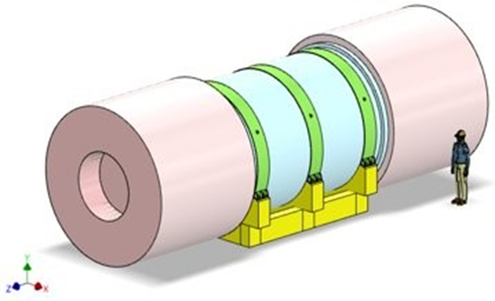
FIG. 4. eVinci Microreactor Reactor Transportation Cask
As previously stated, the transportation package for the eVinci microreactor will need to meet the requirements applied to the design and approval of a fissile Type B fuel transportation package, which includes the following four basic requirements: prevent or limit the release of radioactive contents, prevent an unsafe configuration (i.e., maintain sub-criticality), limit dose rates on and near external package surfaces, and manage any decay heat generated by the contents.
The reactor will be installed and removed from the RTC via the Transportation Insertion Machine (TIM). The TIM is being designed to be capable of pushing the reactor out of the cask both when it is being installed at a deployment site as well as when it is delivered to the centralized facility. The TIM is also capable of pulling the reactor into the RTC when being removed from a deployment site. The relative position of each of these components can be seen in FIG. 5.
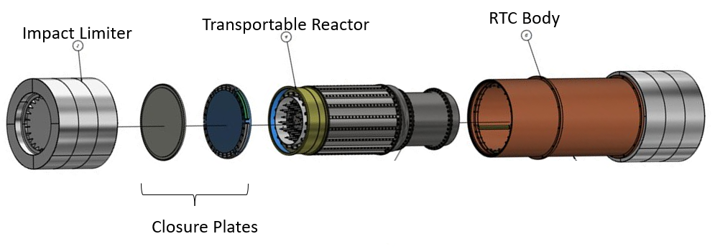
FIG. 5. RTC Major Components

Road Transport
The eVinci microreactor may be transported over public highways. Vehicles that are extremely heavy, long, wide, or tall are known as “superloads” and are typically subject to additional permitting requirements. The eVinci microreactor transportation package will be a classified as a superload for transport over public roadways and will be subjected to the restrictions typically applied to the carefully planned and safe transport of superloads. Superload permit approval will require analysis of not only the equipment used for the transport, but also of the transportation infrastructure.

Rail Transport
Another option for the transport of the eVinci microreactor over land is by rail. Transport via rail is suggested as the preferred method of terrestrial transportation. While transporting the RTC via rail will require permit approval, axle load limits are much greater than those for road transportation. Freight railcars that are acceptable for unrestricted movement on all domestic railways, however, must meet the dimensional requirements, which limit the width of the railcar and its cargo to 10 ft. 8 in. The eVinci microreactor transportation package will exceed this width. Weight limits for rail transportation are based on the capacities of the rail lines being used. Due to potential dimensional restrictions of currently available rail lines, circuitous routing may be required to gain rail clearance approval. It may also be necessary to transfer the RTC from a rail car to another mode of transport to circumvent a restriction. An additional consideration of transport via rail is the maximum capacity of railroad infrastructure. The per axle weight limit of the rail line is used to extrapolate to the number of axles required to transport the eVinci microreactor package via rail. Rail lines to more remote destination do have a lower capacity.

Water Transport
A final means of conveyance for the eVinci microreactor is via sealift on barge or sea faring vessel. Transport of large components such as reactor pressure vessels, steam generators, and pressurizers by barge to and from nuclear power plant sites has routinely been done in the U.S. Ocean and Barge transport do not face restrictions based on the size and mass of the RTC. Approvals for transit through and loading by outside crane will require approvals which should be granted with minimal requirements. Inland waterways provide another viable option for transport of the RTC module that reduces the number of permits and approvals and decreases overall transit time.

TRANSPORTATION SECURITY AND ROUTE MAPPING

Transportation Security
The purpose of the transportation security plan is to confirm that the nuclear material being transported has the required level of protection against incidents that may occur during transportation. The development of a transportation security plan will be guided by sections relevant to transportation in 10 CFR73.26 and REGDOC-2.13.3. At a minimum, the transportation security plan will contain the following information:
- Administrative information detailing the applicant and describing the license application.
- A description of the nuclear material, including the name, quantity, radiation level, chemical and physical characteristics, and isotopic composition
- A threat assessment that consists of an evaluation of the nature, likelihood, and consequences of acts or events that may place prescribed information or nuclear material at risk. Communication with appropriate law enforcement agencies to review the potential threats and with the CNSC to determine if any information that may identify known criminal, extremist, or terrorist threats will also occur.
- A description that describes the act of conveyance from the time the shipment leaves its originating location until it reaches its planned destination.
- Proposed security measures will be developed that consider the fact that a fueled reactor secured within the RTC is being transported. Attention will be given to the distance and type of terrain to be covered, the mode(s) of transport, the results of the threat assessment, and public concerns.
- The communication arrangements will be made among the licensee, the operator of the vehicle or vessel transporting the nuclear material, the recipient of the material, and any off-site response force along the route.
- The arrangements will be made with any off-site response force along the route.
- The planned route and alternate route to be used in case of an emergency will be listed. Attention will be given to all applicable regulations and ordinances regarding transport routes for hazardous materials. Routes that bypass urban areas wherever practical will be utilized.

Route Planning
The most important factor when planning eVinci microreactor transportation routes is safety and will be guided by 10 CFR 73.37 Requirements for physical protection of irradiated reactor fuel in transit in the US. Given the size and weight of the eVinci microreactor package careful consideration must also be given to which routes allow for efficient transport operations. Route planning will include the need to minimize both total time in transit and the number and duration of any transfer operations to switch between modes of transport. Route selection will include the avoidance of areas where natural physical impediments, such as flooding or rockslides, occur at a high frequency. Multiple transport routes will be presented where possible. This may be impeded by remote deployment sites as well as routes with infrastructure that can support a load as large as the eVinci microreactor transportation package. Route planning will consider the availability of appropriate rest and necessary refuelling stops. These stops will be developed using the requirements of Subpart D, Routing of Class 7 (Radioactive) Materials, to 49 CFR Part 397 Transportation of Hazardous Materials: Driving and Parking Rules.
Planning efforts will need to include coordination with local authorities through which eVinci transportation will take place. This includes not only permitting approvals for road, rail, or waterway usage, but also with local law enforcement and emergency response resources. Where necessary, engagement with indigenous peoples is also required. 10 CFR 71.97 Advance notification of shipment of irradiated reactor fuel and nuclear waste. And 10 CFR 73.72 Requirement for advance notice of shipment of formula quantities of strategic special nuclear material, special nuclear material of moderate strategic significance, or irradiated reactor fuel will be followed to develop this coordination.

Social Concerns
As with all facilities, the construction of an eVinci site will ensure that there will be minimum environmental impact to the site and surrounding community. Westinghouse has a comprehensive environmental, social and governance plan for all global office and manufacturing sites. Westinghouse will then create a significantly positive impact to the community by returning the site to greenfield in less than 1 year after the removal of the final reactor and/or refurbishing existing buildings to create a state-of-the-art nuclear facility. The construction of the facility will hire local project management teams and construction partners which ensure the professional and timely completion of the project, including hiring local resources to complete the work.
In addition to Westinghouse’s active role in local communities, nuclear energy is the most socially responsible form of energy. Nuclear is carbon-free and has increased reliability and resilience which improves safety as remote communities are forced into emergency situations when the grid that they are dependent on has an outage. These communities face challenges with the unpredictable and increasing cost of transported diesel, the logistical challenges to transport diesel to remote locations, and diesel generator emissions and spills.

Conclusion
The eVinci microreactor is an Nth of a kind reactor technology, and with that comes special aspects and challenges. The deployment of this reactor technology is, by itself, a complicated matter. However, as versatile as this reactor technology is, these special challenges present the opportunity for unique solutions that consider and meet a vast number of requirements from all angles of the deployment strategy. The eVinci microreactor is to be built in-house and transported in a prebuilt cask to the site to be used for energy production. This transport is unique as the reactor is fully assembled in transit. When the reactor is no longer useful at the site, it is transported away by Westinghouse to be refurbished and redeployed. It is transported using existing infrastructure to reduce costs. Route security and planning will always be considered during the lifespan of the reactor. Westinghouse will engage with all necessary entities, including local authorities and emergency response teams. Westinghouse is proud to have developed the eVinci microreactor and is confident that it will be an integral piece of the energy transition, particularly for remote communities, extraterrestrial projects, and many more specialty applications.

