# CAREM 25 fuel cycle optimization, ATF use and design impact evaluation

H. A. LESTANI

CNEA

Bariloche, Argentina

Email: hectorlestani@cnea.gob.ar

J. E. Bergallo

CNEA

Bariloche, Argentina

E. M. Lopasso

CNEA

Bariloche, Argentina

**Abstract**

The use of Accident Tolerant Fuels (ATF) was evaluated in the CAREM 25 nuclear fuel cycle to assess its economical feasibility, which required a very specific neutronic fine tuning. The ATF evaluated consists on the use of FeCrAl cladding and keeping UO2 and Gadolinia Burnable Poisons (BP) as the fuel itself. The FeCrAl cladding has the outstanding advantage of avoiding the Hydrogen production that results from Zirconium oxidation of conventional Zircaloy cladding undergoing overheating. But the use of FeCrAl imposes a considerable increase in absorptions that has to be counter balanced with an increase in Uranium enrichment. The peculiarities of SMR cores impose tighter restrictions to power distribution, due to its smaller size, and to reactivity constraints, due to ”boron-free” designs and a smaller amount of control rods available. Hence, prior to the economic assessment of the different cladding and the necessary enrichment increase to counter balance absorptions increase, the fuel design, the enrichment and the burnable poisons distribution have to be deeply studied to comply with design criteria and safety constraints. The paper focuses on the neutronic design modifications needed to allow for subsequent economic optimization of fuels with and without ATF cladding.

## INTRODUCTION

The Small Modular Reactors (SMRs) are being developed with the promise of solving one of the biggest problems of Nuclear Power Plants (NPPs): huge capital cost expenditures in construction sites of thousands of workers with construction times between 5 and 10+ years and high financial penalizations for any delay [1]. Competitiveness of the nuclear energy is thus pursued by downscaling and fine optimization of the engineering processes. On the other hand, another big issue deterring power plants from being deployed is related to safety concerns: the approach to handle them is the engineering of passive safety features and better response to severe accidents. SMR designs with passive safety features have a better response to anticipated transients, and CAREM 25 reactor is no exception [2].

But the response to severe accident scenarios still have room for improvements, and those improvements deal with the core and fuel designs. The engineering of nuclear fuel is advancing the development of fuel elements with better response to severe accidents that were given the name of Accident Tolerant Fuels (ATF) [3] and also in a more modern vocabulary, Advanced Technology Fuels (ATF). These fuels are engineered with innovations including new materials for fuel or for cladding. The changes in cladding material aim at replacing Zirconium and hence avoiding the autocatalytic production of hydrogen that occurs when Zircaloy cladding is heated above 1700K [4].

The use of any Iron based alloy (any steel) to replace Zircaloy implies an increase in parasitic neutronic absorptions, provided Zirconium is by far less neutron absorbing than Iron and its alloying elements. Any attempt to use ATF claddings has to mitigate the impact of higher neutron absorptions so that the safer fuel can be used without penalizations. This is achieved by increasing the Uranium enrichment up to a level that has to be optimized.

Whilst the enrichment is optimized, different quantities affected by design criteria such as excess reactivity, shutdown margins, cycle length, power distribution and DNBr have to be checked for compliance and this may lead to further modifications in an iterative process. These design requirements are tighter in SMRs due to some characteristics that are common to most designs, namely, the smaller core and consequent smaller amount of fuel elements, which leaves less room for Control Rod Drive Mechanisms (CRDM), having less reactivity available to accommodate burnup, cold - hot reactivity and transients. And the avoidance of boron dilution as a means for reactivity control, with the so called boron-free cores, only makes these design requirements even tighter.

A criterion for balancing the higher reactivities and burnup achievable with higher enrichments against the bigger resources needed to obtain such fuel is developed in reference [5] which is under preparation, and applies to fuel configurations complying with design neutronic requirements. This work focuses on the neutronic calculations and the criteria and work flow needed to allow different enrichments to be used in a core design.

## nEUTRONIC MODELS

The models used in this work calculate the reactor core neutronics coupled with thermal-hydraulics. The objective is to assess the compliance of different cores with the design requirements, and establishing the achievable burnup for every enrichment and core evaluated.

The neutronics calculations are carried out with a deterministic calculation scheme, divided into cell and core calculations. At cell level the homogenized cross sections (XS) for neutron induced nuclear reactions are obtained with CONDOR code [6] from a fuel element model as the one illustrated in figure 1. Such a fuel is composed of a hexagonal array of 108 fuel rods, 18 guide tubes for control rods and 1 guide tube for instrumentation. The cladding material, the enrichment level and the burnable poisons content and distribution will be varied in this work.

At Core level the calculations are made with CITVAP code [7] coupled with THERMIT [8] for thermal-hydraulic calculations. The model is depicted in figure 2. No changes at core level are made while changing fuel element composition. The refuelling strategy and the geometry remain untouched.

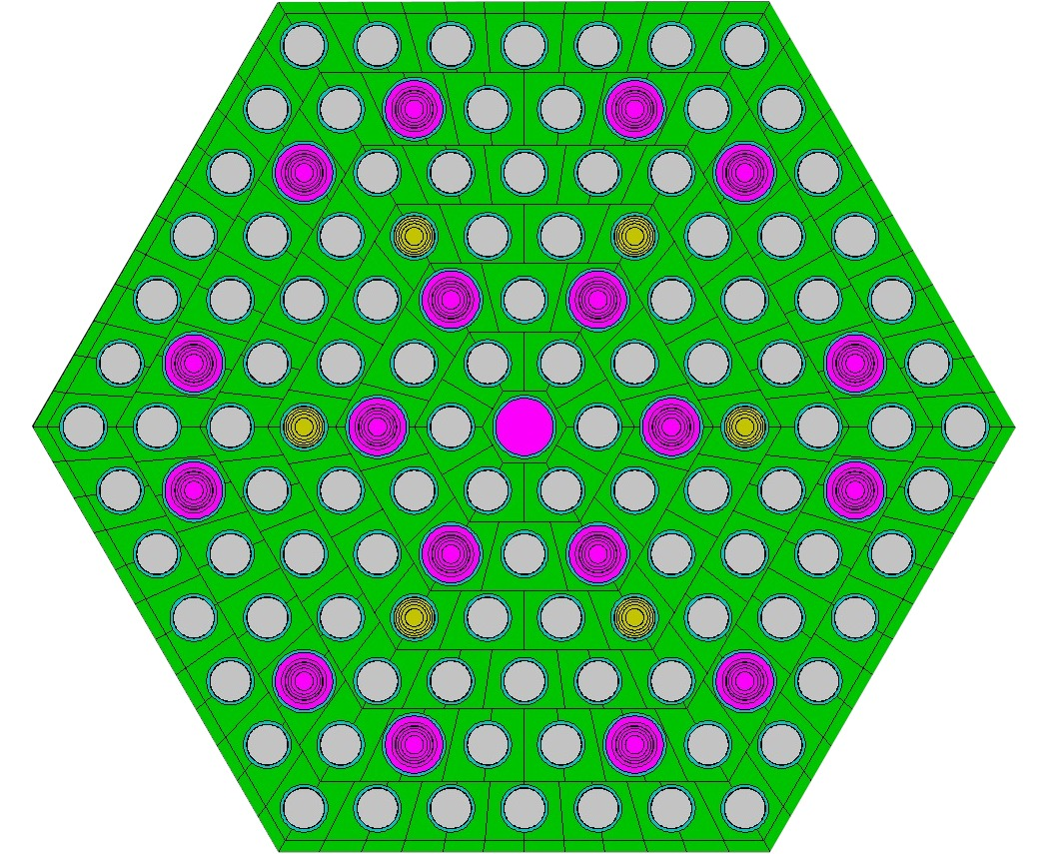

FIG. 1: Cell model of the hexagonal fuel element

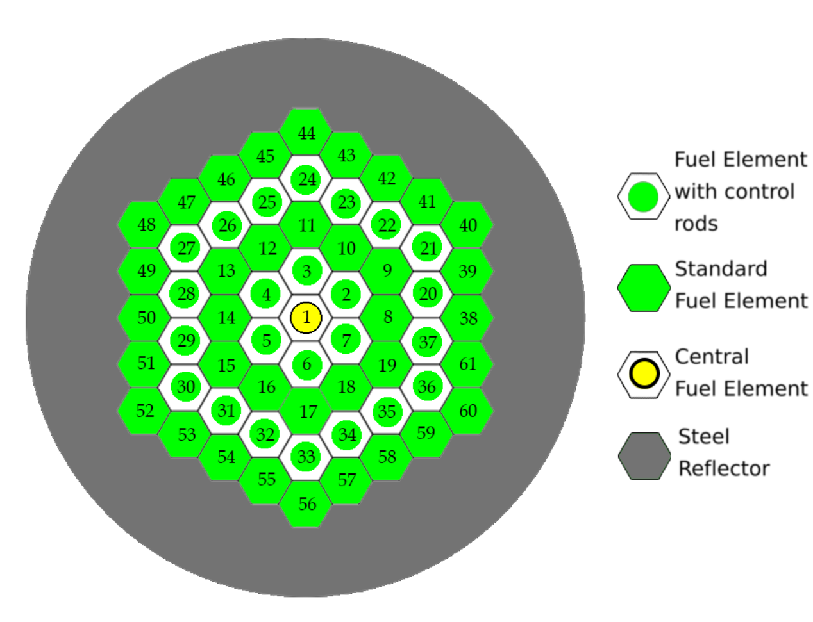FIG. 2: Core model

hexagonal array of 61 fuel elements.

In order to make modifications and look for design requirements compliance, a work flow was implemented as shown in figure 3, which can be read as follows. Once enrichment and burnable poisons content are selected (modifying the previous ones), the homogenized cross sections are obtained with the cell model. This XS are fed into the neutronic core model to begin an iterative process (shown with the red circuit) to determine de cycle length: if reactivity excess at end of cycle (EOC) is higher than the reactivity reserve needed, then the cycle is extended, but the cycle is reduced when such reactivity is lower than the needed value. This iterative process ends up with a cycle length and the associated extraction burnup (which is defined as the average burnup of the fuels being removed from the core during refuelling).

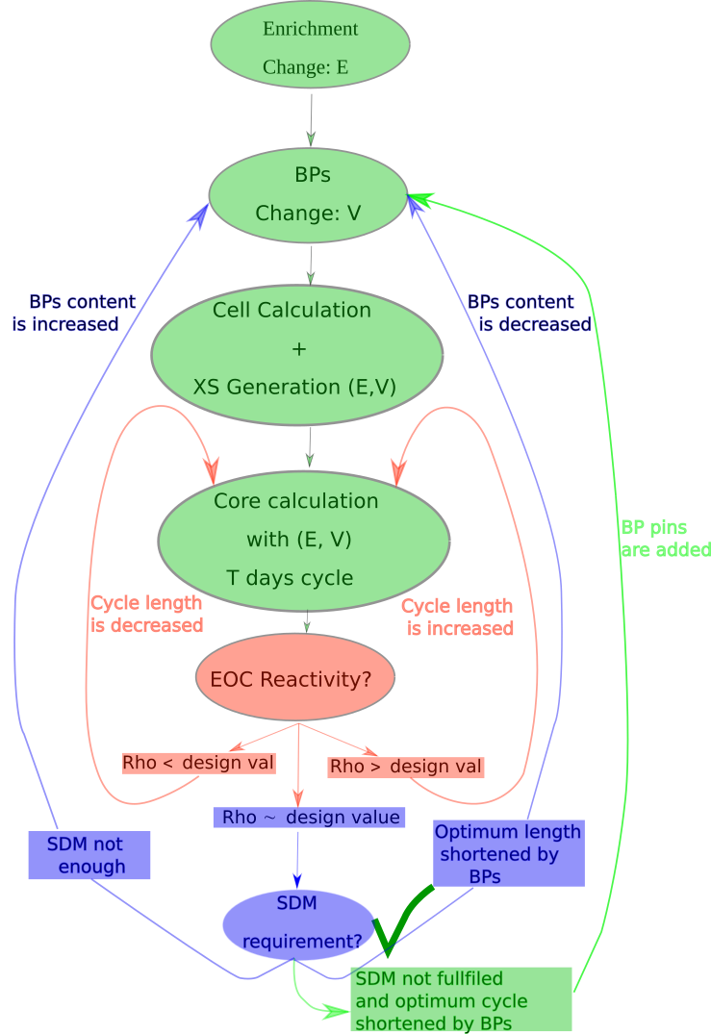

FIG. 3: Neutronic workflow diagram.

Before taking credit of that extraction burnup as achievable, the design has to be checked for compliance with shutdown margins and thermal-hydraulic indicators. Different shutdown margins are required for different plant conditions (fast hot shutdown, shutdown during start up, shutdown maintenance in cold state, etc.), and every plant condition implies a new core calculation probably with a different set of XS. When the shutdown margins are smaller than requested, according to the blue circuit in the work flow, the BPs content has to be increased.

A successful exit from the workflow of figure 3 implies that a proper configuration has been found and no further iterations are needed. Such workflow is applied to every enrichment of the different claddings and the results are presented in the next section.

## RESULTS

The use of the aforementioned models show that there are limitations for both, low and high enrichments. For low enrichments the limitation is found in the red loop of figure 3 when criticality is not achieved. For higher enrichments there is no limitation for this loop as there is always a cycle length that will give the targeted end of cycle reactivity. But the limit for higher enrichments is found in the blue loop, when trying to meet shutdown margins and BPs have to be increased. A lot could be discussed about BPs addition, but in summary, there are two different ways of increasing BPs: increasing the concentration in the existing BP pins, or increasing the number of pins containing BPs.

In figure 4 the effects in cycle reactivity of different increases in BPs content are shown. Taking the red curve as a reference, it can be seen that a concentration change in the BPs content (blue and green curves) has an impact on the irradiation time it takes for the BPs to get depleted, hence, affecting mainly the reactivity at mid - end of cycle. This can be explained by the onion skin effect [9, section 6.4.1], which prevents the neutrons to reach the inner part of the BP pin due to being shielded by an outer layer, until that layer gets depleted. The absorption rate in the rod is thus more related to the rod area exposed to neutron flux than to the BP concentration, which is a black absorber for neutrons even at lower concentrations. So at Beginning Of Cycle (BOC) the reactivity decrease with an increase in BP concentration is not significant. The biggest effect on reactivity reduction due to BP concentration increase is observed at mid to End Of Cycle (EOC). On the other hand, it can be seen that a change in the number of BP pins (light blue and orange curves) has an impact on BOC reactivity rather than in the duration of the BPs. The reason for that is the increase in the rod surface exposed to neutron flux, having the consequence of both: a bigger reactivity decrease and a faster depletion of the BPs.

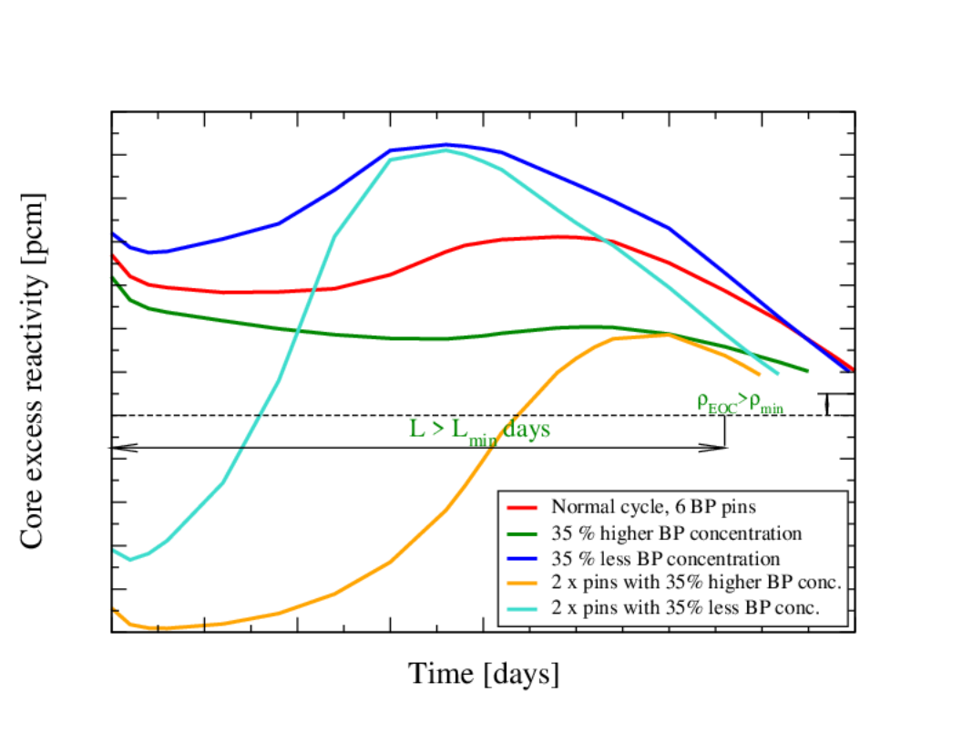

FIG. 4: Effect of burnable poisons content on cycle reactivity.

With these two strategies of BPs content increase in mind, the shutdown margins can be achieved by observing when the maximum reactivity occurs and applying a combination of number of pins and concentration of BPs increase. The blue circuit in the work flow of figure 3 states that if shutdown margins are not enough, the explained BPs increase has to be applied, but two limitations are found. If the number of pins containing BPs is too high, a very deep reactivity valley (relative minimum) can be found near BOL, which would prevent criticality maintenance. And if the concentration of BPs is too high, it might not get fully depleted at EOL, which would reduce the achievable burnup. Should that be the case, the only remaining alternative is to increase the number of control rods, which has layout and mechanical constraints that will limit the number of Control Rod Drive Mechanisms (CRDM).

Finally two thermal-hydraulic merit figures are also checked for. The first is the power peaking factor (PPF), deeply related to fuel utilization. The second is the DNBr, whose design limit is unbreakable, and is a consequence of the PPF and the coolant flow distribution pattern. The strategy to comply with the thermal-hydraulic indicators is basically to avoid clustering of rods with or without BPs, which should produce an even power distribution. The final configuration complying with these indicators is at last found with some trial and error.

In table 1 the configurations complying with the design criteria are presented and in figure 5 the average extraction burnup is shown normalized to a reference burnup, to ease visualization of the impact of different claddings and enrichments.

TABLE 1: BP configuration for each enrichment

|  |  |  |  |  |
| --- | --- | --- | --- | --- |
| Clad | ε [%] | # BP Pins | Max BP Conc. [%] | ε in BP Pins [%] |
| Zircaloy-4 | 2.0 | 0 | 0.0 | 0.711 |
| 2.5 | 6 | 1.0 | 0.711 |
| 3.0 | 6 | 7.4 | 0.711 |
| 3.5 | 9 | 7.5 | 0.711 |
| 4.0 | 12 | 10.0 | 0.711 |
| 4.5 | 15 | 11.0 | 2.5 |
| SS304L | 4.0 | 6 | 0.5 | 0.711 |
| 4.5 | 6 | 2.1 | 0.711 |
| 5.0 | 6 | 4.2 | 0.711 |
| FeCrAl | 3.0 | 6 | 0.5 | 0.711 |
| 3.5 | 6 | 1.4 | 0.711 |
| 4.0 | 6 | 7.0 | 0.711 |
| 4.5 | 10 | 7.0 | 2.5 |
| 5.0 | 11 | 9.0 | 2.5 |

It can be easily seen that some low enrichment configurations are missing for the two Iron based alloys. This is due to the higher absorptions these claddings introduce, up to a level that compromises criticality. And for Zircaloy-4 cladding it was not possible to find a configuration for 5% of enrichment, the reason being the more narrow margin of reactivities available as enrichment is increased with a fixed core design.

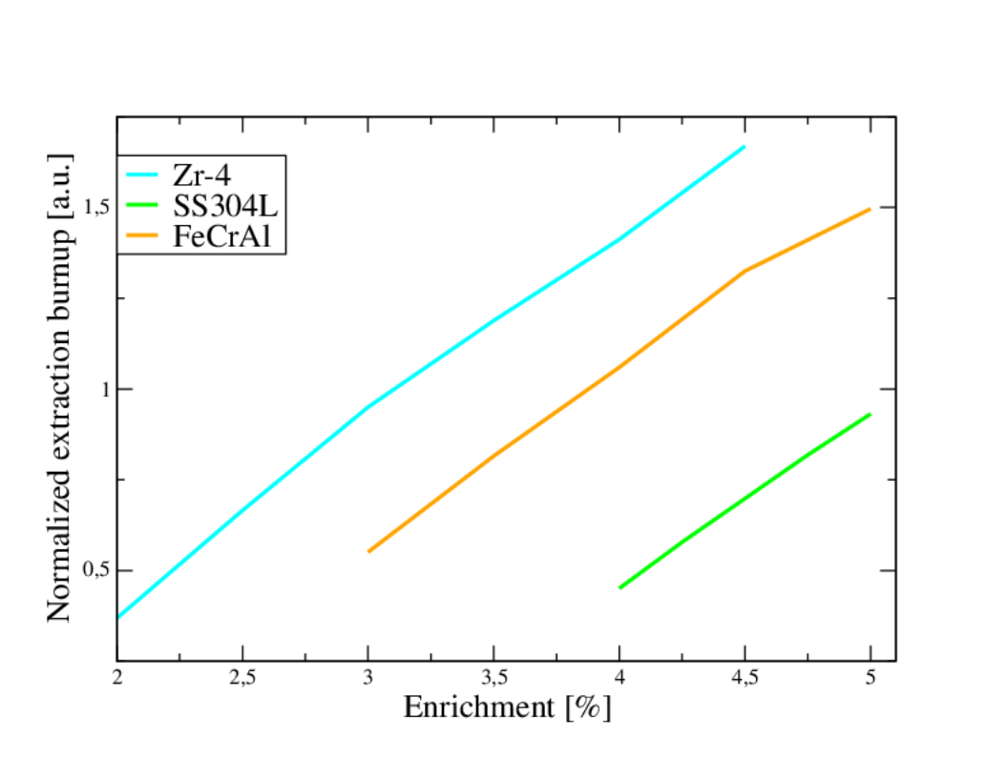FIG. 5: Average extraction burnup as a function of enrichment, for different claddings.

As enrichment is increased the reactivity to be adjusted during burnup (reactivity swing from BOC to EOC) is higher. And, as shown in figure 6, for every enrichment the different possible configurations lead to different control rod weights, but a clear trend towards lower weights is seen with enrichment increase. As a consequence of higher reactivity swings and lower control rod weights, higher demand is put on the reactivity to be managed by BPs, and at some point a limit is found if only proven absorbers are allowed to be used. That is the reason for not having a configuration with 5% of enrichment for Zr-4 cladding. Should higher enrichments be necessary, a combined BPs strategy could be tried co-sintering different absorbers, or a strategy such as IFBA [10] or BigT [11].

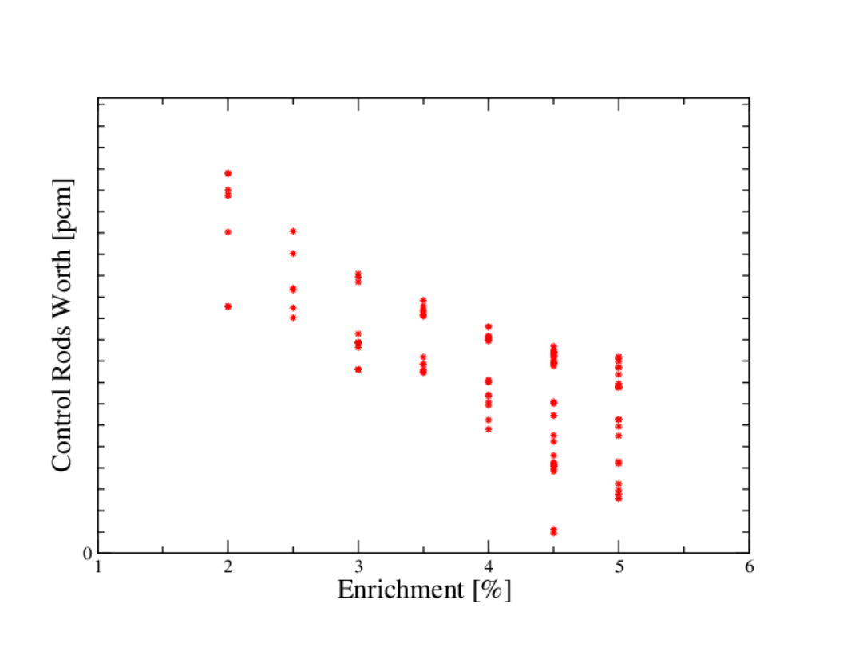

FIG. 6: Control rod worths as a function of enrichment.

## CONCLUSIONS

The neutronic models for deterministic calculation of the CAREM 25 reactor core have been presented. A workflow for neutronic design has been developed, which allows to adjust the fuel cycle parameters depending on the fuel composition: cladding, enrichment and BP content chosen. In an iterative process the developed workflow allows to check for design requirements compliance or to make modifications in an intelligible and ordered way. The requirements checked for are shutdown margins, power peaking factor and DNBr.

The limitations and difficulties found in the process of redesigning a fuel with different enrichment levels were presented. Strategies for solving this difficulties have been explained. However, these strategies proved useful in a certain enrichment range beyond which the limitations remained. To extend the range of possible enrichments some innovative BP strategies are suggested, which could be studied in future work.

As a result of this analysis the fuel configurations complying with design criteria for each cladding and enrichment studied were presented. The average extraction burnup for each of this configurations is also presented in a normalized scale, which will be used in work under preparation [5] related to economical optimization of these fuels. As an extra result the decrease in control rod weight as a function of enrichment is presented, which allowed to understand the limitations observed and will be used in future cases of optimization.

ACKNOWLEDGEMENTS

This work has been possible thanks to the models and tools developed and tested in the CAREM project by a lot of people, some of whom do not belong to the project any more, but whose legacy is well preserved.

References

1. Juanicó, L.E., Florido, P.C., Bergallo, J.E., 2001. “Probabilistic model for the economic evaluation of nuclear projects.” Nuclear Engineering and Design 211, 237–244.
2. Magan, H.B., Delmastro, D.F., Markiewicz, M., Lopasso, E., Diez, F., Giménez, M., Rauschert, A., Halpert, S., Chocrón, M., Dezzutti, J.C., Pirani, H., Balbi, C., Fittipaldi, A., Schlamp, M., Murmis, G.M., Lis, H., 2010. “CAREM Project Status”. Science and Technology of Nuclear Installations 2011, 6. doi:10.1155/2011/140373.
3. Pastore, G., Gamble, K., Cherubini, M., Giovedi, C., Marino, A., Yamaji, A., e.a., 2019. “Benchmark of fuel performance codes for fecral cladding behavior analysis.”, in: 14th International Nuclear Fuel Cycle Conference, GLOBAL 2019 and Light Water Reactor Fuel Performance Conference, TOP FUEL 2019.
4. A. W. Cronenberg, 1990. In-Vessel Zircaloy-Oxidation/Hydrogen Generation-Behavior During Severe Accidents. NUREG/CR-5597 .
5. H. A. Lestani , J. E. Bergallo, E. M. Lopasso. “Neutronic and economic assessment of ATF in CAREM 25 fuel cycle”. In preparation.
6. Ferraro, D., Sardella, F., Villarino, E., 2022. Analysis of the VERA problem #2 using the cell-code Condor. Annals of Nuclear Energy 168. doi:<https://doi.org/10.1016/j.anucene.2021.108908>.
7. Mochi, I., 2011. INVAP’s Nuclear Calculation System. Science and Technology of Nuclear Installations 2011. doi:<https://doi.org/10.1155/2011/215363>.
8. Kelly, J.E., Kazimi, M.S., 1979. Development and testing of the Three dimensional, two-fluid code Thermit for LWR core and subchannel applications. Technical Report. MIT.
9. Cacuci, D.G., 2010. Handbook of Nuclear Engineering. Springer.
10. Haibach, B.V., Feltus, M.A., 1997. A study on the optimization of integral fuel burnable absorbers using deterministic methods. Annals of Nuclear Energy doi:<https://doi.org/10.1016/S0306-4549(96)00055-2>.
11. Yahya, M., Kim, Y., 2017. An innovative core design for a soluble-boron-free small pressurized water reactor. International Journal of Energy Research, Wiley doi:<https://doi.org/10.1002/er.3792>.