Deployment and uses of Floating Nuclear Power Plants powered by Small Modular Reactors

Dr Rory Megginson
CORE POWER
London, UK
Email: rory.megginson@corepower.energy

Thomas Davies
CORE POWER
London, UK

Scott Edwards
CORE POWER
London, UK

Abstract

This paper presents how Floating Nuclear Power Plants, FNPP, combining Advanced Modular Reactors (AMR), particularly Molten salt reactors (MSR) and Heat Pipe Reactors (HPR), with offshore marine engineering and shipyard construction, could address the challenges faced by the nuclear industry in meeting the demand for clean electricity as well as demonstrating potential new use cases. MSRs are intrinsically and passively safe and could allow for modular factory fabrication. Shipyard construction and offshore deployment, as demonstrated by the Oil & Gas Industry, is faster, safer, and cheaper than onshore. FNPP could cut cost and construction time by over 50% and allow the decoupling of construction from site licensing, which will open the possibility of large-scale serial production. This should result in enhanced energy security and a sharp reduction in building costs and time while minimising emissions.

Introduction
The importance of widespread nuclear as part of a green electricity mix is attested by France, sourcing about 58% of its electricity from nuclear plants and having an average carbon intensity of 83 g/kWh. By comparison, neighbouring Germany, using a mixture of intermittent renewables and fossil fuels, has a carbon intensity of 494 g/kWh.[1] While traditional nuclear power offers cost-effective and emission-free electricity, recent large-scale nuclear projects have frequently encountered cost overruns and delays. These issues have been predominately attributable to licensing requirements and the extensive ground and civil work necessary for terrestrial plants, lengthening the construction process and further escalating costs. In addition, these facilities have almost always been massive one-of-a-kind builds that fail to benefit from productivity improvements associated with modern, repeated production practices. As a result, the average capital expenditure (CAPEX) of nuclear power plants in the United States has increased by factors of 5 to 10 since the 1970s.[2]
In this context, developments in advanced reactor technology, especially floating nuclear power plants (FNPP), could offer a substantial benefit. Moving nuclear power generation offshore would allow the deployment of SMRs and the surrounding plant to demonstrate full factory-like construction. Floating nuclear power generation is not a novel idea. The earliest examples date back to 1968 when the US Army used a floating nuclear power plant (FNPP) at the Panama Canal called the Sturgis[3]. Currently, there is only one active example, the Akademic Lomonosov, a Russian-built floating nuclear power facility situated off the coast of Pevek in Siberia, which was successfully deployed in 2019[4]. While these deployments have shown the viability of floating nuclear power stations, they still suffer from many of the issues associated with high-pressure land-based reactors. The effective and widespread deployment of civilian floating reactors will require modern GenIV reactors to succeed.
Three criteria have been identified for a reactor to be suitable for maritime deployment, which are...
- Inherent passive safety and operational simplicity, allowing the crew to walk away in case of an accident.
- Very long fuel cycles, limiting refuelling to 10–30-year intervals and avoiding handling of fuels outside of designated facilities.
- Minimal Emergency Planning Zones (EPZ), facilitating commercial insurability and permitting nuclear access to ports and nearshore environments.
Looking at these criteria, we have identified two reactor types that stand out as being uniquely well-suited for maritime deployment: the Heat Pipe Reactor (HPR) and the Molten Salt Reactor (MSR).[5]
The MSR is an advanced nuclear reactor powered by liquid molten fuel salts rather than solid fuel elements assembled in rods like those in conventional pressurised water reactors (PWR). The MSR operates at ambient pressure only and runs at a very high temperature, between 500°C and 700°C. The heat is then transported to the power conversion systems, which produce electric power. Because MSRs operate at ambient pressure, there is no force to propel radio toxins into the environment in the event of an accident. This should allow for a very small emergency planning zone (EPZ), the area for which contingency plans must be put in place in case of the release of radioactive material. The EPZ of facilities should not extend beyond the boundary of the structures hull, making nearshore deployments and narrow waterway transit possible without requiring extended safe zones around the structure. If the reactor enters a failure state, the liquid fuel can be drained in a safely subcritical drain tank, which accommodates decay heat removal. Draining and solidifying the salt achieves a walk-away safe shutdown, which can be implemented under marine accident scenarios, in the case of operating crew needing to evacuate. This safety feature of the MSR is highly desirable for the marine environment. An example of an MSR reactor in development would be the Molten Chloride Fast Reactor (MCFR) being developed by Terrapower in the US. [6]
The other reactor of interest is the HPR. The HPR is an innovative advanced reactor design combining space reactor technologies and over half a century of commercial nuclear systems design, engineering, and innovation. The HPR is designed to provide small-scale competitive and resilient power with superior reliability and minimal maintenance, particularly for energy consumers in remote locations. Its small size allows for rapid installation and deployment. HPR is a “solid-state” reactor with minimal moving parts, allowing for autonomous operation and inherent load-following capabilities. The HPR also operates at ambient pressure. Being fully factory-built, fuelled, and assembled, current HPR designs promise a 10–15-year refuelling interval, a near-zero EPZ and a very small footprint. The HPR would cover the segment of deployments requiring 5-20MW with between one and four power units installed dependent on requirements. HPRs are being developed by several reactor companies including Westinghouse with their eVinci microreactor.[7]

The benefits of floating nuclear power plants
We have identified several advantages that floating nuclear power generation offers over its land-based counterparts:
- Construction time and cost reduction due to repetitive modular and centralised shipyard construction.
- Immediate and easy access to a heatsink (the sea), further reducing plant complexity, material requirement and costs.
- Decoupling between plant construction and siting, meaning that:
  - The construction of a FNPP can commence independently from site licensing, reducing deployment time, particularly compared to terrestrial counterparts.
  - FNPP can be constructed in series, further leveraging on repetitive modular construction and learning in moving from 1st to n^{th} of a kind, as the design and construction of the assets are not constrained by the site morphology and conditions.
- Complete safety from earthquakes and tsunamis, unless sited in very shallow waters.
- Siting flexibility and re-deployability: while terrestrial plants are unmovable, FNPPs can be redeployed to new locations in response to medium/long-term demand. This will also greatly ease the return to greenfield, as the FNPP will not be decommissioned on-site but in a centralized decommissioning facility specially designed and outfitted.
A key benefit of floating nuclear power plants is the possibility to take advantage of repetitive modular shipyard construction. Traditionally, nuclear power plants have been built on a progressively larger scale, with high complexity and in very few series, resulting in limited design refinement and learning from one project to the next. Conditions contributing to this included regulation changes, reduced on-site productivity and a constantly changing workforce from one project to the next. In this respect, a recent study into US power plants concluded that labour productivity has fallen by up to 13 times lower than industry standards. Consequently, there has been a significant rise in ‘non-nuclear’ costs, including construction, installation, labour work and financing, which form the majority of project expenses. [8] It is in these costs that historically have not been prioritized that the greatest potential for significant expenditure reduction lies.
In contrast, shipbuilding has thrived on the repetitive modular large-scale fabrication of complex assets, employing a well-trained, highly skilled and long-term employed work force, making use of project management, quality assurance and quality control policies. This allows for high-quality construction while at the same time achieving high productivity at a low cost. For these reasons, it is possible to envision the nuclear industry taking advantage of modular shipyard construction [9], much like the Oil & Gas industry has done in the past.
The cost-effectiveness of shipyard nuclear construction is the result of both serial construction of SMR and modular manufacturing, which leverage one another. Studies analysing the benefits of construction in this way have found that SMRs have the potential to be more cost-effective than traditional PWR reactors [10]. This is because SMR design capitalises on factors including multiple unit deployments, enhanced factory production, learning effects (Figure 1), and reduced construction schedules, potentially rendering them more economically competitive than large reactors. Shipbuilding has already demonstrated several of these cost drivers, continuously managing an increased volume of work in a shorter time to meet market demands. [13]
Therefore, leveraging shipyard modular manufacturing could facilitate large-scale SMR production, similar to the maritime industry, promoting serial production and transitioning from first to nth-of-a-kind units, overcoming cost and deployment time challenges.
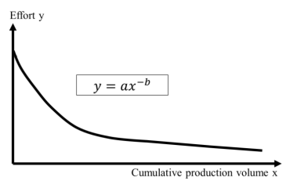
Fig.1 Standard learning curve [12]
The integration of the shipbuilding and nuclear industries has already proven successful in naval shipbuilding. The US Navy, in order to reduce the cost of the Virginia-class nuclear submarine program, developed an SMR to take advantage of shipyard-like construction while also designing the hull to maximise modularisation. In this way, the construction process was moved from a temporary facility to a dedicated factory, facilitating cost-effective factory construction. Once adopted, the build time for the first-of-a-kind was reduced by 29%, and the cost per hull was reduced by 17% [10][11]. Consequently, the improvements to build time and construction cost have facilitated the benefits of serial production, with the cost of the most recent vessel a further eight months ahead of schedule and $90 million under budget. It must also be noted that this example is related to a naval vessel, where cost constraints are less stringent than for commercial applications.

Floating Nuclear Power Plants
Floating Nuclear Power Plants, FNPPs, have the potential to be one of the main solutions for deploying additional emission-free power generation capacity quickly, economically, and at a large scale. Much of the global power demand is situated close to the coast, where FNPPs can be easily deployed.
FNPPs are an ideal solution for providing power to coastal locations where energy availability issues or the construction of land-based nuclear power plants would not be feasible. FNPPs are not only suited for power generation for remote islands, coastal settlements, and industrial sites but also, for instance, for the powering of offshore facilities that are expected to decarbonise. FNPPs could also be deployed in conjunction with offshore wind farms, balancing the power supplied to the onshore grid.
FNPPs should be sited within national waters or within a country’s exclusive economic zone, and relatively close to shore to reduce the costs related to the subsea electric power cables. Different FNPP designs could be considered for different circumstances; for instance, in regions susceptible to tsunamis, FNPPs could be deployed in waters with depths exceeding 100 m in depth to mitigate the associated risk, potentially employing the SPAR Hull configuration seen in Fig 2. The advantage of a SPAR hull with respect to a Ship type hull is the possibility of safe permanent mooring in cyclone conditions, eliminating the issues associated with beam waves, winds, and excessive roll, which are typical in the case of mooring in fixed orientation or in case of rapidly changing waves or wind directions.

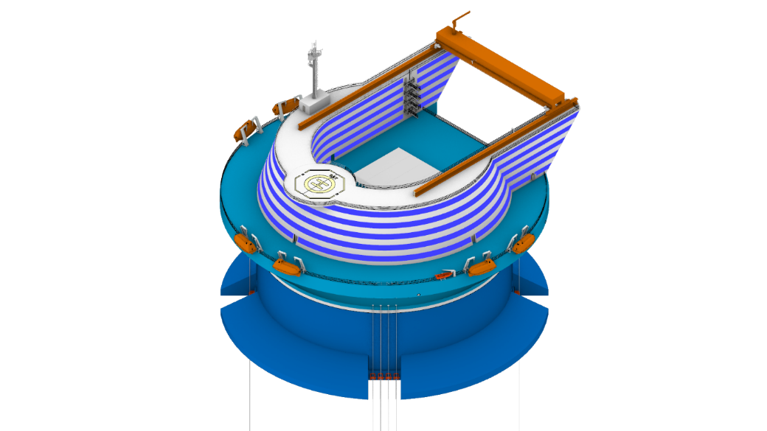 | 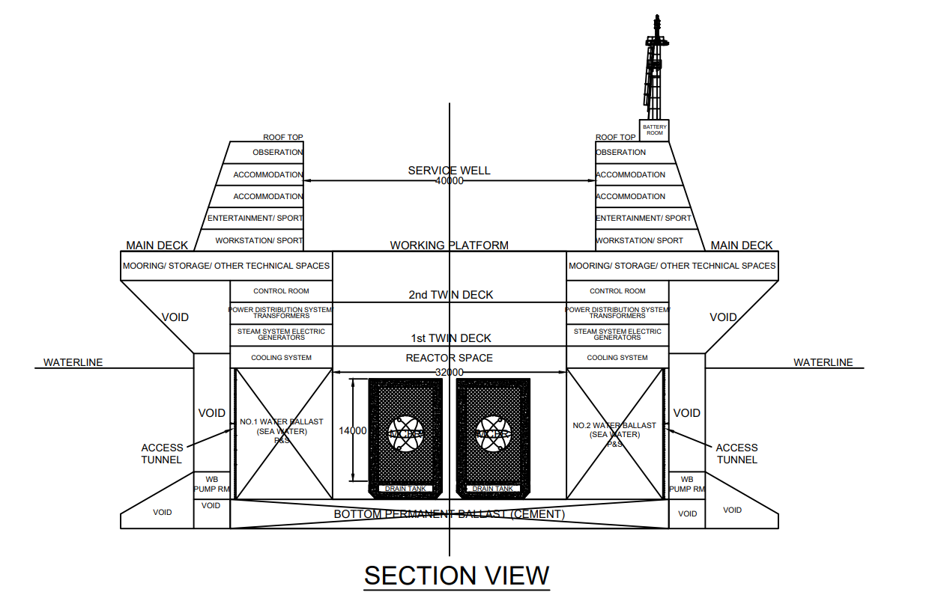
Fig. 2 Core Power Rendering and GA of 1200 MWe FNPP

In other circumstances where geological effects are not an issue, FNPPs could be located directly on the coast behind a breakwater or close to an offshore facility. In this case, a barge design would be more appropriate, such as the example seen in Fig 3. An example use case would include the cogeneration of electricity and heat, as is the case of the ‘Akedemik Lomosnonov’, which currently provides district heating for the town of Pevek in Siberia.[4]

Core Power has investigated different concept designs of FNPPs that are adequate for the installation of medium-sized modular reactors, those with an output of between 300 and 1000 Mwe.[4] In particular, it would be possible to fit up to four medium-sized reactors, depending on their size, either on a SPAR-type floating platform or on a large ship-shaped hull, meaning electricity production capacities of 1.2 GW_{e}.

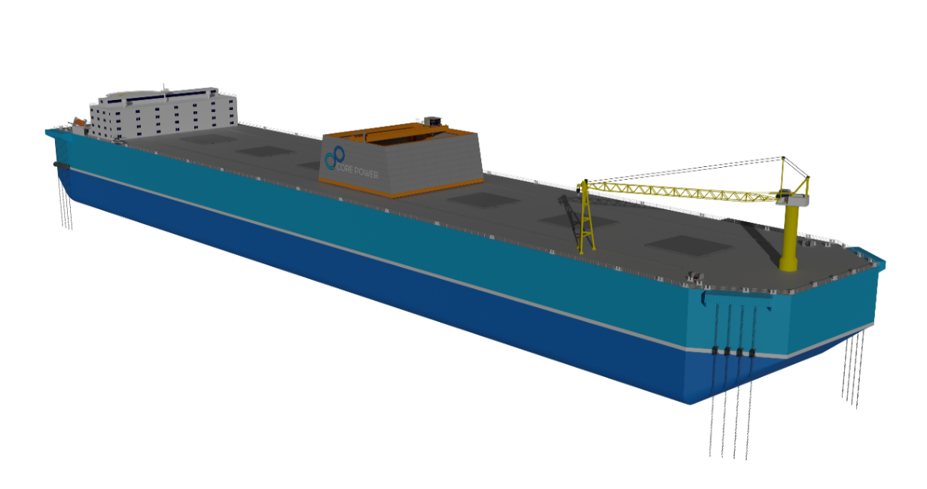
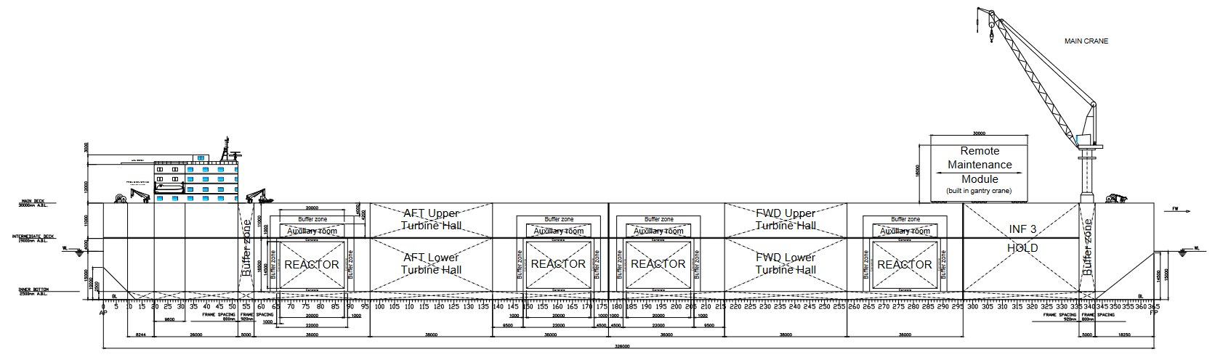
Fig. 3 Core Power Rendering and GA of a 1200 MWe NPG

Desalination Plants
As countries increasingly need to find alternative sources of freshwater for agriculture and domestic use, desalination is rapidly growing, with global water demand expected to rise from its current value of 4,600 billion m3 per year to 6,000 m3 by 2050 [14]. This demand cannot be met from ground or surface water alone, so it will need to be serviced by other means, including increasing levels of desalination.
A possible solution would be to deploy combined floating nuclear plants, designed to produce both electricity and fresh water, alleviating one of the major problems suffered by the desalination industry: the low utilization factors. For instance, the Sydney desalination plants remained on standby between 2012 and 2019, producing no water while still costing approximately $360,000 per day.[15] A combined floating plant would be able to retain economic value by producing clean, reliable electricity for the grid, diversifying the facilities revenue streams, the plant could also be able to prioritize the production of electricity on the basis of the real-time grid demand, while using the water desalination plant as a buffer, maximizing the overall profitability. Also, in this case moving the desalination facility offshore simplifies the civil engineering challenges and one of the major issues associated with desalination: the disposal of the concentrated brine solution, which can have negative effects on the marine environment. By moving offshore, the immediate access to a very large body of water simplifies the environmental and engineering challenges related to the supply of water and the dispersion of the brine. For a floating desalination facility our modelling shows that for a power output of 80 MW_{e,} it would be possible to produce 450,000 m³ per day, enough to supply 170,000 homes.[16]

Production of eFuels
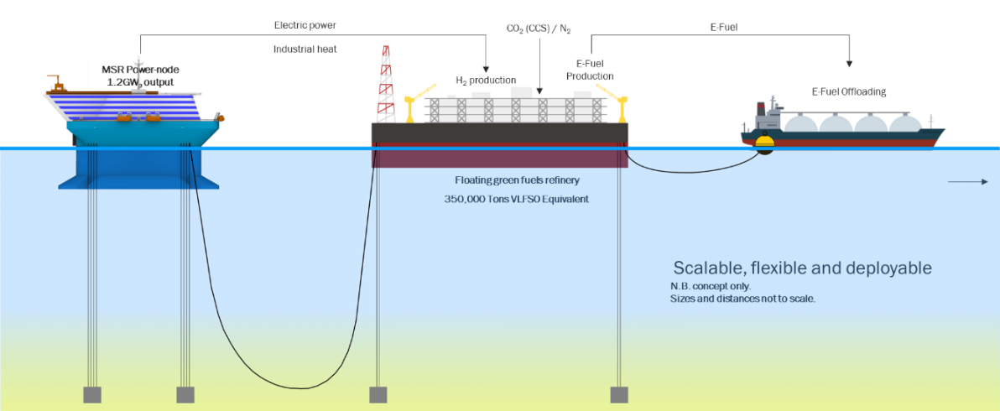
Fig. 4 A floating EFuel Refinery comprising of a 1200 MWe FNPP and a Floating Chemical Plant.
EFuels, such as hydrogen or methanol, offer a plausible solution to decarbonise some of the hardest-to-abate sectors, such as transport. Therefore, significant global importance has already been placed on the production and uptake of these EFuels, and it will be another important driver for global electricity demand, with predictions estimating that by 2050, around 20,000 TWh per year will be required for electro-fuel production alone[17]. In fossil fuels terms, this equates to the replacement of about two billion tonnes of Diesel Oil per year.
A possible solution for the rapid ramp-up of the production of EFuel would be to deploy floating refineries made up by an FNPP providing electric and thermal power to a floating chemical plant. MIT is working with Core Power and Idaho National Laboratory on a Department of Energy funded project to investigate the economic and environmental value of alternative configurations of a floating integrated GW-scale green hydrogen/ammonia production facility powered by an advanced nuclear reactor. The study will investigate the effect different configurations of technology can have on economic performance for a deployment on the Gulf Coast.

Floating Data Centres
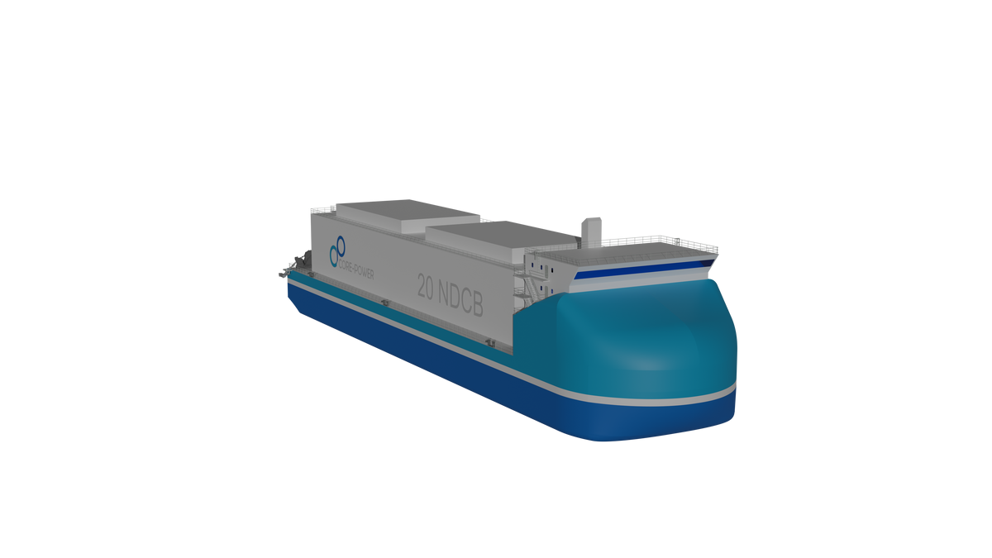
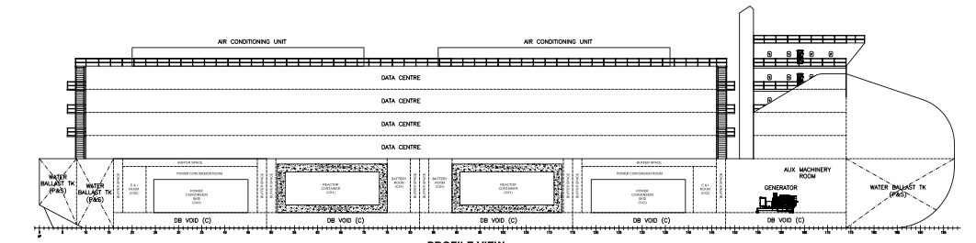
Figure 5. A floating data centre powered by several heat pipe reactors
With the proliferation of data centres, driven by the expanding global digital economy and the potential demands of forthcoming AI applications, the demand for energy from data centres is rapidly increasing. The International Energy Agency predicts that current energy demand from data centres could double by 2026, reaching 2600 TWh.[18] Data centres require large amounts of reliable power to prevent any drop-in service, as well as the ability to dump large amounts of heat into the environment without adverse consequences to plant and animal life. Floating data centres would be able to use the ocean as a heat sink, simplifying the waste heat disposal activities, while floating nuclear is capable of providing the reliable power needed by the server stacks.

Regulations
At present, there are no modern international regulations or standards for FNPPs. While FNPPs have been successfully deployed by the Russian Federation with significant plans for further builds, these have been completed entirely within a single nation and have not required accepted common standards between nation-states. For FNPPs to serve as a viable global solution to the energy challenge, a more comprehensive and internationally recognised set of standards for maritime nuclear power will be required. This work has already begun at the IAEA, which convened its first symposium on FNPPs in 2023. This event led to work beginning on a TECDOC considering the Design Safety and Security Considerations for Floating Nuclear Power Plants involving representatives from the agency, national regulators, and industry participants. The ongoing work considers the applicability of relevant IAEA Safety Standards as well as relevant maritime regulations set out by the IMO.
The IMO carried out regulatory development work in the late 20th century on FNPPs in the context of deploying several nuclear-powered merchant vessels. The most important of these documents is the “The Code of Safety for Nuclear Ships”, known as Regulation A491(XII), which established safety standards for nuclear-powered vessels. However, these rules are unsuitable for modern maritime deployments; they are proscriptive in nature rather than goal-based and only consider the PWR type of reactors. As modern low-pressure reactors present distinct safety cases to PWR reactors, these regulations will require revision to ensure effective application to modern FNPP deployments.
The transport of nuclear material is one area where well-established regulations are already in place. The IAEA’s SSR-6 and IMO’s INF Code both provide comprehensive guidance on this topic. While these regulations do not currently cover the transport of fuelled reactors, work has begun with the International Project on Innovative Nuclear Reactors and Fuel Cycles which completed a study on Transportable Nuclear Power Plants (TNPPs) in 2013. This initiative will require significant effort to implement to allow the transport of fuelled reactors between nation states and therefore regulatory regimes.

Conclusions
The ongoing development of advanced low-pressure modular reactors, such as the MSR, is expected to facilitate their low-cost and efficient factory production. CORE POWER is actively participating in the development of these emerging advanced nuclear technologies and their application in FNPPs. Their integration with shipyard construction could drastically reduce building time and cost, fostering a fundamental change in the speed at which nuclear power can be deployed and widening the range of potential novel applications.
The combination of affordability, scalability, and the intrinsic safety features of these advanced nuclear technologies positions Floating Nuclear Power Plants to play a fundamental role in solving the current energy demand challenges. They have the potential to provide both energy security and decarbonisation, while simultaneously making energy more affordable and abundant.

References
- French and German Yearly Average Electricity Statistics (2023), app.electricitymaps.com/map, accessed 08/03/23
- Lovering et al (2016), Historical construction costs of global nuclear power reactors, Energy Policy, 91:371-382
- The Maritime Executive (2019) Floating nuclear plant sturgis dismantled. https://www.maritime-executive.com/article/floating-nuclear-plant-sturgis-dismantled. Accessed 21 Feb. 2023
- Melchiorre T (2022) The Akademik Lomonosov and the Arctic legal regime: geopolitics versus international law?. Journal
- Meg Dowling et al, Configuration of Commercial Advanced Nuclear Maritime Application, 2023
- Contemporary European Studies. 30:738-749
- Yan B.H et al, 2019, The Technology of Micro Heat Pipe Cooled Reactor: A Review, Annal of Nuclear Energy, vol 135
- NREL, Black & Veatch (2012) Cost and Performance Data for Power Generation Technologies. National Renewable Energy Laboratory, file:///C:/Users/Rory%20Megginson/Downloads/nrel-cost-report.pdf Accessed 10 March 2023
- Song Y, Woo J (2013) New shipyard layout design for the preliminary phase & case study for the green field project.
- Journal of Naval Architecture and Ocean Engineering. 5:132-146
- Stewart, W.R. and Shirvan, K. (2022) ‘Capital Cost Estimation for Advanced Nuclear Power Plants’, Renewable and Sustainable Energy Reviews, 155, p. 111880. doi:10.1016/j.rser.2021.111880.
- Sender J, et al (2021) Integration of learning effects in the design of shipbuilding networks. Procedia CIRP 100 (2021), 103-108.
- Lewis C, et al (2016) Small modular reactors: Can building nuclear power become more cost-effective. National Nuclear Laboratory: Cumbria, UK.
- Boretti A, Rosa L (2019) Reassessing the projections of the world water development report. NPJ Clean Water. 2:15.
- The Daily Telegraph, Desalination plant at Kurnell costing taxpayers $534,246 a day as it sits idle while water levels remain high, Miles Godfrey, 2014
- L. Granwal, Consumption of water per household across Australia in financial year 2020, by state, Statista, 2021
- Rolls Royce (2021) E-fuels powering a climate-neutral future. https://www.rolls-royce.com/media/our-stories/discover/2021/e-fuels-powering-climate-neutral-future.aspx. Accessed 10 Feb. 2023.
- IEA (2024), Electricity Analysis and forecast to 2026.

