3S BY DESIGN APPROACH IN TNPP DEVELOPMENT -
ENABLING DELIVERY OF NUCLEAR ENERGY
TO WHERE IT’S NEEDED

F. PUENTE-ESPEL
Prodigy Clean Energy Ltd.
Montreal, Quebec, Canada
Email: fpespel@prodigy.energy

M. DEVOS
Prodigy Clean Energy Ltd.
Montreal, Quebec, Canada

M. TROJER
Prodigy Clean Energy Ltd.
Montreal, Quebec, Canada

Abstract

Nuclear energy has the potential to substantially help resolve the three biggest energy challenges faced today: mitigating both climate change and energy poverty while bringing greater energy security to where the energy is actually needed. Small Modular Reactors as well as Microreactors extend the end-uses of conventional large nuclear power plants to electric and non-electric applications and present new more versatile deployment scenarios. They are designed to have shorter construction times, lower capital costs, and to serve as the perfect combination for a sustainable power mix supporting renewables as a baseload and/or load following. With SMRs there is an opportunity from the outset to integrate safety, security, and safeguards by design. Some SMRs & MRs offer the possibility of being transported to places where energy is needed, remote places and industrial sites for example. Prodigy Clean Energy is leading development of a SMR technology agnostic architectural approach that includes nuclear oversight and quality assurance models for shipyard fabrication, transport, fuel handling and decommissioning to support sustainable project execution. The paper presents a strategy for successful emergence of marine transportable and rapidly installed nuclear power based on pragmatic and proven technologies, licensable under current regimes. This technology and deployment strategy can be ready to meet commercial needs within the next several years. Several examples are illustrated; for SMR and Microreactor, for several sites, and to replace coastal fossil fired generation.

INTRODUCTION
Energy is crucial for human development and overall prosperity but must also increasingly be sustainable [1]. The ideal energy solution must balance safety, reliability, cleanness, and affordability. In the course of time, the benefits and advantages of nuclear energy have become more apparent; specifically, as a reliable, clean and affordable technology [2]. The goal is to substantially help resolve the three biggest energy challenges faced today: mitigating climate change and energy poverty and bringing greater energy security to where the energy is actually needed.
Classical nuclear power plant projects have been criticized for high costs, project readiness and quality issues and long execution delays. Many issues are a direct result of a site-by-site approach to design and construction which require implementation of project specific organizations, processes and a qualified workforce which adapts to specific circumstances but disperses when the project is completed. This model of project execution is not conducive to knowledge transfer and impedes efficient transformation of lessons learned into technical and project execution refinements. On top of this, there is still insufficient up-front integration of measures for safety, security and safeguarding against proliferation of nuclear substances, in part due to conflicts between what reactor vendors are prepared to furnish in the generic (non-site specific) design activities and what end-users require at each site. In other words, a site-by-site model of project execution tends to put emphasis on site specific measures to meet the requirements rather than having them built into the standard design configuration.
Developers of Small Modular Reactors (SMRs) and Microreactors (MRs) are focused on addressing these circumstances by improving standardization of design features, simultaneously accelerating construction and reducing capital costs through use of modularity and serial manufacturing. There are a variety of sizes and types of power plant designs configurable for different energy products: electric and non-electric commercial applications. This, in turn, presents new ways to deploy and operate nuclear facilities to form the perfect combination for a sustainable power mix, for example, supporting renewables as a baseload and/or load following. Some examples of SMRs and MRs are capable of directly interfacing with large scale energy storage technologies. Increasingly, these new technologies are also taking advantage of the opportunity to integrate not only safety, security, and safeguards by design (3S) into the plant configuration from the outset, but also measures to enable safer and more efficient decommissioning at end of facility life.
One of the most attractive concepts of SMRs & MRs is that smaller sized facilities with compact arrangements enable strategic placement in locations closer to demand centers. These locations are not ideal for larger NPPs and grid expansion to service them is often prohibitively expensive or simply impractical. This may be in more densely occupied areas such as industrial parks or near cities but also in remote areas either poorly serviced or inaccessible by the grid. In most cases, even with modular designs, much of the plant assembly requires significant construction and commissioning work to be carried out at the deployment site, with ample space and facilities required for equipment, workers and assuring security for the project. This means that numerous opportunities still exist to repeat issues discussed earlier which encountered at site-by-site large NPP projects.
Some SMRs and MRs have architectures and inherent characteristics that introduce the possibility of being able to be assembled and even commissioned, to a degree, in a purpose-designed facility designed for replication. A predominantly complete facility, which has been systematically assembled under high quality conditions can then be transported to and deployed at places where energy is needed, but where traditional construction is impractical and less economically feasible.

FILLING ENERGY SUPPLY GAPS BY EXTENDING NUCLEAR POWER ACCESSIBILITY INTO CHALLENGING REGIONS: FLATTENING OUT GEOGRAPHICAL BARRIERS TO ENERGY ACCESS
Coastal areas are historically primary locations for intensive human activities because of access to multiple modes of transport to move bulk goods. For these activities to thrive, they need reliable energy. But a large number of coastal sites and islands are also not suitable for traditional nuclear construction practices:

- Either no local infrastructure present or infrastructure is too costly to make suitable for a land-based facility.
- Land area is scarce, already occupied and/or very expensive to develop. Not to mention the environmental impacts.
- If replacing existing fossil fuel generation, a new nuclear build must not only have a predictable schedule but also be considered within continuity of energy delivery. I.e. minimal downtime between fossil plant shutdown and new plant startup.

For example, in the north of Canada as illustrated in Fig.1 [3, 4], there are many small communities and industry/resource projects that are inaccessible by the Canadian grid network, which was designed to service the densely populated and industrialized south.
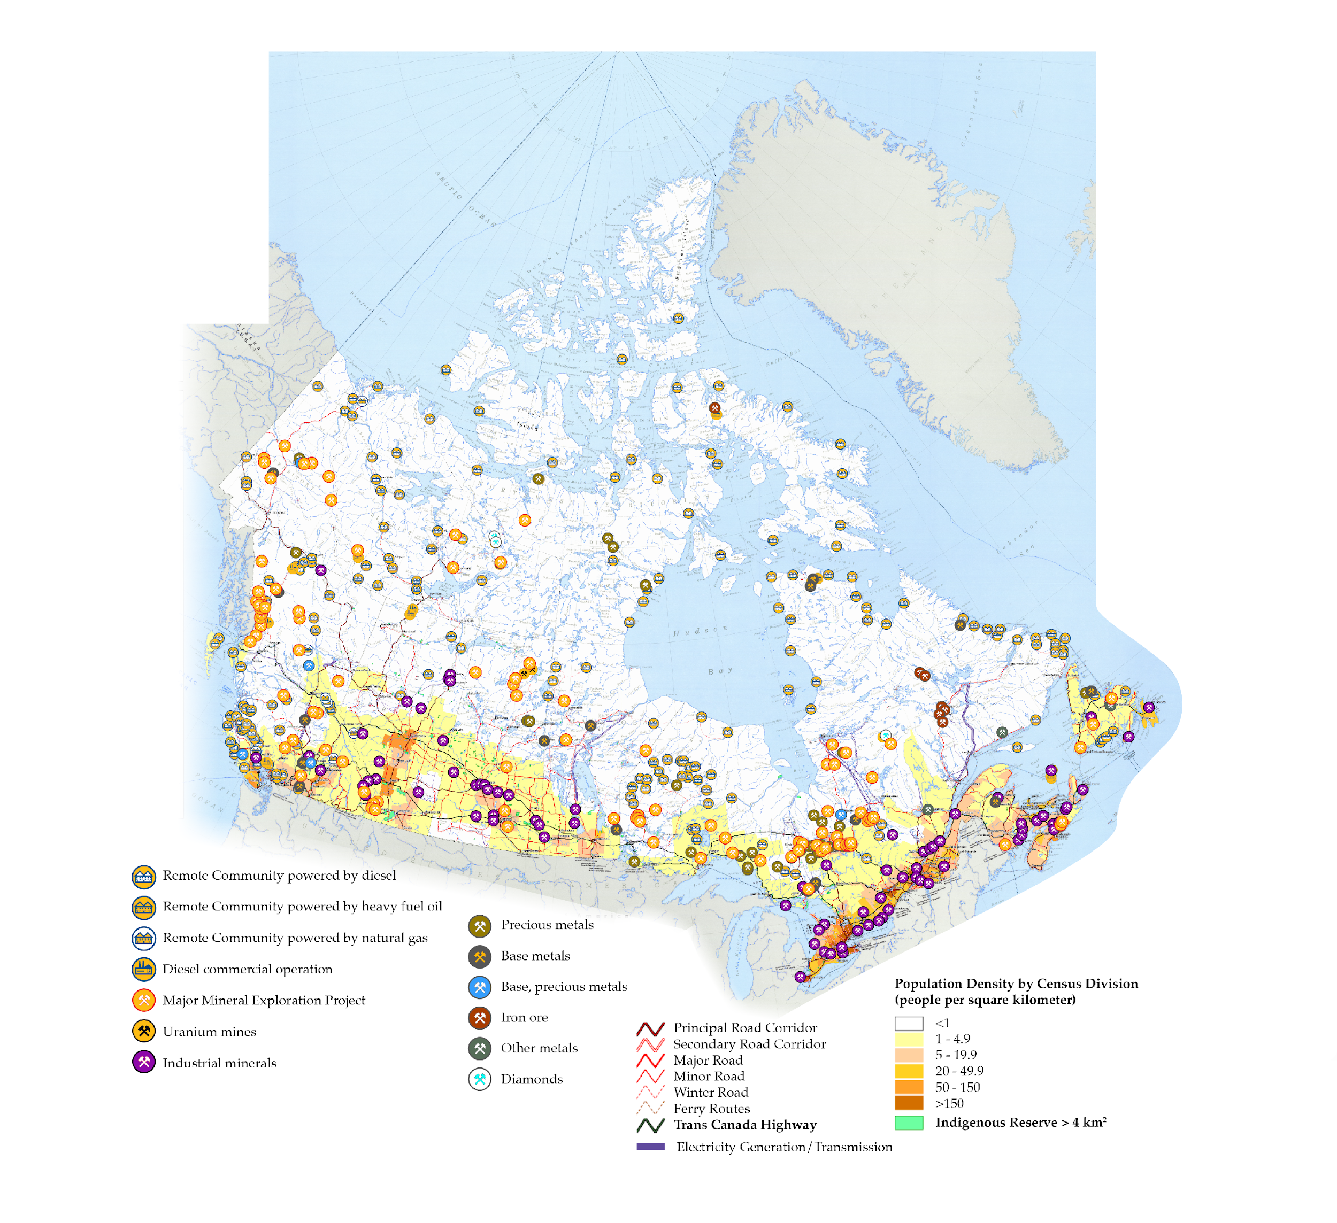
FIG. 1: Powering remote mines, communities and other critical northern infrastructure

Another example, in a more southerly location, is illustrated in Fig. 2 for the island of Puerto Rico [5]. Purple dots indicate fossil fired power plants which range in output from a few megawatts to hundreds [6]. In this specific case, the island is completely dependent on fuel imports and the price volatility that accompanies it. Replacing these fossil fuel power plants with reliable and sustainable solutions on land, including nuclear power, is challenged by a host of issues including but not limited to seismicity, mountainous terrain and density around existing facilities.
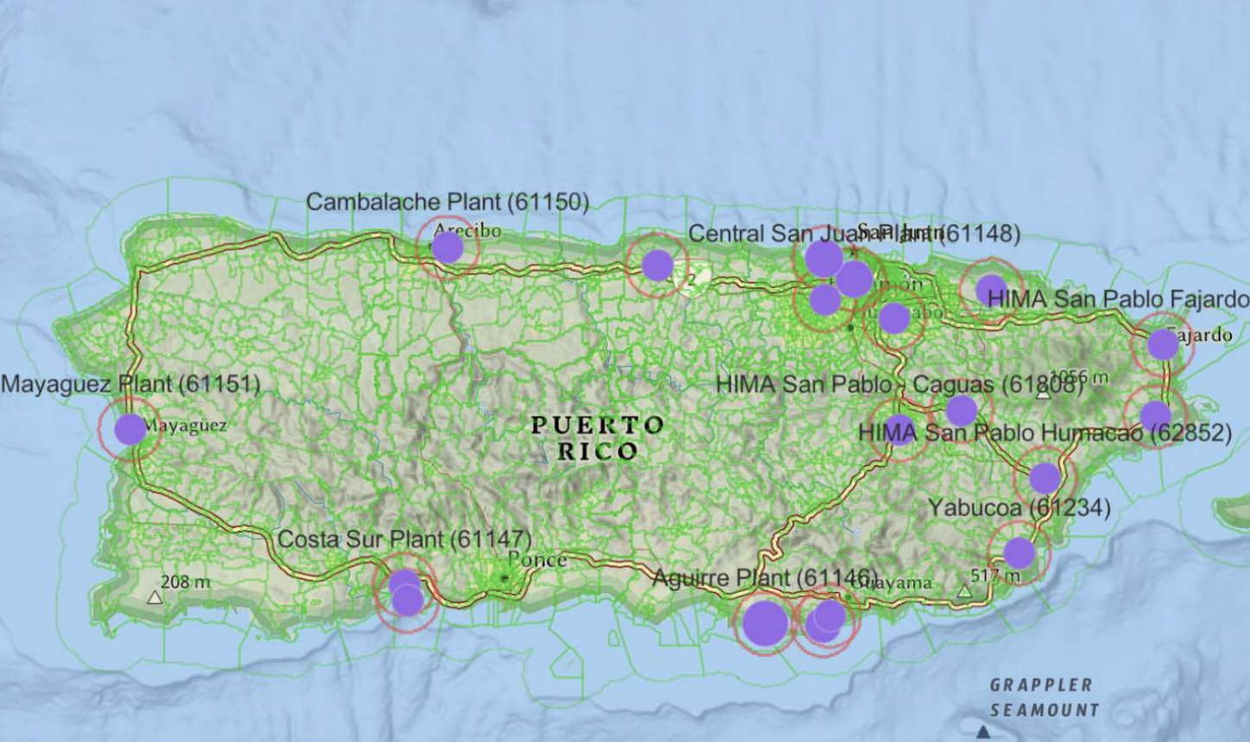

FIG. 2: Fossil fuel power plants in Puerto Rico as of 2023.

In each example, the goal is to present options for appropriately sized, scalable, systematically designed nuclear facility architectures coupled, with a well-supported deployment model that would enable the sustainable deployment of nuclear power solutions to these regions. Increasingly, energy end-users and the organizations that support the planning and delivery of energy are looking at viable options for deploying nuclear power to where it is needed while optimizing predictability of project delivery (i.e. costs, timeliness and high quality). These organizations, as well as all stakeholders who are potentially affected by the project, also want assurances that these facilities will be safe, secure and protect the environment over their full lifecycle.
These types of regions represent a starting point for a large untapped market with near-term needs. Beyond these sites, there is also great potential for offshore applications such as but not limited to mining at sea and, more inspirationally, commercial marine transport. At this time Prodigy has chosen to focus efforts on projects to be sited in shoreside applications.

THE UTILITY OF A TRANSPORTABLE NUCLEAR POWER PLANT (TNPP): REDUCE SITE CONSTRUCTION BY DELIVERING THE PRE-INTEGRATED NUCLEAR FACILITY TO THE END USER
Although there are a number of different definitions being contemplated to address different technology arrangements and how they are used, at its most basic, a TNPP is best understood to be a complete power generation facility (land or marine-based) integrating a nuclear reactor and power conversion system(s), specifically designed to be geographically relocated either as a whole entity, or by using discrete transport modules. These are energy delivery facilities designed to service a location and are different from using a nuclear reactor for motion such as ship propulsion. By energy delivery, the output could be electricity, or heat for use by process systems either already outfitted into the TNPP or already present at the deployment location.
The primary benefits of TNPPs are to reduce construction times, present new & faster deployment models and extend the geographic reach of both grid-scale and off-grid SMR technologies. TNPPs resolve this by constructing as much as possible in a manufacturing/factory facility and then delivering the power plant as a whole entity or in various completed portions to the site for integration and commissioning. In a like manner, when designed appropriately, disposal in mind from design phase even before it is built, i.e. decommissioning by design, decommissioning can be accomplished in an efficient, timely and pre-planned manner, for a rapid return of the site to greenfield status.
A TNPP can be designed to produce energy ranging from a single megawatt to gigawatt scale. The use of modular, factory built and transportable structures that could be installed on land or in a marine environment provides a level of versatility in achieving the goal of accelerating the deployment of SMRs. That is, significantly reducing deployment site construction burden and enabling replication of a completely self-sufficient nuclear generating facility that can be rapidly commissioned and put into service. In addition, a TNPP can be, if appropriately designed, configured to:

- Be competitive: manufacturing the TNPP in a factory setting, in this case a shipyard, and transporting the fully assembled power plant to site will represent a considerable capital cost reduction when compared to traditional on-site construction.
- Customizable to meet specific near term and long-term capacity needs by allowing for addition and removal of generating units.
- Prevent and mitigate adverse environmental impacts: (e.g. minimize site disturbance through more compact site preparation activities).
- Be as safe, secure and robust as a conventionally constructed SMR.
- Better manage both conventional and nuclear wastes.
- Accommodate IAEA verification that safeguards measures are effective.

PRODIGY’S APPROACH TO DEPLOYING TNPPS: FOCUS ON THE END-USERS AND OPERATORS
Prodigy’s TNNPs are not aiming to replace land based SMR/MR designs but rather enable these SMR designs to be more broadly deployable, as variants for operators and end users without significant changes to how they are operated.
Prodigy Clean Energy is implementing an approach that allows for the same techniques to be used to integrate the right type and size of SMR or MR into the right configuration to result in TNPP that meet specific end-user needs. The result is scalable generation using a modular design and construction approach. Either as a singular unit facility or using multiple SMR modules, a TNPP can be configured for an output capacity ranging from less than 10 MWe to as large as 1 GWe. For sites with changing energy demands, the capability exists to plan in advance how to leverage units already at the site or to add new ones.
Prodigy is not a reactor designer, but rather, a designer for the transportable structural elements of a TNPP. In doing this, Prodigy is also:
- Establishing performance and design requirements that must be met by the site-specific infrastructure that supports any TNPP facility’s Defense in Depth (DiD) and day to day operations under varying site conditions;
- Addressing how the TNPP can be safely and securely transported to the site for installation and away from the site to a decommissioning facility.

The TNPP design program embraces the model that the power plant operators who are working with energy end users and planners are best positioned to determine how best to meet their energy delivery requirements. This includes deciding which SMRs/MRs can satisfy those requirements and how best to arrange them for each project. These stakeholders have a major role to make the business function sustainably over the full project lifecycle. Although a completely open-source approach to deploying nuclear power will make standardization and economics ‘messy’, Prodigy sees that middle ground can be achieved by working with these stakeholders to produce standardized TNPP technologies that can be integrated with appropriate SMR configurations to achieve scalable energy outputs and deliver a variety of energy products (electric and non-electric applications). During these discussions, Prodigy will offer perspectives on any benefits and challenges that need to be considered in matching an SMR technology to the TNPP architecture, including those that should be addressed in transporting the facility. For example, the utilization of functional containment provisions in an SMR design allows for a more compact TNPP where the TNPP protects and supports the SMR’s existing barriers to releases rather than acting as a containment building. In a second example, the decision to fuel the reactor at the site versus the factory of origin strongly influences specific design decisions pertaining to safety, security, and safeguards by design.
Once a suitable SMR candidate technology has been identified, Prodigy collaborates with the SMR vendor to integrate the various SMR structures, systems and components (SSC), including if required, energy conversion systems with the various TNPP SSCs necessary for safe and secure operation over the facility lifecycle. The result is a completely integrated SMR TNPP variant that is optimized for Defence in Depth (DiD) and long-term operation in the challenging siting conditions, factory manufacturable, ready for delivery, installation and nuclear commissioning at the deployment site. When a decision is made by the future licensee to proceed with a TNPP facility Project, then Prodigy will establish engineering interfaces with the organizations that will ultimately oversee and execute manufacturing, construction, factory commissioning and deployment to the site.
Prodigy is currently advancing work in two technology development streams for modular, factory built, transportable, and relocatable TNPPs: 1) architectures for smaller off-grid/micro-grid system such as what typically need in small to medium remote sited projects and communities, and 2) architectures for grid scale facilities for coastal energy supply projects in infrastructure constrained areas. Each stream has specific operator and end-user requirements based on how the facility is used. For example, the off-grid facilities may require greater operational self-sufficiency and be able to respond to aggressive load following, whereas grid scale TNPPs have an emphasis on integrating with large end users with multiple energy stream needs. However, the approach to technology development uses similar, if not the same overall principles and approaches.
To support an efficient deployment timeline, examples of critical end-user and operator objectives Prodigy is focusing on are:
- Using Canada as a benchmark because of its close alignment with the IAEA Safety Framework, and to provide a smaller learning curve for Project Stakeholders, Prodigy is working with existing requirements and guidance to the extent practicable and aligning the deployment steps for a TNPP with the traditional steps used in the existing licensing process.
- Minimizing the nature of site preparation activities and land area needed to complete site preparation, construction and facility installation - this translates into reduced environmental impact, and lower cost. The timeline for site preparation could be shortened by half.
- Improving predictability and efficiency of construction by leveraging centralized high-quality manufacturing - factory fabrication - specially shipyard construction - together with transportation, installation on site and cold commissioning could be performed between 18 and 24 months. Quality assurance, cost and schedule is repeatable and improvable for Nth-Of-A-Kind (NOAK).
- Improving predictability and efficiency of commissioning, recognizing that issues that are discovered at the deployment site will be much more costly to resolve than if they are done as the TNPP is being outfitted at the factory. Here, the intention is to have the TNPP better prepared for nuclear commissioning when it arrives on site. This allows for a faster transition to commercial operation.

With the above in mind and considering the same site conditions, Prodigy’s TNPP could be deployed within a 4-year shorter timeline than a SMR constructed on site.

Prodigy Microreactor Power Station
Fig. 3 depicts a microreactor facility with a TNPP structure and site-based infrastructure that work together as an integrated system to address 3S objectives. The TNPP is not a barge; rather, it is a structure that is dry carried to site and fixed to place. Examples of power outputs, depending on the SMR technology, range from between 1 and 20 MWe, per module. This type of structure can be configured for either land-based placement or in shore coastal as well as river-sited marine environments. The Microreactor Power Station TNPP will support powering remote locations that depend on fossil fuels, primarily diesel, that are off-grid. The TNPP is removable from site for decommissioning.

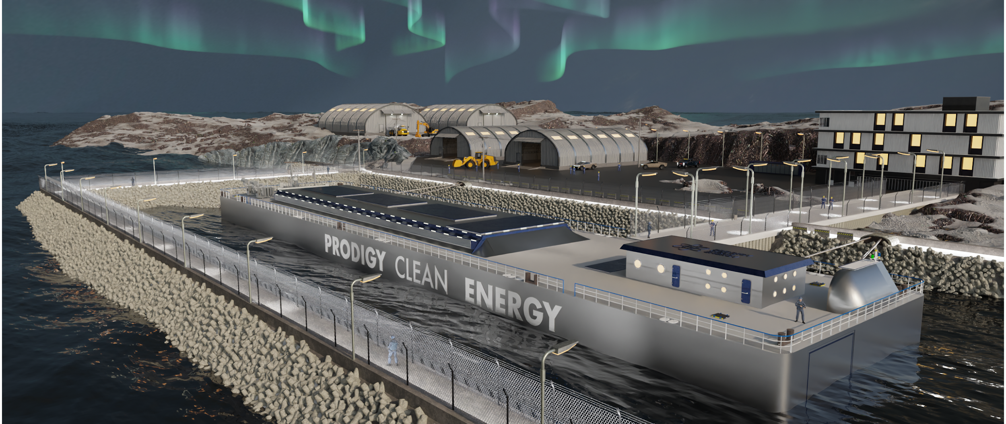

FIG. 3: Prodigy Microreactor Power Station

Prodigy SMR Marine Power Station
Fig. 4 depicts a grid-scale facility with TNPP structure and site-based infrastructure configured using the same principles as the Micro-reactor station. Similarly, the TNPP can be established as one or more structures dry-carried to the site in fixed to place. Examples of power outputs, depending on the SMR technology, range from between 20 MWe and ~100 MWe, per module. A structure could also be fashioned around larger units on an individual unit basis. In this case, the arrangement would be purely marine deployed and is suited for deployment at near-shore coastal locations in cases where either land is scarce, there is little or no infrastructure, or the area is already occupied and/or very expensive to develop. When installed on site, the TNPP will be equivalent to a land based SMR and able to fulfill existing regulatory requirements. In this instance, all power plant systems and components will be located on marine structures, but variants can be produced to connect a pure nuclear heat source to land-based systems. The TNPP is deployed within a protected harbor, avoiding complex and expensive on-site construction practices.
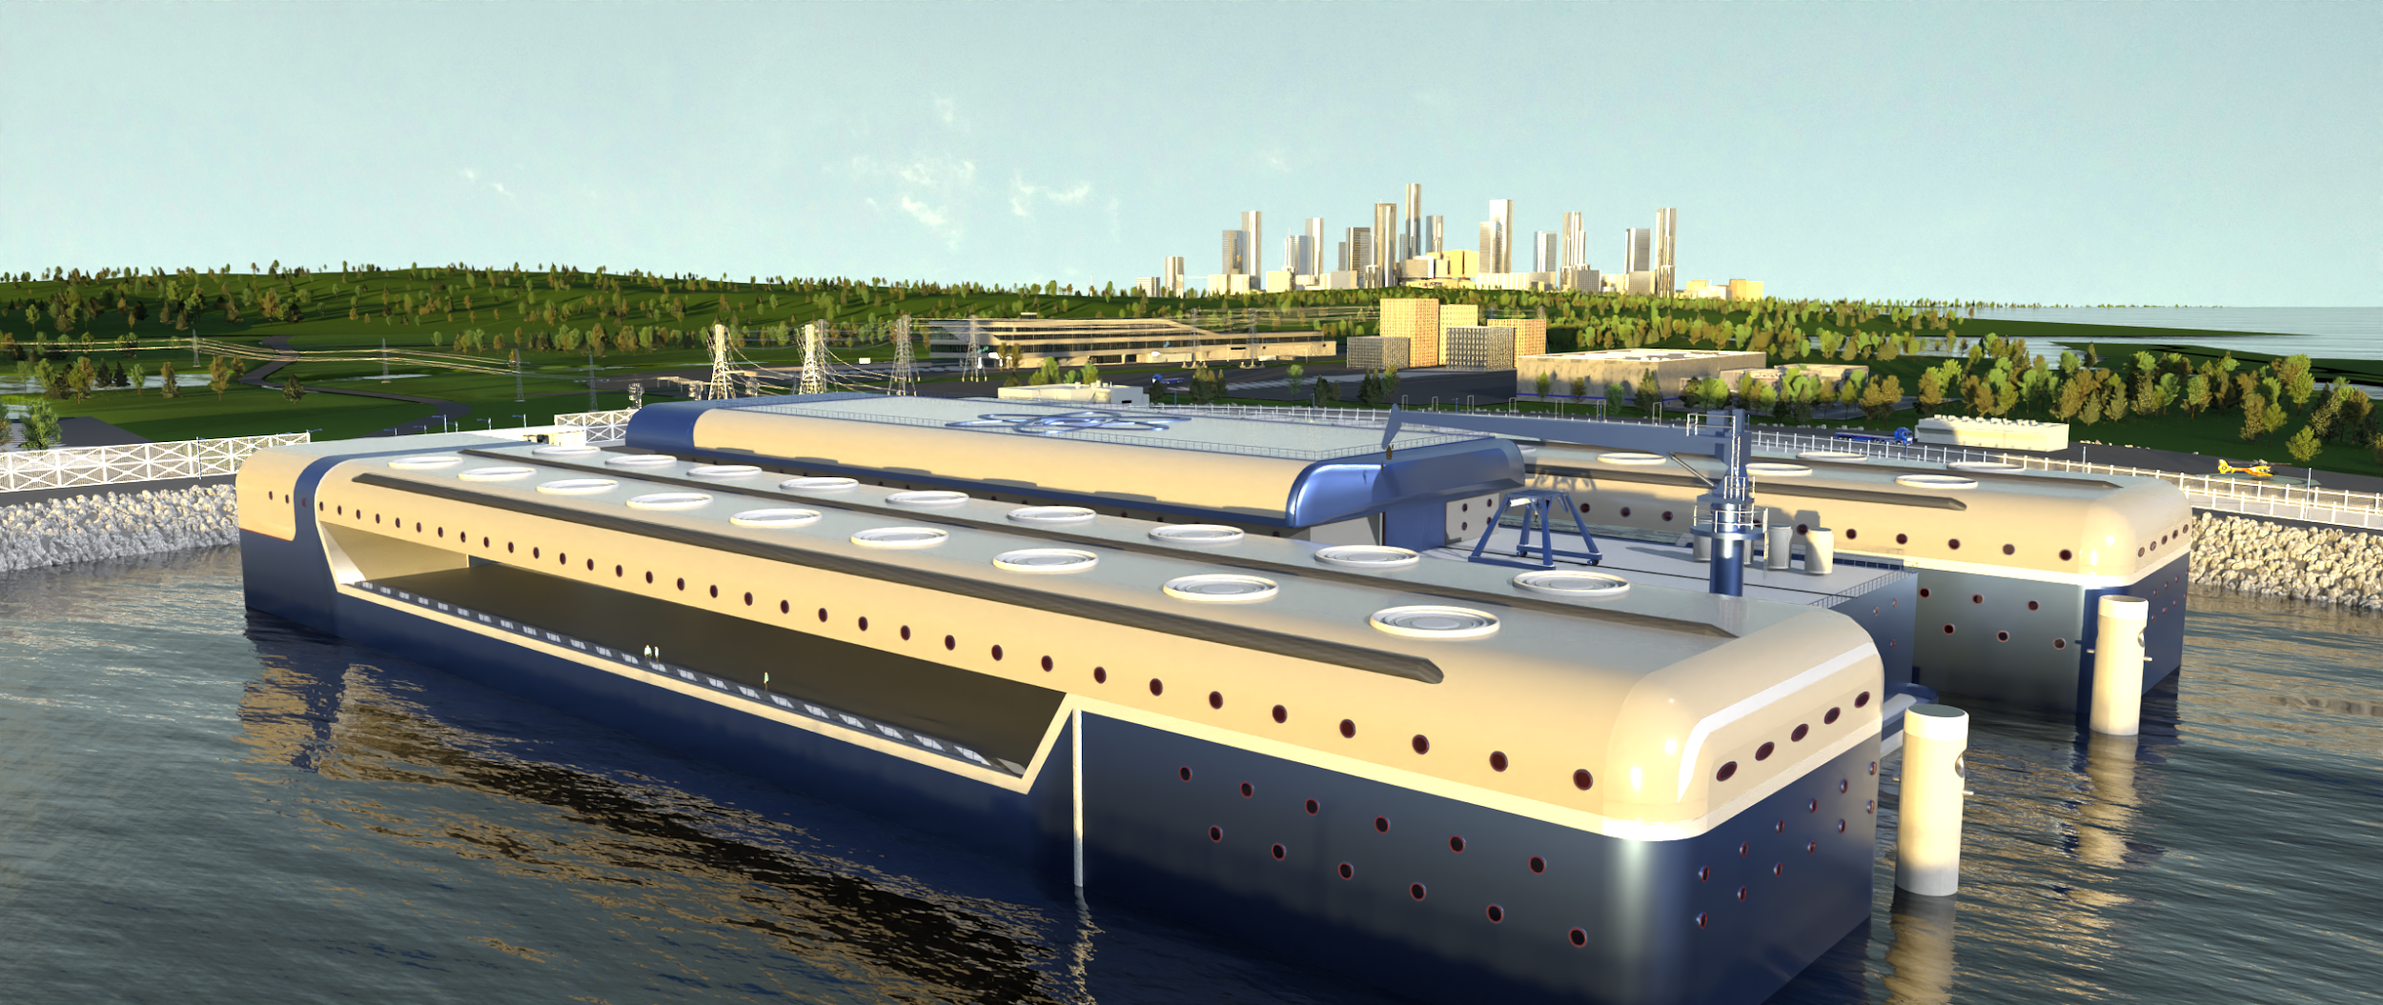

FIG. 4: Prodigy SMR Marine Power Station

IMPLEMENTING 3S BY DESIGN, IN PRACTICE
As part of the overall approach to effectively serve operators and end-users in the conditions presented during transport and at the deployment site, Prodigy is embracing integration of 3S into its standard concept and implementing nuclear oversight and quality assurance models for shipyard fabrication, transport, fuel handling and decommissioning to support sustainable project execution. Although there is an incremental cost of implementing 3S early in the design process, the resulting improvements to the design and how it performs over its lifecycle should yield economic benefits to the owner and operator in terms of lower operating, maintenance and decommissioning costs. This in turn provides a measure of reassurance that the plant will perform reliably, both technically and economically, over its expected lifespan. Thus, a TNPP that is safe, robust, economical and ready for near-term implementation will be the result of the integration of SMR configurations with mature technologies and practices from the nuclear, maritime and transport sectors. The ultimate goal is to enable high quality but also mass-customizable TNPP facility variants.
Prodigy has developed TNPP design objectives and requirements which include implementing 3S using a systems-engineering approach that looks at the entire lifecycle of a TNPP. Doing this in an integrated fashion has been challenging because very little guidance exists in this area and what does exist is not reflected in significant detail in regulatory frameworks. Thus, what is considered to be acceptable practice from one country to the next is not clear. In December 2023, the SMR Regulators’ Forum’s Working Group on Design and Safety Analysis published a Phase 3 Report [7, 8] that proves a series of Common Positions, perspectives and enabling tools that can inform an integrated approach to 3S by design. The information from these common positions is being reflected into Prodigy’s design requirements and processes in order to show that design and verification activities are systematically carried out to demonstrate effective performance of the design.

For the TNPP itself, a number of broad objectives and requirements are being factored in ongoing design work:

- Enhance resilience to external events by considering a broad range of siting conditions in the generic design. Introduce features that protect the SMR systems important to DiD. This includes more self-sufficiency in responding and longer coping periods where offsite response may be delayed.
- Use modular design features to allow for local adaptations as needed.
- Integrate SMR Safety by design features with the TNPP configuration in a supportive manner and confirm they work well together. This means building on inherent safety characteristics and passive features (within fuels, coolants, systems configurations, and operating conditions), decreasing the dependence on human intervention and minimizing the risk of accidents [9].
- Work with the operator and SMR vendor early to plan placement of safeguards by design features in the TNPP. This addresses prioritization of international safeguards by design to enable IAEA verification [10]. It is relevant to all phases of the nuclear fuel cycle. For example, use of advanced technologies focused on unattended monitoring systems and remote data transmission. This represents an initial cost increase that translates into important efficiencies throughout the life cycle of the facilities.
- Build security and robustness features into the TNPP structures systems and components such that they present multiple effective barriers but also do not adversely impact on operations and maintenance.
- Anticipate special outage and maintenance conditions in how features are designed and integrated with the SMR(s)

For the conduct of manufacturing, integration, commissioning, and transport, 3S by design will be implemented into the associated processes, organization of work by function and clearances and sequencing of activities. This is a complex undertaking that will require cooperation between the supply chain partners. Figure 5 illustrates a simplified two-stage approach. Transitioning from Stage 1 to Stage 2 and beyond uses a graded approach to introduce progressively more rigid control measures on, for example, how work is done and who has access to information. This particularly important when leveraging a global supply chain:
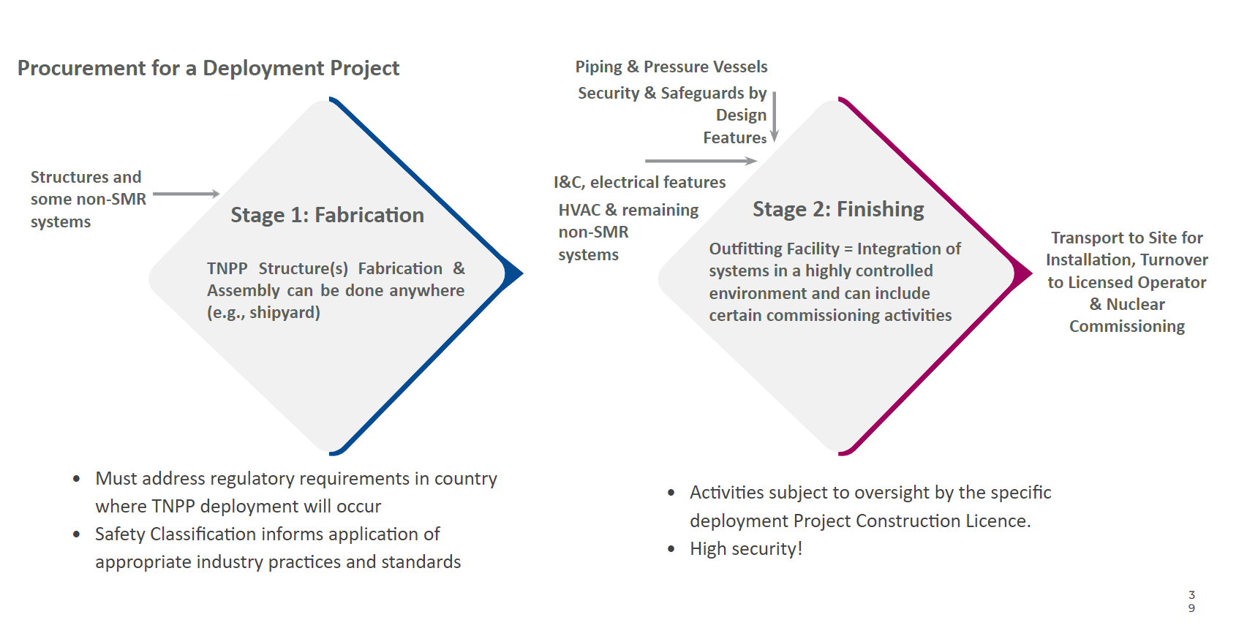
FIG. 5: Staged Manufacturing, Construction (incl. cold commissioning) and Deployment
Areas where implementing integrated 3S by design, in practice, for TNPPs are particularly challenging are very similar to those faced by conventional nuclear power plants and SMRs, such as:

- Doing this makes logical sense, is being encouraged by the IAEA, regulators and, in principle, is supported by the industry at large, but is not established as a requirement in regulatory frameworks with accompanying guidance on what benchmarks need to be met to judge results as acceptable,
- Differences in the requirements from county to another mean that acceptable means for safety, security and safeguards may differ,
- In a highly competitive cost environment, there is an ongoing lack of consensus about who should pay for this up-front development work when the economic benefits are not yet fully understood: the vendors in the supply chain, or the future facility owners and operators.
This becomes a broader concern when technologies such as TNPPs are being designed for international deployment. Ultimately, these implementation challenges make ‘doing the right thing’ a matter of taking leadership where there is enormous competition for the first few to market.

CONCLUSIONS
A TNPP has, if well-designed to suit what it needed for, tremendous potential to extend the deployment of a subset of appropriately configured SMRs into water accessible areas where the circumstances are not suitable or economically feasible for land-based construction. But the key to delivering TNPPs that Operators can operate safely, securely, reliably and in an economically viable manner is responding to what the Operators need to address the requirements of the energy end-users. To Prodigy Clean Energy, this means taking a more SMR technology-neutral approach, but developing practices and technologies that can be used with the right types of SMRs to be standardized but, to the extent practicable, as mass customizable facility concepts. This approach is being applied to two technology development streams for modular, factory built, transportable, and relocatable TNPPs: 1) architectures for smaller off-grid/micro-grid systems, and 2) architectures for grid scale facilities for coastal energy supply projects.
In addition to extending the ‘deployability’ of SMRs, Prodigy is, as part of its development and deployment objectives targeting cost and timeline reductions while assuring that safety, security, environmental protection and safeguards meets the rigorous expectations of regulators, operators and the public. This is being done by implementing ways to reduce the extent of site preparation, transfer a large number of construction and commissioning activities back into a controlled factory environment and have the TNPP better prepared for nuclear commissioning when it arrives on site. This allows for a faster transition to commercial operation and can reduce deployment time by years when compared to conventional construction under similar circumstances. There are discussions taking place around the world to explore alternative ways to licence TNPP Projects with a goal to achieve greater efficiencies and shorter timelines; however, these changes will take time and there is a need to get the first Projects deployed to demonstrate the significant benefits that TNPP facilities can bring. As a result, Prodigy remains focused on using existing modern licensing processes, such as in Canada [11], to deploy the first few of a kind of facilities.
A TNPP, in order to achieve both a degree of standardization for serial manufacturing but also be broadly transportable and deployable at a variety of sites needs to balance economics and the degree of built-in resilience. This can be achieved through, for example:

- Up front design requirements that are based on a series of bounding conditions and natural and human induced events, malicious acts.
- Supporting and protecting the proven existing SMR safety, security and safeguards provisions to provide additional robustness and grace time for on-site and offsite response.
- Use of proven design, manufacturing and operational practices with experience in these environments.
- Use of modular add-ons for the TNPP to adapt from one site to the next.
- Balancing how the site-based infrastructure complements the TNPP features under changeable external conditions.

Manufacturing, integration and commissioning in an enhanced shipyard environment requires merging proven practices of shipbuilding with the supply chain management and controls of a nuclear construction project. Doing this involves the methodical application of a graded approach to ensure safety, security and safeguards are appropriately designed and applied for work being done in the factory production sequence.
The above illustrates that integrating 3S by design affects both the design and production of all of the integrated portions of a TNPP facility and must be considered from the beginning of development of processes and technologies.
Proactively and effectively implementing 3S by design for SMRS as well as an integrated TNPP facility requires leadership, cooperation between supply chain partners and instituting requirements and guidance into the management system governing all activities from the conceptualization of the design to its deployment. The 3S approach has significant overall benefit but requires additional effort and, most likely, will incur some additional costs to be recovered across a fleet. But these costs are well justified when considering the added efficiency gains. E.g. 3S can help support transport-related security and safeguards.
However, some aspects of 3S by design and how they can be effectively integrated are still under development and have not fully achieved international regulatory consensus. The reality is that taking 3S by design might at first represent an extra elaborate task, but a comprehensive systems approach will focus on optimum efficiency and effectiveness.
There is not yet international consensus on frameworks for implementing and judging effectiveness of 3S by design results, but the SMR Regulators’ Forum and the IAEA are commended for exercising leadership to advance the discussion and promote the adoption of a 3S by design approach.
The IAEA should continue to reflect and actively promote on how TNPPs can be used as viable tools to extend nuclear power to where it is needed, and that the potential added cost of ‘building-in more up front’ rather than ‘adding-to after the fact’ builds further confidence in modern nuclear power technologies and enables gains such as a) faster deployment, b) improved overall economics c) efficient fulfillment of requirements and achievement of a license to operate, d) more attractive and sustainable projects that can be replicated internationally. In addition, work should continue to develop and promote 3S by design requirements and guidance in IAEA safety standards such that countries can adopt them into regulatory frameworks. Doing this can further support enhancement of the IAEA Milestones Approach & the IAEA INPRO Methodology application to SMRs and TNPPs, g) enhance compliance with legal and regulatory frameworks, etc.
The nuclear industry, shipbuilding industry and the transport sector also have a role to play in working together to promote the use of integrated 3S by design as modern practice, and to ensure it is carried out systematically through development and use of industry standards with an international focus.
In addition, all SMR and TNPP stakeholders will need to find ways to collaborate to incentivize the investment community to support achievement of the long-term benefits of proactive design for 3S earlier in the design process. For developers this will create better conditions early on to put the right expertise in place under efficient processes.

References

- International Energy Agency (IEA), Energy Systems: Electricity, https://www.iea.org/energy-system/electricity [note: last visited June 12 2024].
- UNECE, “The Role of Nuclear Energy in Sustainable Development - Entry Pathways”, 2021.
- Canadian Small Modular Reactor Roadmap Steering Committee. “A Call to Action: A Canadian Roadmap for Small Modular Reactors”. Ottawa, Ontario, Canada, (2018).
- DEVOS, M., TROJER, M., “Transportable Nuclear Power Plants (TNPPs) to replace coastal fossil fired energy transition”, 42nd Annual Conference of the Canadian Nuclear Society and 47th Annual CNS/CNA Student Conference, Saint John, NB, Canada 4-7 June, 2023.
- U.S. Energy Information Administration (EIA), Puerto Rico Territory Profile and Energy Estimates. https://www.eia.gov/state/analysis.php?sid=RQ [note: last visited June 10 2024].
- DEVOS, M., “Use of bounding site information to inform development of transportable nuclear power plants (TNPPs)”, Generation 4 and Small reactors Conference (G4SR4), Toronto, Canada, 3-6 October 2022.
- SMR Regulators’ Forum, Working Group on Design and Safety Analysis, Phase 3 Report, “Safety, Security and Safeguards from a Regulatory Perspective: An Integrated Approach”, December 2023.
- SMR Regulators’ Forum, “Webinar: WG2 Design and Safety Analysis (DSA)”, May 3 2024.
- International Atomic Energy Agency (IAEA), Safety-By-Design, https://www.iaea.org/bulletin/safety-by-design [note: last visited June 12 2024].
- International Atomic Energy Agency (IAEA), Safeguards-By-Design https://www.iaea.org/topics/assistance-for-states/safeguards-by-design [note: last visited June 12 2024].
- Canadian Nuclear Safety Commission, Government of Canada, Web Page: Nuclear Power Plants, https://www.cnsc-ccsn.gc.ca/eng/reactors/power-plants/ , [note: last revised 2024-03-15].

The model includes long term support by the technology developer states and addresses key requirements such as those pertaining to the IAEA Fundamental Safety Principles.
Mass customization allows a customer to design certain made-to-order features of a product while still keeping costs closer to that of mass-produced products. In some cases, the components of the product are modular. This flexibility allows the client to mix and match options to create a semi-custom final product.
For the first units in a fleet, this is a ‘path of least resistance’ approach recognizing that improvements to the licensing process will emerge from lessons learned.

