radiation Shielding System and Arrangement of Nuclear System for Maritime SMR

Jinho Kim

HD Korea Shipbuilding & Offshore Engineering

Seongnam-Si, Republic of Korea

Email: jinho.kim1@hd.com

Dongbin Park, Jekyoung Lee, Byeonghyeon Min, Taewoo Kim, Jeonghyeon Lee, Yeobum Youn, Byeongju Kim, Sangmin Park and Sungkon Han†

HD Korea Shipbuilding & Offshore Engineering

Seongnam-Si, Republic of Korea

†Email: sungkon.han@hd.com

**Abstract**

Nuclear Propulsion Ships (NPS) as a maritime application of Small Modular Reactor (SMR) has been emerging as a game changer in the shipbuilding and offshore industry. Success of the maritime SMR development highly relies on the shielding systems, which are to be designed to accommodate constraints for maritime applications. In the development the land based concrete shielding system needs to be replaced with a viable alternative to be installed inside the vessels, which secure crews a safe working environment. In addition to the maritime radiation shielding system, it is crucial in the marine application to efficiently arrange complex nuclear reactor systems including the primary and secondary systems within the limited space. A new operation philosophy needs to be developed to overcome such space limits. The present paper addresses how the land based nuclear power plants (NPP) system can be designed and arranged inside a marine vessel.

The present paper suggests a maritime radiation shielding system based on the arrangement of nuclear reactor systems that complies with annual radiation exposure limits. The design of the subject system primarily focuses on replacement of the concrete structures of land based nuclear reactors within the limited space of NPS and floating NPP, with effective shielding against gamma rays and neutrons.

## INTRODUCTION

International Maritime Organization (IMO) sets a target for the international shipping sector to achieve net-zero greenhouse gas (GHG) emissions by around 2050 [1]. If left unchecked, the IMO has indicated that shipping emissions could increase from 2012 levels between 50% and 250% by 2050. IMO has declared a goal of halving greenhouse gas emissions by 2050, and any future revisions to this goal are expected to impose stricter requirements. Maritime industry can address these goals by increasing fuel efficiency, switching to low-carbon alternative fuels such as liquefied natural gas (LNG), methanol/ethanol, biofuels, ammonia, or hydrogen. However, maritime SMR technology also can be the strong candidate of key solution for future decarbonisation alternative power problems [2]. Additionally, it is important to develop the maritime radiation shielding system that can shield from gamma rays and neutrons for the protection of the marine environment and crew in maritime SMR. In addition, the efficient arrangement of this shielding system, primary system and secondary systems in a limited space is essential for the marine application of SMR. In this paper, we developed the structure of the maritime nuclear shielding system and arrangement of nuclear-related systems in the engine room of NPS.

Currently, land-based NPP in operation applied two safety design concepts, one is defence in depth, and the other one is Multiple Protection. Also, Maritime radiation shielding system should apply both of these concepts.

Defence in depth is an approach to designing and operating nuclear facilities that prevents and mitigates accidents that release radiation or hazardous materials. The key is creating multiple independent and redundant layers of defence to compensate for potential human and mechanical failures so that no single layer, no matter how robust, is exclusively relied upon. Defence in depth includes the use of access controls, physical barriers, redundant and diverse key safety functions, and emergency response measures. Also, the concept of Multiple Protection and accident prevention systems (control rods, coolant/temperature sensing devices) are included [3].

Multiple protection is the core of the defence in depth concept, which is to prevent leakage of nuclear fuel, other radioactive substances, and radiation in NPP, and consists of a total of five barriers as below [4].

- First barrier (fuel pellet): Primary shielding of most of the radioactive materials produced by nuclear fuel and fission.

- Second barrier (fuel cladding): It serves to shield a small amount of gas and radioactive materials leaked from the fuel pellet and uses a zirconium alloy that is resistant to heat/radiation/corrosion.

- Third barrier (reactor vessel): It is a reactor vessel composed of 25 cm thick steel based on a pressurized light water reactor, blocks external leakage of radiation from the fuel cover pipe, uses SA 508 and SA 533 based on Pressurized Water Reactors (PWR), and uses SS 304 and SS 316H based on high temperature reactors.

- Fourth barrier (inner wall of reactor containment container): It consists of 6 cm thick steel, shielding radioactive materials leaked inside the containment container in case of a serious accident. SS 308 and SS 309 are used for several lower layers that may come into contact with water, and economical materials are used for the upper layer.

- Fifth barrier (outer wall of reactor containment vessel): 120 cm thick concrete outer wall finally acts as a shield, which is designed to prevent impact outside the reactor.

Currently, there is no clearly disclosed or recognized system for the maritime radiation shielding system. However, since SMR is applied irrespective of land/sea, it seems that it will be applied in the same configuration as NPP from the first to the third barriers. However, it is essential to replace the fourth and fifth barriers, which occupy a large volume, for efficient arrangement in the limited space of ships or floating plants. Therefore, in this paper, the materials and structure of maritime radiation shielding system is suggested that considering gamma rays and neutrons of reactors. In addition, this maritime radiation shielding system should meet the regulation based on annual radiation exposure doses to protect crews in ships or floating plants.

## maritime radiation shielding system

There are various types of radiation such as alpha rays, beta rays, gamma rays, and neutrons. However, in maritime radiation shielding system, the most critical radiation types that must be carefully and thoroughly shielded against are thought to be gamma rays and neutrons, which are electromagnetic waves and electrically neutral particles, respectively. Gamma rays have a very high penetration ability because they travel at the speed of light, and neutrons can penetrate matters without electrical interactions, even at low energies [5].

In this chapter, the materials and structures for the maritime radiation shielding system were suggested, considering the regulation of annual radiation exposure doses.

### Consideration for Regulation of Annual Radiation Exposure Doses (Permissible Radiation Exposure Limits)

The dose limit refers to the sum of external and internal exposure doses, representing the maximum amount of radiation considered harmless to the human body. According to the recommendations by the International Commission on Radiological Protection (ICRP) in 1977, the dose limit for employees at NPP or hospitals is set at 5 rem per year (with 1 Sv equating to 100 rem, an older unit of radiation measurement) [6]. In exceptional circumstances, exposure up to 10 rem per day is permissible. For the general public, the annual dose limit is 5 mSv for whole-body exposure, which can be increased to 250 mSv in unavoidable situations such as accident recovery or life-saving operations, with the individual's consent. It is important to note that the dose limits for radiation workers do not represent a strict boundary between safety and danger. Exceeding the dose limit may increase health risks, but it does not automatically imply adverse effects on the body. The regulation of annual radiation exposure dose limits recommended by the ICRP are summarized in Table 1.

TABLE 1. REGULATION OF ANNUAL RADIATION EXPOSURE DOSES

|  |  |  |  |  |
| --- | --- | --- | --- | --- |
| No. | Category | Annual Whole-Body Dose Limit | Dose Limits by Body Tissue | |
| Lens | Hands, Legs, Skin |
| 1 | Radiation Workers* | 100 mSv over 5 years (no more than 50 mSv annually, average 20 mSv annually) | 150 mSv annually | 500 mSv annually |
| 2 | Occasional Visitors, Transport Workers, and individuals under 18 years recognized by the Nuclear Safety and Security Commission | 6 mSv annually | 15 mSv annually | 50 mSv annually |
| 3 | All other individuals | 1 mSv annually | 15 mSv annually | 50 mSv annually |

* Radiation Workers: The term "radiation workers," as referred to in the context of annual radiation exposure dose limits, denotes individuals engaged in operations, use, maintenance, or related activities at nuclear facilities, as well as those involved in the usage, handling, storage, treatment, disposal, and transportation of radioactive materials. These individuals are either exposed to radiation or at risk of exposure. Radiation workers must strictly adhere to the entry requirements for radiation-controlled areas (including wearing personal dosimeters) and must complete basic training, on-the-job training, and health examinations to be appointed. The crews in NPS are also considered radiation workers, as they have access to the reactor and related systems within the NPS [7].

The regulation of annual radiation exposure dose limits in Table 1 will serve as a strong regulatory basis for designing the maritime radiation shielding system. This regulation will be used to calculate the thickness of the shielding barriers and will also be utilized in the subsequent measurement and review of the overall radiation dose of NPS.

### Materials for Gamma-ray and Neutron Shielding

In the case of the selection radiation shielding materials, rather than choosing materials solely based on superior shielding performance without specific criteria, the materials listed in ASME Boiler & Pressure Vessel Code (BPVC) Section 2 Part D and Section 3 Division 5 [8] were reviewed, which are applicable for PWR and high-temperature reactors (Fourth Generation reactors). The referred material data base are the ones already used in other existing systems of terrestrial NPP. The rationale for focusing only on currently utilized materials, excluding new materials, is that regulatory approval for reactors is rather stringent. Applying new technologies or materials to specific systems can lead to significant delays or rejections in the licensing process.

For gamma-ray shielding, high-density metallic materials are primarily used. For example, stainless steel can be used for gamma-ray shielding with prevent corrosion issues.

In the case of neutron shielding, materials such as water and concrete, which contain a high proportion of hydrogen, can be used to utilize the neutrons’ characteristic of losing significant energy when colliding with light elements.

### Study on the Materials and Structure of the Maritime Radiation Shielding System

The maritime radiation shielding system must replace the fourth and fifth barriers of land-based NPP to be efficiently arranged within limited space of NPS. Additionally, this system should shield gamma rays and neutrons emitted from the reactor, ensuring allowable radiation exposure dose.

First, for shielding of neutrons, land-based NPP use concrete for the outer walls of the reactor containment vessel, serving as the fifth barrier (also intended to mitigate the impact of potential aircraft collisions). However, in the case of NPS, the arrangement of large-volume reactor containment vessels is impractical. Furthermore, From the requirement that neutrons emitted from piping connections to the other systems must be shielded water, an efficient and space-saving material for neutron shielding, has been employed in the current study. Various metals may be used for gamma-ray shielding. However, stainless steel has been chosen for its corrosion-resistant properties, while also being able to contain the water as neutron shielding material.

Consequently, for gamma ray shielding, the first and third shielding barriers were utilized, with the second shielding barrier positioned between the first and third to provide primary neutron shielding, the combination of which creates a multi-layered shielding structure. The first and third shielding barriers are made of stainless steel, while the second shielding barrier is made of water, which is effective for neutron shielding. Additionally, piping penetrations are necessary for connecting the primary and secondary systems of the reactor within the shielding system. To minimize neutron leakage through the gaps in these penetrations, a sealing structure is employed. The structure of the maritime radiation shielding system is shown in Figure 1 and 2 below.

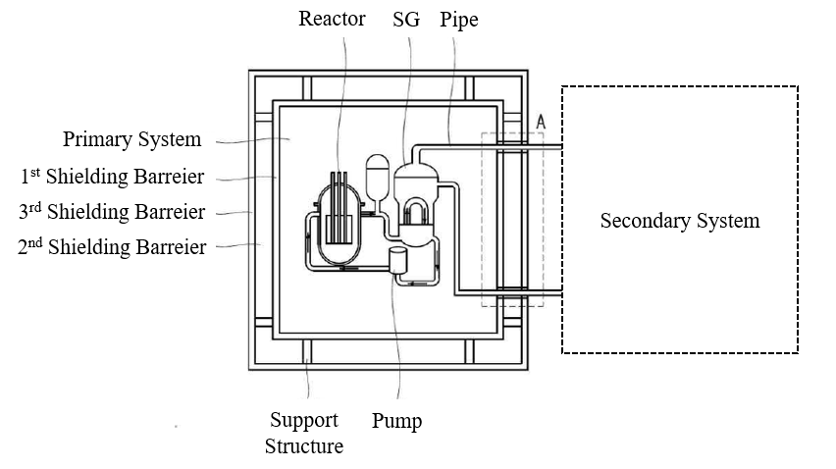

*FIG. 1. Structure of Maritime Radiation Shielding System.*

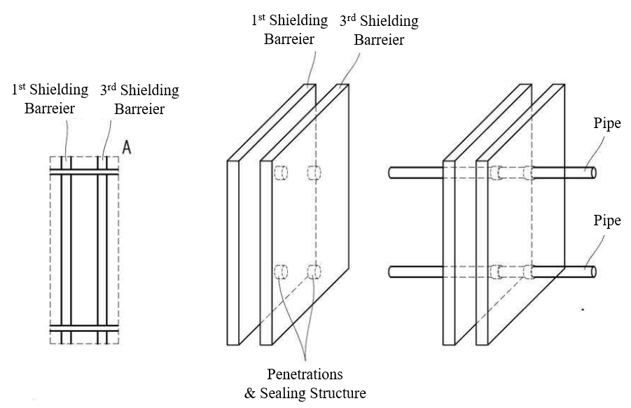

*FIG. 2. Sealing Structure between 1st and 3rd Barriers.*

The thickness of each shielding barrier must be accurately calculated after obtaining the dose data of gamma rays and neutrons from the reactor. Also, the thickness will be calculated based on regulation of annual radiation exposure dose limits of Table 1.

## arrangement of nuclear systemS in 15k cntr

The arrangement of the maritime radiation shielding system, along with the primary and secondary systems within the engine room of NPS, is a critical aspect for NPS design. For the type of ships, the most common 15,000 Twenty-foot Equivalent Unit (TEU) Container Ship (15K CNTR) was selected. The reactor and associated systems were arranged in the existing engine room in a manner that minimizes cargo loss. The current study selected PWR reactor type because PWR is the most widely used and common reactor type globally. Approximated thermal and electrical capacities of the PWR are 200 MWth and 50 MWe, respectively. The electricity generated by the reactor is used for both the propulsion and hotel load of the ship. Deployment of High-Assay Low-Enriched Uranium (HALEU) is expected to reduce the frequency of maintenance activities such as nuclear fuel rearrangement and replacement.

This chapter covers the requirements for arrangement of the 15K CNTR, and provides the list and arrangement results of the primary and secondary systems’ major equipment. Especially, for the secondary system, the equipment list was configured and arranged within the engine room of the 15K CNTR by applying the Brayton cycle using SCO2, instead of the conventional Rankine cycle using steam because Rankine cycle is bulky.

Additionally, Figure 3 shows the general arrangement (G/A) of an 11,400 TEU Container Ship (11K CNTR) [9].

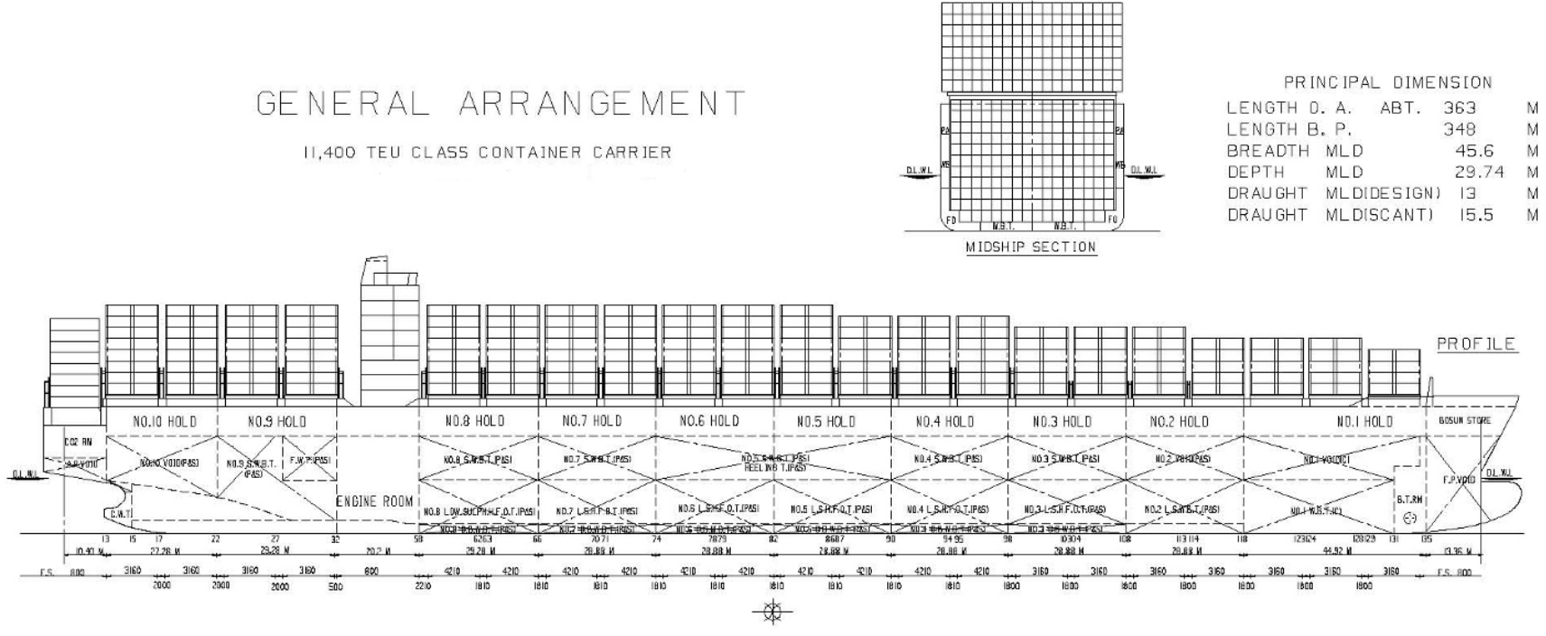

*FIG. 3. G/A of 11K CNTR.*

Figure 3 will serve as a reference for understanding the structure and compartments of existing container ships. Since a publicly available G/A of 15K CNTR does not exist, this G/A was used as a substitute, since the structures of 11K CNTR and 15K CNTR are found similar.

### Requirements for Arrangement of Nuclear Systems for NPS (15K CNTR)

The reactor and related systems have a more complex structure and larger volume compared to the existing engine of the 15K CNTR. There is also a potential risk of radiation leakage in the reactor system. The layout requirements for the 15K CNTR were established to minimize the risk to the crew from radiation and to reduce cargo loss due to the placement of the reactor and related systems. Due to the lack of specific regulations related to NPS, the requirements were supplemented by referring to the Korean Register of Shipping (KR) Structure rules of container ships (Part 14) [10]. The requirements for arrangement of nuclear systems for NPS (15K CNTR) are suggested as below.

* To minimize radiation exposure for the crew on board, the accommodation space is placed near the bow, while the SMR space (previously engine room) is placed near the stern. Arrangement of the SMR space at the stern also has the advantage of allowing the shaft and reactor to be in close proximity, thereby reducing the length of piping required (reduce risk of pipe breakage).
* The arrangement of reactor and associated systems are based on the existing compartments, frames and decks’ levels of 15K CNTR.
* With the replacement of the existing engine, the funnel is removed. While this space can be used for cargo storage, it will be kept vacant for reactor maintenance during dry docking. An emergency diesel generator will be placed on this space to save space and can be removed during reactor maintenance.
* The crews of 15K CNTR who have access to the SMR space are assumed to be radiation workers. Additionally, space must be allocated to allow access to the secondary system, excluding the primary system, for maintenance purposes.

### Study on the Arrangement of Nuclear Systems

The reactor, primary and secondary systems were arranged, based on the requirements for arrangement of nuclear systems for 15K CNTR The list and G/A of 15K CNTR are given in Sub-sections 3.2.1 and 3.2.2.

The primary system includes an SMR of suitable size and capacity for shipboard installation, along with its associated auxiliary systems. The list of primary system components is shown in Table 2.

TABLE 2. LIST OF PRIMARY SYSTEM

|  |  |  |  |
| --- | --- | --- | --- |
| No. | Equipment | Number of Equipment | Detail (Including equipment) |
| 1 | Maritime radiation shielding system | 1 | Containment vessel, Chemical and volume control system (CVCS) |
| 2 | Containment vessel | 1 | SMR, Steam generator, Reactor coolant pump, Safety injection system |
| 3 | Radioactive waste treatment system (RWTS) | 1 | Holdup tank, Liquid waste treatment system, Gas waste treatment system |
| 4 | Containment vessel support structure | 1 | - |

Table 2 shows that the maritime radiation shielding system includes the containment vessel and the CVCS. The containment vessel encompasses the SMR, steam generator, reactor coolant pump, and safety injection system. This arrangement allows that the SMR and most of the primary system equipment are housed within the maritime radiation shielding system. Outside the maritime radiation shielding system, the RWTS and the containment vessel support structure are located. The RWTS in Table 2 is for temporary storage of wastes and the spent fuel pool is necessary for long term storage; however, normal commercial ships cannot afford to host such a large space for spent fuel pool. The radioactive wastes held in the ship need removing at a dedicated harbor on her regular visit. Furthermore, fuel replacement can be made at a regular basis such every dry docking interval or more intervals depending on fuel’s enrichment level.

The secondary system configures using the Brayton cycle with SCO2 instead of the Rankine cycle. This feature offers the advantage of smaller equipment size, which is better for arrangement, and provides higher heat exchange efficiency. The list of secondary system is shown in Table 3 below.

TABLE 3. LIST OF SECONDARY SYSTEM

|  |  |  |  |
| --- | --- | --- | --- |
| No. | Equipment | Number of Equipment | Detail |
| 1 | Compressor | 4 | - |
| 2 | Recuperator | 4 | - |
| 3 | Turbine | 1 | - |
| 4 | First heat exchanger | 4 | Shell and tube heat exchanger |
| 5 | Second heat exchanger | 4 | Plate heat exchanger |
| 6 | Shaft | 2 | Capable of high-speed operation through twin-shaft configuration |

Table 3, due to the limited space in NPS engine room, includes only the essential SCO2 equipment for the secondary system. Additionally, if there is any other necessary components in Tables 2 and 3, their function should be substituted at the port on land to save foot print area; otherwise, other efficient arrangement should be made.

Based on the requirements for arrangement and list of the primary and secondary systems equipment, the G/A of the NPS (15K CNTR) and SMR space are shown in Figure 4.

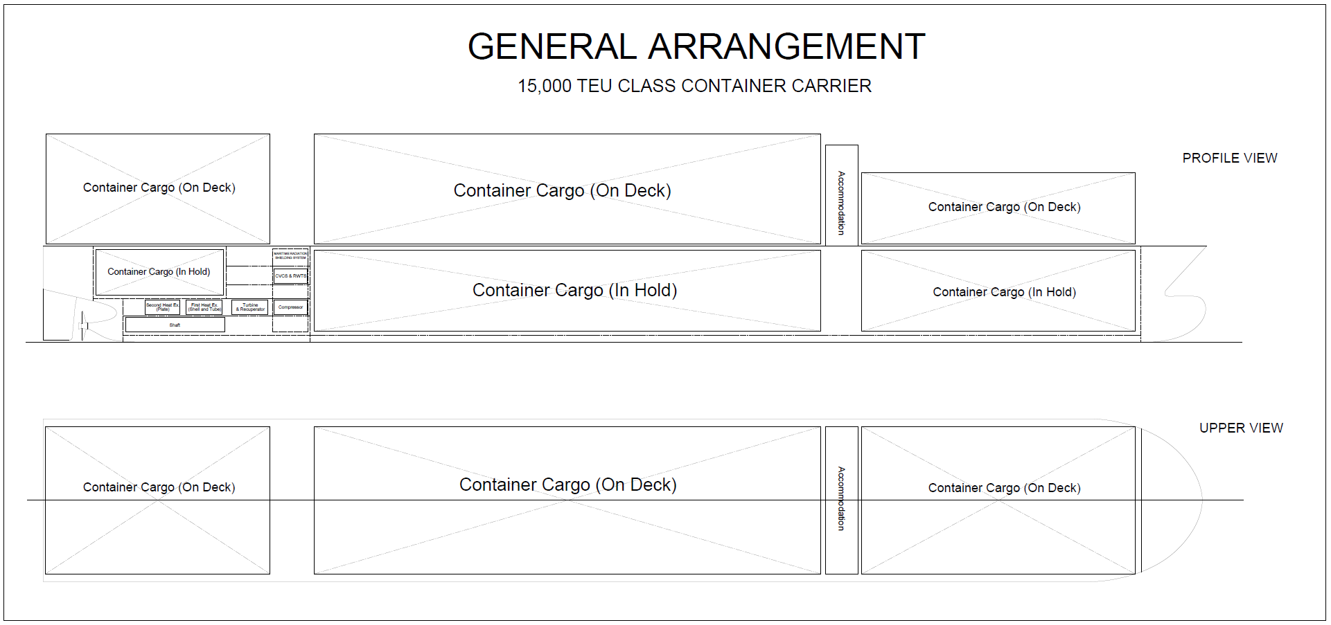

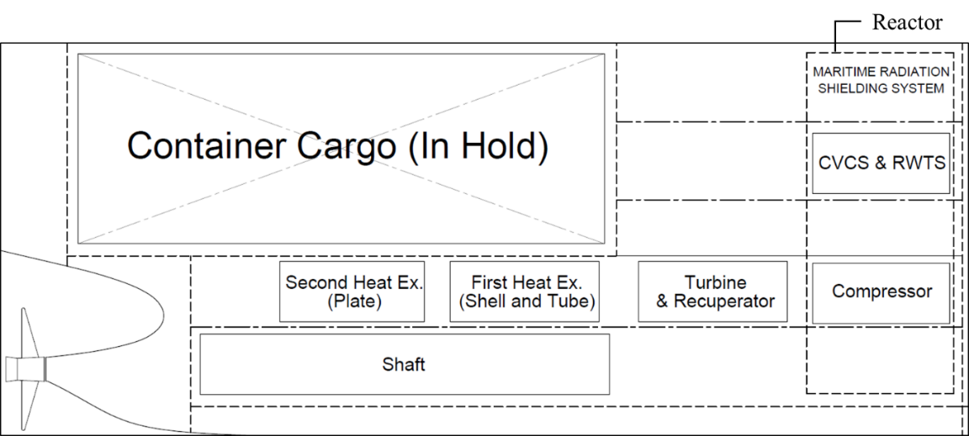

*FIG. 4. G/A and SMR Space of the NPS (15K CNTR)*

Figure 4 shows the G/A of the 15K CNTR with the essential equipment of primary and secondary systems arranged. Additionally, if there is any other necessary equipment in Table 2 and 3, its function should be substituted at the port on land, or an efficient arrangement must be made.

## ConCLUSION

In this study, a maritime radiation shielding system was suggested, which protects the NPS crew while complying with regulation of annual radiation exposure dose limits. Additionally, requirements for arrangement of nuclear systems for NPS (15K CNTR) was proposed to enable the installation of the SMR and related systems in 15K CNTR. Based on these requirements, ~~a~~ system equipment list and the G/A of the NPS (15K CNTR) could be suggested.

However, this arrangement is not precisely defined for the type of reactor. We are strongly considering the molten salt reactor (MSR) as the design for both NPS and floating plants, and conducting various studies accordingly. The MSR offers advantages such as a nuclear fuel replacement cycle of approximately 20 years, similar to the decommissioning cycle of ships. Additionally, it is safer than reactor types used in land-based nuclear power plants, and MSR’s liquid nuclear fuel provides advantages under six degrees of freedom (6DOF) conditions of ships. In addition, PWR is the most widely used reactor type both at land and sea, so we plan to apply both MSR and PWR to NPS and floating plants.

As a result, we will specify the reactor to obtain relevant gamma-ray and neutron data, which will be used to determine the thickness of the maritime radiation shielding system and inform the design with various structures and materials. Additionally, it will be necessary to apply essential systems for operating and maintaining the NPS to derive a more advanced G/A for the 15K CNTR.

ACKNOWLEDGEMENTS

This research was supported by HD Korea Shipbuilding & Offshore Engineering and HD Hyundai Heavy Industries in 2024.

References

1. 2023 IMO Strategy on reduction of GHG emissions from ships, Resolution MEPC.377 (80), IMO, London (2023).
2. Introduction to Advanced Commerical Nuclear for Maritime, Maritime Nuclear Application Group, Idaho (2022).
3. Defence in Depth in Nuclear Safety, INSAG-10, IAEA, Vienna (1996).
4. Nuclear Power Plants: Design, Safety Standards Series No. NS-R-1, IAEA, Vienna (2000).
5. Song, S., High-Spatial-Resolution Position-Sensitive plastic scintillation optical fiber bundle Detector, Photonics. 8(2) (2021), 26.
6. The Recommendations on Radiological Protection, ICRP 26, International Commission on Radiological Protection, Ottawa (1977).
7. General Principles for the Radiation Protection of Workers, ICRP 27(1), International Commission on Radiological Protection, Ottawa (1997).
8. Boiler & Pressure Vessel Code, 2023 Edition, The American Society of Mechanical Engineers, New York (2023).
9. Senjanović, I., Global hydroelastic analysis of ultra large container ships by improved beam structural model, Int. J. Nav. Archit. Ocean Eng. 6(4) (2014), 1041-1063.
10. Rules for the Classification of Steel Ships, RA-14-E, Korean Register of Shipping, Busan (2023).