# AI for Design, Engineering, Construction, and Operation of SMRs

NAWAL K. PRINJA

Jacobs Clean Energy

Knutsford, UK

Email: nawal.prinja@jacobs.com

**Abstract**

Small Modular Reactors (SMRs) hold immense promise for revolutionising the nuclear energy landscape, offering safer, more flexible, and cost-effective alternatives to traditional large-scale reactors. However, the successful deployment of SMRs relies heavily on efficient design, engineering, construction, and operation processes. The paper explores the transformative potential of Artificial Intelligence (AI) and Machine Learning (ML) technologies in accelerating the advancement and adoption of SMRs. Through concrete examples, it demonstrates how AI can streamline material qualification, enhance non-destructive testing, optimise supply chain management, and facilitate knowledge extraction for improved safety and efficiency throughout the SMR lifecycle.

## INTRODUCTION

The emergence of Small Modular Reactors (SMRs) and Advanced Modular Reactors (AMRs) represents a paradigm shift in the nuclear energy sector, offering scalable, versatile, and cost-effective solutions for diverse energy needs. However, the successful realization of SMRs necessitates overcoming various technical, regulatory, and economic challenges. Modular factory-based construction of SMR components opens up opportunities for Advanced Manufacturing (AM) technologies and use of I4.0 digital technologies like Artificial Intelligence (AI). In this context, the integration of advanced digital technologies such as AI and Machine Learning (ML) holds tremendous potential for revolutionising the design, engineering, construction, and operation of SMRs. According to the Coordinated Research Project CRP 2230 [1], AI could reduce SMR installation costs, shorten construction times and better meet user needs through greater flexibility or non-electric applications. This paper explores the multifaceted applications of AI/ML in accelerating the development and deployment of SMRs, with a focus on efficiency, safety, and sustainability.

## AI in Material Qualification

The qualification of new materials for nuclear components traditionally involves rigorous testing and analysis, often leading to lengthy and costly processes. AI-powered predictive modelling and simulation techniques offer a transformative approach to expedite material qualification while ensuring reliability and safety. By leveraging historical data and advanced algorithms, AI can accelerate the identification of suitable materials with desired properties, significantly reducing time-to-market and associated costs.

Suh et al. [2] have provided a state-of-the-art review on the utilization of AI algorithms to analyse vast datasets related to material properties and performance characteristics. The process of material discovery is often conceptualized through the 3M's framework: molecules, materials, and manufacturing. The first phase involves searching chemical databases for molecules that match specific substructures. The second phase focuses on building quantitative structure-property relationships (QSPR), where mathematical models are developed to link the structure of materials (such as atomic arrangements) to their physical, chemical, or mechanical properties (e.g., strength, melting point). In the final phase, manufacturing, the material is produced at scale while maintaining consistent quality. AI is playing an increasingly pivotal role throughout all stages of the 3M's approach. Generative models and deep learning techniques aid in the identification and prediction of molecular structures that exhibit desired properties. Furthermore, AI is being leveraged to predict material properties and enhance production quality. Examples illustrating these advancements are provided in the following sections.

### Prediction of Material Properties

Prinja [3] reported work on Material Properties Predictor for Power Plant Steels (M4Ps) where AI models were trained to predict material properties from known chemical composition and processing history. The data contained 58 steel types in the database of various steel product forms (tubes, plates, bars etc.) used in power plants. The AI models predicted three sets of material properties: tensile properties (Proof Stress, Ultimate Tensile Strength, Elongation% and RA%), creep rupture properties (Fracture time, Elongation% and RA%) and hardness (HRB/HRC). Accuracy ranged from 85% to 98%. Such AI models can help develop new materials for future Advanced Modular Reactors (AMRs) that are being designed to work at much higher temperatures.

Also reported in [3] is the work carried out to predict fracture life of nuclear materials. Artificial Neural Network (ANN) was applied to predict environmental impact on fatigue/fracture behaviour of steel. The data generated under the EU funded H2020 project on INcreasing safety in NPPs by Covering gaps in Environmental Fatigue Assessment (INCEFA) was used. The data set contained results from 246 tests with up to 136 features in each test. Principal Component Analysis (PCA) was applied as a dimensionality reduction technique to reduce the number of input parameters from 136 to 9. A sequential ANN model with 10 dense layers of neurons was developed. 80% of the data from 246 tests was used to train the model and the fracture life results for the remaining 38 tests were predicted with an average of 95.4% accuracy. Life predictions are shown in Fig. 1.

Fracture Life (No. of Cycles)

Test Number

*FIG. 1. Prediction of fracture life by AI*

### Optimisation of Material Tests

SMRs particularly AMRs may require new materials which in turn will require a large number of physical qualification tests for inclusion in the codes and standards. These are needed to cover the natural variability in the material properties. According to the AFCEN guide [4], any material that differs from already codified materials due to dimensional range (thickness, diameter, weight) or grade or in microstructural state, is deemed to be a new material. Qualification of new material involves mechanical, thermal, irradiation, corrosion and creep tests which can take few months to several years. This creates an extra challenge for the nuclear industry is that there is not sufficient material test data available. A feasibility study conducted by Lye et al [5] has shown that uncertainties from the sparse data and material variability can be accounted for by combining ANN with Bayesian statistics and Interval Predictor Models to fill the gap in material data with necessary confidence levels. This AI tool can help reduce the number of experimental campaigns required to characterise material properties.

## AI in Non-Destructive Testing (NDT)

Non-destructive testing plays a critical role in ensuring the integrity and reliability of SMR components during manufacturing and operation. AI-driven NDT techniques offer enhanced sensitivity, accuracy, and efficiency compared to traditional methods. By analysing complex datasets in real-time, AI algorithms can detect anomalies, defects, and structural weaknesses with unprecedented precision, enabling proactive maintenance and quality assurance measures. Advanced Manufacturing techniques like Electron Beam (EB) welding of thick plates and recent initiatives being taken to use Ultrasonic Testing (UT) instead of Radiographic Testing (RT) can be accelerated by use of AI. The following two examples illustrate how AI is being deployed in NDT.

### Quality Control of EB Welds

Electron Beam (EB) welds are going to play crucial role in factory production of SMR components. Their success rate is of utmost importance, not only for nuclear safety but also for economic production. Ortiz-De-Zuniga et al [6] conducted a study using AI models to identify the combination of parameters that could lead to flaws in the EB welds. The error rate was random, and each weld repair could take anywhere from one week to one month causing disruption to planned human resources, machines and documentation. To develop a predictive AI model, all the available data from the previously welded 1802 EB welds was collected and analysed using Machine Learning. This AI model was used to predict outcome of weld inspection for 70 new EB welds. The output of the model showed that all true positives and true negatives were correct: one weld was predicted to fail at 90% probability, and it was confirmed that it actually failed; another 16 welds were predicted to fail at 56% probability, of which 7 failed and 9 passed; and all the remaining 53 predicted to pass actually passed. These accurate predictions and results show that the application of AI in nuclear manufacturing allows manufacturers to improve quality control and reduce impacts on resources, documentation and schedule, therefore de-risking programs.

### PAUT of Butt Welds

Fusion for Energy carried out a pilot project to test AI-powered Phased Array Ultrasonic Testing (PAUT) system in one of the production facilities that demonstrated significant reduction in inspection time and resource utilization. This has the potential to minimise false positives, thereby enhancing overall manufacturing efficiency and product quality. Typically, PAUT can take several days for acquisition and subsequent analysis of inspection data. Furthermore, it can cost 1 to 5 million dollars to train and qualify an inspector.

In PAUT, three main types of scans are used to visualize defects. ‘Amplitude scan’ (A-scan) displays a simple pulse-echo response showing amplitude of a single beam and has 320 data points. In this case, 19 beams were used to sweep a sector from 30o to 66o. A ‘Sectorial scan’ (S-scan) presents a fan shaped 2-D image of the sweep done by the 19 beams. These scans are done at every mm along the weld length. A cross-sectional view of the scan results is presented as ‘Brightness scan’ (B-scan) along the length. Typical B-scan from a 450mm long inspection of a butt weld along with S-scan at 159mm position and A-scan of a beam at 36o are shown in Fig 2. This single PAUT of 450mm long inspection generated 450x19x320 = 2.736 million data points. Ortiz de Zuniga et al [7] have shown that AI models can be trained to provide digital assistance to inspectors and reduce the time taken to inspect the welds. Fig. 2 shows scans from a PAUT inspection of a weld indicating presence of three flaws that took several hours of manual analysis to confirm. Fig. 3 shows the same three defects predicted by AI in couple of minutes.

Location of a defect in a weld is reported by its scan position along the length of the weld, the Focal Law (beam number) and the depth, Zo. Table 1 shows that the AI model predictions accurately match the manual analysis, achieving the same accuracy but in a fraction of time.

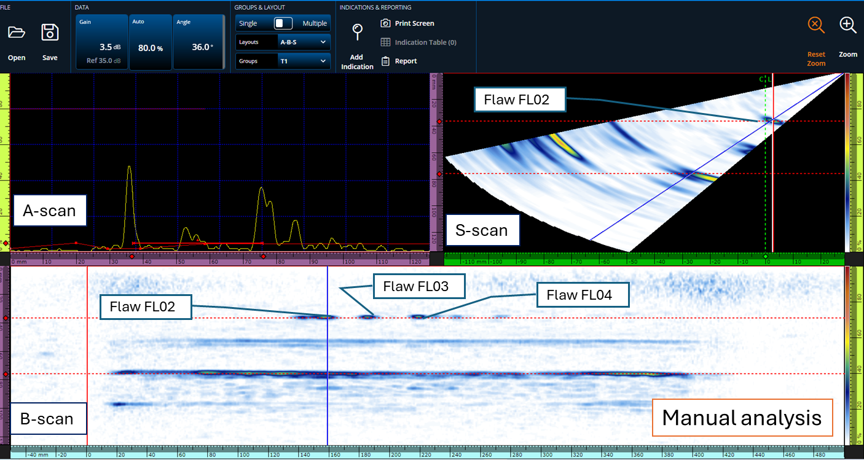

*Fig 2. PAUT inspection of a weld indicating presence of three flaws*

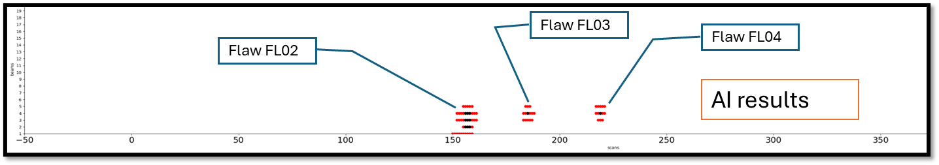

*Fig 3. AI prediction of the three flaws*

TABLE 1. Comparison of manual UT analysis with AI predictions

|  |  |  |  |  |  |  |
| --- | --- | --- | --- | --- | --- | --- |
| Flaw ID | Scan Position of Flaw Centroid, Xo (mm) | | Focal Law  (Beam Number) | | Depth, Zo (mm) | |
| Report | AI | Report | AI | Report | AI |
| FL02 | 159 | 156 | 36o (4) | 36o (4) | 34.8 | 35.44 |
| FL03 | 184 | 186 | 36o (4) | 36o (4) | 33.1-35.6 | 35.44 |
| FL04 | 218 | 219 | 36o (4) | 36o (4) | 32.3-35.2 | 35.05 |

## AI in Supply Chain Management

Efficient supply chain management is crucial for the timely procurement of components, materials, and services essential for SMR construction and operation. AI-driven cognitive search engines and analytics platforms offer advanced capabilities for optimizing supply chain processes, mitigating risks, and enhancing decision-making. By aggregating and analysing vast volumes of data from diverse sources, AI systems can identify cost-saving opportunities, streamline procurement workflows, and ensure compliance with regulatory requirements. AI tools based on the Natural Language Processing (NLP) technology are being developed to check if contractor’s deliverables comply with the technical specifications and regulations. According to the industry trend published by NEI [8], automated contractor management technology can enable nuclear facility owners to monitor key safety metrics. Finance, IT, Project Management, Design and Construction teams can set up an AI-enabled process to optimise administrative approval and alerting processes on their job sites.

## AI in Knowledge Management and Safety Assurance

Effective knowledge management is essential for ensuring regulatory compliance, operational efficiency, and safety in SMR facilities. AI-powered cognitive search engines and data analytics tools enable efficient extraction, aggregation, and dissemination of critical information from diverse sources. By automating data retrieval, analysis, and reporting tasks, AI systems empower operators to make informed decisions, optimize resource allocation, and enhance safety case development. Lifetime of a nuclear power plant project can last from 80 to 100 years. Organisations have to acquire, apply and retain knowledge for people, processes and tools for several generations of employees. Prinja [9] showed that KMKP can be achieved by use of AI-powered cognitive search tool.

Following two examples are presented to show how AI-powered cognitive search engines can be employed to extract relevant information from large number of unstructured archived documents. This can facilitate timely access to comprehensive asset information that can perform Knowledge Management and Knowledge Preservation (KMKP) for SMRs and AMRs to be built in future.

### Knowledge Extraction from Historic Project Archives

The Energy, Security & Technology (ES&T) business unit within Jacobs currently has approximately 25,000 boxes held in a secured offsite storage location. These boxes contain information relating to nuclear projects, dating back over 40+ years. The information contained within these boxes could be vital to support future research and projects. In a pilot project, 200 boxes were identified and retrieved from the archives. 2943 documents from these 200 boxes were scanned and converted into pdf files. In total nearly half a million pages of information was converted into a ‘Knowledge Base’ by a propriety software. A number of complex technical questions were asked related with reactor design and nuclear site investigations. Each search provided accurate information and took less than 20 seconds to complete. A manual search would have taken days.

### Molten Salt Reactor Knowledge Base

A trial for Generation IV International Forum (GIF) was conducted by extracting knowledge from Molten Salt Reactor research reports. Scanned copies of 233 research reports (about 3 GB of data) were used to create a ‘Knowledge Base’ from these reports. The software took 72 minutes to analyse all the reports which involved reading all the contents and creating a knowledge base. In a live demonstration given by Prinja [10], several technical questions related with coolants for heat exchangers and types of salts were asked which were answered accurately in less than 15 second with precise reference given with each reply.

## non-electric Applications and load following

AI can help optimise SMR designs for various non-electric and load following applications as follows:

### Cogeneration

AI can help tailor designs to meet specific process heat requirements where SMRs can provide high-temperature process heat for industrial applications (e.g., hydrogen production, desalination, or district heating). One of the main challenges for cogeneration is that the reactor will require advanced control systems to adjust the balance between heat extracted for industrial use and for electricity generation. This requires ability to model reactor transients and provide tools to the operators to achieve better performance efficiency. That is where AI can help improve overall efficiency for combined electricity and heat production. Prantikos et al at Purdue University [11] have demonstrated how AI algorithms can improve the monitoring and control of SMRs. Physics Informed Neural Networks (PINNs) were trained to monitoring nuclear reactor performance and accuracy of 99% was achieved. PINN is a type of neural network that incorporates known physical laws, typically expressed as partial differential equations and boundary constraints, directly into the learning process. Instead of relying solely on data, PINNs combine data-driven models with physics-based constraints ensuring that the model predictions respect the underlying physics. The enhanced control can facilitate the efficient cogeneration of heat and electricity by optimising reactor performance.

### Load-following

Load following means changing the power generation as closely as possible to the expected power demand it can be planned or unplanned. Chang [12] has provided a review of the requirements and challenges for load following of SMRs. Since an SMR has a smaller unit capacity compared to a large nuclear reactor, thermal power control is relatively easier and less risky in terms of nuclear safety. AI-controlled load-following capabilities can enable SMRs to contribute to grid stability by providing ancillary services (e.g., frequency regulation) and be part of smart grids.

Gong [13] has reviewed application of reinforced learning, deep learning neural networks and combined deep reinforced learning for power start up, collaborative control and emergency handling of complex systems of nuclear power plants. In the nuclear industry, the startup and shutdown operations are performed manually and thus have the potential for human error. As part of the development of an autonomous operation system for startup operation, Kim [14] has proposed an action coordinating strategy to obtain the optimal actions. Long Short Term Memory (LSTM) AI models were trained to predict the future outcomes according to the selected actions. The information obtained from the prediction models allows one to know the consequences of actions at a particular moment. These can help choose the action that will take the reactor to the desired state of operation.

## Conclusion

The successful deployment of SMRs hinges on the efficient integration of advanced digital technologies such as Artificial Intelligence (AI) and Machine Learning (ML). By harnessing the power of AI/ML, SMR stakeholders can accelerate innovation, improve safety, and reduce costs throughout the lifecycle of SMR projects. Through concrete examples and case studies, this paper has demonstrated the transformative potential of AI in material qualification, non-destructive testing, supply chain management, and knowledge management for SMRs. As the nuclear industry embraces the digital revolution, AI-driven solutions will play an increasingly pivotal role in shaping the future of clean, reliable, and sustainable energy generation.

## References

1. Technologies Enhancing the Competitiveness and Early Deployment of Small Modular Reactors, CRP 2230, IAEA, Vienna, (2022).
2. SUH, C., FARE, C., WARREN, J.A., AND PYZER-KNAPP, E. O., Evolving the Materials Genome: How Machine Learning Is Fueling the Next Generation of Materials Discovery, Annual Review of Materials Research, 50:1–25 (2020).
3. PRINJA, N., ‘Artificial Intelligence for Engineering Projects’, Research Seminar Series 2021-22, University of Bolton, School of Engineering, 14 October 2021.
4. Guide for introducing a new material in the RCC-MRx, ACEN/RX.17.006 revA, AFCEN, (2017).
5. LYE, A., PRINJA, N., PATELLI, E., Probabilistic Artiﬁcial Intelligence Prediction of Material Properties for Nuclear Reactor Designs, Proceedings of the 32nd European Safety and Reliability Conference (ESREL), 2022.
6. ORTIZ DE ZUNIGA, M., CASANOVA,C., DANS, A., FEBVRE, M., PRINJA, N., RODRÍGUEZ-PRIETO, A., CAMACHO, A.M., Artificial Intelligence for the output processing of phased-array ultrasonic test applied to materials defects detection in the ITER Vacuum Vessel welding operations, SMiRT-26, Berlin, Germany,10 – 15 July 2022.
7. ORTIZ DE ZUNIGA, M., CASANOVA,C., DANS, A., FEBVRE, M., PRINJA, N., RODRÍGUEZ-PRIETO, A., CAMACHO, A.M., Artificial Intelligence for the prediction of the success rate in electron-beam welding operations applied to the ITER Vacuum Vessel manufacturing, Artificial Intelligence in Engineering Conference, ARIC and CAE-Forum,1 Dec 2021.
8. AI and automation streamlining nuclear, NEI Magazine, <https://www.neimagazine.com/analysis/ai-and-automation-streamlining-nuclear>.
9. PRINJA, N., AI for Knowledge and Quality Management, OECD NEA Workshop on Nuclear Supply Chain- Assurance Today, Confidence Tomorrow, Paris, 5-6 March 2024.
10. PRINJA, N., AI for KMKP, 56th Policy Group / 50th Expert Group meeting of Gen IV International Forum, Versailles, France, Oct 2023.
11. PRANTIKOS, K., CHATZIDAKIS, S., TSOUKALAS, L. H., HEIFETZ, A., Physics-informed neural network with transfer learning (TL-PINN) based on domain similarity measure for prediction of nuclear reactor transients. Sci Rep 13, 16840 (2023). <https://doi.org/10.1038/s41598-023-43325-1>.
12. CHANG, C.,OYANDO, H. C., Review of the Requirements for Load Following of Small Modular Reactors, , Energies 2022, 15(17), 6327; <https://doi.org/10.3390/en15176327>.
13. GONG, A., CHEN, Y., LI, X., Possibilities of reinforcement learning for nuclear power plants: Evidence on current applications and beyond, Nuclear Engineering and Technology, 56 (2024).
14. KIM, J. M., BAESEUNG, J., LEE, J., Strategy to coordinate actions through a plant parameter prediction model during startup operation of a nuclear power plant, Nuclear Engineering and Technology, March 2023.