Maintenance strategy for I-SMR

HYUNSUK NAM
Korea Hydro & Nuclear Power Central Research Institute
Daejeon, Korea republic of
Email: hyunsuk.nam@khnp.co.kr

Abstract

The innovative-SMR (i-SMR) being developed in South Korea has maintenance challenges due to its integral reactor design compared to conventional nuclear power plants. To overcome these limitations, the i-SMR has been designed with maintenance considerations. The maintenance procedure for the i-SMR includes several steps aimed at optimizing maintenance efficiency. The maintenance procedure for the i-SMR comprise the following steps : 1) Containment Vessel upper head disassembly & inspection (CV head is maintained at laydown area), 2) Reactor Closure Head disassembly & maintenance (Remove of CEDM/ICI penetration seal and increasing of level of refueling pool), 3) Reactor Vessel Internals (inner barrel assembly → upper guide structure → core support plate), 4) Transfer the fuel assembly to spent fuel pool, 5) Non destructive testing inspection for main component (UT inspection for RV/CV welds). These detailed steps allow the i-SMR to undergo maintenance in less time compared to conventional nuclear power plants. By prioritizing maintenance considerations in its design and implementing efficient maintenance procedure, the i-SMR demonstrates its potential to minimized overhaul time and maximized operational efficiency.

INTRODUCTION
In recent years, the global energy landscape has been witnessing a significant shift towards more sustainable and efficient power generation technologies. Among these, Small Modular Reactors (SMRs) have emerged as an innovation technology, attracting considerable attention for their potential to offer flexible, scalable, and cost-effective energy solutions. SMRs, their smaller size compared to traditional nuclear power plants, provide distinct advantages in terms of safety, economy, and flexibility.
Based on these advantages, many countries are actively developing various SMR designs to address their energy needs and goals. In the United States, for example, the development of small module reactors (SMRS) is being carried out by various companies such as NuScale Power [1]. NuScale’s reactor, which has received design approval from the Nuclear Regulatory Commission (NRC)[2], promises enhanced safety features and economic benefits due to its modular type and small size reactor. In Europe, the United Kingdom and France are also making significant results in SMR development. The UK government has initiated programs to support the development and deployment of SMRs as part of its strategy to achieve net-zero carbon emissions by 2050 [1]. Similarly, France is aiming to enhance energy security and reduce carbon emissions through the development of SMR. Asia is another region with great interest in SMR development. China, for instance, is actively developing its own SMR designs, such as the ACP100, also known as Linglong One [1]. This reactor is currently under construction and is expected to provide a reliable and low-carbon energy source for the China’s growing energy needs.
In response to this global trend, South Korea has got started on a R&D program to develop its SMR model, termed innovative-SMR (i-SMR) [1]. The i-SMR development program is driven by the government. i-SMR apply proven technologies applied in conventional nuclear reactors to enhance the economic viability and maintenance efficiency of SMRs. The i-SMR development project is designed to build on the operational experiences of conventional reactors, applying advanced safety features and maintenance strategies.
This paper will describe the key features of the i-SMR and provide a concise overview of the maintenance strategies based on proven technologies and procedures. Chapter 2 will present an overview of the Nuclear Steam Supply System (NSSS), which includes the reactor and the containment vessel, introducing the integral components and their functions within the system. Finally, Chapter 3 will briefly describe the maintenance procedures for the NSSS system.

Overview of i-smr

Technical parameters of i-SMR
i-SMR was designed as an integrated nuclear reactor, and a passive safety system design was considered [3]. The main design variables of i-SMR are as follows,

- Reactor Type / Coolant / Moderator : Integral PWR / Light water / Light water
- Thermal / electrical capacity : 520MWt / 170MWe
- Primary circulation : Forced circulation
- NSSS operation pressure : 15 MPa
- Number of fuel assemblies : 69 EA
- Design life : 80 years
- Seismic design (SSE) : 0.5g

Overview of the nuclear steam supply system (NSSS) design [4]
The i-SMR has an integral Reactor Coolant System (RCS) configuration that eliminates large pipes for connection of the major components. The major primary components such as a core with 69 fuel assemblies, four Reactor Coolant Pumps (RCPs), a helical once-through Steam Generator (SG), and a Pressurizer (PZR) are installed in an integrated Reactor pressure Vessel (RV). And RV is mounted in a compact steel Containment Vessel (CV). Due to the integral arrangement, the possibility of a Large Break Loss of Coolant Accident (LB-LOCA) is inherently eliminated. Figure 1(a) illustrates the i-SMR reactor and containment vessel, while Fig. 1(b) shows the main components and flow paths.

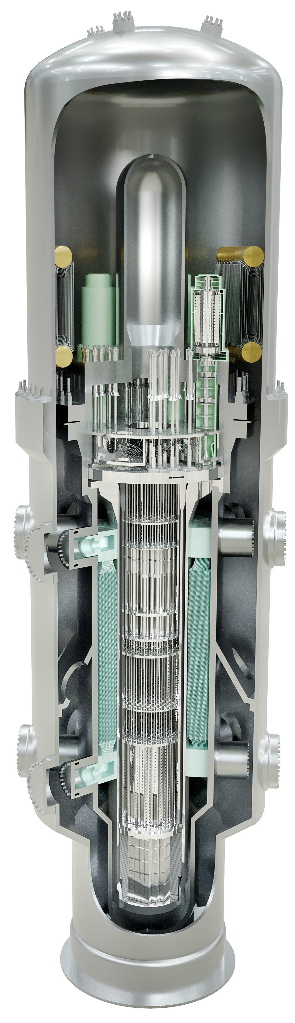
(a) (b)
FIG. 1. (a) schematic of Reactor Vessel, Containment Vessel,
(b) flow path and main components of RCS.

maintenance strategy of nsss system
The i-SMR is designed to meet the target component and inspection requirements specified by various code standards. One of the key innovations in the i-SMR design is its emphasis on maintenance efficiency. Despite being designed with four modules, each i-SMR module can be maintained directly within the CV pool, eliminating the need for relocations for maintenance. This approach significantly reduces the time and resources required for maintenance activities, thereby enhancing the overall operational efficiency of the reactor. This maintenance-oriented design has also been applied to the reactor layout. Figure 2 show i-SMR reactor building general arrangement for maintenance and fuel refueling. A description of each area in figure 2 is as below,

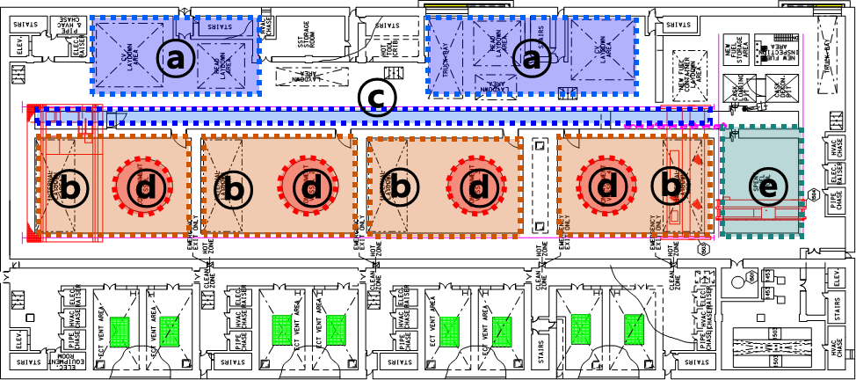
(a)
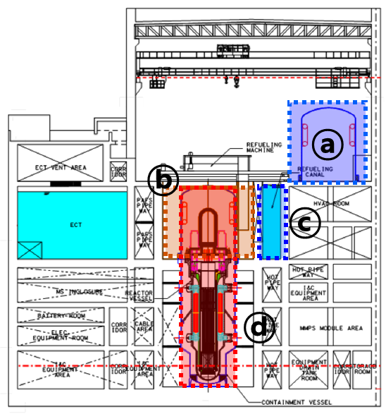
(b)
FIG. 2.Layout of reactor building of i-SMR (a) top view, (b) side view
In figure 2, area ⓐ serves as the laydown area, where the CV upper head, Reactor Closure head, and Reactor Coolant Pump (RCP) can be inspected. Area ⓑ is designated as the refueling pool. Under normal operating conditions, this area remains dry, but it is filled with water during the refueling process. Area ⓒ is the refueling canal, which acts as the pathway for moving fuel assemblies during refueling. This zone is consistently filled with water. Area ⓓ is kept dry under both normal operation and maintenance conditions and is utilized as a maintenance space. And, area ⓔ contains the spent fuel pool. Based on this reactor building layout, the i-SMR can perform more efficient maintenance procedures. This design allows for easier access to main components, reducing time for maintenance. Figure 3 illustrates the assembly and disassembly procedures of the reactor / containment vessel.

FIG. 3.Disassembly & assembly procedure for reactor vessel / containment vessel

As shown in Figure 3, the disassembly occurs in the following order: containment vessel head, reactor head, and internal structures. The detailed maintenance procedure for the i-SMR is composed of several stages as described below.

- CV head disassembly & inspection: This step involves disassembling the CV head and conducting a thorough inspection.
- RCH disassembly & maintenance: Here, the RCH (Reactor Coolant Pump) is disassembled and necessary maintenance tasks are performed.
- RVIs remove & maintenance: In this step, the RVI (Reactor Vessel Internals) components, including IBA (Inner Barrel Assembly), UGS (Upper Guide Structure), and CSB (Core Support Barrel), are removed and undergo maintenance procedures.
- Transfer the fuel assembly to SFP: The fuel assembly is transferred to the Spent Fuel Pool (SFP) for further processing or storage.
- NDT inspection for main component: Finally, Non-Destructive Testing (NDT) is conducted on the main components to ensure their integrity and detect any potential defects.

The first activity in the maintenance process is the disassembly and inspection of the CV head. This process involves the use of a multiple stud tensioner, which allows for the simultaneous removal of multiple bolts, enhancing efficiency. After the bolts are removed, the reactor building crane is employed to transfer the CV head to a designated laydown area. At this location, an inspection of the CV upper head welds is conducted alongside an inspection of the PCCS (Passive Containment Cooling System).
The second activity involves maintenance of the Reactor Closure Head (RCH). Initially, the CEDM (Control Element Drive Mechanism) and ICI (In-Core Instrumentation) cables are dismantled. Following the dismantling of these cables, multiple bolts are removed similarly to the CV stud bolts. The RCH is then transferred to the RCH Laydown area using the reactor building crane, during which the water level in the CV pool is concurrently increased. Once the RCH is moved to the laydown area, maintenance of the Reactor Coolant Pump (RCP) is carried out at the same location. Inspections such as UT (Ultrasonic Testing), ECT (Eddy Current Testing), and VT (Visual Testing) for penetrations are performed at the laydown area. Additionally, inspections of the RCH welds are also conducted in the laydown area.
The third activity is the removal and maintenance of the Reactor Vessel Internals (RVIs). The RVIs are removed sequentially, starting with the IBA, followed by the UGS, and finally the CSB. These components are then stored in the refueling pool. Additionally, the IV-CEDM along with the RVIs are inspected in this area.
The fourth activity described in the maintenance sequence is refueling. A single refueling machine is shared among four modules. When the water level in the refueling pool aligns with that in the refueling canal, the water gate connecting the two will be opened. This concept allows for simultaneous maintenance of multiple modules.
The final activity in the maintenance process is the NDT inspection of the main components. Inspections of the RV and CV lower part welds are conducted, either internally or externally, depending on the specific location of the inspection. The steam generator inspection will be carried out by inserting a probe into the steam generator header.
Through the above process, i-SMR can efficiently carry out disassembly and maintenance of integrated nuclear reactors.

Conclution
This paper describes the design characteristics of the i-SMR being developed in Korea and the maintenance procedures of the NSSS system of i-SMR. The maintenance procedure for the i-SMR comprise the five steps. In this paper, the maintenance item performed at each stage is described in detail, and simplified maintenance procedures are described compared to conventional nuclear power plants. It is believed that this optimized maintenance procedure for i-SMR can improve the economic feasibility of SMR.
ACKNOWLEDGEMENTS
This work was supported by the Innovative Small Modular Reactor Development Agency grant funded by the Korea Government (Ministry of Trade Industry and Energy) (RS-2024-00404240)
References
- IAEA, “Advances in Small Modular Reactor Technology Developments”, 2022
- USNRC, “NuScale Power, LLC Request for Standard Design Approval based on the NuScale Standard Plant Design Certification Application”, ML20195C766, 2020
- Korea Hydro and Nuclear Power company, “i-SMR Top Tier Requirement Research Report”, 2023.
- Korea Hydro and Nuclear Power company, “Plant Design Description Report”, 2023.

