# Analysis of the new RCC-MRx

# methodologies for creep-fatigue damage

A. MARTIN

Framatome

Lyon, France

Email: antoine.martin@framatome.com

J. MACEDO

Framatome

Lyon, France

V. BARBE

EDF

Lyon, France

**Abstract**

The design and construction rules for mechanical components of nuclear installations (RCC Codes) published by AFCEN primarily apply to safety class components. RCC-MRx code has been developed for Sodium-cooled Fast Reactors (SFRs), experimental reactors and fusion reactors but can be used, on condition that the rules applicability is justified, for components for other nuclear installations including the other GEN IV reactors (gas-cooled fast reactors, lead-cooled fast reactors, molten salt reactors, supercritical-water-cooled reactors and very high-temperature reactors). Due to its specificities, RCC-MRx proposes rules for significant creep and significant irradiation domains.

In the 2022 version, the RCC-MRx code introduced methodologies to calculate more precisely the creep-fatigue damage of a loaded structure.

Firstly, the article presents these recently introduced methodologies and their characteristics. Secondly, tests on structures whose design and operating loadings are representative of SFRs are shown. Comparisons between the historical and the recently introduced methodologies are performed.

In conclusion, the results show important gains on creep-fatigue damage by using the new methodologies, even if some local areas still present damages higher than allowable limits for a long-life duration. Nevertheless, it allows the designers to focus their work on these few areas.

## INTRODUCTION

The design and construction rules for mechanical components of nuclear installations (RCC Codes) published by AFCEN primarily apply to safety class components. RCC-MRx code has been developed for Sodium-cooled Fast Reactors (SFRs), experimental reactors and fusion reactors but can be used, on condition that the rules applicability is justified, for components for other nuclear installations including the other GEN IV reactors (gas-cooled fast reactors, lead-cooled fast reactors, molten salt reactors, supercritical-water-cooled reactors and very high-temperature reactors). Due to its specificities, RCC-MRx proposes rules for significant creep and significant irradiation domains.

In the 2022 version, the RCC-MRx code introduced methodologies to calculate more precisely the creep-fatigue damage of a loaded structure.

Firstly, the article presents these recently introduced methodologies and their characteristics. Secondly, tests on structures whose design and operating loadings are representative of SFRs are shown. Finally, comparisons between the historical and the recently introduced methodologies are performed.

## PRESENTATION OF CREEP-FATIGUE METHODOLOGIES

The new methodologies of RCC-MRx edition 2022 [1] are non-mandatory improvements of the historical creep-fatigue methodology. Hence, before the presentation of the recently introduced methodologies, we will first recall the historical one. All these methodologies are gathered in paragraph RB 3262.112 or RPP (Probationary Phase Rules) 17 of RCC-MRx.

### Historical methodology

The objective of this methodology is to calculate two types of damages: fatigue damage through the fatigue usage fraction V and creep damage through the creep usage fraction W. These fractions are then compared to the creep-fatigue interaction diagram for the analysed material (indicated in Appendix A3 of RCC-MRx). The recently introduced methodologies are mainly focused on the computation of creep usage fraction so only its calculation is detailed below.

The creep usage fraction W is calculated by comparing the stress $σ_{k}$ (corresponding to the stress on the analysis point during the holding time) to the allowable stress ${\left(S_{r}\right)}_{min}$ (corresponding to the minimal value of creep rupture stress and depending on time and temperature).

The process to determine $σ_{k}$ begins with the calculation of $\overline{∆σ_{tot}}$ which corresponds to the range of the total stress calculated elastically at the point under examination. The latter is calculated using a finite element model or an analytical computation. Using this total stress range, it is possible to estimate an elastoplastic strain range $σ_{k}$ which corresponds to the sum of four strain ranges which represent different phenomenon:

* $\overline{∆ε_{1}}$ represents the strain range given by elastic analysis.
* $\overline{∆ε_{2}}$ represents the plastic increase in strain due to the primary stress range ($\overline{∆P})$.
* $\overline{∆ε_{3}}$ represents the plastic increase in strain corresponding to a projection on the cyclic curve.
  + - * This projection is performed through a Neuber hyperbola whose formula is $\overline{∆σ}∙\overline{∆ε}=constant$;
      * This range represents an estimation of the elastoplastic behaviour of the structure.
* $\overline{∆ε_{4}}$ represents the plastic increase in strain due to triaxiality.

After the determination of $\overline{∆ε}$, the calculation of the stress range ${\overline{∆σ}}^{*}$ is performed. The latter corresponds to the point ordinate on the cyclic curve for which the abscissa is equal to $\overline{∆ε}$ (see below figure) and is representative of the elastoplastic stress range in the structure.

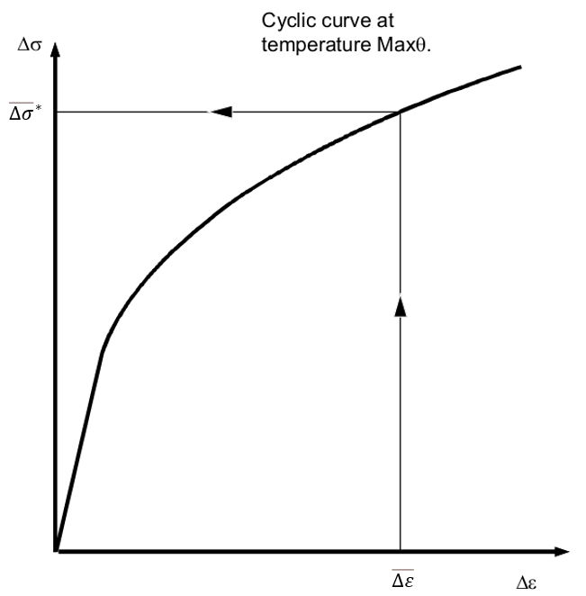

*FIG. 1. Determination of ${\overline{∆σ}}^{*}$.*

The rest of the process consists in evaluating the stress during the holding time $σ_{k}$ that is obtained by the formula $σ_{k}=\overline{P_{max}}+K_{S}∙\overline{{∆S}^{*}}$ with:

* $\overline{P_{max}}$ corresponding to the primary stress during the holding time;
* $\overline{{∆S}^{*}}={\overline{∆σ}}^{*}-\overline{∆P}$ corresponding of an estimation of the secondary stress range;
* $K_{S}$ is the symmetrisation coefficient. This coefficient is evaluated on the basis of a curve given in appendix A3 (see below an example for an austenitic stainless steel) and the ratio $R={{\overline{∆σ}}^{*}}/{\left(2∙{\left(R_{p0.2}\right)}_{min}\right)}$ where ${\left(R_{p0.2}\right)}_{min}$ is the conventional yield strength at 0.2% offset).

This last parameter represents the mean stress relaxation phenomenon. If ${\overline{∆σ}}^{*}$ is lower than ${\left(R_{p0.2}\right)}_{min}$, the material is considering as purely elastic so there is no mean stress relaxation. In this case, the coefficient $K_{S}$ is equal to 1. If ${\overline{∆σ}}^{*}$ is significantly higher than $2∙{\left(R_{p0.2}\right)}_{min}$, the material is considering as completely plastic. In this case, the mean stress relaxation is complete, and the coefficient $K_{S}$ is equal to 0.5.

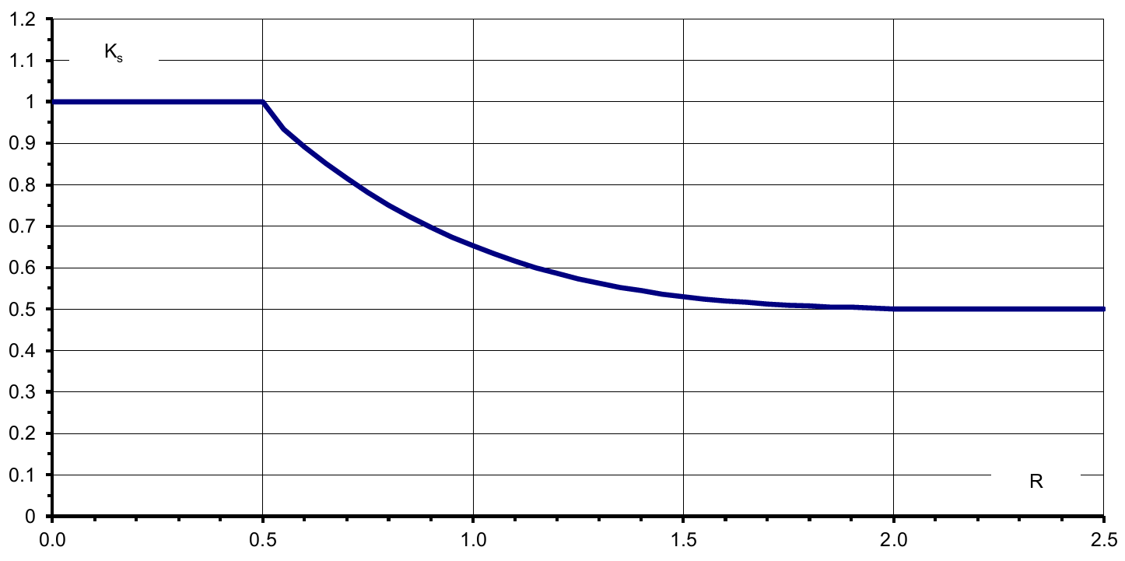

*FIG. 2. Example of curve for the determination of $K_{S}$.*

It is important to note that through this process, the historical methodology considers that:

* The rebuild hysteresis loop is a curve without information on compressive or tensile stresses (see figure below);
* The holding time is considered as positioned at the point ($\overline{∆ε}$, ${\overline{∆σ}}^{*}$).

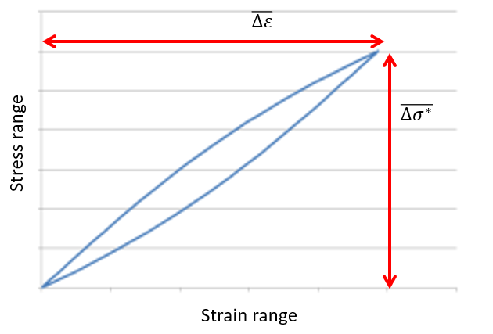

*FIG. 3. Rebuild hysteresis loop.*

### Recently introduced methodology 1: Compressive and tensile stress-strain hysteresis curve

The first recently introduced methodology (described in RB 3262.1123 of RCC-MRx) corresponds to the use of the calculation of coefficient K’s whose formula is ${K'}_{S}=min\left(K_{S};{\overline{σ_{max}}}/{{\overline{∆σ}}^{*}}\right)$ with $\overline{σ_{max}}$ corresponding to the maximal total stress during all the analysed elastic cycles. This modification allows to take into account a part of the cycle in compression or in tension, instead of considering the cycle completely in compression or in tension. So even if the cycle is purely elastic, it is possible to decrease the value of $σ_{k}$.

### Recently introduced methodology 2: Holding time is not located at one of the extrema of the cycle

The second recently introduced methodology (described in RB 3262.1124 of RCC-MRx) can be used when the holding time (the creep dwell) is not located at one of the extrema of the cycle. It allows to avoid using the point ($\overline{∆ε}$, ${\overline{∆σ}}^{*}$) in the rebuild hysteresis loop and to decrease the holding time stress. To use this methodology, it is important to evaluate when the holding time appears: in elastic domain of the cycle (B type cycle) or in plastic domain (A type cycle) as indicated in figure below (figure with an example of the holding time in plastic domain). Formulas for each type of cycle are not detailed after. For example, it allows to compute a creep usage factor with the stress of point 5 instead of the stress of point 1, in the following figure.

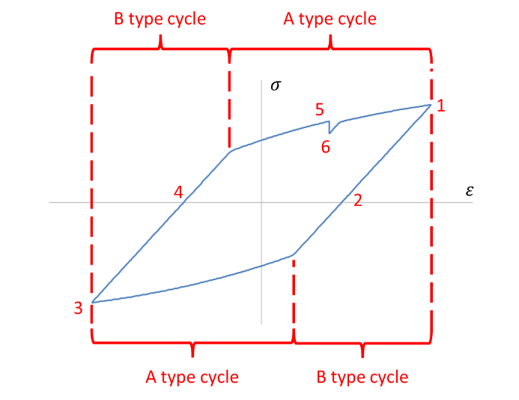

*FIG. 4. Different types of cycle.*

### Recently introduced methodology 3: Consideration of compression during the holding time

This methodology is described in RPP 17 (Rule in Probationary Phase) in RCC-MRx. It gives the possibility indicated in paragraph RB 3226.1 of RCC-MRx which adapts the formula of $σ_{k}$ in the case where the holding time is in compressive stress state after an inelastic computation to an elastic computation for austenitic stainless steels. In RB 3226.1, $σ_{k}$ is replaced by $0.867∙σ_{k}+0.133∙trace\left(σ_{k}\right)$. This formula comes from interpretation of tests on austenitic stainless steel with compressive stress, which were realized in 80’s. It is already present in the previous version of the code but only for inelastic computation.

In compression, the $trace\left(σ_{k}\right)$ is negative and, considering the equation above mentioned, the value of $σ_{k}$ is decreased. Indeed, it is well-known that, for this type of steel, a compressive stress is less damaging than a tensile stress for creep damage.

In elastic computation, it is not possible to estimate the value of $trace\left(σ_{k}\right)$. In this case, a new formula is used: $σ_{k}$ is replaced by $0.867∙σ_{k}+0.133∙\frac{σ_{k}}{\overline{σ_{el_h}}}∙\frac{σ_{k}-\overline{P_{max}}}{σ_{k}}∙trace\left(σ_{el_h}\right)$ with $\overline{σ_{el_h}}$ the elastic stress tensor calculated during the holding time. Nevertheless, it is possible to use this adaptation only if the two following conditions are verified:

* $trace\left(\overline{σ_{el_h}}\right)≤0$;
* $\overline{σ_{el_{h}}-σ_{min}}≤0.5∙\overline{∆σ_{tot}}$,

with $σ_{min}$ the stress tensor corresponding to one of extrema of $\overline{∆σ_{tot}}$ having the greatest negative trace in absolute value.

These conditions ensure that if the holding time is in a compressive stress state for an elastic computation, it stays in compression for an elastoplastic computation.

This methodology is not compatible with the methodologies 2 (presented above before) and 4 (presented below).

### Recently introduced methodology 4: Use of R5 procedure, in case the primary stress is neglected

The fourth and last methodology, described in RB 3262.1125 of RCC-MRx, corresponds to the methodology performed in R5 [2] to assess creep-fatigue damage. First, it requires that the hysteresis cycle is split into two half-cycles: without creep and with creep. The purpose is to estimate two strain ranges $\overline{∆ε}$ (see 2.1) and use the larger one for the assessment of fatigue damage. Except for the symmetrisation coefficient $K_{S}$ and the strain range $∆ε_{4}$, their determinations are comparable to 2.3. Concerning the creep damage, it is determined using a stress $σ_{k}$ calculated in the half-cycle with creep. As 2.4, it is also possible to consider a compression during the creep dwell. The stress $σ_{k}$ is then replaced by 0.734 $σ_{k}$.

Fig. 4 is taken to exemplify the methodology. First, the elastic stress range of the half-cycle corresponding to the points 123 ${\overline{∆σ}}_{123}$ is used to determine the strain range without creep ${\overline{∆ε}}_{123}$. Before starting the calculation of the strain range with creep ${\overline{∆ε}}_{34561}$, the stress at the point 3, $σ_{3}$, is positioning based on the relative magnitudes of the range of $K_{S}{\left(R_{p0.2}\right)}_{min}$ and ${\overline{∆σ}}_{123}$ in order to consider a steady state stress range. Then, the dwell stress $σ_{5}$ is determined using the relative stress along the points 345 and the Neuber hyperbola. This stress is used as the start of the dwell stress to calculate the stress $σ_{k}$ (at the point 6), the creep strain, and to assess the creep damage. After that, the elastic stress range ${\overline{∆σ}}_{34561}$ is adjusted using $σ_{k}$ to find the strain range ${\overline{∆ε}}_{34561}$. Finally, the larger of (${\overline{∆ε}}_{123}$, ${\overline{∆ε}}_{34561})$ is taken for assessment of fatigue damage.

## Representative Industrial applications

Two structures are chosen to evaluate the four new methodologies proposed above: the Inner Vessel (IV) and the Intermediate Heat eXchanger (IHX). These components are illustrated in Fig. 5.

The IV’s shell is submitted to the difference of temperature created by cold plenum and hot plenum during nominal state. The second structure, the IHX, is mainly submitted to a cyclic thermal loading issued from the cold shock during reactor’s shutdown.

The fatigue-creep analysis is carried out on several cross-sections of the structures. The gain is defined as the logarithm ratio between the creep damage fraction of the historical methodology and the one obtained by the latest modifications. The smallest creep damage fraction obtained from the recently introduced methodologies is used to calculate the gain.

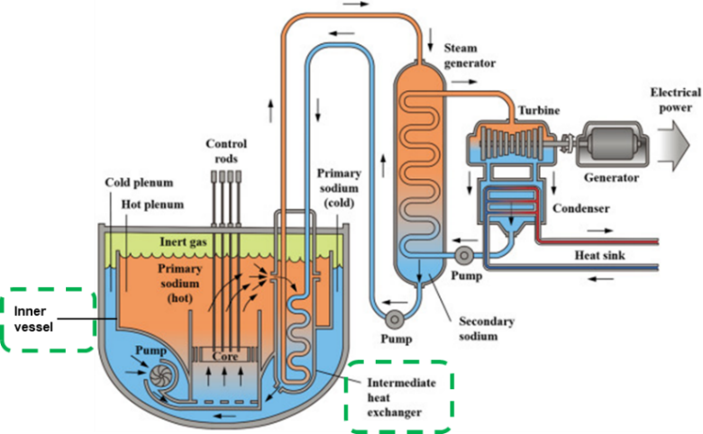

*FIG. 5. Schematic of sodium-cooled fast reactor.*

Fig. 6 below shows the impact assessment of the new methodologies to assess the fatigue-creep damage on the IV. The recently introduced methodologies, mainly the third one presented above (from RPP 17 of RCC-MRx), allow to reduce considerably the creep damage fraction W. It is about 10-100 times smaller. On some cross sections, the risk of creep damage fraction is even reduced to “zero” (for convenience these gains are not presented in the figures below). Concerning the most loaded cross-section obtained with the historical methodology, the creep damage fraction is about 37 times smaller.

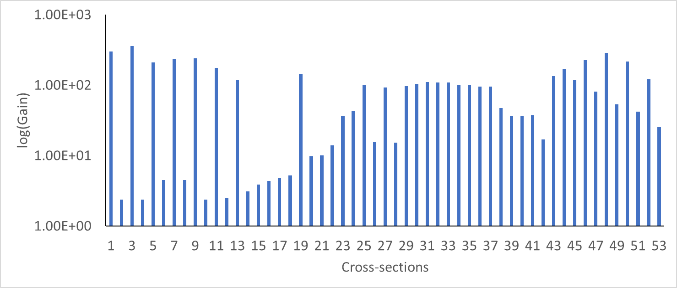

*FIG. 6. Gain of the new methodologies on the IV.*

Fig. 7 and 8 below show the impact assessment of the recently introduced methodologies to assess the fatigue-creep damage on the IHX. These methodologies, mainly the third and fourth ones presented above (from respectively RPP 17 and RB 3262.1125 of RCC-MRx), allow to reduce considerably the creep damage fraction W. The gain varies significantly with the cross sections from slight values (sections 2 and 14) up to the elimination of the risk of creep damage (sections 11 and 15). Concerning the most loaded cross-section obtained with the historical methodology, the creep damage fraction is about 8 times smaller. For the component as a whole, the creep damage fraction is reduced by a factor of 2.5.

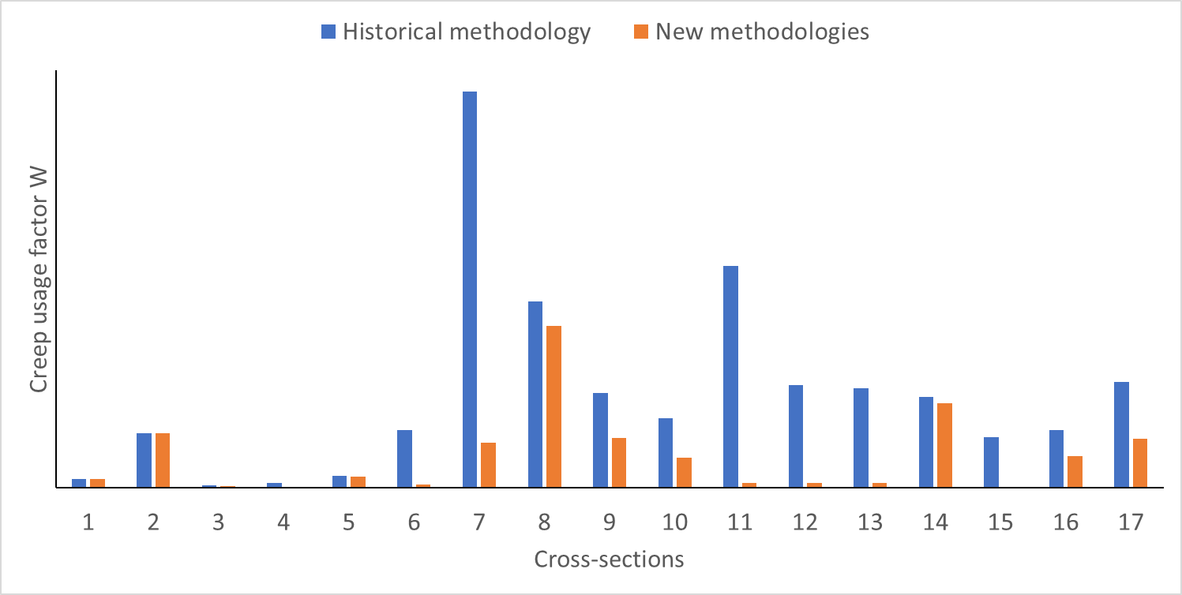

*FIG. 7. Comparison between the creep damage fraction of historical methodology and that obtained by new methodologies on the IHX.*

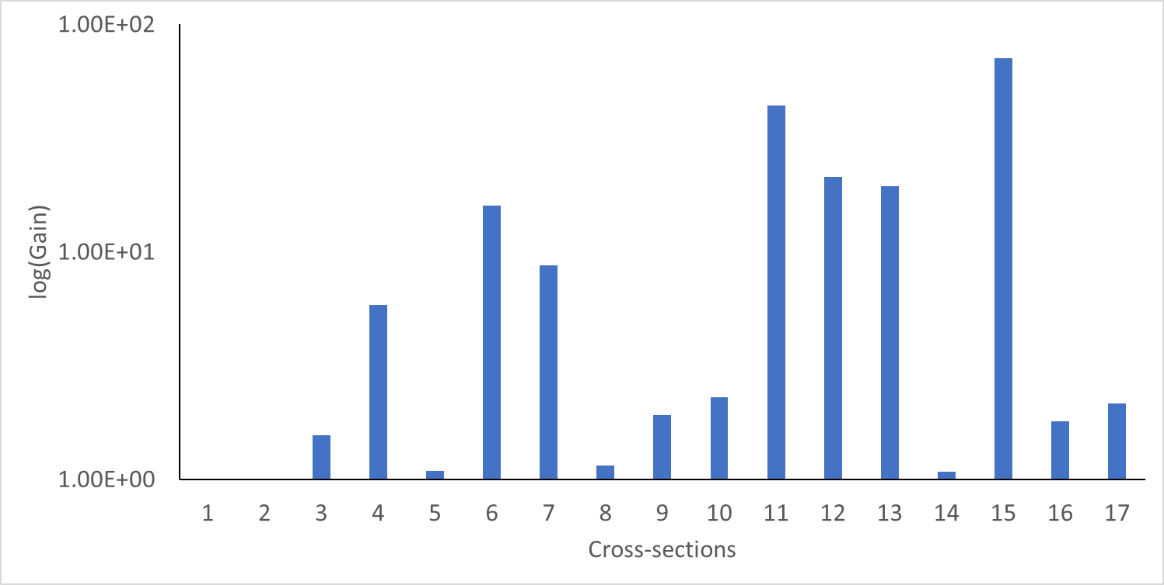

*FIG. 8. Gain of the new methodologies on the IHX.*

## CONCLUSION

This paper is devoted to present the recently introduced methodologies of RCC-MRx code for the assessment of creep-fatigue damage. In the 2022 Edition of the code, four additional methodologies are proposed in order to capture certain creep phenomena which were not considered in the historical methodology – specially a compression dwell stress and a dwell stress not on the extrema of a hysteresis cycle.

To illustrate and quantify these methodologies, two industrial applications have been evaluated on this paper. The results presented indicate that the latest modifications lead to notable gains for the assessment of creep-fatigue damage which were obtained without modifications of material, geometry, or nuclear safety requirements. Nevertheless, it is important to note that the creep damage is still significant, consequently the risk of creep-fatigue is still an on-going challenge for the design of heat exchangers in sodium fast reactors, and more generally for any component of a GEN IV reactor submitted to thermal loadings in the vicinity of the core outlet.

Recent improvements given to creep-fatigue methodologies have incorporated important aspects of creep phenomenon. As a result of that and based on the observations here presented, the recently introduced RCC-MRx methodologies of creep-fatigue are predictive and adapted to evaluate the creep-fatigue damage observed on SFR components. The assessment of creep-fatigue damage of innovative nuclear reactors – particularly to the GEN IV and SMR projects can be evaluated using the RCC-MRx Code, on condition that the rules applicability is justified. These methodologies can be used in the design of SMRs in order to demonstrate a more important lifetime of their components and consequently not to decrease the performance of their plant.

References

1. RCC-MRx, Design and Construction Rules for Mechanical Components of Nuclear Installations: High Temperature, Research and Fusion Reactors, 2022.
2. R5, Procedures for Assessing Structural Integrity of Components under Creep and Creep-Fatigue Conditions, 2012.