**IAEA Coordinated Research Project on Challenges, Gaps and Opportunities for Managing Spent Fuel from SMRs**

A. GONZÁLEZ ESPARTERO

Nuclear Fuel Cycle and Materials Section, International Atomic Energy Agency

Vienna, Austria

Email: a.g.espartero@iaea.org

**Extended Abstract**

There is an increasing interest in Small Modular Reactors (SMRs) and their applications, in part due to their consideration as a low carbon energy source in the climate change mitigation plans of many Member States. SMRs are newer generation reactors designed to generate electric power typically up to 300 MW(e) and for non-electrical industrial applications (e.g., water desalination and heat generation for industrial processes). According to the IAEA Booklet on Advances in SMR Technology Developments [1], complementary to ARIS and published in 2022, there are more than 80 SMR concepts currently under development, spanning a significant range of reactor technologies.

SMR concepts vary from evolutionary variants of Light Water Reactors (LWR-SMRs, either land or marine based), that benefit from many decades of operating experience of the current fleet of LWRs; High Temperature Gas Cooled Reactors (HTGR-SMRs); Liquid Metal Fast Reactors (LMFR-SMRs) and molten salt reactors (MSR-SMRs). SMR designs use a variety of coolants (e.g., water, liquid metal, molten salts) and fuel forms (e.g., oxide/ceramic, metal, TRISO, liquid fuel salts) having different Technology Readiness Levels (TRLs) and fuel compositions and forms (e.g., UOX (LEU, HALEU); Mixed U and Pu (oxide, metal, salt); kernel particles).

While much focus has been given to aspects of SMR deployment such as reactor concepts, engineering, economics, safety and security, etc, the fuel cycle, and in particular the management of spent fuel, appears to have had limited consideration so far. As the SMR concepts are becoming more refined, it is an appropriate time to start identifying the challenges, opportunities, and gaps for managing spent fuel from SMRs during all stages of the back end of the fuel cycle such as storage, transportation, reprocessing & recycling, and disposal.

The management of spent fuel is very dependent on the characteristics of the nuclear fuel relating to its enrichment, matrix and composition, and its irradiation history. Spent fuels coming from SMRs will have different characteristics and irradiation histories that will require either adaptation of currently implemented technologies or new developments for all stages of the back end of the fuel cycle to accommodate higher thermal outputs, criticality risks, different radionuclide inventories, new matrices and claddings, etc., implying the need for R&D, demonstration projects and licensing to ensure that the fundamental safety objective is met.

In its 17th Meeting in April 2019, the Technical Working Group on Nuclear Fuel Cycle Options and Spent Fuel Management (TWG-NFCO) recommended that “*The next update of the Advances in Small Modular Reactor Technology Developments report should consider technologies for managing SNF from SMRs. This update should not only consider the reactor technology, but also the back end infrastructure that would be needed to support SMRs’ deployment - including transportation, storage, recycling, and disposal technologies. Newcomer countries should be made aware that, as with all reactor types, the management of SNF from SMRs needs to be fully considered. Nuclear fuel cycle aspects, in particular the back end, should be integrated into all IAEA working groups that are looking at SMRs*”.

Based on those recommendations, a Technical Meeting on Considerations for the Back End of the Fuel Cycle of SMRs was convened in September 2022 in Vienna. The purpose of the meeting was to facilitate the exchange of information and discussions regarding the management of spent fuels coming from all envisaged SMR technologies to enable experts to collaboratively identify the opportunities and challenges faced at all stages of the back end of the fuel cycle, the gaps in current infrastructures and the knowledge required to ensure an integrated approach to the overall spent fuel management strategy, as well as the potential ways to move forward in addressing them in the near, medium, and long terms.

The technical meeting was scheduled in three technical sessions on (i) IAEA Perspectives, (ii) International Organizations Perspectives, and (iii) Member States Perspectives and three topical break out sessions on LWR-SMRs, HTGR-SMRs and AMRs including Molten Salt Reactors.

The meeting was attended by 107 participants from 32 Member States, and 3 International Organizations, delivering 40 oral presentations. The attending countries and organizations were Argentina, Armenia, Belarus, Bulgaria, Canada, China, Czech Republic, Egypt, Ethiopia, Finland, France, Hungary, India, Japan, Jordan, Lithuania, Malaysia, Netherlands, Pakistan, Philippines, Poland, Romania, Russian Federation, Singapore, Slovenia, South Africa, Sudan, Sweden, Thailand, United Kingdom of Great Britain and Northern Ireland, United States of America, Uzbekistan, the European Commission, the OECD/Nuclear Energy Agency (NEA) and the European Repository Development Organization (ERDO).

Presented material and detailed discussions have been published in the IAEA-TECDOC-2040 on Considerations for the Back End of the Fuel Cycle of Small Modular Reactors [2]. Discussions concluded that understanding the implications of the SMR’s spent fuel management programme is important for countries embarking or willing to embark on an SMR programme, whether they are nuclear countries or newcomers, to make informed decision on the specificities of different SMR technologies and related fuel cycle options.

For the different spent fuels from SMR technologies, it is paramount to identify:

* The various steps to be undertaken, their timeline and duration.
* The data required to develop the various fuel cycle options based on collected data on mass flows of nuclear materials and wastes; isotopic and chemical forms; waste forms and their compatibility with disposal.
* The data to be collected from irradiated fuel to be used in designing systems for licensing.
* The gaps with existing practices/technologies/infrastructures developed for existing systems and the specific characteristics associated to SMR deployment as well as the opportunities to develop new technologies to fill the gaps.
* Which infrastructures, including their size, would need to be developed, whether they would be locally implemented or based on existing industry solutions/services, including cost elements.

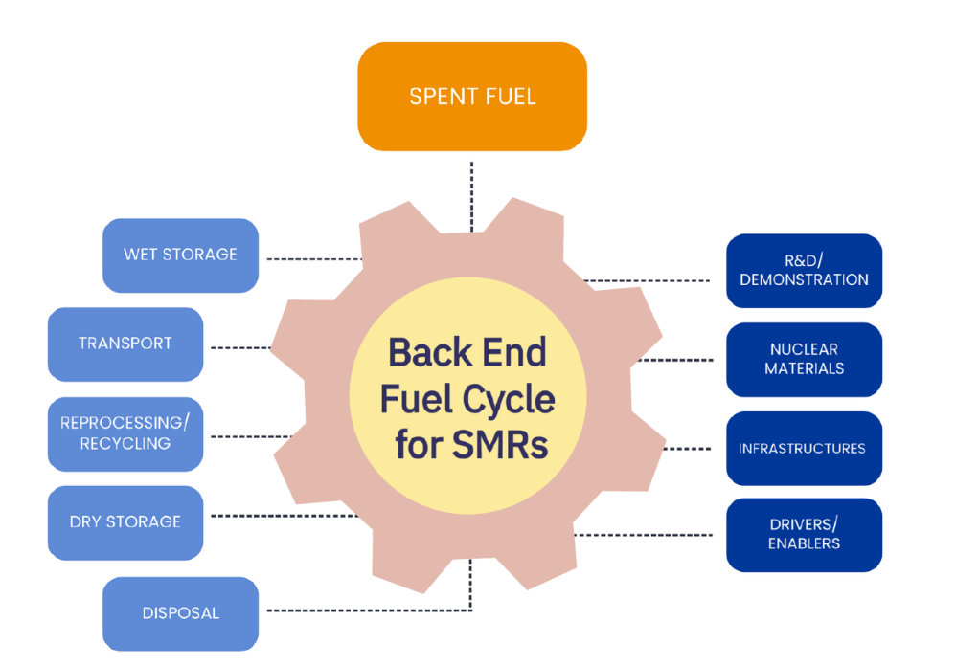

Figure 1.- IAEA Coordinated Research Project on

“Challenges, Gaps and Opportunities for Managing Spent Fuel from SMRs” (SMR-COGS, T13021)

This would require establishing specific roadmaps of activities to be developed per technology, identifying what can be derived from existing practices, optimized, adapted, or fully developed considering the lack of data, gaps with existing knowledge, and defining required additional data and the way to acquire them.

This would allow for comparison of various reactor technology systems, comparing fuel cycle options to identify/quantify the effort required to implement a spent fuel management strategy in terms of nuclear facilities, technology developments, types of nuclear materials involved, generated waste forms and other infrastructures needed such as human resources, regulatory framework, financing, etc.

In order to address this request from Member States, the IAEA has launched the Coordinated Research Project on “Challenges, Gaps and Opportunities for Managing Spent Fuel from SMRs” (SMR-COGS, T13021, Fig. 1) [3] with the main objective of:

* Identifying viable nuclear fuel cycle options for the different SMR technologies;
* Establishing generic key parameters that would then allow a country to develop from that tool their analysis incorporating their specific context;
* Identifying common technologies/similarities for various reactor types and/or significant differences;
* Identifying and highlighting key parameters for designing the back end programme of the different fuel cycle options associated with the different SMR technologies.

References

1. INTERNATIONAL ATOMIC ENERGY AGENCY, Advances in Small Modular Reactor Technology Developments A Supplement to: IAEA Advanced Reactors Information System (ARIS), 2022 Edition, Vienna (2022).
2. INTERNATIONAL ATOMIC ENERGY AGENCY, Considerations for the Back End of the Fuel Cycle of Small Modular Reactors, Vienna (2023).
3. IAEA CRP on Challenges, Gaps and Opportunities for Managing Spent Fuel from Small Modular Reactors (T13021) [NEW CRP: Challenges, Gaps and Opportunities for Managing Spent Fuel from Small Modular Reactors (T13021) | IAEA](https://www.iaea.org/newscenter/news/new-crp-challenges-gaps-and-opportunities-for-managing-spent-fuel-from-small-modular-reactors-t13021)