THE DEVELOPMENT OF A VERSATILE TYPE B(U)F TRANSPORT PACKAGE TO SUPPORT THE FRONT-END FUEL CYCLE OF GEN-IV REACTORS - 24174

S. PERRY CEng MIMechE,

Lead Design Engineer

Nuclear Transport Solutions,

Warrington, England, UK

Email: sean.perry@ntsglobal.uk

A. LEVER,

Graduate Design Engineer

Nuclear Transport Solutions,

Warrington, England, UK

Email: adam.lever@ntsglobal.uk

**Abstract**

Nuclear Transport Solutions (NTS) is the leading global provider of safe, secure and reliable nuclear transport and logistics solutions that help make the world safer and more sustainable. We support the global nuclear market by providing standalone or end-to-end solutions to nuclear transport and logistics challenges.

We use our expertise to support decommissioning, waste disposal activities, global security and threat reduction goals, and new nuclear ambitions. We help to advance the global nuclear industry by investing in innovation, influencing international nuclear transport standards, and sharing our knowledge of transporting dangerous cargos.

NTS have been successful in receiving funding from the Department for Energy Security and Net Zero (DESNZ) Nuclear Fuel Fund (NFF) to develop a new IAEA SSR-6 compliant transport package.

The package shall be designed to transport High Assay Low Enriched Uranium (HALEU) in multiple forms to support the front-end fuel cycle of the UKs Gen-IV Advanced Modular Reactor (AMR) development strategy. Due to the UKs history of operating gas cooled reactors, the Gen-IV reactor technology of choice is likely to be a High Temperature Gas Cooled Reactor that utilises TRISO fuel.

The HALEU Transport Package (HTP) has been designed with an interchangeable basket to allow an array of contents to be transported. As Gen-IV reactors are still in development, the fuel specification and design are not yet fixed. Therefore NTS have focussed on the transport of HALEU powder (U235 ≤ 20% enrichment) in cans from deconversion facilities to fuel manufacturing facilities.

The package incorporates features from a number of existing NTS package designs and utilises both a Multiple Water Barrier and Commercial off the Shelf material to simplify package licensing and manufacture.

The lack of a fully defined Contents specification pose a number of challenges to the HTP development:

* HALEU powder created from down-blended highly enriched Uranium leads to an inappropriately engineered solution
* Lack of appropriate criticality benchmarking data leads to an overly pessimistic criticality safety assessment
* The assumed internals (i.e. HALEU powder product cans) do not meet future customer requirements
* Lack of upfront stakeholder engagement could lead to a package that cannot be operated in specific facilities

This paper provides an overview of the HTP design with a particular focus on the challenges associated with developing a package with an assumed contents specification.

1. INTRODUCTION

Nuclear Transport Solutions (NTS) are developing a new Type B(U)F package to transport High Assay Low Enriched Uranium (HALEU) in multiple forms, knows at the HALEU Transport Package (HTP). The development of the HTP is being jointly funded by NTS and the UK Department of Energy Security and Net Zero (DESNZ) Nuclear Fuel Fund with the intention of demonstrating Technical Readiness Level (TRL) 4 by the end of March 2025.

The design philosophy of the HTP is to utilise as much commercial off the shelf (COTS) material as possible to reduce unit cost and simplify both procurement and manufacture. The HTP also incorporates features from existing NTS package designs to streamline the design substantiation and subsequent licensing activities.

The HTP is being designed to support the front-end fuel cycle of Gen-IV Advanced Modular Reactors (AMR) which led to the incorporation of an interchangeable internal basket. Figure 1 shows a representation of the HALEU fuel cycle [1]. The removable internal basket will allow the HTP to transport both HALEU powder (enriched up to 20% U235 in product cans) post enrichment to fuel fabrication facilities and Tri-structural Isotropic (TRISO) fuel following production to the reactor.

A two year programme of work has been produced to develop the HTP through concept design (demonstrating TRL 3) to a preliminary design (TRL 4) that will be supported by a manufacturing demonstration. A summary of the key activities include:

* Impact and Thermal Finite Element Analysis (FEA) of Normal and Accident Conditions of Transport [2]
* Shielding and dose assessment
* Criticality safety assessment
* Two-phase manufacturability assessment to be undertaken by the Nuclear Advanced Manufacturing Research Centre (AMRC)

*Figure 1 - HALEU Fuel Cycle*

1. HTP ASSUMED CONTENTS

Due to the lack of an end user for the HTP, an assumption was made on the contents to be transported. The worst case has been assumed as HALEU powder in cans due to the inherent robustness of TRISO fuel. The following information came from a report by The Idaho National Laboratory that reviewed the HALEU transportation capabilities in the United States [3].

The isotopic composition provided in Table 1 is for HALEU in the form of UO2 powder that has been produced from down-blending Highly Enriched Uranium (HEU). Figure 2 shows the assumed HALEU canister design. It is assumed that 28 kg of powder is transported per HALEU Canister. The UO2 powder particles full theoretical density shall be assumed as 10.96 g/cc.

Table 1 - Uranium Composition of HALEU

|  |  |  |  |  |
| --- | --- | --- | --- | --- |
| **Isotope** | **Units** | **Average** | **Minimum** | **Maximum** |
| U232 | ppb U | 0.66 | 0.07 | 5.04 |
| U233 | ppb U | 49.12 | 4.88 | 318.43 |
| U234 | iso% U | 0.17 | 0.16 | 0.21 |
| U235 | iso% U | 19.39 | 18.97 | 19.99 |
| U236 | iso% U | 0.58 | 0.50 | 1.22 |
| U237 | ppt U | 0.06 | 0.00 | 0.22 |
| U238 | iso% U | 79.86 | 79.05 | 80.36 |
| Total U (wt%) | | 99.95 | 99.89 | 99.97 |

|  |  |
| --- | --- |
|  | Canister Details:  Length = 482.6 mm  OD = Ø126.5 mm  Unladen Mass = 16 kg  Laden Mass = 44 kg  Material = 304L |

*Figure 2 - Concept HALEU Canister [3]*

1. HTP CONCEPT DESIGN DEVELOPMENT
   1. **Iteration 3**

The HTP utilises a “Russian doll” principle by having two independent Containment Vessels (CV) assembled together and encased in a Shock Absorber. The CVs are made from standard rolled pipe with machined upper and base sections. Each CV has a lid assembly that is secured using a bayonet locking system. Both lids incorporate a double O-ring sealing arrangement that is used to demonstrate containment by means of a pressure drop leak test. The HTP Internal Basket is made up of standard lengths of pipe assembled within a tubeplate spacer matrix.

An integrated design team was assembled to facilitate quick and informed decision making to develop the HTP. The design went through several iterations before scoping structural, shielding and criticality assessments were completed on the design shown in Figure 3, with the key features summarised in Table 2.

Table 2 - HTP Iteration 3 Details

|  |  |
| --- | --- |
| **Component** | **Mass (kg)** |
| Inner CV | 535 |
| Inner CV Lid | 232 |
| Outer CV | 930 |
| Outer CV Lid | 350 |
| Shock Absorber Body + Lid | 800 |
| Maximum Payload  (including Internal Basket) | 1970 |
| Unladen Weight | 3530 |
| Gross Laden Weight | 5500 |

|  |  |
| --- | --- |
|  |  |

*Figure 3 - Exploded and Section View of HTP Iteration 3*

FEA was completed on HTP Iteration 3 to determine its performance following a regulatory impact accident i.e. 9m drop [2]. The results of this analysis are shown in Figure 4. Fundamentally, the contents striking the Inner CV Lid was causing significant deformation which would compromise the containment boundary, meaning the Multiple Water Barrier argument could not be achieved.

A solution was proposed to introduce a “fuel retainer” combined with a membrane type inner lid which is a feature that worked well in a previous NTS package design. A proposal is shown in Figure 5. The introduction of a fuel retainer would add considerable mass and additional manufacturing complexity to both HTP containment vessels.

The Trunnions, which were intended for package handling, were acting in a way that was tearing the Shock Absorber Lid off (as seen in Figure 4). This would remove any protection during the regulatory fire accident (i.e. 30 minute all engulfing 800°C fire) [2] which would lead to the Outer CV Lid seals exceeding their operating temperature, hence losing containment.

As a result of this scoping FEA a decision was made to make a significant change to the design. As the concept was still at an early stage, a number of changes were enacted without compromising the agreed programme of work.

|  |  |
| --- | --- |
|  |  |

*Figure 4 - HTP Iteration 3 Impact FEA Results*

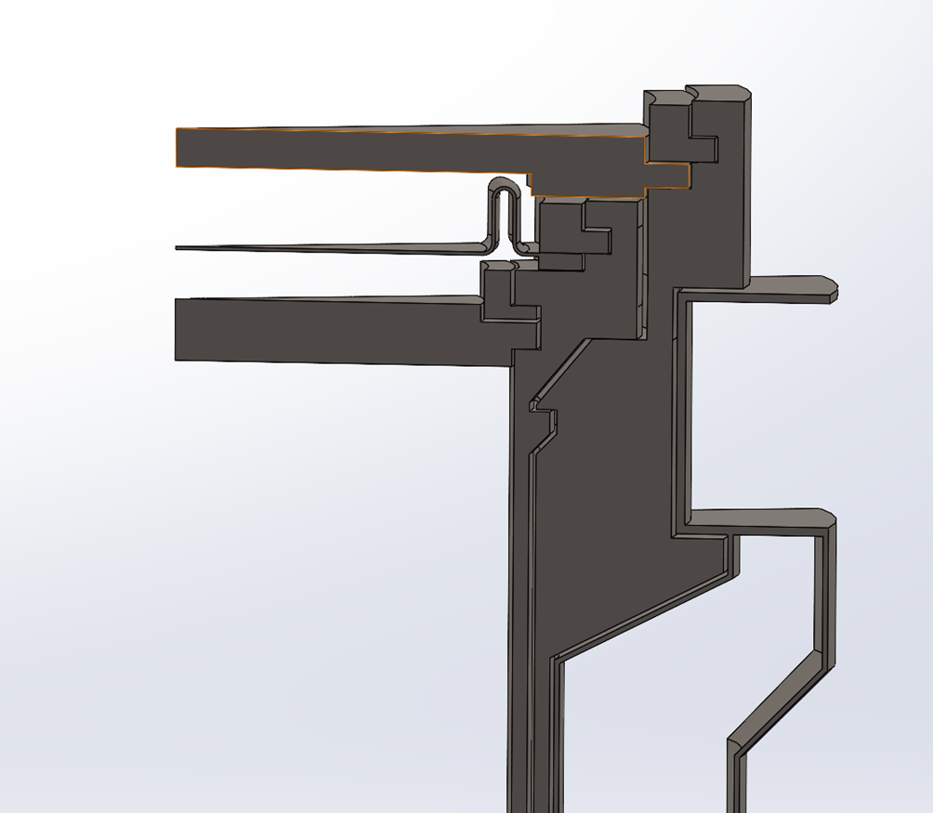

*Figure 5 - Fuel Retainer Proposal*

* 1. **Iteration 4**

The next significant design stage was Iteration 4. This updated variant of the HTP maintained the majority of the key design features however, the following significant changes were incorporated:

* Reduction of the Internal Basket from 19 Channels to 7 (i.e. 38 HALEU canisters to 14)
* Inner and Outer Containment Vessels and Shock Absorber reduction to suit new Internal Basket diameter
* Change from standard pipe end fitting to a flat bottom for each containment vessel
* Incorporation of an Internal Shock Absorber fabricated from stainless steel honeycomb to protect the Inner CV Lid during an impact accident
* Removal of the Trunnions and incorporation of a lower skirt with integrated forklift pockets for package handling

HTP Iteration 4 is shown in Figure 6 with a summary of the component details provided in Table 3.

Table 3 - HTP Iteration 4 Details

|  |  |
| --- | --- |
| **Component** | **Mass (kg)** |
| Inner CV | 270 |
| Inner CV Lid | 109 |
| Outer CV | 457 |
| Outer CV Lid | 162 |
| Shock Absorber Body + Lid | 649 |
| Maximum Payload  (including Internal Basket) | 720 |
| Unladen Weight | 1750 |
| Gross Laden Weight | 2360 |

*Figure 6 - HTP Iteration 4*

* + 1. *HTP iteration 4 design substantiation*
       1. Impact and Thermal FEA

Following the update of the HTP to Iteration 4, more detailed Impact and Thermal accident conditions of transport [2] assessments were undertaken.

Figure 7 shows the results from a lid down and side down impact. The assessments demonstrated the successful functioning of both the wood filled Shock Absorbers and the Internal Impact Limiter. A number of issues with the package design were identified and recommendations provided that shall be included in the next iteration of the package design to improve performance.

|  |  |
| --- | --- |
|  |  |

*Figure 7 - HTP Iteration 4 Impact FEA*

Figure 8 shows the results from a thermal assessment where it was assumed two of the timber blocks that make up the Body and Lid Shock Absorber have ignited in the 800°C fire. The purpose of this model is to investigate whether the containment seals in Outer CV lid would exceed their maximum operating temperature. Although there is suitable margin, the results of this assessment combined with feedback from the Nuclear AMRC manufacturability assessment suggest it is likely the wooden blocks will be wrapped in a thermal insulating material to prevent ignition.

*Figure 8 - HTP Iteration 4 Thermal FEA*

* + - 1. Shielding

An initial shielding assessment has been completed for HTP Iteration 4. A simplified model is generated in MCNP with the results verified in a separate shielding code, ATILLA. Figure 9 shows the two independent models that were created, and Table 4 provides a summary of the results. The results suggest there is considerable margin in the dose assessment based on the regulatory requirements [2] and no further shielding material is required for the HTP.

Table 4 - HTP Iteration 4 Shielding Assessment

|  |  |  |  |
| --- | --- | --- | --- |
| Location | Position | Calculated Dose Rate | Regulatory Dose Rate Limit |
| mSv/hr | mSv/hr |
| Surface | Side | 0.38 | 2 |
| Base | 0.52 |
| 1m | Side | 0.06 | 0.1 |
| Base | 0.02 |

|  |  |
| --- | --- |
|  |  |

*Figure 9 - Simplified Shielding Assessment Models*

* + - 1. Criticality Safety

Criticality safety assessment for nuclear transport packages are deterministic and must undertake fully optimised, worst case arrangements of the fissile material in the package. As the HTP incorporates a Multiple Water Barrier closure system the ingress of water can be excluded from the assessment.

Figure 10 shows an array of different assessments that were performed replicating different scenarios following regulatory accident conditions. Figure 11 shows some preliminary results from a dry package assessment. The results show the HTP design is feasible and that a Multiple Water Barrier is required.

|  |  |  |  |
| --- | --- | --- | --- |
|  |  |  |  |

*Figure 10 - Simplified Criticality Safety Assessment models of HTP Iteration 4*

*Figure 11 - Initial Scoping Results*

* 1. **HTP Transport Configuration Assessment**

It is assumed that the HTP shall be transported in a standard 20’ ISO container. The container shall be capable of transport by road, rail and sea. An assessment of the anticipated conveyance configuration was completed, as shown in Table 5 and Figure 12, to highlight the marginal differences in quantities of HALEU powder transported in the two HTP Iterations.

Table 5 - HTP Capacity Comparison

|  |  |  |
| --- | --- | --- |
|  | **Iteration 3** | **Iteration 4** |
| UO2 / Can | 28 kg | |
| Cans / HTP | 38 | 14 |
| UO2 / HTP | 1064 kg | 392 kg |
| HTP / 20’ ISO | 3 | 8 |
| UO2 / 20’ ISO | 3192 kg | 3136 kg |

|  |  |
| --- | --- |
|  |  |

*Figure 12 - HTP Transport Configuration Comparison*

The move to Iteration 4 allowed the HTP to be handled by a standard forklift truck, as shown in Figure 8. This change improves the impact performance of the package as the lower skint acts as a shock absorber in a base down drop. It also provides greater flexibility to future customers for facility operations.

*Figure 13 - HTP Forklift Handling*

1. HTP FINAL CONCEPT DESIGN
   1. **Iteration 5**

Iteration 5 was created using recommendations for the substantiation assessments completed in iteration 4 and information by a desktop manufacturability assessment completed by the Nuclear AMRC.A summary of the main changes to the design are:

* Fabricated plates added onto lid shock absorber to improve impact performance in lid down drop tests.
* Locking ring integrated into lid design to improve operability during loading and unloading of the package
* Wood added to base of package to improve performance for criticality
* Amended forklift pockets and base construction to stabilise during manoeuvring and loading operations

HTP Iteration 5 is shown in Figure 14 with a summary of the components listed in Table 6.

Table 6 - Iteration 5 component details

|  |  |
| --- | --- |
| Component | Mass (kg) |
| Inner CV | 257 |
| Inner CV Lid | 94 |
| Outer CV | 441 |
| Outer CV Lid | 170 |
| Shock Absorber Body + Lid | 679 |
| Maximum Payload (including Internal Basket) | 720 |
| Unladen Weight | 1753 |
| Gross Laden Weight | 2365 |

*Figure 14 - HTP Iteration 5*

* + 1. *HTP Iteration 5 Design Substantiation*
       1. Impact and Thermal FEA

The impact assessments were repeated for the updated HTP design to determine if the changes operated as intended. The thermal assessments were assumed to be consistent with both iteration 4 and 5 due to the similarity in designs for the body shock absorber and containment vessels. Figure 15 showcases the performance of the HTP for ACT impact conditions with its improved performance.

*Figure 15 - HTP Iteration 5 Impact FEA*

* + - 1. Shielding

Due to no changes being implemented to the basket design between Iteration 4 and 5, the shielding assessment from Iteration 4 remained applicable.

* + - 1. Criticality

As demonstrated in Iteration 4, the design of the HTP uses a MWB and prevents water ingress for ACT. The worst case scenario for the design was for all the HALEU powder to escape the basket, gathering at the base of the inner CV. The criticality model is shown in Figure 16:

|  |  |
| --- | --- |
|  |  |

*Figure 16 - HTP Iteration 5 Criticality Model*

The assessments conducted for iteration 5 evaluated the criticality safety within the package for varying shock absorber conditions following a fire in the event of an accident. Results are presented in Figure 17. The K effective for the HTP should be 0.92 or less. The results in Figure 17 demonstrate a sensitivity loss of shock absorber material. As a result, additional work is needed to protect the shock absorber following ACT. This will be done in the next design phase.

*Figure 17 - HTP Iteration 5 Criticality Assessment*

1. MANUFACTURING DEMONSTRATOR

In the second year of funding for the design and development of the HTP, the Nuclear AMRC are developing a manufacturing demonstrator to rapidly progress the design process and inform decisions at the next stage. Nuclear AMRC will be making this model using Iteration 5 manufacturing drawings.

This approach is unique for NTS; however it is necessary to ensure the deadline for TRL 4 by end of March 2025 agreed with DESNZ is met.

*Figure 18 -HTP Iteration 5 Model for Manufacture*

1. CONCLUSIONS
   1. **Justification for Significant Design Change**

As described in this report, a number of factors contributed to the decision to change the HTP design. Once the decision was made to reduce the capacity of the package it became clear that a number of other benefits would be realised:

1. Reduction in size and simplification of the design will make the HTP easier to manufacture and should reduce the unit cost
2. Reduction in fissile mass to be transported should improve the margins in the criticality safety assessment
3. Incorporation of forklift pockets improves handling capability
4. Removal of Trunnions improves impact performance
5. Reduction in the contents mass removes the requirement for a “fuel retainer” and membrane lid configuration

Design changes from iteration 4 to Iteration 5 are less significant, however improve the design for operational safety, manufacturability and ACT performance.

* 1. **Work for TRL 4**

Upon demonstration of TRL 3 and moving into TRL 4, the following areas will be investigated:

1. Design of lifting equipment, tie-down mechanisms and other ancillary equipment.
2. More detailed analysis into impact for the package, including inspecting weld integrity, retention of forklift pockets, controlling of external surface finishes and further assessments on shock absorber bolts.
3. Further criticality assessments to determine if additional or alternative material is needed within the package to improve package performance for an infinite array (both mirror and periodic).
4. Conduct a transport feasibility study to inform future transport decisions.
5. Nuclear AMRC to manufacture a HTP model and report findings and suggestions for improvement to NTS
6. REFERENCES

|  |  |
| --- | --- |
| [1] | EESI Briefing: The State of Play for Nuclear Energy in the United States, *Commercializing Advanced Nuclear Energy,* Dr P White, Nuclear Innovation Alliance, April 2023. |
| [2] | IAEA Safety Standards, *Regulations for the Safe Transport of Radioactive Material - Specific Safety Requirements No. SSR-6 (Rev 1),* IAEA, 2018 Edition. |
| [3] | INL/EXT-19-56333 Rev 0, *UO2 HALEU Transportation Package Evaluation and Recommendations,* Idaho National Laboratory , November 2019. |

1. ACKNOWLEDGEMENTS

The author would like to extend thanks to Sean Duvall, Michelle Nuttall and Craig Williams for their technical expertise in supporting the development of the HTP and subsequent input to this paper. Thanks also to Ian Grainey for his invaluable advice and Adam Lever for his unwavering support.

Special thanks are extended to David Anson and the team at the Nuclear Advanced Manufacturing Research Centre for their crucial input into the package design.